Supplements 2: Melt curves and efficiency of primers
Figure S1. The melt curves of primer, the template for detection was from 6th instar of whole-body larvae. (A)melt curves of SlitEF primers. (B) melt curves of SlitGAPDH primers. (C)melt curves of SlitOBP11 primers. The yellow was the melt curves with the template quality of 1μg, light red was 0.3333μg, light green was 0.1111μg, red was 0.0370μg. green was 0.0123μg and blue was 0.0041μg.
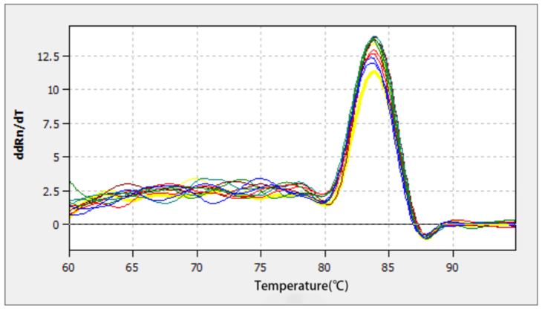
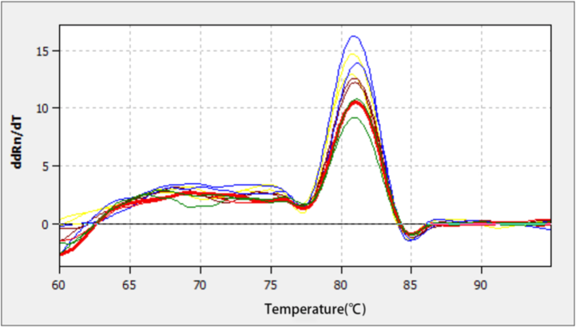
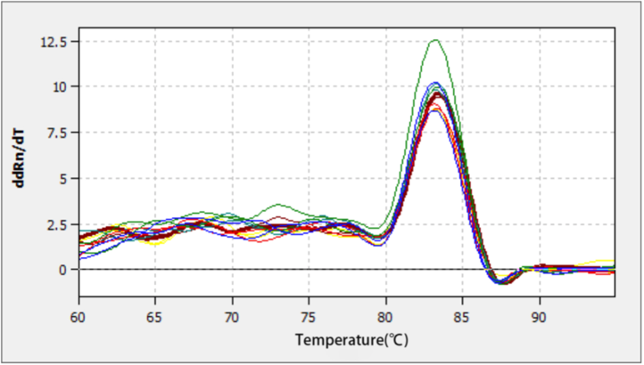
A
B
C

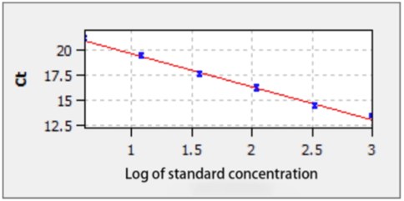
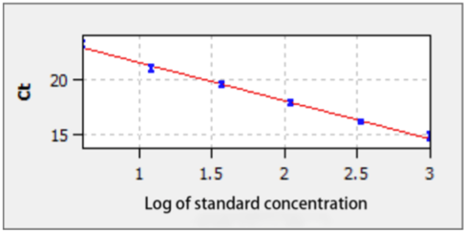
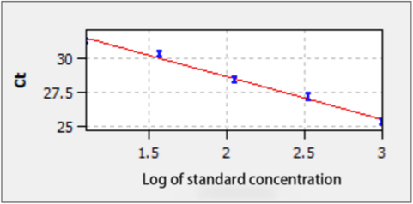
Figure S2. The standard curve and efficiency for each gene primers. (A) standard curve of of SlitEF primers with the primers efficiency of 1.01(R²:0.99348). (B) standard curve of of SlitGAPDH primers with the primers efficiency of 0.94 (R²: 0.99506). (C) standard curve of of SlitOBP11 primers with the primers efficiency of 1.08 (R²: 0.99178).
A
B
C

