II. Supplemental Figures: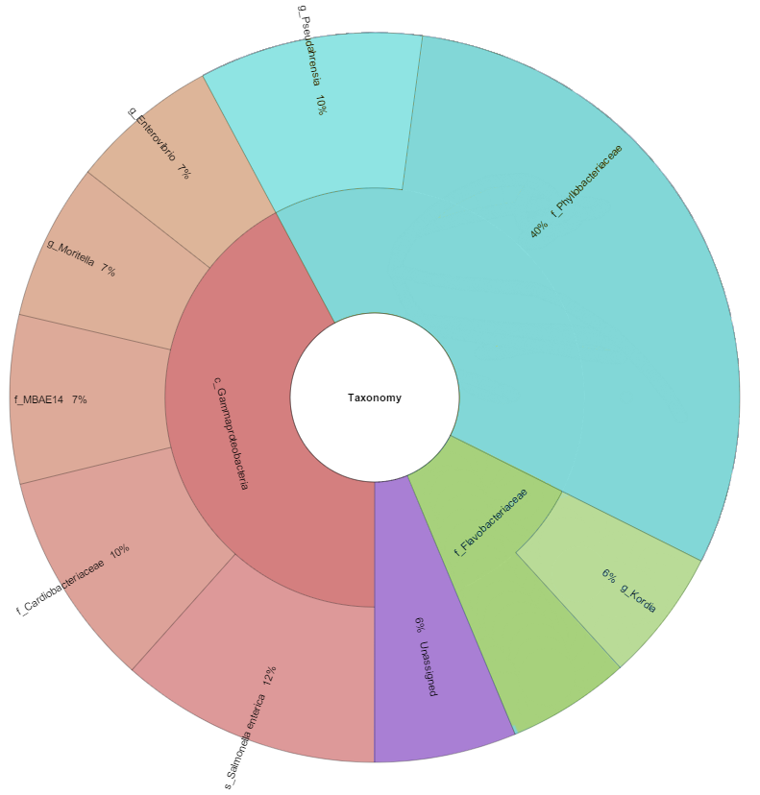
Figure S1. Krona Graphical representation of the 10 most abundant taxa in all sample locations of the nurse sharks sampled. Percentages are calculated based on overall relative abundance across all nurse sharks.
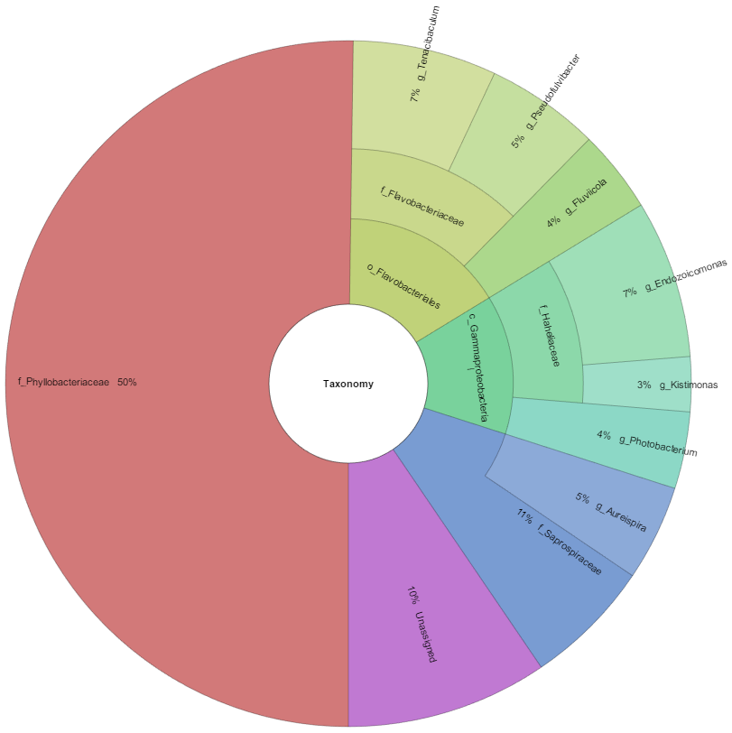
Figure S2. Krona Graphical representation of the 10 most abundant taxa in all sample locations of the lemon sharks sampled. Percentages are calculated based on overall relative abundance across all lemon sharks.
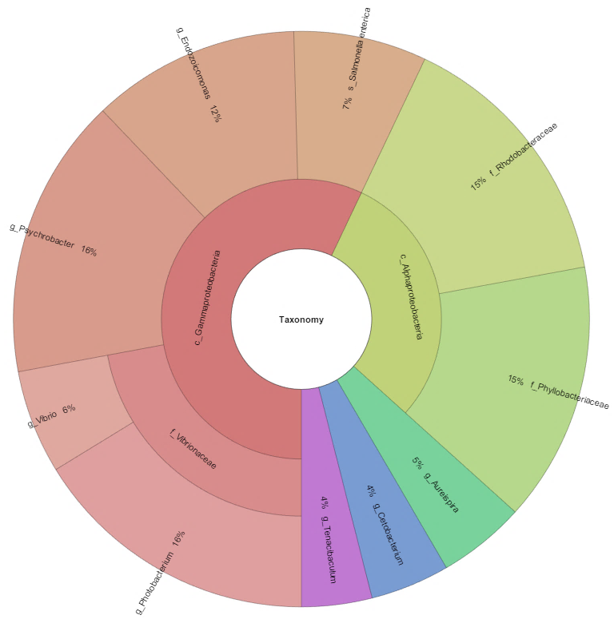
Figure S3. Krona Graphical representation of the 10 most abundant taxa in all sample locations of the tiger sharks sampled. Percentages are calculated based on overall relative abundance across all tiger sharks.
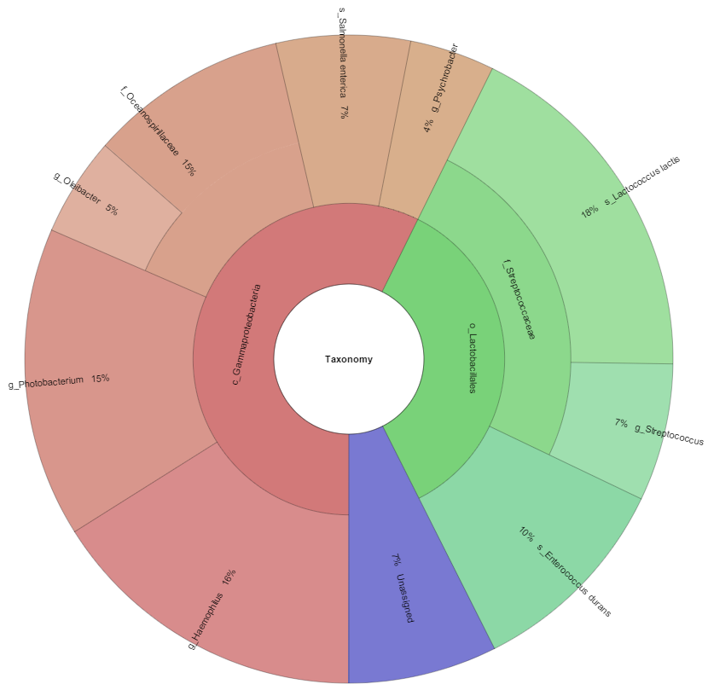
Figure S4. Krona Graphical representation of the 10 most abundant taxa in all sample locations of the Caribbean reef sharks sampled. Percentages are calculated based on overall relative abundance across all Caribbean reef sharks.
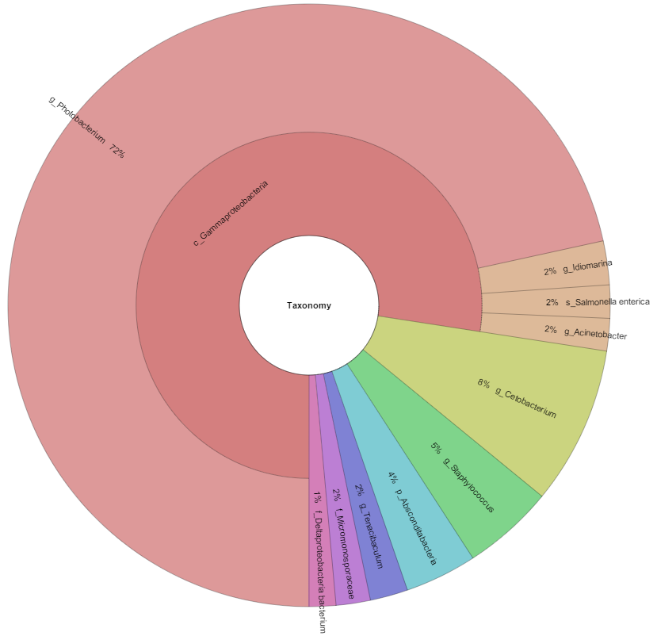
Figure S5. Krona Graphical representation of the 10 most abundant taxa in all sample locations of the sandbar sharks sampled. Percentages are calculated based on overall relative abundance across all sandbar sharks.

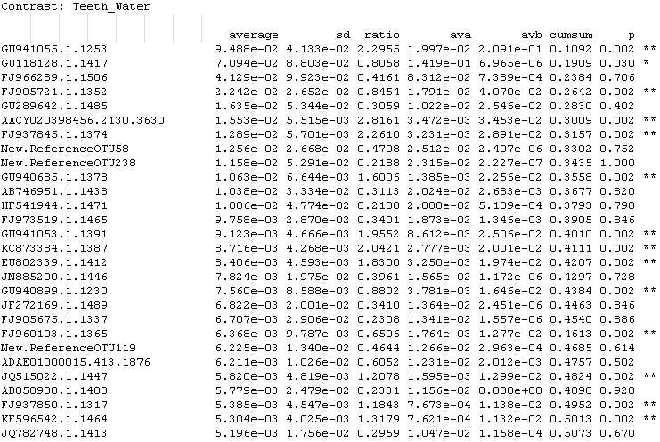
Figure S6. Simper analysis comparing all teeth to water sample OTUS, up to a cumulative sum of .5 (50.0%). (Significant codes: *= .05 **=.01)
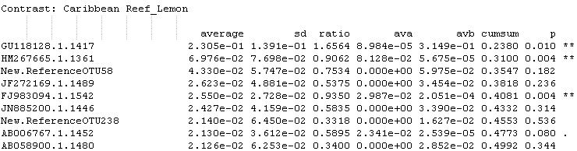
Figure S7. Simper analysis comparing all Caribbean reef to lemon shark teeth sample OTUS, up to a cumulative sum of .5 (50%). (Significant codes: *= .05 **=.01 ‘.’=.5)

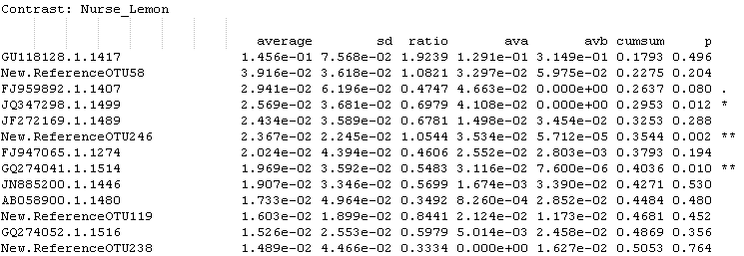
Figure S8. Simper analysis comparing all nurse to lemon shark teeth sample OTUS, up to a cumulative sum of .5 (50.0%). (Significant codes: *= .05 **=.01 ‘.’=.5)

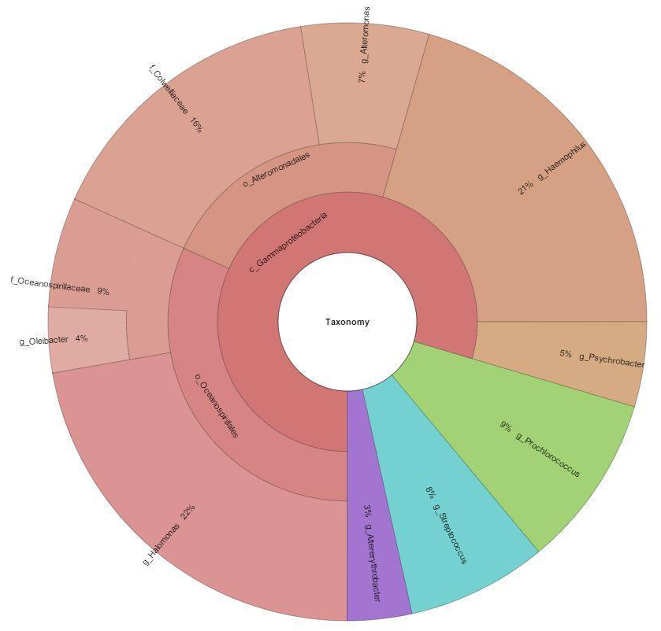
Figure S9. Krona Graphical representation of the most abundant taxa in the microbial community of the teeth of the Caribbean reef sharks sampled. Percentages are calculated based on overall relative abundance across all Caribbean reef shark teeth samples.

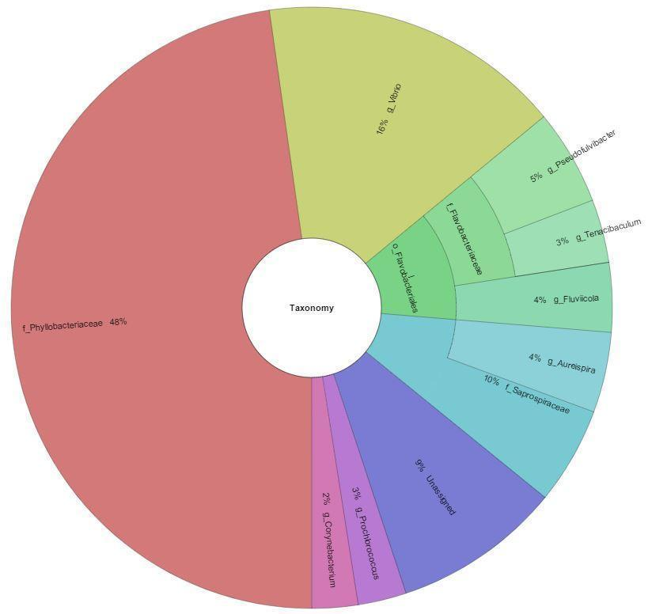
Figure S10. Krona Graphical representation of the most abundant taxa in the microbial community of the teeth of the lemon sharks sampled. Percentages are calculated based on overall relative abundance across all lemon shark teeth samples.
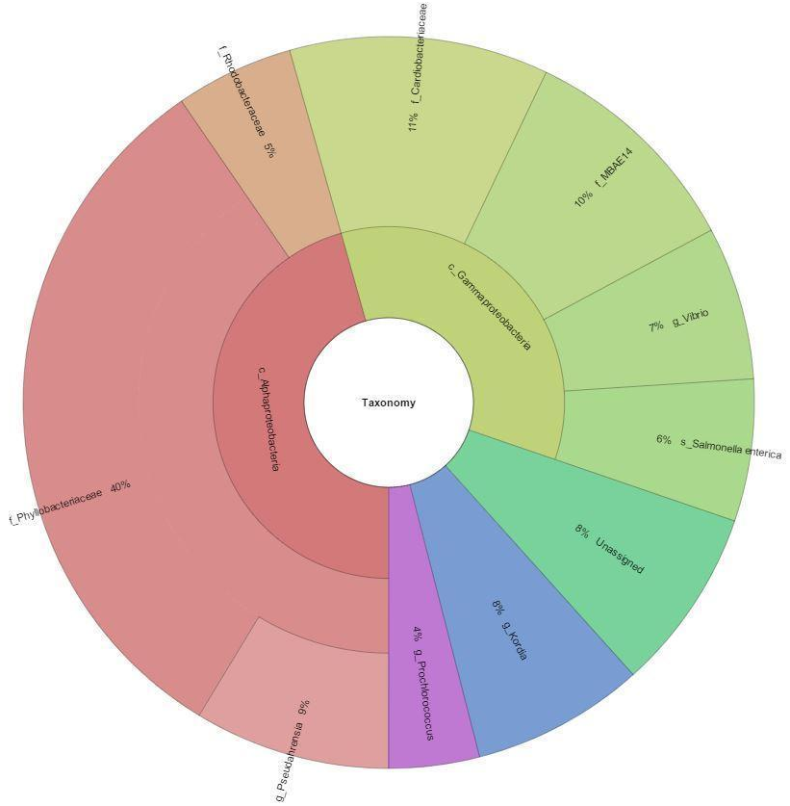
Figure S11. Krona Graphical representation of the most abundant taxa in the microbial community of the teeth of the nurse sharks sampled. Percentages are calculated based on overall relative abundance across all nurse shark teeth samples.

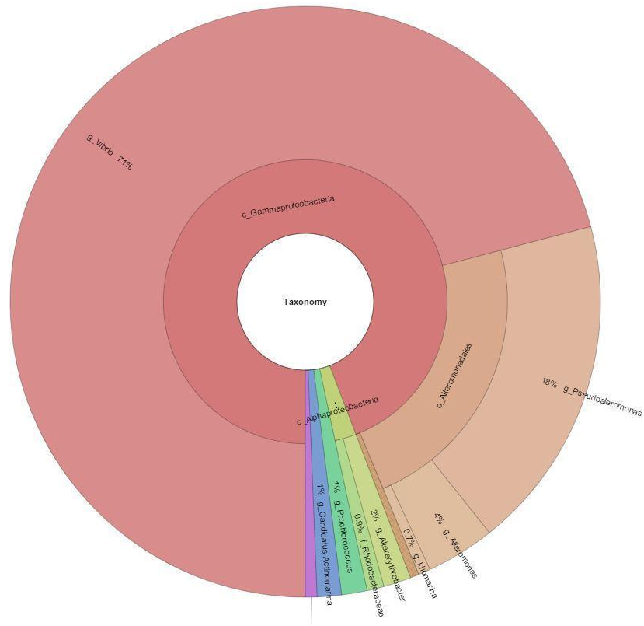
Figure S12. Krona Graphical representation of the most abundant taxa in the microbial community of the teeth of the sandbar sharks sampled. Percentages are calculated based on overall relative abundance across all sandbar shark teeth samples. (Purple=f_NS9 marine group, .6%)

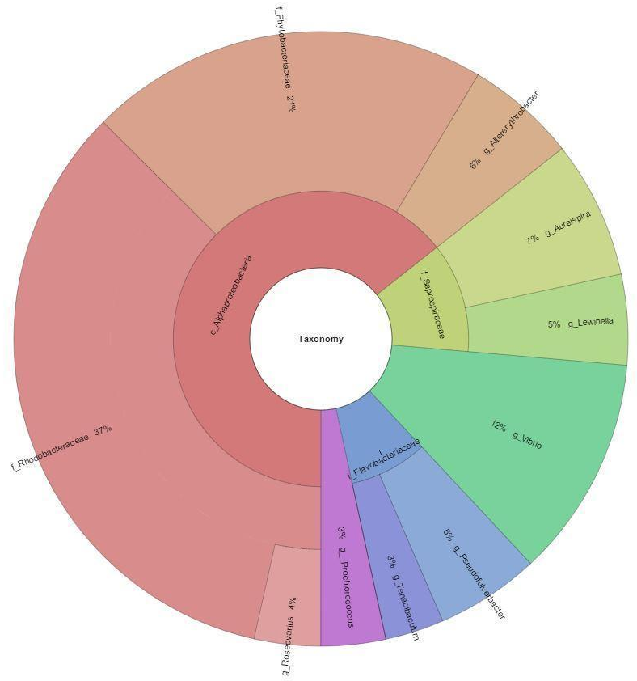
Figure S13. Krona Graphical representation of the most abundant taxa in the microbial community of the teeth of the tiger sharks sampled. Percentages are calculated based on overall relative abundance across all tiger shark teeth samples.

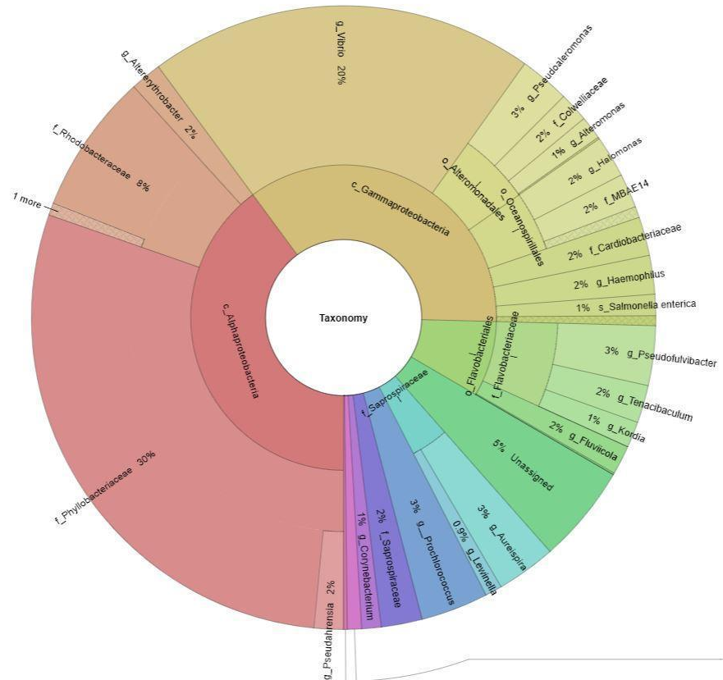
Figure S14. Krona Graphical representation of the most abundant taxa in the microbial community of the teeth of sharks sampled. Percentages are calculated based on overall relative abundance across all sandbar shark teeth samples. (Purple=g_Streptococcus, .7%, Pink=G_Canditatus Actinomarina, .2%)

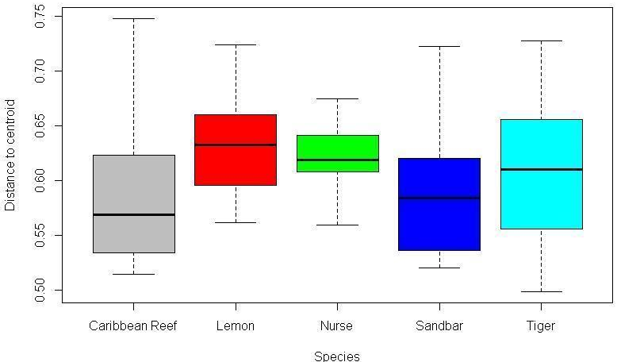
Figure S15. Beta dispersion analysis of shark teeth samples by species. (ANOVA, df=4, F=3.774, p=.006)
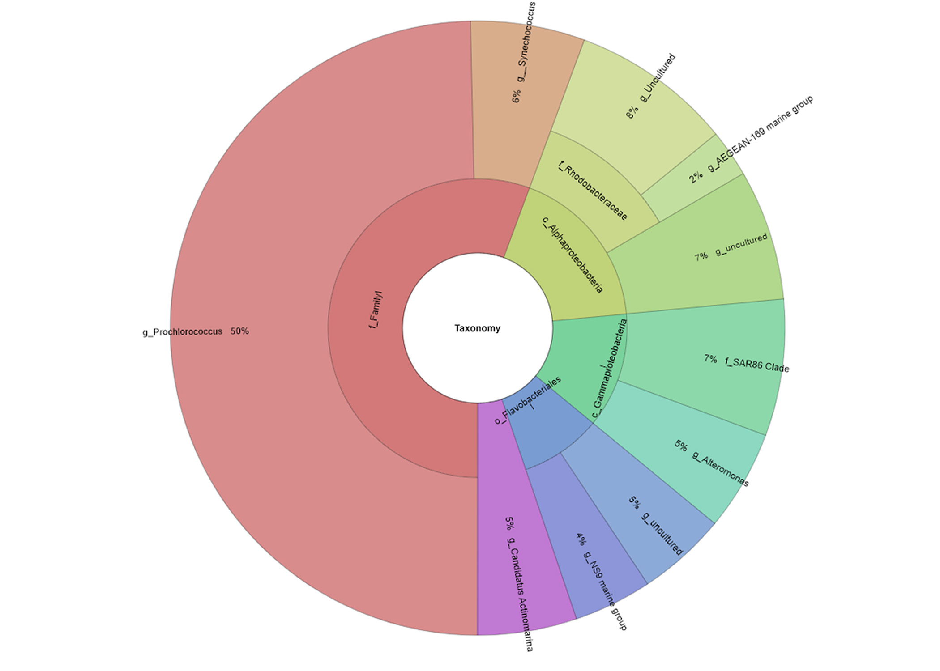
Figure S16. Krona Graphical representation of the most abundant taxa in the microbial community of the water sampled. Percentages are calculated based on overall relative abundance across all water samples.

Tables
Summary Sequencing Statistics
Total MiSeq Reads: | 12,374,571
Range for Individual Samples: | 1,116-545,115
Total OTUs: | 26,309
Table 1. Summary sequencing data for all species (nurse, tiger, sandbar, Caribbean reef, and lemon) and water samples. Total reads are a sum of all reads for three separate sequencing runs that the samples were sequenced on. Range for individual species indicates the lowest number of reads among all samples, and the highest among all samples.
Test | P-value
Richness | .0377
Diversity-Shannon | .00134
Diversity-Inverse Simpson | .00364
Adonis | .001
Table 2. Summary of p-values of statistics when teeth samples were compared based on shark species, with environmental OTUs removed.

Comparison | Sample Size | Mean Richness | Shannon (ANOVA) | Inverse Simpson
Species | 117 | 765.6± 516.9 | df=4, F=.512, p=0.727 | df=4, F=1.58, p=0.184
Sample Location | 117 | 765.6± 516.9 | df=3, F=9.832, p<0.001 | df=3, F=4.952, p=0.0029
Species:Location | 117 | 765.6± 516.9 | df=12, F=4.05, p=<0.001 | df=12, F=1.764, p=0.065
Table 3. Summary of statistics and sample size for each grouping considered in comparisons of the shark microbiome.

Sample | Species | Sample Location | Month | Type | Latitude | Longitude | Gender
B051316 | Bait | Bait | May | Environment | 26.09582 | 80.04554
B051816 | Bait | Bait | May | Environment | 26.14134 | 80.04847
B052416 | Bait | Bait | May | Environment | 26.13789 | 80.039
B052616 | Bait | Bait | May | Environment | 26.21083 | 80.03233
B060116 | Bait | Bait | June | Environment | 26.09485 | 80.04416
B060316 | Bait | Bait | June | Environment | 25.58992 | 80.05762
B062216 | Bait | Bait | June | Environment | 26.03651 | 80.05088
B063016 | Bait | Bait | June | Environment | 26.03651 | 80.05088
B091716 | Bait | Bait | Sept | Environment | 26.12633 | 80.04755
B092216 | Bait | Bait | Sept | Environment | 26.18271 | 80.04049
B092316 | Bait | Bait | Sept | Environment | 26.00659 | 80.05802
B111116 | Bait | Bait | Nov | Environment | 26.02991 | 80.0556
C236C | Caribbean Reef | Cloaca | Sept | Shark | 26.18271 | 80.04049 | F
C236G | Caribbean Reef | Gills | Sept | Shark | 26.18271 | 80.04049 | F
C236S | Caribbean Reef | Skin | Sept | Shark | 26.18271 | 80.04049 | F
C236T | Caribbean Reef | Teeth | Sept | Shark | 26.18271 | 80.04049 | F
C236W | Water | Water | Sept | Environment | 26.18271 | 80.04049 | F
C247C | Caribbean Reef | Cloaca | Nov | Shark | 26.00662 | 80.05114 | F
C247G | Caribbean Reef | Gills | Nov | Shark | 26.00662 | 80.05114 | F
C247S | Caribbean Reef | Skin | Nov | Shark | 26.00662 | 80.05114 | F
C247T | Caribbean Reef | Teeth | Nov | Shark | 26.00662 | 80.05114 | F
CR202C | Caribbean Reef | Cloaca | June | Shark | 26.09485 | 80.04416 | F
CR202G | Caribbean Reef | Gills | June | Shark | 26.09485 | 80.04416 | F
CR202S | Caribbean Reef | Skin | June | Shark | 26.09485 | 80.04416 | F
CR202T | Caribbean Reef | Teeth | June | Shark | 26.09485 | 80.04416 | F
CR202W | Water | Water | June | Environment | 26.09485 | 80.04416
L079C | Lemon | Cloaca | May | Shark | 26.13549 | 80.04914 | F
L079G | Lemon | Gills | May | Shark | 26.13549 | 80.04914 | F
L079S | Lemon | Skin | May | Shark | 26.13549 | 80.04914 | F
L079T | Lemon | Teeth | May | Shark | 26.13549 | 80.04914 | F
L079W | Water | Water | May | Environment | 26.13549 | 80.04914
L110C | Lemon | Cloaca | May | Shark | 26.09582 | 80.04554 | M
L110G | Lemon | Gills | May | Shark | 26.09582 | 80.04554 | M
L110S | Lemon | Skin | May | Shark | 26.09582 | 80.04554 | M
L110T | Lemon | Teeth | May | Shark | 26.09582 | 80.04554 | M
L110W | Water | Water | May | Environment | 26.09582 | 80.04554
L164C | Lemon | Cloaca | Sept | Shark | 26.00399 | 80.05626 | M
L164G | Lemon | Gills | Sept | Shark | 26.00399 | 80.05626 | M
L164S | Lemon | Skin | Sept | Shark | 26.00399 | 80.05626 | M
L164T | Lemon | Teeth | Sept | Shark | 26.00399 | 80.05626 | M
L164W | Water | Water | Sept | Environment | 26.00399 | 80.05626
L169C | Lemon | Cloaca | Sept | Shark | 26.00429 | 80.05195 | F
L169G | Lemon | Gills | Sept | Shark | 26.00429 | 80.05195 | F
L169S | Lemon | Skin | Sept | Shark | 26.00429 | 80.05195 | F
L169T | Lemon | Teeth | Sept | Shark | 26.00429 | 80.05195 | F
L169W | Water | Water | Sept | Environment | 26.00429 | 80.05195 | M
L191C | Lemon | Cloaca | June | Shark | 26.03369 | 80.05599 | M
L191G | Lemon | Gills | June | Shark | 26.03369 | 80.05599 | M
L191S | Lemon | Skin | June | Shark | 26.03369 | 80.05599 | M
L191T | Lemon | Teeth | June | Shark | 26.03369 | 80.05599 | M
L191W | Water | Water | June | Environment | 26.03369 | 80.05599 | M
L221C | Lemon | Cloaca | May | Shark | 26.22286 | 80.03008 | M
L221G | Lemon | Gills | May | Shark | 26.22286 | 80.03008 | M
L221S | Lemon | Skin | May | Shark | 26.22286 | 80.03008 | M
L221T | Lemon | Teeth | May | Shark | 26.22286 | 80.03008 | M
L221W | Water | Water | May | Environment | 26.22286 | 80.03008
L223.W | Water | Water | June | Environment | 26.09695 | 80.0447
L223C | Lemon | Cloaca | June | Shark | 26.09695 | 80.0447 | F
L223G | Lemon | Gills | June | Shark | 26.09695 | 80.0447 | F
L223S | Lemon | Skin | June | Shark | 26.09695 | 80.0447 | F
L223T | Lemon | Teeth | June | Shark | 26.09695 | 80.0447 | F
L224C | Lemon | Cloaca | June | Shark | 25.58992 | 80.05762 | M
L224G | Lemon | Gills | June | Shark | 25.58992 | 80.05762 | M
L224S | Lemon | Skin | June | Shark | 25.58992 | 80.05762 | M
L224T | Lemon | Teeth | June | Shark | 25.58992 | 80.05762 | M
L224W | Water | Water | June | Environment | 25.58992 | 80.05762
L225C | Lemon | Cloaca | May | Shark | 26.13789 | 80.039 | M
L225G | Lemon | Gills | May | Shark | 26.13789 | 80.039 | M
L225S | Lemon | Skin | May | Shark | 26.13789 | 80.039 | M
L225T | Lemon | Teeth | May | Shark | 26.13789 | 80.039 | M
L225W | Water | Water | May | Environment | 26.13789 | 80.039
L231C | Lemon | Cloaca | Sept | Shark | 26.1303 | 80.04121 | F
L231G | Lemon | Gills | Sept | Shark | 26.1303 | 80.04121 | F
L231S | Lemon | Skin | Sept | Shark | 26.1303 | 80.04121 | F
L231T | Lemon | Teeth | Sept | Shark | 26.1303 | 80.04121 | F
L231W | Water | Water | Sept | Environment | 26.1303 | 80.04121
L238C | Lemon | Cloaca | Sept | Shark | 26.00765 | 80.05163 | M
L238G | Lemon | Gills | Sept | Shark | 26.00765 | 80.05163 | M
L238S | Lemon | Skin | Sept | Shark | 26.00765 | 80.05163 | M
L238T | Lemon | Teeth | Sept | Shark | 26.00765 | 80.05163 | M
L238W | Water | Water | Sept | Environment | 26.00765 | 80.05163
N080C | Nurse | Cloaca | April | Shark | 26.13353 | 80.08902 | M
N080G | Nurse | Gills | April | Shark | 26.13353 | 80.08902 | M
N080S | Nurse | Skin | April | Shark | 26.13353 | 80.08902 | M
N080T | Nurse | Teeth | April | Shark | 26.13353 | 80.08902 | M
N082C | Nurse | Cloaca | April | Shark | 26.13642 | 80.08358 | F
N082G | Nurse | Gills | April | Shark | 26.13642 | 80.08358 | F
N082S | Nurse | Skin | April | Shark | 26.13642 | 80.08358 | F
N082T | Nurse | Teeth | April | Shark | 26.13642 | 80.08358 | F
N113C | Nurse | Cloaca | April | Shark | 26.05427 | 80.09445 | F
N113G | Nurse | Gills | April | Shark | 26.05427 | 80.09445 | F
N113S | Nurse | Skin | April | Shark | 26.05427 | 80.09445 | F
N113T | Nurse | Teeth | April | Shark | 26.05427 | 80.09445 | F
N114G | Nurse | Gills | April | Shark | 26.36457 | 80.06137 | F
N114S | Nurse | Skin | April | Shark | 26.36457 | 80.06137 | F
N114T | Nurse | Teeth | April | Shark | 26.36457 | 80.06137 | F
N157C | Nurse | Cloaca | May | Shark | 26.02676 | 80.06018 | F
N157G | Nurse | Gills | May | Shark | 26.02676 | 80.06018 | F
N157S | Nurse | Skin | May | Shark | 26.02676 | 80.06018 | F
N157T | Nurse | Teeth | May | Shark | 26.02676 | 80.06018 | F
N197C | Nurse | Cloaca | June | Shark | 26.03651 | 80.05088 | M
N197G | Nurse | Gills | June | Shark | 26.03651 | 80.05088 | M
N197S | Nurse | Skin | June | Shark | 26.03651 | 80.05088 | M
N197T | Nurse | Teeth | June | Shark | 26.03651 | 80.05088 | M
N197W | Water | Water | June | Environment | 26.03651 | 80.05088
N203C | Nurse | Cloaca | June | Shark | 26.03651 | 80.05088 | F
N203G | Nurse | Gills | June | Shark | 26.03651 | 80.05088 | F
N203S | Nurse | Skin | June | Shark | 26.03651 | 80.05088 | F
N203T | Nurse | Teeth | June | Shark | 26.03651 | 80.05088 | F
N203W | Water | Water | June | Environment | 26.03651 | 80.05088
N235C | Nurse | Cloaca | Sept | Shark | 26.13051 | 80.0434 | M
N235G | Nurse | Gills | Sept | Shark | 26.13051 | 80.0434 | M
N235S | Nurse | Skin | Sept | Shark | 26.13051 | 80.0434 | M
N235T | Nurse | Teeth | Sept | Shark | 26.13051 | 80.0434 | M
N235W | Water | Water | Sept | Environment | 26.13051 | 80.0434
SB159C | Sandbar | Cloaca | May | Shark | 26.09699 | 80.04415 | F
SB159G | Sandbar | Gills | May | Shark | 26.09699 | 80.04415 | F
SB159S | Sandbar | Skin | May | Shark | 26.09699 | 80.04415 | F
SB159T | Sandbar | Teeth | May | Shark | 26.09699 | 80.04415 | F
SB159W | Water | Water | May | Environment | 26.09699 | 80.04415
SB174C | Sandbar | Cloaca | May | Shark | 26.07791 | 80.05269 | F
SB174G | Sandbar | Gills | May | Shark | 26.07791 | 80.05269 | F
SB174S | Sandbar | Skin | May | Shark | 26.07791 | 80.05269 | F
SB174T | Sandbar | Teeth | May | Shark | 26.07791 | 80.05269 | F
SB174W | Water | Water | May | Environment | 26.07791 | 80.05269
SB198C | Sandbar | Cloaca | June | Shark | 25.58854 | 80.05157 | F
SB198G | Sandbar | Gills | June | Shark | 25.58854 | 80.05157 | F
SB198S | Sandbar | Skin | June | Shark | 25.58854 | 80.05157 | F
SB198T | Sandbar | Teeth | June | Shark | 25.58854 | 80.05157 | F
SB198W | Water | Water | June | Environment | 25.58854 | 80.05157
T209C | Tiger | Cloaca | May | Shark | 26.20859 | 80.0344 | F
T209G | Tiger | Gills | May | Shark | 26.20859 | 80.0344 | F
T209S | Tiger | Skin | May | Shark | 26.20859 | 80.0344 | F
T209T | Tiger | Teeth | May | Shark | 26.20859 | 80.0344 | F
T209W | Water | Water | May | Environment | 26.20859 | 80.0344
T228C | Tiger | Cloaca | Sept | Shark | 26.00659 | 80.05802 | F
T228G | Tiger | Gills | Sept | Shark | 26.00659 | 80.05802 | F
T228S | Tiger | Skin | Sept | Shark | 26.00659 | 80.05802 | F
T228T | Tiger | Teeth | Sept | Shark | 26.00659 | 80.05802 | F
T228W | Water | Water | Sept | Environment | 26.00659 | 80.05802
TGH107C | Tiger | Cloaca | May | Shark | 26.09456 | 80.05056 | F
TGH107G | Tiger | Gills | May | Shark | 26.09456 | 80.05056 | F
TGH107S | Tiger | Skin | May | Shark | 26.09456 | 80.05056 | F
TGH107T | Tiger | Teeth | May | Shark | 26.09456 | 80.05056 | F
TGH116C | Tiger | Cloaca | Nov | Shark | 26.02914 | 80.05036 | F
TGH116G | Tiger | Gills | Nov | Shark | 26.02914 | 80.05036 | F
TGH116S | Tiger | Skin | Nov | Shark | 26.02914 | 80.05036 | F
TGH116T | Tiger | Teeth | Nov | Shark | 26.02914 | 80.05036 | F
TGH117C | Tiger | Cloaca | Nov | Shark | 26.08349 | 80.04573 | F
TGH117G | Tiger | Gills | Nov | Shark | 26.08349 | 80.04573 | F
TGH117S | Tiger | Skin | Nov | Shark | 26.08349 | 80.04573 | F
TGH117T | Tiger | Teeth | Nov | Shark | 26.08349 | 80.04573 | F
TGH117W | Water | Water | Nov | Environment | 26.08349 | 80.04573
TGH240C | Tiger | Cloaca | Nov | Shark | 26.08018 | 80.05205 | M
TGH240G | Tiger | Gills | Nov | Shark | 26.08018 | 80.05205 | M
TGH240S | Tiger | Skin | Nov | Shark | 26.08018 | 80.05205 | M
TGH240T | Tiger | Teeth | Nov | Shark | 26.08018 | 80.05205 | M
Table 4. Sample table summarizing all environmental and shark samples

