Supplementary Figures
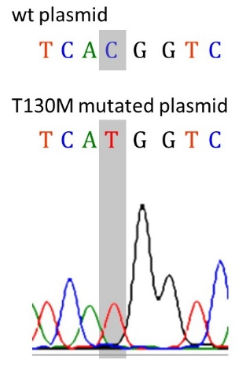

Supplementary Figure S1. Chromatogram of Sanger sequencing of the mutated plasmid exhibits thymine (T) at nucleotide position 389 of p32 cDNA instead of cytosine (C) (highlighted in grey).
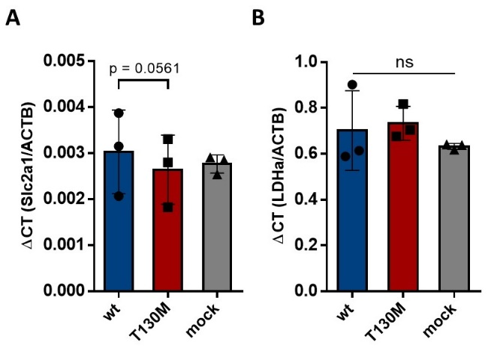

Supplementary Figure S2. Expression levels of (A) Slc2a1 and (B) LDHa mRNA were quantified in stable HAP1-p32-wt, HAP1-p32-T130M and HAP1-mock transfectants by qPCR. Statistical significance was determined using (A) a paired t-test or (B) one-way ANOVA followed by Tukey’s multiple comparison test.

