# **Supplementary Figure**

Figure S1 Scheme of F2O pretreatment process.

Figure S2 Mass balance after F2O pretreatment. The standard deviations were calculated based on three replicates.

Figure S3 GPC overlay of lignins from F2O pretreated switchgrass and Raw switchgrass

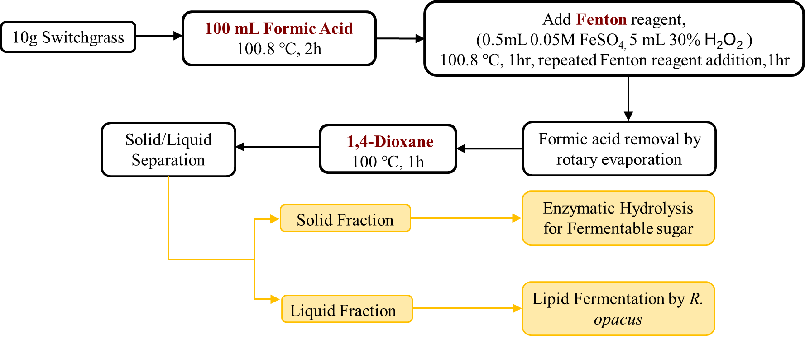

## Figure S1 Scheme of F2O pretreatment process.

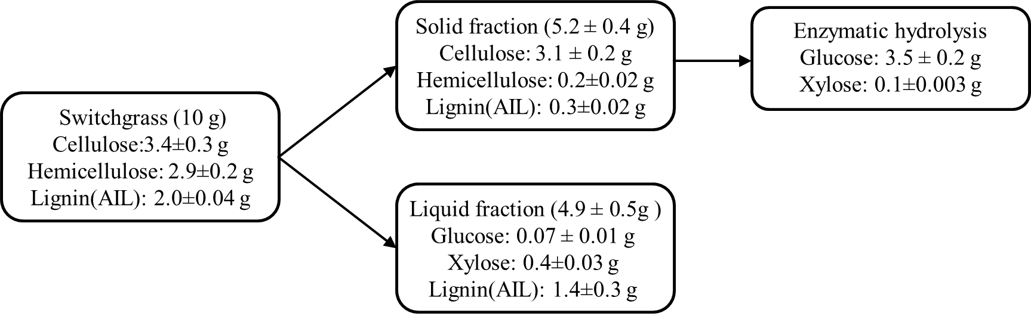

## Figure S2 Mass balance after F2O pretreatment. The standard deviations were calculated based on three replicates.



## Figure S3 GPC overlay of lignin from F2O pretreated switchgrass and untreated switchgrass

# **Supplementary Table**

Table S1 Pretreatment strategies used for the component fractionation from switchgrass biomass

Table S2 Lipid fermentation using F2O fractionated lignin as a carbon source

Table S3 2D-NMR results of the fractionated lignin from F2O pretreated and raw switchgrass

Table S4 Hydroxyl group contents in lignin from F2O pretreated and raw switchgrass

## Table S1 Pretreatment strategies used for the component fractionation from switchgrass biomass

|  |  |  |  |
| --- | --- | --- | --- |
| Process | Formic Acid  (100.8 °C, 4h) | Fenton Reagent  Addition | Dioxane  (101 °C, 1h) |
| Raw | No | No | No |
| Dioxane | No | No | Yes |
| Formic Acid/Dioxane | Yes | No | Yes |
| Fenton/Dioxane | No | Yes | Yes |
| Formic Acid & Fenton/Dioxane | Yes | Yes | Yes |

## Table S2 Lipid fermentation using F2O fractionated lignin as a carbon source. The fermentations were done in three replicates.

|  |  |  |
| --- | --- | --- |
| Cell Dry Weight(g/L) | Lipid Yield(g/L) | Lipid Content(g/g) |
| 6.02±0.48 | 1.16±0.08 | 0.19±0.02 |

## Table S3 2D-NMR results of the fractionated lignin from F2O pretreated and raw switchgrass

|  |  |  |
| --- | --- | --- |
| Lignin subunits | Raw | F2O |
| S | 30 | 8 |
| G | 67 | 75 |
| H | 4 | 17 |
| S/G ratio | 0.45 | 0.11 |
| Hydroxycinnamates |  |  |
| FA | 19 | 22 |
| pCA | 29 | 11 |
| Lignin interunit linkages |  |  |
| β-O-4 | 58 | 16 |
| β-5 | 2 | 1 |
| β-b | 1 | 0 |

S: syringyl, G: guaiacyl,H: *p*-hydroxyphenyl, FA: ferulate, *p*CA: *p*-coumarate

## Table S4 Hydroxyl group contents in lignin from F2O pretreated and raw switchgrass

|  |  |  |  |  |  |  |
| --- | --- | --- | --- | --- | --- | --- |
|  |  | Phenolic OH (mmol/g) | | |  |  |
|  | Aliphatic (mmol/g) | C5 substituted | Guaiacyl | p-Hydroxyphenyl | Tricin | -COOH  (mmol/g) |
| Raw switchgrass | 4.18 | 0.26 | 0.47 | 0.42 | 0.10 | 0.33 |
| F2O pretreated switchgrass | 0.77 | 0.24 | 0.12 | 0.14 | 0.03 | 0.54 |