Supplementary material

Daytime, not nighttime, elevated atmospheric CO₂exposure improves plant growth and leaf quality of mulberry(MorusalbaL.)seedlings

Songmei Shi^{a,}, YulingQiu^{a,}, Miao Wenª, Xiao Xu^{b}, Xingshui Dongª, ChenyangXuª, Xinhua He^{a, c*}

ªCentre of Excellence for Soil Biology, School of Resource and Environment, Southwest University, Chongqing 400715, China
^{b}Key Laboratory of Southwest China Wildlife Resources Conservation (China West Normal University), Ministry of Education, Nanchong 637009, Sichuan, China
^{c}School of Biological Sciences, University of Western Australia, Perth, WA 6009, Australia

These authors contributed equally to this work
*Correspondences: xinhua.he@uwa.edu.au

Figure captions
Fig.S1Overview of environmentally controlled growth chambers
A total of 12 growth environmentally controlled glass-made chamberswere constructed in 2016 at the National Monitoring Station of SoilFertility and Fertilizer Efficiency on Purple Soils, which is located on the Southwest University Campus, theBeibei District (29°48′N, 106°24′E, 266.3 m above the sea level), Chongqing, China. The temperatures and humidity inside the growth chambers were also automatically maintained as the same as those outside the chambers. The temperature, humidity, light and CO₂ concentration had been monitored every 6 second by a CO₂auto-controlling facility. The plants grown in pots inside chambers had the same growth conditions (nitrogen-fertilization, temperature, light intensity, etc.), except CO₂ concentrations: ambient CO₂ (ACO₂, 410µmol mol⁻¹ daytime/460µmol mol⁻¹nighttime), daytime eCO₂only (DeCO₂, 710/460µmol mol⁻¹), nighttime eCO₂only (NeCO₂, 410/760µmol mol⁻¹), and continuousdaytime/nighttime eCO₂(D+NeCO₂, 710/760µmol mol⁻¹).
Fig. S2Relationships between leaf biomass production and leaf carbon (C), nitrogen (N), phosphorous (P), potassium (K), calcium (Ca), magnesium (Mg), Manganese (Mn), boron (B), copper (Cu), iron (Fe) and zinc (Zn) accumulation in mulberry plants. Data are means ± SD, n = 12.See treatment abbreviations in Fig.S1.
Fig. S3Relationships between leaf soluble sugar, starch, fatty acid, total free amino acid and proteinaccumulation with leaf biomass productionin mulberry plants. n=12.See treatment abbreviations as in Fig.S2.

Fig. S1

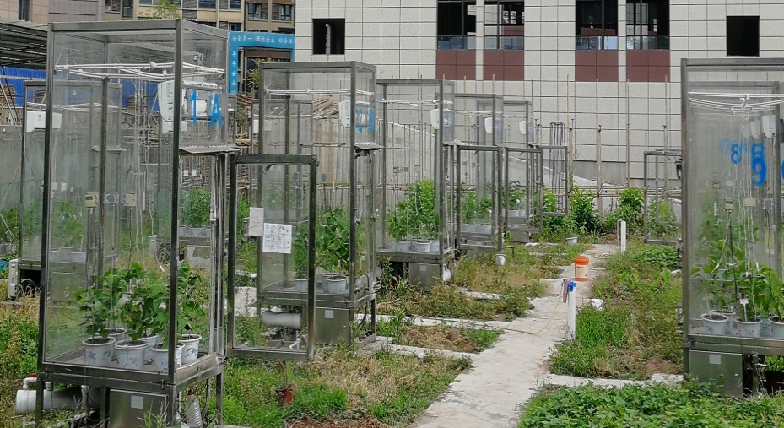

Fig. S2

Fig.S3

