Anthropogenic Influences on July 2019 Precipitation Extremes over the Mid-Lower Reaches of the Yangtze River

Nergui Nanding¹, Yang Chen², Huan Wu^{1, *}, Buwen Dong³, Fangxing Tian³, Fraser C. Lott⁴,
Simon F. B. Tett⁵, Miguel Angel Rico-Ramirez⁶, Yiheng Chen⁶, Zhijun Huang¹,
Yan Yan¹, Delei Li⁷, Rouke Li⁸, Xuan Wang⁹, Xuewei Fan¹⁰

List of supplemental materials

Fig S1. shows the observed precipitation anomalies of RxNday events during entire summertime from June to August.

Fig S2. shows attribution results for summertime Rx2day and Rx14day events based on HadGEM3-GA6 and CMIP5 models.

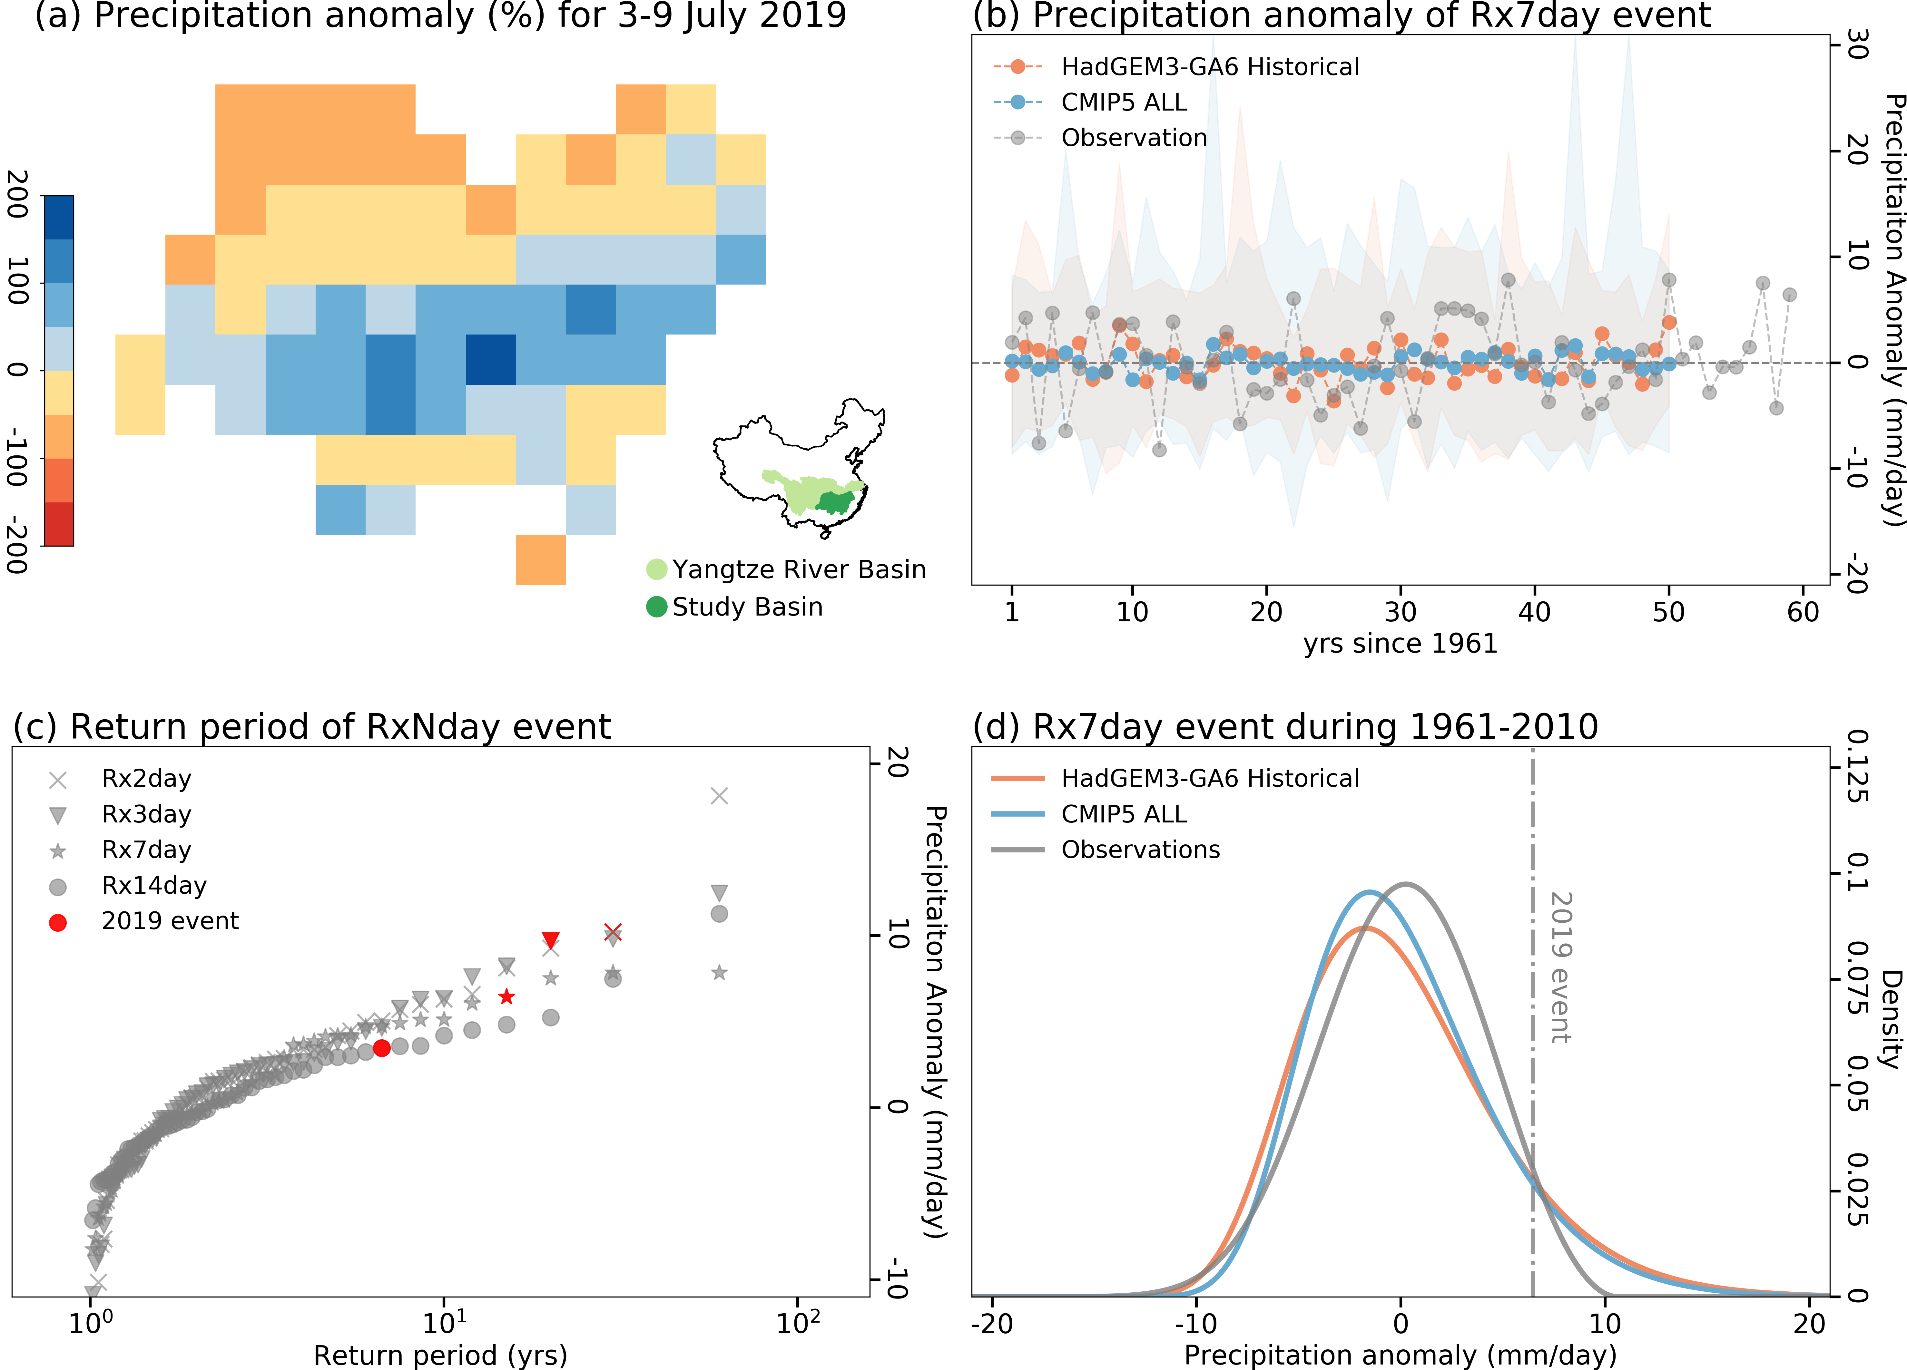
Fig S1. (a) Observed anomalies (%) in precipitation accumulations for 3-9 July 2019 with respect to the summertime Rx7day precipitation anomalies during 1961-2010 climatology. The study basin (dark green) was located at the mid-lower reaches of the Yangtze River Basin; (b) Time series of observed and simulated summertime Rx7day precipitation anomalies with respect to the 1961-2010 climatology. The shaded areas indicate the spread of 15 and 36 members of HadGEM3-GA6 Historical and CMIP5 ALL simulations respectively, whereas the solid lines show their ensemble means; (c) The empirical return periods of summertime RxNday events estimated from the observations during 1961-2019; (d) PDFs of summertime Rx7day precipitation anomalies for the observations, HadGEM3-GA6 Historical and CMIP5 ALL ensemble simulations during 1961-2010 climatology.

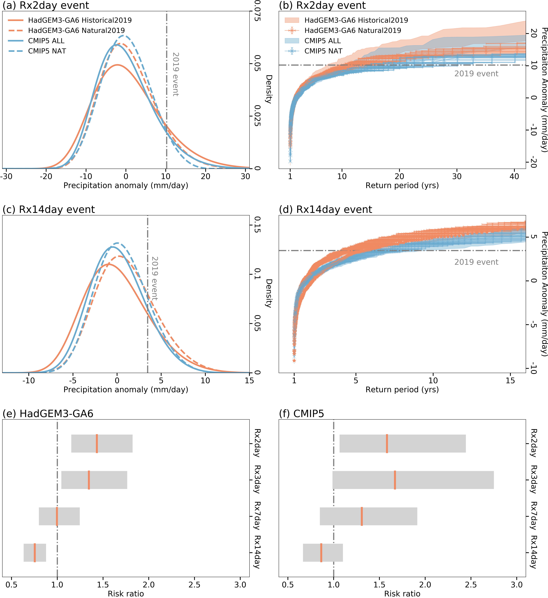
Fig S2. PDFs of precipitation anomalies for the HadGEM3-GA6 and CMIP5 model ensembles with all-forcings (orange) and natural-only forcings (blue) simulations for summertime (a) Rx2day and (c) Rx14day extreme event; Return periods of summertime (b) Rx2day and (d) Rx14day extreme events estimated from the HadGEM3-GA6 and CMIP5 model ensembles; Empirical risk ratios (vertical line) with 90% confidence interval (shaded) for summertime RxNday extreme events estimated from the (e) HadGEM3-GA6 model and (f) CMIP5 multi-model ensembles.

