Differential patterns of gyral and sulcal morphological changes during normal aging process
Hsin-Yu Lin^{1,3†}, Chu-Chung Huang^{2,3†*}, Kun-Hsien Chou^{3,4}, Albert C. Yang^{5,6}, Chun-Yi Zac Lo⁷, Shih-Jen Tsai ^{5,8} and Ching-Po Lin^{3,4*}

1 Centre for Research and Development in Learning, Nanyang Technological University, Singapore, Singapore, 2 Institute of Cognitive Neuroscience, School of Psychology and Cognitive Science, East China Normal University, Shanghai, China,
3 Institute of Neuroscience, National Yang-Ming University, Taipei, Taiwan,
4 Brain Research Center, National Yang-Ming University, Taipei, Taiwan,
5 Department of Psychiatry, Taipei Veterans General Hospital, Taipei, Taiwan,
6 Division of Interdisciplinary Medicine and Biotechnology, Beth Israel Deaconess Medical Center, Harvard Medical School, Boston, MA, United States,
7 Institute of Science and Technology for Brain Inspired Intelligence, Fudan University, Shanghai 200433, China,
8 School of Medicine, National Yang-Ming University, Taipei, Taiwan
† These authors contributed equally to this work.

*Corresponding authors:
Dr. Chu-Chung Huang
Email: czhuang@psy.ecnu.edu.cn
Institute of Cognitive Neuroscience, School of Psychology and Cognitive Science, East China Normal University, Shanghai, China

Dr. Ching-Po Lin
E-mail: chingpolin@gmail.com
Institute of Neuroscience, National Yang-Ming University, 155, Li-Nong St. 11221, Taipei, Taiwan
Tel: +886-2-2826 7338; Fax: +886-2-2826 2285

Supplemental Materials
Linear regression results
Result of age correlated with cortical thickness showed in Figure S1. Both gyral and sulcal regions negatively correlated with age. The adjusted R-square values were 0.400/0.363 and 0.596/0.559 for left/right hemisphere respectively, which were both moderately correlated. Gyri/Sulci thickness ratio increased while the age increased and the adjusted R-square were 0.320/0.262.
The aging trends of gyral and sulcal intrinsic curvature on pial surface were opposite. In gyral region, intrinsic curvature was slightly increasing, hardly altered with age (R²=0.054/0.051) while it was declining in sulcal regions (R²=0.474/0.442). Therefore, gyri/sulci ratio increased by age and had R-square values 0.375/0.334. On the gray-white matter boundary of cortical cortex, both gyral and sulcal intrinsic curvature increased with age. Their R-square values were 0.467/0.452 in gyral region and 0.316/0.334 in sulcal region. The gyri/sulci ratio remained stable and unchanged during lifespan. All permutation tests were significant (p < 0.05).

Supplemental Figures

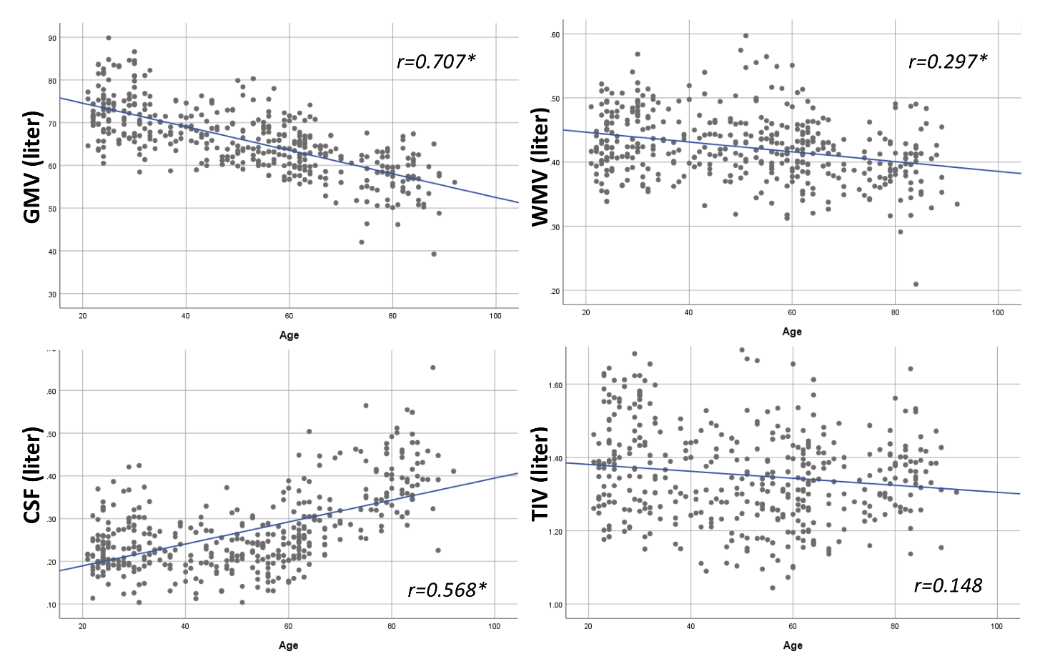
Fig. S1 Pearson correlation between age and GMV / WMV / CSF / TIV. *p<0.001

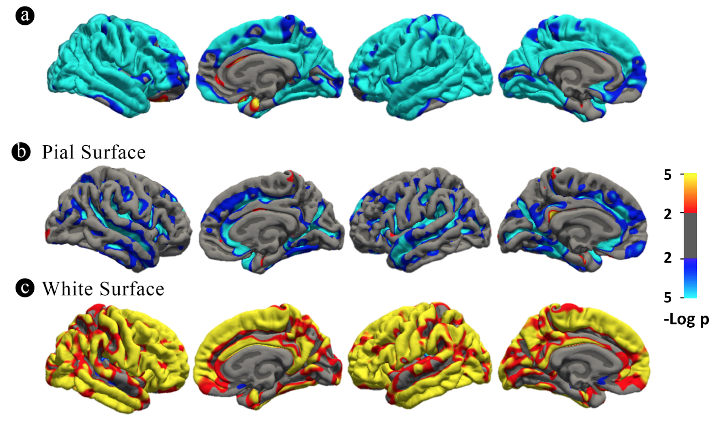
Fig. S2 Vertex-wise age correlation results (smoothed with a 10-mm Gaussian kernel)

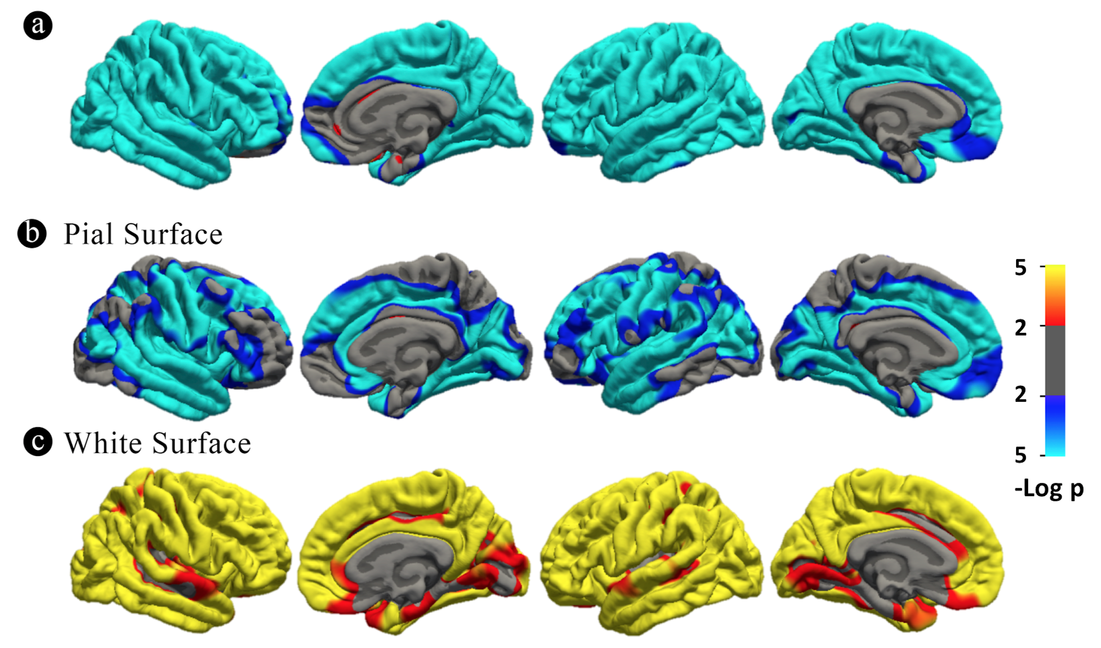
Fig. S3 Vertex-wise age correlation results (smoothed with a 20-mm Gaussian kernel)

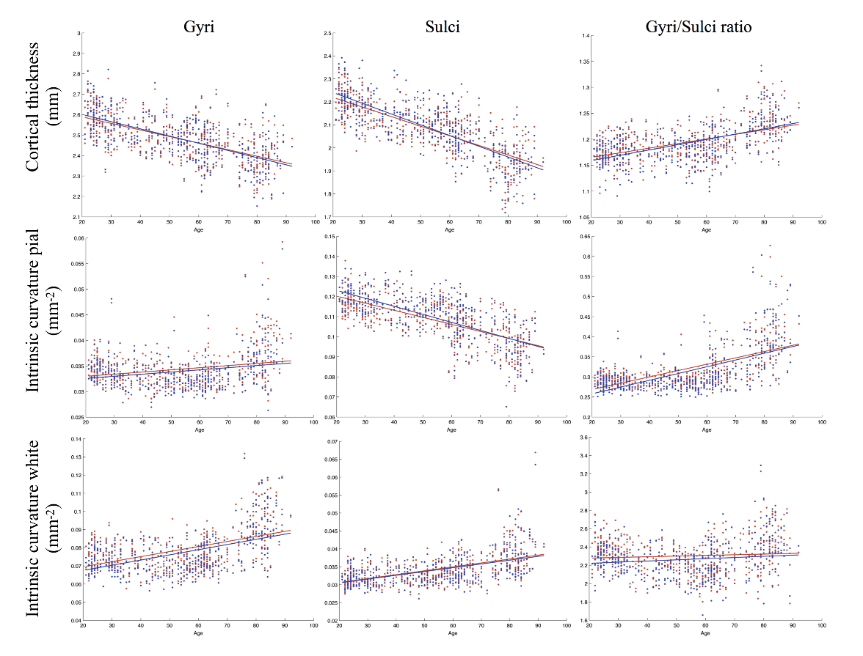
Fig. S4 Linear regression results of age with gyri, sulci and gyri/sulci ratio of cortical thickness and intrinsic curvature on pial/white surfaces. The red and blue color represent the right and left hemisphere respectively. The lines refer to the fitting curve for the age and measurements of thickness, and the dots indicate the distribution of that data for the subjects.

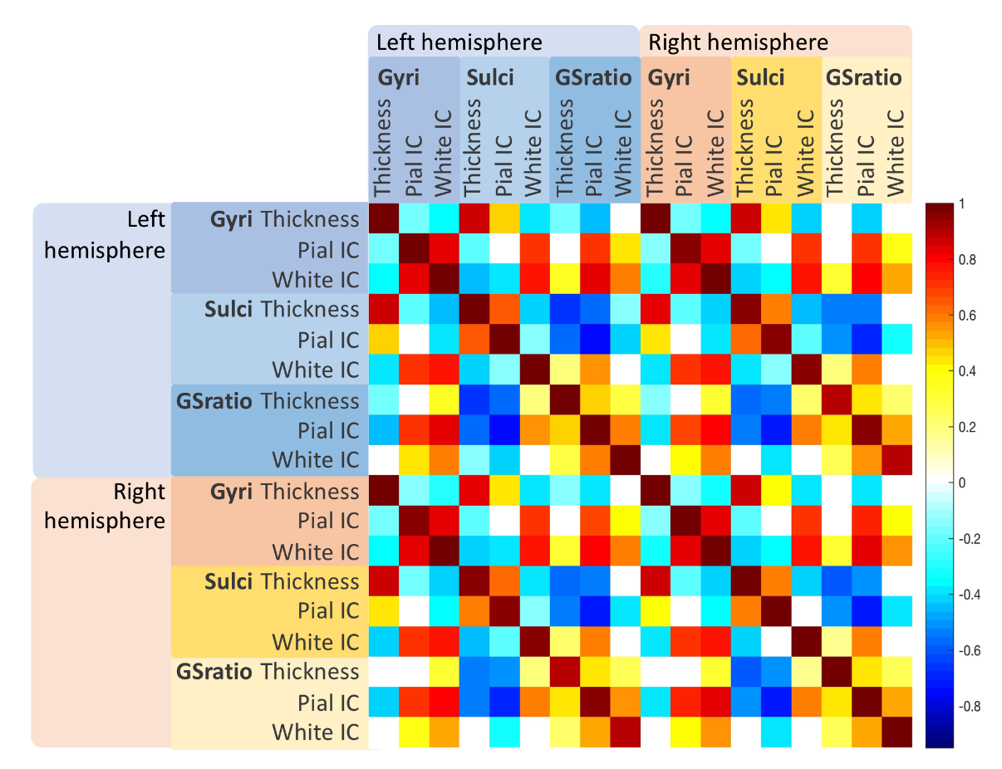
Fig. S5 A correlation matrix between the structural measurements (cortical thickness, intrinsic curvature) for gyri, sulci, and gyri/sulci ratio. Only significant correlations were shown colored (p<0.05/18; adjusted by the Bonferroni correction for multiple comparisons).

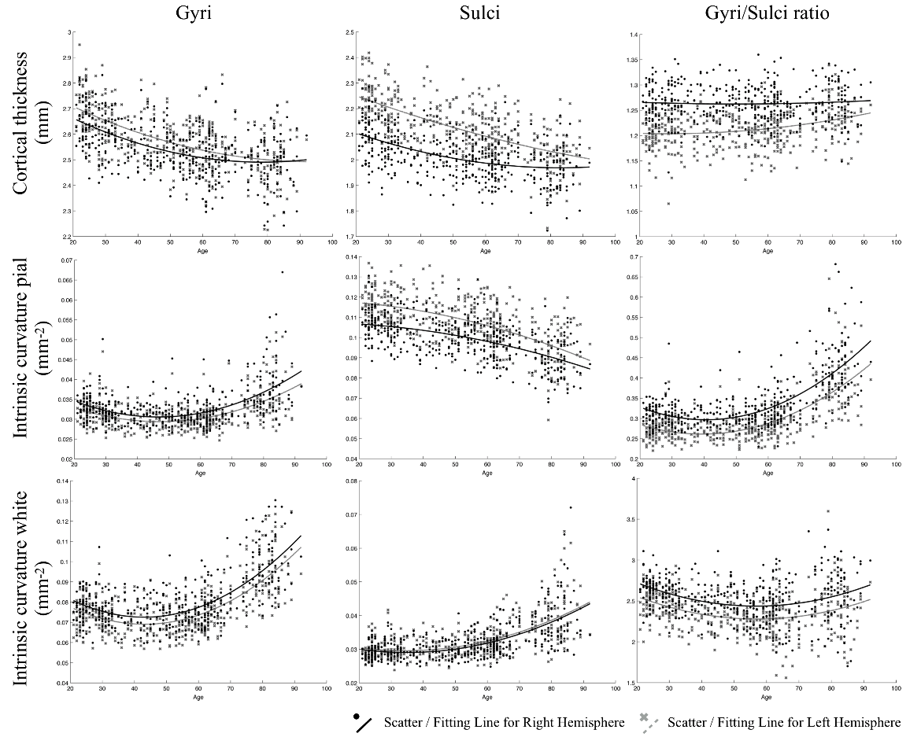
Fig. S6 Quadratic regression results in frontal lobe of age with gyri, sulci and gyri/sulci ratio of cortical thickness and intrinsic curvature on pial/white surfaces. The lines refer to the fitting curve for the age and measurements, and the dots indicate the distribution of that data for the subjects.

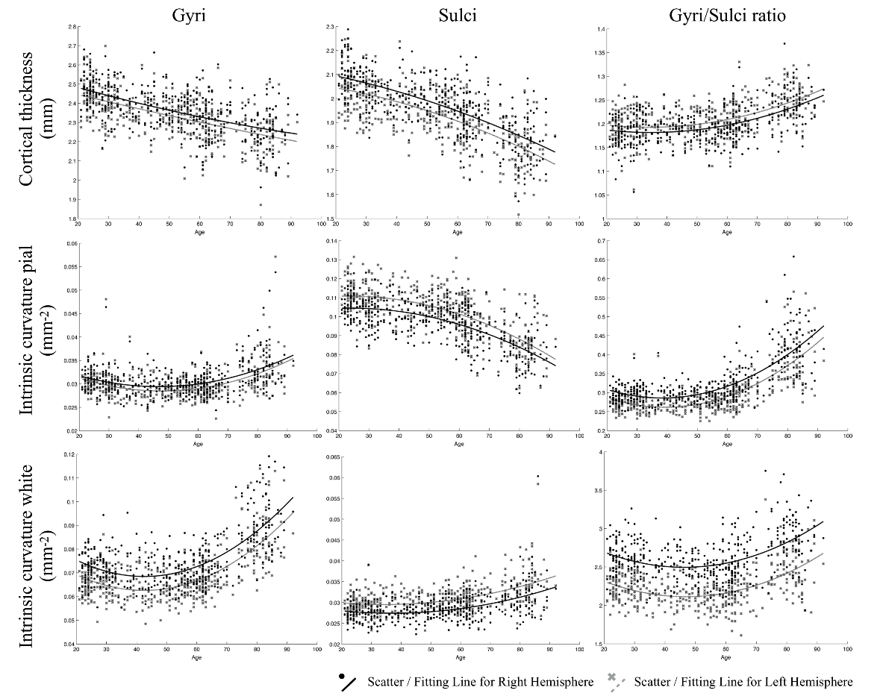
Fig. S7 Quadratic regression results in parietal lobe of age with gyri, sulci and gyri/sulci ratio of cortical thickness and intrinsic curvature on pial/white surfaces. The lines refer to the fitting curve for the age and measurements, and the dots indicate the distribution of that data for the subjects.
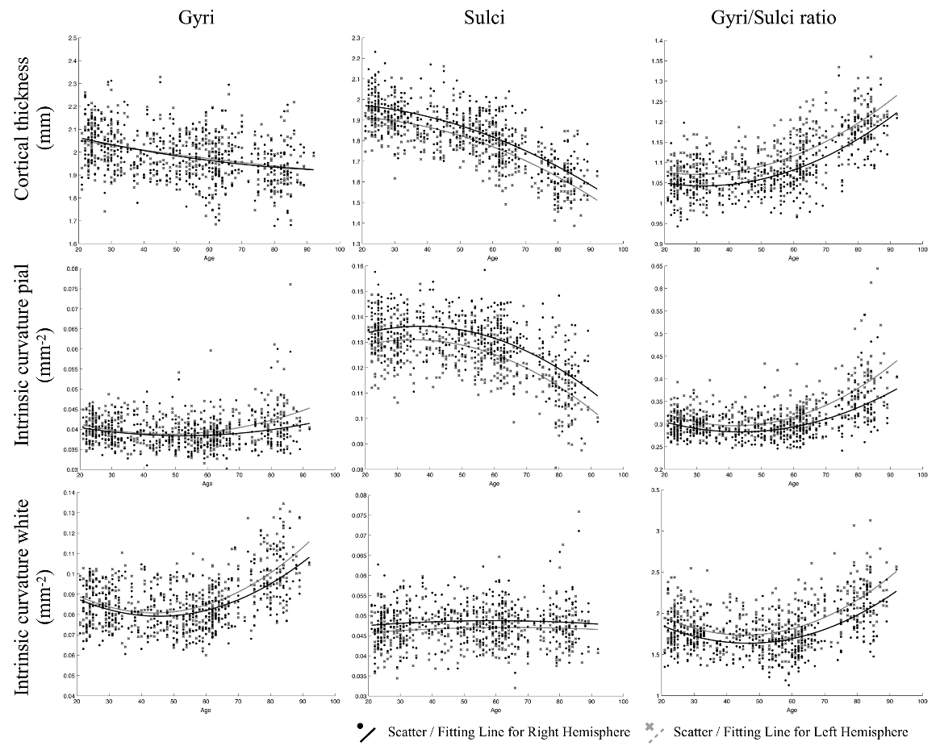
Fig. S8 Quadratic regression results in temporal lobe of age with gyri, sulci and gyri/sulci ratio of cortical thickness and intrinsic curvature on pial/white surfaces. The lines refer to the fitting curve for the age and measurements, and the dots indicate the distribution of that data for the subjects.
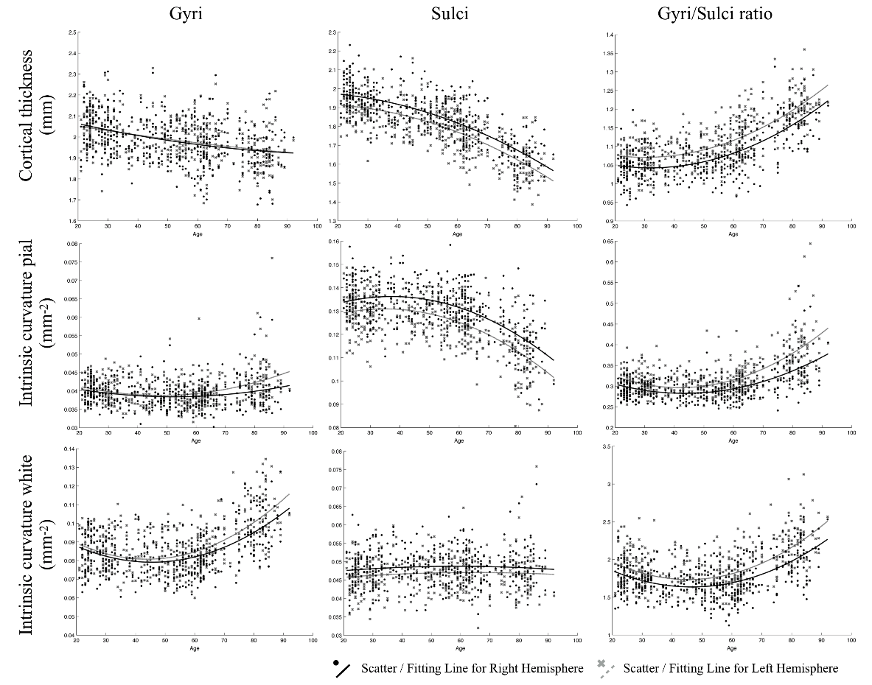
Fig. S9 Quadratic regression results in occipital lobe of age with gyri, sulci and gyri/sulci ratio of cortical thickness and intrinsic curvature on pial/white surfaces. The lines refer to the fitting curve for the age and measurements, and the dots indicate the distribution of that data for the subjects.
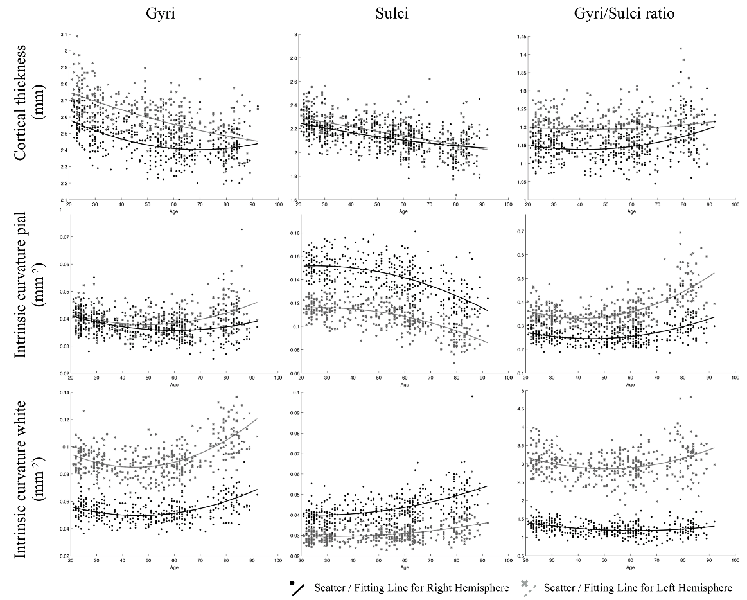
Fig. S10 Quadratic regression results in cingulate of age with gyri, sulci and gyri/sulci ratio of cortical thickness and intrinsic curvature on pial/white surfaces. The lines refer to the fitting curve for the age and measurements, and the dots indicate the distribution of that data for the subjects.

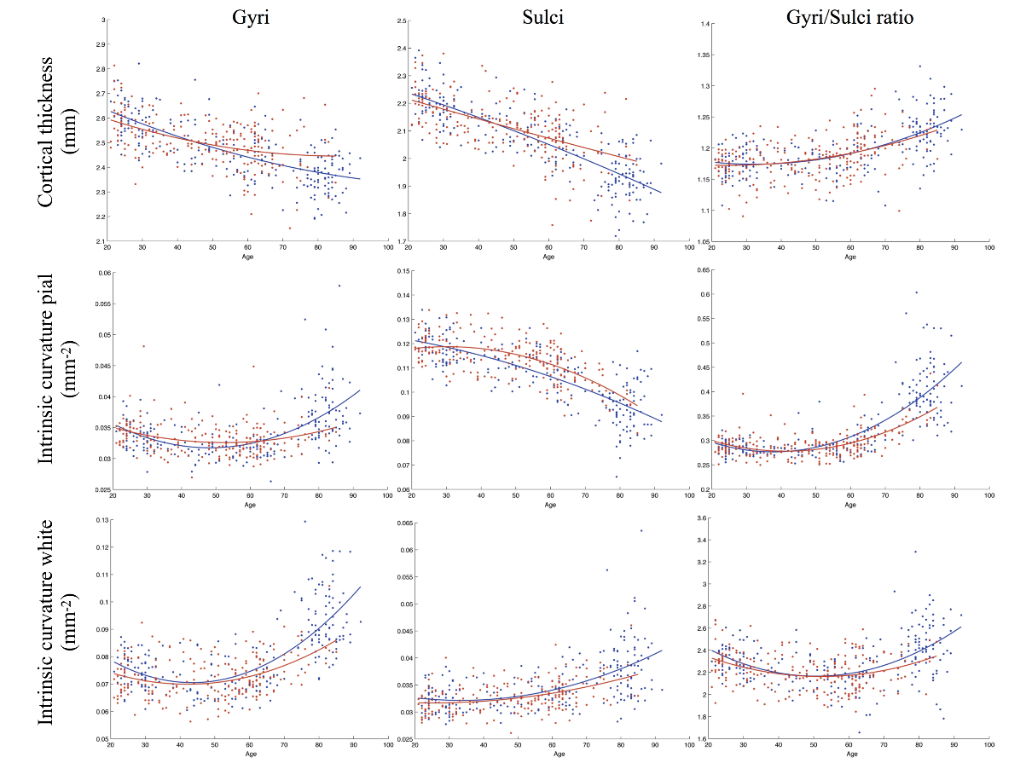
Fig. S11 Quadratic regression results of age with gyri, sulci and gyri/sulci ratio of cortical thickness and intrinsic curvature on pial/white surfaces grouped by sex on left hemisphere. The red and blue color stood for female and male respectively. The lines refer to the fitting curve for the age and measurements, and the dots indicate the distribution of that data for the subjects.

Supplemental Tables

Table S1 Goodness of fit – Cortical thickness
Model | RMSE (lh/rh) | AIC value (lh/rh)
Gyri
Linear | 0.08809 / 0.08693 | -885.2 / -896.8*
Quadratic | 0.08812 / 0.08675* | -883.9 / -897.6
Cubic | 0.08819 / 0.08683 | -882.2 / -895.8
Sulci
Linear | 0.07884 / 0.07592 | -982.5 / -1015.7
Quadratic | 0.07799 / 0.07547* | -991.2 / -1019.9*
Cubic | 0.07805 / 0.07542 | -989.4 / -1019.5
Gyri/Sulci ratio
Linear | 0.03034 / 0.03040 | -1821.0 / -1819.3
Quadratic | 0.02881 / 0.02895* | -1865.4 / -1861.3*
Cubic | 0.02885 / 0.02893 | -1863.4 / -1860.8
RMSE, Root Mean Square Error: lower is better

AIC Akaike Information Criterion: lower is better
* better fitting properties

Table S2 Goodness of fit - Intrinsic Curvature on pial surface
Model | RMSE (lh/rh) | AIC value (lh/rh)
Gyri
Linear | 0.003519 / 0.003628 | -3712.5 / -3685.8
Quadratic | 0.003139 / 0.003278 | -3811.7 / -3773.8
Cubic | 0.003124 / 0.003262* | -3815.0 / -3777.1*
Sulci
Linear | 0.008598 / 0.008090 | -2928.1 / -2981.6
Quadratic | 0.008424 / 0.007926* | -2945.1 / -2998.6*
Cubic | 0.008433 / 0.007934 | -2943.2 / -2996.7
Gyri/Sulci ratio
Linear | 0.04443 / 0.04544 | -1486.2 / -1466.4
Quadratic | 0.03836 / 0.03992 | -1614.1 / -1579.2
Cubic | 0.03826 / 0.03983* | -1615.5 / -1580.2*
RMSE, Root Mean Square Error: lower is better

AIC Akaike Information Criterion: lower is better
* better fitting properties

Table S3 Goodness of fit - Intrinsic Curvature on white surface
Model | RMSE (lh/rh) | AIC value (lh/rh)
Gyri
Linear | 0.010130 / 0.010220 | -2784.5 / -2776.4
Quadratic | 0.008741 / 0.008898 | -2912.6 / -2897.0
Cubic | 0.008712 / 0.008868* | -2914.6 / -2899.0*
Sulci
Linear | 0.003658 / 0.003715 | -3678.5 / -3664.9
Quadratic | 0.003513 / 0.003574 | -3713.0 / -3697.9
Cubic | 0.003497 / 0.003563* | -3716.1 / -3699.7*
Gyri/Sulci ratio
Linear | 0.2019 / 0.2015 | -157.0 / -158.6
Quadratic | 0.1849 / 0.1858* | -233.0 / -229.1*
Cubic | 0.1851 / 0.1860 | -231.2 / -227.1
RMSE, Root Mean Square Error: lower is better

AIC Akaike Information Criterion: lower is better
* better fitting properties

Table S4 Results of linear regression analyses
Age correlation | Cortical Thickness  (lh/rh) |  | Intrinsic Curvature (lh/rh)
 |  |  | Pial surface |  | White surface
Gyri | – (0.400/0.363) |  | + (0.054/0.051) |  | + (0.467/0.452)
Sulci | – (0.596/0.559) |  | – (0.474/0.442) |  | + (0.316/0.334)
Gyri/Sulci ratio | + (0.320/0.262) |  | + (0.375/0.334) |  | + (0.014/0.003)
The variables are adjusted r-square; + represents positive correlation, – represents negative correlation

Table S5 Average cortical thickness and intrinsic curvature
 | Cortical Thickness  (lh/rh) |  | Intrinsic Curvature (lh/rh)
 |  |  | Pial surface |  | White surface
Gyri | 2.483/2.485 |  | 0.034/0.034 |  | 0.079/0.079
Sulci | 2.082/2.086 |  | 1.109/0.110 |  | 0.034/0.034
Gyri/Sulci ratio | 1.194/1.193 |  | 0.321/0.314 |  | 2.303/2.263
The variables are the average values of measurements

