Supplementary Material

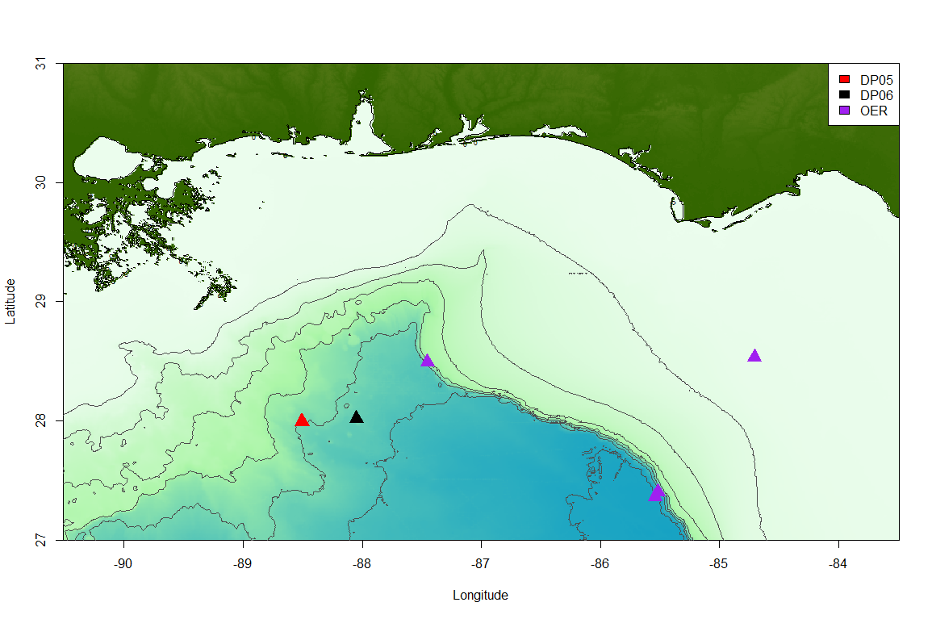
Supplementary Data

Supplementary Figure 1. Map of collection sites for samples used in this study.

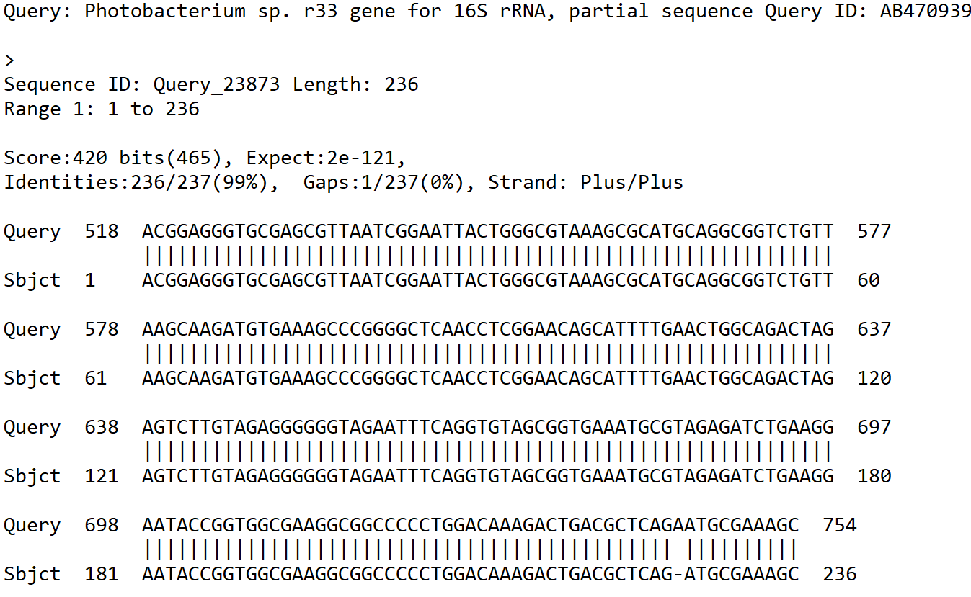
Supplementary Figure 2. BLAST alignment of recorded Photobacterium sp. r33 from NCBI and sequence of Photobacterium pulled from the 16S rRNA analysis.

Supplementary Figure 3. Relative abundance of bacterial taxa (at the species level) across different samples. Columns 1 – 3 represent microbiomes derived from tunicate specimens preserved under different conditions. The next ten samples show bacterial distributions in seawater samples from the same location.

Supplementary Figure 4. Phylogeny based on mitochondrial cytochrome oxidase I (COI) amino acid sequences using the PhyML method (Guindon and Gascuel, 2003). All taxa were subphylum Tunicata except for two outgroup mammals. The topology indicates a clear ingroup of only tunicates, with the pelagic tunicates more closely grouping. The following parameters were used to construct the tree: Substitution model - WAG; Gamma shape parameter - 0.543 Number of categories- 4; Proportion of invariant: 0.155. The following COI sequences were retrieved from NCBI and aligned with MUSCLE - Rhodosoma turcicum [YP_008083018.1], Doliolum nationalis [BAD86512.1]; Ascidiella aspersa [YP_008083028.1]; Ciona intestinalis [YP_006341036.1], Ciona savignyi [QDO67183.1]. Aplidium conicum [YP_003331401.1], Herdmania momus [YP_003331094.1], Polyandrocarpa misakiensis [BAJ21359.1]. Halocynthia papillosa [CAQ68496.1], Botryllus schlosseri [CAQ68352.2], Botrylloides leachii YP_009029811.1, Styela plicata YP_003331150.1; Mustela sibirica [BAX03304.1]; Perognathus longimembris [ABO84893.1].

