Minimal residual disease detection by next-generation sequencing in multiple myeloma: A comparison with real-time quantitative PCR
Running title: Residual disease detection in myeloma
Qiumei Yao^{1#}, Yinlei Bai^{2#}, Shaji Kuma³, Elaine AU⁴, Alberto Orfao⁵, Chor Sang Chim1*
¹Department of Medicine, Queen Mary Hospital, The University of Hong Kong, Pokfulam, Hong Kong
²Institute for Immunology and School of Medicine, Tsinghua University, Beijing, China
³ Division of Hematology, Mayo Clinic, Rochester, MN, USA
⁴Department of Pathology, Queen Mary Hospital, The University of Hong Kong, Pokfulam, Hong Kong
⁵Department of Medicine and Cytometry Service (Nucleus), Cancer Research Centre (IBMCC, USAL-CSIC) and CIBERONC, Institute for Biomedical Research of Salamanca (IBSAL), University of Salamanca (USAL), Salamanca, Spain
#These authors contributed equally.
*Corresponding author: Prof. Chor Sang CHIM, MD, PhD, Department of Medicine, Queen Mary Hospital, The University of Hong Kong, Pokfulam Road, Pokfulam, Hong Kong
Email: jcschim@hku.hk
Tel: (852) 2255 4769
Fax: (852) 2816 2187
Table S1. Results of clonality identification by Sanger sequencing and next-generation sequencing.
Patient ID | Clonality detected by Sanger sequencing |  |  |  | Clonality detected by NGS |  |  | Type of clonal sequence
 | Clonal sequence |  | PCR |  | V-gene | J-gene | CDR3 identical to Sanger sequencing
Clonality done by both Sanger sequencing and NGS
1 | V_{H}3.9(0)-1-7-(2)D5.12(4)-2-J_{H}6 |  | IGH VDJ |  | IGHV3-9_01 | IGHJ6_03 | Yes | Productive
 | V_{H}3.13(10)-5-(7)D3.22(10)-11-(1)J_{H}3 |  | IGH VDJ |  | IGHV3-13_01 | IGHJ3_02 | Yes | Unproductive
2 | V_{H}2.5(2)-6-(2)D1.26(2)-3-(5)J_{H}4 |  | IGH VDJ |  | IGHV2-5_09 | IGHJ4_02 | Yes | Productive
3 | V_{H}3.66(0)-5-(15)D3.16(7)-7-(14)J_{H}6 |  | IGH VDJ |  | IGHV3-66_02 | IGHJ6_02 | Yes | Productive
4 | V_{H}3.21(1)-9-(8)D2.21(3)-3-(5)J_{H}6 |  | IGH VDJ |  | IGHV3-21_02 | IGHJ6_03 | Yes | Productive
5 | V_{H}1.18(4)-9-(1)D3.10(10)-20-(3)J_{H}4 |  | IGH VDJ |  | IGHV1-69_02 | IGHJ4_02 | Yes | Productive
6 | V_{H}3.11(1)-15-(5)D2.21(12)-8-(10)J_{H}6 |  | IGH VDJ |  | IGHV3-11_05 | IGHJ6_03 | Yes | Productive
7 | V_{H}3.20(0)-10-(5)D1.26(3)-8-(4)J_{H}4 |  | IGH VDJ |  | IGHV3-20_01 | IGHJ4_02 | Yes | Productive
8 | V_{H}1.24(2)-(7)D1.1(1)-12-(17)J_{H}5 |  | IGH VDJ |  | IGHV1-24_01 | IGHJ5_02 | Yes | Productive
9 | V_{H}4.61(2)-4-(6)D2.2(12)-20-(8)J_{H}3 |  | IGH VDJ |  | IGHV4-61_02 | IGHJ3_02 | Yes | Productive
10 | V_{H}3.66(0)-0-(0)D3.3(21)-12-(3)J_{H}5 |  | IGH VDJ |  | IGHV3-66_02 | IGHJ5_02 | Yes | Productive
11 | V_{H}3.23(5)-10-(7)D4.23(0)-5-(8)J_{H}5 |  | IGH VDJ |  | IGHV3-23_04 | IGHJ5_02 | Yes | Productive
12 | V_{H}2.5(2)-15-(0)D5.18(3)-2-(11)J_{H}4 |  | IGH VDJ |  | IGHV2-5_08 | IGHJ4_02 | Yes | Productive
13 | V_{H}1.18(0)-1-6-(2)D5.24(2)-13-(19)J_{H}6 |  | IGH VDJ |  | IGHV1-18_01 | IGHJ6_03 | Yes | Productive
14 | V_{H}4.34(3)-14-(16)D2.2(2)-25-(16)J_{H}4 |  | IGH VDJ |  | IGHV3-33_01 | IGHJ3_02 | No | Unproductive (Sanger)  Productive (NGS)
15 | V_{H}5.10(1)-15-(3)D3.22(11)-3-(3)J_{H}4 |  | IGH VDJ |  | IGHV5-10_01 | IGHJ4_02 | Yes | Productive
16 | V_{H}1.2(2)-11-(6)D4.11(2)-5-1-(0)J_{H}5 |  | IGH VDJ |  | IGHV1-2_02 | IGHJ5_02 | Yes | Productive
17 | V_{H}4.61(2)-4-(1)D4.23(2)-1-(8)J_{H}4 |  | IGH VDJ |  | IGHV4-61_01 | IGHJ4_02 | Yes | Productive
18 | V_{H}1.3(2)-8-(0)D6.19(0)-3-(7)J_{H}5 |  | IGH VDJ |  | IGHV1-3_01 | IGHJ5_02 | Yes | Productive
19 | V_{H}4.61(4)-8-4-D5.18(7)-11-(6)J_{H}4 |  | IGH VDJ |  | IGHV4-61_03 | IGHJ4_02 | Yes | Productive
20 | V_{H}3.30(3)-3-(0)D3.10(9)-4-(3)J_{H}4 |  | IGH VDJ |  | IGHV3-30_04 | IGHJ4_02 | Yes | Productive
21 | V_{H}4.4(2)-13-(7)D6.6(0)-3-(1)J_{H}3 |  | IGH VDJ |  | IGHV4-4_02 | IGHJ3_01 | Yes | Productive
22 | V_{H}4.39(0)-11-(2)D3.22(9)-8-(10)J_{H}4 |  | IGH VDJ |  | IGHV4-39_07 | IGHJ4_02 | Yes | Productive
23 | V_{H}5.51(3)-12-(4)D3.10(9)-4-(8)J_{H}4 |  | IGH VDJ |  | IGHV5-51_03 | IGHJ4_02 | Yes | Productive
24 | V_{H}3.23(0)-2-(7)D3.3(12)-0-(5)J_{H}3 |  | IGH VDJ |  | IGHV3-23_04 | IGHJ3_01 | Yes | Productive
25 | V_{H}1.68(6)-4-(5)D6.13(2)-11-(14)J_{H}6 |  | IGH VDJ |  | IGHV1-68_02 | IGHJ6_02 | Yes | Unproductive
 |  |  |  |  | IGHV3-20_01 | IGHJ4_02 |  | Productive
26 | V_{H}3.30(2)-7-(2)D3.3(15)-11-(8)J_{H}4 |  | IGH VDJ |  | IGHV3-30-3_01 | IGHJ4_02 | Yes | productive
27 | V_{H}3.53(2)-3-(9)D3.9(12)-5-(11)J_{H}6 |  | IGH VDJ |  | IGHV3-53_02 | IGHJ6_02 | Yes | Productive
28 | V_{H}4.39 (1)-(7)D5.12(5)-19-(12)J_{H}6 |  | IGH VDJ |  | IGHV4-39_07 | IGHJ6_02 | Yes | Productive
29 | V_{H}3.30(0)-4-(8)D5.12(9)-4-(6)J_{H}4 |  | IGH VDJ |  | IGHV3-30_04 | IGHJ4_02 | Yes | Productive
30 | V_{H}2.70(5)-9-(12)D3.16(14)-3-(15)J_{H}6 |  | IGH VDJ |  | IGHV2-70_12 | IGHJ6_02 | Yes | Productive
31 | D6.25(0)-5-(10)J_{H}4b |  | IGH DJ |  | IGKV1-5_03 | IGKJ2_01 | N/A | N/A (Sanger)  Productive (NGS)
32 | D4.17(3)-6-(0)J_{H}4b |  | IGH DJ |  | IGKV1-5_03 | IGKJ1_01 | N/A | N/A (Sanger)  Productive (NGS)
33 | D2.2(11)- 12-(6)J_{H}5b |  | IGH DJ |  | IGKV3-11_01 | IGKJ4_01 | N/A | N/A (Sanger)  Productive (NGS)
34 | D6.25(3)-18-(11)J_{H}4b |  | IGH DJ |  | IGKV2-29_02 | IGKJ4_01 | N/A | N/A (Sanger)  Productive (NGS)
 |  |  |  |  | IGKV1-6_01 | IGKJ1_01 |  | N/A (Sanger)  Productive (NGS)
35 | D2.2(19)-9-(6)J_{H}4b |  | IGH DJ |  | IGKV2D-29_01 | IGKJ2_03 | N/A | N/A (Sanger)  Unproductive (NGS)
36 | D2.2(6)-6-(2)J_{H}5b |  | IGH DJ |  | No clonality
37 | D6.25(3)-20-(12)J_{H}4b |  | IGH DJ |  | No clonality
38 | D1.26(4)-7-(0)J_{H}3b |  | IGH DJ |  | No clonality
39 | D2.2(4)-8-(15)JH6b |  | IGH DJ |  | No clonality
40 | D6.13(2)-0-(9)J_{H}4b |  | IGH DJ |  | No clonality
41 | D3.9(17)-12-(2)J_{H}5b |  | IGH DJ |  | No clonality
42 | D1.26(2)-11-(5)J_{H}5b |  | IGH DJ |  | No clonality
43 | V_{K}1.39(1)-2-(8)J_{K}1 |  | IGK |  | IGKV1D-39_01 | IGKJ1_01 | Yes | Unproductive
 |  |  |  |  | IGKV1D-33_01 | IGKJ4_01 |  | Productive
44 | V_{K}1.39(0)-0-(0)J_{K}5 |  | IGK |  | IGKV1D-39_01 | IGKJ5_01 | Yes | Productive
 |  |  |  |  | IGKV1D-33_01 | IGKJ4_02 |  | Unproductive
45 | V_{K}1.39(4)-0-(1)J_{K}1 |  | IGK |  | IGKV1D-39_01 | IGKJ1_01 | Yes | Unproductive
46 | V_{K}1.12(1)-0-(2)J_{K}3 |  | IGK |  | IGKV3D-20_01 | Kdel | No | NA (Sanger)  N/A (NGS)
47 | V_{K}1.5(8)-6-(2)J_{K}2 |  | IGK |  | no clonality |  |  | NA (Sanger)
48 | No clonality |  |  |  | No clonality
49 | No clonality |  |  |  | No clonality
50 | No clonality |  |  |  | No clonality
51 | No clonality |  |  |  | No clonality
52 | No clonality |  |  |  | No clonality
53 | No clonality |  |  |  | No clonality
Clonality done by Sanger sequencing only
54 | V_{H}3.9(1)-5-(2)D6.6-(0)-13-(15)J_{H}6 |  | IGH VDJ |  |  |  |  | NA (Sanger)
55 | D2.15(2)-15-(0)JH6 |  | IGH DJ
Clonality done by NGS only
56 |  |  |  |  | IGHV3-7_01 | IGHJ4_02 |  | Unproductive
 |  |  |  |  | IGHV3-64_05 | IGHJ4_02 |  | Productive
57 |  |  |  |  | IGHV2-70_01 | IGHJ6_02 |  | Productive
58 |  |  |  |  | IGKV4-1_01 | Kdel |  | N/A
59 |  |  |  |  | IGHV3-21_02 | IGHJ4_02 |  | Productive
60 |  |  |  |  | IGHV3-23_04 | IGHJ6_02 |  | Productive
61 |  |  |  |  | IGHV3-74_01 | IGHJ4_02 |  | Productive
62 |  |  |  |  | IGHV4-39_01 | IGHJ5_02 |  | Productive
63 |  |  |  |  | IGKV2D-40_01 | IGKJ4_01 |  | Unproductive
64 |  |  |  |  | IGKV2D-26_01 | Kdel |  | N/A
65 |  |  |  |  | IGKV1D-33_01 | IGKJ2_01 |  | Productive
66 |  |  |  |  | IGHV4-b_02 | IGHJ4_02 |  | Productive
67 |  |  |  |  | IGHV3-48_01 | IGHJ6_02 |  | Productive
68 |  |  |  |  | IGKV2D-28_01 | Kdel |  | N/A
69 |  |  |  |  | IGHV3-30_07 | IGHJ1_01 |  | Productive
70 |  |  |  |  | IGHV2-5_10 | IGHJ4_02 |  | Productive
 |  |  |  |  | IGHV4-30-4_06 | IGHJ6_03 |  | Unproductive
71 |  |  |  |  | IGHV4-59_07 | IGHJ4_02 |  | Productive
72 |  |  |  |  | IGHV3-48_03 | IGHJ4_02 |  | Productive
73 |  |  |  |  | IGHV4-39_03 | IGHJ5_02 |  | Productive
74 |  |  |  |  | IGHV2-26_01 | IGHJ6_02 |  | Productive
75 |  |  |  |  | IGHV4-59_01 | IGHJ6_02 |  | Productive
76 |  |  |  |  | IGHV3-74_03 | IGHJ4_02 |  | Productive
77 |  |  |  |  | IGKV5-2_01 | IGKJ1_01 |  | Unproductive
78 |  |  |  |  | IGHV6-1_02 | IGHJ5_02 |  | Productive
79 |  |  |  |  | No clonality
80 |  |  |  |  | No clonality
Abbreviations: NGS: next-generation sequencing; Kdel: Kappa deleting element; N/A: not applicable; NA: not available; IGH VDJ: IGH complete VDJ rearrangement; IGH DJ: IGH incomplete DJ rearrangement; IGK: IGK VJ rearrangement in Sanger sequencing, IGK VJ and V-Kdel rearrangement in NGS PCR.
Table S2. Results of clonality detection by Sanger sequencing in 16 patients who failed clonality identification by next-generation sequencing.
Sanger sequencing | Number of patients (n)
Unsuccessful | 6
Successful | 8
Not assessed | 2
Total | 16

Table S3. Minimal residual disease (MRD) levels measured by next-generation sequencing and allele-specific oligonucleotide real-time quantitative-PCR (ASO RQ-PCR) in follow-up bone marrow samples.
Patient ID | Replicate | Sequencing reads (million) | 10⁻⁵ control reads | 10⁻⁴ control reads (frequency) | MRD reads | Normalized MRD | Mean MRD | ASO RQ-PCR MRD
1 (FU1) | -1 | 0.8 | 0 | 13128 (1.5x10⁻²) | 1737 | 0.0013% | 0.0004% | PNQ<10
 | -2 | 0.9 | 1279 | 8216 (0.9x10⁻²) | 0 | 0
 | -3 | 0.5 | 858 | 9344 (2.0x10⁻²) | 0 | 0
1 (FU2) | -1 | 2.0 | 11 | 702 (3.5x10⁻⁴) | 1021 | 0.016% | 0.010% | PNQ<50
 | -2 | 1.2 | 250 | 616 (5.2x10⁻⁴) | 807 | 0.013%
 | -3 | 1.7 | 0 | 407 (2.4x10⁻⁴) | 141 | 0.003%
2 (FU1) | -1 | 1.2 | 0 | 65 (5.5x10⁻⁵) | 0 | 0 | Negative | Negative
 | -2 | 1.0 | 11 | 70 (5.5x10⁻⁵) | 0 | 0
 | -3 | 0.9 | 1 | 43 (4.8x10⁻⁵) | 0 | 0
2 (FU2) | -1 | 1.1 | 0 | 369 (3.4x10⁻⁴) | 0 | 0 | Negative | Negative
 | -2 | 0.5 | 5 | 0 | 0 | 0
 | -3 | 0.8 | 48 | 516 (6.7x10⁻⁴) | 0 | 0
3 | -1 | 1.4 | 185 | 208 (1.4x10⁻⁴) | 3547 | 0.17% | 0.082% | PNQ<50
 | -2 | 2.0 | 8 | 730 (3.7x10⁻⁴) | 1962 | 0.027%
 | -3 | 1.1 | 5 | 340 (3.2x10⁻⁴) | 1674 | 0.049%
4 | -1 | 2.9 | 99 | 111 (3.8x10⁻⁵) | 687 | 0.061% | 0.042% | 30
 | -2 | 1.3 | 9 | 120 (9.3x10⁻⁵) | 280 | 0.023%
 | -3 | 2.1 | 7 | 5 (2.3x10⁻⁶) | 311 | N/A
6 | -1 | 1.4 | 298 | 729 (5.1x10⁻⁴) | 242 | 0.003% | 0.012% | PNQ<10
 | -2 | 1.8 | 0 | 612 (3.4x10⁻⁴) | 1790 | 0.029%
 | -3 | 1.4 | 856 | 1206 (8.9x10⁻⁴) | 562 | 0.005%
7 | -1 | 1.5 | 0 | 601 (4.0x10⁻⁴) | 18207 | 0.303% | 0.209% | 128/10⁵cells
 | -2 | 1.3 | 0 | 1399 (1.1x10⁻³) | 21781 | 0.156%
 | -3 | 1.2 | 144 | 1243 (1.0x10⁻³) | 20949 | 0.169%
8 | -1 | 1.5 | 184 | 101 (6.7x10⁻⁵) | 0 | 0 | Negative | Negative
 | -2 | 1.0 | 0 | 280 (2.9x10⁻⁴) | 0 | 0
 | -3 | 1.2 | 83 | 154 (1.3x10⁻⁴) | 0 | 0
9 | -1 | 0.4 | 0 | 12123 (3.4x10⁻²) | 8757 | 0.007% | 0.005% | 16/10⁵ cells
 | -2 | 0.4 | 464 | 15234 (4.3x10⁻²) | 10007 | 0.007%
 | -3 | 0.5 | 2187 | 21140 (4.4x10⁻²) | 4541 | 0.002%
12 | -1 | 1.2 | 108 | 1500 (1.4x10⁻³) | 1076 | 0.007% | 0.013% | 12/10⁵ cells
 | -2 | 1.0 | 100 | 569 (0.6x10⁻³) | 658 | 0.012%
 | -3 | 1.3 | 221 | 579 (0.5x10⁻³) | 1155 | 0.020%
13 | -1 | 1.7 | 0 | 1548 (1.0x10⁻³) | 9883 | 0.064% | 0.067% | 122/10⁵ cells
 | -2 | 1.4 | 187 | 1462 (1.0x10⁻³) | 10616 | 0.073%
 | -3 | 0.8 | 17 | 934 (1.1x10⁻³) | 6294 | 0.067%
14 | -1 | 1.0 | 54 | 219 (2.3x10⁻⁴) | 0 | 0 | Negative | PNQ<10
 | -2 | 0.9 | 0 | 84 (9.2x10⁻⁵) | 0 | 0
 | -3 | 0.9 | 188 | 149 (1.6x10⁻⁴) | 0 | 0
16 | -1 | 1.2 | 35 | 233 (1.9x10⁻⁴) | 20 | 0.0009% | 0.0006% | 75/10⁵ cells
 | -2 | 1.4 | 146 | 346 (2.4x10⁻⁴) | 18 | 0.0005%
 | -3 | 1.2 | 0 | 313 (2.6x10⁻⁴) | 13 | 0.0005%
17 (FU1) | -1 | 1.3 | 377 | 2125 (1.6x10⁻³) | 64 | 0.0005% | 0.0005% | PNQ<50
 | -2 | 1.3 | 72 | 2101 (1.6x10⁻³) | 82 | 0.0005%
 | -3 | 1.4 | 174 | 6587 (4.6x10⁻³) | 99 | 0.0005%
17 (FU2) | -1 | 1.1 | 2054 | 6751 (6.1x10⁻³) | 46 | 0.0005% | 0.0003% | Negative
 | -2 | 1.3 | 1397 | 8120 (6.1x10⁻³) | 36 | 0.0005%
 | -3 | 1.2 | 1802 | 11728 (9.7x10⁻³) | 0 | 0
18 | -1 | 1.3 | 682 | 6827 (1.6x10⁻³) | 4097 | 0.008% | 0.011% | 503/10⁵ cells
 | -2 | 1.2 | 1224 | 1892 (1.6x10⁻³) | 4269 | 0.022%
 | -3 | 1.5 | 1695 | 7078 (1.6x10⁻³) | 4322 | 0.006%
19 | -1 | 1.2 | 47 | 1456 (1.2x10⁻³) | 3080 | 0.02% | 0.02% | 30/10⁵ cells
 | -2 | 1.2 | 0 | 1129 (0.9x10⁻³) | 2506 | 0.02%
 | -3 | 1.3 | 0 | 1508 (1.2x10⁻³) | 2612 | 0.02%
20 | -1 | 1.2 | 177 | 3066 (2.6x10⁻³) | 0 | 0 | 0.0008% | PNQ<10
 | -2 | 1.6 | 405 | 7442 (4.6x10⁻³) | 870 | 0.0012%
 | -3 | 1.2 | 0 | 4085 (3.4x10⁻³) | 609 | 0.0015%
21 | -1 | 0.9 | 118 | 1632 (1.8x10⁻³) | 5 | 0.0005% | 0.0005% | 3.6/10⁵ cells
 | -2 | 0.8 | 115 | 979 (1.2x10⁻³) | 52 | 0.0005%
 | -3 | 1.0 | 0 | 1624 (1.7x10⁻³) | 21 | 0.0005%
22 | -1 | 1.4 | 0 | 19143 (1.4x10⁻²) | 44946 | 0.023% | 0.023% | 76/10⁵ cells
 | -2 | 1.2 | 0 | 19897 (1.6x10⁻²) | 45450 | 0.023%
 | -3 | 1.3 | 10111 | 25462 (1.9x10⁻²) | 61598 | 0.024%
23 | -1 | 0.7 | 2255 | 6005 (8.5x10⁻³) | 0 | 0 | Negative | Negative
 | -2 | 1.1 | 2924 | 7490 (6.9x10⁻³) | 0 | 0
 | -3 | 1.2 | 826 | 4637 (3.8x10⁻³) | 0 | 0
24 | -1 | 1.1 | 2544 | 6263 (6.0x10⁻³) | 0 | 0 | 0.0029% | PNQ<10
 | -2 | 1.1 | 1563 | 3695 (3.5x10⁻³) | 0 | 0
 | -3 | 0.9 | 0 | 3280 (3.6x10⁻³) | 2856 | 0.0087%
29 | -1 | 1.2 | 10564 | 28172 (2.4x10⁻²) | 8882 | 0.0032% | 0.0089% | not done
 | -2 | 1.5 | 4 | 26516 (1.8x10⁻²) | 53399 | 0.021%
 | -3 | 1.3 | 6350 | 37562 (2.9x10⁻²) | 12676 | 0.0034%
30 | -1 | 1.1 | 0 | 603 (5.7x10⁻⁴) | 3 | 0.0005% | 0.0002% | not done
 | -2 | 1.1 | 0 | 545 (5.1x10⁻⁴) | 0 | 0
 | -3 | 1.5 | 0 | 581 (3.8x10⁻⁴) | 0 | 0
31 | -1 | 1.3 | 8 | 3608 (2.7x10⁻³) | 5732 | 0.016% | 0.021% | not done
 | -2 | 1.3 | 1673 | 2432 (1.9x10⁻³) | 4583 | 0.019%
 | -3 | 1.0 | 643 | 1750 (1.7x10⁻³) | 5122 | 0.029%
32 | -1 | 1.1 | 0 | 229 (2.1x10⁻⁴) | 6926 | 0.3% | 0.300% | 184/10⁵ cells
 | -2 | 1.1 | 131 | 281 (2.6x10⁻⁴) | 6909 | 0.2%
 | -3 | 1.2 | 0 | 228 (1.9x10⁻⁴) | 7945 | 0.3%
34 | -1 | 1.0 | 43 | 167 (1.7x10⁻⁴) | 2401 | 0.144% | 0.207% | 1758/10⁵cells
 | -2 | 1.0 | 50 | 66 (6.7x10⁻⁵) | 2352 | 0.357%
 | -3 | 0.6 | 57 | 113 (1.8x10⁻⁴) | 1349 | 0.119%
43 | -1 | 0.9 | 48 | 79 (8.7x10⁻⁵) | 0 | 0 | Negative | not done
 | -2 | 1.1 | 41 | 157 (1.4x10⁻⁴) | 0 | 0
 | -3 | 0.9 | 0 | 70 (7.5x10⁻⁵) | 0 | 0
44 | -1 | 0.9 | 5 | 1819 (2.1x10⁻³) | 9497 | 0.052% | 0.049% | 129/10⁵cells
 | -2 | 0.7 | 0 | 2742 (3.7x10⁻³) | 11814 | 0.043%
 | -3 | 1.1 | 0 | 2907 (3.8x10⁻³) | 15268 | 0.053%
45 | -1 | 1.3 | 35 | 81 (6.1x10⁻⁵) | 9595 | 1.2% | 1% | 584/10⁵ cells
 | -2 | 1.7 | 102 | 114 (6.8x10⁻⁵) | 11574 | 1.0%
 | -3 | 1.4 | 0 | 128 (9.2x10⁻⁵) | 10030 | 0.8%
Abbreviations: FU: follow-up; PNQ: positive but not quantifiable; N/A: not applicable.
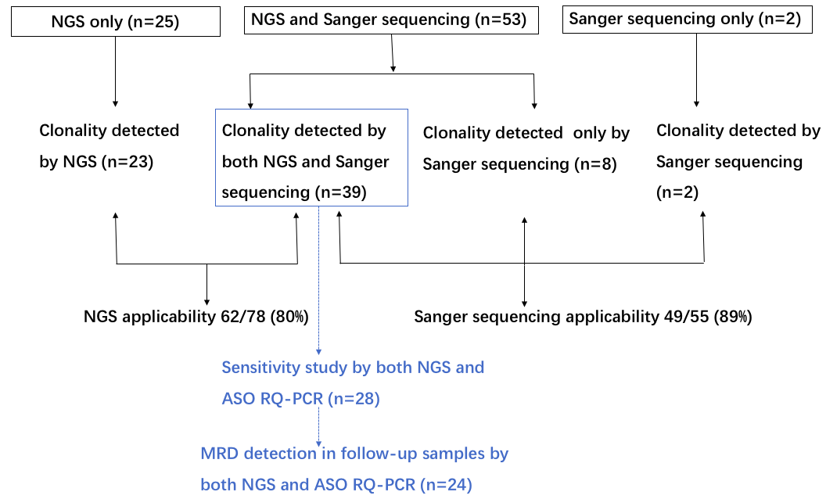
Figure S1. Schematic diagram of clonality detection at diagnosis, sensitivity study and MRD detection at follow-up, by NGS and Sanger sequencing. NGS: next-generation sequencing; ASO RQ-PCR: allele-specific oligonucleotide real-time quantitative-PCR; MRD: minimal residual disease.

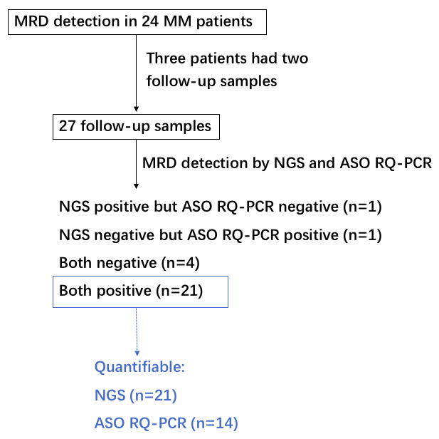
Figure S2. MRD measured by NGS and ASO RQ-PCR in 27 follow-up bone marrow samples from 24 MM patients. MM: multiple myeloma; NGS: next-generation sequencing; ASO RQ-PCR: allele-specific oligonucleotide real-time quantitative-PCR; MRD: minimal residual disease.

