Supplementary Material 1

Forward model of post-entrapment processes in long-stored MIs.
The forward model of post-entrapment processes suffered by a MI set is based on the equations describing the PEC and Fe-loss processes of (Danyushevsky et al., 2000). To simplify calculations, the model assumes a close system for $f_{O_{2}}$, where Fe³⁺ is taken as an incompatible element during olivine crystallization. The effect of H₂O concentrations on olivine liquidus temperature are not considered, and liquidus temperatures calculated with (Ford et al., 1983) are used to derive temperature variations between each calculation step, instead of absolute temperatures.
After MI selection from the FC LLD generated with rhyolite-MELTS, each of the MI compositions is modified by the three phases of post-entrapment processes described in the main text.
Phase 1: Olivine host composition during entrapment and initial liquidus temperature of the MI are calculated with (Ford et al., 1983). To calculate a step of PEC the following equation is used (Danyushevsky et al., 2000):
${MIwt}_{i} = {MIwt}_{i+1}*\left(1-∆x\right)+{Olwt}_{i+1}*∆x$ Eq (A1)
Where ${MIwt}_{i}$ is the current MI composition (in wt%), ${MIwt}_{i+1}$ is the MI composition after the PEC step, which is in equilibrium with ${Olwt}_{i+1}$, the olivine composition calculated with (Ford et al., 1983). $∆x$ is the fraction of olivine crystallization in each step (0.0001 or 0.01 wt%). ${MIwt}_{i+1}$ is found by iteratively solving equation A1.
After each PEC step, the Fe-loss step is calculated by iterating steps of Fe-Mg exchange follow by smaller steps of PEC to compensate for the increase of olivine liquidus temperature with MgO gain.
${X{Fe}^{2+}}_{i+1}= {X{Fe}^{2+}}_{i}-{∆x}_{1}$ Eq (A2)
${XMg}_{i+1}= {XMg}_{i}+{∆x}_{1}$ Eq (A3)
Where ${X{Fe}^{2+}}_{i}$ and ${XMg}_{i}$ are cation fractions of the MI after the previous PEC step, ${X{Fe}^{2+}}_{i+1}$ and ${XMg}_{i+1}$ are cation fractions of the melt after Fe-Mg exchange and ${∆x}_{1}$ indicates the amount of Fe-Mg exchange for each step, set as $∆x$/128. After each step of Fe-Mg exchange, the extra PEC is calculated using equation (A1) with fractionation steps of ${∆x}_{2}$ = $∆x$/512, until reaching the same liquidus temperature as prior to Fe-Mg exchange. The Fe-Mg exchange and extra PEC steps are repeated until the MI reaches equilibrium with ${Fo}_{rim}$, defined as:
${Fo}_{rim}={Fo}_{2}+\left({Fo}_{1}-{Fo}_{2}\right)*(Y/{100})$ Eq (A4)
Where ${Fo}_{1}$is the olivine composition in equilibrium with the melt before phase 1, ${Fo}_{2}$ is the olivine composition in equilibrium with the melt after phase 1 and $Y$ indicates the degree of re-equilibration (as %). In the first stage of this model, $Y$ is set randomly between 90 and 100% to simulate the slow cooling process, where the Fe-loss degree is expected to be close to maximum. The PEC and Fe-loss iterations stop when all MIs reach olivine liquidus temperatures 10 °C below that of the most differentiated MI, to simulate that all MIs evolve under similar conditions during the FC process.
Phase 2: To model complete re-equilibration during the second stage the calculations follows a inverse. The re-equilibration temperature is set as the temperature where the first stage stops, and the interstitial melt Mg# is taken from the FC LLD at 10 °C below the temperature of entrapment of the most differentiated MI, to simulate the simplified case where crystals are stored in the same magma that they were fractionated from. As re-equilibration of the olivine host reaches the vicinity of the MI, the MI start exchanging Fe-Mg with the olivine as Fo content of the olivine starts dropping. This is simulated with the following equations.
${X{Fe}^{2+}}_{i+1}= {X{Fe}^{2+}}_{i}+{∆x}_{3}$ Eq. (A5)
${XMg}_{i+1}= {XMg}_{i}-{∆x}_{3}$ Eq. (A6)
These equations are the inverse of equations A2 and A3, and ${∆x}_{3}$ is set to 0.01. After each re-equilibration step, the higher Fe content of the melt inclusion decreases the liquidus temperature of olivine, triggering melting on the MI walls. Olivine melting is modelled by applying the following equation:
${MI}_{i+1} \left(wt\%\right)= {MI}_{i} \left(wt\%\right)*\left(1-{∆x}_{4}\right)+{Ol}_{i} \left(wt\%\right)*{∆x}_{4}$ Eq. (A7)
Where ${MI}_{i}$ is the MI composition after Fe gain and before melting, ${MI}_{i+1}$ is the MI composition after one step of melting, ${Ol}_{i}$ is the composition of the olivine after the Fe-gain step. The melting step ${∆x}_{4}$ corresponds to ${∆x}_{3}$/1024. Equation A7 is repeated until the olivine liquidus temperature reaches the liquidus temperature before the Fe-gain step. The melting process increases the Mg# of the melt, counteracting the effect of Fe-gain, so equations A5 and A6 are applied again with a step ${∆x}_{5}$ = ${∆x}_{3}$/4096. Fe-gain and melting equations are iterated until the MI composition is in thermal and compositional equilibrium with the new host olivine composition. This process is repeated for each ${∆x}_{3}$ step of re-equilibration until the MI is in equilibrium with the olivine that is in turn in equilibrium with the interstitial melt.
Phase 3: The third and final step models the post-entrapment processes occurring during ascent and eruption. PEC and Fe-loss is modelled with the same equation than stage 1, by setting the amount of PEC randomly between 0% and 10% and the degree of re-equilibration between 0% and 50%.

Appendix B: Test of rhyolite-MELTS crystallization sequence for hydrous basalts
Before applying the rhyolite-MELTS algorithm to generate the crystallization models used by MushPEC, its capability to reproduce the crystallization behavior of hydrous basic magmas needs to be assessed. For the model to successfully reproduce the cotectic behavior of magmas, the liquidus temperature of each of the mineral phases involved must be accurately reproduced. The rhyolite-MELTS algorithm has been successfully applied for reproducing the crystallization sequence of low H₂O basic magmas, like MORB or OIB’s. It has been shown by several studies that H₂O content of the melt has a strong effect of depressing liquidus temperatures of silicate mineral phases (e.g., Almeev et al., 2012; Danyushevsky, 2001; Médard and Grove, 2008; Sisson and Grove, 1993; Waters and Lange, 2015). Therefore, it is necessary to check if the behavior the liquidus temperature of the minerals of interest is correctly modelled with rhyolite-MELTS. For hydrous basic magmas, the mineral phases involved during crystallization are usually olivine, plagioclase, clino- and orthopyroxene and spinel (titanomagnetite).
Olivine and plagioclase liquidus depression models as a function of water content have been developed from experimental data (Almeev et al., 2012; Médard and Grove, 2008). Comparison of rhyolite-MELTS behavior with the empirical models shows that rhyolite-MELTS liquidus depression is slightly lower for both phases (Figure 1). Hence, even though temperatures of hydrous melts will be slightly overestimated, the cotectic relationship between both phases should not be affected as both liquidus lines are displaced in similar amounts.
As no empirical models of the dependence of H₂O content on the liquidus depression of clino- and orthopyroxene have been developed to date, a different approach is needed to analyze the behavior of the crystallization sequence when these phases are involved. (Takagi et al., 2005) conducted a series of equilibrium crystallization experiments at 100, 200 to 500 MPa with variable water contents for a sample from Iwate volcano. Iwate volcano is the closest stratovolcano to Akita-Komagatake volcano (km) and the used composition (IWL16) is very similar to the AK melt (low-alkali hydrous tholeiite). For the experimental runs, two types of initial bulk material were used with slightly different compositions, a glass powder produced by previous melting of the IWL16 whole rock composition, and a powder produced directly from the whole rock material. Buffer conditions the experimental runs were estimated to be NNO + 1 (±1) Here, the crystallization sequence produced by the experimental runs was compared with rhyolite-MELTS equilibrium crystallization models.
Takahashi et al estimated the bulk H₂O contents of the experiments by the water added before the experiment and the volatile loss determined by weighting the experimental capsule before and after the experiments. No direct H₂O analyses were made of the glasses after the experiments and the water content of the glasses was estimated using the difference method (for unsaturated experiments) and using the solubility model of (Moore et al., 1995) for saturated experiments. Water content estimations were checked here using the (Waters and Lange, 2015) plagioclase-melt hygrometer for runs where glass and plagioclase compositions were available. The degree of crystallization of the runs was estimated by least square mass balance calculations with the Geobalance program (Li et al., 2020) using the compositions of all phases in the experimental run. Bulk H₂O contents were then estimated by mass balance using the glass H₂O content calculated with the hygrometer and the degree of crystallinity. Uncertainties of these new H₂O estimations are c. ±0.5 wt% H2O (1σ). Results show that a lot of experiments had unaccounted loss of H₂O and that H₂O values were thus overestimated, especially for experiments at 500 MPa and 100 MPa. The H₂O estimates of experimental runs at 200 MPa are usually within error for H₂O contents <2.5 wt%. Some samples with low H₂O contents are seen to slightly underestimate water contents. H₂O corrections could only be made to experiments in which plagioclase was present and compositions for all phases were available.
Equilibrium crystallization models were run using alphaMELTS2 with the rhyolite-MELTS 1.2.0 model for different water contents at 100, 200 and 500 MPa. Different buffer conditions were tested between the estimated values of the experimental runs (NNO to NNO + 2). Figure 2 shows the experimental results for all runs compared to the best fit models. The equilibrium crystallization models match the corrected H₂O contents of the experimental data very well (Figure 2). In rhyolite-MELTS, there is usually an interplay between the appearance of orthopyroxene and low-Ca pyroxene (pigeonite), the latter not appearing in the experimental runs. In the comparison between experiments and models, low-Ca pyroxene is taken as orthopyroxene, as is closer in composition to it, and it will have a similar effect as orthopyroxene in the liquid line of decent.
Experimental data is well reproduced within uncertainties at 100 MPa, with relatively small temperature discrepancies for the appearance of spinel and olivine in runs at 1150°C. Corrected H₂O concentrations for the experiment at 200 MPa also fit the rhyolite-MELTS models very well within the uncertainties in bulk H₂O contents of the experiments. In particular, rhyolite-MELTS captures the small T-H₂O space were olivine and orthopyroxene coexist in equilibrium. Again, small discrepancies are found in the appearance of spinel at high temperatures for a nearly anhydrous experiment and the absence of clinopyroxene in experiments at low water and temperature conditions. Experiments at 500 MPa also present few discrepancies with the rhyolite-MELTS models. Here, the absence of olivine equilibration at high pressures is reproduced by the models, in addition to the increase of liquidus temperature of pyroxenes in relation to plagioclase. As at lower pressure experiments, some runs at low water content did not crystallize clinopyroxene, predicted by the rhyolite-MELTS algorithm.
It is concluded that rhyolite-MELTS appears to dependably reproduce the cotectic relationships during crystallization of hydrous basalts, including phases with less well understood behavior, like pyroxenes and Fe-Ti oxides. Small discrepancies are only found at low water contents (< 2 wt%) at conditions that do not stabilize olivine, which do not constitute possible conditions for melts trapped in olivine crystals as in this study.

Supplementary Figures

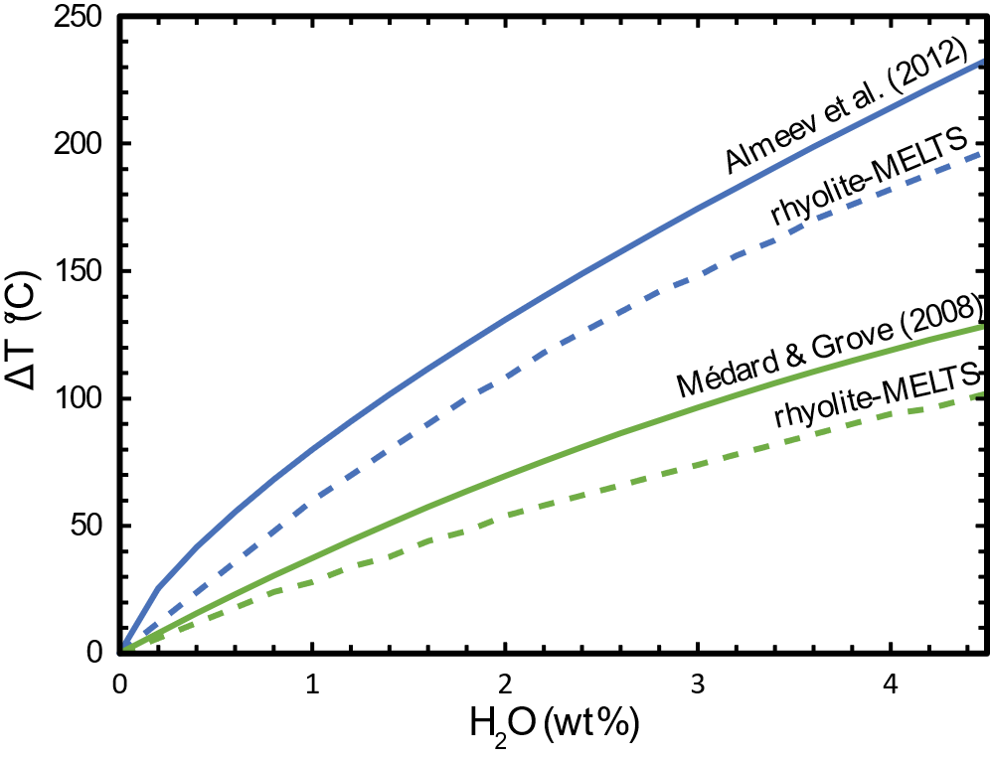
Supplementary Figure 1. Effect of melt H2O concentration in liquidus temperature suppression (ΔT). Green and blue lines indicate the ΔT for olivine and plagioclase, respectively. Hashed lines are the ΔT obtained from rhyolite-MELTS, whereas continuous lines represent the ΔT empirical models from (Almeev et al., 2012; Médard and Grove, 2008)Médard and Grove (2008) and Almeev et al. (2012).

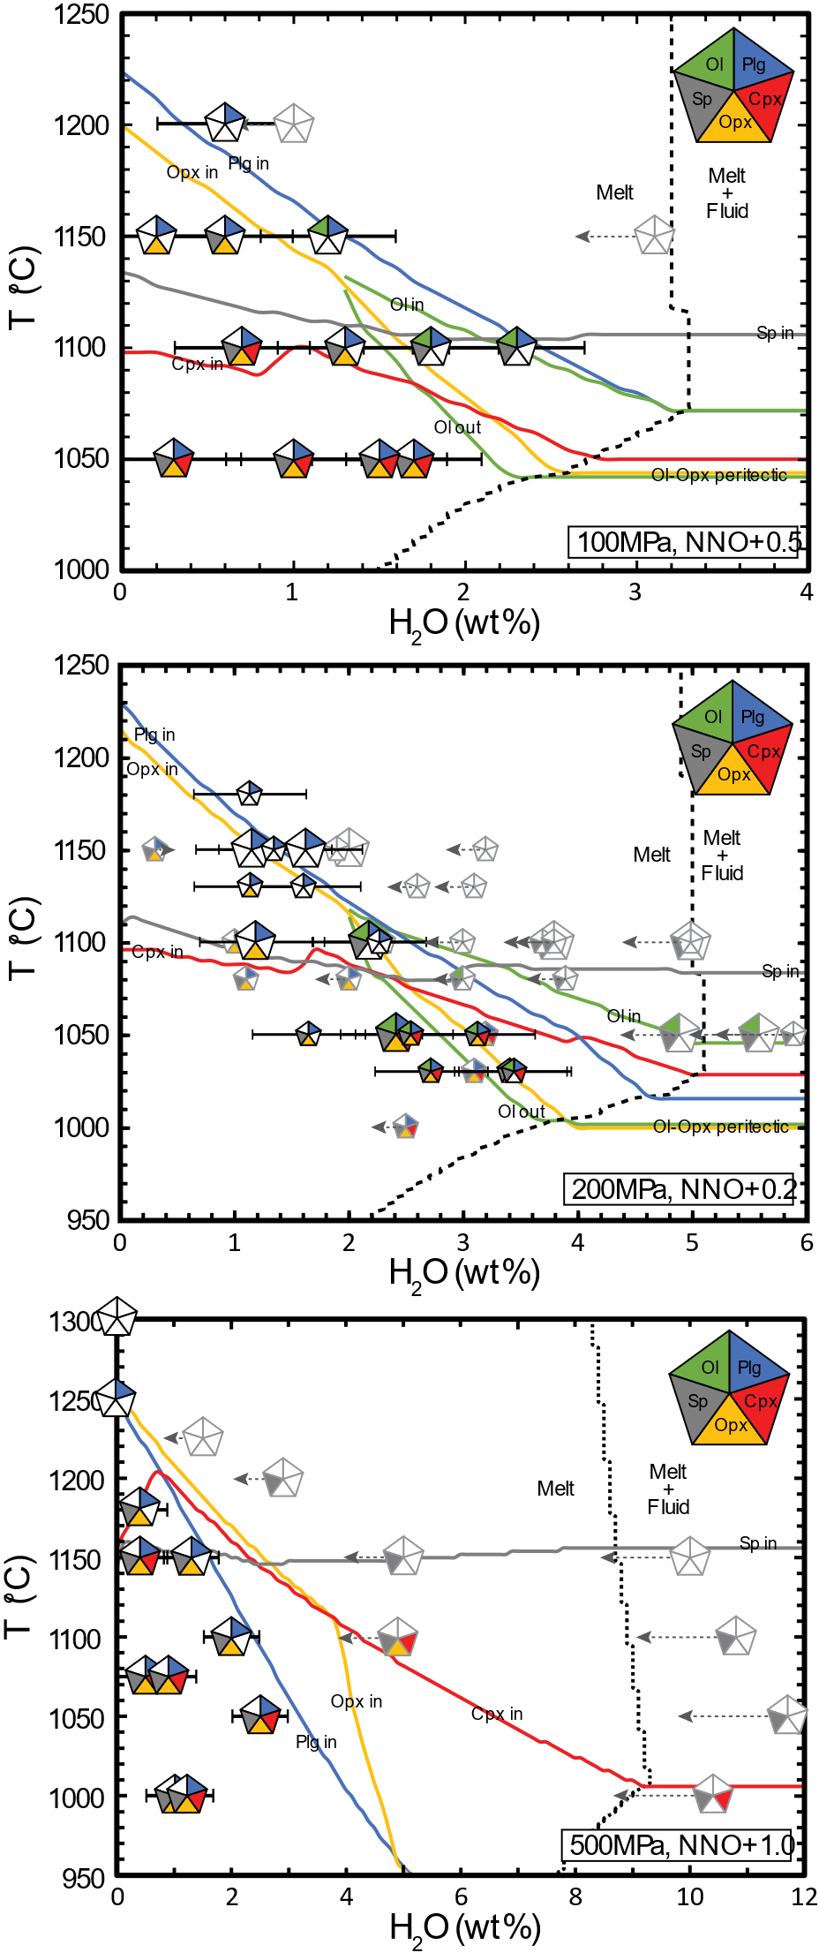
Supplementary Figure 2. Phase diagrams showing the phase equilibria for the IWL16 sample experiments (Takagi et al., 2005) and the rhyolite-MELTS equilibrium crystallization models. Pentagon symbols indicates the mineral assemblage observed in the experimental runs and curves indicates the entering or leaving of the phases into the crystallization sequence reproduced by rhyolite-MELTS. Line and pentagon colour code is indicated by the large pentagon at the top left corner of each plot (Ol = olivine, Plg = plagioclase, Cpx = clinopyroxene, Opx = orthopyroxene, Sp = spinel). Hashed black line indicates fluid saturation in rhyolite-MELTS. Big pentagons are experimental runs using glass powder from IWL16, which correspond to the composition used to generate the rhyolite-MELTS models, whereas smaller pentagons in (b) are experimental runs of whole rock powder from IWL16, which has a slightly different composition. Experimental runs with corrected bulk H₂O concentrations are shown as the pentagons with black lines and error bars, whereas uncorrected experiments are shown with light grey lines. Hashed grey arrows indicates the expected displacement of bulk H₂O contents from the values given in (Takagi et al., 2005).

Supplementary references
Almeev, R.R., Holtz, F., Koepke, J. and Parat, F., 2012. Experimental calibration of the effect of H2O on plagioclase crystallization in basaltic melt at 200 MPa. American Mineralogist, 97(7): 1234-1240.
Danyushevsky, L.V., 2001. The effect of small amounts of H2O on crystallisation of mid-ocean ridge and backarc basin magmas. Journal of Volcanology and Geothermal Research, 110(3-4): 265-280.
Danyushevsky, L.V., Della-Pasqua, F.N. and Sokolov, S., 2000. Re-equilibration of melt inclusions trapped by magnesian olivine phenocrysts from subduction-related magmas: Petrological implications. Contributions to Mineralogy and Petrology, 138(1): 68-83.
Ford, C.E., Russell, D.G., Craven, J.A. and Fisk, M.R., 1983. Olivine-liquid equilibria: temperature, pressure and composition dependence of the crystal/liquid cation partition coefficients for Mg, Fe2+, Ca and Mn. Journal of Petrology, 24(3): 256-265.
Li, X., Zhang, C., Almeev, R.R. and Holtz, F., 2020. GeoBalance: An Excel VBA program for mass balance calculation in geosciences. Geochemistry, 80(2): 125629.
Moore, G., Vennemann, T. and Carmichael, I.S.E., 1995. Solubility of water in magmas to 2 kbar. Geology, 23(12): 1099-1102.
Médard, E. and Grove, T.L., 2008. The effect of H2O on the olivine liquidus of basaltic melts: experiments and thermodynamic models. Contributions to Mineralogy and Petrology, 155(4): 417-432.
Sisson, T.W. and Grove, T.L., 1993. Experimental investigations of the role of H2O in calc-alkaline differentiation and subduction zone magmatism. Contributions to Mineralogy and Petrology, 113(2): 143-166.
Takagi, D., Sato, H. and Nakagawa, M., 2005. Experimental study of a low-alkali tholeiite at 1–5 kbar: optimal condition for the crystallization of high-An plagioclase in hydrous arc tholeiite. Contributions to Mineralogy and Petrology, 149(5): 527-540.
Waters, L.E. and Lange, R.A., 2015. An updated calibration of the plagioclase-liquid hygrometer-thermometer applicable to basalts through rhyolites. American Mineralogist, 100(10): 2172-2184.

