Key components of inflammasome and pyroptosis are deficient in canines and felines, implying the mild symptoms of SARS-CoV-2 infection

Haoran Cui, Leiliang Zhang

Supplemental Figures legends
Figure S1. Sequence alignment of dog IFI16 isoforms and human IFI16.
Figure S2. Protein sequence alignment of NLRP3.
Figure S3. mRNA sequence alignment of NLRP3.
Figure S4. Protein sequence alignment of NLRP6.
Figure S5. mRNA sequence alignment of NLRP6.
Figure S6. Protein sequence alignment of NLRP9.
Figure S7. mRNA sequence alignment of NLRP9.
Figure S8. Protein sequence alignment of NLRP12.
Figure S9. mRNA sequence alignment of NLRP12.
Figure S10. Protein sequence alignment of NLRP1.
Figure S11. mRNA sequence alignment of NLRP1.
Figure S12. Genome data viewer of tiger genome in the corresponding site of cat NLRP1.
Figure S13. Genome data viewer of tiger genome in the corresponding site of human NLRP1.
Figure S14. Protein sequence alignment of NLRC4.
Figure S15. mRNA sequence alignment of NLRC4.
Figure S16. Protein sequence alignment of ASC.
Figure S17. mRNA sequence alignment of ASC.
Figure S18. Protein sequence alignment of caspase-1.
Figure S19. mRNA sequence alignment of caspase-1.
Figure S20. Protein sequence alignment of GSDMA.
Figure S21. mRNA sequence alignment of GSDMA.
Figure S22. Protein sequence alignment ofGSDMC.
Figure S23. mRNA sequence alignment of GSDMC.
Figure S24. Protein sequence alignment of GSDMD.
Figure S25. mRNA sequence alignment of GSDMD.
Figure S26. Protein sequence alignment of GSDMB.

Figure S1. Sequence alignment of dog IFI16 isoforms and human IFI16.
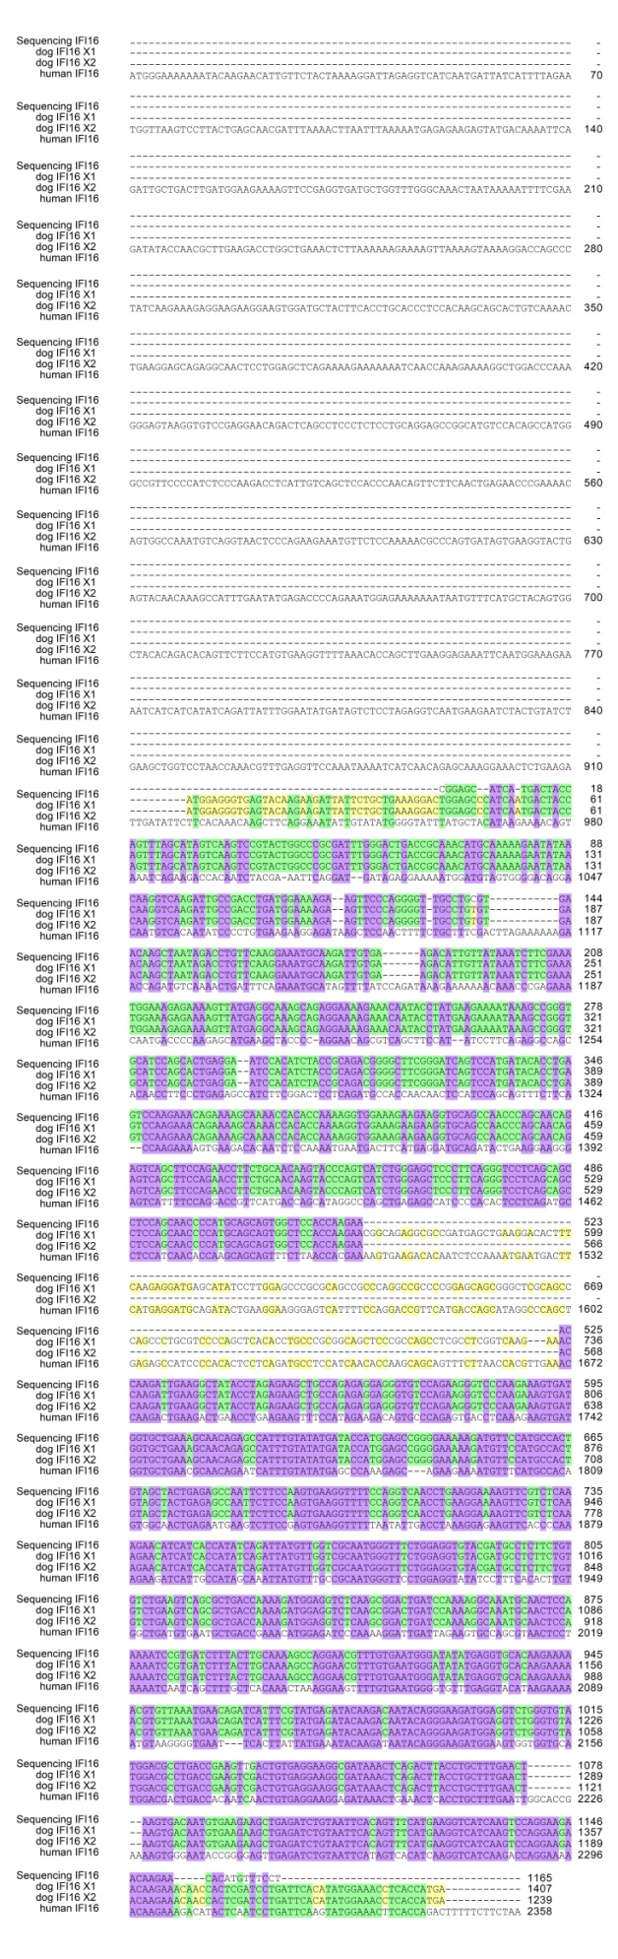
Figure S2. Protein sequence alignment of NLRP3.
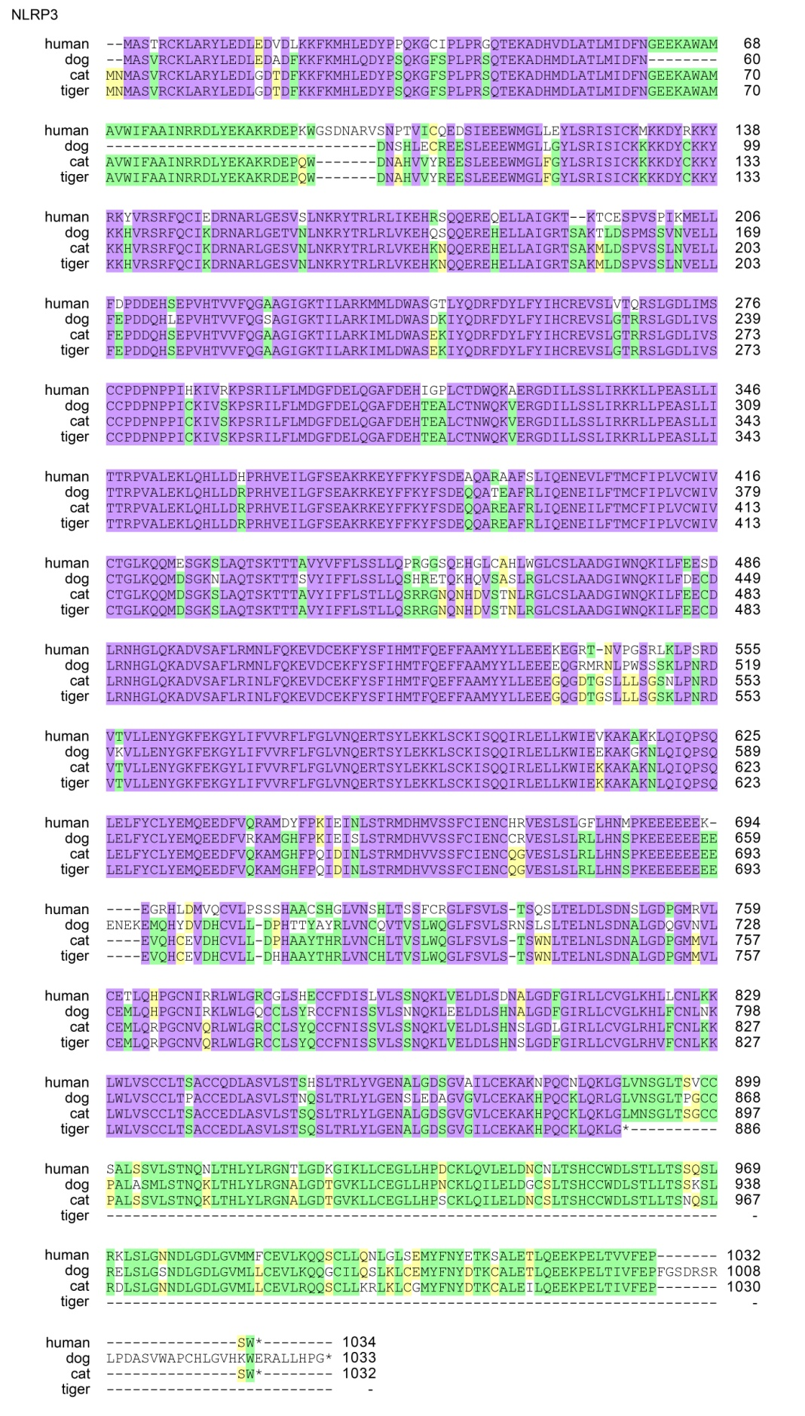
Figure S3. mRNA sequence alignment of NLRP3.
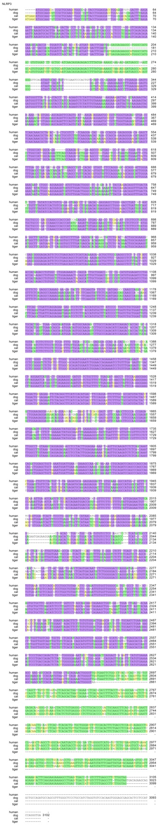
Figure S4. Protein sequence alignment of NLRP6.
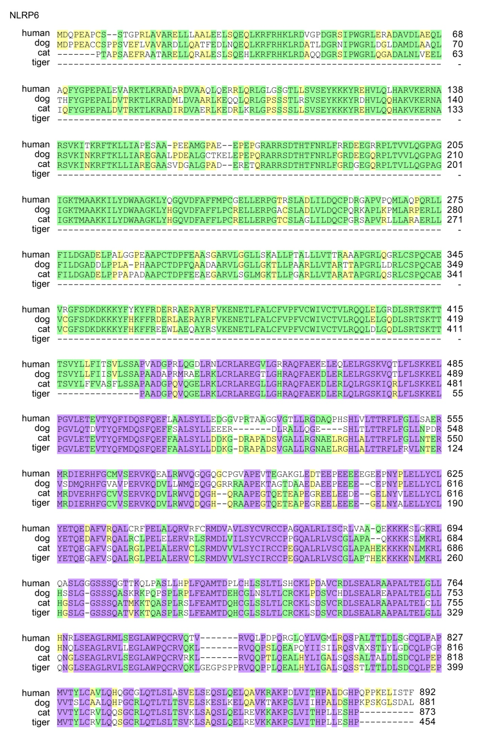
Figure S5. mRNA sequence alignment of NLRP6.
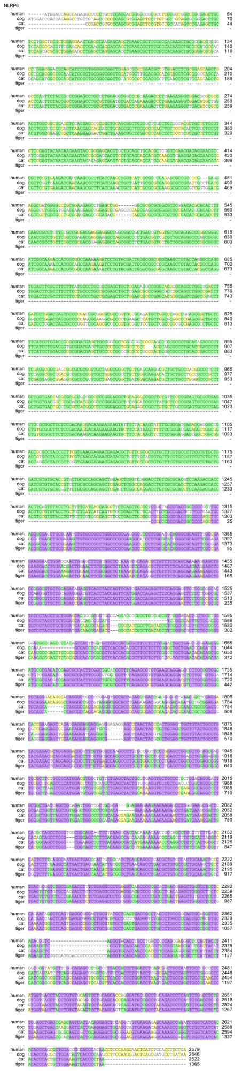
Figure S6. Protein sequence alignment of NLRP9.
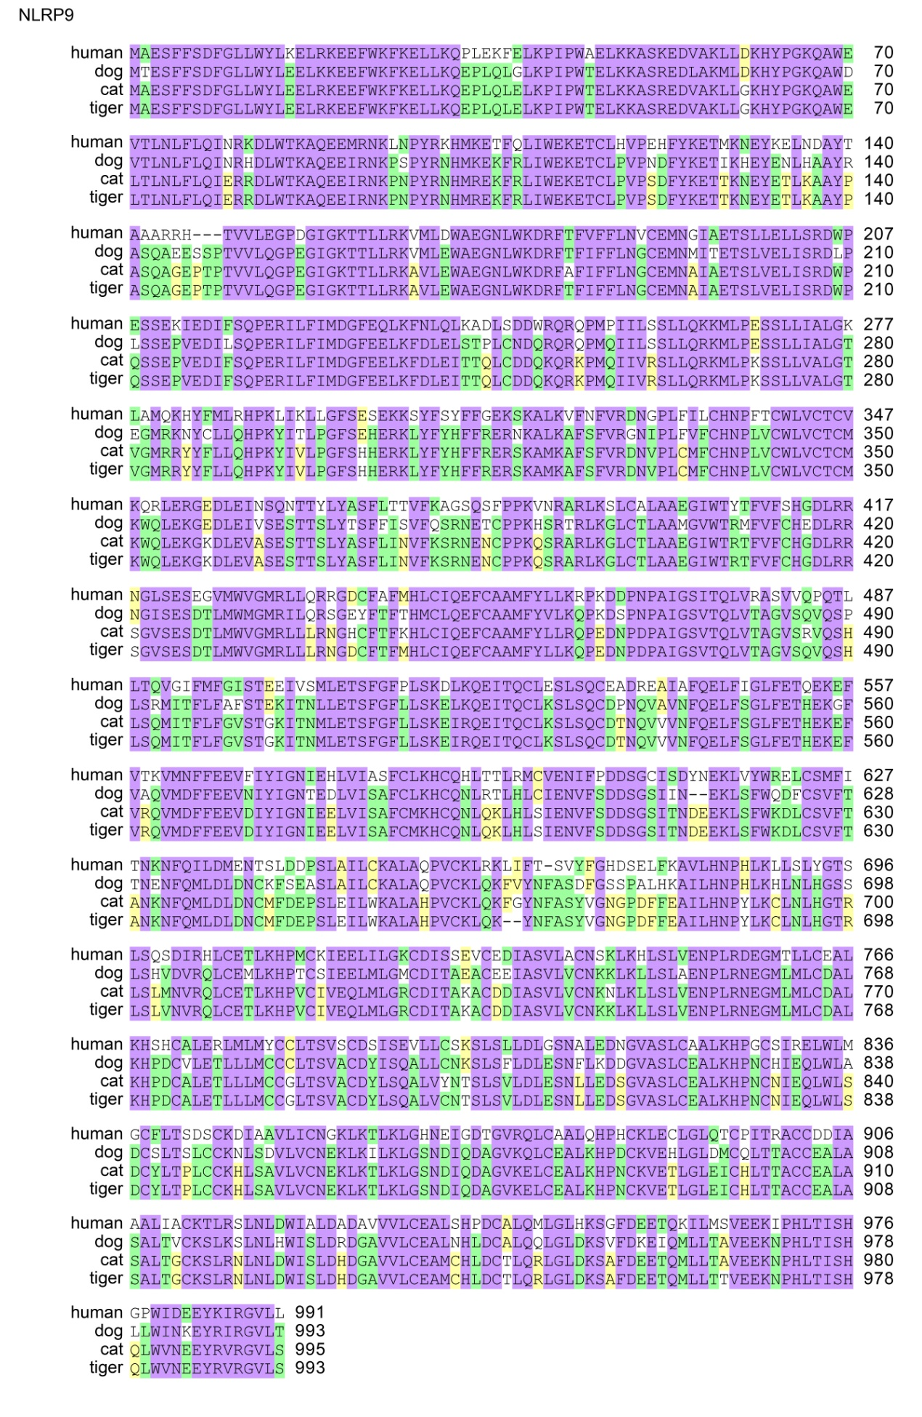
Figure S7. mRNA sequence alignment of NLRP9.
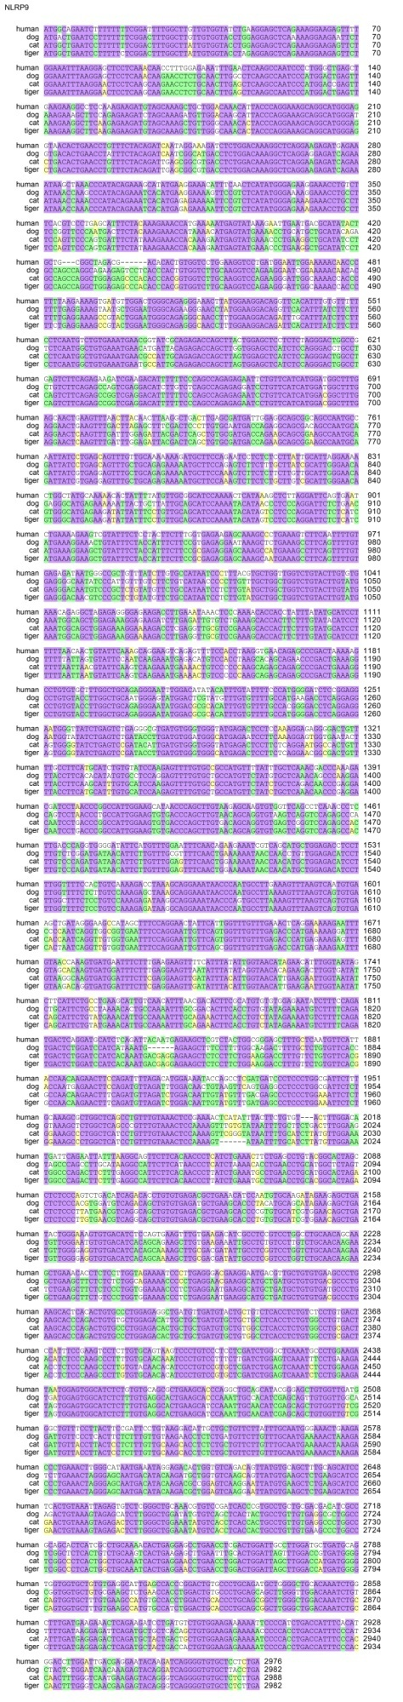
Figure S8. Protein sequence alignment of NLRP12.
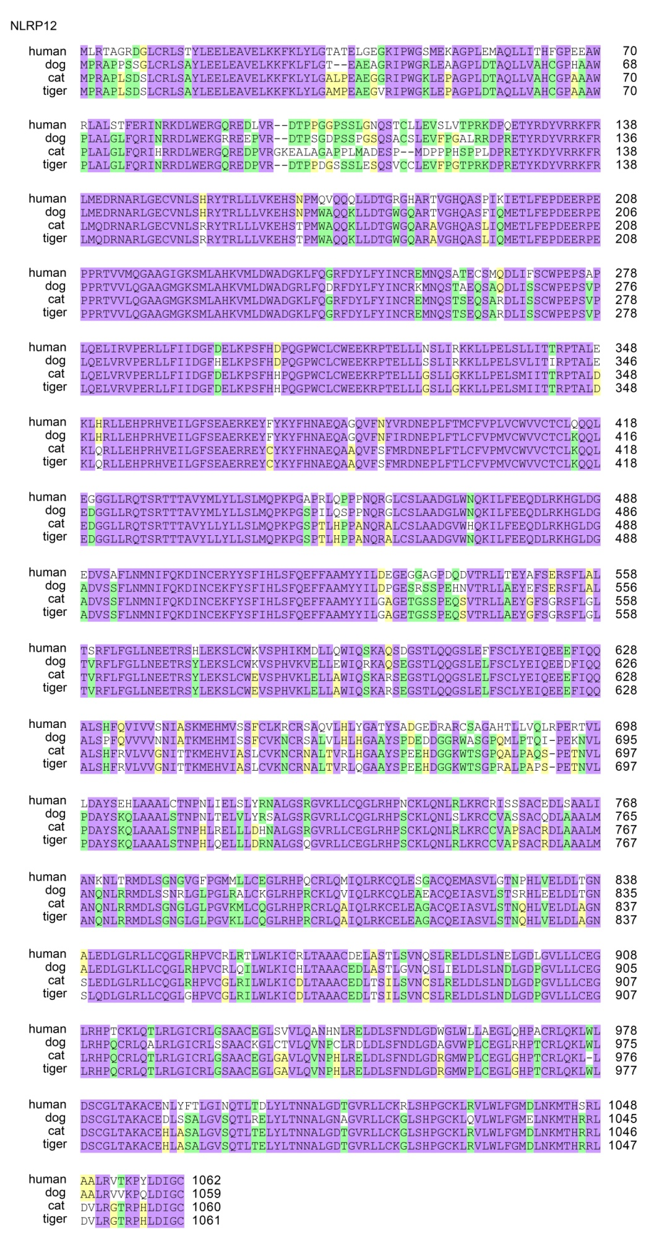
Figure S9. mRNA sequence alignment of NLRP12.
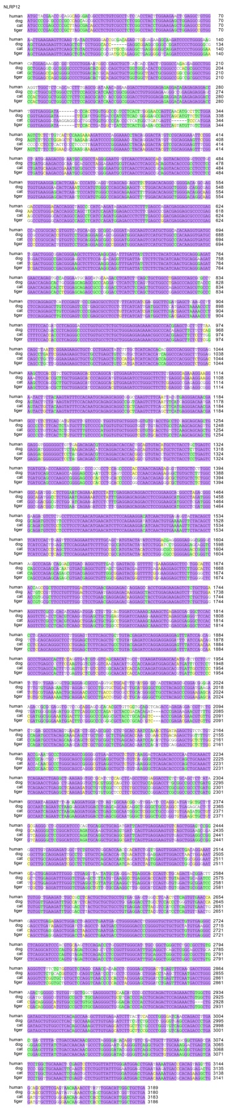

Figure S10. Protein sequence alignment of NLRP1.
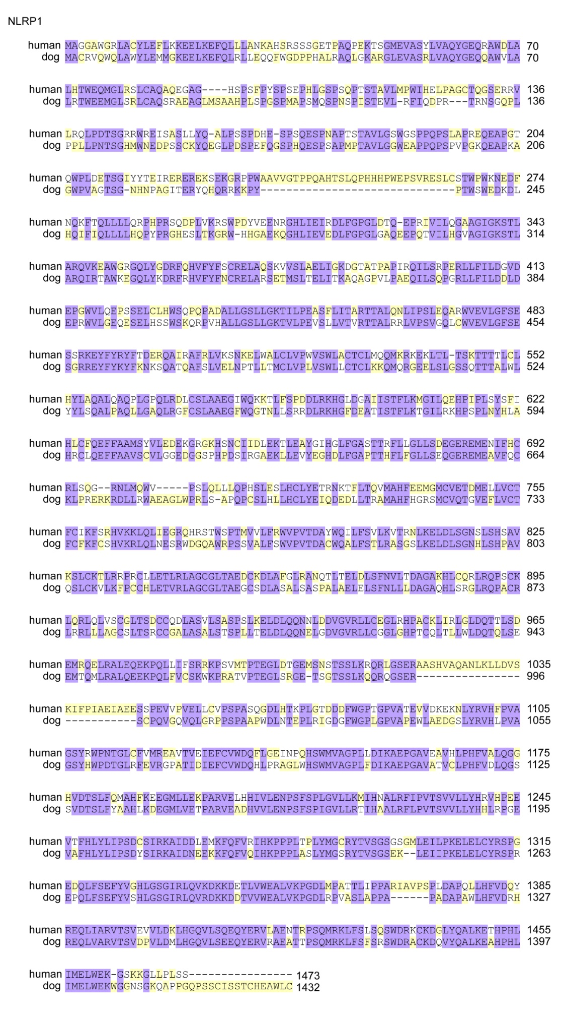
Figure S11. mRNA sequence alignment of NLRP1.
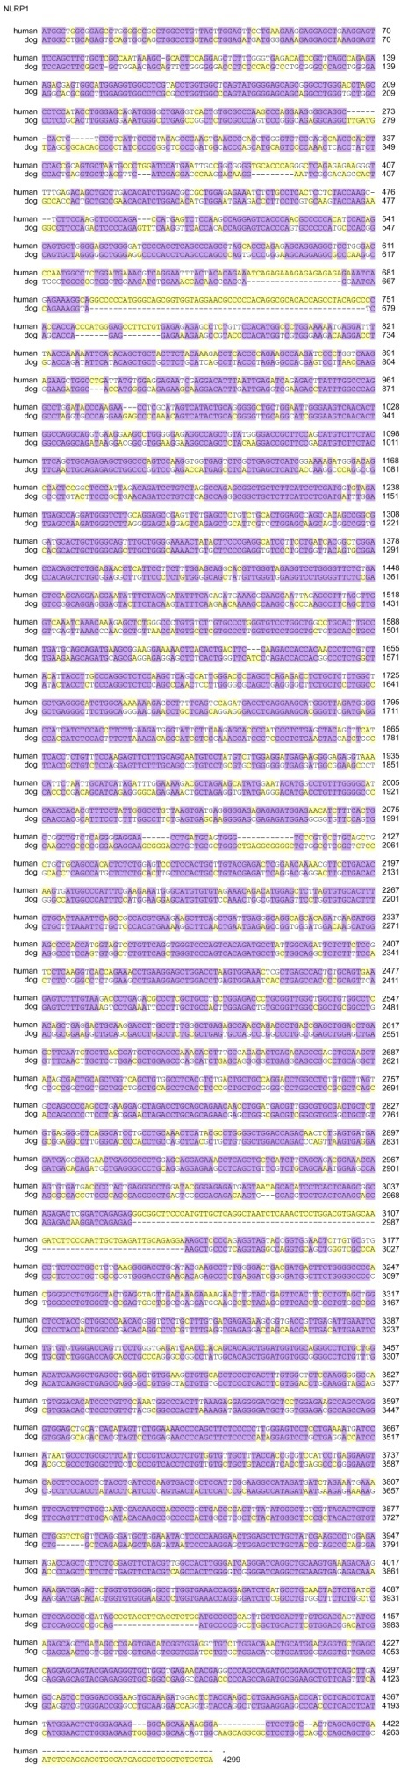
Figure S12. Genome data viewer of tiger genome in the corresponding site of cat NLRP1.
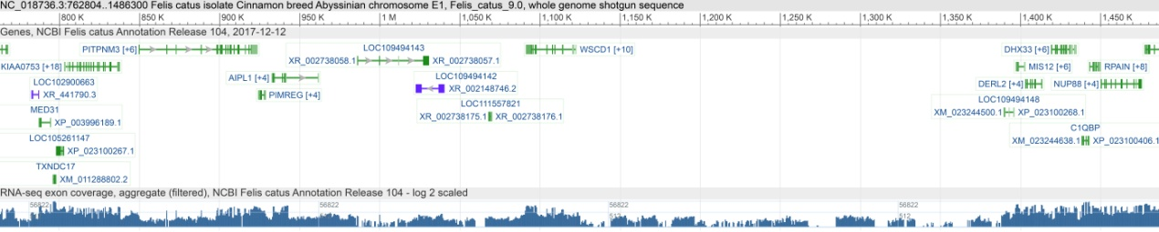

Figure S13. Genome data viewer of tiger genome in the corresponding site of human NLRP1.
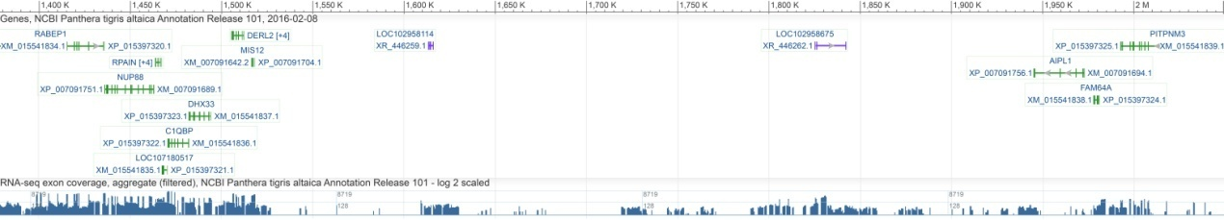
Figure S14. Protein sequence alignment of NLRC4.
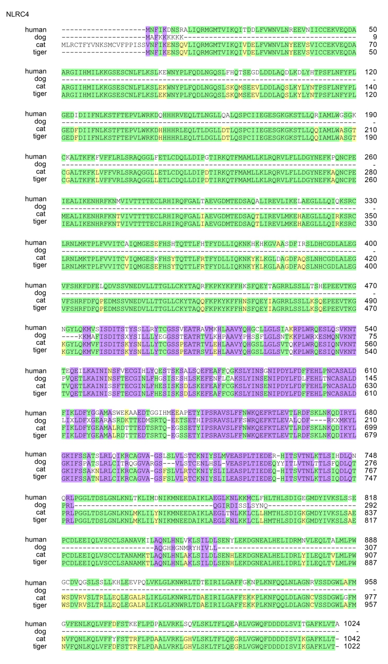
Figure S15. mRNA sequence alignment of NLRC4.
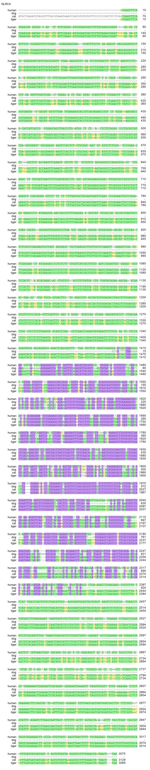

Figure S16. Protein sequence alignment of ASC.
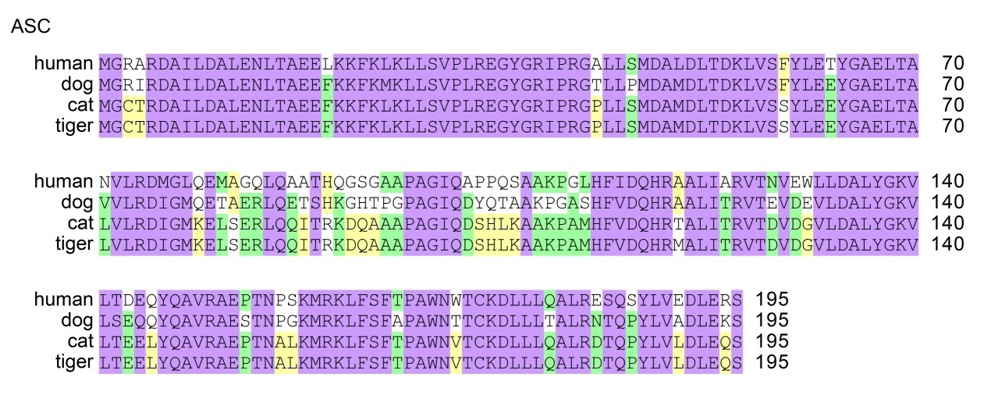
Figure S17. mRNA sequence alignment of ASC.
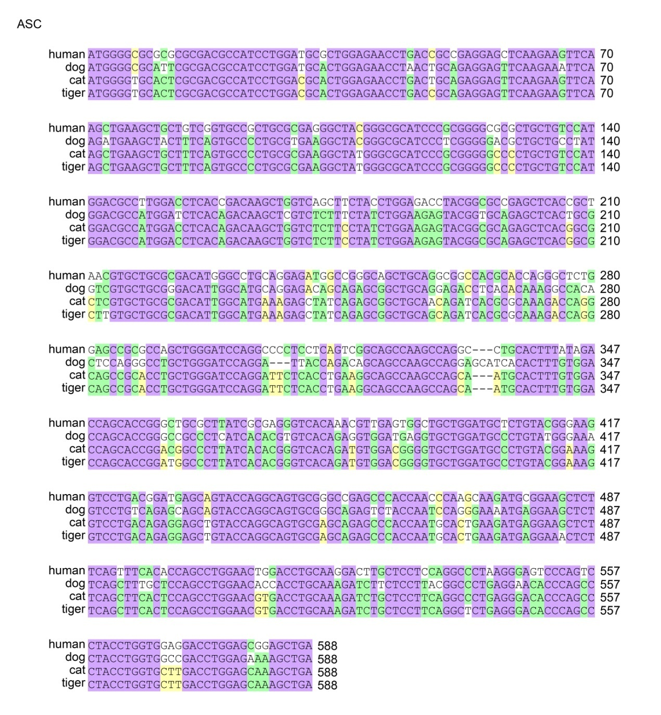
Figure S18. Protein sequence alignment of caspase-1.
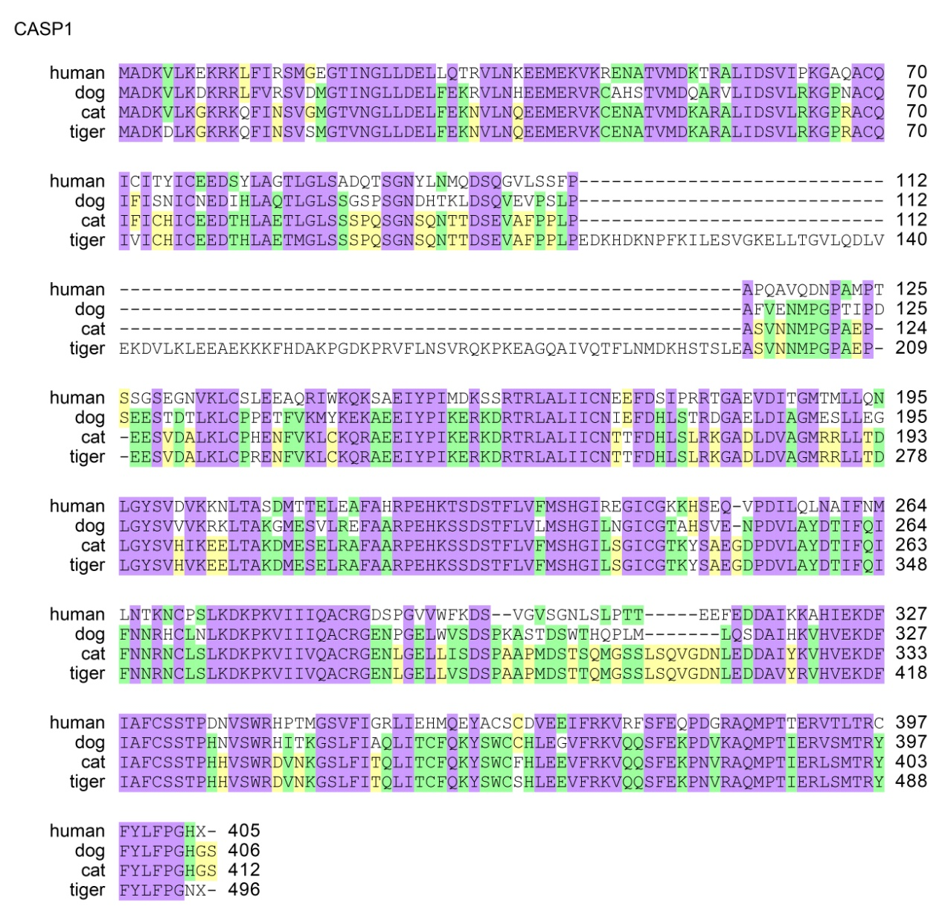
Figure S19. mRNA sequence alignment of caspase-1.
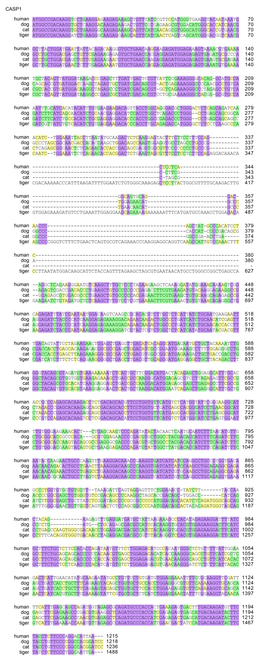
Figure S20. Protein sequence alignment of GSDMA.
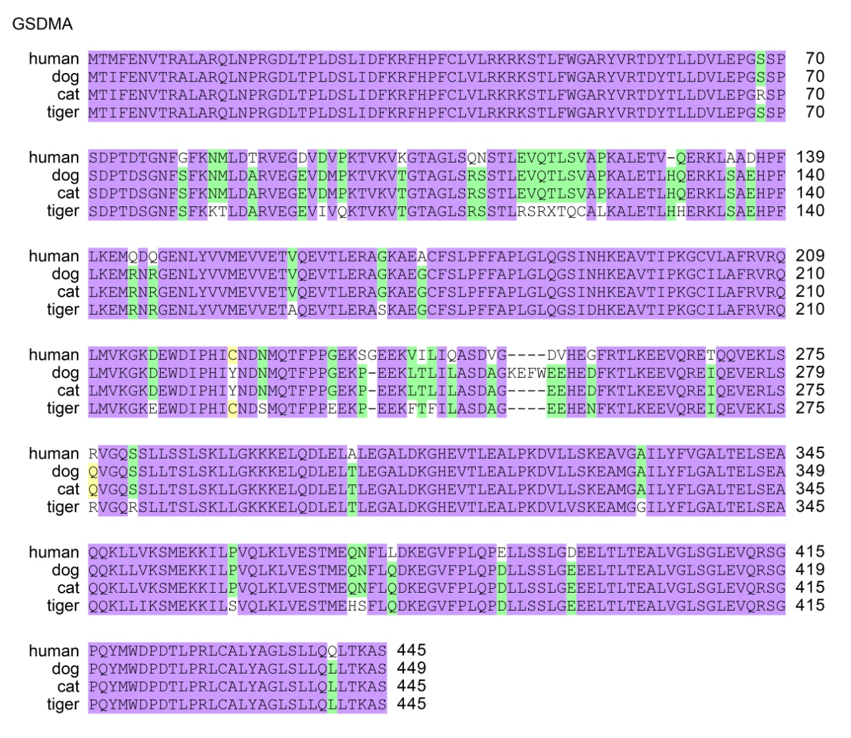
Figure S21. mRNA sequence alignment of GSDMA.
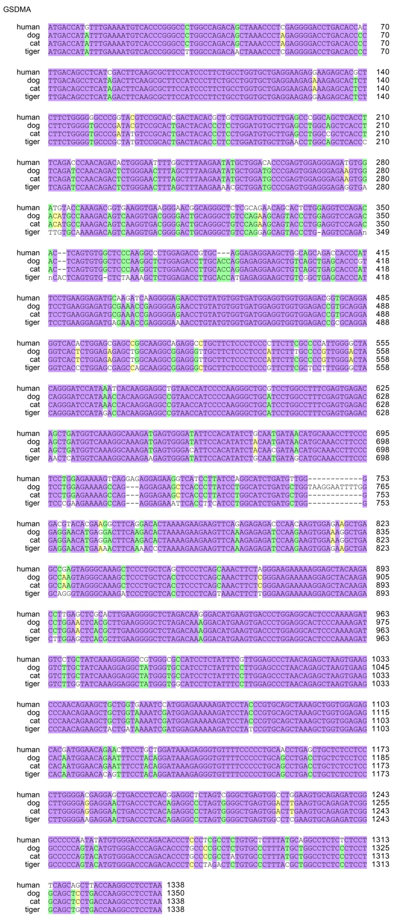
Figure S22. Protein sequence alignment ofGSDMC.
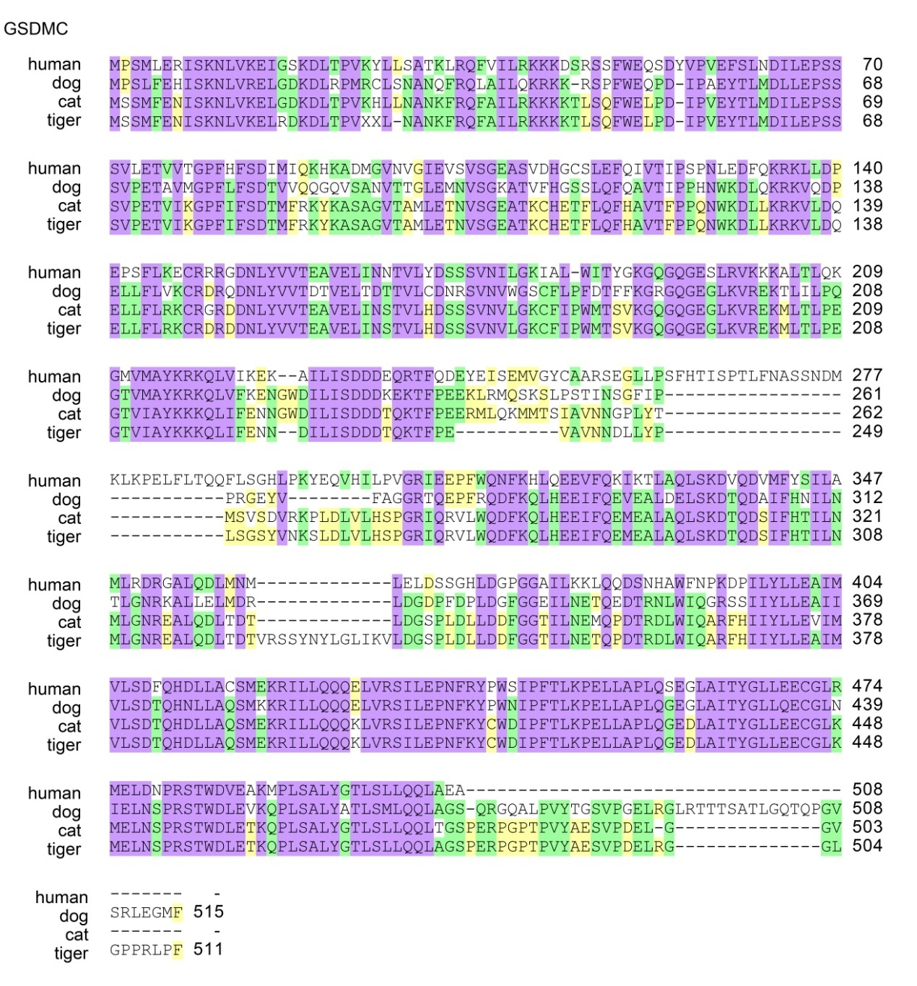
Figure S23. mRNA sequence alignment of GSDMC.
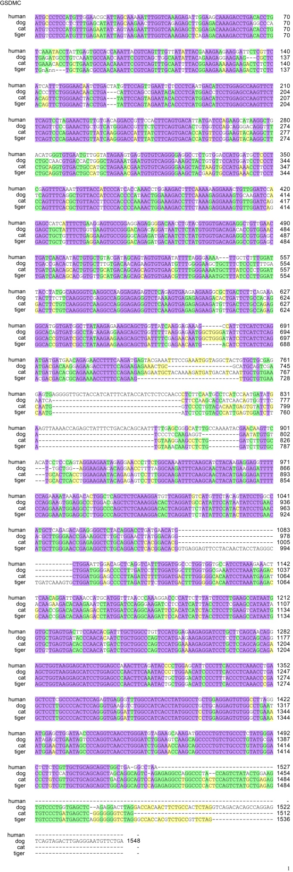
Figure S24. Protein sequence alignment of GSDMD.
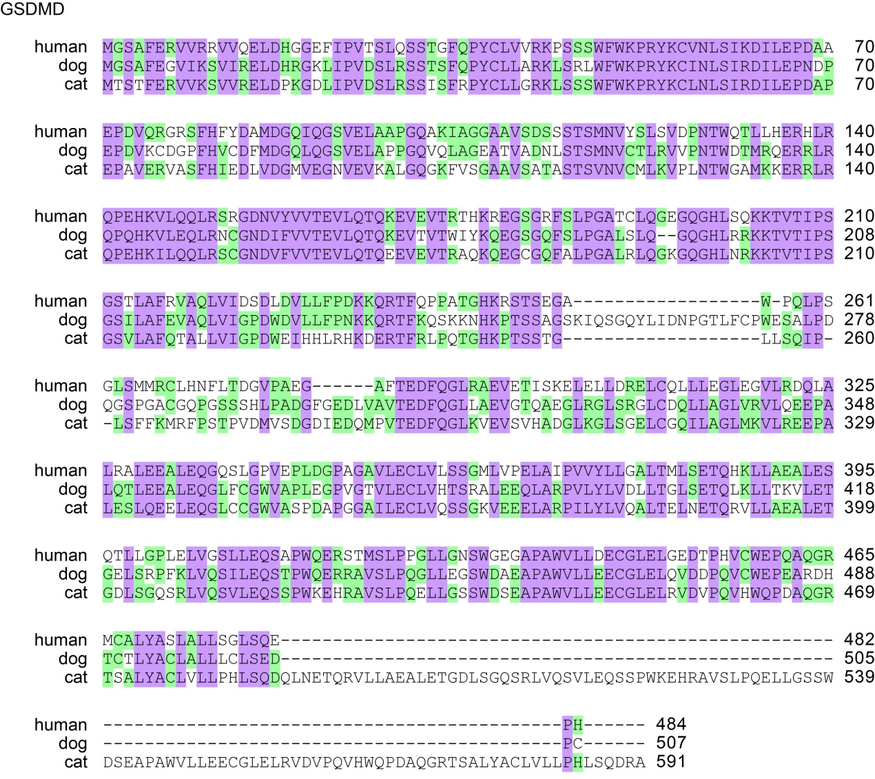
Figure S25. mRNA sequence alignment of GSDMD.
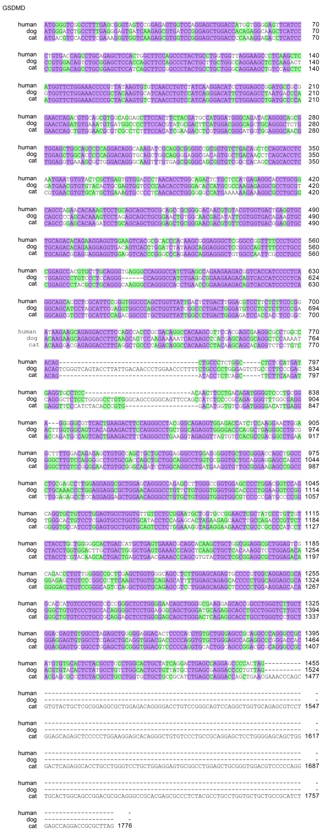
Figure S26. Protein sequence alignment of GSDMB.
