**Supplementary material**

**Modeling of solar collector**

The modeling of heat and mass transfer in the solar collector system below are adopted from the validated model of (Vásquez, Reyes, and Pailahueque 2019; Aboul-Enein et al. 2000; Hodali and Bougard 2001). The solar collector model, depending on the air mass flow rate, has a correlation coefficient (R2) of 0.94 - 0.978 and a root mean squared error (RMSE) of 1.999 - 2.464 (Vásquez, Reyes, and Pailahueque 2019). Each control strategy configuration is discussed separately.

1. **Solar collector without storage**

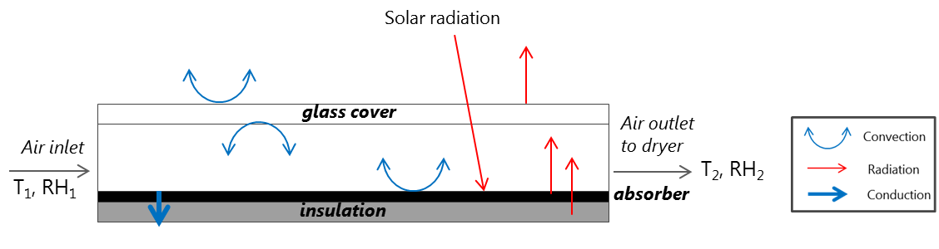

Figure A. Heat transfer mechanisms in the solar collector without storage.

1. Energy balance of the glass cover

The temperature of the glass cover, *Tg*, is influenced by:

* Convective heat transfer between the glass cover surface and the air inside the solar collector
* Convective heat transfer between the glass cover surface and the ambient air
* Radiative heat transfer between the glass cover surface and absorber plate surface
* Radiative heat transfer between the glass cover surface and the sky
* Solar radiation absorbed by the glass cover.

The energy balance on the glass cover is:



where *ρg* is the glass density [kg m-3], *Ag* is the collector surface area [m2], *δg* is the glass thickness [m], *Cg* is the glass heat capacity [J kg-1 K-1], *αg* is the glass absorptivity [-], *hr,bg*is the radiative heat transfer coefficient between glass and absorber [W m-2 K-1]*, hc,gf*is the convective heat transfer coefficient between the glass and drying air [W m-2 K-1], *hc,ga*is the convective heat transfer coefficient between the glass and ambient air [W m-2 K-1], *hr,gs* is the radiative heat transfer coefficient between the glass cover surface and the sky [W m-2 K-1], and *I* is the solar irradiation [W m-2].

1. Energy balance of the air

The temperature of the air, *Tf*, is influenced by the convective heat transfer between the air and both the glass cover and absorber plate. The energy balance for the drying air is:



where *ρg* is the air density [kg m-3], *δg* is the height of the air channel [m], *Cg* is the air heat capacity [J kg-1 K-1], *β* is the length of the air channel [m], *Wf* is the air mass flow rate [kg s-1], *hc,bf*is the convective heat transfer coefficient between the air and absorber [W m-2 K-1].

1. Energy balance of the absorber plate

The absorber plate is made from a zinc plate (Reyes et al. 2013) width a thickness of to be 5 mm. The temperature of the absorber plate, *Tb*, is influenced by:

* Convective heat transfer between the absorber plate surface and the air in the solar collector
* Radiative heat transfer between the glass cover surface and absorber plate surface
* Conductive heat transfer to the insulator
* Radiation absorbed by the absorber plate

The energy balance of the absorber plate is:



where *ρb* is the absorber density [kg m-3], *Ab* is the absorber surface area [m], *δb* is the absorber thickness [m], *Cb* is the absorber heat capacity [J kg-1 K-1], τg is the glass transmissivity [-],*αg* is the absorber absorptivity [-], kb is the absorber thermal conductivity [W m-1 K-1].

1. Energy balance of the insulator

The insulation is made from mineral wool with 50 mm thickness. The temperature of the insulator, *Tin*, is influenced by:

* Conductive heat transfer to the absorber plate.
* Convective heat transfer between the insulator and the outside air.

The energy balance of the insulator is:



where *ρin* is the insulator density [kg m-3], *Ain* is the insulator surface area [m], *δin* is the insulator thickness [m], *Cin* is the insulator heat capacity [J kg-1 K-1].

1. Calculation of heat transfer coefficient

The radiative heat transfer coefficient *hr,gs*between the glass cover and the sky is given by (Duffie, Beckman, and Worek 1994):



where *εg* is the surface emissivity of the glass, *σ* is the Boltzmann constant, and *Ts* is the equivalent temperature of the sky that is calculated based on the ambient temperature, *Ta* (Swinbank 1963):



The radiative heat transfer coefficient *hr,bg* between the glass cover and the absorber plate is given by(Duffie, Beckman, and Worek 1994):



The convective heat transfer coefficient to the ambient air *hw,ga* at the upper surface of the glass cover where it is in contact with the ambient air that has airspeed *U* is (Duffie, Beckman, and Worek 1994):



The convective heat coefficients between the air and either the inner surface of the glass cover *hc,gf* or absorber plate *hc,bf* are dependent on the Nusselt number Nu fand the hydraulic diameter Dh:



where the Nusselt number is calculated for a turbulent flow when the length *L*/Dh > 10



Where the Reynolds number, Re, is given



The hydraulic diameter *Dh* is calculated from the relationship given by:



1. **Solar collector with storage**

An additional layer of heat storage material is added between the absorber plate and the insulation material. The energy balance of the absorber plate and the insulation in section 1.1 are therefore changed, while energy balance for the glass cover and air are similar.

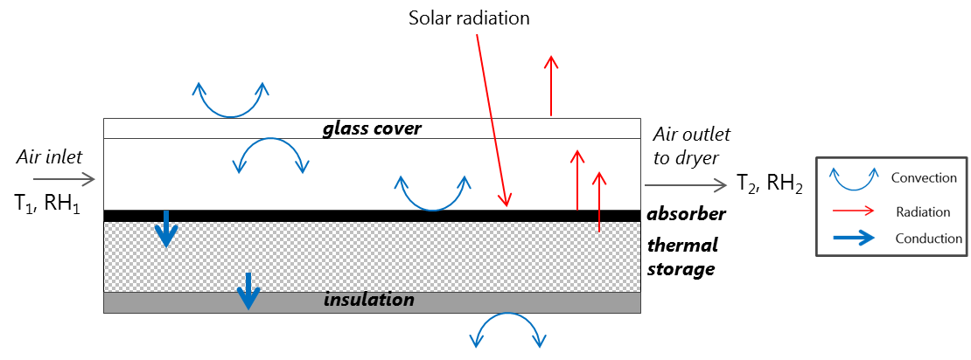

Figure B. Heat transfer mechanisms in the solar collector with storage.

1. Energy balance of the absorber plate

In this case, the temperature of the absorber plate, *Tb*, is influenced by:

* Convective heat transfer between the absorber plate surface and the air in the solar collector
* Radiative heat transfer between the glass cover surface and absorber plate surface
* Conductive heat transfer to the storage material
* Radiation absorbed by the absorber plate

The energy balance of the absorber plate is:



1. Energy balance of the storage material

In this case, the temperature of the storage material, *Tst*, is influenced by:

* Conductive heat transfer from the absorber plate.
* Conductive heat transfer to the insulator.

The energy balance of the storage material is:



where *ρst* is the storage material density [kg m-3], *Ast* is the storage material surface area [m], *δst* is the storage material thickness [m], *Cst* is the storage material heat capacity [J kg-1 K-1], *kst* is the storage material thermal conductivity [W m-1 K-1].

1. Energy balance of the insulator

* Conductive heat transfer from the storage material
* Convective heat transfer between the insulator and the outside air



1. **Solar collector with dehumidifier unit**

The dehumidifier unit is placed before the solar collector. The air inlet is fed into the humidifier unit, which causes the change of RH from RH1 to RH1a (Figure C). The impact of adsorption heat on the outlet temperature T1a is not taken into account. The calculation of heat transfer in the solar collector is the same as in Section 1.1.

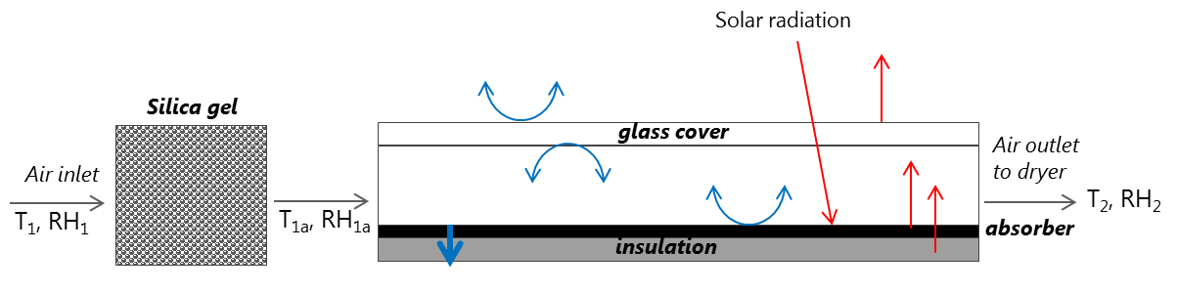

Figure C. Heat transfer mechanisms in the solar collector with storage.

According to the law of mass conservation, the water vapor lost by air equals the water vapor adsorbed by the solid desiccant. The mass balance between the process air and the solid desiccant is given as (Yang et al. 2018):



where *Asi* is the surface area of the dehumidifier unit [m2], *U* is the airflow speed [m s-1], *ρa* is the air density [kg m-3], *din* is the specific humidity of the incoming air [kg kg], *dout* is the specific humidity of the air at the outlet [kg kg], *Lsi* is the length of the humidifier unit [m], *ε* is the desiccant porosity [kg m-3], and *wsi* is the moisture content of the desiccant. The moisture content of the outlet air is supposed to be in equilibrium with the moisture content on the surface of the solid desiccant material (Kabeel 2009):



where, *de* is the moisture content of the air when it reaches the moisture balance with the moisture on the surface of the desiccant. *de* depends on the amount of dehumidification per unit mass of the desiccant and the thermophysical properties of the solid adsorbent-adsorbate pair. When the adsorbates and adsorbents are silica gel and water vapor, respectively, a linear function between *d* and *wsi* can be obtained as following (Kabeel 2009):



where *K1* and *K2* are the model parameters.

1. **Solar collector with auxiliary heating**

During the off-sun hours, the system is assumed to be connected to a fuel burner that provides constant heat.

**Table A**. Properties of the solar collector material

|  |  |
| --- | --- |
| Material property | Value |
| **Base Case** | |
| **Glass** |  |
| Thermal conductivity ofglass*, kg* | 1.4 [W m-1 K-1] |
| Density of glass, *ρg* | 2210 [kg m-3] |
| Heat capacity of glass, *Cg* | 800 [J kg-1 K-1] |
| Absorptivity of glass, *αg* | 0.0475 |
| **Absorber (zinc plate)** |  |
| Transmissivity of zinc plate, *τg* | 0.9 |
| Density of zinc plate, *ρb* | 2710 [kg m-3] |
| Thermal conductivity of zinc plate, *kb* | 385 [W m-1 K-1] |
| Absorptivity of zinc plate, *αg* | 0.95 |
| **Insulation: Mineral wool** |  |
| Thermal conductivity ofmineral wool*, kin* | 0.04 [W m-1 K-1] |
| Density of mineral wool, *ρin* | 50 [kg m-3] |
| Heat capacity of mineral wool, *Cin* | 720 [J kg-1 K-1] |
| **Case 2: Storage (sand)** | |
| Heat capacity of sand, *Cst* | 798 [J kg-1 K-1] |
| Density of sand, *ρst* | 1500 [kg m-3] |
| Thermal conductivity of sand, *kst* | 0.25 [W m-1 K-1] |
| **Case 3: Dehumidifier (silica gel)** | |
| Porosity of silica gel, *εs* | 0.4 |
| Density of silica gel, *ρs* | 2200 [kg m-3] |
| Model parameter*, K1* | -0.000663 |
| Model parameter*, K2* | 0.0502858 |

**Performance metrics scoring**

**Table B**. The performance metrics results obtained from simulations, with indication of the best result, *pmb* (in green) and worst result, *pmw* (in yellow) for each metric.

|  |  |  |  |  |
| --- | --- | --- | --- | --- |
| Drying case | Drying time (h) | Vitamin C (%) | Browning absorbance (Au) | Energy (kWh) |
| Base case | 30.7 | 31 | 1.6 | 0 |
| With desiccant 1 m3 | 25 | 44 | 0.75 | 0 |
| With desiccant 0.5 m3 | 26.8 | 39 | 0.95 | 0 |
| With storage 10 cm | 32.2 | 30 | 1.6 | 0 |
| With storage 5 cm | 31 | 31 | 1.62 | 0 |
| With auxiliary heater, 100 W | 20.2 | 44 | 1.37 | 920 |
| With auxiliary heater, 50 W | 27.8 | 34 | 1.57 | 840 |

**Reference**

Aboul-Enein, S, A A El-Sebaii, M R I Ramadan, and H G El-Gohary. 2000. “Parametric Study of a Solar Air Heater with and without Thermal Storage for Solar Drying Applications.” *Renewable Energy* 21 (3–4): 505–22. https://doi.org/10.1016/S0960-1481(00)00092-6.

Duffie, J A, William A Beckman, and W. M. Worek. 1994. “Solar Engineering of Thermal Processes, 2nd Ed.” *Journal of Solar Energy Engineering* 116 (1): 67–68. https://doi.org/10.1115/1.2930068.

Hodali, Riyad, and Jacques Bougard. 2001. “Integration of a Desiccant Unit in Crops Solar Drying Installation: Optimization by Numerical Simulation.” *Energy Conversion and Management* 42 (13): 1543–58. https://doi.org/10.1016/S0196-8904(00)00159-X.

Kabeel, A E. 2009. “Adsorption–Desorption Operations of Multilayer Desiccant Packed Bed for Dehumidification Applications.” *Renewable Energy* 34 (1): 255–65. https://doi.org/10.1016/J.RENENE.2008.04.011.

Reyes, Alejandro, Andrea Mahn, Francisco Cubillos, and Pedro Huenulaf. 2013. “Mushroom Dehydration in a Hybrid-Solar Dryer.” *Energy Conversion and Management* 70 (June): 31–39. https://doi.org/10.1016/J.ENCONMAN.2013.01.032.

Swinbank, W. C. 1963. “Long‐wave Radiation from Clear Skies.” *Quarterly Journal of the Royal Meteorological Society* 89 (381): 339–48. https://doi.org/10.1002/qj.49708938105.

Vásquez, José, Alejandro Reyes, and Nicolás Pailahueque. 2019. “Modeling, Simulation and Experimental Validation of a Solar Dryer for Agro-Products with Thermal Energy Storage System.” *Renewable Energy* 139 (August): 1375–90. https://doi.org/10.1016/J.RENENE.2019.02.085.

Yang, Wansheng, Jiayun Ren, Zhongqi Lin, Zhangyuan Wang, and Xudong Zhao. 2018. “Study on Dehumidification Performance of a Multi-Stage Internal Cooling Solid Desiccant Adsorption Packed Bed.” *Energies* 11 (11): 3038. https://doi.org/10.3390/en11113038.