Supplementary Material
Supplementary Figure 1. 2-D orthoslice across the synthetic peat core that was spiked with basaltic glass shards. The histogram highlights the approximate greyscale value of plastic and air (blue), chalk (see section 3.2.2) and partial volume-affected glass (red), as well as pure glass (green).
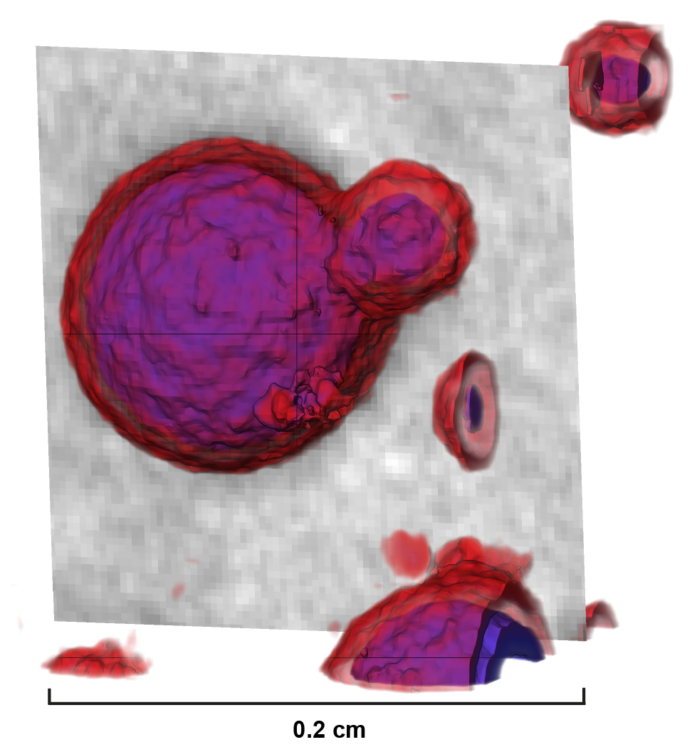
Supplementary Figure 2. Close-up 2-D orthoslice and 3-D volume rendering of our minerogenic synthetic core spiked with glass of intermediate composition (see section 3.2.3 and Fig. 5). The color gradient highlights the blended CT grayscale range along the transition between air-filled pores (~0.001 g/cm³, in blue) and silty clay (~2.65 g/cm³, in red).
1.1 Porosity extraction
The porosity extraction approach that we applied for this study (also see section 3.2.3 of the main manuscript) consists of multiple steps in version 9.1.1 of the Avizo software (see Suppl. Fig. 3). First step is the iterative identification of the CT grayscale range of the transition between pores and sediment. Next, we employed the closing tool (precise, ball type, size 8 px) to identify spheres (possible pores) as separate objects. To avoid misidentification of fuzzier smaller objects, we subsequently used the grayscale reconstruction tool by attaching the raw 3-D volume rendering as an input image (Input A) and the aforementioned closing tool results as a marker image – Input B (Suppl. Fig. 3). To highlight the differences between raw and processed data, we then subtracted Input B from Input A with the Arithmetic module. Next, the Auto Thresholding module was used to separate voxels into two classes (in this case, pores and non-pores). Finally, boundaries were smoothed with the dilation module (using the same size applied for closing – 8 px). The above steps visualize porosity: to remove it from scans while highlighting glass shards, the raw data should be transformed into a binary file that distinguishes tephra from non-tephra using the Interactive Thresholding module. Identified porosity of a similar CT density as tephra can then be extracted using the Arithmetic module (Arithmetic 2 in Suppl. Fig. 3) – subtracting pores identified with the dilation module (see above) from the Interactive Thresholding results. Fig. 5B shows the impact of the outlined method on glass shard visualization (porosity is extracted from CT imagery on the right).
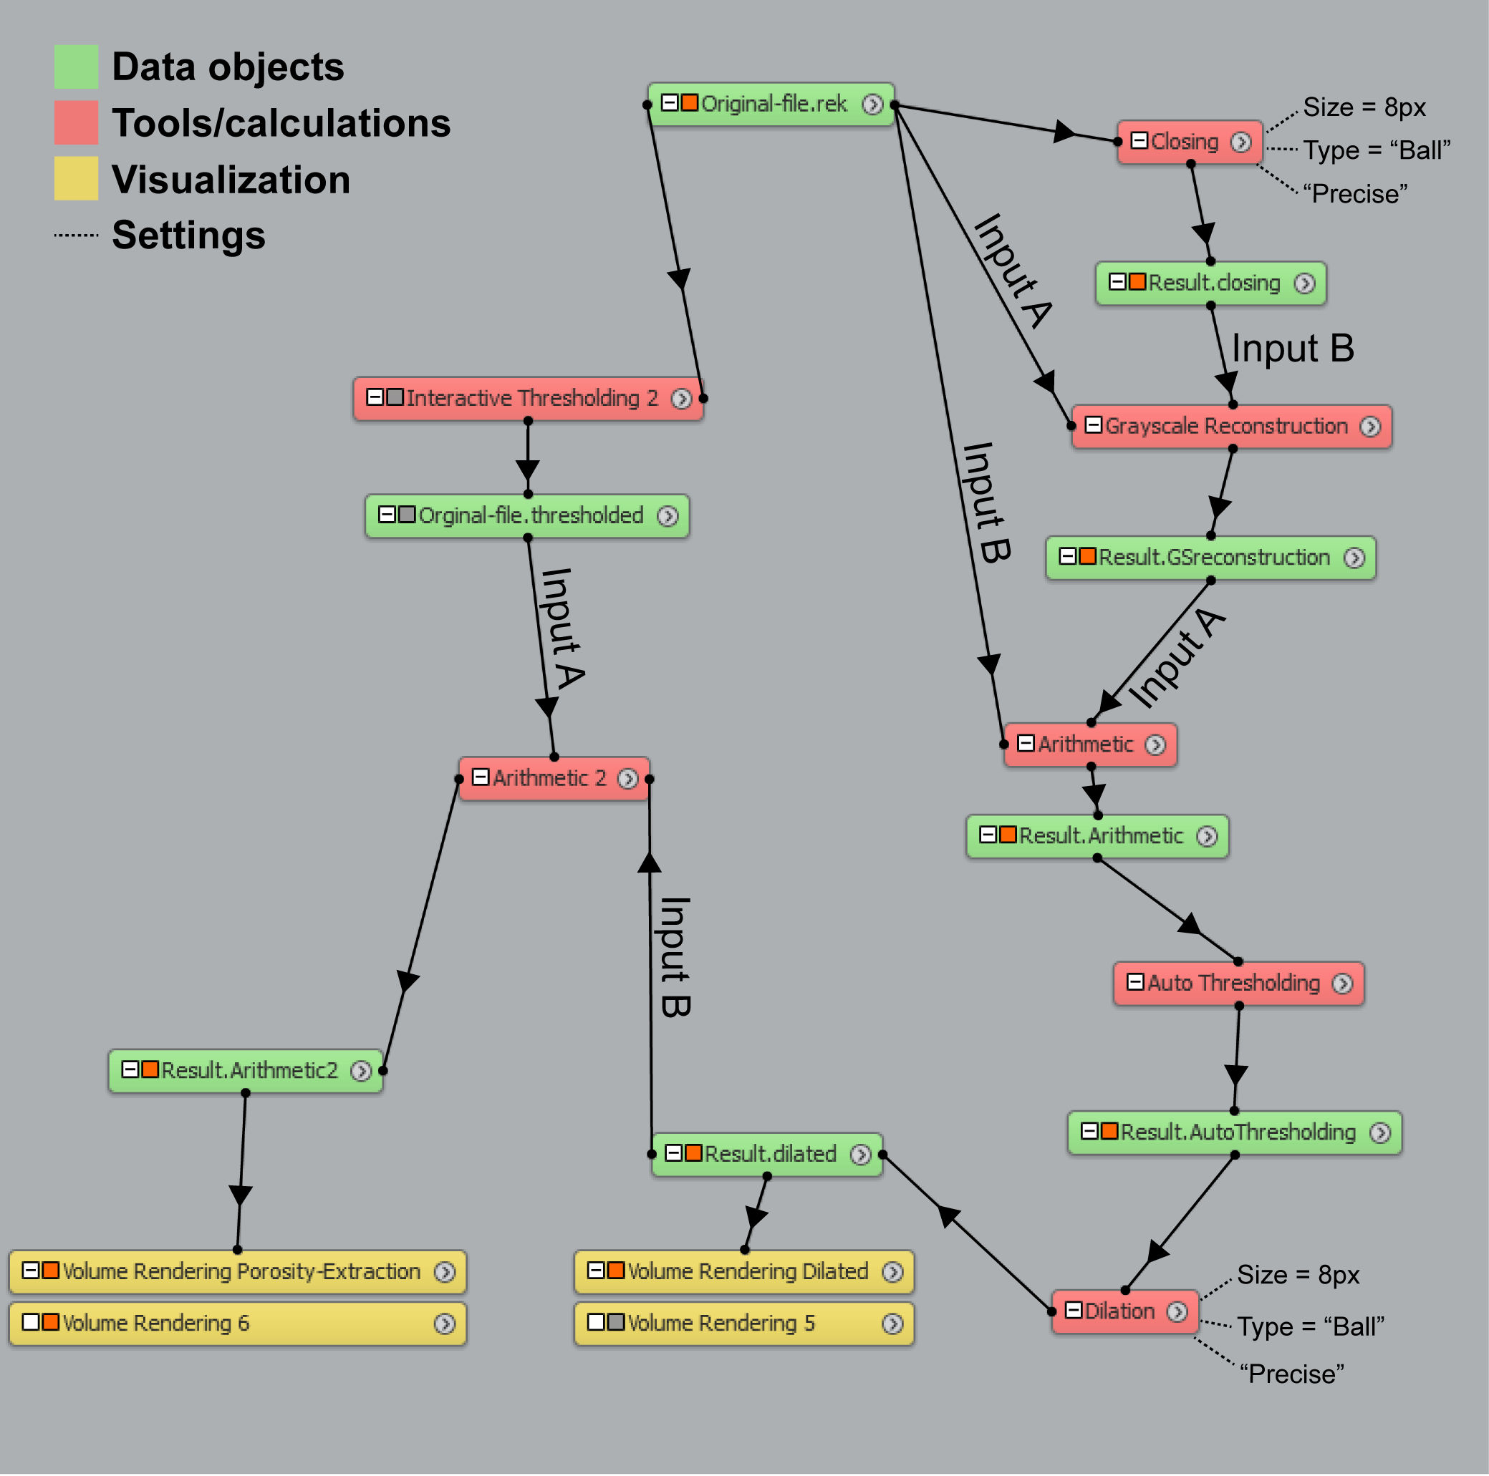
Supplementary Figure 3. The applied and described porosity extraction method, as seen in the project view of version 9.1.1 of the Avizo software. See Figs. 5A and 5B for before-after results.
Supplementary Figure 4. Inter-connected 2-D CT orthoslices and 3-D representations of glass of intermediate composition in the synthetic minerogenic cores scanned for this study. The histograms show the grayscale value distribution of each scan in grey, while highlighting the range of partial-volume affected glass in red and pure glass in green. (A) visualizations based on unprocessed data. (B) visualization following the extraction of porosity as outlined in paragraph 1.1 above. (C) visualization following the application of the Sobel edge detection filter (see section 3.2.3 in the main text). The position of each added glass concentration is highlighted with a red dash (and letter; see Fig. 1).
1.2 Grain size analysis
As outlined in 3.2.3, we used grain size analysis to assess the possibility that heavier and larger basaltic shards in our minerogenic core sank through the fine silty clay that top each layer of gravity-settled host sediment (see section 2.13). To do so, we took out slices of sediment at 0.1 cm intervals along a 0.4 cm transect across horizon b (see Fig. 5). The extracted 5 samples were then measured in triplicate on a Mastersizer 3000 with a Hydro SV sampler. To disperse particles, we added a few drops of aqueous 5 % Na₂CO₃ and applied 40 s. of ultrasonic treatment.
Supplementary Figure 5. Mean grain size data plotted alongside 2-D orthoslice and 3-D volume rendering data from the analyzed depth interval (horizon b in Fig. 5). Basaltic glass (in red), originally dispersed ~1.1 cm depth, has sunk through the fine-grained silts ~1.2 cm depth that settled on top of the underlying density-settled (see section 2.1.3) host sediment.

