Supplemental Materials
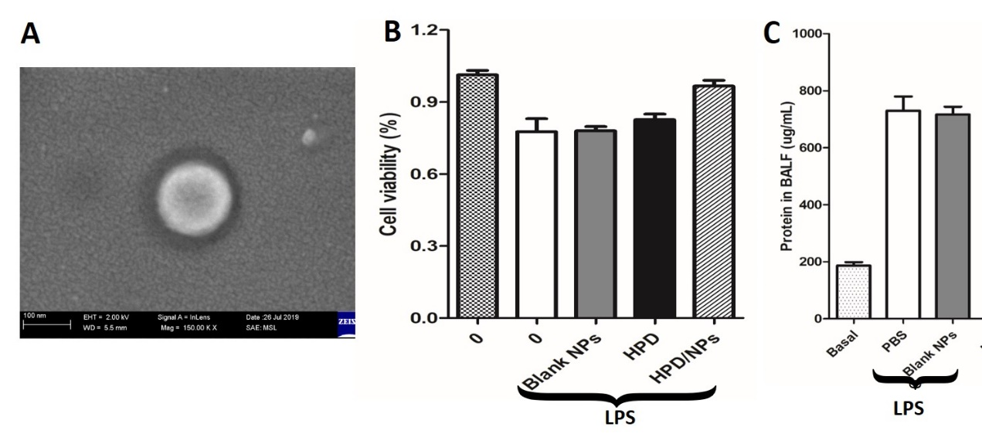
Figure S1: Impact of HPD/NPs on inflammatory response in vitro and in vivo. (A) Scanning electron microscopy (SEM) image of a free NP in suspension. (B) Viability of RAW264.7 macrophages exposed to 10mg/ml blank NPs, free HPD, or HPD/NPs for 3h, followed by stimulation with 1 µg/mL of LPS for 24h. (C) Impact of blank NPs on BALF protein in LPS-treated mice. At 3 hours post-LPS, PBS (vehicle) or blank NPs were nasally administered to mice. BALF was collected at 24h post-LPS challenge (n=4/group).

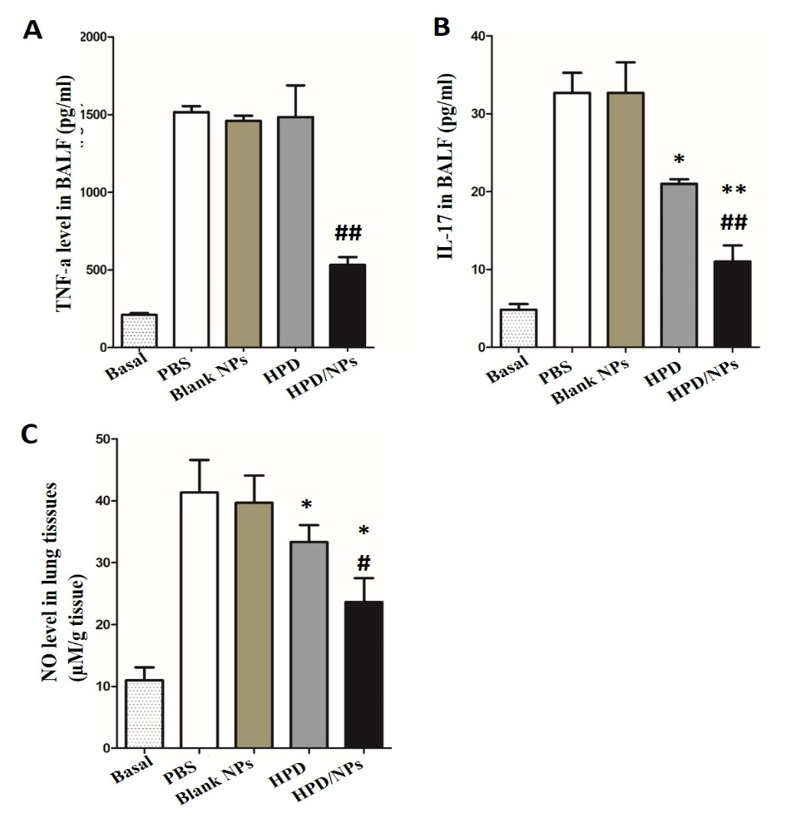
Figure S2: Impact of HPD on LPS-induced inflammation in mice. At 3 hours post-LPS, PBS (vehicle), free NPs, free HPD, or HPD/NPs were nasally administered to mice. Lung tissues were collected at 24h post-LPS challenge. (A) Expression levels of TNF-α and (B) IL-17 in BALF at 24h post-LPS challenge. (C) NO level in lung tissues. N=4/group; *P<0.05 and **P<0.01 versus PBS (vehicle); #P<0.05 and ##P<0.01 versus HPD.

