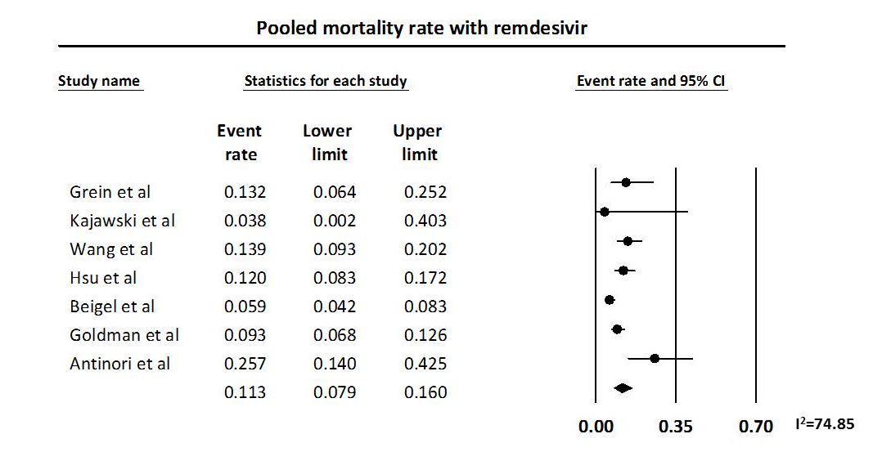
Figure S1A: Pooled mortality with remdesivir

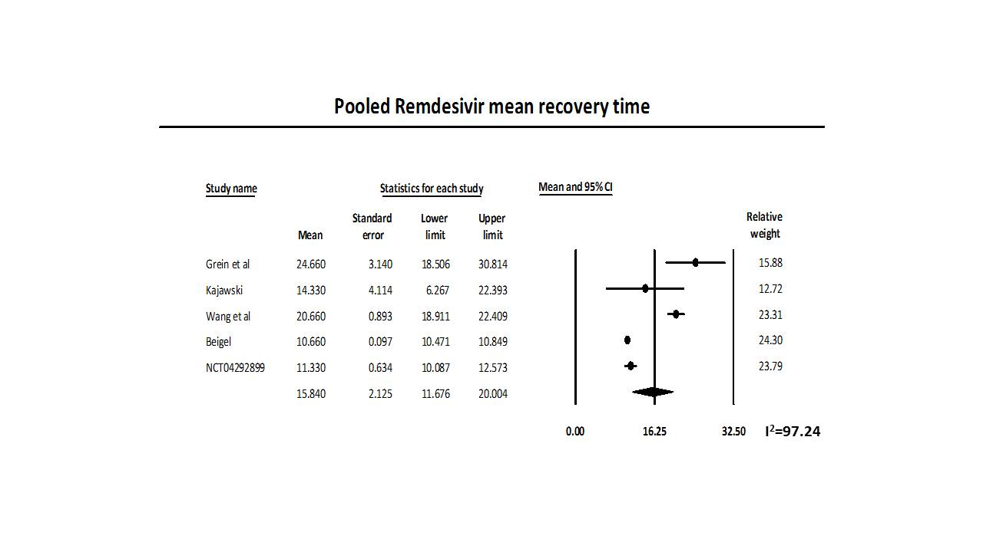
Figure S1B: Pooled Mean Recovery time with remdesivir

Figure S1C: Pooled adverse event rate with remdesivir
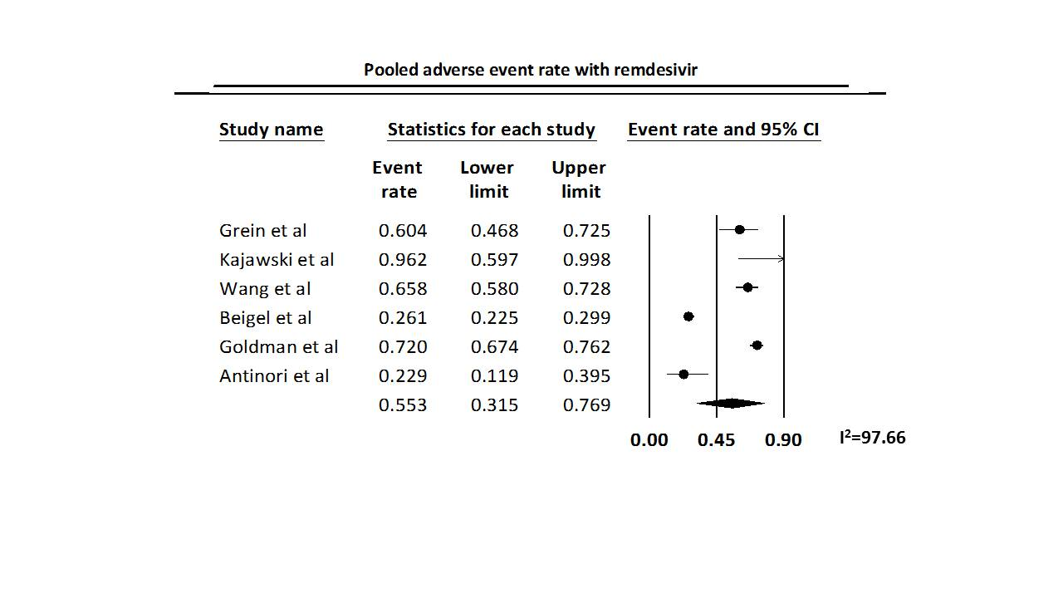
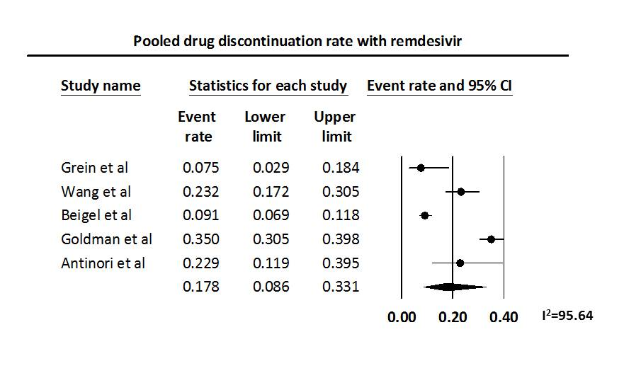
Figure S1D: Pooled Drug discontinuation rate with remdesivir

