Development and application of a water temperature related physiologically based pharmacokinetic model for enrofloxacin and its metabolite ciprofloxacin in rainbow trout

Fan Yang^{1,2*}, Fang Yang¹, Dan Wang³, Chao-Shuo Zhang¹, Han Wang¹, Zhe-Wen Song¹, Hao-Tian Shao¹, Mei Zhang¹, Meng-Li Yu¹, Yang Zheng¹

¹ College of Animal Science and Technology, Henan University of Science and Technology, Luoyang 471023, China
² Environmental and Animal Products Safety Laboratory of Key Discipline in University of Henan Province, Henan University of Science and Technology, Luoyang 471023, China
³ Jiaozuo Livestock Product Quality and Safety Monitoring Center, Jiaozuo 454003, China

Supplementary Materials

1 PBPK model code written in acslXtreme software 3
2 M-type code file used to calculate the withdrawal intervals 9
3 Supplementary Tables 10
Table S1. The distribution information of those influential parameters subjected to Monte Carlo analysis 10
Table S2. Normalized sensitivity coefficients of all 48 parameters for the sensitivity analysis about the influence of model parameters on the AUCs of enrofloxacin (ENR) 11
Table S3. Normalized sensitivity coefficients of all 48 parameters for the sensitivity analysis about the influence of model parameters on the AUCs of ciprofloxacin (CIP) 12
4 Supplementary Figures 14
Figure S1. Predicted ENR concentrations (μg/ml or μg/g) after a single oral dose of ENR at 10 mg/kg BW in rainbow trout reared at 5 °C based on the Monte Carlo analysis with 500 iterations: a plasma, b serum, c liver, d kidney, e muscle, f skin 14
Figure S2. Predicted CIP concentrations (μg/ml or μg/g) after a single oral dose of ENR at 10 mg/kg BW in rainbow trout reared at 5 °C based on the Monte Carlo analysis with 500 iterations: a plasma, b serum, c liver, d muscle, e muscle, f skin 15
Figure S3. Predicted total concentrations (μg/ml or μg/g) of ENR and CIP after a single oral dose of ENR at 10 mg/kg BW in rainbow trout reared at 5 °C based on the Monte Carlo analysis with 500 iterations: a plasma, b serum, c liver, d kidney, e muscle, f skin 16
Note: The horizontal red straight line represents the MRL of ENR in the muscle (0.1 μg/g). 16
Figure S4. Predicted ENR concentrations (μg/ml or μg/g) after a single oral dose of ENR at 10 mg/kg BW in rainbow trout reared at 10 °C based on the Monte Carlo analysis with 500 iterations: a plasma, b serum, c liver, d kidney, e muscle, f skin 16
Figure S5. Predicted CIP concentrations (μg/ml or μg/g) after a single oral dose of ENR at 10 mg/kg BW in rainbow trout reared at 10 °C based on the Monte Carlo analysis with 500 iterations: a plasma, b serum, c liver, d kidney, e muscle, f skin 17
Figure S6. Predicted total concentrations (μg/ml or μg/g) of ENR and CIP after a single oral dose of ENR at 10 mg/kg BW in rainbow trout reared at 10 °C based on the Monte Carlo analysis with 500 iterations: a plasma, b serum, c liver, d kidney, e muscle, f skin 18
Figure S7. Predicted ENR concentrations (μg/ml or μg/g) after a single oral dose of ENR at 10 mg/kg BW in rainbow trout reared at 16 °C based on the Monte Carlo analysis with 500 iterations: a plasma, b serum, c liver, d kidney, e muscle, f skin 19
Figure S8. Predicted CIP concentrations (μg/ml or μg/g) after a single oral dose of ENR at 10 mg/kg BW in rainbow trout reared at 16 °C based on the Monte Carlo analysis with 500 iterations: a plasma, b serum, c liver, d kidney, e muscle, f skin 19
Figure S9. Predicted total concentrations (μg/ml or μg/g) of ENR and CIP after a single oral dose of ENR at 10 mg/kg BW in rainbow trout reared at 16 °C based on the Monte Carlo analysis with 500 iterations: a plasma, b serum, c liver, d kidney, e muscle, f skin 20
Figure S10. Predicted ENR concentrations (μg/ml or μg/g) after multiple oral doses of ENR at 20 mg/kg BW per day for 7 consecutive days in rainbow trout reared at 16 °C based on the Monte Carlo analysis with 500 iterations: a plasma, b serum, c liver, d kidney, e muscle, f skin 21
Figure S11. Predicted CIP concentrations (μg/ml or μg/g) after multiple oral doses of ENR at 20 mg/kg BW per day for 7 consecutive days in rainbow trout reared at 16 °C based on the Monte Carlo analysis with 500 iterations: a plasma, b serum, c liver, d kidney, e muscle, f skin 21
Figure S12. Predicted total concentrations (μg/ml or μg/g) of ENR and CIP after multiple oral doses of ENR at 20 mg/kg BW per day for 7 consecutive days in rainbow trout reared at 16 °C based on the Monte Carlo analysis with 500 iterations: a plasma, b serum, c liver, d kidney, e muscle, f skin 22
Figure S13. Predicted ENR concentrations (μg/ml or μg/g) after an immersion bath in water with ENR concentration at 20 ppm for 2.5 hours for rainbow trout reared at 16 °C based on the Monte Carlo analysis with 500 iterations: a plasma, b serum, c liver, d kidney, e muscle, f skin 23
Figure S14. Predicted CIP concentrations (μg/ml or μg/g) after an immersion bath in water with ENR concentration at 20 ppm for 2.5 hours for rainbow trout reared at 16 °C based on the Monte Carlo analysis with 500 iterations: a plasma, b serum, c liver, d kidney, e muscle, f skin 23
Figure S15. Predicted total concentrations (μg/ml or μg/g) of ENR and CIP after an immersion bath in water with ENR concentration at 20 ppm for 2.5 hours for rainbow trout reared at 16 °C based on the Monte Carlo analysis with 500 iterations: a plasma, b serum, c liver, d kidney, e muscle, f skin 24
Figure S16. Predicted ENR concentrations (μg/ml or μg/g) after an immersion bath in water with ENR concentration at 100 ppm for 0.5 hours for rainbow trout reared at 16 °C based on the Monte Carlo analysis with 500 iterations: a plasma, b serum, c liver, d kidney, e muscle, f skin 25
Figure S17. Predicted CIP concentrations (μg/ml or μg/g) after an immersion bath in water with ENR concentration at 100 ppm for 0.5 hours for rainbow trout reared at 16 °C based on the Monte Carlo analysis with 500 iterations: a plasma, b serum, c liver, d kidney, e muscle, f skin 25
Figure S18. Predicted total concentrations (μg/ml or μg/g) of ENR and CIP after an immersion bath in water with ENR concentration at 100 ppm for 0.5 hours for rainbow trout reared at 16 °C based on the Monte Carlo analysis with 500 iterations: a plasma, b serum, c liver, d kidney, e muscle, f skin 26
Figure S19. Distributions of withdrawal intervals in the muscle (a) and skin (b) after an immersion bath in water with ENR concentration of 20 ppm for 2.5 h based on the Monte Carlo analysis. Notes: the solid arrows indicated the 99th percentiles of the distribution at different water temperatures. 26
Figure S20. Distributions of withdrawal intervals in the muscle (a) and skin (b) after an immersion bath in water with ENR concentration of 10 ppm for 0.5 h based on the Monte Carlo analysis. Notes: the solid arrows indicated the 99th percentiles of the distribution at different water temperatures. 27
Supplementary References 27

1 PBPK model code written in acslXtreme software
PROGRAM
! This PBPK model was developed by Dr. Fan Yang in the summer of 2020.
INITIAL
!parameters of Cardiac output
constant Temp=5 ! water temperature, °C
CO=3.95*Temp-12.9 ! Cardiac output, ml/min/kg; (1) References, the same below
Qtot=CO/1000*60*bw ! translate the CO unit from ml/min/kg to L/h
!body weight
constant bw=0.05 ! kg, equal to L
!parameters of tissue weight (fraction of BW) and blood flow (fraction of CO)
constant Vcgi=0.039, Qcgi=1 ! gill, (2)
constant Vck=0.00841,Qck=0.056 ! kidney, (3)
constant Vcm=0.66,Qcm=0.6 ! muscle, (3)
constant Vcs=0.1, Qcs=0.053 ! skin, (2)
constant Vcg=0.0852, Qcg=0.1539 ! gut, (2)
constant Vcl=0.0126, Qcl=0.029 ! liver, (3)
constant Vcvb=0.059 ! Venous blood, (4)
constant Vcab=0.015 ! Arterial blood, (4)
Vcr=1-(Vcgi+Vck+Vcm+Vcs+Vcg+Vcl+Vcvb+Vcab) ! the rest body, fraction of BW
Qcr=1-(Qck+Qcm+Qcs+Qcl+Qcg) ! the rest body, fraction of CO
constant pcv=0.304 ! Hematocrit, (1)
constant pre=0.555 ! 1 minus serum ratio
! translate the units of parameter (V and Q) listed above from fraction to real value
! tissue weight
Vgi=bw*Vcgi Vk=bw*Vck Vm=bw*Vcm Vs=bw*Vcs Vg=bw*Vcg
Vl=bw*Vcl Vvb=bw*Vcvb Vab=bw*Vcab Vr=bw*Vcr Vmr=Vr+Vg
! change the weight (volume) of blood to that of plasma
Vvp=Vvb*(1-pcv) Vap=Vab*(1-pcv)
! change the weight (volume) of blood to that of serum
Vvs=Vvb*(1-pre) Vas=Vab*(1-pre)
! blood flow
Qk=Qck*Qtot Qm=Qtot*Qcm Qs=Qtot*Qcs
Qg=Qcg*Qtot Ql=Qtot*Qcl Qr=Qtot*Qcr

! parameters for enrofloxacin (ENR)
! partition coefficient
constant Pgi=3.46,Pl=4.9,Pk=11.53,Pm=2.83,Ps=7.38,Pg=4.88,Pr=0.13
! These partition coefficients were calculated according to the area method (5) based on the enrofloxacin concentrations in plasma and tissues (including muscle, skin, gut, kidney, and liver) derived from a previous report (6). Three dosage regimens were applied in that study, including one oral dosing and two immersion baths with different drug concentrations. Therefore, we calculated the partition coefficient for enrofloxacin based on the average AUC values.
! Pr and Pgi were obtained by optimization.

! parameters for ciprofloxacin
! partition coefficient
constant Pmgi=2.45,Pml=3.67,Pmk=8.2,Pmm=1.6,Pms=0.718,Pmg=3.39,Pmr=0.15
! Partition coefficients for ciprofloxacin in the tissues of muscle, skin, gut, liver, and kidney in rainbow trout were assumed to be equal to those previously reported in humans (7). Those in the other compartments (gill and the rest of body) were optimized using a maximum likelihood algorithm of Nelder-Mead based on the concentrations of ciprofloxacin in serum, muscle, and liver, derived from a previous report (8).

! oral absorpation
constant Kst=0.175, KaPO=0.052 ! optimization
! Kst (1/h) is the rate constant of gastric emptying, and KaPO (1/h) is the absorption rate constant.
constant F=0.6613 ! Oral bioavailability; (9)

! IB absorption
constant KaIB=1.103 ! 1/h

! elimination for enrofloxacin
! elimination from gut
constant Kguc=0.605 ! optimization
! Kguc (1/h) is the elimination rate constant with feces for the unabsorbed enrofloxacin.
! elimination from metabolism
constant Kf=0.0725 ! optimization; Kf (1/h) is the metabolism rate constant from enrofloxacin to ciprofloxacin.
! elimination from Renal excretion
constant Clreperkg=0.058 ! L/kg/h; renal clearance for enrofloxacin; optimization
Clre=Clreperkg*bw
! elimination from exchange between gill and water body
constant Kgw=0.061 ! 1/h
! drug degradation in water
constant Kde=12003.31 ! 1/h

! elimination for ciprofloxacin
constant Clmreperkg=116.14 ! L/kg/h; renal clearance for ciprofloxacin; optimization
Clmre=Clmreperkg*bw

! molecular weight of enrofloxacin and ciprofloxacin
constant MWENR=359.4, MWCIP=331.347 ! g/mol
! dose
constant perdoseiv=10, perdosepo=10 ! mg/kg bw
constant perdoseib=10 ! ppm in water for 2.5 h exposure, equal to mg/kg or mg/L; (6)
constant Vwater=40 ! L
doseib=perdoseib*Vwater !! enrofloxacin IBly given, mg
doseiv=perdoseiv*bw !! enrofloxacin IVly given, mg
dosepo=perdosepo*bw !! enrofloxacin POly given, mg

END ! INITIAL

DYNAMIC

ALGORITHM IALG = 2
NSTEPS NSTP = 10
MAXTERVAL MAXT = 1.0e9
MINTERVAL MINT = 1.0e-9
CINTERVAL CINT = 0.1

DERIVATIVE
!!!!!!!!!!!!!! code for enrofloxacin is listed below
!! multiple doses code
CONSTANT timepo=0.001 ! Length of oral gavage exposure (h)
constant timeiv=0.001 ! Length of IV exposure (h)
constant timeib=1 ! Length of immersion bath exposure (h); 0.5 h for 100 ppm IB; (6)
CONSTANT tinterval = 24 ! Varied dependent on the exposure (h)
CONSTANT Dstart = 0 ! Initiation day of the first dose (day)
CONSTANT Dstop = 1 ! Termination day of the last dose (day)
Tsim = TSTOP ! Tstop in hours
DS = Dstart*24 ! Initiation time point of oral gavage (h)
Doff = (Dstop - Dstart)*24 !
ExposureIB = PULSE(DS, Tsim, Doff)*PULSE(0,tinterval,timeib) ! pulse function to simulate the IB dosing time
ExposurePO = PULSE(DS, Tsim, Doff)*PULSE(0,tinterval,timepo) ! pulse function to simulate the IB dosing time
ExposureIV = PULSE(DS, Tsim, Doff)*PULSE(0,tinterval,timeiv) ! pulse function to simulate the IB dosing time
!! multiple PO dosing
Rdosepo=dosepo/timepo*ExposurePO
poin=integ(Rdosepo,0)
!! multiple IV dosing
Rdoseiv=doseiv/timeiv*ExposureIV
ivin=integ(Rdoseiv,0)
!! multiply IB dosing
Rdoseib=doseib/timeib*ExposureIB
ibin=integ(Rdoseib,0)

MASSIN=poin+ivin+ibin

!!!!!!!!!!!!!!!!!!!
! code for simulating the drug exchange between water and fish (gill)
raw=-KaIB*aw+Kgw*agi+Reli1+Reli3+Rdoseib-Rade ! mg/h
Rade=Kde*aw !mg/h
aw=integ(raw,0) !mg
Cwater=aw/Vwater !mg/L, equal to ug/ml
aucwa=integ(Cwater,0) !mg*h/L
MASSOUT=integ(Rade,0)+outbio

!!!!!!!!!!!!!!!!!!!
! code for simulating the enrofloxacin in the fish body
! gill
ragi=Qtot*(Cvb-Cgi/Pgi)-Kgw*agi !mg/h
agi=integ(ragi,0) !mg
Cgi=agi/Vgi !mg/L, equal to ug/ml
aucgi=integ(Cgi,0) !ug*h/ml; AUC

! Stomach contents
rastc=Rdosepo-Kst*astc !mg/h
astc=integ(rastc,0) !mg

! Intestinal contents
raic=Kst*astc-F*KaPO*aic-Reli1 !mg/h
Reli1=Kguc*aic*(1-F) !mg/h
aic=integ(raic,0) !mg

! gut
rag=Qg*(Cab-Cg/Pg) !mg/h
ag=integ(rag,0) !mg
Cg=ag/Vg !mg/L
aucgu=integ(Cg,0) !ug*h/ml; AUC

! liver
ral=F*KaPO*aic+Ql*Cab+Qg*Cg/Pg-(Ql+Qg)*Cl/Pl-Reli2 !mg/h
Reli2=Kf*al !mg/h
al=integ(ral,0) !mg
Cl=al/Vl !mg/L
outbio=integ(Reli2,0) !mg
aucli=integ(Cl,0) !ug*h/ml; AUC

! kidney
rak=Qk*(Cab-Ck/Pk)-Reli3 !mg/h
ak=integ(rak,0) !mg
Ck=ak/Vk !mg/L
aucki=integ(Ck,0) !ug*h/ml; AUC
Reli3=Clre*Ck/Pk !mg/h
out3=integ(Reli3,0) !mg

! muscle
ram=Qm*(Cab-Cm/Pm) !mg/h
am=integ(ram,0) !mg
Cm=am/Vm !mg/L
aucmu=integ(Cm,0) !ug*h/ml; AUC

! skin
ras=Qs*(Cab-Cs/Ps) !mg/h
as=integ(ras,0) !mg
Cs=as/Vs !mg/L
aucsk=integ(Cs,0) !ug*h/ml; AUC

! rest
rar=Qr*(Cab-Cr/Pr) !mg/h
ar=integ(rar,0) !mg
Cr=ar/Vr !mg/L
aucre=integ(Cr,0) !ug*h/ml; AUC

! Venous blood
ravb=Rdoseiv+KaIB*aw+Qr*Cr/Pr+Qs*Cs/Ps+Qm*Cm/Pm+Qk*Ck/Pk+(Ql+Qg)*Cl/Pl-Qtot*Cvb !mg/h
avb=integ(ravb,0) !mg
Cvb=avb/Vvb !mg/L
Cvp=avb/Vvp !mg/L
Cvs=avb/Vvs !mg/L
aucvb=integ(Cvb,0) !ug*h/ml; AUC
aucvp=integ(Cvp,0) !ug*h/ml; AUC
aucvs=integ(Cvs,0) !ug*h/ml; AUC

! Arterial blood
raab=Qtot*(Cgi/Pgi-Cab) !mg/h
aab=integ(raab,0) !mg
Cab=aab/Vab !mg/L
Cap=aab/Vap !mg/L
Cas=aab/Vas !mg/L

!!!!!!!!!!!!!!!!!!! check the mass balance for enrofloxacin
MBenr=MASSIN-MASSOUT-(aw+aab+avb+agi+ar+ag+as+am+ak+al+aic+astc) ! As time increases, the value should eventually approach zero.

!!!!!!!!!!!!!!!!!!!!!!!!!!!!!!!!!!!!!!!!!!!!!!!!!!!!!!!!!!!!!!!!!!!!!!!!!!!!!!!
! code for ciprofloxacin is listed below
! biotransform enrflocaxin to ciprofloxacin
Rbiotrans=Kf*al/MWENR*MWCIP !mg/L
! liver
raml=Rbiotrans+(Ql+Qg)*(Cmab-Cml/Pml) !mg/h
aml=integ(raml,0) !mg
Cml=aml/Vl !mg/L
aucMli=integ(Cml,0) ! AUC for CIP in the liver

MASSMin=integ(Rbiotrans,0)

! KIDNEY
ramk=Qk*(Cmab-Cmk/Pmk)-relim !mg/h
relim=Clmre*Cmk/Pmk !mg/h
amk=integ(ramk,0) !mg
Cmk=amk/Vk !mg/L
mout=integ(relim,0) !mmol
aucMki=integ(Cmk,0) ! AUC for CIP in the kidney

MASSMout=mout

! muscle
ramm=Qm*(Cmab-Cmm/Pmm) !mg/h
amm=integ(ramm,0) !mg
Cmm=amm/Vm !mg/L
aucMmu=integ(Cmm,0) ! AUC for CIP in the muscle

! skin
rams=Qs*(Cmab-Cms/Pms) !mg/h
ams=integ(rams,0) !mg
Cms=ams/Vs !mg/L
aucMsk=integ(Cms,0) ! AUC for CIP in the skin

! rest
ramr=Qr*(Cmab-Cmr/Pmr) !mg/h
amr=integ(ramr,0) !mg
Cmr=amr/Vmr !mg/L
aucMre=integ(Cmr,0) ! AUC for CIP in the rest compartment

! gill
ramgi=Qtot*(Cmvb-Cmgi/Pmgi) !mg/h
amgi=integ(ramgi,0) !mg
Cmgi=amgi/Vgi !mg/L
aucMgi=integ(Cmgi,0) ! AUC for CIP in the gills

! Venous blood
ramvb=Qr*Cmr/Pmr+Qs*Cms/Pms+Qm*Cmm/Pmm+Qk*Cmk/Pmk+(Ql+Qg)*Cml/Pml-Qtot*Cmvb !mg/h
amvb=integ(ramvb,0) !mg
Cmvb=amvb/Vvb !mg/L
Cmvp=amvb/Vvp !mg/L
Cmvs=amvb/Vvs !mg/L
aucMvp=integ(Cmvp,0) !AUC for CIP in the venous plasma
aucMvs=integ(Cmvs,0) !AUC for CIP in the venous serum

! Arterial blood
ramab=Qtot*(Cmgi/Pmgi-Cmab) !mg/h
amab=integ(ramab,0) !mg
Cmab=amab/Vab !mg/L
Cmap=amab/Vap !mg/L
Cmas=amab/Vas !mg/L
aucMap=integ(Cmap,0) !AUC for CIP in the arterial plasma
aucMas=integ(Cmas,0) !AUC for CIP in the arterial serum

!!!!!!!!!!!!!!!!!!! check the mass balance for ciprofloxacin
MBcip=MASSMin-MASSMout-(amab+amvb+amgi+amr+ams+amm+amk+aml) ! As time increases, the value should eventually approach zero.

END ! DERIVATIVE

CONSTANT TSTOP =100

! CHECK P
ppki=aucki/aucvb
ppmu=aucmu/aucvb
ppsk=aucsk/aucvb
ppgu=aucgu/aucvb
ppgi=aucgi/aucvb
ppre=aucre/aucvb

TERMT (T .GE. TSTOP, 'checked on communication interval: REACHED TSTOP')
END ! DYNAMIC
END ! PROGRAM

2 M-type code file used to calculate the withdrawal intervals
MRLmu=0.1; % ug/g, EMA 2002
MRLsk=0.1; % ug/g, EMA 2002

maxt=max(_t);
time=[0:4:maxt];
time=flipud(time);
nn=length(time);
one=ones(1,nn);

mu=one*MRLmu;
sk=one*MRLsk;
mu=flipud(mu);
sk=flipud(sk);

plot(time,mu,_t,__ctotalmu_th__);
plot(time,sk,_t,__ctotalsk_th__);

ta=flipud(_t);
cmutoa=flipud(__ctotalmu_th__);
csktoa=flipud(__ctotalsk_th__);

for b=1:numIts;
muCH=find(cmutoa(:,b)>MRLmu);
if isempty (muCH)
wtmuCH(b)=0;
else
firmu=muCH(1)-1;
wtmuCH(b)=ta(firmu);
end

skCH=find(csktoa(:,b)>MRLsk);
if isempty (skCH)
wtskCH(b)=0;
else
firsk=skCH(1)-1;
wtskCH(b)=ta(firsk);
end
end

plot(wtmuCH);
plot(wtskCH);

3 Supplementary Tables

Table S1. The distribution information of those influential parameters subjected to Monte Carlo analysis
Parameters | unit | Average value | SD | Min | Max | Reference
Q_{ck} | unitless | 0.056 | 0.0056 | 0.0504 | 0.0616 | (3)
V_{cm} | unitless | 0.66 | 0.066 | 0.594 | 0.726 | (3)
V_{cl} | unitless | 0.029 | 0.0029 | 0.0261 | 0.0319 | (3)
P_{l} | unitless | 4.9 | 0.49 | 4.41 | 5.39 | (8)
P_{m} | unitless | 2.83 | 0.283 | 2.547 | 3.113 | (8)
P_{mm} | unitless | 1.6 | 0.16 | 1.44 | 1.76 | (7)
F | % | 66.13 | 6.613 | 59.517 | 72.743 | (9)
K_{f} | h⁻¹ | 0.0725 | 0.02 | 0.0525 | 0.0925 | Optimization
Note: The water temperature was also an influential parameter. However, multiple different water temperatures were used in the previous studies (6, 8-11); therefore, although unlisted in this table, the water temperature was also subjected to the Monte Carlo analysis. Its distribution was based on the previous studies (6, 8-11) and had a mean value, a standard deviation (SD), a lower bound (Mean - SD), and an upper bound (Mean + SD).

Table S2. Normalized sensitivity coefficients of all 48 parameters for the sensitivity analysis about the influence of model parameters on the AUCs of enrofloxacin (ENR)
Model parameters ª | AUC_{plasma} | AUC_{serum} | AUC_{muscle} | AUC_{kidney} | AUC_{liver} | AUC_{skin} | AUC_{gut}
Blood flow (Q_{cx})
Q_{cgi} | 0.00E+00 | 0.00E+00 | 0.00E+00 | 0.00E+00 | 0.00E+00 | 0.00E+00 | 0.00E+00
Q_{ck} | -1.81E-01 | -1.81E-01 | -1.72E-01 | 5.39E-01 | -1.61E-01 | -1.53E-01 | -1.73E-01
Q_{cm} | -1.38E-03 | -1.38E-03 | 4.57E-02 | -1.71E-03 | -2.78E-03 | -1.50E-02 | -3.07E-03
Q_{cs} | -2.61E-02 | -2.61E-02 | -3.05E-02 | -2.69E-02 | -2.76E-02 | 2.88E-01 | -2.99E-02
Q_{cg} | -1.96E-03 | -1.96E-03 | -2.37E-03 | -2.03E-03 | 1.41E-02 | -4.73E-03 | 3.92E-02
Q_{cl} | -3.33E-04 | -3.33E-04 | -3.43E-04 | -3.35E-04 | 2.39E-03 | -3.95E-04 | -3.42E-04
Tissue weight (V_{cx})
V_{cgi} | -1.26E-01 | -1.26E-01 | -1.43E-01 | -1.47E-01 | -1.33E-01 | -1.32E-01 | -1.43E-01
V_{ck} | -1.18E-03 | -1.18E-03 | -1.24E-03 | -7.86E-03 | -1.14E-03 | -1.38E-03 | -1.23E-03
V_{cm} | -3.11E-01 | -3.11E-01 | -3.72E-01 | -3.13E-01 | -2.97E-01 | -3.43E-01 | -3.21E-01
V_{cs} | -8.85E-02 | -8.85E-02 | -8.57E-02 | -8.81E-02 | -7.98E-02 | -4.04E-01 | -8.61E-02
V_{cg} | -6.67E-02 | -6.67E-02 | -6.92E-02 | -6.72E-02 | -9.63E-02 | -7.41E-02 | -1.10E-01
V_{cl} | -7.13E-02 | -7.13E-02 | -6.86E-02 | -7.07E-02 | -1.24E-01 | -6.25E-02 | -6.89E-02
V_{cvb} | -9.20E-03 | -9.20E-03 | -9.65E-03 | -9.29E-03 | -8.87E-03 | -1.09E-02 | -9.59E-03
V_{cab} | -2.14E-03 | -2.14E-03 | -2.45E-03 | -2.36E-03 | -2.25E-03 | -2.78E-03 | -2.44E-03
Partition coefficient for ENR (P_{x})
P_{gi} | -1.27E-01 | -1.27E-01 | -1.44E-01 | -1.48E-01 | -1.34E-01 | -1.33E-01 | -1.44E-01
P_{l} | -7.16E-02 | -7.16E-02 | -6.89E-02 | -7.10E-02 | 8.76E-01 | -6.28E-02 | -6.92E-02
P_{k} | -1.37E-03 | -1.37E-03 | -1.44E-03 | 9.92E-01 | -1.32E-03 | -1.61E-03 | -1.43E-03
P_{m} | -3.26E-01 | -3.26E-01 | 6.13E-01 | -3.29E-01 | -3.11E-01 | -3.61E-01 | -3.37E-01
P_{s} | -9.08E-02 | -9.08E-02 | -8.81E-02 | -9.04E-02 | -8.20E-02 | 5.94E-01 | -8.85E-02
P_{g} | -6.86E-02 | -6.86E-02 | -7.13E-02 | -6.92E-02 | -9.82E-02 | -7.64E-02 | 8.87E-01
P_{r} | -4.74E-04 | -4.74E-04 | -4.97E-04 | -4.78E-04 | -4.56E-04 | -5.61E-04 | -4.94E-04
Partition coefficient for CIP (P_{mx})
P_{mgi} | 0.00E+00 | 0.00E+00 | 0.00E+00 | 0.00E+00 | 0.00E+00 | 0.00E+00 | 0.00E+00
P_{ml} | 0.00E+00 | 0.00E+00 | 0.00E+00 | 0.00E+00 | 0.00E+00 | 0.00E+00 | 0.00E+00
P_{mk} | 0.00E+00 | 0.00E+00 | 0.00E+00 | 0.00E+00 | 0.00E+00 | 0.00E+00 | 0.00E+00
P_{mm} | 0.00E+00 | 0.00E+00 | 0.00E+00 | 0.00E+00 | 0.00E+00 | 0.00E+00 | 0.00E+00
P_{ms} | 0.00E+00 | 0.00E+00 | 0.00E+00 | 0.00E+00 | 0.00E+00 | 0.00E+00 | 0.00E+00
P_{mg} | 0.00E+00 | 0.00E+00 | 0.00E+00 | 0.00E+00 | 0.00E+00 | 0.00E+00 | 0.00E+00
P_{mr} | 0.00E+00 | 0.00E+00 | 0.00E+00 | 0.00E+00 | 0.00E+00 | 0.00E+00 | 0.00E+00
Parameters related to drug absorption
K_{st} | 3.94E-03 | 3.94E-03 | 4.44E-03 | 4.03E-03 | 4.03E-03 | 6.42E-03 | 4.37E-03
K_{aPO} | 9.13E-02 | 9.13E-02 | 9.07E-02 | 9.12E-02 | 1.47E-01 | 8.81E-02 | 9.08E-02
F | 2.64E-01 | 2.64E-01 | 2.61E-01 | 2.63E-01 | 4.29E-01 | 2.51E-01 | 2.62E-01
K_{aIB} | 6.12E-02 | 6.12E-02 | 6.12E-02 | 6.12E-02 | 5.67E-02 | 6.13E-02 | 6.12E-02
Parameters related to drug elimination
K_{guc} | -8.84E-02 | -8.84E-02 | -8.75E-02 | -8.83E-02 | -1.44E-01 | -8.34E-02 | -8.76E-02
K_{f} | -6.14E-02 | -6.14E-02 | -5.82E-02 | -6.08E-02 | -1.10E-01 | -5.09E-02 | -5.86E-02
Cl_{reperkg} | -6.90E-02 | -6.90E-02 | -6.55E-02 | -7.79E-01 | -6.11E-02 | -5.74E-02 | -6.59E-02
K_{gw} | -1.05E-01 | -1.05E-01 | -1.19E-01 | -1.24E-01 | -1.11E-01 | -1.05E-01 | -1.20E-01
K_{de} | -6.22E-02 | -6.22E-02 | -6.22E-02 | -6.22E-02 | -5.77E-02 | -6.24E-02 | -6.22E-02
Cl_{mreperkg} | 0.00E+00 | 0.00E+00 | 0.00E+00 | 0.00E+00 | 0.00E+00 | 0.00E+00 | 0.00E+00
The other parameters
Temp | -6.68E-01 | -6.68E-01 | -4.60E-01 | 1.46E+00 | -5.03E-01 | 3.31E-01 | -4.82E-01
bw | -7.92E-02 | -7.92E-02 | -7.93E-02 | -7.92E-02 | -7.48E-02 | -7.94E-02 | -7.93E-02
pcv | 4.37E-01 | 0.00E+00 | 0.00E+00 | 0.00E+00 | 0.00E+00 | 0.00E+00 | 0.00E+00
pre | -2.33E-11 | 1.25E+00 | -2.49E-11 | -2.30E-11 | -2.32E-11 | -3.65E-11 | -2.70E-11
MWENR | 0.00E+00 | 0.00E+00 | 0.00E+00 | 0.00E+00 | 0.00E+00 | 0.00E+00 | 0.00E+00
MWCIP | 0.00E+00 | 0.00E+00 | 0.00E+00 | 0.00E+00 | 0.00E+00 | 0.00E+00 | 0.00E+00
perdoseiv | 4.40E+00 | 4.40E+00 | 4.40E+00 | 4.40E+00 | 4.36E+00 | 4.40E+00 | 4.40E+00
perdoseib | 3.85E+00 | 3.85E+00 | 3.85E+00 | 3.85E+00 | 3.86E+00 | 3.85E+00 | 3.85E+00
perdosepo | 3.67E+00 | 3.67E+00 | 3.67E+00 | 3.67E+00 | 3.76E+00 | 3.67E+00 | 3.67E+00
Vwater | 1.43E+01 | 1.43E+01 | 1.43E+01 | 1.43E+01 | 1.44E+01 | 1.43E+01 | 1.43E+01
Note: ª All parameters listed here can be found in the model code written in acslXtreme software.
All parameters whose values are marked in red are the influential ones.

Table S3. Normalized sensitivity coefficients of all 48 parameters for the sensitivity analysis about the influence of model parameters on the AUCs of ciprofloxacin (CIP)
Model parameters ª | AUC_{plasma} | AUC_{serum} | AUC_{muscle} | AUC_{kidney} | AUC_{liver} | AUC_{skin}
Blood flow (Q_{cx})
Q_{cgi} | 0.00E+00 | 0.00E+00 | 0.00E+00 | 0.00E+00 | 0.00E+00 | 0.00E+00
Q_{ck} | -6.20E-01 | -6.20E-01 | -6.02E-01 | 3.81E-01 | -4.62E-01 | -6.06E-01
Q_{cm} | -3.19E-02 | -3.19E-02 | 1.53E-02 | -3.21E-02 | -2.26E-02 | -3.53E-02
Q_{cs} | -4.15E-02 | -4.15E-02 | -4.33E-02 | -4.16E-02 | -3.71E-02 | -3.84E-03
Q_{cg} | 2.45E-02 | 2.45E-02 | 2.55E-02 | 2.45E-02 | -2.60E-01 | 2.53E-02
Q_{cl} | 5.23E-03 | 5.23E-03 | 5.54E-03 | 5.25E-03 | -4.86E-02 | 5.47E-03
Tissue weight (V_{cx})
V_{cgi} | -1.46E-01 |  | -1.48E-01 | -1.49E-01 | -1.43E-01 | -1.48E-01
V_{ck} | -8.59E-04 | -1.46E-01 | -8.71E-04 | -8.66E-04 | -9.56E-04 | -8.68E-04
V_{cm} | -6.64E-01 | -8.59E-04 | -7.26E-01 | -6.64E-01 | -5.41E-01 | -6.72E-01
V_{cs} | -8.37E-02 | -6.64E-01 | -8.19E-02 | -8.35E-02 | -8.21E-02 | -1.21E-01
V_{cg} | -1.29E-01 | -8.37E-02 | -1.33E-01 | -1.29E-01 | -1.19E-01 | -1.33E-01
V_{cl} | 8.58E-01 | -1.29E-01 | 8.58E-01 | 8.58E-01 | 8.59E-01 | 8.58E-01
V_{cvb} | -2.97E-02 | 8.58E-01 | -3.06E-02 | -2.98E-02 | -2.28E-02 | -3.04E-02
V_{cab} | -7.16E-03 | -2.97E-02 | -7.78E-03 | -7.58E-03 | -5.79E-03 | -7.74E-03
Partition coefficient for ENR (P_{x})
P_{gi} | -1.16E-01 | -1.16E-01 | -1.13E-01 | -1.16E-01 | -1.21E-01 | -1.14E-01
P_{l} | 8.82E-01 | 8.82E-01 | 8.83E-01 | 8.82E-01 | 8.80E-01 | 8.82E-01
P_{k} | -1.56E-03 | -1.56E-03 | -1.59E-03 | -1.56E-03 | -1.48E-03 | -1.58E-03
P_{m} | -3.35E-01 | -3.35E-01 | -3.38E-01 | -3.35E-01 | -3.27E-01 | -3.37E-01
P_{s} | -6.55E-02 | -6.55E-02 | -6.33E-02 | -6.54E-02 | -7.08E-02 | -6.38E-02
P_{g} | -1.31E-01 | -1.31E-01 | -1.36E-01 | -1.32E-01 | -1.21E-01 | -1.35E-01
P_{r} | -5.46E-04 | -5.46E-04 | -5.58E-04 | -5.47E-04 | -5.18E-04 | -5.55E-04
Partition coefficient for CIP (P_{mx})
P_{mgi} | -3.38E-02 | -3.38E-02 | -3.75E-02 | -3.64E-02 | -2.42E-02 | -3.73E-02
P_{ml} | -2.44E-02 | -2.44E-02 | -2.54E-02 | -2.44E-02 | 9.78E-01 | -2.51E-02
P_{mk} | -1.01E-09 | -9.59E-10 | -1.05E-09 | 1.00E+00 | -7.03E-10 | -1.02E-09
P_{mm} | -3.84E-01 | -3.84E-01 | 5.55E-01 | -3.85E-01 | -2.55E-01 | -3.91E-01
P_{ms} | -2.64E-02 | -2.64E-02 | -2.71E-02 | -2.65E-02 | -1.75E-02 | 9.34E-01
P_{mg} | 0.00E+00 | 0.00E+00 | 0.00E+00 | 0.00E+00 | 0.00E+00 | 0.00E+00
P_{mr} | -6.03E-03 | -6.03E-03 | -6.21E-03 | -6.04E-03 | -4.00E-03 | -6.17E-03
Parameters related to drug absorption
K_{st} | 9.89E-03 | 9.89E-03 | 1.07E-02 | 9.94E-03 | 8.01E-03 | 1.05E-02
K_{aPO} | 1.60E-01 | 1.60E-01 | 1.61E-01 | 1.60E-01 | 1.56E-01 | 1.61E-01
F | 4.57E-01 | 4.57E-01 | 4.61E-01 | 4.57E-01 | 4.48E-01 | 4.60E-01
K_{aIB} | 5.56E-02 | 5.56E-02 | 5.54E-02 | 5.56E-02 | 5.59E-02 | 5.55E-02
Parameters related to drug elimination
K_{guc} | -1.52E-01 | -1.52E-01 | -1.53E-01 | -1.52E-01 | -1.50E-01 | -1.53E-01
K_{f} | 9.02E-01 | 9.02E-01 | 9.04E-01 | 9.02E-01 | 8.98E-01 | 9.03E-01
Cl_{reperkg} | -4.79E-02 | -4.79E-02 | -4.62E-02 | -4.78E-02 | -5.21E-02 | -4.66E-02
K_{gw} | -8.85E-02 | -8.85E-02 | -8.55E-02 | -8.83E-02 | -9.56E-02 | -8.62E-02
K_{de} | -5.66E-02 | -5.66E-02 | -5.65E-02 | -5.66E-02 | -5.70E-02 | -5.65E-02
Cl_{mreperkg} | -9.74E-05 | -9.74E-05 | -9.46E-05 | -1.00E+00 | -6.40E-05 | -9.52E-05
The other parameters
Temp | -1.92E+00 | -1.92E+00 | -1.73E+00 | 9.71E-01 | -2.39E+00 | -1.77E+00
bw | -7.38E-02 | -7.38E-02 | -7.36E-02 | -7.38E-02 | -7.41E-02 | -7.37E-02
pcv | 4.37E-01 | 0.00E+00 | 0.00E+00 | 0.00E+00 | 0.00E+00 | 0.00E+00
pre | -4.08E-11 | 1.25E+00 | -4.46E-11 | -4.40E-11 | -3.77E-11 | -4.64E-11
MWENR | -1.00E+00 | -1.00E+00 | -1.00E+00 | -1.00E+00 | -1.00E+00 | -1.00E+00
MWCIP | 1.00E+00 | 1.00E+00 | 1.00E+00 | 1.00E+00 | 1.00E+00 | 1.00E+00
perdoseiv | 4.35E+00 | 4.35E+00 | 4.35E+00 | 4.35E+00 | 4.35E+00 | 4.35E+00
perdoseib | 3.87E+00 | 3.87E+00 | 3.87E+00 | 3.87E+00 | 3.87E+00 | 3.87E+00
perdosepo | 3.77E+00 | 3.77E+00 | 3.78E+00 | 3.77E+00 | 3.77E+00 | 3.78E+00
Vwater | 1.44E+01 | 1.44E+01 | 1.44E+01 | 1.44E+01 | 1.44E+01 | 1.44E+01
Note: ª All parameters listed here can be found in the model code written in acslXtreme software.
All parameters whose values are marked in red are the influential ones.

4 Supplementary Figures
a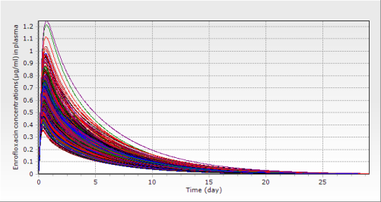 | b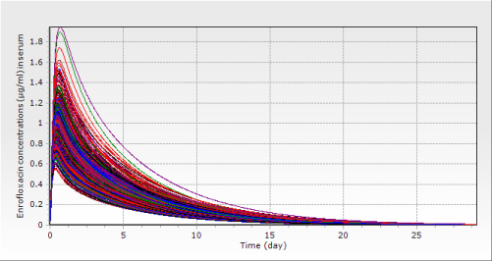
c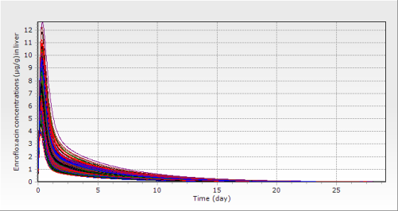 | d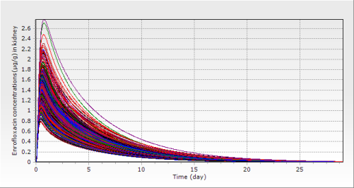
e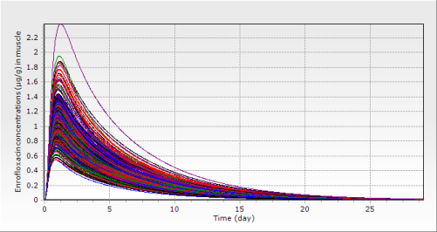 | f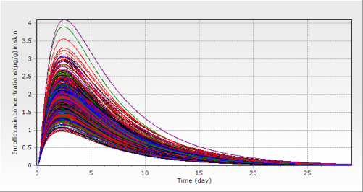

Figure S1. Predicted ENR concentrations (μg/ml or μg/g) after a single oral dose of ENR at 10 mg/kg BW in rainbow trout reared at 5 °C based on the Monte Carlo analysis with 500 iterations: a plasma, b serum, c liver, d kidney, e muscle, f skin

a 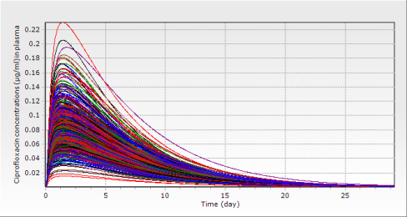 | b 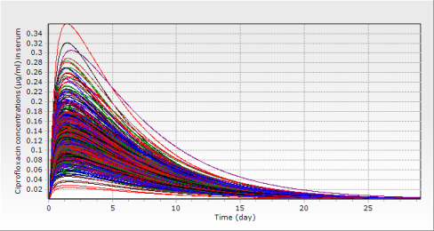
c 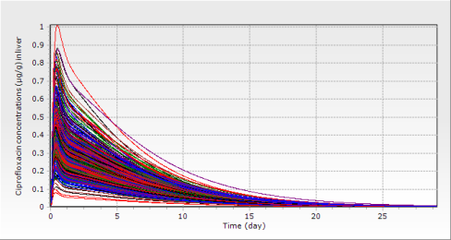 | d 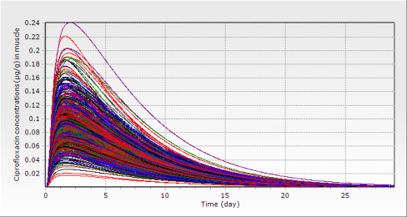
e 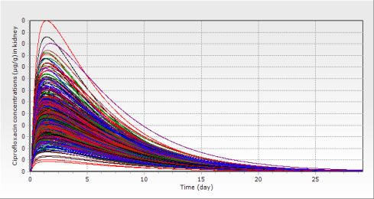 | f 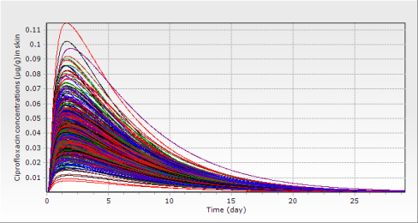

Figure S2. Predicted CIP concentrations (μg/ml or μg/g) after a single oral dose of ENR at 10 mg/kg BW in rainbow trout reared at 5 °C based on the Monte Carlo analysis with 500 iterations: a plasma, b serum, c liver, d muscle, e muscle, f skin

a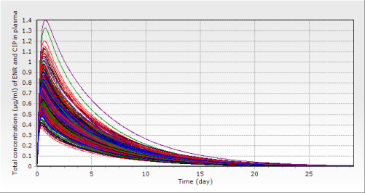 | b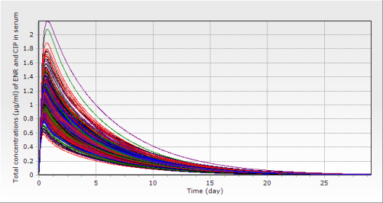
c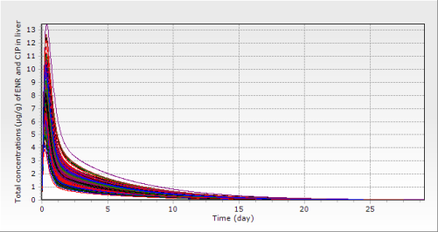 | d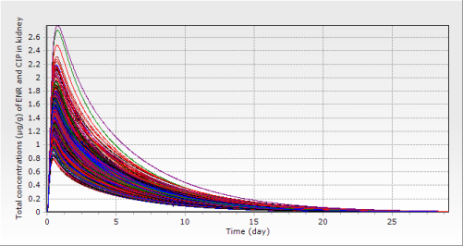
e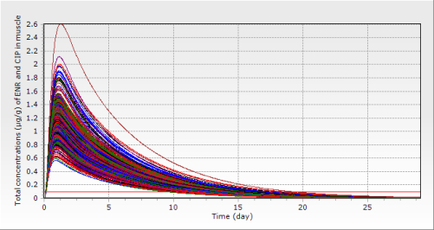 | f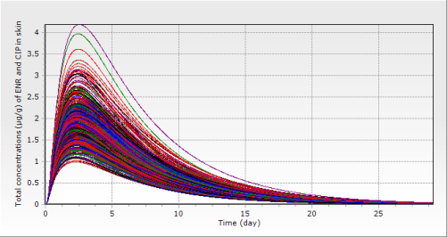

Figure S3. Predicted total concentrations (μg/ml or μg/g) of ENR and CIP after a single oral dose of ENR at 10 mg/kg BW in rainbow trout reared at 5 °C based on the Monte Carlo analysis with 500 iterations: a plasma, b serum, c liver, d kidney, e muscle, f skin

Note: The horizontal red straight line represents the MRL of ENR in the muscle (0.1 μg/g).

a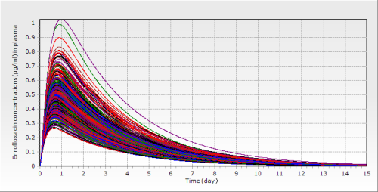 | b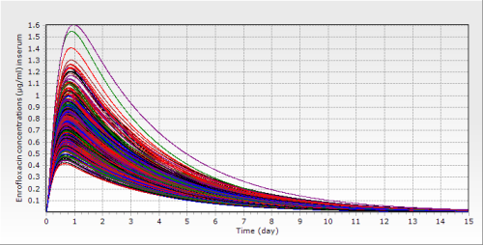
c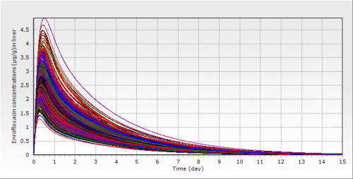 | d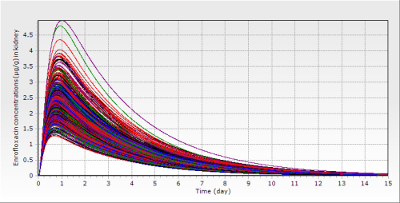
e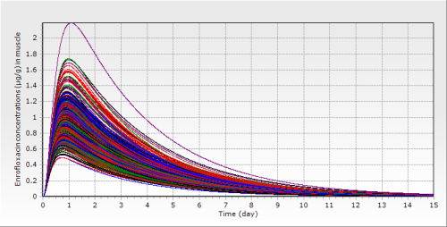 | f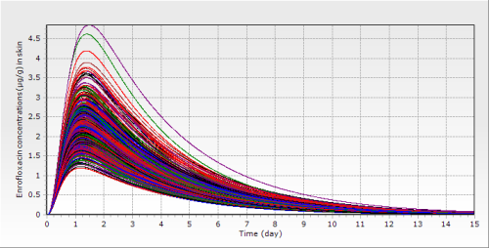

Figure S4. Predicted ENR concentrations (μg/ml or μg/g) after a single oral dose of ENR at 10 mg/kg BW in rainbow trout reared at 10 °C based on the Monte Carlo analysis with 500 iterations: a plasma, b serum, c liver, d kidney, e muscle, f skin

a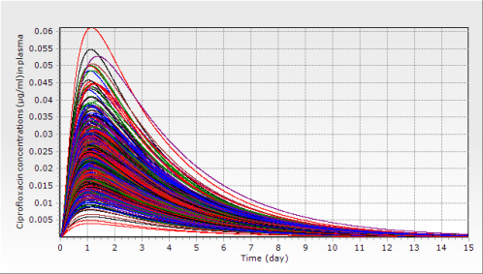 | b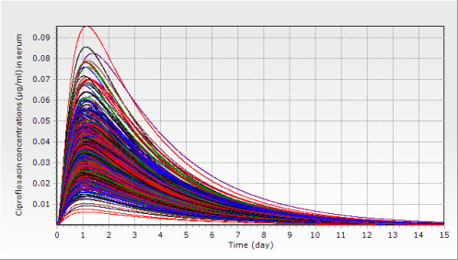
c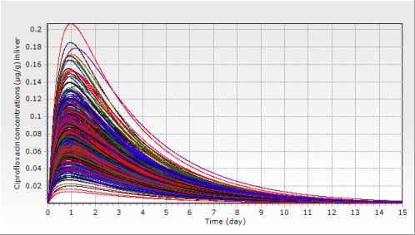 | d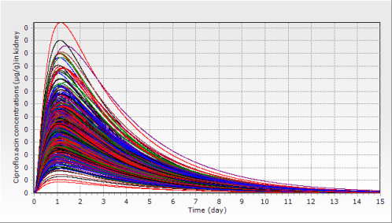
e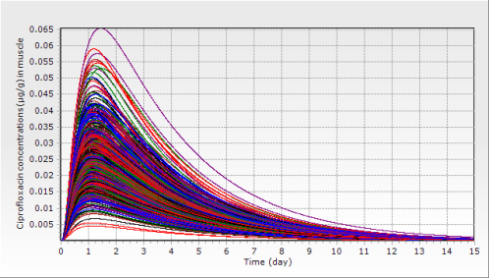 | f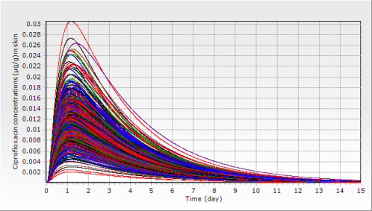

Figure S5. Predicted CIP concentrations (μg/ml or μg/g) after a single oral dose of ENR at 10 mg/kg BW in rainbow trout reared at 10 °C based on the Monte Carlo analysis with 500 iterations: a plasma, b serum, c liver, d kidney, e muscle, f skin

a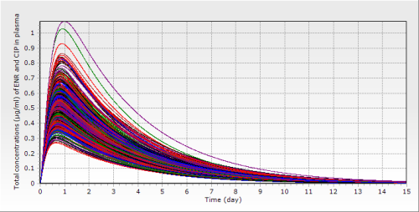 | b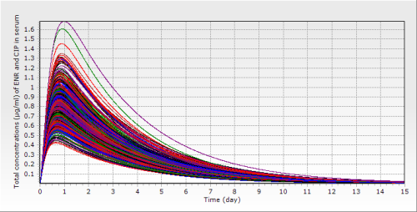
c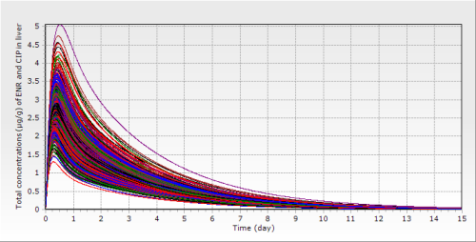 | d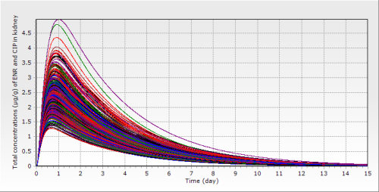
e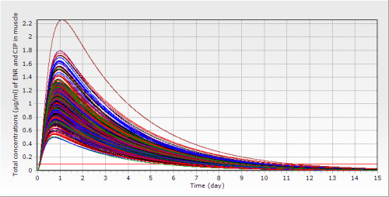 | f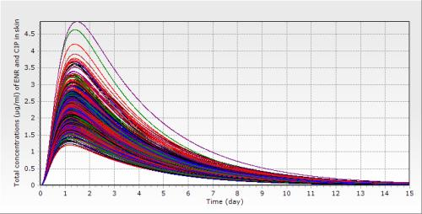

Figure S6. Predicted total concentrations (μg/ml or μg/g) of ENR and CIP after a single oral dose of ENR at 10 mg/kg BW in rainbow trout reared at 10 °C based on the Monte Carlo analysis with 500 iterations: a plasma, b serum, c liver, d kidney, e muscle, f skin
Note: The horizontal red straight line represents the MRL of ENR in the muscle (0.1 μg/g).

a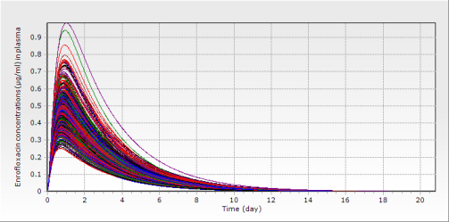 | b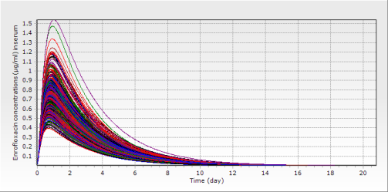
c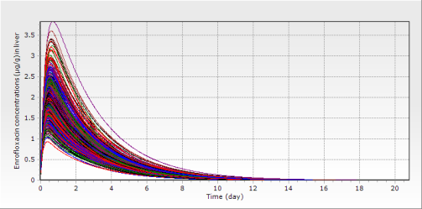 | d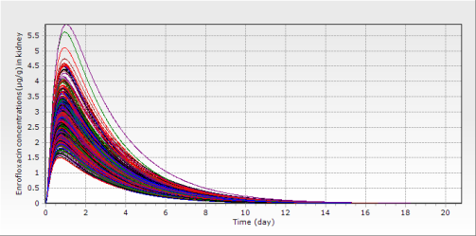
e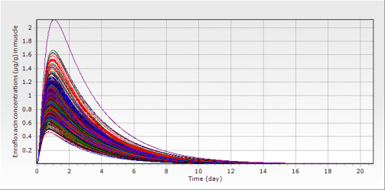 | f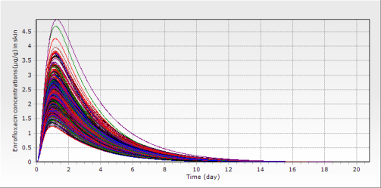

Figure S7. Predicted ENR concentrations (μg/ml or μg/g) after a single oral dose of ENR at 10 mg/kg BW in rainbow trout reared at 16 °C based on the Monte Carlo analysis with 500 iterations: a plasma, b serum, c liver, d kidney, e muscle, f skin

a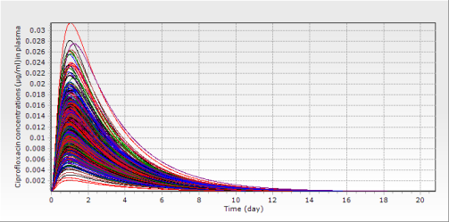 | b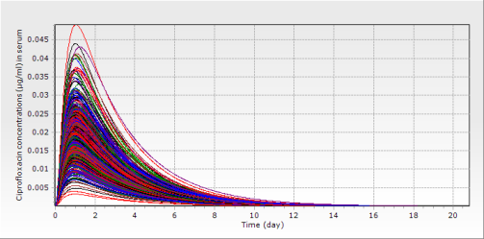
c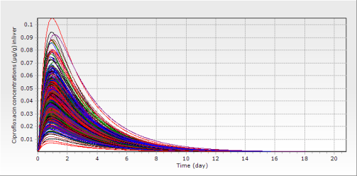 | d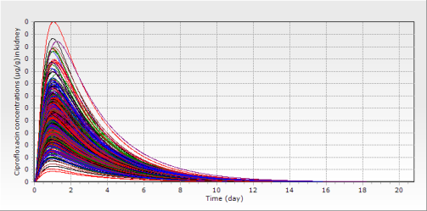
e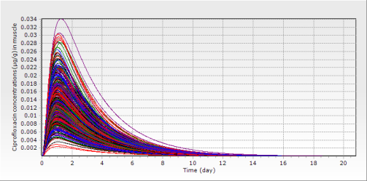 | f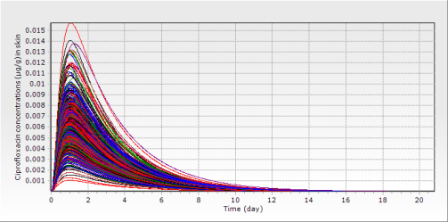

Figure S8. Predicted CIP concentrations (μg/ml or μg/g) after a single oral dose of ENR at 10 mg/kg BW in rainbow trout reared at 16 °C based on the Monte Carlo analysis with 500 iterations: a plasma, b serum, c liver, d kidney, e muscle, f skin

a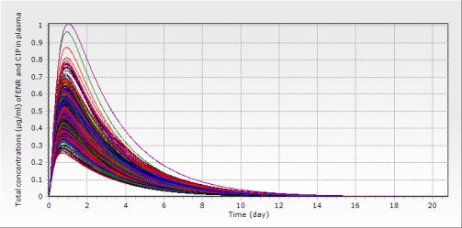 | b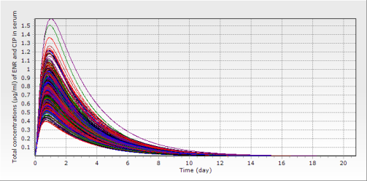
c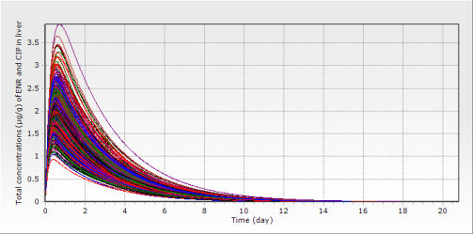 | d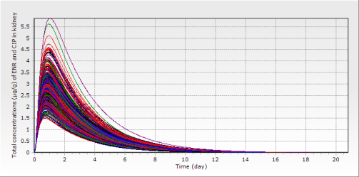
e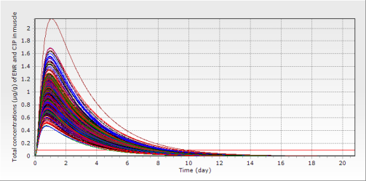 | f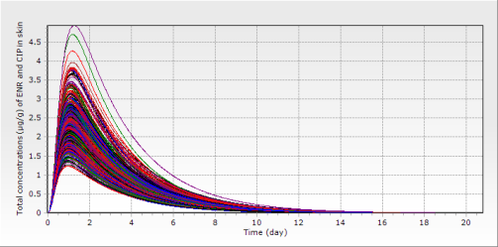

Figure S9. Predicted total concentrations (μg/ml or μg/g) of ENR and CIP after a single oral dose of ENR at 10 mg/kg BW in rainbow trout reared at 16 °C based on the Monte Carlo analysis with 500 iterations: a plasma, b serum, c liver, d kidney, e muscle, f skin
Note: The horizontal red straight line represents the MRL of ENR in the muscle (0.1 μg/g).

a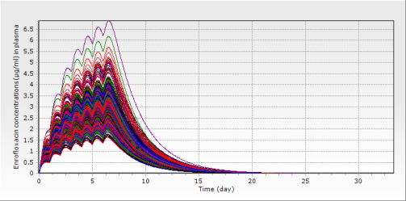 | b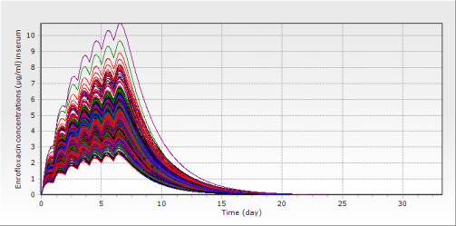
c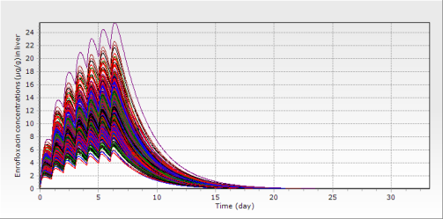 | d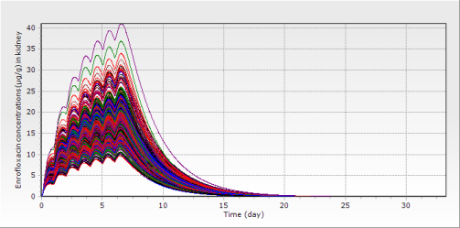
e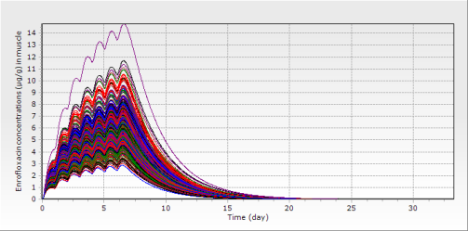 | f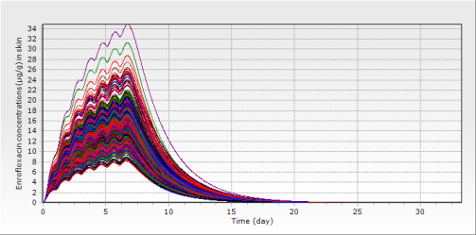

Figure S10. Predicted ENR concentrations (μg/ml or μg/g) after multiple oral doses of ENR at 20 mg/kg BW per day for seven consecutive days in rainbow trout reared at 16 °C based on the Monte Carlo analysis with 500 iterations: a plasma, b serum, c liver, d kidney, e muscle, f skin

a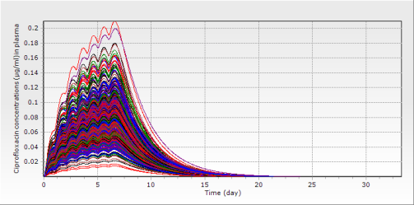 | b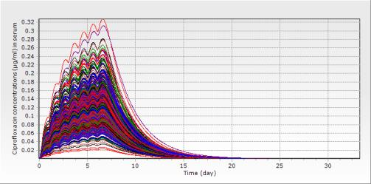
c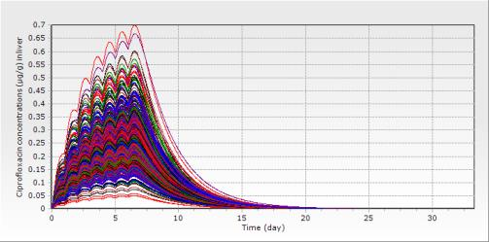 | d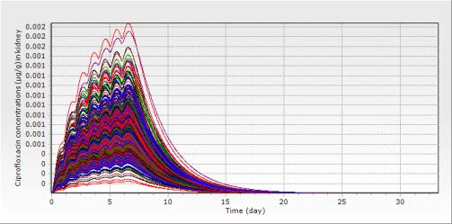
e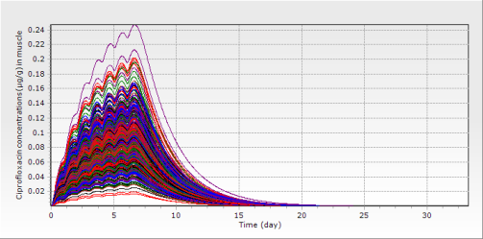 | f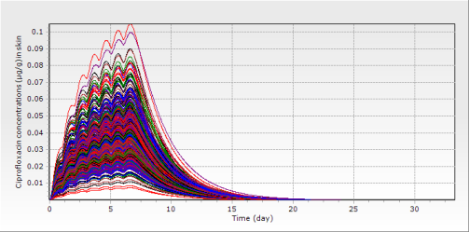

Figure S11. Predicted CIP concentrations (μg/ml or μg/g) after multiple oral doses of ENR at 20 mg/kg BW per day for seven consecutive days in rainbow trout reared at 16 °C based on the Monte Carlo analysis with 500 iterations: a plasma, b serum, c liver, d kidney, e muscle, f skin

a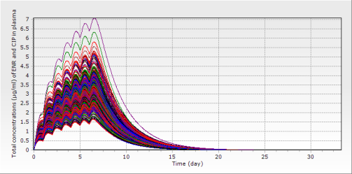 | b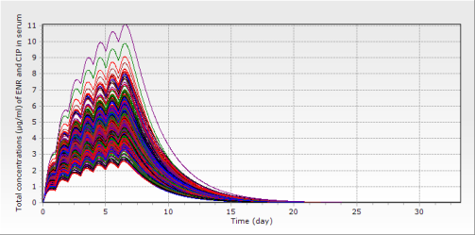
c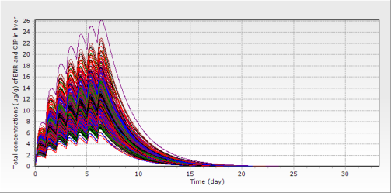 | d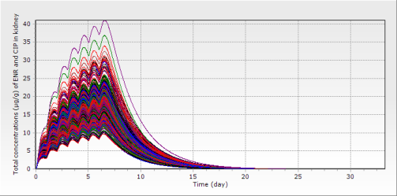
e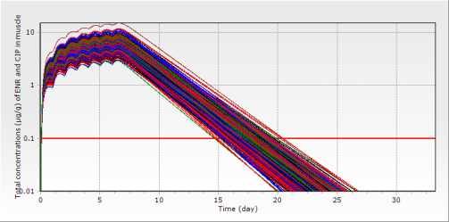 | f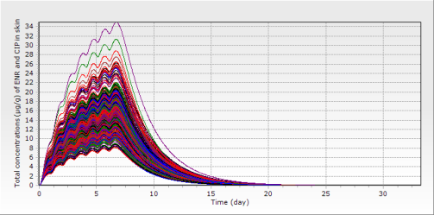

Figure S12. Predicted total concentrations (μg/ml or μg/g) of ENR and CIP after multiple oral doses of ENR at 20 mg/kg BW per day for seven consecutive days in rainbow trout reared at 16 °C based on the Monte Carlo analysis with 500 iterations: a plasma, b serum, c liver, d kidney, e muscle, f skin
Note: The horizontal red straight line represents the MRL of ENR in the muscle (0.1 μg/g).

a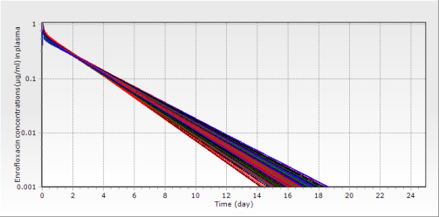 | b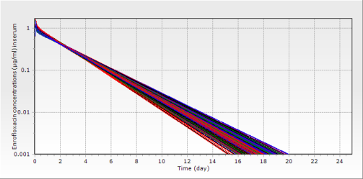
c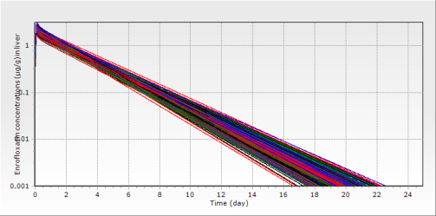 | d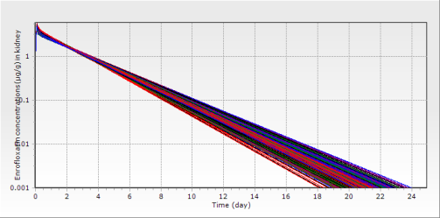
e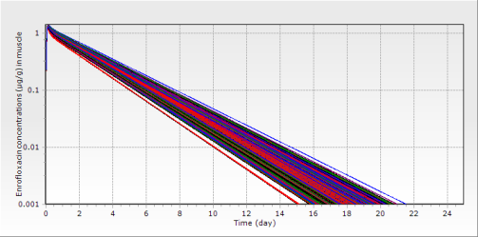 | f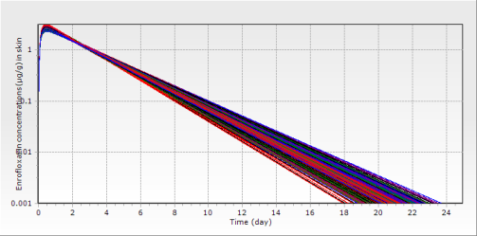

Figure S13. Predicted ENR concentrations (μg/ml or μg/g) after an immersion bath in water with ENR concentration at 20 ppm for 2.5 hours for rainbow trout reared at 16 °C based on the Monte Carlo analysis with 500 iterations: a plasma, b serum, c liver, d kidney, e muscle, f skin

a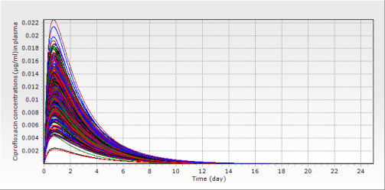 | b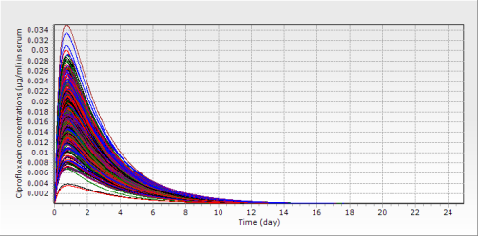
c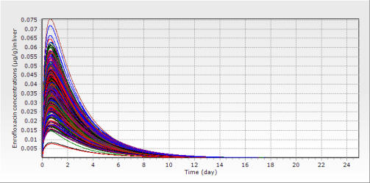 | d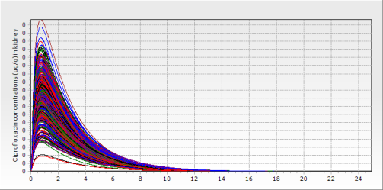
e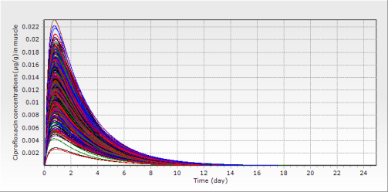 | f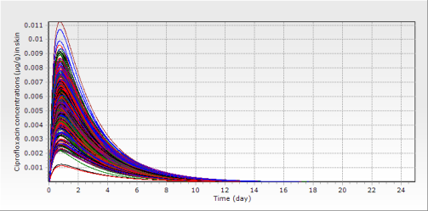

Figure S14. Predicted CIP concentrations (μg/ml or μg/g) after an immersion bath in water with ENR concentration at 20 ppm for 2.5 hours for rainbow trout reared at 16 °C based on the Monte Carlo analysis with 500 iterations: a plasma, b serum, c liver, d kidney, e muscle, f skin

a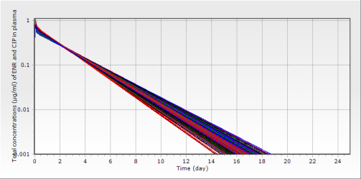 | b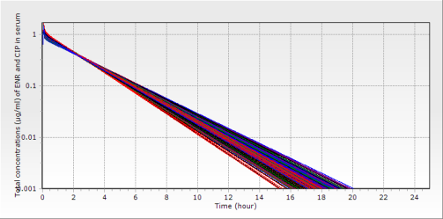
c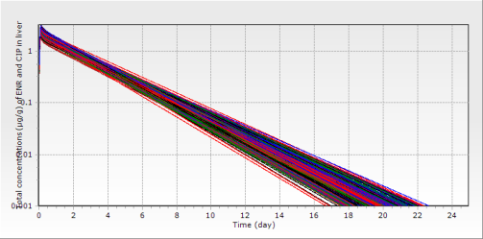 | d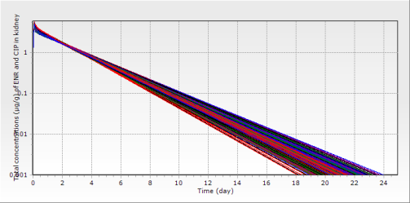
e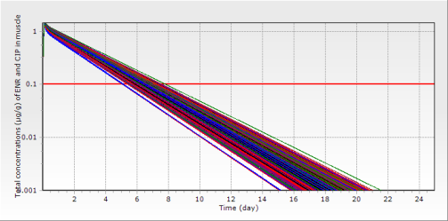 | f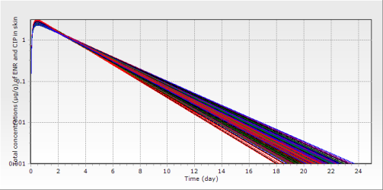

Figure S15. Predicted total concentrations (μg/ml or μg/g) of ENR and CIP after an immersion bath in water with ENR concentration at 20 ppm for 2.5 hours for rainbow trout reared at 16 °C based on the Monte Carlo analysis with 500 iterations: a plasma, b serum, c liver, d kidney, e muscle, f skin
Note: The horizontal red straight line represents the MRL of ENR in the muscle (0.1 μg/g).

a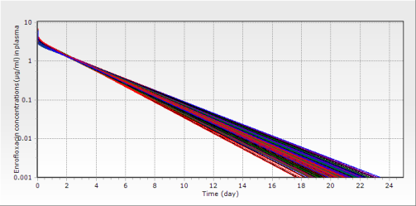 | b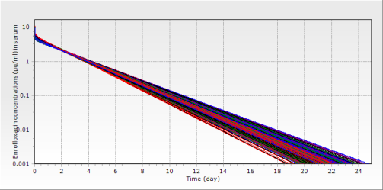
c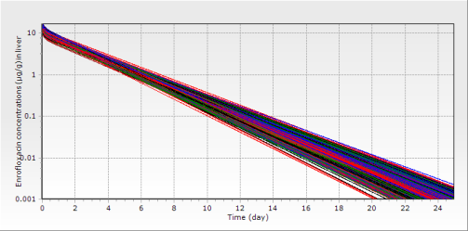 | d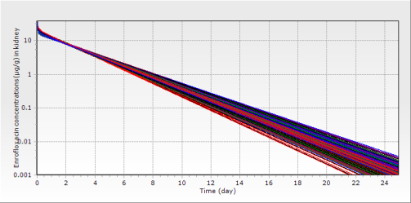
e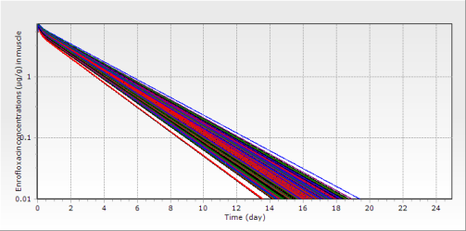 | f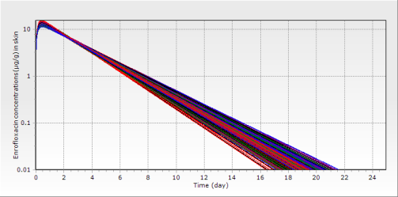

Figure S16. Predicted ENR concentrations (μg/ml or μg/g) after an immersion bath in water with ENR concentration at 100 ppm for 0.5 hours for rainbow trout reared at 16 °C based on the Monte Carlo analysis with 500 iterations: a plasma, b serum, c liver, d kidney, e muscle, f skin

a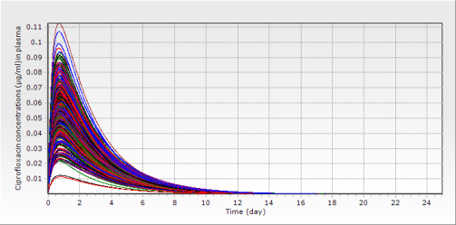 | b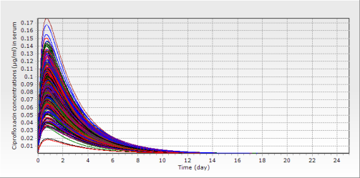
c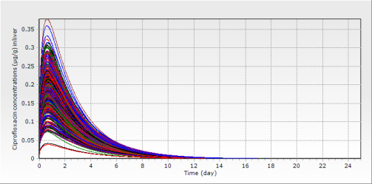 | d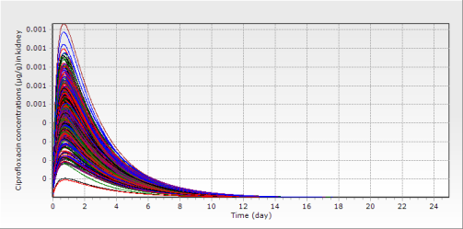
e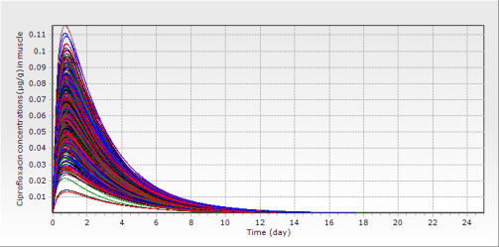 | f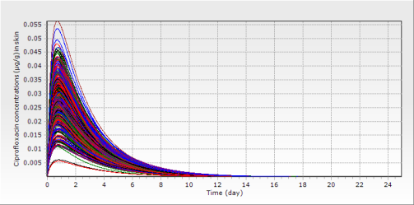

Figure S17. Predicted CIP concentrations (μg/ml or μg/g) after an immersion bath in water with ENR concentration at 100 ppm for 0.5 hours for rainbow trout reared at 16 °C based on the Monte Carlo analysis with 500 iterations: a plasma, b serum, c liver, d kidney, e muscle, f skin

a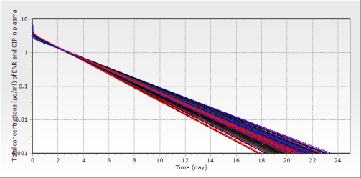 | b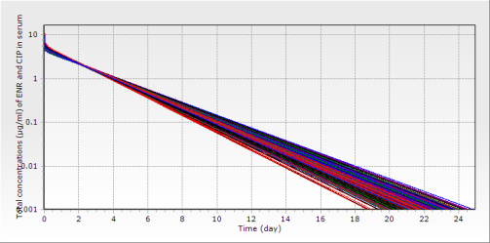
c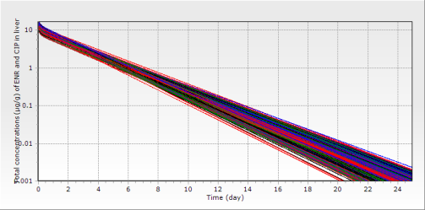 | d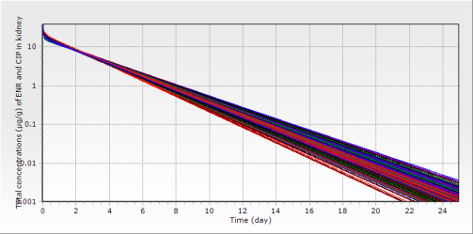
e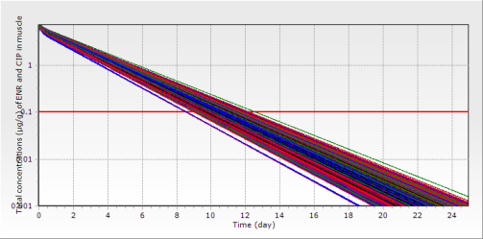 | f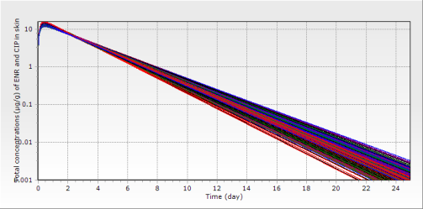

Figure S18. Predicted total concentrations (μg/ml or μg/g) of ENR and CIP after an immersion bath in water with ENR concentration at 100 ppm for 0.5 hours for rainbow trout reared at 16 °C based on the Monte Carlo analysis with 500 iterations: a plasma, b serum, c liver, d kidney, e muscle, f skin
Note: The horizontal red straight line represents the MRL of ENR in the muscle (0.1 μg/g).

a | b

Figure S19. Distributions of withdrawal intervals in the muscle (a) and skin (b) after an immersion bath in water with ENR concentration of 20 ppm for 2.5 h based on the Monte Carlo analysis. Notes: the solid arrows indicated the 99th percentiles of the distribution at different water temperatures.

Figure S20. Distributions of withdrawal intervals in the muscle (a) and skin (b) after an immersion bath in water with ENR concentration of 10 ppm for 0.5 h based on the Monte Carlo analysis. Notes: the solid arrows indicated the 99th percentiles of the distribution at different water temperatures.

Supplementary References
1. Barron MG, Tarr BD, Hayton WL. Temperature-dependence of cardiac output and regional blood flow in rainbow trout, Salmo gairdneri Richardson. J Fish Biol. (1987) 31:735-744. doi: 10.1111/j.1095-8649.1987.tb05276.x
2. Yang F, Sun N, Sun YX, Shan Q, Zhao HY, Zeng DP, Zeng ZL. A physiologically based pharmacokinetics model for florfenicol in crucian carp and oral-to-intramuscular extrapolation. J Vet Pharmacol Ther. (2013) 36:192-200. doi: 10.1111/j.1365-2885.2012.01419.x
3. Abbas R, Hayton WL. A physiologically based pharmacokinetic and pharmacodynamic model for paraoxon in rainbow trout. Toxicol Appl Pharmacol. (1997) 145:192-201. doi: 10.1006/taap.1997.8168
4. Xu N, Li M, Chou WC, Lin Z. A physiologically based pharmacokinetic model of doxycycline for predicting tissue residues and withdrawal intervals in grass carp (Ctenopharyngodon idella). Food Chem Toxicol. (2020) 137:111127. doi: 10.1016/j.fct.2020.111127
5. Gallo JM, Lam FC, Perrier DG. Area method for the estimation of partition coefficients for physiological pharmacokinetic models. J Pharmacokinet Biopharm. (1987) 15:271-80. doi: 10.1007/BF01066322
6. Urzua N, Messina MJ, Prieto G, Luders C, Errecalde C. Pharmacokinetics and tissue disposition of enrofloxacin in rainbow trout after different routes of administration. Xenobiotica. (2020) 50:1236-1241. doi: 10.1080/00498254.2020.1747119
7. Sadiq MW, Nielsen EI, Khachman D, Conil JM, Georges B, Houin G, Laffont CM, Karlsson MO, Friberg LE. A whole-body physiologically based pharmacokinetic (WB-PBPK) model of ciprofloxacin: a step towards predicting bacterial killing at sites of infection. J Pharmacokinet Pharmacodyn. (2017) 44:69-79. doi: 10.1007/s10928-016-9486-9
8. Kyuchukova R, Milanova A, Pavlov A, Lashev L. Comparison of plasma and tissue disposition of enrofloxacin in rainbow trout (Oncorhynchus mykiss) and common carp (Cyprinus carpio) after a single oral administration. Food Addit Contam Part A Chem Anal Control Expo Risk Assess. (2015) 32:35-9. doi: 10.1080/19440049.2014.983998
9. Liang J, Li J, Zhao F, Liu P, Chang Z. Pharmacokinetics and tissue behavior of enrofloxacin and its metabolite ciprofloxacin in turbot Scophthalmus maximus at two water temperatures. Chin J Oceanol Limnol. (2012) 30:644-653. doi: 10.1007/s00343-012-1228-2
10. Bowser PR, Wooster GA, St Leger J, Babish JG. Pharmacokinetics of enrofloxacin in fingerling rainbow trout (Oncorhynchus mykiss). J Vet Pharmacol Ther. (1992) 15:62-71. doi: 10.1111/j.1365-2885.1992.tb00987.x
11. Pan H. Effect of water velocity, temperature and light intensity on pharmacokinetics of enrofloxacin in rainbow, Shanghai Ocean University, Shanghai Ocean University, Shanghai, 2017.

