Supplementable Table 1 PCR primers for mitochondrial amplification

Primer | Sequences (5’–3’)
Mtd1F: GGCTCCCAAAGCCAGA ATTCT | Mtd1R: GCCCTCTTAACACTAAC TGAGT
Mtd2F: CACCCCCAAGGGAATT CAGCAG | Mtd2R: GGTACTATTTCTATTGC TTTGTG
Mtd3F: CCTAACACTAAAAATT AAATCAT | Mtd3R: TGCTGGCAAATAGAAT TATTGC
Mtd4F: GTAGAAGCAACAACAA AATACTT | Mtd4R: CGTAATCTGTATACTCA TAGCTT
Mtd5F: GACCCCCACCTAACAA TCAAAG | Mtd5R: AGACTGCTGCTAATACT ATTGAT
Mtd6F: CTACCAAAAGCACATG TAGAAGC | Mtd6R: CAAGGATTAGCAGTGC TTGCTA
Mtd7F: GGAGTTAAAATCTCCTT ACTCA | Mtd7R: ACCAATCGTAAAATAA GTTGAG
Mtd8F: CCGAAAAATAGGAGGC CTAT | Mtd8R: AGAAAATAGTTTAGTTT AGAA

Supplementable Table 2 The GenBank number used in the article

Species | GenBank accession number
Myxocyprinus asiaticus | AY526869
 | NC_006401
 | AB223007
 | AP006764
 | AY986503
Carassius carassius | JQ911695
Goldfish | KU146528
Megalobrama amblycephala | EU434747
 | MF522177
Red carassius auratus | KJ1874428
 | KJ874430
 | AY714387
Improved red carassius_auratus | KX781320
Cyprinus carpio | X61010
 | KU050703
 | MH202953
Goldfish-like fish | MK726307
 | Mk726306
Elopichthys bambusa | NC_024834
 | KM196112
 | NC_024834
Hemibarbus maculatus | JF906109
Carassius cuvieri | AB045144
 | AP011237
Cyprinus carpio haematopterus | JX188254
 | KP993138
 | JN105354
Schizothorax yunnanensis | KR780749
 | KP892531
Gymnocypris przewalskii | KT833113
Hypophthalmichthys molitrix | EU315941
 | NC_010156
Chanodichthys ilishaeformis | NC_029722
 | KU200257
Red curcian carp-like fish | MK658748
 | MK726305
 | MK688992
Saurogobio dabryi | KF612272
 | KU314696
Megalobrama terminalis | NC_018816
 | AB626850
Common diploid crucian carp | GU086395
Common tetraploid crucian carp | GU086397
Plagiognathops microlepis | NC_022711
 | KF383387
Xenocypris argentea | AP009059
 | AP011283
 | NC_008682
Hypophthalmichthys nobilis | EU343733
 | HM162839
 | NC_010194
Danio rerio | NC_002333
 | KM244705
Carassius gibelio | GU138989
 | GU170401
 | KX505166
Ctenopharyngodon idellus | KT894100
 | MG827396
 | EU391390
 | NC_010288

Supplementable Table 3 Comparison of the mutation rate and similarity between the nucleotide sequences of GF-L, RCC-L, Koi, BSB, RCC and GF in 2rRNA and 22 tRNA genes
Gene | Length (bp) |  |  |  |  | GF-L and RCC-L |  | GF-L and KOC |  | GF-L and BSB |  | RCC-L and RCC |  | GF-L and GF
 | GF-L | RCC-L | KOC | BSB | RCC | Divergence (%) | Similarity (%) | Divergence (%) | Similarity (%) | Divergence (%) | Similarity (%) | Divergence (%) | Similarity (%) | Divergence (%) | Similarity (%)
12s rRNA | 954 | 955 | 955 | 962 | 954 | 0.1 | 99.8 | 2.5 | 97.5 | 8.0 | 91.5 | 0.4 | 99.5 | 0.6 | 99.4
16s rRNA | 1682 | 1684 | 1679 | 1693 | 1682 | 0.1 | 99.8 | 5.1 | 94.8 | 8.1 | 91.3 | 0.7 | 99.2 | 0.6 | 99.3
tRNA-Phe | 69 | 69 | 69 | 69 | 69 | 0.0 | 100.0 | 4.5 | 95.7 | 11.0 | 89.9 | 0.0 | 100.0 | 1.5 | 98.6
tRNA-Val | 72 | 72 | 72 | 72 | 72 | 0.0 | 100.0 | 0.0 | 100.0 | 2.9 | 97.2 | 1.4 | 98.6 | 0.0 | 100.0
tRNA-Leu-1 | 76 | 76 | 76 | 76 | 76 | 0.0 | 100.0 | 1.3 | 98.7 | 2.7 | 97.4 | 0.0 | 100.0 | 0.0 | 100.0
tRNA-Ile | 72 | 72 | 72 | 72 | 72 | 0.0 | 100.0 | 1.4 | 98.6 | 22.0 | 81.9 | 0.0 | 100.0 | 0.0 | 100.0
tRNA-Gln | 71 | 71 | 71 | 71 | 71 | 0.0 | 100.0 | 1.4 | 98.6 | 12.8 | 88.7 | 1.4 | 98.6 | 1.4 | 98.6
tRNA-Met | 69 | 69 | 69 | 69 | 69 | 0.0 | 100.0 | 0.0 | 100.0 | 7.7 | 92.8 | 1.5 | 98.6 | 1.5 | 98.6
tRNA-Trp | 71 | 71 | 71 | 71 | 71 | 1.4 | 98.6 | 4.4 | 95.8 | 6.0 | 94.4 | 1.4 | 98.6 | 0.0 | 100.0
tRNA-Ala | 69 | 69 | 69 | 69 | 69 | 1.5 | 98.6 | 11.2 | 89.9 | 22.9 | 81.2 | 0 | 100.0 | 1.5 | 98.6
tRNA-Asn | 73 | 73 | 73 | 73 | 73 | 0.0 | 98.6 | 2.9 | 94.5 | 0.0 | 100.0 | 0.0 | 98.6 | 0.0 | 100.0
tRNA-Cys | 69 | 69 | 67 | 68 | 69 | 0.0 | 100.0 | 4.7 | 92.8 | 11.4 | 88.4 | 0.0 | 100.0 | 0.0 | 100.0
tRNA-Tyr | 71 | 71 | 71 | 71 | 71 | 0.0 | 100.0 | 2.9 | 97.2 | 7.6 | 93.7 | 0.0 | 100.0 | 0.0 | 100.0
tRNA-Ser-1 | 71 | 71 | 71 | 71 | 71 | 0.0 | 100.0 | 7.7 | 92.8 | 7.6 | 93.0 | 0.0 | 100.0 | 0.0 | 100.0
tRNA-Asp | 72 | 72 | 72 | 74 | 72 | 0.0 | 100.0 | 5.8 | 94.4 | 9.0 | 89.2 | 0.0 | 100.0 | 0.0 | 100.0
tRNA-Lys | 76 | 76 | 76 | 76 | 76 | 0.0 | 100.0 | 0.0 | 100.0 | 9.8 | 90.8 | 0.0 | 100.0 | 0.0 | 100.0
tRNA-Gly | 72 | 72 | 72 | 72 | 72 | 0.0 | 100.0 | 1.4 | 98.6 | 5.8 | 94.4 | 0.0 | 100.0 | 0.0 | 100.0
tRNA-Arg | 70 | 70 | 70 | 70 | 70 | 0.0 | 100.0 | 6.1 | 94.3 | 12.8 | 88.6 | 0.0 | 100.0 | 0.0 | 100.0
tRNA-His | 69 | 69 | 69 | 69 | 69 | 0.0 | 100.0 | 11.3 | 89.9 | 4.5 | 95.7 | 3.0 | 97.1 | 3.0 | 97.1
tRNA-Ser-2 | 70 | 70 | 69 | 69 | 69 | 1.5 | 98.6 | 7.7 | 92.8 | 24.8 | 79.7 | 7.7 | 91.4 | 0.0 | 100.0
tRNA-Leu-2 | 73 | 73 | 73 | 73 | 73 | 0.0 | 100.0 | 1.4 | 98.6 | 7.4 | 93.2 | 0.0 | 100.0 | 4.5 | 95.7
tRNA-Glu | 69 | 69 | 69 | 69 | 69 | 0.0 | 100.0 | 0.0 | 100.0 | 6.1 | 94.2 | 0.0 | 100.0 | 0.0 | 100.0
tRNA-Thr | 72 | 72 | 72 | 72 | 72 | 0.0 | 100.0 | 2.8 | 97.2 | 1.4 | 98.6 | 1.4 | 98.6 | 1.4 | 98.6
tRNA-Pro | 70 | 70 | 70 | 70 | 70 | 2.9 | 97.1 | 1.4 | 98.6 | 4.5 | 95.7 | 2.9 | 97.1 | 0.0 | 100.0

Supplementable Table 4 The spacer among the mitochondrial genes in the KOC, BSB, RCC-L, GF-L, RCC and GF

Genes | Numbers of the nucleotide spacer (bp) |  |  |  |  |  | Sequences of the spacer (5，-3，),on the height strand
 | GF-L | RCC-L | KOC | BSB | RCC | GF | GF-L | RCC-L | KOC | BSB | RCC | GF
tRNA-Leu and ND1 | 1 | 1 | 1 | 1 | 1 | 1 | T | T | T | C | T | T
ND1 and tRNA-Ile | 4 | 4 | 4 | 4 | 4 | 4 | CTAA | CTAA | TTAA | TTCA | CTAA | ACCC
tRNA-Gln and tRNA-Met | 1 | 1 | 2 | 1 | 1 | 1 | T | A | A | A | A | A
tRNA-Trp and tRNA-Ala | 2 | 2 | 2 | 1 | 2 | 2 | AT | AT | AT | A | AT | AT
tRNA-Ala and tRNA-Asn | 1 | 1 | 1 | 1 | 1 | 1 | A | A | A | A | A | A
tRNA-Asn and tRNA-Cys | 33 | 33 | 33 | 32 | 33 | 33 | CTTTTCCCGCCGTTTAA  CTCAGAAAGGCGGGAA | CTTTTCCCGCCGTTTAACTC  AGAAAGGCGGGAA | CTTTTCCCGCCGTTTAACTCAGTA  AGGCGGGAA | CTTTTCCCGCCTATGGCCTAGTAAGGCG  GGAA | CTTTTCCCGCCGTTTAACTCA  GAAAGGCGGGAA | CTTTTCCCGCCGTTTAACTCAGAAAGGCGGGAA
tRNA-Cys and tRNA-Tyr | 0 | 0 | 0 | 2 | 0 | 0 | ----- | ---- | ----- | GA | ---- | -----
tRNA-Tyr and COI | 1 | 1 | 1 | 1 | 1 | 0 | T | T | T | T | T | ------
tRNA-Ser and tRNA-Asp | 3 | 3 | 3 | 2 | 3 | 3 | CTA | CTA | CTA | CT | CTA | CTA
tRNA-Asp and CoII | 2 | 12 | 13 | 13 | 12 | 12 | AC | CACTTAAAATTA | ACCCAAAGACTTA | AGCTCAAGGCTTA | CACTTAAAATTA | CACTTAAAATTA
tRNA-Lys and ATPase 8 | 1 | 1 | 1 | 1 | 1 | 1 | A | A | A | A | A | A
tRNA-Ser and tRNA-Leu | 1 | 1 | 1 | 1 | 1 | 0 | C | C | C | C | C | -----
tRNA-Leu and ND5 | 3 | 3 | 3 | 0 | 3 | 3 | AAA | AAA | AAA | ATG | AAA | AAA
ND6 and tRNA-Glu | 7 | 0 | 0 | 0 | 0 | 0 | AGGTCAT | ----- | ----- | ---- | ---- | ------
tRNA-Glu and Cyt b | 5 | 5 | 5 | 4 | 5 | 5 | CATTA | CATTA | CACTA | CATA | CATTA | CATTA
Cyt b and tRNA-Thr | 0 | 0 | 0 | 4 | 0 | 0 | ---- | ----- | ---- | GCTT | ------ | ------

Supplementable Table 5 The overlap of mitochondrial genome genes between KOC, BSB, RCC-L, GF-L, RCC and GF

Genes | Number of the nucleotide overlap (bp) |  |  |  |  |  | Sequences of the overlap (5’-3’on the height strand)
 | GF-L | RCC-L | KOC | BSB | RCC | GF | GF-L | RCC-L | KOC | BSB | RCC | GF
tRNA-Ile and tRNA-Gln | 2 | 2 | 2 | 2 | 2 | 2 | CT | CT | CT | TT | CT | TA
tRNA-Cys and tRNA-Tyr | 1 | 1 | 1 | 0 | 1 | 1 | T | T | T | ------- | T | T
ATPase 8 and ATPase 6 | 7 | 7 | 7 | 7 | 7 | 7 | ATGATAG | ATGATAG | ATGATAG | ATGCTAA | ATGATAG | ATGATAG
ND4L and ND4 | 7 | 7 | 7 | 7 | 7 | 7 | ATGCTAA | ATGCTAA | ATGCTAA | ATGCTAA | ATGCTAA | TACCCAC
ND5 and ND6 | 5 | 4 | 4 | 4 | 4 | 4 | TCTAA | CTAA | TTAA | TTAA | CTAA | CCAC
tRNA-Thr and tRNA-Pro | 1 | 1 | 1 | 1 | 1 | 1 | T | C | C | C | C | T

Supplementable Table 6 Nucleotide composition of different parts of the mitochondrial genome of KOC, BSB, RCC-L, GF-L, RCC and GF
mtDNA | GF-L |  |  |  | RCC-L |  |  |  | KOC |  |  |  | BSB |  |  |  | RCC |  |  |  | GF
 | T% | C% | A% | G% | T% | C% | A% | G% | T% | C% | A% | G% | T% | C% | A% | G% | T% | C% | A% | G% | T% C% | A% | G%
Complete | 26.1 | 26.3 | 31.6 | 16.1 | 26.0 | 26.3 | 31.5 | 16.2 | 24.8 | 27.6 | 31.8 | 15.8 | 24.7 | 27.9 | 31.2 | 16.2 | 26.1 | 26.2 | 31.6 | 16.0 | 26.1 26.3 | 31.6 |  | 16.0
13protein genes | 28.1 | 26.9 | 29.7 | 15.3 | 28.1 | 26.8 | 29.6 | 15.4 | 26.6 | 28.4 | 29.8 | 15.2 | 26.6 | 28.7 | 29.0 | 15.6 | 28.3 | 26.7 | 29.7 | 15.3 | 28.2 26.8 | 29.7 |  | 15.3
1st coden | 21.4 | 26.2 | 26.7 | 25.7 | 21.4 | 25.8 | 26.6 | 26.1 | 20.4 | 26.7 | 26.8 | 26.1 | 20.5 | 26.5 | 27.1 | 26.0 | 21.3 | 25.9 | 26.7 | 26.1 | 21.3 25.9 | 26.7 |  | 26.1
2nd coden | 40.7 | 27.0 | 18.5 | 13.7 | 40.7 | 27.3 | 18.3 | 13.7 | 40.7 | 27.3 | 18.3 | 13.8 | 40.6 | 27.4 | 18.3 | 13.7 | 40.8 | 27.1 | 18.3 | 13.7 | 40.7 27.2 | 18.3 |  | 13.7
3 rd coden | 22.1 | 27.4 | 44.1 | 6.4 | 22.3 | 27.4 | 43.9 | 6.4 | 18.7 | 31.3 | 44.3 | 5.7 | 18.8 | 32.2 | 41.8 | 7.1 | 22.7 | 27.2 | 44.1 | 6.0 | 22.6 27.2 | 44.1 |  | 6.0
2 rRNA genes | 20.2 | 24.1 | 34.6 | 24.1 | 20.2 | 24.1 | 34.6 | 21.1 | 19.3 | 25.0 | 35.0 | 20.7 | 19.7 | 24.5 | 34.5 | 21.3 | 20.2 | 24.1 | 34.7 | 21.0 | 20.2 24.0 | 34.6 |  | 21.1
22 tRNA genes | 25.1 | 24.3 | 30.7 | 19.9 | 25.3 | 24.3 | 30.2 | 20.2 | 25.5 | 23.6 | 30.5 | 20.4 | 25.5 | 24.7 | 30.1 | 19.8 | 25.1 | 24.2 | 30.6 | 20.1 | 27.1 20.7 | 28.6 |  | 23.6
D-loop region | 32.7 | 20.5 | 32.4 | 14.5 | 31.8 | 21.5 | 32.7 | 14.0 | 33.0 | 19.7 | 33.3 | 13.9 | 30.5 | 21.8 | 33.3 | 14.4 | 32.5 | 20.8 | 32.5 | 14.2 | 32.3 20.9 | 32.5 |  | 14.2

Supplementable Figure 1

Phylogenetic relationships among KOC, BSB, RCC-L, GF-L, RCC, GF and Danio rerio based on entire mtDNA by using IQ-tree

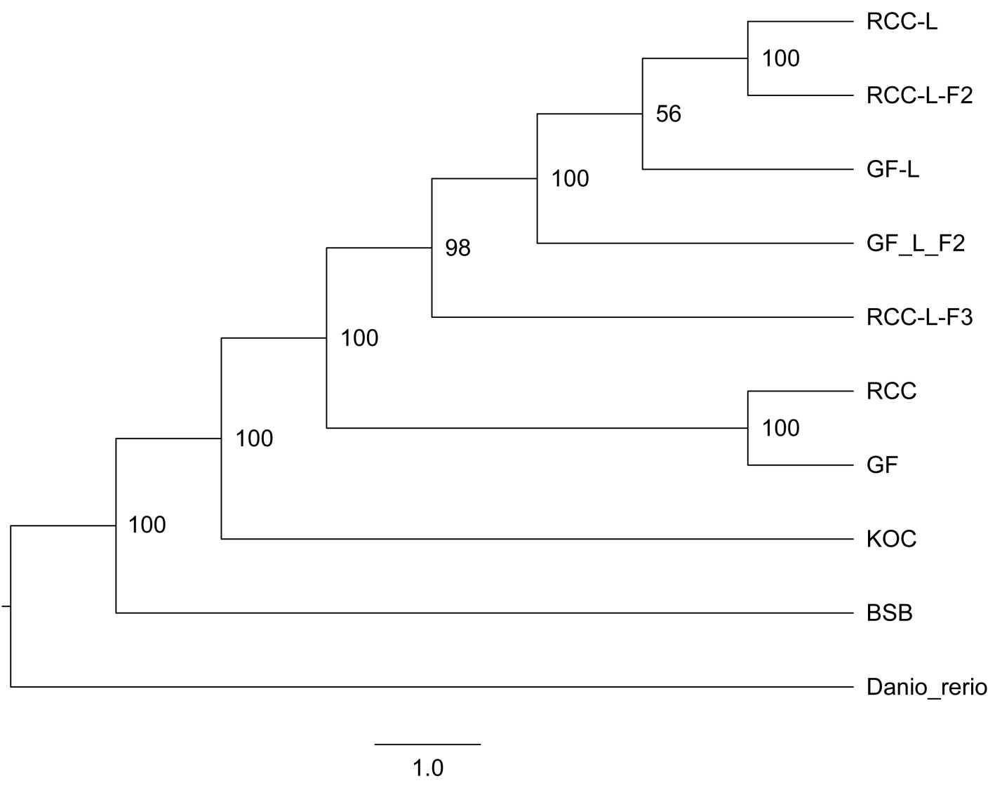
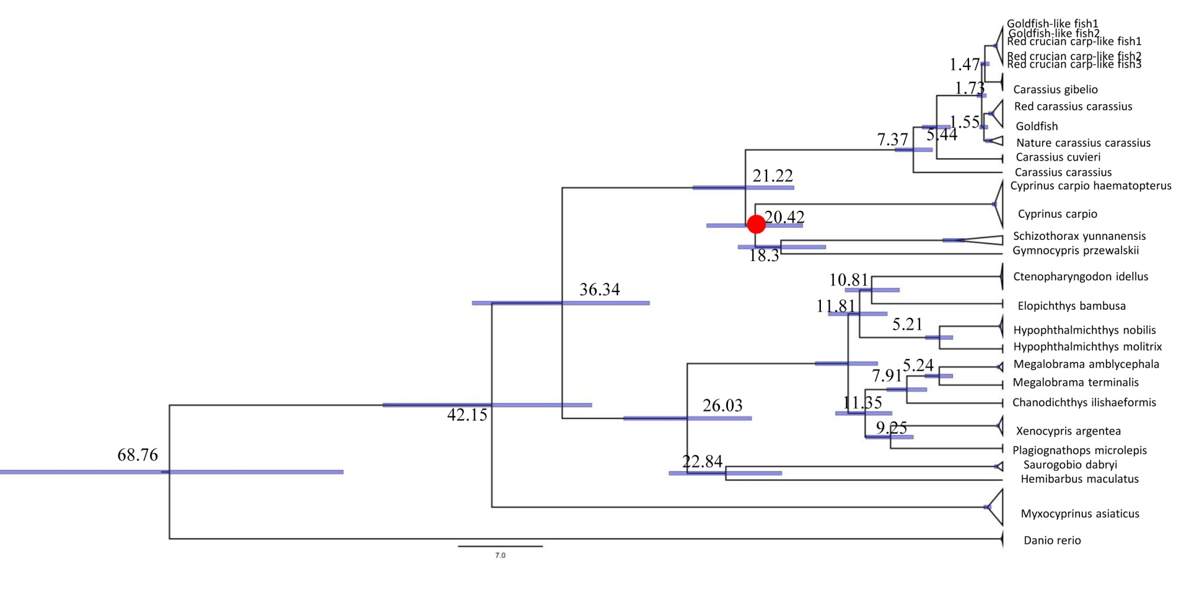
Supplementable Figure 2
Dated phylogeny using one calibration point [red dots indicate the time-calibration marker (Wang et al., 2016; Wu et al., 2020)] to estimate the divergence of Carassius. Node ages are shown together with 95% highest posterior density bars indicating a range of age estimates

