Tittle:
Iron speciation in Fram Strait and over the northeast Greenland shelf: An inter-comparison study of voltammetric methods
Authors:
Indah Ardiningsih¹, Kechen Zu², Pablo Lodeiro², Martha Gledhill², Gert-Jan Reichart^{1,3}, Eric P. Achterberg², Rob Middag¹, Loes J.A. Gerringa¹
- Department of Ocean Systems, Royal Netherlands Institute for Sea Research (NIOZ), Texel, Netherlands
- GEOMAR Helmholtz Centre for Ocean Research, Kiel, Germany
- Earth and Geoscience Department, University of Utrecht, Utrecht, Netherlands

Supplementary Material
Supplementary Figure 1. Boxplot of the values of log K´_{Fe´L} (a) and log ${\text{α}}_{\text{Fe}ˊ\text{L}}$ (b) according to the one-ligand model from overall samples analyzed using the TAC, SA and NN.
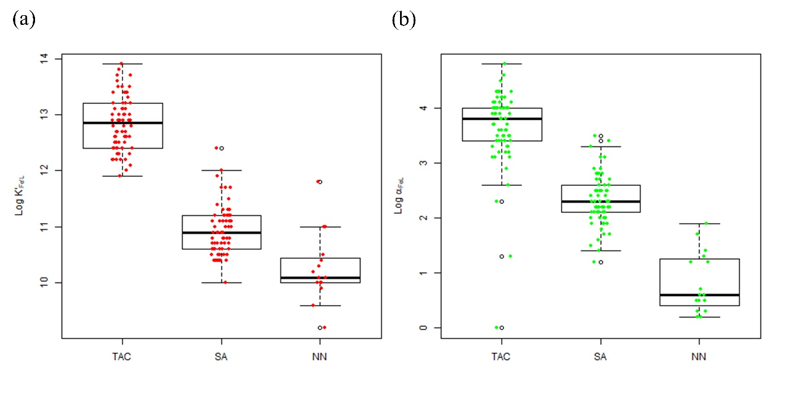
Supplementary Figure 2. Comparison between ligand concentrations (a) [L_{t}]_{TAC} versus [L_{t}]_{SA} according to the one-ligand model. (b) [L_{t}]_{SA} versus $\sum{L_{1+2(SA)}}$, the sum of the relatively strong and weak ligand groups [L₁]_{SA}, [L₂]_{SA}, obtained using SA according to the two-ligand model. (c) [L_{t}]_{TAC} versus $\sum{L_{1+2(TAC)}}$, the sum of the relatively strong and weak ligand groups [L₁]_{TAC}, [L₂]_{TAC}, obtained using TAC according to the two-ligand model. The diagonal line indicates the 1:1 ratio. Figures were made using the software package R.
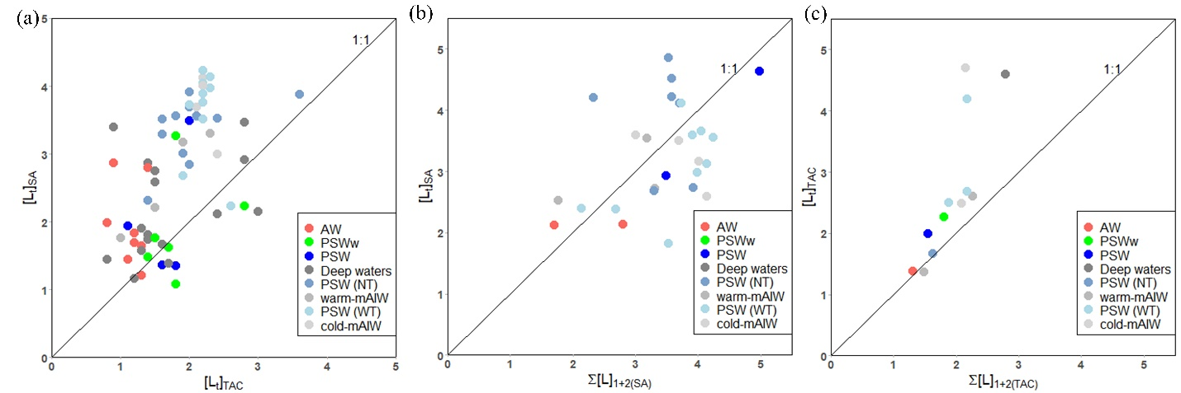
Supplementary Figure 3. The depth profiles of dissolved-Fe (DFe) and total ligand concentrations [L_{t}] of three different methods using different added ligands (TAC, SA and NN) for each station in Fram Strait and over the Northeast Greenland shelf. Station numbers are indicated at the bottom right of each figure. Figures were made using the software package R.
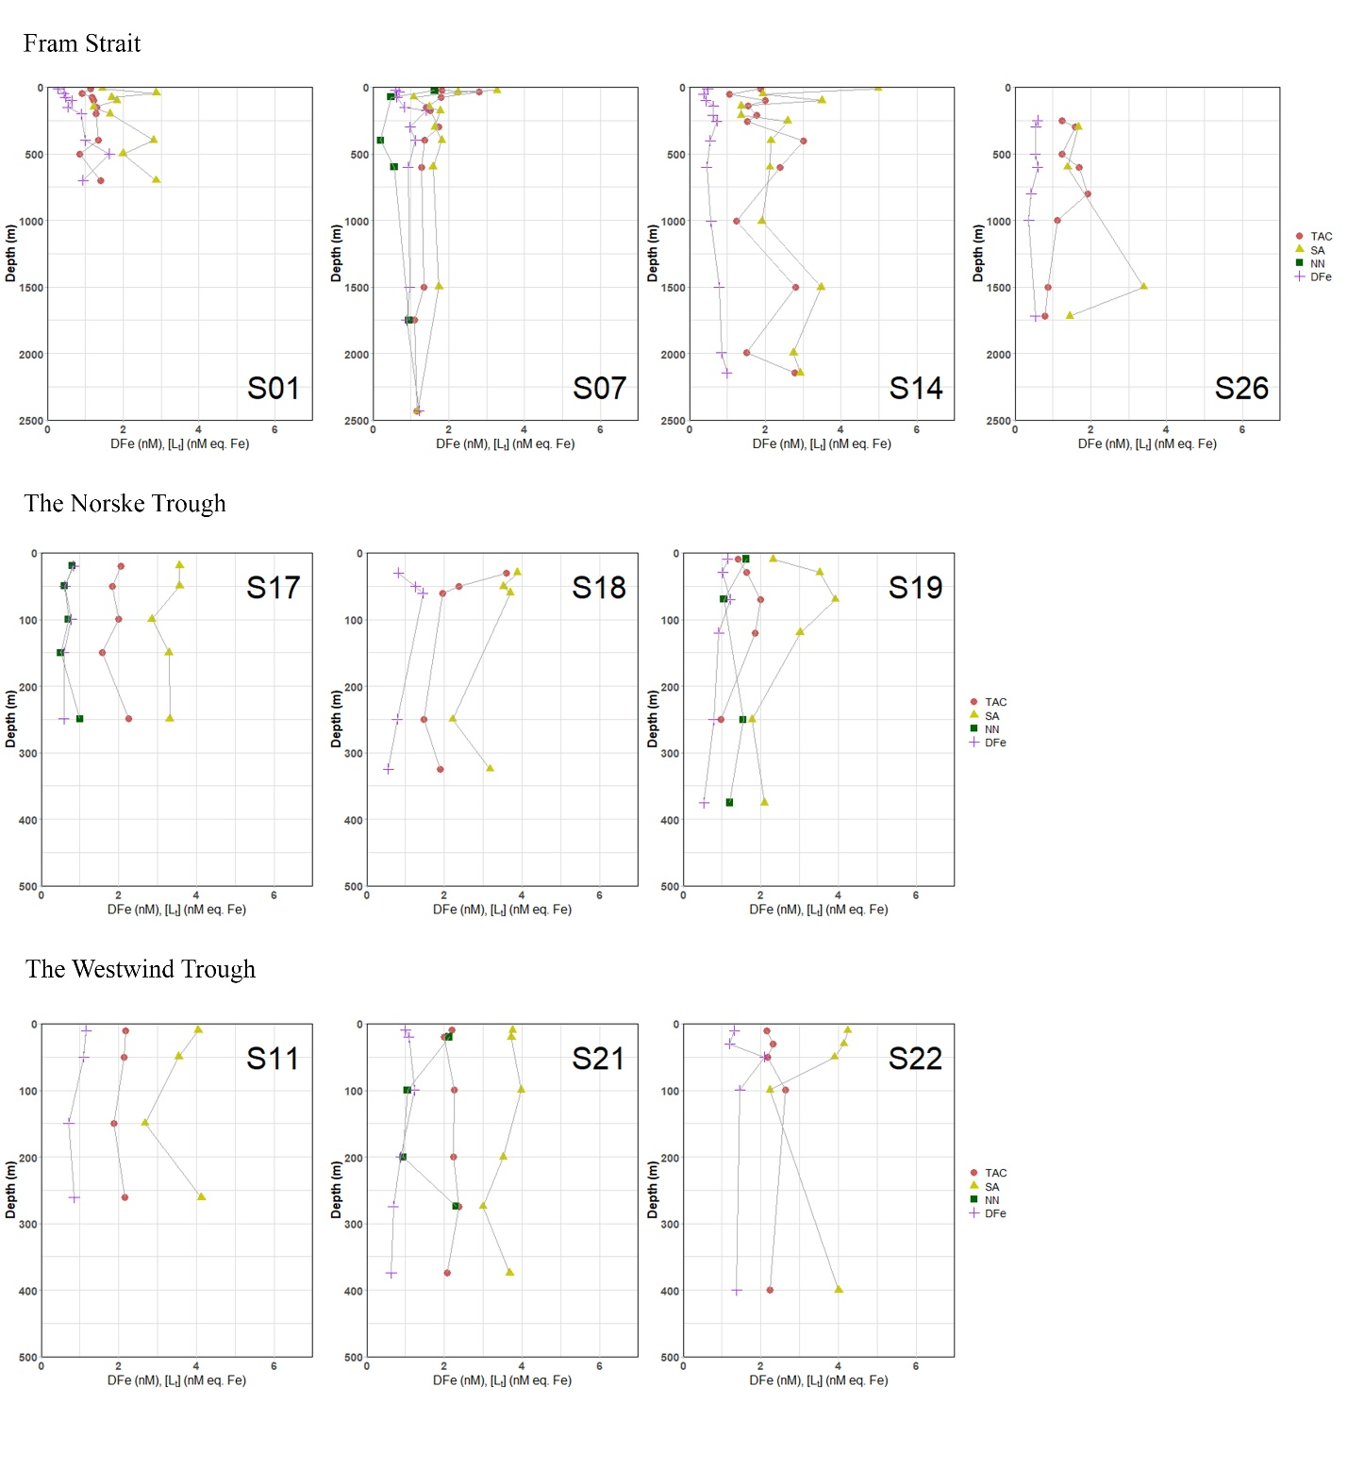

Supplementary Figure 4. Boxplot of excess ligand concentrations ([Lˊ]) the TAC (a) and SA (b) methods according to the one-ligand model. The added ligand used is indicated at the top left of each figure. The calculation was done using the script written in R software. The details of the boxplot are described in Figure 2.
