Source contribution of firecrackers burst vs. long-range transport of biomass burning emissions over an urban background

Prashant Rajput^{1, 2*}, Amit Kumar Singh¹, Kaniska Biswas³, Adnan Mateen Qadri¹, Tarun Gupta^{1, 4*}

Supplementary material
Special issue—“The Role of Climate and Air Pollution in Human Health and Urban Chemistry in Asian Cities”
Journal: Frontiers in Sustainable Cities
Section: Climate Change and Cities
December 2020

¹Department of Civil Engineering, Indian Institute of Technology Kanpur, Kanpur - 208 016, India
²Current affiliation: Centre for Environmental Health (CEH), Public Health Foundation of Indian, Gurugram - 122 002, India
³Design Programme, Indian Institute of Technology Kanpur, Kanpur - 208 016, India
⁴Atmospheric Particle Technology Laboratory at Centre for Environmental Science and Engineering (CESE), Indian Institute of Technology Kanpur, Kanpur - 208 016, India
*Corresponding author’s E-mail: prashant.rajput@phfi.org; tarun@iitk.ac.in
Based on fire-count imageries (over source region of BB) and cluster analysis the long-range transport of BB-emissions from its source region in north-west direction has been inferred. We have found a quite similar observation using wind pattern analysis by wind-rose plot and cluster analysis. Since Diwali is a 1-day festival and firecrackers are burst predominantly on Diwali, we have attributed the Diwali period to be associated with the firecrackers burst. Furthermore, the influence of urban background was systematically considered (Table 4) for the entire study period (pre-Diwali, Diwali, and post-Diwali) as sources within urban agglomeration are active throughout the year.
There are already potentially existing evidences highlighting the source-region of BB-emissions and its transport to downwind locations. For the land-use agro pattern, and source-region of BB-emissions we have shown below two adopted figures from the published articles (Rajput et al., 2011; 2014; Rajput and Gupta 2020).

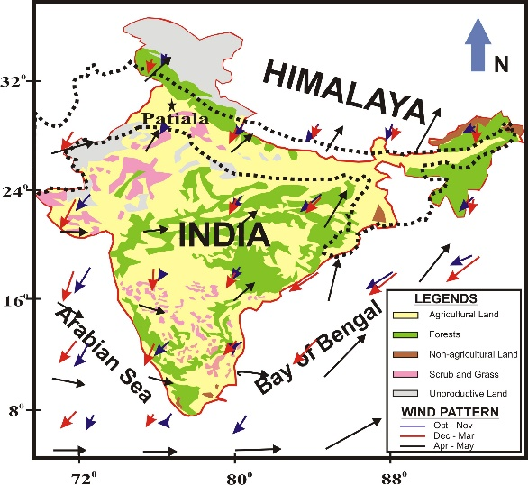
FIGURE S1 | Showing land-use agro pattern in India (adopted from: Rajput et al., 2011).

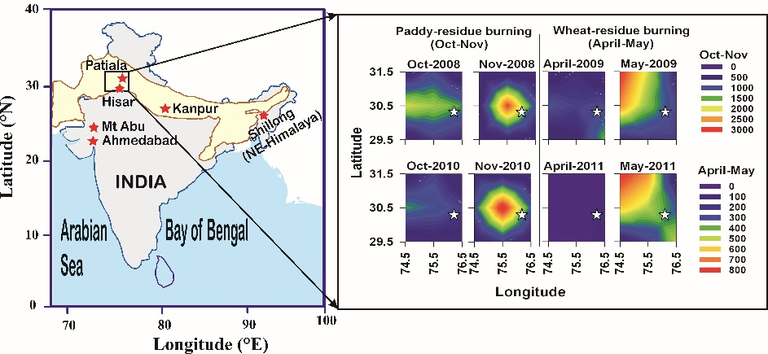
FIGURE S2 | A typical scenario of source-region (2° x 2°) of large-scale post-harvest agricultural-waste burning of paddy- and wheat residues during Oct‒Nov and April‒May periods, respectively in Indo-Gangetic Plain (IGP) (adopted from: Rajput et al., 2014).

References
Rajput, P., Sarin, M., Sharma, D., Singh, D. (2014). Characteristics and emission budget of carbonaceous species from post-harvest agricultural-waste burning in source region of the Indo-Gangetic Plain. Tellus B: Chem. Phys. Meteorol. 66, 21026.
Rajput, P., Sarin, M.M., Rengarajan, R., Singh, D. (2011). Atmospheric polycyclic aromatic hydrocarbons (PAHs) from post-harvest biomass burning emissions in the Indo-Gangetic Plain: Isomer ratios and temporal trends. Atmos. Environ. 45, 6732‒6740.

