Supplementary File 1. Brief SCARP: 7-8 Years Scoring Guide

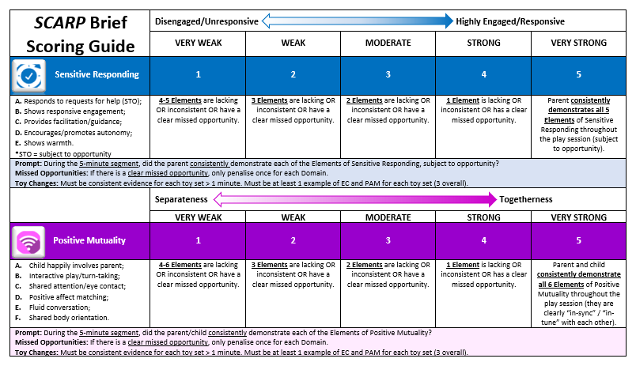
Supplementary File 2. Guide to Rating SCARP:7-8 Years Elements.

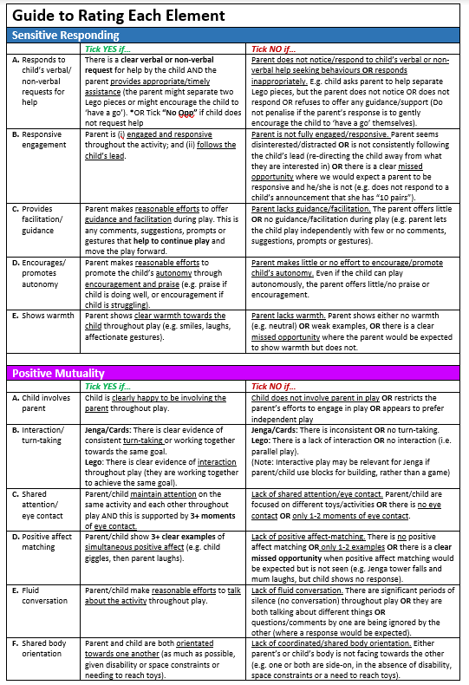
Supplementary File 3. Scoring Sheet for SCARP:7-8 Years

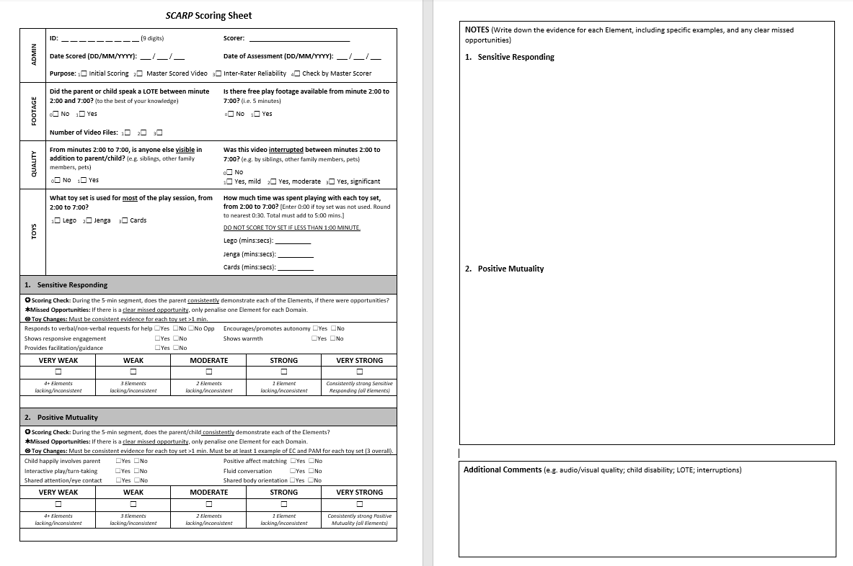
Supplementary File 4. Adjusted associations between sensitive responding, positive mutuality and demographic factors.

 | Sensitive responding |  | Positive mutuality
 | Coefficient (95% CI) | p | Coefficient (95% CI) | p
Child age (years) | -.12 (-.45, .22) | .49 | -.03 (-.37, .31) | .86
Parent age (years) | .02 (.00, .03) | .04 | -.01 (-.03, .01) | .30
Child gender (male) | -.01 (-.19, .16) | .90 | -.11 (-.28, .07) | .23
Parent gender (male) | -.57 (-1.08, -.07) | .03 | -.50 (-1.02, .01) | .05
Language other than English | -.22 (-.43, -.01) | .04 | -.12 (-.33, .09) | .26
Single parent | -.09 (-.38, .21) | .56 | .04 (-.26, .33) | .81
Parent without year 12 | -.02 (-.38, .35) | .93 | -.24 (-.61, .13) | .21
Household unemployment | -.16 (-.49, .17) | .35 | -.17 (-.50, .17) | .33
Neighbourhood disadvantage | .002 (.000, .003) | .02 | .0002 (-.001, .002) | .78
 | Adj R² = .10 |  | Adj R² = .21

*Adjusted for main toy used, allocated condition, local government area, and locality (during participation in RCT approximately five years earlier)

