Supplementary Material

Continental heat flow and seismic precursors
The recent new compilation and model of the global heat flow by Lucazeau (2019) offers the opportunity to calculate the average heat flow value in the area where a precursor occurred with an approximation of 0.5°. The majority of the listed precursors occurred in areas with heat flow value higher than the average continental heat flow (~67 mW·m⁻²).
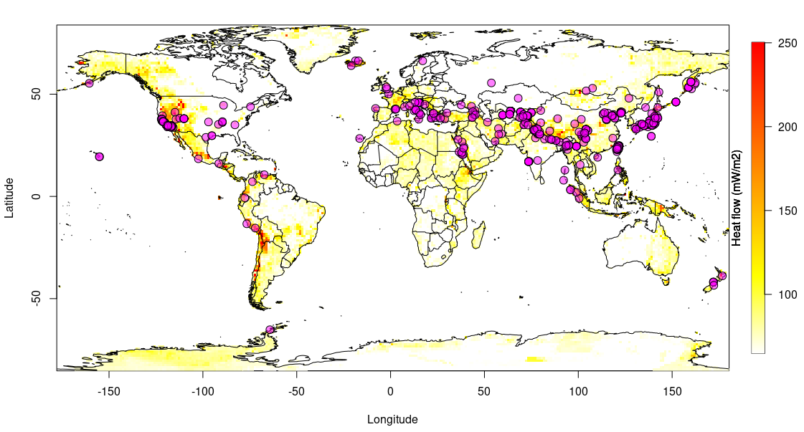
Supplementary Figure 1. Continental heat flow map from Lucazeau (2019) and seismic precursors (purple circles) from our updated catalogue.

Tectonic stress regimes and seismic precursors
The World Stress Map (WSM) compiled since 1986 shows the orientation of the maximum horizontal stress and the dominant tectonic regime. Heidbach et al. (2018) recently updated the WSM database with further data records. We divided the tectonic regimes into two categories: normal faulting/strike-slip (NF/SS in Fig. 2a) and thrust faulting (TF in Fig. 2b). The plots in Figure 2 show that the first category is the most dominant where the majority of seismic precursors have occurred, in particular in Central Asia and North America.
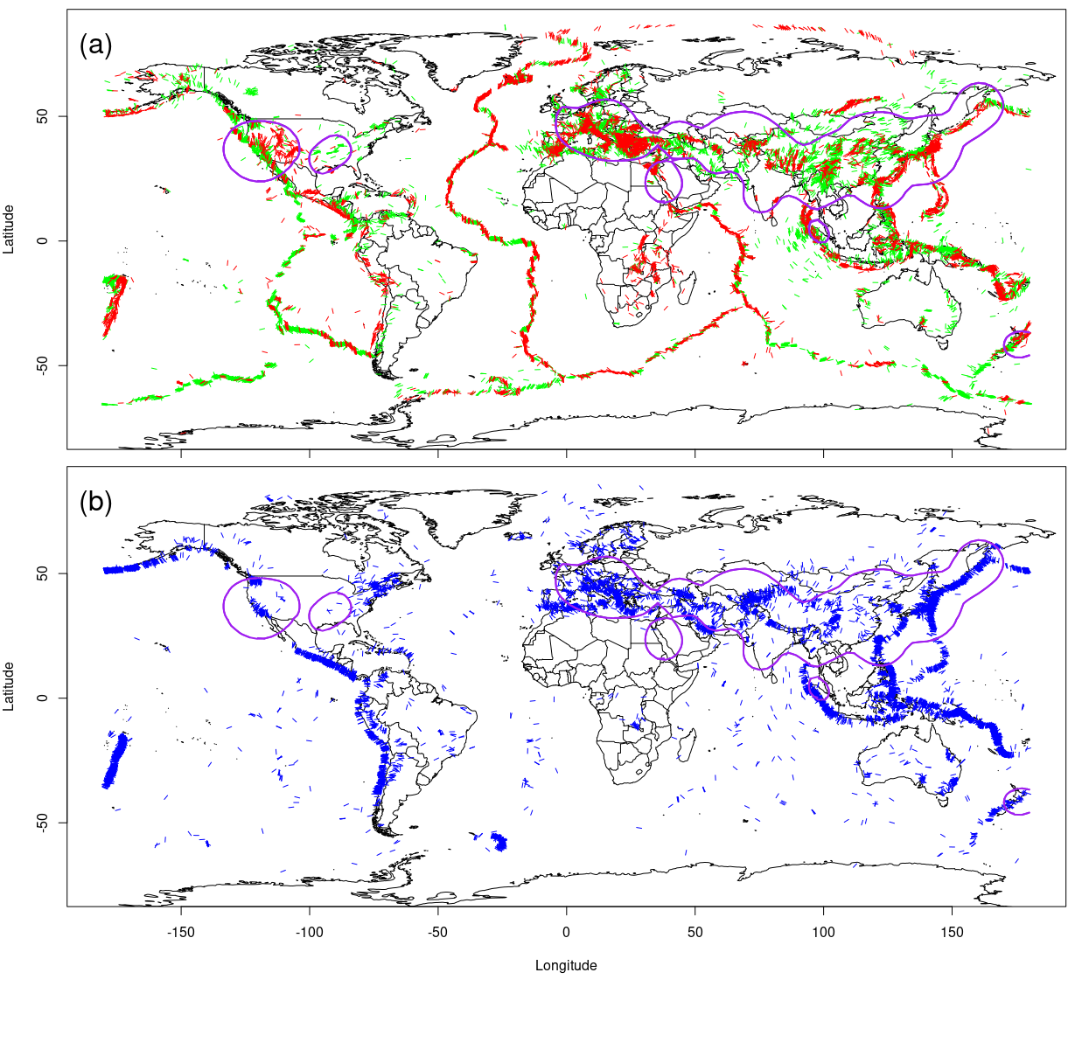
Supplementary Figure 2. Horizontal stress orientation and tectonic regimes for (a) normal (red) and strike-slip (green) faulting and (b) thrust faulting (blue) from Heidbach et al. (2018). The areas where the majority of seismic precursors occur are within the purple lines.

Seismic precursors deep seismicity
We show in our work that seismic precursors are clustered in regions in the world characterized by shallow seismicity (with hypocentral depth < 20 km). In Figure 3, we calculated the kernel density of the distribution of deep earthquakes (with hypocentral depth ≥ 20 km) and compared with the position of the seismic precursors of our catalogue. We found no apparent spatial correspondence between the seismic precursors and regions with more deep seismicity as, instead, observed for the shallow seismicity.
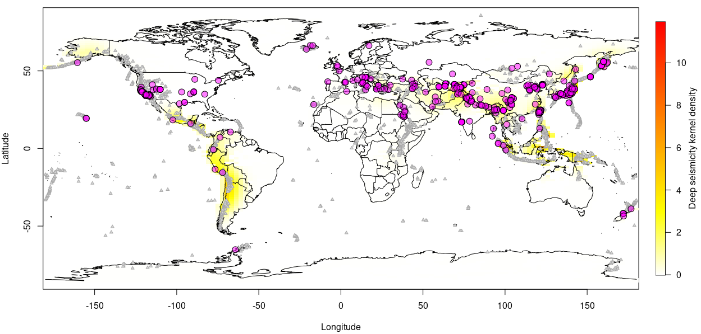
Supplementary Figure 3. Kernel density map of deep (hypocentral depth ≥ 20 km) seismic activity. Seismic precursors are shown as purple circles and Holocene and Pleistocene volcanoes as small light gray triangles.

Potential areas for monitoring earthquake preparation processes
In these figures are shown earthquakes (green dots) characterized by M>=5.5 (International Seismological Centre, 2020) that occurred in areas affected by relatively high heat flux (>=65 mW/m²) in the depth interval 0-20 km. Each seismic event is inserted in a pixel (50·50 km) indicating the local heat flux (Lucazeau , 2019). Pleistocenic and Holocenic volcanic areas (red triangles) are also indicated (Global Volcanism Program, 2013). Earthquake precursors that occurred in the considered areas are shown in Fig.2 and in Supplementary Material Fig.4a-h through more detailed local maps.
Clusters of shallow earthquakes in area with high heat flux and volcanism represent areas characterized by a relatively higher favourability to detect possible earthquake precursors.

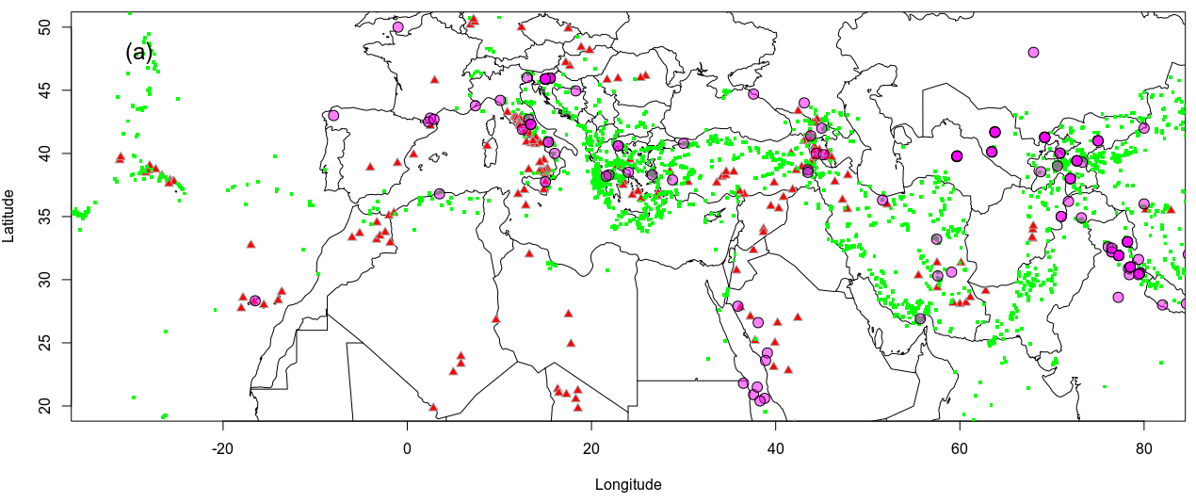

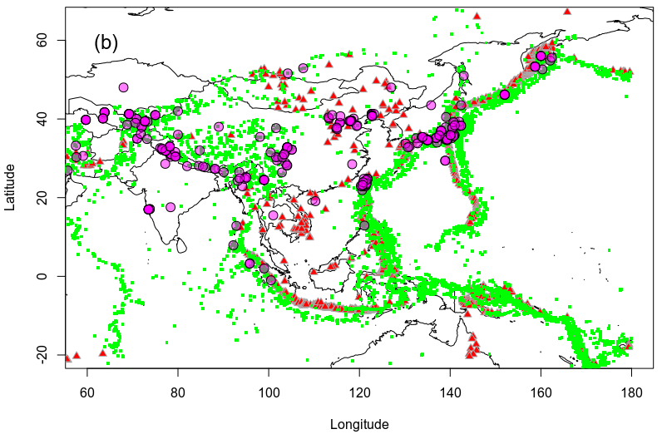

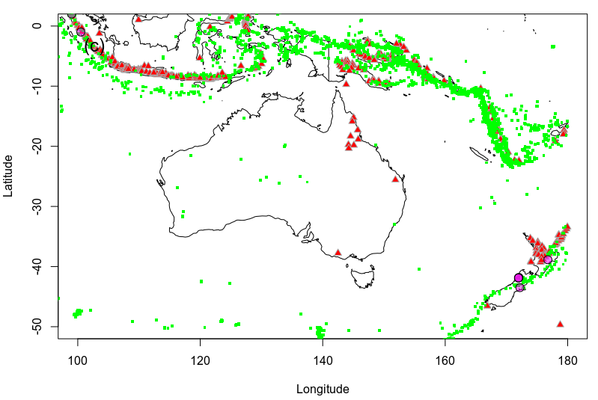

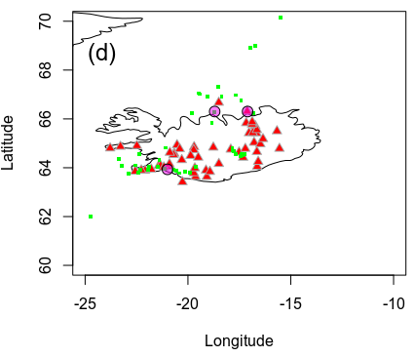

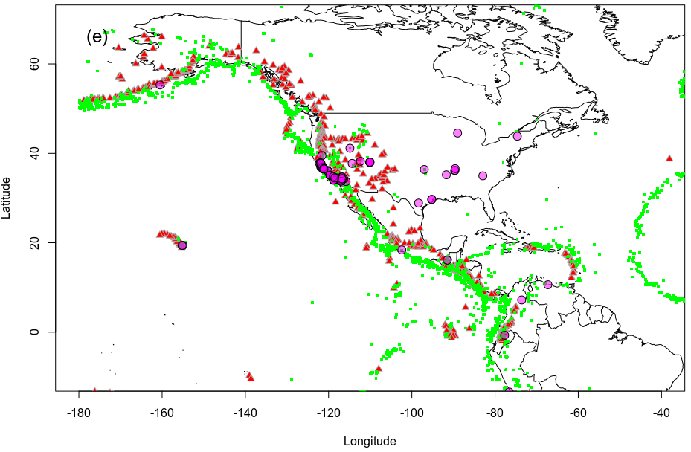

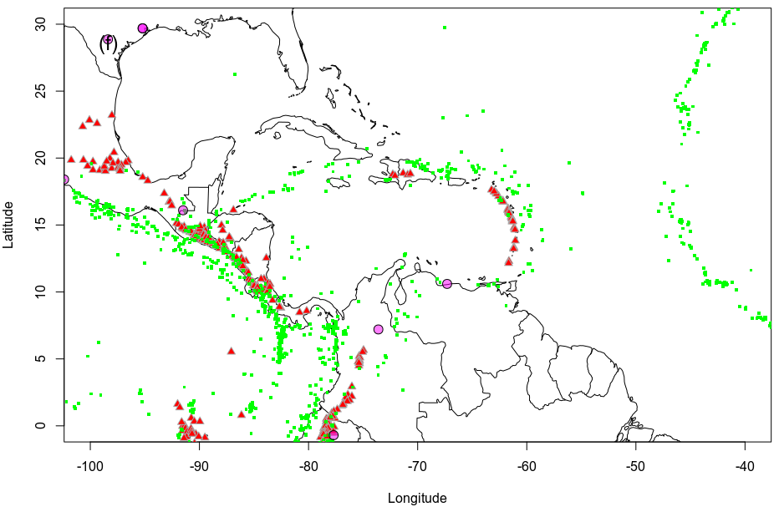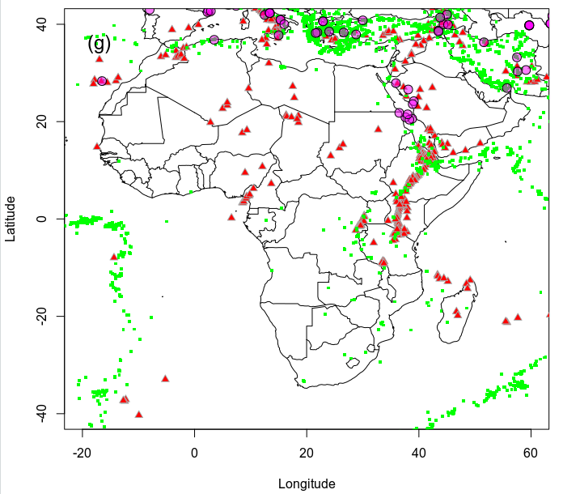

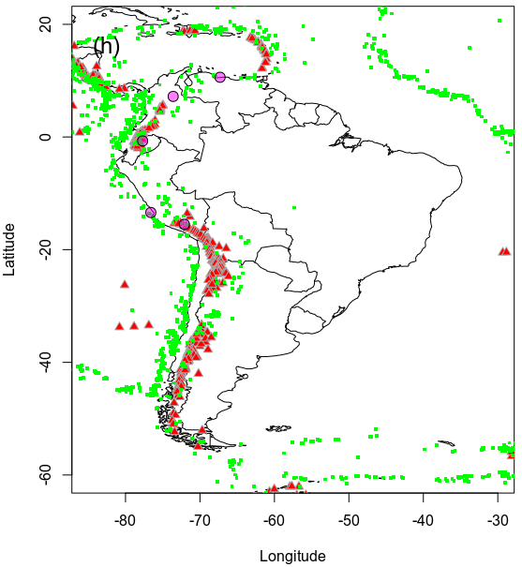

Supplementary Figure 4. Different areas of the world where shallow earthquakes (0-20 km, green dots) with M>=5.5 occur in areas characterized by heat flux ≥ 65 mW/m². Pleistocenic and Holocenic volcanic areas (red triangles) and seismic precursors (purple circles) are also shown.

Seismic precursor catalogue
In Table 1, we report our catalogue of seismic precursors. The precursor-earthquake distance and time lag (in days) for b-value-type precursors must be considered as our interpretation of the work where these values are not clearly expressed. The references in Table 1 are fully reported in the section References at the end of the Supplementary Material.

Long | Lat | M | Distance | Days lag | Type | Ref
51.60 | 36.30 | 6.3 | 100 | 730 | bvalue | Agh-Atabai and Mirabedini, 2014
15.95 | 40.01 | 5 | 100 |  | bvalue | Baskoutas and D'Alessandro 2014
39.06 | 24.24 | 5.8 |  | 1140 | bvalue | Baskoutas and Papadopoulos 2013
38.79 | 20.56 | 6.4 |  | 900 | bvalue | Baskoutas and Papadopoulos 2013
38.13 | 26.59 | 6 |  | 510 | bvalue | Baskoutas and Papadopoulos 2013
37.58 | 20.86 | 6.1 |  | 990 | bvalue | Baskoutas and Papadopoulos 2013
38.34 | 20.42 | 6 |  | 1680 | bvalue | Baskoutas and Papadopoulos 2013
36.50 | 21.78 | 6.7 |  | 660 | bvalue | Baskoutas and Papadopoulos 2013
37.98 | 21.51 | 7 |  | 2190 | bvalue | Baskoutas and Papadopoulos 2013
35.85 | 27.92 | 6.7 |  | 1560 | bvalue | Baskoutas and Papadopoulos 2013
38.85 | 23.62 | 6.1 |  | 630 | bvalue | Baskoutas and Papadopoulos 2013
79.42 | 30.41 | 6.8 | 100 |  | bvalue | Baskoutas et al, 2011
93.60 | 24.90 | 6.7 | 100 |  | bvalue | Borgohain et al., 2018
104.01 | 28.24 | 7.1 |  | 861 | bvalue | Chen et al., 1984b
98.96 | 24.49 | 6.7 | 200 | 695 | bvalue | Chen et al., 1984b
121.51 | 24.46 | 6.4 |  | 251 | bvalue | Chen et al., 1990
95.80 | 3.20 | 9 | 150 | 4015 | bvalue | DasGupta et al., 2007
135.01 | 34.58 | 7.2 | 100 | 2637 | bvalue | Enescu and Ito, 2001
43.50 | 38.50 | 7.2 | 100 | 573 | bvalue | Görgün, 2013
140.70 | 39.18 | 6.2 | 100 | 730 | bvalue | Hasegawa et al., 1975
140.10 | 35.90 | 6 |  | 730 | bvalue | Imoto, 1991
133.90 | 35.40 | 6.2 |  | 730 | bvalue | Imoto, 1991
137.60 | 35.80 | 6.8 |  | 730 | bvalue | Imoto, 1991
140.10 | 35.90 | 6.1 |  | 730 | bvalue | Imoto, 1991
133.90 | 35.40 | 6.7 | 100 | 730 | bvalue | Imoto, 1991
-76.55 | -13.38 | 8 | 250 | 920 | bvalue | Kulhanek et al., 2018
120.70 | 23.20 | 5.2 | 30 | 30 | bvalue | Lin, 2010
172.20 | -43.50 | 7.2 | 150 | 365 | bvalue | Lu, 2017
118.20 | 39.40 | 7.8 |  | 545 | bvalue | Ma, 1978
122.80 | 40.70 | 7.3 |  | 665 | bvalue | Ma, 1978
115.00 | 37.80 | 7.2 |  | 1030 | bvalue | Ma, 1978
119.40 | 38.20 | 7.4 |  | 365 | bvalue | Ma, 1978
115.80 | 40.70 | 5.5 |  | 84 | bvalue | Ma, 1978
118.00 | 39.50 | 4.2 |  | 96 | bvalue | Ma, 1978
104.10 | 28.20 | 7.1 |  | 665 | bvalue | Ma, 1982
100.40 | 31.50 | 7.9 |  | 515 | bvalue | Ma, 1982
130.72 | 32.77 | 7.3 | 50 |  | bvalue | Nanjo and Yoshida, 2017
142.40 | 38.30 | 9 | 300 | 3650 | bvalue | Nanjo et al., 2012
92.19 | 7.92 | 7.2 | 150 | 135 | bvalue | Nuannin et al., 2012
29.97 | 40.76 | 6.7 | 100 |  | bvalue | Öztürk, 2010
70.59 | 38.95 | 6.3 | 100 |  | bvalue | Popandopoulos, 2018
-121.90 | 37.80 | 4.3 |  | 1 | bvalue | Bufe, 1970
-67.30 | 10.60 | 6.6 | 100 | 930 | bvalue | Fiedler, 1974
-121.20 | 36.60 | 5 |  | 130 | bvalue | Wyss and Lee, 1973
-121.10 | 36.50 | 4.6 |  | 120 | bvalue | Wyss and Lee, 1973
95.10 | 25.10 | 7.3 | 300 | 4259 | bvalue | Sahu and Saikia, 1994
-118.88 | 34.80 | 5 |  | 1278 | bvalue | Smith, 1981
172.04 | -41.76 | 7.1 |  | 2191 | bvalue | Smith, 1981
-118.50 | 34.50 | 6.4 |  | 2556 | bvalue | Smith, 1981
171.97 | -41.90 | 5.9 |  | 1168 | bvalue | Smith, 1981
176.77 | -38.86 | 5.7 |  | 1460 | bvalue | Smith, 1981
171.97 | -41.90 | 6 |  | 1168 | bvalue | Smith, 1981
55.70 | 26.90 | 6.1 | 100 | 170 | bvalue | Sorbi et al., 2012
76.50 | 32.50 | 5 |  | 105 | bvalue | Srivastava et al., 1984
142.37 | 38.32 | 9 |  | 4450 | bvalue | Tormann et al., 2015
120.80 | 23.90 | 7.6 | 100 | 1577 | bvalue | Tsai et al., 2006
141.00 | 38.40 | 6.2 | 100 | 170 | bvalue | Tsukakoshi and Shimazaki, 2008
-97.00 | 36.40 | 5.8 | 100 | 60 | bvalue | Walter et al., 2017
-155.15 | 19.44 | 7.2 | 20 | 2340 | bvalue | Wyss et al., 1981
103.40 | 31.00 | 8 | 200 | 5110 | bvalue | Zhao and Wu. 2008
114.00 | 41.00 | 6.3 | 150 | 365 | bvalue | Zheng and Zhou, 2014
57.48 | 33.21 | 7.4 | 500 | 21 | gas emissions | Barsukov et al., 1985
43.81 | 41.45 | 5.6 |  |  | gas emissions | Bella et al., 1995a, 1995b
45.20 | 39.88 | 6.9 | 400 |  | gas emissions | Bella et al., 1995a, 1995b
160.00 | 56.00 | 7.1 | 100 |  | gas emissions | Biagi et al., 2000a,2000b
160.00 | 56.00 | 7 | 152 |  | gas emissions | Biagi et al., 2000a,2000b
160.00 | 56.00 | 6.9 | 96 | 60 | gas emissions | Biagi et al., 2000a,2000b
160.00 | 56.00 | 7.1 | 228 |  | gas emissions | Biagi et al., 2000a,2000b
160.00 | 56.00 | 7.7 | 366 | 3 | gas emissions | Biagi et al., 2000a,2000b
13.38 | 42.35 | 6.3 | 10 | 7 | gas emissions | Bonfanti et al., 2012
94.70 | 24.80 | 5.8 | 748 | 2 | gas emissions | Chaudhuri et al., 2010
73.22 | 34.90 | 5 | 215 | 2 | gas emissions | Chaudhuri et al., 2013
84.81 | 32.00 | 6.3 | 938 | 16 | gas emissions | Chaudhuri et al., 2013
71.84 | 36.25 | 5 | 212 | 4 | gas emissions | Chaudhuri et al., 2013a
-116.85 | 34.26 | 4.8 | 30 | 150 | gas emissions | Chung, 1985
-116.85 | 34.26 | 4.8 |  |  | gas emissions | Craig, 1980
-74.64 | 43.84 | 3.9 | 14 |  | gas emissions | Fleischer, 1981
-88.99 | 44.55 | 1.5 | 1 |  | gas emissions | Fleischer, 1981
-110.07 | 38.03 | 6.6 | 300 |  | gas emissions | Fleischer, 1981
122.75 | 40.85 | 7.3 | 26 |  | gas emissions | Fleischer, 1981
122.75 | 40.85 | 7.3 |  | NA | gas emissions | Fleischer, 1981
123.17 | 41.27 | 4.8 | 32 |  | gas emissions | Fleischer, 1981
63.45 | 40.13 | 7.3 | 400 |  | gas emissions | Fleischer, 1981
-77.67 | -0.68 | 6.9 | 367 |  | gas emissions | Flores Humanante et al., 1990
-117.91 | 34.51 | 3.5 | 25 | 31 | gas emissions | Hauksson, 1981
-82.94 | 34.97 | 2.3 | 1 | 14 | gas emissions | Hauksson, 1981
-118.78 | 34.03 | 4.7 | 20 | 82 | gas emissions | Hauksson, 1981
-116.85 | 34.26 | 5 | 85 | 12 | gas emissions | Hauksson, 1981
-116.85 | 34.26 | 5 | 31 | 45 | gas emissions | Hauksson, 1981
-110.07 | 38.03 | 6.6 | 335 | 116 | gas emissions | Hauksson, 1981
-110.07 | 38.03 | 6.6 | 310 | 95 | gas emissions | Hauksson, 1981
-110.07 | 38.03 | 6.6 | 265 | 145 | gas emissions | Hauksson, 1981
-110.07 | 38.03 | 6.6 | 260 | 2 | gas emissions | Hauksson, 1981
118.18 | 39.63 | 7.8 | 50 | 970 | gas emissions | Hauksson, 1981
118.18 | 39.63 | 7.8 | 100 | 15 | gas emissions | Hauksson, 1981
118.18 | 39.63 | 7.8 | 130 | 1370 | gas emissions | Hauksson, 1981
118.18 | 39.63 | 7.8 | 130 | 162 | gas emissions | Hauksson, 1981
105.13 | 32.24 | 5.2 | 345 | 14 | gas emissions | Hauksson, 1981
98.95 | 24.51 | 7.5 | 20 | 510 | gas emissions | Hauksson, 1981
98.95 | 24.51 | 7.5 | 190 | 425 | gas emissions | Hauksson, 1981
98.95 | 24.51 | 7.5 | 210 | 160 | gas emissions | Hauksson, 1981
98.95 | 24.51 | 7.5 | 215 | 130 | gas emissions | Hauksson, 1981
98.95 | 24.51 | 7.5 | 360 | 75 | gas emissions | Hauksson, 1981
98.95 | 24.51 | 7.5 | 420 | 290 | gas emissions | Hauksson, 1981
98.95 | 24.51 | 7.5 | 450 | 12 | gas emissions | Hauksson, 1981
104.09 | 32.78 | 7.2 | 40 | 480 | gas emissions | Hauksson, 1981
104.09 | 32.78 | 7.2 | 100 | 420 | gas emissions | Hauksson, 1981
104.09 | 32.78 | 7.2 | 100 | 190 | gas emissions | Hauksson, 1981
104.09 | 32.78 | 7.2 | 320 | 200 | gas emissions | Hauksson, 1981
104.09 | 32.78 | 7.2 | 340 | 48 | gas emissions | Hauksson, 1981
104.09 | 32.78 | 7.2 | 340 | 160 | gas emissions | Hauksson, 1981
104.09 | 32.78 | 7.2 | 390 | 160 | gas emissions | Hauksson, 1981
104.09 | 32.78 | 7.2 | 560 | 34 | gas emissions | Hauksson, 1981
69.22 | 41.26 | 5.3 | 5 | 400 | gas emissions | Hauksson, 1981
69.22 | 41.26 | 4 | 5 | 11 | gas emissions | Hauksson, 1981
69.22 | 41.26 | 3.5 | 5 | 3 | gas emissions | Hauksson, 1981
69.22 | 41.26 | 3.5 | 5 | 3 | gas emissions | Hauksson, 1981
69.22 | 41.26 | 3 | 5 | 8 | gas emissions | Hauksson, 1981
69.22 | 41.26 | 3.3 | 5 | 7 | gas emissions | Hauksson, 1981
69.22 | 41.26 | 3 | 5 | 4 | gas emissions | Hauksson, 1981
63.83 | 41.67 | 4.7 | 130 | 5 | gas emissions | Hauksson, 1981
73.35 | 39.30 | 7.3 | 530 | 100 | gas emissions | Hauksson, 1981
80.00 | 42.00 | 5.3 | 100 | 110 | gas emissions | Hauksson, 1981
63.45 | 40.13 | 7.3 | 470 | 4 | gas emissions | Hauksson, 1981
63.45 | 40.13 | 7.3 | 550 | 90 | gas emissions | Hauksson, 1981
70.85 | 40.04 | 6.6 | 200 | 125 | gas emissions | Hauksson, 1981
53.73 | 55.53 | 7.1 | 65 | 50 | gas emissions | Hauksson, 1981
72.71 | 39.42 | 6.7 | 270 | 470 | gas emissions | Hauksson, 1981
72.71 | 39.42 | 6.7 | 300 | 470 | gas emissions | Hauksson, 1981
72.71 | 39.42 | 6.7 | 150 | 75 | gas emissions | Hauksson, 1981
72.71 | 39.42 | 6.7 | 150 | 70 | gas emissions | Hauksson, 1981
70.85 | 40.04 | 6.6 | 190 | 60 | gas emissions | Hauksson, 1981, Fleischer, 1981
105.13 | 32.24 | 7.2 | 350 | 2 | gas emissions | Jiang and Li, 1981
117.76 | 39.46 | 6.9 |  | 12 | gas emissions | Jiang et al., 1981
132.77 | 33.84 | 4.9 | 50 | 120 | gas emissions | Kawabe, 1984
-119.65 | 35.12 | 4.3 | 25 | 60 | gas emissions | King, 1978, King, 1980
-119.65 | 35.12 | 4 | 47 | 90 | gas emissions | King, 1978, King, 1980
121.53 | 23.51 | 5 | 32 | 54 | gas emissions | Kuo et al., 2013
122.75 | 40.85 | 7.4 |  |  | gas emissions | Liang, 1980
118.18 | 39.63 | 7.8 |  |  | gas emissions | Liang, 1980
104.09 | 32.78 | 7.9 |  |  | gas emissions | Liang, 1980
117.76 | 39.46 | 6.5 |  |  | gas emissions | Liang, 1980
139.84 | 35.21 | 6.6 | 280 | 0 | gas emissions | Nagamine and Sugisaki, 1991a
-121.54 | 36.84 | 4.8 | 15 | 30 | gas emissions | O'Neil and King, 1980
2.90 | 42.70 | 5.2 | 100 |  | gas emissions | Perez, 1996
10.14 | 44.15 | 5.2 |  | 20 | gas emissions | Pierotti et al., 2015
-8.00 | 43.00 | 4.6 | 90 |  | gas emissions | Redondo et al., 1996
-121.40 | 36.85 | 5.2 |  | 11 | gas emissions | Reimer, 1980
-121.84 | 37.11 | 7.1 | 60 |  | gas emissions | Reimer, 1990
-121.54 | 37.09 | 5.9 | 65 |  | gas emissions | Reimer, 1990
-121.91 | 37.88 | 5.5 | 155 |  | gas emissions | Reimer, 1990
-121.38 | 36.48 | 4.9 | 35 |  | gas emissions | Reimer, 1990
-121.77 | 37.68 | 4.1 | 120 |  | gas emissions | Reimer, 1990
-121.54 | 36.84 | 4.5 | 45 |  | gas emissions | Reimer, 1990
139.10 | 40.46 | 7.7 | 480 |  | gas emissions | Satake et al., 1985
-120.31 | 36.23 | 5.2 | 40 |  | gas emissions | Sato et al., 1986
104.19 | 51.61 | 6.2 |  | 20 | gas emissions | Semenov and Smekalin, 2011
-117.00 | 33.75 | 3.7 | 13 | 3 | gas emissions | Shapiro et al., 1985
113.15 | 40.44 | 5.8 | 285 | 15 | gas emissions | Shi and Cai, 1986
118.18 | 39.63 | 7.8 | 460 | 8 | gas emissions | Shi and Cai, 1986
138.00 | 37.00 | 6.8 | 50 | 230 | gas emissions | Sugisaki and Sugiura, 1985, Sugisaki and Sugiura, 1986
138.00 | 37.00 | 6.8 | 230 | 120 | gas emissions | Sugisaki and Sugiura, 1985, Sugisaki and Sugiura, 1986
138.00 | 37.00 | 6.8 | 50 | 120 | gas emissions | Sugisaki and Sugiura, 1985, Sugisaki and Sugiura, 1986
138.00 | 37.00 | 6.8 |  | 15 | gas emissions | Sugisaki and Sugiura, 1985, Sugisaki and Sugiura, 1986
134.96 | 34.65 | 6.9 | 50 |  | gas emissions | Sugisaki et al., 1996
134.96 | 34.65 | 7.2 | 220 | 0 | gas emissions | Sugisaki et al., 1996
134.96 | 34.65 | 7.2 | 220 | 0 | gas emissions | Sugisaki et al., 1996
136.91 | 35.18 | 4.1 | 100 | 60 | gas emissions | Sugisaki, 1978
136.91 | 35.18 | 4.1 | 60 | 50 | gas emissions | Sugisaki, 1978
136.91 | 35.18 | 4.1 | 75 | 50 | gas emissions | Sugisaki, 1978
136.91 | 35.18 | 4.1 | 130 | 120 | gas emissions | Sugisaki, 1978
110.31 | 19.10 | 5.2 | 340 | 14 | gas emissions | Teng, 1980
104.09 | 32.78 | 7.2 | 320 | 1 | gas emissions | Teng, 1980
68.80 | 38.55 |  | 20 | 1 | gas emissions | Varshal et al., 1985
77.25 | 31.92 | 2.2 | 166 |  | gas emissions | Virk and Baljinder, 1995
77.25 | 31.92 | 2.7 | 105 |  | gas emissions | Virk and Baljinder, 1995
77.25 | 31.92 | 4.4 | 440 |  | gas emissions | Virk and Baljinder, 1995
77.25 | 31.92 | 4.4 | 440 |  | gas emissions | Virk and Baljinder, 1995
77.25 | 31.92 | 3.6 | 265 |  | gas emissions | Virk and Baljinder, 1995
77.25 | 31.92 | 3.7 | 325 |  | gas emissions | Virk and Baljinder, 1995
77.25 | 31.92 | 3.7 | 325 |  | gas emissions | Virk and Baljinder, 1995
79.50 | 30.50 | 6.8 |  |  | gas emissions | Virk et al., 2001
79.50 | 30.50 | 6.8 |  |  | gas emissions | Virk et al., 2001
79.50 | 30.50 | 6.8 |  |  | gas emissions | Virk et al., 2001
139.37 | 34.72 | 6.8 | 25 | 230 | gas emissions | Wakita et al., 1988
139.37 | 34.72 | 6.8 | 25 | 7 | gas emissions | Wakita et al., 1988
118.37 | 28.45 | 7.9 | 200 | 9 | gas emissions | Wakita et al., 1988
103.67 | 28.84 | 5.5 | 200 | 9 | gas emissions | Wakita et al., 1988
121.00 | 24.75 | 7 |  | 30 | gas emissions | Walia et al., 2009
120.30 | 23.00 | 7 |  | 30 | gas emissions | Walia et al., 2009
121.59 | 23.66 | 6.1 |  | 3 | gas emissions | Walia et al., 2013
120.70 | 22.97 | 6.4 |  | 8 | gas emissions | Walia et al., 2013
42.506 | 13.39 | 3 | 11.5 |  | ground deformation | Bella et al., 1995a,b
42.499 | 13.41 | 3.1 | 9.1 |  | ground deformation | Bella et al., 1995a,b
42.412 | 13.46 | 3.3 | 7.6 |  | ground deformation | Bella et al., 1995a,b
42.537 | 13.19 | 3.5 | 27.7 |  | ground deformation | Bella et al., 1995a,b
42.72 | 13.50 | 3.5 | 28 |  | ground deformation | Bella et al., 1995a,b
42.534 | 13.09 | 3.7 | 35.8 |  | ground deformation | Bella et al., 1995a,b
42.582 | 13.29 | 3.7 | 27.7 |  | ground deformation | Bella et al., 1995a,b
42.36 | 13.27 | 3.9 | 23.1 |  | ground deformation | Bella et al., 1995a,b
120.97 | 23.77 | 7.6 | 100 | 365 | ground deformation | Chen et al., 2015
-117.50 | 34.26 | 4.1 | 15 | 21 | ground deformation | Clark, 1981
101.62 | 37.68 | 6.4 | 30 | 150 | ground deformation | Cui et al., 2016
13.00 | 46.20 | 3.9 | 2.9 | 9 | ground deformation | Dal Moro and Zadro, 1999
13.00 | 46.00 | 4.1 | 2 | 60 | ground deformation | Dragoni et al., 1985
162.35 | 55.58 | 6.9 | 100 | 2 | ground deformation | Fedotov et al., 1992
139.01 | 37.89 | 7.5 | 30 | 1825 | ground deformation | Fujii and Nakane, 1997
-121.7 | 37.4 | 2.5 |  |  | ground deformation | Iwatsubo and Mortersen, 1979
-121.7 | 37.4 | 3.9 | 4.5 | 2.6 | ground deformation | Iwatsubo and Mortersen, 1979
-121.80 | 37.30 | 4.2 | 6 | 3 | ground deformation | Iwatsubo and Mortersen, 1979
-122.18 | 37.80 | 4.3 | 6 | 30 | ground deformation | Jones et al., 1977
140.88 | 39.03 | 6.9 | 50 | 1460 | ground deformation | Kumazawa et al., 2010
-116.40 | 34.28 | 5.1 | 8 | 2 | ground deformation | Leary and Malin, 1984
-116.40 | 34.28 | 2 | 8 | 5 | ground deformation | Leary and Malin, 1984
-116.40 | 34.28 | 2.4 | 24 | 2 | ground deformation | Leary and Malin, 1984
-116.40 | 34.28 | 3.1 | 32 | 2 | ground deformation | Leary and Malin, 1984
-114.87 | 41.14 | 6.2 | 60 | 30 | ground deformation | Li and Lin, 2020
-114.34 | 37.76 | 4.5 | 50 | 30 | ground deformation | Li and Lin, 2020
-112.35 | 38.25 | 4.6 | 50 | 30 | ground deformation | Li and Lin, 2020
-98.38 | 28.87 | 4.8 | 50 | 30 | ground deformation | Li and Lin, 2020
135.75 | 43.50 | 7.7 | 90 | 150 | ground deformation | Linde et al., 1988
-72.08 | -15.54 | 7.6 | 120 | 1 | ground deformation | Melbourne and Webb, 2002
137.10 | 34.00 | 8.1 | 200 | 1 | ground deformation | Mogi, 1985
13.38 | 42.35 | 6.3 | 30 | 180 | ground deformation | Nardò et al., 2020
130.17 | 33.74 | 6.6 | 100 | 180 | ground deformation | Ogata, 2010
-115.82 | 33.75 | 6.1 |  | 46 | ground deformation | Shifflett and Witbaard, 1996
-116.39 | 34.27 | 7.3 |  | 22 | ground deformation | Shifflett and Witbaard, 1996
-154.96 | 19.37 | 7.2 |  | 150 | ground deformation | Wyss et al., 1981
80.00 | 36.00 | 7.3 | 200 |  | ground deformation | Yiqing et al. 2015
103.70 | 31.60 | 8 | 200 |  | ground deformation | Yiqing et al. 2015
102.20 | 30.20 | 7 | 100 |  | ground deformation | Yiqing et al. 2015
115.67 | 39.00 | 6.9 | 100 | 100 | groundwater level | Alimova and Zubkov, 1983
138.92 | 34.86 | 7 | 35 | 289 | groundwater level | Alimova and Zubkov, 1983
22.93 | 40.64 | 4.8 | 33 | 5 | groundwater level | Asteriadis and Livieratos, 1989
73.50 | 17.00 | 4.4 | 3 | 23 | groundwater level | Chadha et al., 2003
73.50 | 17.00 | 4.3 | 12 | 3 | groundwater level | Chadha et al., 2003
73.50 | 17.00 | 4.7 | 24 | 28 | groundwater level | Chadha et al., 2003
73.50 | 17.00 | 5.2 | 12 | 24 | groundwater level | Chadha et al., 2003
107.61 | 52.85 | 5 | 25 | 60 | groundwater level | Golenetskii et al., 1982
139.77 | 35.42 | 5.9 | 90 | 2 | groundwater level | Igarashi et al., 1992
142.45 | 43.52 | 8.1 | 1,260 |  | groundwater level | Igarashi et al., 1996
142.00 | 39.33 | 7.8 | 800 |  | groundwater level | Igarashi et al., 1996
63.83 | 41.67 | 7.3 | 200 | 1 | groundwater level | Ishankulov and Kalugin, 1976
131.00 | 33.00 | 6.6 | 226 | 0 | groundwater level | Kawabe et al., 1988
139.10 | 35.24 | 6.1 | 510 | 5 | groundwater level | King et al., 2000
139.10 | 35.24 | 7.2 | 220 | 10 | groundwater level | King et al., 2000
139.10 | 35.24 | 7.5 | 800 | 10 | groundwater level | King et al., 2000
139.10 | 35.24 | 8.1 | 1,260 | 30 | groundwater level | King et al., 2000
139.10 | 35.24 | 6.6 | 290 | 5 | groundwater level | King et al., 2000
139.10 | 35.24 | 5.8 | 50 | 180 | groundwater level | King et al., 2000
63.83 | 41.67 | 5.1 | 150 | 40 | groundwater level | Kissin et al., 1984a
63.83 | 41.67 | 5.1 | 150 | 5 | groundwater level | Kissin et al., 1984a
71.00 | 35.00 | 6.6 | 450 | 4 | groundwater level | Kissin et al., 1984b
138.92 | 34.86 | 2.5 | 30 | 1 | groundwater level | Koizumi et al., 1999, Koizumi et al., 2004
158.68 | 53.32 | 5.2 | 139 |  | groundwater level | Kopylova and Boldina, 2012
158.68 | 53.32 | 6.3 | 152 |  | groundwater level | Kopylova and Boldina, 2012
158.68 | 53.32 | 5.4 | 153 |  | groundwater level | Kopylova and Boldina, 2012
158.68 | 53.32 | 5.5 | 145 |  | groundwater level | Kopylova and Boldina, 2012
158.68 | 53.32 | 5.2 | 296 |  | groundwater level | Kopylova and Boldina, 2012
158.68 | 53.32 | 5 | 259 |  | groundwater level | Kopylova and Boldina, 2012
158.68 | 53.32 | 5.4 | 185 |  | groundwater level | Kopylova and Boldina, 2012
162.04 | 54.84 | 7.8 | 300 | 90 | groundwater level | Kopylova and Boldina, 2020
-116.78 | 34.69 | 5 |  | 25 | groundwater level | Kovach et al., 1975
-116.78 | 34.69 | 4.7 |  | 40 | groundwater level | Kovach et al., 1975
75.00 | 41.00 | 6.8 | 140 | 3 | groundwater level | Mavlyanov and Sultankhodzhaev, 1981
-116.97 | 33.79 | 5.5 | 35 | 4 | groundwater level | Merifield and Lamar, 1981
59.07 | 30.61 | 6.7 | 400 | 21 | groundwater level | Mil'kis & Voronin, 1983
63.83 | 41.67 | 7.3 | 530 | 300 | groundwater level | Mil'kis and Voronin, 1983
59.67 | 39.75 | 7.3 | 10 | 180 | groundwater level | Mil'kis, 1984
59.67 | 39.75 | 7.3 | 10 | 60 | groundwater level | Mil'kis, 1984
59.67 | 39.75 | 7.3 | 90 | 225 | groundwater level | Mil'kis, 1984
59.67 | 39.75 | 7.3 | 90 | 150 | groundwater level | Mil'kis, 1984
152.00 | 46.17 | 5.6 | 440 | 9 | groundwater level | Monakhov et al., 1979
152.00 | 46.17 | 7 | 450 | 6 | groundwater level | Monakhov et al., 1980
152.00 | 46.17 | 5.2 | 90 | 6 | groundwater level | Monakhov et al., 1980
152.00 | 46.17 | 7.5 | 270 | 7 | groundwater level | Monakhov, 1981
152.00 | 46.17 | 5.4 | 95 | 5 | groundwater level | Monakhov, 1981
152.00 | 46.17 | 6.3 | 170 | 6 | groundwater level | Monakhov, 1981
75.00 | 41.00 | 6.6 | 300 | 35 | groundwater level | Orolbaev, 1984
75.00 | 41.00 | 6.6 | 140 | 14 | groundwater level | Orolbaev, 1984
68.00 | 48.00 | 5.3 | 95 | 2 | groundwater level | Ospanov and Mizev, 1985
122.67 | 41.25 | 7.3 | 40 | 8 | groundwater level | Raleigh et al., 1977
122.67 | 41.25 | 7.3 | 145 | 4 | groundwater level | Raleigh et al., 1977
-120.06 | 36.00 | 6.1 | 70 |  | groundwater level | Roeloffs and Quilty, 1997
72.00 | 38.00 | 6.3 | 210 | 135 | groundwater level | Sultankhodzhaev and Chernov, 1978
72.00 | 38.00 | 5 | 25 | 150 | groundwater level | Sultankhodzhaev and Chernov, 1978
72.00 | 38.00 | 5.9 | 100 | 3 | groundwater level | Sultankhodzhaev et al., 1986
139.25 | 34.75 | 7 | 30 | 0 | groundwater level | Wakita, 1984
98.14 | 35.45 | 6.8 | 20 | 20 | groundwater level | Wang et al., 1984a
122.67 | 41.25 | 5.6 | 20 | 1 | groundwater level | Wang et al., 1984a
115.67 | 39.00 | 7.8 | 5 | 2640 | groundwater level | Wang et al., 1984b
115.67 | 39.00 | 7.8 | 30 | 1090 | groundwater level | Wang et al., 1984b
138.92 | 34.86 | 6.6 | 30 | 40 | groundwater level | Yamaguchi, 1980
121.00 | 24.00 | 6.3 |  | 0 | groundwater level | Yu and Mitchell, 1988
59.67 | 39.75 | 4.5 | 120 | 60 | groundwater level | Zhukov et al., 1978
15.32 | 40.90 | 6.5 | 220 | 150 | radon | Allegri et al., 1983
15.32 | 40.90 | 6.5 | 200 | 180 | radon | Allegri et al., 1983
7.40 | 43.77 | 3.9 | 56 | 5 | radon | Borchiellini et al., 1991
78.32 | 30.91 | 4.9 | 60 | 7 | radon | Choubey et al., 2009
3.48 | 36.77 | 6.7 | 1,120 | 2 | radon | Cigolini et al., 2007
-1.00 | 50.00 | 1.2 | 90 |  | radon | Crockett et al., 2006
-2.08 | 52.50 | 3.1 | 90 |  | radon | Crockett et al., 2006
-2.24 | 53.48 | 5 | 90 |  | radon | Crockett et al., 2006
92.87 | 12.84 | 5 | 1,215 |  | radon | Das et al., 2006
95.85 | 3.32 | 9.1 | 2,275 |  | radon | Das et al., 2006
100.50 | -1.00 | 5.8 | 2,120 |  | radon | Das et al., 2006
99.00 | 2.00 | 5.1 | 2,070 |  | radon | Das et al., 2006
84.60 | 28.10 | 7.8 | 722 | 5 | radon | Deb et al., 2016
88.10 | 27.30 | 6.9 | 612 | 6 | radon | Deb et al., 2016
86.00 | 27.70 | 7.3 | 618 | 13 | radon | Deb et al., 2016
90.10 | 26.50 | 5.6 | 470 | 29 | radon | Deb et al., 2016
-160.50 | 55.34 | 6.3 | 180 |  | radon | Fleischer and Mogro-Campero, 1985
118.18 | 39.63 | 7.8 | 1,800 |  | radon | Fleischer, 1981
120.54 | 22.92 | 6.6 | 31 | 14 | radon | Fu et al., 2017
88.19 | 27.30 | 5 | 93 | 9 | radon | Ghosh et al., 2011
85.45 | 27.90 | 4.9 | 98 | 24 | radon | Ghosh et al., 2011
-21.00 | 63.93 | 2.7 | 14 | 22 | radon | Hauksson and Goddard, 1981
-21.00 | 63.93 | 3.4 | 5 | 17 | radon | Hauksson and Goddard, 1981
-21.00 | 63.93 | 3.4 | 21 | 17 | radon | Hauksson and Goddard, 1981
-21.00 | 63.93 | 4.3 | 16 | 18 | radon | Hauksson and Goddard, 1981
-21.00 | 63.93 | 1.9 | 9 | 19 | radon | Hauksson and Goddard, 1981
-21.00 | 63.93 | 2.8 | 8 | 17 | radon | Hauksson and Goddard, 1981
-21.00 | 63.93 | 2.8 | 5 | 33 | radon | Hauksson and Goddard, 1981
-17.10 | 66.30 | 4.1 | 56 | 50 | radon | Hauksson and Goddard, 1981
119.47 | 38.43 | 7.4 | 170 | 170 | radon | Hauksson, 1981
114.90 | 37.60 | 4.3 | 42 | 40 | radon | Hauksson, 1981
115.10 | 37.40 | 4.9 | 18 | 16 | radon | Hauksson, 1981
122.75 | 40.85 | 7.3 | 50 | 270 | radon | Hauksson, 1981
122.75 | 40.85 | 7.3 | 50 | 50 | radon | Hauksson, 1981
122.75 | 40.85 | 7.3 | 140 | 66 | radon | Hauksson, 1981
122.75 | 40.85 | 7.3 | 140 | 8 | radon | Hauksson, 1981
138.94 | 29.38 | 7.9 | 1,000 | 2 | radon | Igarashi and Wakita, 1990
138.94 | 29.38 | 7.9 | 4 | 3 | radon | Igarashi and Wakita, 1990
140.47 | 37.75 | 6.6 | 260 |  | radon | Igarashi et al., 1990
140.47 | 37.75 | 6.7 | 130 |  | radon | Igarashi et al., 1990
140.47 | 37.75 | 6.6 | 110 |  | radon | Igarashi et al., 1990
135.18 | 34.69 | 7.2 | 30 | 90 | radon | Igarashi et al., 1995
14.99 | 37.75 | 3.5 | 650 | 6 | radon | Imme et al., 2005
26.55 | 38.27 | 4.1 | 7 | 6 | radon | Inan et al., 2010
-119.65 | 35.12 | 4 | 45 | 15 | radon | King, 1980
-119.65 | 35.12 | 4.2 | 75 | 240 | radon | King, 1980
-119.65 | 35.12 | 3.4 | 40 | 1 | radon | King, 1985
-119.65 | 35.12 | 3.4 | 1 | 1 | radon | King, 1985
121.40 | 23.07 | 6.8 |  |  | radon | Kuo et al., 2010
121.09 | 22.88 | 6.1 |  |  | radon | Kuo et al., 2010
121.30 | 22.86 | 5.9 |  |  | radon | Kuo et al., 2010
121.46 | 23.30 | 5.4 |  |  | radon | Kuo et al., 2010
121.76 | 24.75 | 5.8 | 39 |  | radon | Liu et al., 1985
121.76 | 24.75 | 5.2 | 23 |  | radon | Liu et al., 1985
121.76 | 24.75 | 4.6 | 14 |  | radon | Liu et al., 1985
121.76 | 24.75 | 5 | 37 |  | radon | Liu et al., 1985
121.76 | 24.75 | 5.3 | 45 |  | radon | Liu et al., 1985
57.55 | 30.28 | 4.2 | 20 | 10 | radon | Montazeri et al., 2011
21.55 | 38.15 | 6.5 | 20 | 60 | radon | Nikolopoulos et al., 2012; Nikolopoulos et al., 2014; Petraki et al., 2013a; Petraki et al., 2013b
24.00 | 38.50 | 5.1 | 80 | 7 | radon | Nikolopoulos et al., 2015
-16.51 | 28.33 | 2.5 |  | 180 | radon | Perez et al., 2007
12.51 | 41.89 | 2.5 | 25 |  | radon | Garavaglia et al., 1998
18.30 | 44.95 | 2.8 | 70 | 30 | radon | Planinic et al. 2000
-73.58 | 7.23 | 6.2 |  | 0 | radon | Ghosh et al., 2009
-91.51 | 16.11 | 4.7 | 100 | 10 | radon | Alekseev et al., 1995
101.00 | 15.50 | 6.2 | 293 | 14 | radon | Wattananikorn et al., 1998
82.00 | 28.00 | 3 | 17 |  | radon | Ghosh et al., 2009
37.60 | 44.70 | 5 |  | 3 | radon | Nevinsky and Tsvetkova, 2005
-64.26 | -65.25 | 7.5 | 1,176 |  | radon | Ilic et al., 2005
143.00 | 51.00 | 5.4 | 700 | 12 | radon | Tsvetkova et al., 2005
78.43 | 30.37 | 4.6 | 16 |  | radon | Ramola et al., 2008
78.37 | 17.56 | 1 | 30 | 1 | radon | Reddy et al., 2004
121.09 | 12.93 | 7.1 | 48 | 7 | radon | Richon et al., 2003
-102.39 | 18.35 | 8.1 | 260 |  | radon | Segovia et al., 1989
-118.17 | 34.15 | 2.9 | 21 | 1 | radon | Shapiro et al., 1980
-118.17 | 34.15 | 2.8 | 12 | 10 | radon | Shapiro et al., 1980
-118.78 | 34.03 | 4.6 | 54 |  | radon | Shapiro et al., 1980
-95.21 | 29.69 | 2.9 | 21 | 3 | radon | Shapiro et al., 1980
-95.21 | 29.69 | 2.8 | 12 | 9 | radon | Shapiro et al., 1980
-118.78 | 34.03 | 4.7 | 54 | 42 | radon | Shapiro et al., 1980
76.50 | 32.17 | 6.8 | 150 |  | radon | Singh et al., 1991
77.24 | 28.60 | 5.4 |  | 15 | radon | Singh et al., 1999
78.20 | 33.00 | 5 | 201 | 13 | radon | Singh et al., 2010
79.40 | 31.60 | 4 | 339 |  | radon | Singh et al., 2010
78.20 | 33.00 | 5 | 210 | 14 | radon | Singh et al., 2010
78.20 | 33.00 | 5 | 188 | 13 | radon | Singh et al., 2010
78.20 | 33.00 | 5 | 199 | 3 | radon | Singh et al., 2010
94.90 | 25.30 | 4.8 | 278 | 1 | radon | Singh et al., 2016
94.20 | 22.90 | 4.7 | 176 | 4 | radon | Singh et al., 2016
93.50 | 26.50 | 5.5 | 320 | 12 | radon | Singh et al., 2016
93.20 | 24.30 | 4.5 | 78 | 24 | radon | Singh et al., 2016
-89.66 | 36.18 | 3.9 |  | 33 | radon | Steele, 1981
-89.66 | 36.18 | 4 | 40 | 150 | radon | Steele, 1984
-91.73 | 35.23 | 4 | 160 | 365 | radon | Steele, 1984
89.00 | 38.00 | 4.2 | 120 | 60 | radon | Steele, 1984
-89.59 | 36.58 | 3.5 | 50 | 60 | radon | Steele, 1984
44.43 | 40.00 | 4.2 | 65 | 90 | radon | Ghosh et al., 2009
-120.06 | 36.00 | 5.6 | 300 | 10 | radon | Teng and Sun, 1986
-117.32 | 34.18 | 5 | 20 | 42 | radon | Teng and Sun, 1986
118.74 | 40.10 | 6 | 200 | 3 | radon | Teng, 1980
101.84 | 29.52 | 5.2 | 70 | 12 | radon | Teng, 1980
101.63 | 30.31 | 5.8 | 54 | 12 | radon | Teng, 1980
45.00 | 42.00 | 2.7 | 150 | 10 | radon | Tsvetkova et al., 2001
43.06 | 44.05 | 5.4 | 300 | 3 | radon | Tsvetkova et al., 2005
138.00 | 37.00 | 6.8 | 65 | 14 | radon | Ui et al., 1988
78.50 | 31.00 | 7 | 450 | 7 | radon | Virk and Singh, 1994
78.50 | 31.00 | 7 | 270 | 7 | radon | Virk and Singh, 1994
78.50 | 31.00 | 7 | 330 | 7 | radon | Virk and Singh, 1994
71.00 | 35.00 | 5 | 400 |  | radon | Virk et al., 1993
76.50 | 32.17 | 6.6 | 400 |  | radon | Virk et al., 1993
139.25 | 34.75 | 7 | 25 |  | radon | Wakita et al., 1980
140.93 | 35.75 | 6 | 200 | 1 | radon | Wakita et al., 1989
140.73 | 35.63 | 6 | 200 | 2 | radon | Wakita et al., 1991
76.10 | 32.57 | 5.1 | 10 | 3 | radon | Walia et al., 2006
103.37 | 31.02 | 8 | 99 | 7 | radon | Ye et al., 2015
102.96 | 30.28 | 7 | 15 | 7 | radon | Ye et al., 2015
15.49 | 45.96 | 0.8 | 1 | 2 | radon | Zmazek et al., 2005
15.49 | 45.96 | 0.7 | 2 | 3 | radon | Zmazek et al., 2005
15.49 | 45.96 | 2.1 | 2 | 17 | radon | Zmazek et al., 2005
15.49 | 45.96 | 1.8 | 2 |  | radon | Zmazek et al., 2005
15.49 | 45.96 | 3.2 | 1 |  | radon | Zmazek et al., 2005
15.49 | 45.96 | 2.2 | 1 | 33 | radon | Zmazek et al., 2005
15.49 | 45.96 | 3 | 0 |  | radon | Zmazek et al., 2005
15.49 | 45.96 | 1.8 | 1 |  | radon | Zmazek et al., 2005
15.49 | 45.96 | 1.9 | 2 | 5 | radon | Zmazek et al., 2005
15.49 | 45.96 | 1.1 | 1 |  | radon | Zmazek et al., 2005
15.49 | 45.96 | 2.7 | 2 |  | radon | Zmazek et al., 2005
15.49 | 45.96 | 1.3 | 1 | 1 | radon | Zmazek et al., 2005
15.49 | 45.96 | 1 | 2 |  | radon | Zmazek et al., 2005
15.49 | 45.96 | 1.6 | 1 | 22 | radon | Zmazek et al., 2005
15.49 | 45.96 | 1.4 | 0 | 10 | radon | Zmazek et al., 2005
15.49 | 45.96 | 2.7 | 2 | 33 | radon | Zmazek et al., 2005
15.49 | 45.96 | 1.9 | 1 |  | radon | Zmazek et al., 2005
15.51 | 45.96 | 3 | 0 | 3 | radon | Zmazek et al., 2005
15.51 | 45.96 | 1.4 | 0 |  | radon | Zmazek et al., 2005
15.51 | 45.96 | 2.7 | 2 |  | radon | Zmazek et al., 2005
15.51 | 45.96 | 1.9 | 1 |  | radon | Zmazek et al., 2005
14.99 | 45.90 | 3 | 0 | 18 | radon | Zmazek et al., 2005
14.99 | 45.90 | 1.8 | 1 | 7 | radon | Zmazek et al., 2005
14.99 | 45.90 | 1.9 | 2 |  | radon | Zmazek et al., 2005
14.99 | 45.90 | 1.4 | 0 |  | radon | Zmazek et al., 2005
14.99 | 45.90 | 2.7 | 2 | 4 | radon | Zmazek et al., 2005
22.93 | 40.64 | 4.8 | 41 | 5 | temp. variations | Asteriadis and Livieratos, 1989
141.00 | 35.90 | 7 | 290 | 0 | temp. variations | Mogi et al., 1989
139.10 | 34.90 | 5.4 | 16 |  | temp. variations | Mogi et al., 1989
139.19 | 34.92 | 6.7 | 16 | 3 | temp. variations | Mogi et al., 1989
139.30 | 34.60 | 7 | 31 | 10 | temp. variations | Mogi et al., 1989
140.32 | 35.15 | 5.4 | 28 |  | temp. variations | Mogi et al., 1989
142.03 | 38.19 | 7.4 | 470 |  | temp. variations | Mogi et al., 1989
139.38 | 35.12 | 5.7 | 46 | 0 | temp. variations | Mogi et al., 1989
113.29 | 40.09 | 6.1 | 200 | 2 | temp. variations | Qiang et al., 1997
-121.88 | 37.04 | 7.1 | 43 | 3 | temp. variations | Silver et al., 1990; Valette-Silver and Silver, 1991; Silver and Valette-Silver, 1992
21.88 | 38.33 | 5.4 | 2 | 1 | temp. variations | Soter, 1999
-121.65 | 37.13 | 6.1 | 200 | 1 | temp. variations | Valette-Silver and Silver, 1991; Silver and Valette-Silver, 1992
-121.57 | 39.52 | 5.8 | 200 | 1 | temp. variations | Valette-Silver and Silver, 1991; Silver and Valette-Silver, 1992
13.22 | 42.71 | 6 | 57 | 120 | water composition | Barberio et al., 2017
17.10 | 66.30 | 5.8 | 100 | 7 | water composition | Claesson et al., 2004
28.81 | 37.92 | 4.5 | 8 | 30 | water composition | Inan et al., 2010
43.51 | 38.72 | 7.2 |  |  | water composition | Inan et al., 2012
-121.49 | 36.78 | 4.8 | 10 | 30 | water composition | King et al., 1981
134.41 | 35.00 | 3.7 | 10 |  | water composition | Koizumi et al., 1985
132.50 | 35.10 | 6.1 | 182 |  | water composition | Koizumi et al., 1985
134.59 | 34.95 | 4.3 | 9 |  | water composition | Koizumi et al., 1985
134.23 | 34.95 | 4.9 | 24 |  | water composition | Koizumi et al., 1985
134.59 | 34.94 | 3.9 | 9 |  | water composition | Koizumi et al., 1985
134.56 | 34.92 | 3.5 | 7 |  | water composition | Koizumi et al., 1985
133.73 | 35.43 | 6.2 | 88 |  | water composition | Koizumi et al., 1985
120.60 | 21.90 | 7.2 | 22 | 120 | water composition | Liu et al., 2010
13.38 | 42.35 | 6.3 |  | 30 | water composition | Plastino et al., 2010
2.54 | 42.80 | 5.2 | 29 | 8 | water composition | Poitrasson et al., 1999
73.83 | 17.12 | 4.7 | 24 | 8 | water composition | Reddy and Nagabhushanam, 2011
73.82 | 17.11 | 5.1 | 24 | 2 | water composition | Reddy and Nagabhushanam, 2011
160.32 | 52.59 | 6.5 | 48 |  | water composition | Ryabinin et al., 2012
-18.75 | 66.31 | 5.6 | 76 | 150 | water composition | Skelton et al., 2014
127.00 | 48.00 | 5 |  |  | water composition | Sorokina et al., 2011
2.25 | 42.50 | 5.2 | 29 | 5 | water composition | Toutain et al., 1997
135.18 | 34.69 | 7.2 | 20 | 4 | water composition | Tsunogai and Wakita, 1995, Tsunogai and Wakita, 1996
102.87 | 26.38 | 5.4 | 200 | 100 | water composition | Wang et al., 2018

References
Agh-Atabai, M., Mirabedini, M.S. Temporal variations of seismicity parameters in the Central Alborz, Iran. Acta Geophys. 62, 486–504 (2014). https://doi.org/10.2478/s11600-013-0172-7
Alekseev, V.A., Alekseeva, N.G., Jchankuliev, 1995. On relation between fluxes of metals in waters and radon in Turkmenistan region of seismic activity. Radiation Measurements 25 (1–4), 637–639.
Alimova, V.A., Zubkov, S.I., 1983. Catalog of earthquake precursors. Hydrogeodynamic Precursors: Institute of Physics of the EarthAkad. Nauk SSSR, Moscow. (140 pp. in Russian).
Allegri, L., Bella, F., DellaMonica, G., Ermini, A., Improta, S., Sgrigna, V., Biagi, P.F.,1983. Radon and tilt anomalies detected before the Irpinia (south Italy) earthquake ofNovember 23, 1980 at great distances from the epicenter. Geophys. Res. Lett. 10, 269–272.
Asteriadis, G., Livieratos, E., 1989. Pre-seismic responses ofundergroundwater level and temperature concerning a 4.8 magnitude earthquake in Greece on October 20,1998. Tectonophysics 170, 165–169.
Barberio, M.D., Barbieri, M., Billi, A. et al. Hydrogeochemical changes before and during the 2016 Amatrice-Norcia seismic sequence (central Italy). Sci Rep 7, 11735 (2017). https://doi.org/10.1038/s41598-017-11990-8
Barsukov, V.L., Varshal, G.M., Zamokina, N.S., 1985. Recent results of hydrogeochemical studies for earthquake prediction in the USSR. Pure Appl. Geophys. 122, 143–156.
Baskoutas, & Papadopoulos (2013). Qualitative precursory pattern before several strong earthquakes in Greece.. Bulletin of the Geological Society of Greece, 47, 1061-1070.
Baskoutas, I. and D'Alessandro, A.: Study of the seismicity temporal variation for the current seismic hazard evaluation in Val d'Agri, Italy, Nat. Hazards Earth Syst. Sci., 14, 3169–3174, https://doi.org/10.5194/nhess-14-3169-2014, 2014.
Bella, F., Biagi, P.F., Caputo, M., Cozzi, E., Della Monica, G., Ermini, A., Plastino, W., Sgrigna, V., Zilpimiani, D., 1995a. Helium content in thermal waters in the Caucasus from 1985 to 1991 and correlations with the seismic activity. Tectonophysics 246, 263–278.
Bella, F., Biagi, P.F., Caputo, M., Della Monica, G., Ermini, A., Manjgaladze, P.V., Sgrigna, V., Zilpimiani, D.O.,1995b. Possible creep-related tilt precursors obtained in the central Apennines (Italy) and in the southern Caucasus (Georgia). Pure Appl. Geophys.144, 277–300
Biagi, P.F., Ermini, A., Cozzi, E., Khatkevich, Y.M., Gordeev, E.I., 2000a. Hydrogeochemical precursors in Kamchatka (Russia) related to the strongest earthquakes in 1988– 1997. Nat. Hazards 21, 263–276.
Biagi, P.F., Ermini, A., Kingsley, S.P., Khatkevich, Y.M., Gordeev, E.I., 2000b. Groundwater ion content precursors of strong earthquakes in Kamchatka (Russia). Pure Appl. Geophys. 157, 1359–1377
Bonfanti, P., Genzano, N., Heinicke, J., Italiano, F., Martinelli, G., Pergola, N., Telesca, L., and Tramutoli, V.: Evidence of CO2-gas emission variations in the central Apennines (Italy) during the L’Aquila seismic sequence (March–April 2009), Teor. Appl., 53, 147–168, doi:10.4430/bgta0043, 2012. Boll. Geof.
Borchiellini, S., Bernat, M., Campredon, R., 1991. Ground variation of radon 222 for location of hidden structural features: example of the south of France (Alpes Maritimes). Pure Appl. Geophys. 135, 625–638.
Borgohain, J. M., Borah, K., Biswas, R., & Bora, D. K. (2018). Seismic b-value anomalies prior to the 3rd January 2016, Mw = 6.7 Manipur earthquake of northeast India. Journal of Asian Earth Sciences, 154, 42–48. https://doi.org/https://doi.org/10.1016/j.jseaes.2017.12.013
Bufe CG (1970) Frequency-magnitude variations during the 1970 Danville earthquake swarm. Earthquake Notes 41:3–7
Chadha, R.K., Pandey, A.P., and Kuempel, H.J., (2003). Search for earthquake precursors in well water levels in a localized seismically active area of reservoir triggered earthquakes in India, Geophys. Res. Lett., 30, 1416 Geophys. Res. Lett., 31, L10606. doi:10.1029/2004GL019557.
Chaudhuri, H., Barman, C., Iyengar, A.N.S. et al. Long range correlation in earthquake precursory signals. Eur. Phys. J. Spec. Top. 222, 827–838 (2013). https://doi.org/10.1140/epjst/e2013-01886-y
Chaudhuri, H., Barman, C., Iyengar, A.N.S. et al. Network of seismo-geochemical monitoring observatories for earthquake prediction research in India. Acta Geophys. 61, 1000–1025 (2013). https://doi.org/10.2478/s11600-013-0134-0
Chaudhuri, H., Ghose, D., Bhandari, R.K. et al. The enigma of helium. Acta Geod. Geoph. Hung 45, 452–470 (2010). https://doi.org/10.1556/AGeod.45.2010.4.5
Chen C-H., Tang C-H., Cheng K-C., Wang C-H., Wen S., Lin C-H., Wen Y-Y., Meng G., Yeh T-K., Jan J.C., Yen H-Y., Liu J-Y. (2015) Groundwater–strain coupling before the 1999 Mw 7.6 Taiwan Chi-Chi earthquake. Journal of Hydrology, 524 , 378–384.
Chen KC, Wang JH, Yeh YL (1990) Premonitory phenomena of the May 10, 1983 Taipingshan, Taiwan earthquake. Terr Atmos Ocea Sci 1:1–21
Chen Z, Liu P, Huang D, Zheng D, Xue F, Wang Z (1984b) Characteristics of regional seismicity before major earth- quakes. In: Evison et al (eds) Earthquake Prediction. Terra Scientific Publishing Co Tokyo, Unesco Paris, pp 505–521
Choubey VM, Naresh Kumar, Arora BR (2009) Precursory signatures in the radon and geohydrological borehole data for M4.9 Kharsali earthquake of Garhwal Himalaya. Sci Tot Environ 407: 5877-5883.100
Chung, C.Y., 1985. Radon variations at Arrowhead and Murietta Springs: continuous and discrete measurements. Pure Appl. Geophys. 122, 294–308
Cigolini, C., Laiolo, M., Coppola, D., 2007.Earthquake–volcano interactions detect-ed from radon degassing at Stromboli (Italy). Earth Planet. Sci. Lett. 257,511–525.
Claesson,L., Skelton, A.,Graham, C.,Dietl, C., Mörth, M.,Torssander, P., Kockum, I., 2004. Hydrogeochemical changes before and after a major earthquake. Geology 32, 641–644.
Clark, B., 1981. Stress anomaly accompanying the 1979 Lytle Creek earthquake: implications for earthquake prediction. Science 211, 51–53
Craig, H., 1980. Fluid-phase earthquake precursor studies n southern California. Trans.- Am. Geophys. Union 61, 1035
Crockett, R.G.M., Gillmore, G.K., Phillips, P.S., Denman, A.R., Groves-Kirkby, C.J., 2006. Radon anomalies preceding earthquakes which occurred in the UK, in summer and autumn 2002. Science of the Total Environment 364, 138–148.
Cui D., Qin S., Wang W. (2016) Dynamic evolution of crustal horizontal deformation before the Ms6.4 Menyuan earthquake. Geodesy and Geodynamics, 7, 253e260, http://dx.doi.org/10.1016/j.geog.2016.05.006
Dal Moro, G., Zadro, M., 1999. Remarkable tilt-strain anomalies preceding two seismic events in Friuli (NE Italy): their interpretation as precursors. Earth Planet. Sci. Lett. 170, 119–129.
Das, N.K., Choudhury, H., Bhandari, R.K., Ghose, D., Sen, P., Sinha, B., 2006. Continuous monitoring of 222Rn and its progeny at a remote station for seismic hazard surveillance. Radiation Measurements 41, 634–637.
DasGupta S, Mukhopadhyay B, BhattacharyaA (2007) Seismicity pattern in north Sumatra–Great Nicobar region: in search of precursor for the 26 December 2004 earthquake. J Earth Syst Sci 116(3):215–223
Deb, A., Gazi, M. & Barman, C. Anomalous soil radon fluctuations – signal of earthquakes in Nepal and eastern India regions. J Earth Syst Sci 125, 1657–1665 (2016). https://doi.org/10.1007/s12040-016-0757-z
Dragoni, M., Bonafede, M., Boschi, E., 1985. On the interpretation of slow ground defor- mation precursory to the 1976 Friuli earthquake. Pure Appl. Geophys. 122, 781–792.
Enescu B, Ito K (2001) Some premonitory phenomena ofthe 1995 Hyogo-Ken Nanbu (Kobe) earthquake: seismicity, b-value and fractal dimension. Tectonophys 338(3/4):297–314
Fedotov, S.A.,Maguskin,M.A., Kirienko, A.P., Zharinov, N.A.,1992. Vertical groundmovements on the coast of the Kamchatka Gulf: their specific features in the epicentral zone of the August 17, 1983,earthquakeM= 6.9, before and after. Tectonophysics 202, 163–167.
Fiedler G (1974) Local b-values related to seismicity. Tectonophys 23:277–282
Fleischer, R.L., 1981. Dislocation model for radon response to distant earthquakes. Geophys. Res. Lett. 8, 477–480
Fleischer, R.L., Mogro-Campero, A., 1985. Association of subsurface radon changes in Alaska and the northeastern United States with earthquakes. Geochim. Cosmochim. Acta 49, 1061–1071
Flores Humanante, B., Giroletti, E., Idrova, J., Monnin, M., Pasinetti, R., Seidel, J.L., 1990. Radon signals related to seismic activity in Ecuador, March 1987. Pure Appl. Geophys. 132, 505–520
Fu, C.-C., V. Walia, T. F. Yang, L.-C. Lee, T.-K. Liu, C.-H. Chen, A. Kumar, S.-J. Lin, T.-H. Lai, and K.-L. Wen, 2017: Preseismic anomalies in soil-gas radon associated with 2016 M 6.6 Meinong earthquake, Southern Taiwan. Terr. Atmos. Ocean. Sci., 28, 787-798, doi: 10.3319/TAO.2017.03.22.01
Fujii, Y., Nakane, K., 1997. Reevaluation ofanomalous crustal movement associated with the 1964 Niigata, Japan, earthquake. Pure Appl. Geophys. 149, 115–127
Garavaglia, M., Braitenberg, C., Zadro, M., 1998. Radon monitoring in a cave of North- Eastern Italy. Physics and Chemistry of the Earth 23 (9–10), 949.
Ghosh, D., Deb, A., & Sengupta, R. (2009). Anomalous radon emission as precursor of earthquake. Journal of Applied Geophysics, 69(2), 67–81. https://doi.org/10.1016/j.jappgeo.2009.06.001
Ghosh, D., Deb, A., Sahoo, S.R. et al. Radon as seismic precursor: new data with well water of Jalpaiguri, India. Nat Hazards 58, 877–889 (2011). https://doi.org/10.1007/s11069-010-9694-3
Golenetskii, S.I., Dem'yanovitch, M.G., Semenov, R.M., Vas'ko, V.G., Avdeev, V.A., Kashkin, V.F., Misharina, L.A., Serebrennikov, S.P., 1982. Seismicity of the regions of the Orongoi basins and the earthquake of2 October 1980 in western Transbaikal. Sov. Geol. Geophys. 23, 39–46
Görgün, E. (2013). Analysis of the b-values before and after the 23 October 2011 Mw 7.2 Van–Erciş, Turkey earthquake. Tectonophysics, 603, 213–221. https://doi.org/https://doi.org/10.1016/j.tecto.2013.05.030
Hasegawa A, Hasegawa T, Hori S (1975) Premonitory variation in seismic velocity related to the Southeastern Akita earthquake of1970. J Phys Earth 23:189–203
Hauksson, E., 1981. Radon content of groundwater as an earthquake precursor: evaluation of worldwide data and physical basis. J. Geophys. Res. 86, 9397–9410
Hauksson, E., 1981. Radon content of groundwater as an earthquake precursor: evaluation of worldwide data and physical basis. J. Geophys. Res. 86, 9397–9410.
Hauksson, E., 1981. Radon content of groundwater as an earthquake precursor: evaluation of worldwide data and physical basis. J. Geophys. Res. 86, 9397–9410. Fleischer, R.L., 1981. Dislocation model for radon response to distant earthquakes. Geophys. Res. Lett. 8, 477–480
Igarashi, G., Saeki, S., Takahata, N., Sumikawa, K., Tasaka, S., Sasaki, Y., Takashasi, M., Sano, Y., 1995. Ground-water radon anomaly before the Kobe earthquake in Japan. Science 269, 60–61
Igarashi, G., Wakita, H., Notsu, K., 1990. Groundwater observations at KSM site in northeast Japan: a most sensitive site to earthquake occurrence. Tohoku Geophys. J. 33, 163–175.
Igarashi, G., Wakita, H., Sato, T., 1992. Precursory and coseismic anomalies in well water levels observed for the February 2, 1992 Tokyo Bay earthquake. Geophys. Res. Lett. 19, 1583–1586.
Igarashi, G., Wakita, H., Umeda, K.,1996. Precursory and coseismic changes in well water levels observed for some large earthquakes in Japan. Eos, Trans.-Am. Geophys. Union 77, 457.
Ilic, R., Rusov, V.D., Pavlovych, V.N., Vaschenko, V.M., Hanzic, L., Bondarchuk, Y.A., 2005. Radon in Antarctica. Radiation Measurements 40, 415–422.
Immè, G., La Delfa, S., Lo Nigro, S., Morelli D., Patanè, G. (2005). Gas Radon emission related to geodynamic activity of Mt. Etna. Annals of Geophysics, 48 N.1, 65-7.
Imoto M (1991) Changes in the magnitude-frequency b-value prior to large (≥6.0) earthquakes in Japan. Tectonophys 193:311–325
Inan, S., A. Kop, H. Cetin, F. Kulak, Z. Pabuccu, C.,Seyis, S. Ergintav, O. Tan, R. Saatcilar and M.N. Bodur (2012). Seasonal variations in soil radon emanation: long-term continuous monitoring in light of seismicity, Nat. Hazards, 62 (2), 575-591; http://dx.doi.org/10.1007/s11069-012-0096-6.
İnan, S., Ertekin, K., Seyis, C. et al. Multi-disciplinary earthquake researches in Western Turkey: Hints to select sites to study geochemical transients associated to seismicity. Acta Geophys. 58, 767–813 (2010). https://doi.org/10.2478/s11600-010-0016-7
Ishankulov, R.I., Kalugin, G.P., 1976. On water level changes within the Bukantaus mountain massifduring the Gazli earthquake. In: Mavlyanov, G.A. (Ed.), Earthquake Hazard Zoning and Search for Earthquake Precursors. FAN, Tashkent, pp. 65–66 (in Russian)
Iwatsubo, E.Y., Mortensen, C.E., 1979. Short-term tilt anomalies preceding three local earthquakes near San Jose, California. Eos, Trans.-Am. Geophys. Union 60, 319
Jiang, F.L., Li, G.R., 1981. The application of geochemical methods in earthquake prediction in China. Geophys. Res. Lett. 8, 469–47
Jiang, F.L., Li, G.R., Kellogg, W.K., 1981. Experimental studies of the mechanisms of seismo-geochemical precursors. Geophys. Res. Lett. 8, 473–476
Jones, A.C., Johnston, M.J.S., Daul, W., Mortensen, C.E.,1977. Tilt near an earthquake (ML= 4.3), Briones Hills, California. Eos, Trans.-Am. Geophys. Union 58, 1227
Kawabe, I., 1984. Anomalous changes of CH4/Ar ratio in subsurface gas bubbles as seismogeochemical precursors at Matsuyama. Japan, Pure Appl. Geophys. 122, 194–214
Kawabe, I., Ohno, I., Nadano, S., 1988. Groundwater flow records indicating earthquake occurrence and induced Earth's free oscillations. Geophys. Res. Lett. 15, 1235–1238
King, C. ‐Y, Evans, W. C., Presser, T., & Husk, R. H. (1981). Anomalous chemical changes in well waters and possible relation to earthquakes. Geophysical Research Letters, 8(5), 425–428. https://doi.org/10.1029/GL008i005p00425
King, C.Y., 1978. Radon emanation on San Andreas Fault. Nature 271, 516–519. King, C.Y., 1980. Episodic radon changes in subsurface soil gas along active faults and possible relation to earthquakes. J. Geophys. Res. 85, 3065–3078
King, C.Y., 1980. Episodic radon changes in subsurface soil gas along active faults and possible relation to earthquakes. J. Geophys. Res. 85, 3065–3078
King, C.Y., 1985. Radon monitoring for earthquake prediction in China. Earthqu. Predict. Res. 3, 47–68
King, C.Y., Azuma, S., Ohno, M., Asai, Y., He, P., Kitagawa, Y., Igarashi, G., Wakita, H., 2000. In search of earthquake precursors in the water-level data of 16 closely clustered wells at Tono. Japan, Geophys. J. Int. 143, 469–477.
Kissin, I.G., Barabanov, V.L., Grinevsky, A.O., Khudzinsky, L.L., 1984b. Variation of groundwater level in the western Fergana Valley. In: Nikolaev, A.V., Kissin, I.G. (Eds.), Hydrogeodynamic Earthquake Precursors. InNauka, Moscow, pp. 96–119 (in Russian).
Kissin, I.G., Barabanov, V.L., Grinevsky, A.O., Markov, V.M., Khudzinsky, L.L., 1984a. Experimental investigations into conditions of ground water in order to intensify hydrodynamic earthquake forerunners. Izv. Acad. Sci. USSR, Phys. Earth 6, 74–86 (in Russian).
Koizumi, N., Tsukuda, E., Kamigaichi, O., Matsumoto, N., Takahashi, M., Sato, T., 1999. Preseismic changes in groundwater level and volumetric strain associated with earthquake swarms of the east coast of Izu Peninsula. Japan Geophys. Res. Lett. 31, L10606. doi:10.1029/2004GL019557. Koizumi, N., Kitagawa, Y., Matsumoto, N., Takahashi, M., Sato, T., Kamigaichi, O., Nakamura, K., 2004. Preseismic groundwater level changes induced by crustal deformations related to earthquake swarms of the east coast of the Izu Peninsula. Japan, Geophys. Res. Lett. 26, 3509–3512
Koizumi, N., Yoshioka, R., & Kishimoto, Y. (1985). Earthquake prediction by means of change of chemical composition in mineral spring water. Geophysical Research Letters, 12(8), 510–513.
Kopylova, G.N., Boldina, S.V. Effects of Seismic Waves in Water Level Changes in a Well: Empirical Data and Models. Izv., Phys. Solid Earth 56, 530–549 (2020). https://doi.org/10.1134/S1069351320030039
Kopylova, G.N., Boldina, S.V. On the relationships of water-level variations in the E-1 well, Kamchatka to the 2008–2009 resumption of activity on Koryakskii volcano and to large (M ≥ 5) earthquakes. J. Volcanolog. Seismol. 6, 316–328 (2012). https://doi.org/10.1134/S074204631205003X
Kovach, R.L., Nur, A., Wesson, R.L., Robinson, R., 1975. Water-level fluctuation and earthquakes on the San-Andreas Fault Zone. Geology 3, 437–456.
Kulhanek, O., Persson, L., & Nuannin, P. (2018). Variations of b-values preceding large earthquakes in the shallow subduction zones of Cocos and Nazca plates. Journal of South American Earth Sciences, 82, 207–214. https://doi.org/https://doi.org/10.1016/j.jsames.2018.01.005
Kumazawa T., Ogata Y.,Toda S. (2010) Precursory seismic anomalies and transient crustal deformation prior to the 2008 Mw = 6.9 Iwate‐Miyagi Nairiku, Japan, earthquake, J. Geophys. Res., 115, B10312, doi:10.1029/2010JB007567.
Kuo, T., Liu, C., Su, C., Chang, C., Chen, W., Chen, Y., … Lin, H. (2013). Concurrent concentration declines in groundwater-dissolved radon, methane and ethane precursory to 2011 MW 5.0 Chimei earthquake. Radiation Measurements, 58, 121–127. https://doi.org/https://doi.org/10.1016/j.radmeas.2013.04.006
Kuo, T., Su, C., Chang,C., Lin, C.,Cheng, W., Liang, H., Lewis, C. and Chian C. (2010) Application of recurrent radon precursors for forecasting large earthquakes (Mw > 6.0) near Antung, Taiwan. Radiation Measurements, 45, 9, 1049-1054, https://doi.org/10.1016/j.radmeas.2010.08.009
Leary, P.C., Malin, P.E., 1984. Ground deformation events preceding the Homestead Valley earthquakes. B. Seismol. Soc. Am. 74, 1799–1817
Li N., Kong X., Lin L. (2020) Anomalies in continuous GPS data as precursors of 15 large earthquakes inWestern North America during 2007-2016. Earth Science Informatics, 13,163–174
Liang, W., 1980. Anomalous fluorine variations in groundwater as earthquake precursors. Eos, Trans.-Am. Geophys. Union 61, 1035
Lin CH (2010) Temporal b-value variations throughout a seismic faulting process: the 2008 Taoyuan earthquake in Taiwan. Terr Atmos Ocean Sci 21(2):229–234. doi:10.3319/TAO. 2009.02.09.01(T)
Linde, A.T., Suyehiro, K., Miura, S., Selwyn Sacks, I., Takagi, A., 1988. Episodic aseismic earthquake precursors. Nature 334, 513–515.
Liu, C.-P., Wang, C.-H., & Hwang, L.-S. (2010). Temporal variation of seepage water chemistry before and after the Hengchun Ms 7.2 earthquake in south Taiwan. Geoderma, 155(1), 107–114. https://doi.org/https://doi.org/10.1016/j.geoderma.2009.12.001
Liu, K.K., Yui, T.F., Yeh, Y.H., Tsai, Y.B., Teng, T.L., 1985. Variations of radon content in ground waters and possible correlation with seismic activities in northern Taiwan. Pure Appl. Geophys. 122, 231–244.
Lu, S. Long-Term b Value Variations of Shallow Earthquakes in New Zealand: A HMM-Based Analysis . Pure Appl. Geophys. 174, 1629–1641 (2017). https://doi.org/10.1007/s00024-017-1482-5
Ma H (1978) Variation of the b-values before several large earth- quakes occurred in North China. Acta Geophys Sin 21:126– 141 (in Chinese)
Mavlyanov, S.R., Sultankhodzhaev, A.N., 1981. Anomalous variations of groundwater hydrogeochemical parameters in eastern Fergana: precursor to the February 2,1978 Alai earthquake. Uzb. Geol. Z. 2, 9–13 (in Russian).
Melbourne, T. I., & Webb, F. H. (2002). Precursory transient slip during the 2001 Mw = 8.4 Peru earthquake sequence from continuous GPS. Geophysical Research Letters, 29(21), 28-1-28–4. https://doi.org/10.1029/2002GL015533
Merifield, P.M., Lamar, D.L., 1981. Anomalous water-level changes and possible relation with earthquakes. Geophys. Res. Lett. 8, 437–440
Mil'kis, M.R., 1984. Hydrogeological precursors of the 1948 Ashkhabad earthquake. In: Nikolaev, A.V., Kissin, I.G. (Eds.), Hydrogeodynamic Earthquake Precursors. Nauka, Moscow, pp. 76–95 (in Russian)
Mil'kis, M.R., Voronin, I.V., 1983. Methodological principles in the planning of hydrogeological studies for prediction of large earthquakes. In: Vartanyan, G.S. (Ed.), Summaries of Reports at the All-Union Sciences and Technology Seminar, March 24–25, 1983, qMethodology and Observations ofGroundwater Behaviour for Earthquake Prediction”. VSEGINGEO, Moscow, pp. 15–17 (in Russian)
Mogi, K., 1985. Temporal variation of crustal deformation during the days preceding a thrust-type great earthquake — the 1944 Tonankai earthquake of magnitude 8.1. Japan, Pure Appl. Geophys. 122, 765–780
Mogi, K., Mochizuki, H., Kurokawa, Y., 1989. Temperature changes in an artesian spring at Usami in the Izu Peninsula (Japan) and their relation to earthquakes. Tectonophysics 159, 95–108
Monakhov, F.I., 1981. Comparative characterization of earthquake preparation at different depths. Dokl. Akad. Nauk SSSR 261, 458–460 (in Russian).
Monakhov, F.I., Khantaev, A.M., Saprygin, S.M., 1979. A Short-Term Precursor and Its Relation to Elastic Crustal Strain. Yuzhno-Sakhalinsk. (16 pp. in Russian).
Monakhov, F.I., Kissin, I.G., Khantaev, A.M., Saprygin, S.M., Grishechkin, B.A., 1980. New evidence ofthe hydrogeodynamic effect preceding earthquakes. Izv. Acad. Sci. U.S.S. R., Phys. Earth 1, 105–107 (in Russian).
Montazeri, H., Abbasnejad, A., Negarestani, A. (2011), Continuous radon monitoring in the Jowshan hot spring as an earthquake precursor, SE Iran, GEOCHEMICAL JOURNAL,45, 6, 463-472, https://doi.org/10.2343/geochemj.1.0148
Nagamine, K., Sugisaki, R., 1991a. Coseismic changes of subsurface gas compositions disclosed by an improved seismo-geochemical system. Geophys. Res. Lett. 18, 2221–2224.
Nanjo, K. Z., Hirata, N., Obara, K., & Kasahara, K. (2012). Decade-scale decrease in b value prior to the M9-class 2011 Tohoku and 2004 Sumatra quakes. Geophysical Research Letters, 39(20), 3–6. https://doi.org/10.1029/2012GL052997
Nanjo, K.Z., Yoshida, A. Anomalous decrease in relatively large shocks and increase in the p and b values preceding the April 16, 2016, M7.3 earthquake in Kumamoto, Japan. Earth Planets Space 69, 13 (2017). https://doi.org/10.1186/s40623-017-0598-2
Nardò S., Ascione A., Mazzoli S., Terranova C., Vilardo G. (2020) PS-InSAR data analysis: pre-seismic ground deformation in the 2009 L’Aquila earthquake region. Bollettino di Geofisica Teorica ed Applicata, 61, 41-56.
Nevinsky, I., Tsvetkova, T., 2005. SSNTDs in the automatic detector of radon. Radiation Measurements 39, 115–119
Nikolopoulos D, Petraki E, Marousaki A, Potirakis S, Koulouras G, Nomicos C, Panagiotaras D, Stonham J, Louizi A. 2012. Environmental monitoring of radon in soil during a very seismically active period occurred in South-West Greece. J Environ Monit. 14:564578. Petraki E, Nikolopoulos D, Fotopoulos A, Panagiotaras D, Koulouras G, Zisos A, Nomicos C, Louizi A, Stonham J. 2013a. Self-organised critical features in soil radon and MHz electromagnetic disturbances: results from environmental monitoring in Greece. Appl Radiat Isotopes. 72:3953. Petraki E, Nikolopoulos D, Fotopoulos A, Panagiotaras D, Nomicos C, Yannakopoulos P, Kottou S, Zisos A, Louizi A, Stonham J. 2013b. Long-range memory patterns in variations of environmental radon in soil. Anal Method. 5:40104020.
Nikolopoulos D, Petraki E, Nomicos C, Koulouras G, Kottou S et al. (2015) Long-Memory Trends in Disturbances of Radon in Soil Prior to the Twin ML=5.1 Earthquakes of 17 November 2014 Greece. J Earth Sci Clim Change 2015: 1.102
Nuannin, P., Kulhánek, O., & Persson, L. (2012). Variations of b-values preceding large earthquakes in the Andaman–Sumatra subduction zone. Journal of Asian Earth Sciences, 61, 237–242. https://doi.org/https://doi.org/10.1016/j.jseaes.2012.10.013
O'Neil, J.R., King, C.Y., 1980. Deuterium anomalies in groundwater as precursors to seismic activity in California. Eos, Trans.-Am. Geophys. Union 61, 1033.
Ogata Y. (2010) Anomalies of Seismic Activity and Transient Crustal Deformations Preceding the 2005 M 7.0 Earthquake West of Fukuoka. Pure Appl. Geophys., 167, 1115–1127.
Orolbaev, E.E., 1984. First results in the study of groundwater behaviour in a search for hydrogeodynamic earthquake precursors. In: Nikolaev, A.V., Kissin, I.G. (Eds.), Hydrogeodynamic Earthquake Precursors. Nauka, Moscow, pp. 50–65 (in Russian).
Ospanov, A.B., Mizev, V.A., 1985. Hyrdrogeochemical Features of the Alma-Ata Seismic Zone. Nauka Kazakhskoi SSR, Alma-Ata. (128 pp. in Russian).
Öztürk, S. Characteristics of seismic activity in the Western, Central and Eastern parts of the North Anatolian Fault Zone, Turkey: Temporal and spatial analysis. Acta Geophys. 59, 209–238 (2011). https://doi.org/10.2478/s11600-010-0050-5
Pérez, N. M., Nakai, S., Wakita, H., Trujillo, I., Hernández, P. A. and Salazar, J. M. L. (1996a) Premonitory Hydrogeochemical Signatures of the 1995 Galicia Earthquakes, Spain (abstract). Geochemical Society of Japan, Sapporo, 256.
Perez, N.M., 1996. Precursory hydrogeochemical signatures of the 1996 Perpignan earthquake, France. Eos, Trans.-Am. Geophys. Union 77, 457.
Pérez NM, Hernández PA, Padrón E, Melián G, Marrero R, Padilla G, Barrancos J, Nolasco D (2007) Precursory subsurface 222Rn and 220Rn degassing signatures of the 2004 seismic crisis at Tenerife, Canary Islands. Pure Appl Geophys 164:2431–2448. doi:10.1007/s00024-007-0280-x
Pierotti L., F. Botti, V. D’Intinosant , G. Facca, F. Gherardi, (2015), Anomalous CO2 content in the Gallicano thermo-mineral spring (Serchio Valley, Italy) before the 21 June 2013, Alpi Apuane earthquake (M=5.2), Physics and Chemistry of the Earth, Parts A/B/C, 85–86, 131-140, https://doi.org/10.1016/j.pce.2015.02.007.
Planinic, J., Radolic, V., Culo, D., 2000. Searching for an earthquake precursor: temporal variations of radon in soil and water. FIZIKA B 9 (2), 75–82.
Plastino, W., Panza, G.F., Doglioni, C. et al. Uranium groundwater anomalies and active normal faulting. J Radioanal Nucl Chem 288, 101–107 (2011). https://doi.org/10.1007/s10967-010-0876-y
Poitrasson, F., Dundas, S. H., Toutain, J. P., Munoz, M., & Rigo, A. (1999). Earthquake-related elemental and isotopic lead anomaly in a springwater. Earth and Planetary Science Letters, 169(3–4), 269–276. https://doi.org/10.1016/S0012-821X(99)00085-0
Popandopoulos, G.A. Detailed Study of Time Variations in the Gutenberg–Richter b-value Based on Highly Accurate Seismic Observations at the Garm Prognostic Site, Tajikistan. Izv., Phys. Solid Earth 54, 612–631 (2018). https://doi.org/10.1134/S1069351318040092
Qiang, Z.J., Xu, X.D., Dian, C.G., 1997. Thermal infrared anomaly precursor of impending earthquakes. Pure Appl. Geophys. 149, 159–171
Raleigh, C.B., Molnar, P., Hanks, T., Nur, A., Wu, F., Savage, J., Scholz, C., Craig, H., Turner, R., Bennett, G., 1977. Prediction of the Haicheng earthquake. Eos, Trans. Am. Geophys. Union 58, 236–272.
Ramola RC, Prasad Y, Prasad G, Kumar S, Choubey VM (2008) Soil-gas radon as seismotectonic indicator in Garhwal Himalaya. Applied Radiation and Isotopes 66: 1523- 1530.
Reddy, D.V. and Nagabhushanam, P. (2011) Groundwater Electrical Conductivity and Soil Radon Gas Monitoring for Earthquake Precursory Studies in Koyna, India. Applied Geochemistry, 26, 731-737. http://dx.doi.org/10.1016/j.apgeochem.2011.01.031
Reddy, D.V., Sukhija, B.S., Nagabhushanam, P., Kumar, D., 2004. A clear case of radon anomaly associated with a microearthquake event in a stable continental region. Geophys. Res. Lett. 31, L10609. doi:10.1029/2004GL019971.
Redondo, R., Trujillo, I., Hernandez, P.A., Salazar, J.M., Perez, N.M., Nakai, S., Wakita, H., 1996. Hydrochemical and isotopic secular variations and relation to the 1995 Galicia earthquakes, Spain. Eos, Trans.-Am. Geophys. Union 77, 457.
Reimer, G.M.,1990. Soil–gas helium increase preceding the Loma Prieta earthquake. Eos, Trans.-Am. Geophys. Union 71, 289
Richon, P., Sabroux, J.C., Halbwachs, M., Vandemeulebrouck, J., Poussielgue, N., Tabbagh, J., Punongbayan, R., 2003. Radon anomaly in the soil of Taal volcano, the Philippines: a likely precursor of the M7.1 Mindoro earthquake (1994). Geophys. Res. Lett. 30, 1481. doi:10.1029/2003GL016902
Roeloffs, E.A., Quilty, E., 1997. Water level and strain changes preceding and following the August4, 1985 Kettleman Hills, California, earthquake. Pure Appl. Geophys. 149, 21–60
Ryabinin, G.V., Gavrilov, V.A., Polyakov, Y.S. et al. Cross-correlation earthquake precursors in the hydrogeochemical and geoacoustic signals for the Kamchatka peninsula. Acta Geophys. 60, 874–893 (2012). https://doi.org/10.2478/s11600-012-0031-y
Sahu OP, Saikia MM (1994) The b value before the 6th August, 1988 India-Myanmar border region earthquake: a case study. Tectonophys 234:349–354
Satake, H., Ohashi, M., & Hayashi, Y. (1984). Discharge of H2 from the Atotsugawa and Ushikubi Faults, Japan, and its relation to earthquakes. Pure and Applied Geophysics PAGEOPH, 122(2–4), 185–193. https://doi.org/10.1007/BF00874592
Sato, M., Sutton, A.J., McGee, K.A., Russell-Robinson, S.L., 1986. Monitoring of hydrogen along the San Andreas and Calaveras faults in central California in 1980–1984. J. Geophys. Res. 91, 12,315–12,326
Segovia, N., de la Cruz-Reyna, S., Mena, M., Ramos, E., Monnin, M., Seidel, J.L., 1989. Radon in soil anomaly observed at Los Azufres geothermal field, Michoacan: a possible precursor of the 1985 Mexico earthquake (Ms = 8.1). Nat. Hazards 1, 319–329
Semenov, R. M., & Smekalin, O. P. (2011). The large earthquake of 27 August 2008 in Lake Baikal and its precursors. Russian Geology and Geophysics, 52(4), 405–410. https://doi.org/https://doi.org/10.1016/j.rgg.2011.03.003 Semenov, R.M., Imaev, V.S., Smekalin, O.P. et al. Deepwater helium in Lake Baikal as an earthquake precursor. Dokl. Earth Sc. 432, 767–770 (2010). https://doi.org/10.1134/S1028334X10060127
Shapiro, M.H., Melvin, J.D., Tombrello, T.A., Whitcomb, J.H., 1980. Automated radon monitoring at a hard-rock site in the southern California Transverse Ranges. J. Geophys. Res. 85, 3058–3064.
Shapiro, M.H., Rice, A., Mendenhall, M.H., Melvin, J.D., Tombrello, T.A., 1985. Recognition ofenvironmentally caused variations in radon time series. Pure Appl. Geophys. 122, 309–326.
Shi, H., Cai, Z., 1986. Geochemical characteristics of underground fluids in some active fault zones in China. J. Geophys. Res. 91, 12,282–12,290
Shifflett, H., Witbaard, R., 1996. Multiple precursors to the Landers earthquake. B. Seismol. Soc. Am. 86, 113–121.
Silver, P.G., Valette-Silver, J.N., Linde, A.T., Kolbek, O., 1990. Detection of a hydrothermal precursor of the Loma Prieta earthquake of Oct. 18, 1989. Eos, Trans.-Am. Geophys. Union 71, 1461 Valette-Silver, N.J., Silver, P.G., 1991. Detection of hydrothermal precursors to northern California earthquakes. Eos, Trans.-Am. Geophys. Union 72, 202. Silver, P.G., Valette-Silver, N.J., 1992. Detection of hydrothermal precursors to large northern California earthquakes. Science 257, 1363–1368
Singh M, Kumar M, Jain RK, Chatrath RP (1999) Radon in ground water related to seismic events. Radiat Meas 30: 465-469.
Singh M, Ramola R, Singh B, Singh S, Virk H (1991) Subsurface soil gas radon changes associated with earthquakes. Nuc Trac Rad Meas 19: 417-420.
Singh, S., Jaishi, H.P., Tiwari, R.P. et al. A study of variation in soil gas concentration associated with earthquakes near Indo-Burma Subduction zone. Geoenviron Disasters 3, 22 (2016). https://doi.org/10.1186/s40677-016-0055-8
Singh, Surinder & Kumar, Arvind & Bajwa, B. & Mahajan, Sandeep & Kumar, Vinod & Dhar, Sunil. (2008). Radon Monitoring in Soil Gas and Ground Water for Earthquake Prediction Studies in North West Himalayas, India. Terrestrial Atmospheric and Oceanic Sciences - TERR ATMOS OCEAN SCI. 21. 10.3319/TAO.2009.07.17.01(TT).
Skelton, A., M. Andren, H. Kristmannsdottir, G. Stockmann, C.-M. Morth, A. Sveinbjornsdottir, S. Jonsson, E. Sturkell, H. R. Gurunardottir, H. Hjartarson, et al. (2014). Changes in groundwater chemistry before two consecutive earthquakes in Iceland, Nat. Geosci. 7, 752–756, doi: 10.1038/ngeo2250.
Smith WD (1981) The b-value as an earthquake precursor. Nature 289:136–139. doi:10.1038/289136a0
Sorbi, M.R., Nilfouroushan, F. & Zamani, A. Seismicity patterns associated with the September 10th, 2008 Qeshm earthquake, South Iran. Int J Earth Sci (Geol Rundsch) 101, 2215–2223 (2012). https://doi.org/10.1007/s00531-012-0771-6
Sorokina, A.T., Sorokin, A.P., Serov, M.A. et al. Fault-block structures in the eastern margin of the Amur lithospheric plate, their seismicity, and fluid regimes. Russ. J. of Pac. Geol. 5, 13–25 (2011). https://doi.org/10.1134/S1819714011010064
Soter, Steven, 1999. Macroscopic seismic anomalies and submarine pockmarks in the Corinth–Patras Rift, Greece. Tectonophysics 308, 275–290
Srivastava HN, Dube RK, Chandhury MM (1984) Precursory seismic observations in the Himalayan region. In: Evision et al. (eds) Earthquake Prediction Terra Scientific Publishing Co Tokyo Unesco Paris 101-110.
Steele, S.R., 1981. Radon and hydrologic anomalies on the Rough Creek Fault: possible precursors to the M5.1 eastern Kentucky Earthquake, 1980. Geophys. Res. Lett. 8, 465–468.
Steele, S.R., 1984. Anomalous radon emanation at local and regional distances preceding earthquakes in the New Madrid Seismic Zone and adjacent areas ofthe central Mid- Continent of North America 1981–1984. Pure Appl. Geophys. 122, 353–368
Sugisaki, R., 1978. Changing He/Ar and N2/Ar ratios of fault air may be earthquake precursors. Nature 275, 209–211.
Sugisaki, R., Ito, T., Nagamine, K., Kawabe, I., 1996. Gas geochemical changes at mineral springs associated with the 1995 southern Hyogo earthquake (M = 7.2), Japan, Earth Planet. Sci. Lett. 139, 239–249
Sugisaki, R., Sugiura, T., 1985. Geochemical indicator of tectonic stress resulting in an earthquake in central Japan, 1984. Science 229, 1261–1262
Sugisaki, R., Sugiura, T., 1985. Geochemical indicator of tectonic stress resulting in an earthquake in central Japan, 1984. Science 229, 1261–1262. Sugisaki, R., Sugiura, T., 1986. Gas anomalies at three mineral springs and a fumarole before an inland earthquake, central Japan. J. Geophys. Res. 91, 12,296–12,304
Sugisaki, R., Sugiura, T., 1986. Gas anomalies at three mineral springs and a fumarole before an inland earthquake, central Japan. J. Geophys. Res. 91, 12,296–12,304.
Sultankhodzhaev, A.N., Azizov, G.Y.u., Latypov, S.V., Zigan, F.G., Arifbaev, A.K.h., 1986. Hydroseismological precursors of the Dzhirgatal earthquake based on studies conducted in the Fergana Prediction Test Area. Uzb. Geol. Z. 3, 7–12 (in Russian)
Sultankhodzhaev, A.N., Chernov, I.G., 1978. Seismological earthquake precursors: varia- tions ofgroundwater hydrogeodynamic parameters. Uzb. Geol. Z. 4, 3–7(in Russian)
Teng TL, Sun LF (1986) Research on groundwater radon as a fluid phase precursor to earthquakes. J Geophys Res 91: 305-313.
Teng, T.L., 1980. Some recent studies on groundwater radon content as an earthquake precursor. J. Geophys. Res. 85, 3089–3099.
Teng, T.L., Sun, L.F., 1986. Research on groundwater radon as a fluid phase precursor to earthquakes. J. Geophys. Res. 91, 12,305–12,313.
Tormann T, Enescu B,Woessner J, Wiemer S (2015) Randomness of megathrust earthquakes implied by rapid stress recovery after the Japan earthquake. Nature Geosci 8:152–158. doi:10. 1038/ngeo2343
Toutain, J.P., Munoz, M., Poitrasson, F., Lienard, A.C., 1997. Springwater chloride ion anomaly prior to a ML = 5.2 Pyrenean earthquake. Earth Planet. Sci. Lett. 149, 113–119.
Tsai YB, Liu JY, Ma KF, Yen HY, Chen KS, Chen YI, Lee CP (2006) Precursory phenomena associated with the 1999 Chi- Chi earthquake in Taiwan as identified under the iSTEP program. Phys Chem Earth 31:365–377. doi:10.1016/j.pce. 2006.02.035
Tsukakoshi, Y., Shimazaki, K. Decreased b-value prior to the M 6.2 Northern Miyagi, Japan, earthquake of 26 July 2003. Earth Planet Sp 60, 915–924 (2008). https://doi.org/10.1186/BF03352847
Tsunogai, U., Wakita, H., 1995. Precursory chemical changes in groundwater: Kobe earthquake, Japan. Science 269, 61–63. Tsunogai, U., Wakita, H., 1996. Anomalous changes in groundwater chemistry: possible precursors ofthe1995Hyogo-kenNanbuearthquake. Japan. J. Phys. Earth 44,381–390.
Tsvetkova, T., Monnin, M., Nevinsky, I., Perelygin, V., 2001. Research on variation of radon and gamma-background as a prediction of earthquakes in the Caucasus. Radiation Measurements 33, 1–5.
Tsvetkova, T., Przylibski, T.A., Nevinsky, I., Nevinsky, V., 2005. Measurement of radon in the East Europe under the ground. Radiation Measurements 40, 98–105
Ui,H., Moriuchi,H., Takemura,Y., Tsuchida,H., Fujii, I.,Nakamura, M., 1988. Ano- mously high radon discharge from the Atotsugawa Fault prior to the western Nagano prefecture earthquake (M6.8) of September 14, 1984. Tectonophysics 152, 147–152.
Valette-Silver, N.J., Silver, P.G., 1991. Detection of hydrothermal precursors to northern California earthquakes. Eos, Trans.-Am. Geophys. Union 72, 202 Silver, P.G., Valette-Silver, N.J., 1992. Detection of hydrothermal precursors to large northern California earthquakes. Science 257, 1363–1368.
Varshal, G.M., Sobolev, G.A., Barsukov, V.L., Koltsov, A.V., Kostin, B.I., Kudinova, T.F., Stakheyev, Y.I., Tretyakova, S.P., 1985. Separation of volatile components from rocks under mechanical loading as the source of hydrogeochemical anomalies preceding earthquakes. Pure Appl. Geophys. 122, 463–477
Virk HS, Singh B (1993) Radon anomalies in soil-gas and groundwater as earthquake precursor phenomena. Tectonophysics 227: 215-224.
Virk, H.S., Baljinder, S., 1994. Radon recording of Uttarkashi earthquake. Geophys. Res. Lett. 21, 737–740.
Virk, H.S., Baljinder, S., 1995. Correlation of radon anomalies with the Uttarkashi earthquake. Geol. Soc. India Bull. 30, 125–132.
Virk, H.S., Walia, V., Kumar, N., 2001. Helium/radon precursory anomalies of Chamoli earthquake, Garhwal Himalaya, India. J. Geodyn. 31, 201–210
Wakita, H., 1984. Groundwater observations for earthquake prediction in Japan. A Collection of Papers of International Symposium on Continental Seismicity and Earthquake Prediction (ISCSEP) (Seismological Press, Beijing), pp. 494–500
Wakita, H., Igarashi, G., Nakamura, Y., Sano, Y., Notsu, K., 1989. Coseismic radon changes in groundwater. Geophys. Res. Lett. 16, 417–420.
Wakita, H., Igarashi, G., Notsu, K., 1991. An anomalous radon decrease in ground- water prior to an M6.0 earthquake: a possible precursor? Geophys. Res. Lett. 18, 629–632.
Wakita, H., Nakamura, Y., Notsu, K., Noguchi, M., Asada, T., 1980. Radon anomaly: a possible precursor to the 1978 Izu–Oshima–kinkai earthquake. Science 207, 882–883
Wakita, H., Nakamura, Y., Sano, Y., 1988. Short-term and intermediate-term geochem- ical precursors. Pure Appl. Geophys. 126, 267–278
Walia V, Virk HS, Bajwa BS (2006) Radon Precursory Signals for Some Earthquakes of Magnitude > 5 Occurred in N-W Himalaya: An Overview. Pure Appl Geophys. 163: 711-721.
Walia, V., Lin, S. J., Hong, W. L., Fu, C. C., Yang, T. F., Wen, K. L., & Chen, C.-H. (2009). Continuous temporal soil-gas composition variations for earthquake precursory studies along Hsincheng and Hsinhua faults in Taiwan. Radiation Measurements, 44(9), 934–939. https://doi.org/https://doi.org/10.1016/j.radmeas.2009.10.010
Walia, V., Yang, T. F., Lin, S.-J., Kumar, A., Fu, C.-C., Chiu, J.-M., … Chen, C.-H. (2013). Temporal variation of soil gas compositions for earthquake surveillance in Taiwan. Radiation Measurements, 50, 154–159. https://doi.org/https://doi.org/10.1016/j.radmeas.2012.11.007
Walter, Jacob & Chang, Jefferson & Dotray, Peter. (2017). Foreshock Seismicity Suggests Gradual Differential Stress Increase in the Months Prior to the 3 September 2016 M w 5.8 Pawnee Earthquake. Seismological Research Letters. 88. 1032-1039. 10.1785/0220170007.
Wang, B., Liu, Y., Sun, X. et al. Hydrogeological and Geochemical Observations for Earthquake Prediction Research in China: A Brief Overview. Pure Appl. Geophys. 175, 2541–2555 (2018). https://doi.org/10.1007/s00024-018-1885-y
Wang, C., Wang, Y., Guo, Y., 1984a. Some results of groundwater level observation in earthquake areas in China during the past 15 years. In: Gu Congxu, Ma Xingyuan (Eds.), A Collection of Papers of the International Symposium on Continental Seismicity and Earthquake Prediction. Seismological Press, Beijing, China, pp. 501–513
Wang, C., Wang, Y., Zhang, H., Li, Y., Zhao, S., 1984b. Characteristics of water level variation in deep wells before and after the Tangshan earthquake. In: Evison, F.F. (Ed.), Proceedings of an Internal Symposium on Earthquake Prediction, Terra. Tokyo/Unesco, Paris, pp. 215–232
Wattananikorn, K., Kanaree, M., Wiboolsake, S., 1998. Soil gas radon as an earthquake precursor: some considerations on data improvement. Radiation Measurements 29 (6), 593–598.
Wyss J, KleinFW, JohnstonAC (1981) Precursors to the Kalapana M=7.2 earthquakes. J Geophys Res 86(B5):3881–3900
Wyss M., Lee WHK (1973) Time variation of the average earth- quake magnitude in Central California, Proc. Conf. Tectonic Problems of the San Andreas Fault System School of Earth Sci Stanford Univ 24–42
Wyss, M., Klein, F.W., Johnston, A.C., 1981. Precursors to the Kalapana M7.2 earthquake. J. Geophys. Res. 86, 3881–3900
Yamaguchi, R., 1980. Changes in water-level on Funabara and Kakigi before the Izu– Kanto–Toho–Ohi earthquake of 1980. Bull. Earthq. Res. Inst. Univ. Tokyo 55, 1065–1071.
Ye, Q., Singh, R. P., He, A., Ji, S., & Liu, C. (2015). Characteristic behavior of water radon associated with Wenchuan and Lushan earthquakes along Longmenshan fault. Radiation Measurements, 76, 44–53. https://doi.org/https://doi.org/10.1016/j.radmeas.2015.04.001
Yiqing Z., Fang L., Xinzhao Y., Weifeng L., Yunfeng Z., Lian L. (2015), Earthquake prediction from China's mobile gravity data. Geodesy and Geodynamics, 6, 81-90.
Yu, G.K., Mitchell, B.J., 1988. A study of the non-tectonic influences on groundwater level fluctuations. Proc. Geol. Soc. China 31, 111–124
Zhao YZ, Wu ZL (2008) Mapping the b-values along the Longmenshan fault zone before and after the 12 May 2008, Wenchuan, China, MS8.0 earthquake. Nat Hazards Earth Syst Sci 8(suppl):1375–1385
Zheng, Y., Zhou, S. The spatiotemporal variation of the b-value and its tectonic implications in North China. Earthq Sci 27, 301–310 (2014). https://doi.org/10.1007/s11589-014-0086-8
Zhukov, V.S., Lykov, V.I., Sukhomlin, V.F., 1978. Some results of electrometric observations in the Ashkabad Geodynamical Test Area, Izv. Akad. Nauk Turk. SSR, Phys.-Tech. Chem. Geol. Sci. 2, 41–46 (in Russian).
Zmazek, B., Zivcic, M., Todorovski, L., Dzeroski, S., Vaupotic, J., Kobal, I., 2005. Radon in soil gas: how to identify anomalies caused by earthquakes. Applied Geochemistry 20, 1106–1119.

