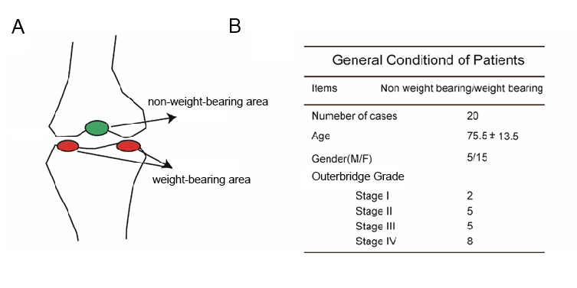
Supplement Figure 1
- Model diagram of chondrocyte selection location. The blue is non bearing area, act as normal cartilage(control). The red is bearing area, act as osteoarthritis (OA).
- Basic information and Outerbrige Grade scores of 20 patients.

Supplement Figure 2
- Actinomycin D assay to measure the stability of RNA at different time of 4h, 8h, 12h and 24h. The host gene SLC7A2 of circ0083429 was used as a positive control for linear RNA.
- The standard curve described the relationship between CT value and LOG (copies) of Circ0083429 in chondrocytes.

Supplement Figure 3
A The structure of PLKO.1 for ShRNA construction.
B The structure of plasmid for Circ0083429 overexpression.
C The structure of plasmid for SMAD3 overexpression.
D Adenovirus plasmid structure overexpressing Circ0083429.

A
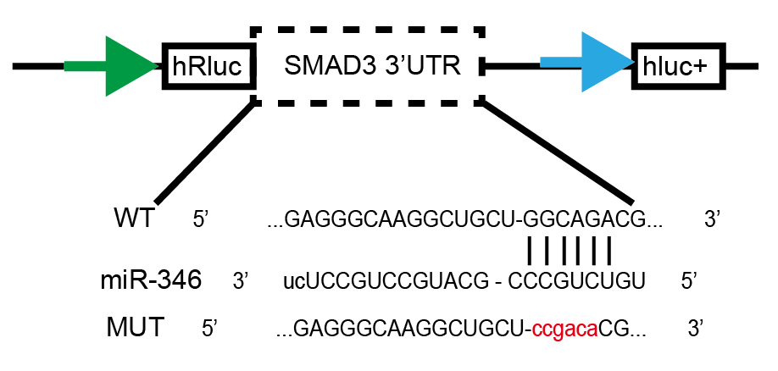

Supplement Figure 4
A Luciferase reporter assay was used to evaluate the luciferase activity of LUC-SMAD3 WT and LUC-SMAD3 mutant (MUT) in HEK-293T cells co-transfected with miR-346 mimic or mimic NC. Data represent mean ± SD (n=3); *P < 0.05.

