Title: Quantitative proteomic profiling of marine diatom Skeletonema dohrnii in response to temperature and silicate induced environmental stress

Authors: Satheeswaran Thangaraj, Satheesh Kumar Palanisamy, Guicheng Zhang, Jun Sun*

Supplementary Table S4: General chemical methods, Figures and Tables

General methods

Chemical composition used for the preparation of ASW

The used composition of anhydrous salts NaCl (24.54g); (Na₂SO₄, 4.09 g); (KCL, 0.7 g); (NaHCO₃, 0.2 g), (KBr, 0.1 g), (H₃BO₃, 0.003 g), (NaF, 0.003 g), and the Hydrous Salts (MgCl₂,11.10 g), (CaCl₂, 1.54 g), (SrCl₂, 0.017 g) were dissolved in 950 mL of de-ionize water and brought the volume to 1 L after adding nutrients, trace metal and vitamin described below.
Major nutrients were prepared as a stock solution (NaH₂PO₄, 1.38 g L-1), (NaNO₃, 8.50 gL-1) and (Na₂SiO₃, 28.40 g L-1) and 1 mL of each solution was added to 1 L of medium. For the metal stock solution, first (CuSO₄, 4.9 g L-1) and (Na₂SeO₃, 1.9 g L-1) were prepared as individual stock solution, then chemicals (EDTA 29.2 g), (FeCl₃, 0.27 g), (ZnSO₄, 0.023g), (MnCl₂, 0.0024 g), (CoCl₂, 0.012 g), (Na₂MoO₄, 0.024 g), (CuSO₄, 4.9 g) and (Na2SeO₃, 1.9g) were dissolved in 950 mL of de-ionized water, then 1 mL of each stock solution were added and brought the volume to 1 L finally. For the medium 1 L of final solution was added to the 1 L of medium. To prepare the vitamin stock solution initially cyanocobalamin (5.5gL-1) and Biotin (5.0g L-1) were prepared as an individual solution. Then to prepare the mixed vitamin solution in 950 mL, cyanocobalamin stock solution 1 mL, Biotin stock solution 1 mL and Thiamine (100 mg) was added and brought to 1L. For each liter of ASW medium 1 ml of stock, vitamin stock solution was used. All the chemicals were used in the culture medium were purchased from Sigma – Aldrich (USA).

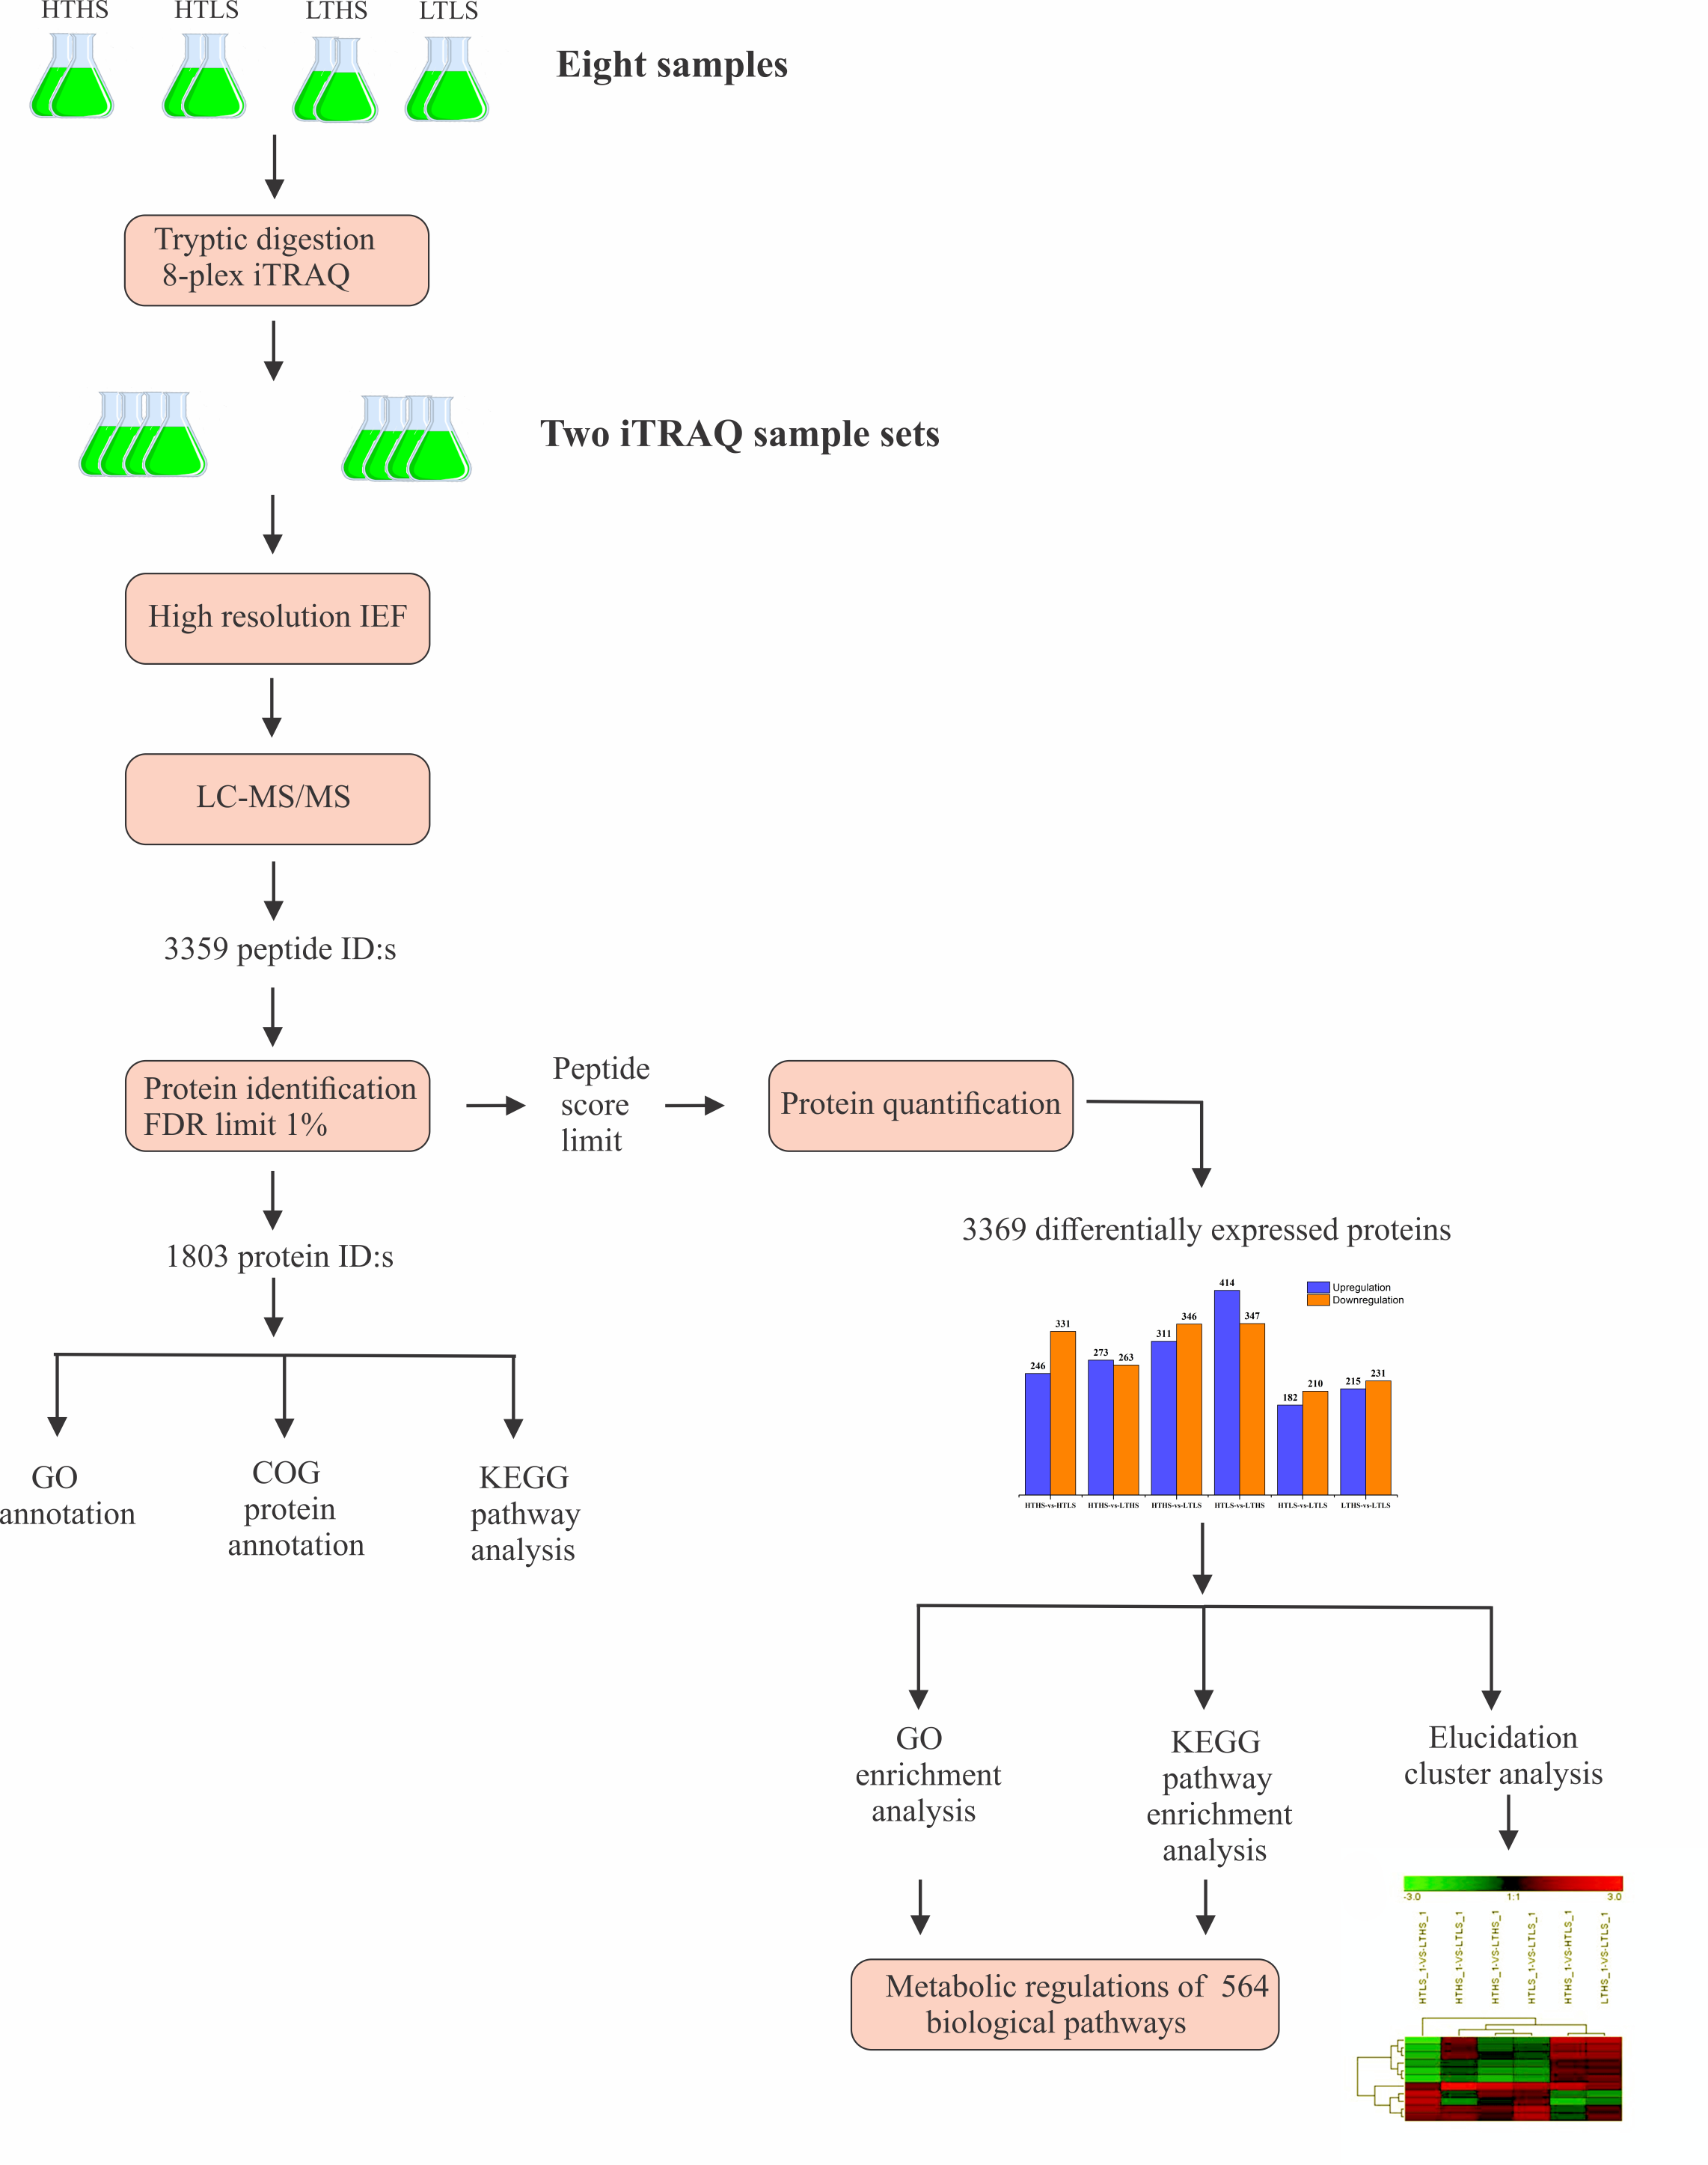
Fig. S1. Experimental setup and carried out bioinformatics analysis of this study.

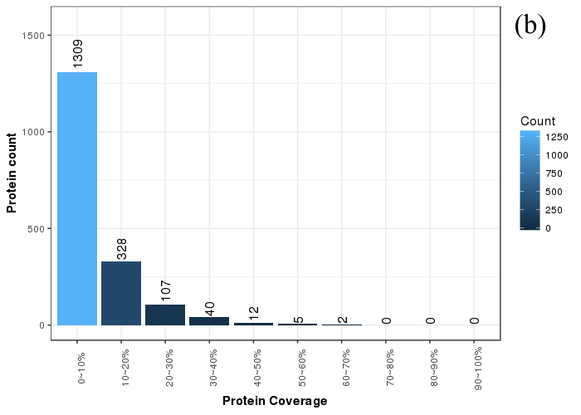
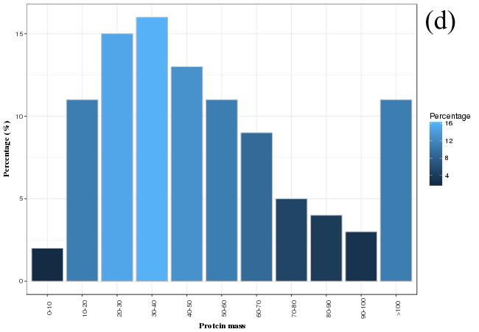

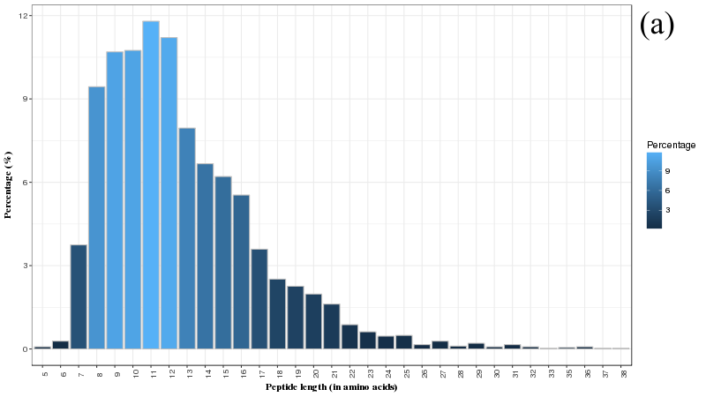

(c)
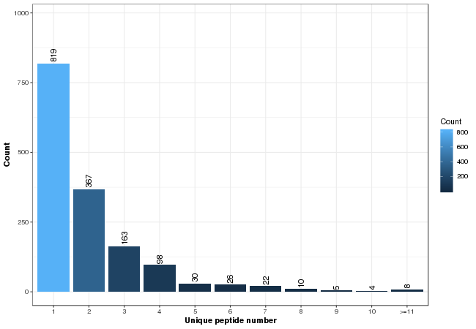

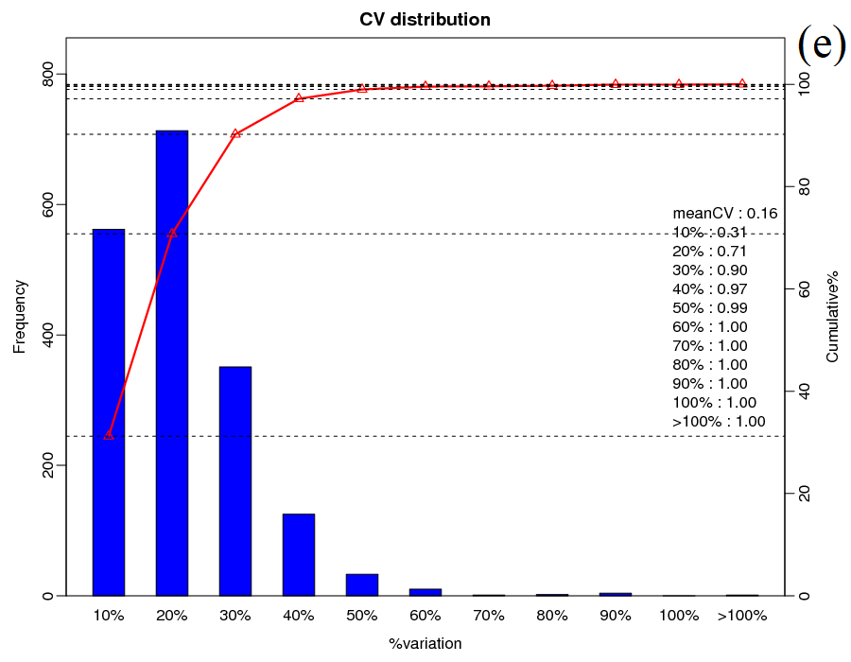
Fig. S2. Peptide and protein statistics. The distributions of peptide length (a), protein spectrum coverage (b), unique peptide number distribution identified using Mascot version 2.3.02 against selected database (FDR of 1%) (c), protein mass distribution (d) protein coverage were determined by iTRAQ analysis in the entire study (e) cv distribution of peptide determined by iTRAQ analysis.
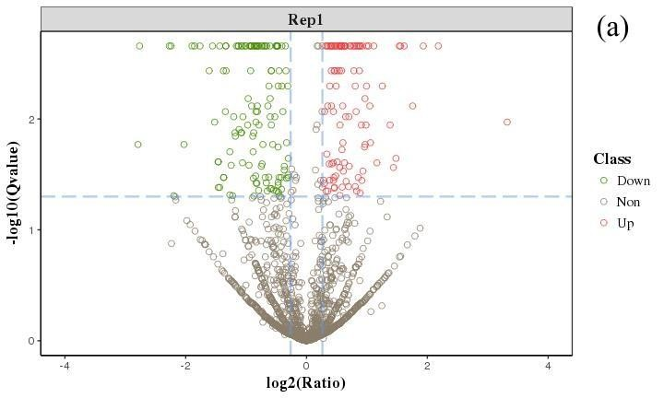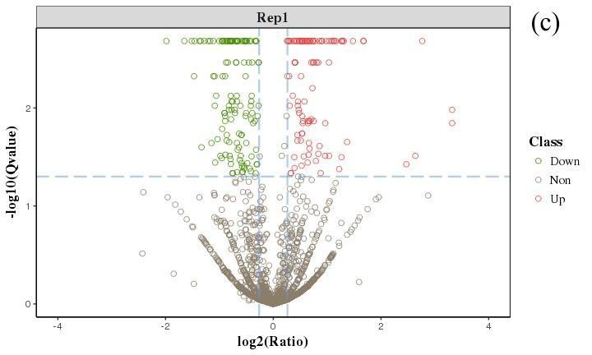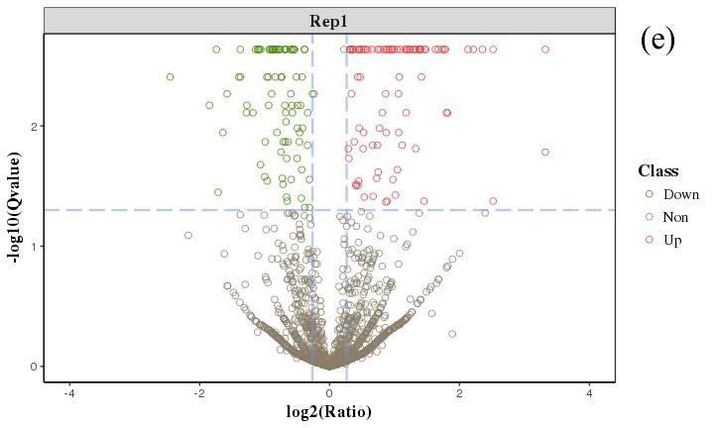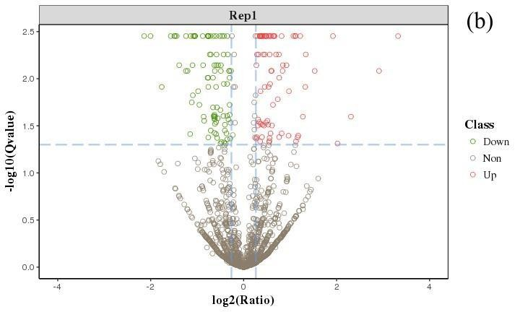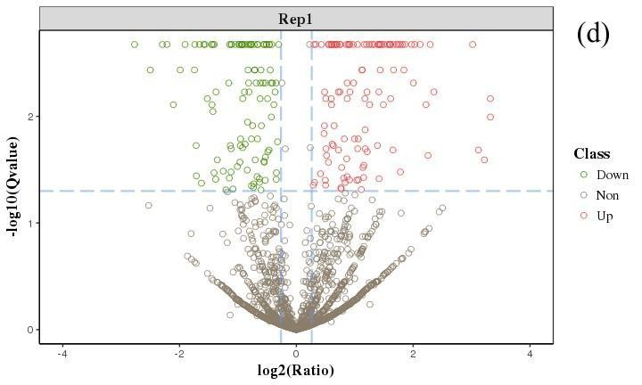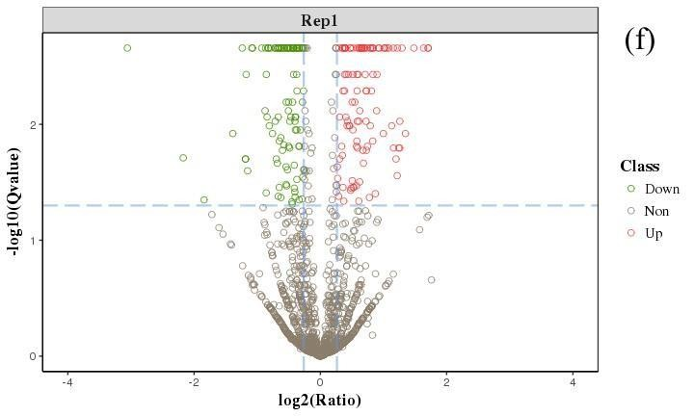

Fig. S3. Identified differently expressed proteins by volcano plot analysis. Differentially expressed protein of HTHS vs. HTLS (a), HTHS vs. LTHS (b), HTHS vs. LTLS (c), HTLS vs. LTHS (d), LTHS vs. LTLS (e), LTHS vs.
LTLS (f) This plot depicts volcano plot of log2 fold-change (x-axis) versus -log10 Q-value (y-axis, representing the probability that the protein is differentially expressed). Q-value <0.05 and Foldchange > 1.2 are set as the significant threshold for differentially expression. The red and green dots indicate points-of-interest that display both large- magnitude fold-changes as well as high statistical significance. Dots in red mean significant up-regulated proteins which passed screening threshold. Dots in green mean significant down-regulated proteins which passed screening threshold. And grey dots are non-significant differentially expressed protein.
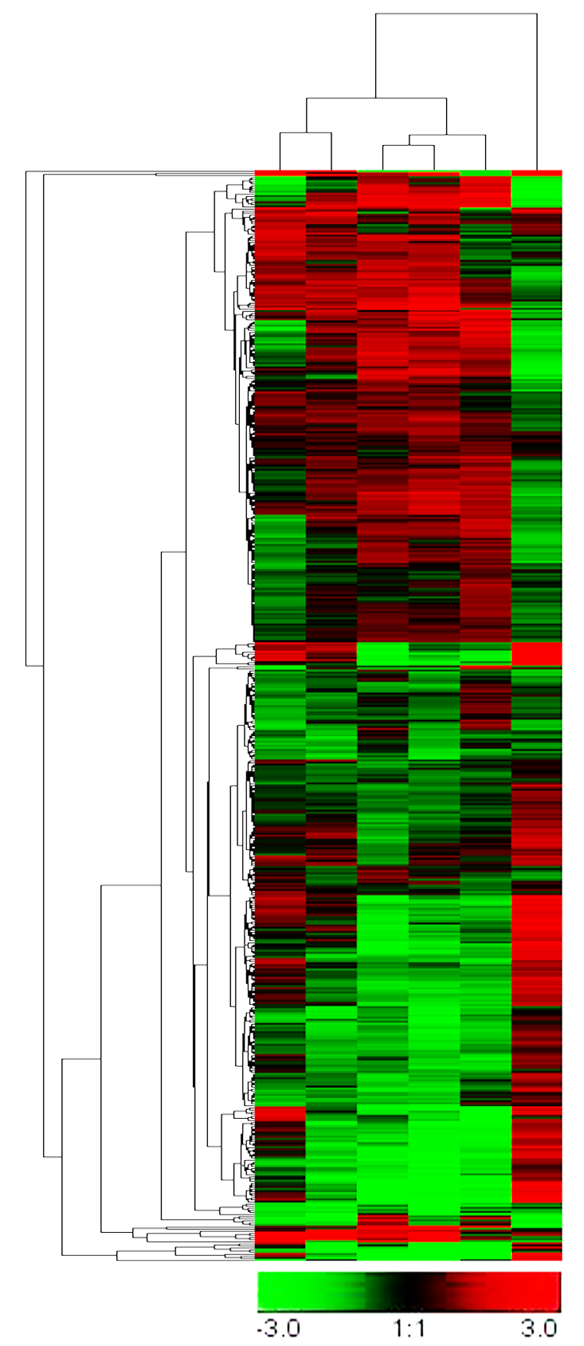
Fig. S4. Cluster analysis of whole gene expression profiles. Green indicates down-regulation, red indicates upregulation, Grey indicates no detectable expression. Array (1) HTHS vs. HTLS; (2) HTHS vs. LTHS; (3) HTHS vs. LTLS; (4) HTLS vs. LTHS; (5) HTLS vs. LTLS (6) LTHS vs. LTLS

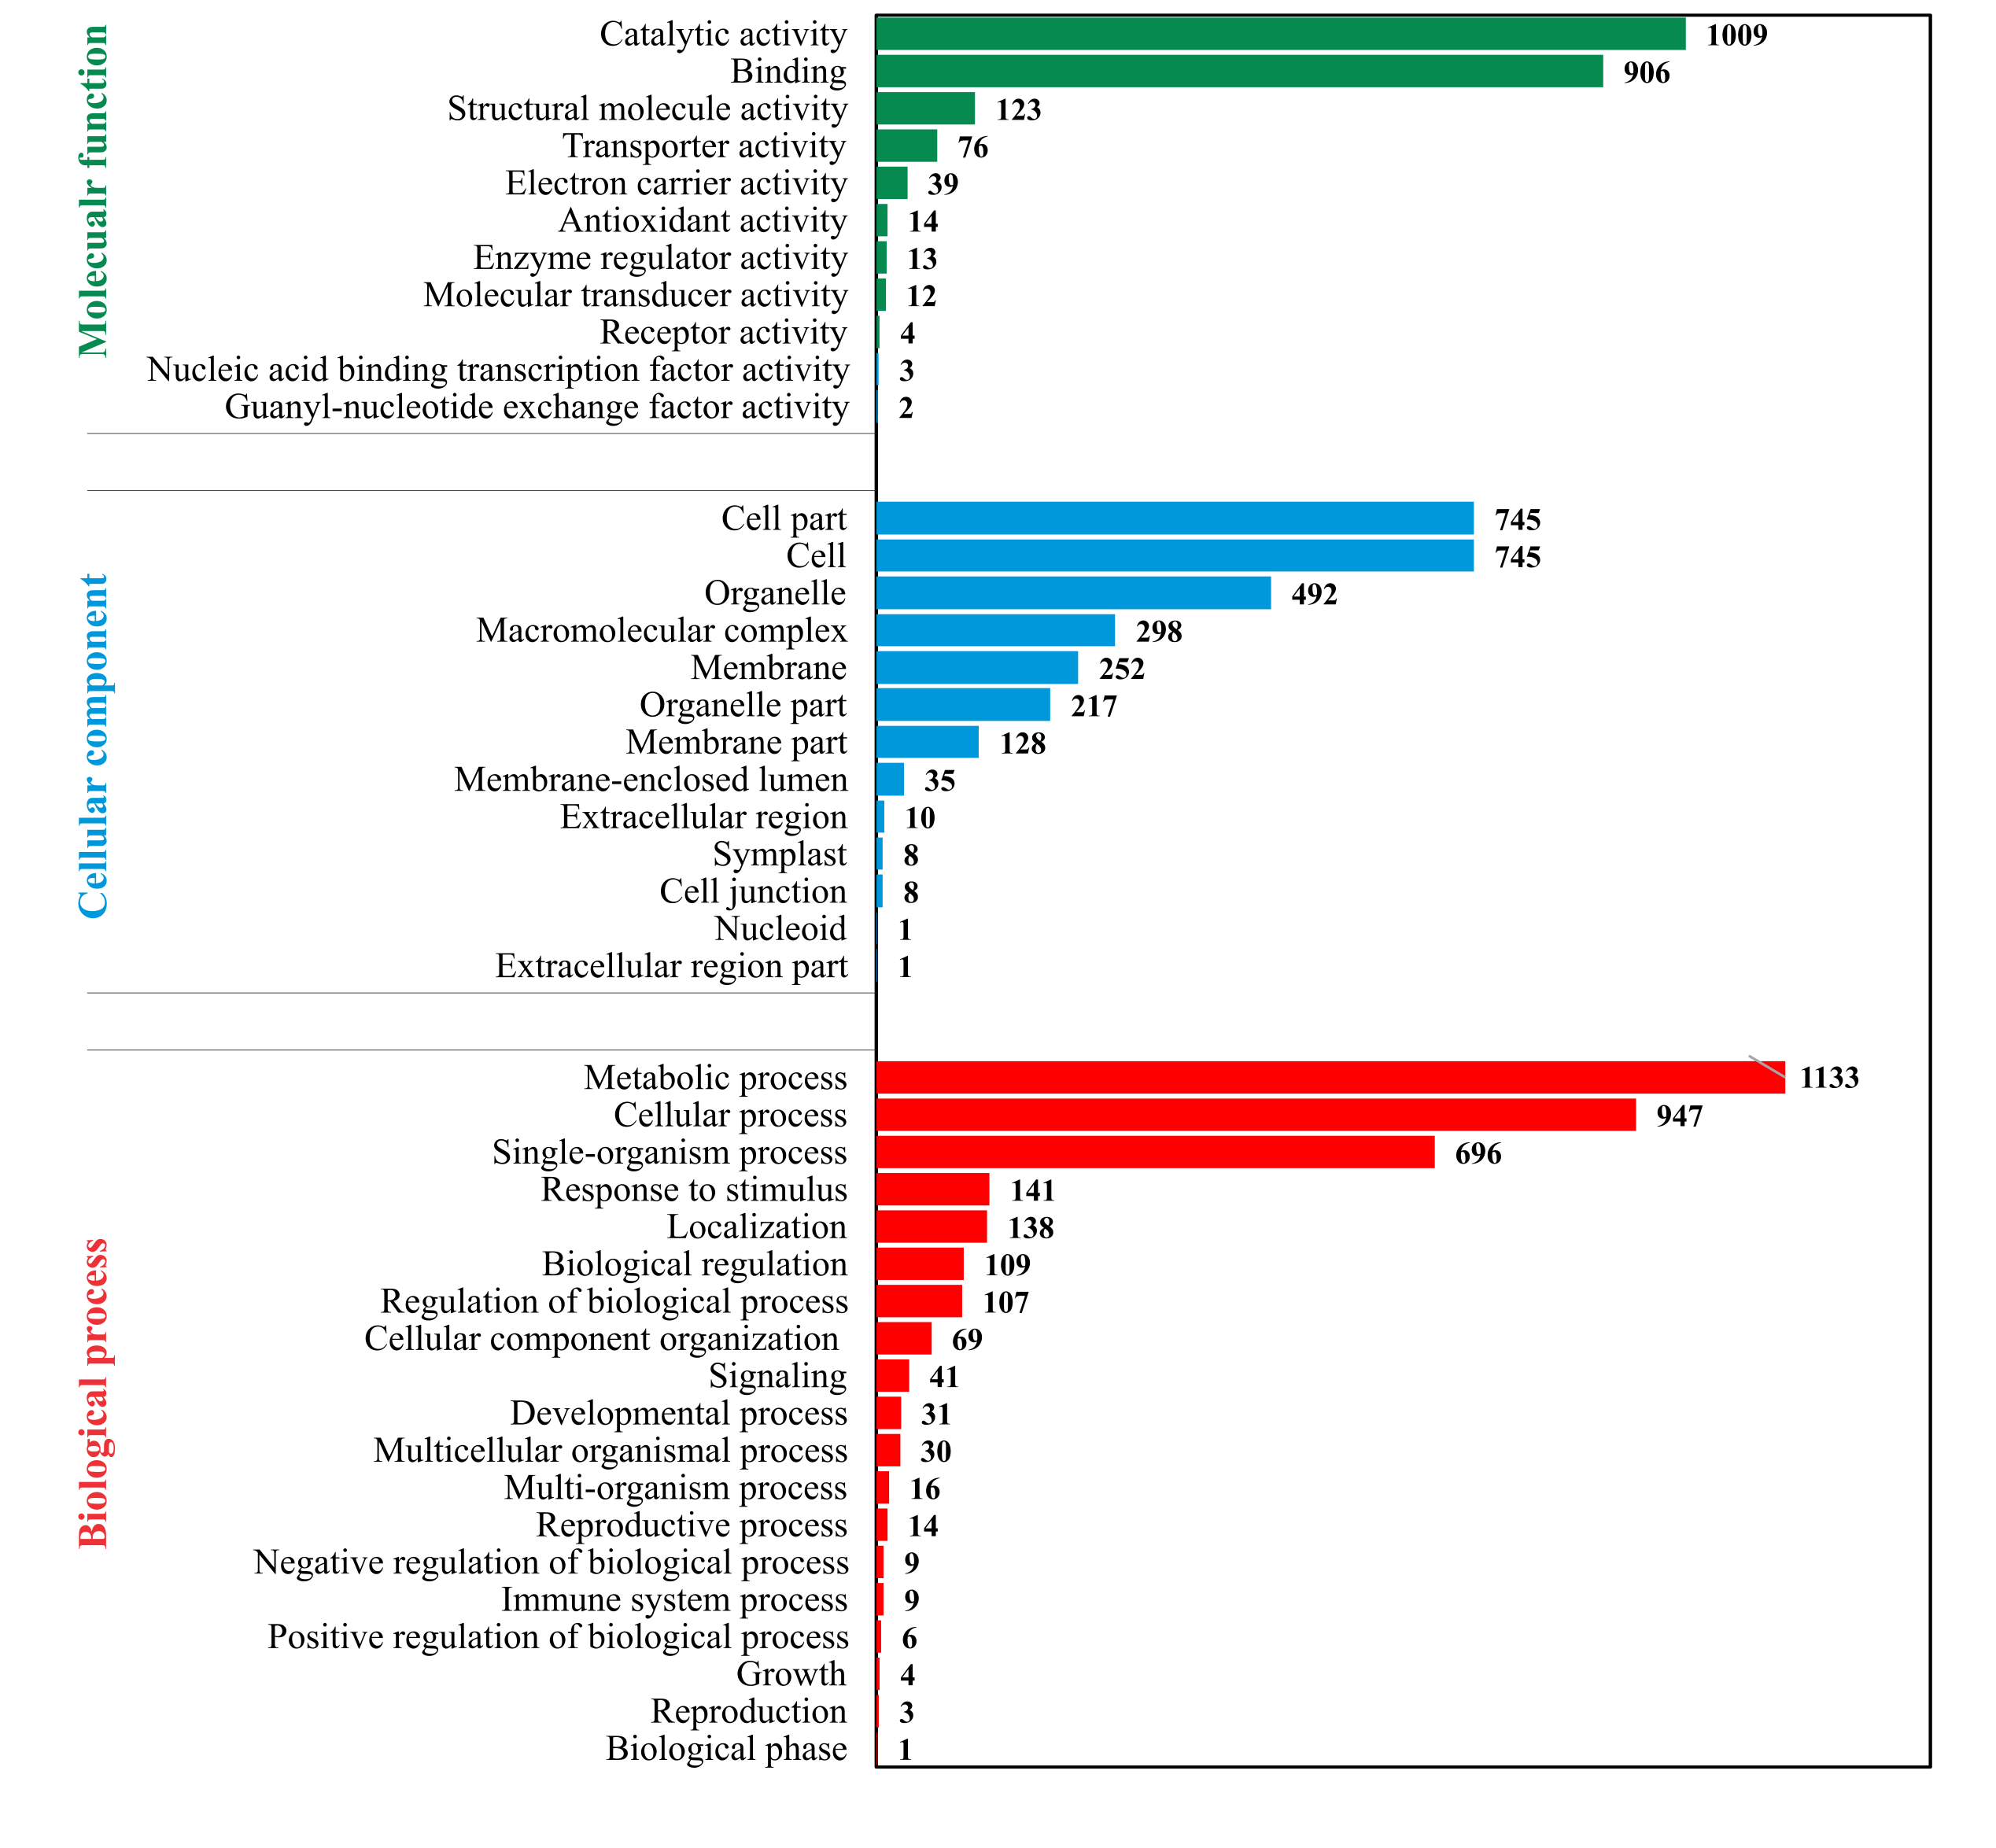
Fig. S5. Bar plot of the Gene Ontology (GO) analysis. The bar chart shows the distribution of corresponding GO terms. Different colors represent different GO categories. The GO analyzes were done for differentially expressed proteins before KEGG pathway analysis that were found around all conditions in this study.

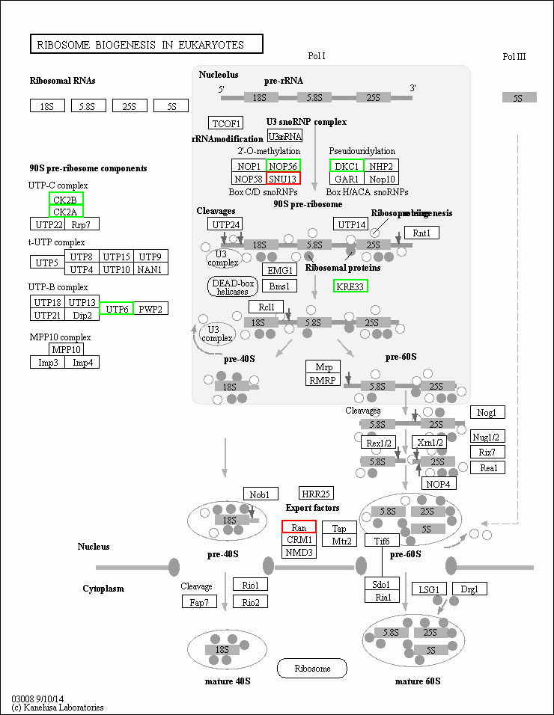
Fig. S6. The ribosome biogenesis pathway map for Skeletonema dohrnii during the changes of temperature and silicate (HTHS vs. HTLS). The down-regulated proteins were shown in light green color boxes and up- regulated proteins are given in red color.

Table S4A. Number of unique proteins family of other species relevant to S. dohrnii species.

Species name | The number of unique protein family
Thalassiosira pseudonana | 1030
Thalassiosira oceanica | 672
Cyclotella sp. | 21
Thalassiosira weissflogii | 21
Roundia cardiophora | 20
Skeletonema costatum | 12
Skeletonema marinoi | 5
Cyclotella cryptica | 4
Detonula confervacea | 3
Detonula confervacea | 3
Thalassiosira nordenskioeldii | 2
Thalassiosira sp | 2
Thalassiosira nordenskioeldii | 2
Cyclotella meneghiniana | 2
Stephanodiscus hantzschii | 1
Cyclotella striata | 1
Skeletonema tropicum | 1
Thalassiosira punctigera | 1
Skeletonema pseudocostatum | 1

Table S4B. Significantly enriched KEGG pathways in S. dohrnii under HTHS vs. HTLS condition.
Si | KEGG Pathway | Differential expressed protein number | P-value
1 | Ribosome | 68 | 5.54E-11
2 | Photosynthesis | 24 | 0.000841
3 | Photosynthesis - antenna proteins | 13 | 0.007265
4 | Oxidative phosphorylation | 24 | 0.019885
5 | Phagosome | 11 | 0.07924
6 | Riboflavin metabolism | 4 | 0.085863
7 | Spliceosome | 16 | 0.094507
8 | Monoterpenoid biosynthesis | 2 | 0.101409
9 | Steroid biosynthesis | 2 | 0.101409
10 | Endocytosis | 13 | 0.123436
11 | Arachidonic acid metabolism | 4 | 0.151002
12 | ABC transporters | 4 | 0.228806
13 | Thiamine metabolism | 4 | 0.228806
14 | Other types of O-glycan biosynthesis | 2 | 0.239782
15 | mRNA surveillance pathway | 9 | 0.241989
16 | Nicotinate and nicotinamide metabolism | 5 | 0.252502
17 | RNA transport | 14 | 0.266667
18 | Protein export | 6 | 0.267998
19 | Purine metabolism | 25 | 0.279071
20 | MAPK signalling pathway - plant | 4 | 0.313745
21 | Nucleotide excision repair | 4 | 0.313745
22 | Biotin metabolism | 4 | 0.313745
23 | Indole alkaloid biosynthesis | 1 | 0.318681
24 | AGE-RAGE signalling pathway in diabetic complications | 1 | 0.318681
25 | Butanoate metabolism | 2 | 0.381345
26 | Base excision repair | 2 | 0.381345
27 | Glycerophospholipid metabolism | 4 | 0.400651
28 | Carbon fixation in photosynthetic organisms | 19 | 0.418089
29 | Pyrimidine metabolism | 16 | 0.427218
30 | Fatty acid biosynthesis | 8 | 0.458858
31 | Ribosome biogenesis in eukaryotes | 8 | 0.458858
32 | RNA degradation | 11 | 0.493643
33 | Circadian rhythm – plant | 2 | 0.510039
34 | Glycolysis / Gluconeogenesis | 20 | 0.522475
35 | N-Glycan biosynthesis | 1 | 0.535954
36 | Fatty acid metabolism | 9 | 0.559266
37 | RNA polymerase | 5 | 0.614662
38 | Homologous recombination | 2 | 0.619686
39 | Inositol phosphate metabolism | 4 | 0.636749

40 | Fructose and mannose metabolism | 5 | 0.674832
41 | Plant hormone signal transduction | 1 | 0.68404
42 | Protein processing in endoplasmic reticulum | 13 | 0.686158
43 | Glycine, serine and threonine metabolism | 12 | 0.697546
44 | Mismatch repair | 2 | 0.70934
45 | Histidine metabolism | 2 | 0.70934
46 | Glycerolipid metabolism | 2 | 0.70934
47 | Aminoacyl-tRNA biosynthesis | 14 | 0.709845
48 | Phenylalanine, tyrosine and tryptophan biosynthesis | 5 | 0.728418
49 | Fatty acid degradation | 3 | 0.734021
50 | DNA replication | 3 | 0.734021
51 | One carbon pool by folate | 3 | 0.734021
52 | Pyruvate metabolism | 14 | 0.74182
53 | Sulfur metabolism | 4 | 0.755931
54 | Arginine and proline metabolism | 5 | 0.775323
55 | Terpenoid backbone biosynthesis | 2 | 0.780586
56 | Galactose metabolism | 3 | 0.836594
57 | Pentose and glucuronate interconversions | 3 | 0.836594
58 | Valine, leucine and isoleucine degradation | 4 | 0.842463
59 | alpha-Linolenic acid metabolism | 1 | 0.853664
60 | Amino sugar and nucleotide sugar metabolism | 6 | 0.858375
61 | Porphyrin and chlorophyll metabolism | 6 | 0.858375
62 | Glutathione metabolism | 7 | 0.866607
63 | Plant-pathogen interaction | 2 | 0.878492
64 | Phosphatidylinositol signalling system | 1 | 0.900459
65 | Tyrosine metabolism | 1 | 0.900459
66 | Propanoate metabolism | 5 | 0.903049
67 | Selenocompound metabolism | 2 | 0.910597
68 | Glyoxylate and dicarboxylate metabolism | 12 | 0.917508
69 | Carbon metabolism | 42 | 0.926523
70 | Citrate cycle (TCA cycle) | 8 | 0.92896
71 | Tropane, piperidine and pyridine alkaloid biosynthesis | 1 | 0.932312
72 | Biosynthesis of unsaturated fatty acids | 1 | 0.932312
73 | Vitamin B6 metabolism | 1 | 0.932312
74 | Alanine, aspartate and glutamate metabolism | 8 | 0.941845
75 | Metabolic pathways | 167 | 0.949483
76 | beta-Alanine metabolism | 1 | 0.953987
77 | Ascorbate and aldarate metabolism | 2 | 0.96557
78 | Peroxisome | 3 | 0.968567
79 | Monobactam biosynthesis | 1 | 0.968732
80 | Nitrogen metabolism | 2 | 0.975177
81 | Lysine biosynthesis | 1 | 0.985574
82 | Proteasome | 6 | 0.991215

83 | Carotenoid biosynthesis | 1 | 0.993354
84 | Ubiquitin mediated proteolysis | 2 | 0.995398
85 | Arginine biosynthesis | 1 | 0.999048
86 | Valine, leucine and isoleucine biosynthesis | 1 | 0.999048
87 | Pentose phosphate pathway | 2 | 0.999437
88 | Cysteine and methionine metabolism | 4 | 0.999883
89 | Biosynthesis of secondary metabolites | 70 | 0.999894
90 | Biosynthesis of amino acids | 27 | 0.999963
91 | 2-Oxocarboxylic acid metabolism | 1 | 0.999987

Table S4C. The significantly enriched KEGG pathways in S. dohrnii under HTHS vs. LTHS condition.
Si | KEGG Pathway | Differential expressed protein number | P-value
1 | Ribosome | 45 | 0.010963
2 | Photosynthesis | 20 | 0.015161
3 | Propanoate metabolism | 11 | 0.053342
4 | Inositol phosphate metabolism | 7 | 0.061665
5 | Phosphatidylinositol signalling system | 4 | 0.070169
6 | One carbon pool by folate | 6 | 0.0776
7 | Glyoxylate and dicarboxylate metabolism | 20 | 0.081449
8 | Carbon fixation in photosynthetic organisms | 22 | 0.083614
9 | Biotin metabolism | 5 | 0.098302
10 | Fatty acid metabolism | 12 | 0.100969
11 | Pyruvate metabolism | 19 | 0.115872
12 | Fatty acid biosynthesis | 10 | 0.118542
13 | Nitrogen metabolism | 7 | 0.130226
14 | Glycerophospholipid metabolism | 5 | 0.149735
15 | Aminoacyl-tRNA biosynthesis | 18 | 0.160694
16 | Carbon metabolism | 52 | 0.177602
17 | Photosynthesis - antenna proteins | 9 | 0.185172
18 | Metabolic pathways | 177 | 0.22901
19 | Riboflavin metabolism | 3 | 0.255626
20 | Phenylpropanoid biosynthesis | 1 | 0.300137
21 | Indole alkaloid biosynthesis | 1 | 0.300137
22 | Caffeine metabolism | 1 | 0.300137
23 | Alanine, aspartate and glutamate metabolism | 13 | 0.30039
24 | Biosynthesis of unsaturated fatty acids | 3 | 0.353086
25 | Vitamin B6 metabolism | 3 | 0.353086
26 | Glutathione metabolism | 10 | 0.363685
27 | Pentose phosphate pathway | 9 | 0.372442
28 | Citrate cycle (TCA cycle) | 12 | 0.390738
29 | Glycolysis / Gluconeogenesis | 20 | 0.394194
30 | Valine, leucine and isoleucine degradation | 6 | 0.403426

31 | Protein export | 5 | 0.416136
32 | Ascorbate and aldarate metabolism | 5 | 0.416136
33 | Fatty acid degradation | 4 | 0.430842
34 | beta-Alanine metabolism | 3 | 0.448663
35 | Arginine biosynthesis | 6 | 0.466266
36 | alpha-Linolenic acid metabolism | 2 | 0.472205
37 | N-Glycan biosynthesis | 1 | 0.510337
38 | Folate biosynthesis | 1 | 0.510337
39 | Monoterpenoid biosynthesis | 1 | 0.510337
40 | Sulfur relay system | 1 | 0.510337
41 | Peroxisome | 6 | 0.527198
42 | Arginine and proline metabolism | 6 | 0.527198
43 | Purine metabolism | 21 | 0.547798
44 | Ribosome biogenesis in eukaryotes | 7 | 0.561493
45 | RNA transport | 11 | 0.578106
46 | Homologous recombination | 2 | 0.580494
47 | Protein processing in endoplasmic reticulum | 13 | 0.585232
48 | Other types of O-glycan biosynthesis | 1 | 0.657505
49 | Tryptophan metabolism | 1 | 0.657505
50 | Cyan amino acid metabolism | 1 | 0.657505
51 | Arachidonic acid metabolism | 2 | 0.671457
52 | Histidine metabolism | 2 | 0.671457
53 | Biosynthesis of amino acids | 42 | 0.687738
54 | Selenocompound metabolism | 3 | 0.688499
55 | DNA replication | 3 | 0.688499
56 | Nicotinate and nicotinamide metabolism | 3 | 0.688499
57 | mRNA surveillance pathway | 6 | 0.688714
58 | Pyrimidine metabolism | 13 | 0.692866
59 | RNA degradation | 9 | 0.698718
60 | Phagosome | 6 | 0.733616
61 | Oxidative phosphorylation | 14 | 0.738071
62 | Biosynthesis of secondary metabolites | 86 | 0.738479
63 | ABC transporters | 2 | 0.745722
64 | Terpenoid backbone biosynthesis | 2 | 0.745722
65 | RNA polymerase | 4 | 0.755928
66 | Butanoate metabolism | 1 | 0.760513
67 | Base excision repair | 1 | 0.760513
68 | Cysteine and methionine metabolism | 11 | 0.760564
69 | Nucleotide excision repair | 2 | 0.805098
70 | Spliceosome | 9 | 0.827471
71 | Phenylalanine, tyrosine and tryptophan biosynthesis | 4 | 0.837381
72 | Endocytosis | 7 | 0.843526
73 | Starch and sucrose metabolism | 1 | 0.883009

74 | Ubiquinone and other terpenoid-quinone biosynthesis | 1 | 0.883009
75 | Lysine biosynthesis | 2 | 0.888108
76 | Glycine, serine and threonine metabolism | 9 | 0.909179
77 | Amino sugar and nucleotide sugar metabolism | 5 | 0.911655
78 | Mismatch repair | 1 | 0.918268
79 | Carotenoid biosynthesis | 2 | 0.937283
80 | Thiamine metabolism | 1 | 0.942917
81 | Proteasome | 7 | 0.958141
82 | Pantothenate and CoA biosynthesis | 1 | 0.960145
83 | MAPK signalling pathway - plant | 1 | 0.960145
84 | Monobactam biosynthesis | 1 | 0.960145
85 | Sulfur metabolism | 2 | 0.965485
86 | Ubiquitin mediated proteolysis | 3 | 0.965522
87 | Porphyrin and chlorophyll metabolism | 4 | 0.96796
88 | Plant-pathogen interaction | 1 | 0.972181
89 | Fructose and mannose metabolism | 2 | 0.981281
90 | 2-Oxocarboxylic acid metabolism | 1 | 0.999972

Table S4D. The significantly enriched KEGG pathways in S. dohrnii under HTHS vs. LTLS condition.
Si | KEGG Pathway | Differential expressed protein number | P-value
1 | Ribosome | 64 | 5.30E-06
2 | Carbon fixation in photosynthetic organisms | 32 | 0.001424
3 | Glyoxylate and dicarboxylate metabolism | 28 | 0.004227
4 | Riboflavin metabolism | 5 | 0.028584
5 | Carbon metabolism | 68 | 0.038368
6 | Propanoate metabolism | 13 | 0.043466
7 | Arginine and proline metabolism | 11 | 0.050894
8 | Aminoacyl-tRNA biosynthesis | 23 | 0.076645
9 | Pyruvate metabolism | 23 | 0.095848
10 | Proteasome | 18 | 0.096127
11 | Plant-pathogen interaction | 6 | 0.119975
12 | beta-Alanine metabolism | 5 | 0.130364
13 | N-Glycan biosynthesis | 2 | 0.136882
14 | Monoterpenoid biosynthesis | 2 | 0.136882
15 | Glutathione metabolism | 14 | 0.141794
16 | Glycolysis / Gluconeogenesis | 27 | 0.169852
17 | Fatty acid biosynthesis | 11 | 0.192567
18 | Ascorbate and aldarate metabolism | 7 | 0.229037
19 | Arachidonic acid metabolism | 4 | 0.233947
20 | Glycerolipid metabolism | 4 | 0.233947
21 | Protein processing in endoplasmic reticulum | 19 | 0.239726

22 | Valine, leucine and isoleucine degradation | 8 | 0.267106
23 | Glycerophospholipid metabolism | 5 | 0.293838
24 | Other types of O-glycan biosynthesis | 2 | 0.309538
25 | Biosynthesis of secondary metabolites | 115 | 0.321129
26 | Fatty acid metabolism | 12 | 0.322519
27 | Inositol phosphate metabolism | 6 | 0.338824
28 | Pyrimidine metabolism | 19 | 0.363668
29 | Phenylpropanoid biosynthesis | 1 | 0.370192
30 | Indole alkaloid biosynthesis | 1 | 0.370192
31 | AGE-RAGE signalling pathway in diabetic complications | 1 | 0.370192
32 | Caffeine metabolism | 1 | 0.370192
33 | RNA polymerase | 7 | 0.374714
34 | Selenocompound metabolism | 5 | 0.385218
35 | One carbon pool by folate | 5 | 0.385218
36 | RNA transport | 15 | 0.386082
37 | Phosphatidylinositol signalling system | 3 | 0.393958
38 | Pantothenate and CoA biosynthesis | 4 | 0.442027
39 | MAPK signalling pathway - plant | 4 | 0.442027
40 | Biotin metabolism | 4 | 0.442027
41 | Fructose and mannose metabolism | 7 | 0.450039
42 | Citrate cycle (TCA cycle) | 14 | 0.470165
43 | Base excision repair | 2 | 0.472807
44 | Ribosome biogenesis in eukaryotes | 9 | 0.495068
45 | Mismatch repair | 3 | 0.513967
46 | Alanine, aspartate and glutamate metabolism | 14 | 0.521345
47 | Steroid biosynthesis | 1 | 0.603503
48 | mRNA surveillance pathway | 8 | 0.605622
49 | alpha-Linolenic acid metabolism | 2 | 0.609988
50 | Purine metabolism | 25 | 0.636645
51 | Protein export | 5 | 0.639194
52 | Phagosome | 8 | 0.664584
53 | 2-Oxocarboxylic acid metabolism | 10 | 0.679426
54 | Glycine, serine and threonine metabolism | 14 | 0.705459
55 | Nitrogen metabolism | 5 | 0.707839
56 | Monobactam biosynthesis | 3 | 0.70873
57 | Nucleotide excision repair | 3 | 0.70873
58 | Arginine biosynthesis | 6 | 0.710496
59 | Homologous recombination | 2 | 0.718004
60 | Ubiquinone and other terpenoid-quinone biosynthesis | 2 | 0.718004
61 | RNA degradation | 11 | 0.730882
62 | Cysteine and methionine metabolism | 14 | 0.744036
63 | Cyanoamino acid metabolism | 1 | 0.750485
64 | Metabolic pathways | 204 | 0.761674

65 | Peroxisome | 6 | 0.764838
66 | Carotenoid biosynthesis | 4 | 0.771352
67 | Pentose and glucuronate interconversions | 4 | 0.771352
68 | Spliceosome | 12 | 0.773617
69 | Tropane, piperidine and pyridine alkaloid biosynthesis | 2 | 0.799618
70 | Biosynthesis of unsaturated fatty acids | 2 | 0.799618
71 | Vitamin B6 metabolism | 2 | 0.799618
72 | Pentose phosphate pathway | 8 | 0.806721
73 | DNA replication | 3 | 0.837301
74 | Nicotinate and nicotinamide metabolism | 3 | 0.837301
75 | Lysine biosynthesis | 3 | 0.837301
76 | Endocytosis | 9 | 0.840255
77 | Butanoate metabolism | 1 | 0.843044
78 | Isoquinoline alkaloid biosynthesis | 1 | 0.843044
79 | Valine, leucine and isoleucine biosynthesis | 5 | 0.856832
80 | Biosynthesis of amino acids | 49 | 0.85705
81 | ABC transporters | 2 | 0.859548
82 | Terpenoid backbone biosynthesis | 2 | 0.859548
83 | Sulfur metabolism | 4 | 0.866533
84 | Porphyrin and chlorophyll metabolism | 7 | 0.876673
85 | Galactose metabolism | 3 | 0.913668
86 | Phenylalanine metabolism | 1 | 0.937969
87 | Tyrosine metabolism | 1 | 0.937969
88 | Fatty acid degradation | 2 | 0.95442
89 | Ubiquitin mediated proteolysis | 4 | 0.970952
90 | Thiamine metabolism | 1 | 0.975524
92 | Photosynthesis | 10 | 0.982955
93 | Phenylalanine, tyrosine and tryptophan biosynthesis | 3 | 0.984815
94 | Photosynthesis - antenna proteins | 2 | 0.999505
95 | Oxidative phosphorylation | 9 | 0.999551
96 | Amino sugar and nucleotide sugar metabolism | 1 | 0.999992

Table S4E. The significantly enriched KEGG pathways in S. dohrnii under HTLS vs. LTHS condition.
Si | KEGG Pathway | Differential expressed protein number | P-value
1 | Photosynthesis - antenna proteins | 19 | 2.82E-05
2 | Ribosome | 61 | 0.006436
3 | Selenocompound metabolism | 9 | 0.009806
4 | Vitamin B6 metabolism | 6 | 0.026916
5 | Photosynthesis | 25 | 0.028752
6 | Glycine, serine and threonine metabolism | 24 | 0.028856

7 | Biosynthesis of amino acids | 73 | 0.046166
8 | Nitrogen metabolism | 10 | 0.053647
9 | Fructose and mannose metabolism | 10 | 0.136488
10 | One carbon pool by folate | 7 | 0.136694
11 | Glycolysis / Gluconeogenesis | 31 | 0.148841
12 | Endocytosis | 16 | 0.160293
13 | Oxidative phosphorylation | 26 | 0.176609
14 | N-Glycan biosynthesis | 2 | 0.182917
15 | Steroid biosynthesis | 2 | 0.182917
16 | Alanine, aspartate and glutamate metabolism | 19 | 0.184263
17 | Phenylalanine, tyrosine and tryptophan biosynthesis | 10 | 0.193842
18 | Thiamine metabolism | 5 | 0.219188
19 | Amino sugar and nucleotide sugar metabolism | 13 | 0.230128
20 | Phagosome | 12 | 0.239352
21 | Sulfur metabolism | 8 | 0.283057
22 | Inositol phosphate metabolism | 7 | 0.29627
23 | Galactose metabolism | 7 | 0.29627
24 | Lysine biosynthesis | 6 | 0.310777
25 | Histidine metabolism | 4 | 0.345182
26 | Glycerolipid metabolism | 4 | 0.345182
27 | Arginine biosynthesis | 9 | 0.347972
28 | Ascorbate and aldarate metabolism | 7 | 0.387
29 | Plant hormone signal transduction | 2 | 0.392504
30 | Cyanoamino acid metabolism | 2 | 0.392504
31 | Peroxisome | 9 | 0.427458
32 | Phenylpropanoid biosynthesis | 1 | 0.427885
33 | AGE-RAGE signalling pathway in diabetic complications | 1 | 0.427885
34 | Caffeine metabolism | 1 | 0.427885
35 | Glycerophospholipid metabolism | 5 | 0.437996
36 | RNA degradation | 15 | 0.443162
37 | mRNA surveillance pathway | 10 | 0.480962
38 | Aminoacyl-tRNA biosynthesis | 21 | 0.501861
39 | Pentose and glucuronate interconversions | 6 | 0.508463
40 | Phosphatidylinositol signalling system | 3 | 0.513446
41 | Riboflavin metabolism | 3 | 0.513446
42 | Protein processing in endoplasmic reticulum | 19 | 0.537434
43 | Spliceosome | 16 | 0.541304
44 | Fatty acid degradation | 5 | 0.544013
45 | DNA replication | 5 | 0.544013
46 | Fatty acid biosynthesis | 10 | 0.553528
47 | Cysteine and methionine metabolism | 18 | 0.556351
48 | Base excision repair | 2 | 0.572521
49 | MAPK signalling pathway - plant | 4 | 0.586591

50 | Monobactam biosynthesis | 4 | 0.586591
51 | Nucleotide excision repair | 4 | 0.586591
52 | Metabolic pathways | 241 | 0.590449
53 | Pentose phosphate pathway | 11 | 0.594961
54 | Protein export | 6 | 0.59956
55 | Mismatch repair | 3 | 0.639644
56 | Arachidonic acid metabolism | 3 | 0.639644
57 | Carbon fixation in photosynthetic organisms | 23 | 0.654276
58 | Monoterpenoid biosynthesis | 1 | 0.672852
59 | Sulfur relay system | 1 | 0.672852
60 | Carbon metabolism | 64 | 0.685099
61 | Circadian rhythm - plant | 2 | 0.70989
62 | Fatty acid metabolism | 11 | 0.713533
63 | beta-Alanine metabolism | 3 | 0.740724
64 | Nicotinate and nicotinamide metabolism | 4 | 0.766592
65 | RNA transport | 14 | 0.782618
66 | Purine metabolism | 27 | 0.803157
67 | Homologous recombination | 2 | 0.808111
68 | Starch and sucrose metabolism | 2 | 0.808111
69 | Ubiquinone and other terpenoid-quinone biosynthesis | 2 | 0.808111
70 | Tyrosine metabolism | 2 | 0.808111
71 | Lysine degradation | 1 | 0.813026
72 | Other types of O-glycan biosynthesis | 1 | 0.813026
73 | Tryptophan metabolism | 1 | 0.813026
74 | Biotin metabolism | 3 | 0.817791
75 | Ribosome biogenesis in eukaryotes | 8 | 0.839956
76 | Biosynthesis of secondary metabolites | 121 | 0.848535
77 | Glutathione metabolism | 10 | 0.865477
78 | Biosynthesis of unsaturated fatty acids | 2 | 0.875498
79 | Butanoate metabolism | 1 | 0.893195
80 | Valine, leucine and isoleucine degradation | 5 | 0.916914
81 | Ubiquitin mediated proteolysis | 6 | 0.920387
82 | ABC transporters | 2 | 0.920423
83 | Terpenoid backbone biosynthesis | 2 | 0.920423
84 | Glyoxylate and dicarboxylate metabolism | 17 | 0.924059
85 | Propanoate metabolism | 7 | 0.924421
86 | alpha-Linolenic acid metabolism | 1 | 0.939021
87 | Pantothenate and CoA biosynthesis | 2 | 0.949746
88 | Pyrimidine metabolism | 15 | 0.955417
89 | RNA polymerase | 4 | 0.959407
90 | Phenylalanine metabolism | 1 | 0.965203
92 | Proteasome | 11 | 0.96577
93 | Plant-pathogen interaction | 2 | 0.968577
94 | Citrate cycle (TCA cycle) | 10 | 0.980037

95 | Tropane, piperidine and pyridine alkaloid biosynthesis | 1 | 0.980154
96 | Porphyrin and chlorophyll metabolism | 6 | 0.985501
97 | Arginine and proline metabolism | 4 | 0.987713
98 | Carotenoid biosynthesis | 2 | 0.992659
99 | Pyruvate metabolism | 13 | 0.994563
100 | 2-Oxocarboxylic acid metabolism | 5 | 0.999226
101 | Valine, leucine and isoleucine biosynthesis | 2 | 0.999413

Table S4F. The significantly enriched KEGG pathways in S. dohrnii under HTLS vs. LTLS condition.
Si | KEGG Pathway | Differential expressed protein number | P-value
1 | Thiamine metabolism | 5 | 0.013642
2 | Vitamin B6 metabolism | 4 | 0.041357
3 | Selenocompound metabolism | 5 | 0.063992
4 | One carbon pool by folate | 5 | 0.063992
5 | Carbon metabolism | 41 | 0.064985
6 | beta-Alanine metabolism | 4 | 0.069073
7 | Pyruvate metabolism | 15 | 0.080114
8 | Inositol phosphate metabolism | 5 | 0.123234
9 | Protein processing in endoplasmic reticulum | 13 | 0.124972
10 | Arachidonic acid metabolism | 3 | 0.171745
11 | Carbon fixation in photosynthetic organisms | 15 | 0.196866
12 | Base excision repair | 2 | 0.201833
13 | Ether lipid metabolism | 1 | 0.213599
14 | Phenylpropanoid biosynthesis | 1 | 0.213599
15 | Caffeine metabolism | 1 | 0.213599
16 | Metabolic pathways | 127 | 0.239452
17 | Ubiquitin mediated proteolysis | 6 | 0.24127
18 | Proteasome | 10 | 0.251477
19 | Cysteine and methionine metabolism | 11 | 0.272153
20 | alpha-Linolenic acid metabolism | 2 | 0.290679
21 | Pyrimidine metabolism | 12 | 0.290691
22 | Pantothenate and CoA biosynthesis | 3 | 0.298015
23 | Nucleotide excision repair | 3 | 0.298015
24 | Endocytosis | 8 | 0.300763
25 | Photosynthesis - antenna proteins | 6 | 0.323082
26 | Protein export | 4 | 0.348983
27 | Ascorbate and aldarate metabolism | 4 | 0.348983
28 | Propanoate metabolism | 6 | 0.365448
29 | Glycine, serine and threonine metabolism | 10 | 0.374995
30 | Glyoxylate and dicarboxylate metabolism | 12 | 0.37588
31 | Homologous recombination | 2 | 0.378086

32 | Phosphatidylinositol signalling system | 2 | 0.378086
33 | N-Glycan biosynthesis | 1 | 0.381689
34 | Monoterpenoid biosynthesis | 1 | 0.381689
35 | Steroid biosynthesis | 1 | 0.381689
36 | Sulfur relay system | 1 | 0.381689
37 | Arginine and proline metabolism | 5 | 0.382869
38 | RNA transport | 9 | 0.390896
39 | Nitrogen metabolism | 4 | 0.403142
40 | Fatty acid degradation | 3 | 0.427842
41 | DNA replication | 3 | 0.427842
42 | Mismatch repair | 2 | 0.460623
43 | Biosynthesis of unsaturated fatty acids | 2 | 0.460623
44 | Glycerolipid metabolism | 2 | 0.460623
45 | Valine, leucine and isoleucine degradation | 4 | 0.508008
46 | Cyanoamino acid metabolism | 1 | 0.513941
47 | Citrate cycle (TCA cycle) | 8 | 0.515914
48 | ABC transporters | 2 | 0.536381
49 | Purine metabolism | 15 | 0.543496
50 | Galactose metabolism | 3 | 0.54821
51 | Valine, leucine and isoleucine biosynthesis | 4 | 0.55729
52 | Ribosome biogenesis in eukaryotes | 5 | 0.564999
53 | Biosynthesis of amino acids | 31 | 0.569458
54 | Fatty acid metabolism | 6 | 0.571846
55 | Glycolysis / Gluconeogenesis | 13 | 0.582547
56 | Photosynthesis | 9 | 0.589258
57 | Monobactam biosynthesis | 2 | 0.604486
58 | Glutathione metabolism | 6 | 0.609353
59 | Butanoate metabolism | 1 | 0.617977
60 | Glycerophospholipid metabolism | 2 | 0.664742
61 | Plant-pathogen interaction | 2 | 0.664742
62 | Pentose phosphate pathway | 5 | 0.681741
63 | RNA polymerase | 3 | 0.697622
64 | Circadian rhythm - plant | 1 | 0.699802
65 | Oxidative phosphorylation | 10 | 0.702401
66 | Spliceosome | 7 | 0.70655
67 | Alanine, aspartate and glutamate metabolism | 7 | 0.70655
68 | Biosynthesis of secondary metabolites | 61 | 0.712175
69 | Lysine biosynthesis | 2 | 0.717387
70 | mRNA surveillance pathway | 4 | 0.724251
71 | Aminoacyl-tRNA biosynthesis | 9 | 0.728098
72 | Fructose and mannose metabolism | 3 | 0.738254
73 | RNA degradation | 6 | 0.739439
74 | Fatty acid biosynthesis | 4 | 0.757777
75 | Starch and sucrose metabolism | 1 | 0.764145
76 | Phenylalanine metabolism | 1 | 0.764145

77 | Riboflavin metabolism | 1 | 0.764145
78 | Arginine biosynthesis | 3 | 0.774446
79 | Carotenoid biosynthesis | 2 | 0.801949
80 | Pentose and glucuronate interconversions | 2 | 0.801949
81 | Peroxisome | 3 | 0.806442
82 | Histidine metabolism | 1 | 0.814732
83 | Terpenoid backbone biosynthesis | 1 | 0.854496
84 | Sulfur metabolism | 2 | 0.863304
85 | Biotin metabolism | 1 | 0.885747
86 | 2-Oxocarboxylic acid metabolism | 4 | 0.896882
87 | Ribosome | 19 | 0.906124
88 | Amino sugar and nucleotide sugar metabolism | 3 | 0.928075
89 | Porphyrin and chlorophyll metabolism | 3 | 0.928075
90 | Nicotinate and nicotinamide metabolism | 1 | 0.929595
92 | Phagosome | 2 | 0.972041
93 | Phenylalanine, tyrosine and tryptophan biosynthesis | 1 | 0.987145

Table S4G. The significantly enriched KEGG pathways in S. dohrnii under LTHS vs. LTLS condition.
Si | KEGG Pathway | Differential expressed protein number | P-value
1 | Biosynthesis of amino acids | 50 | 0.01522984
2 | Glycine, serine and threonine metabolism | 17 | 0.02151314
3 | Sulfur metabolism | 8 | 0.021816
4 | Cysteine and methionine metabolism | 17 | 0.02770129
5 | Fructose and mannose metabolism | 8 | 0.04989129
6 | Biosynthesis of secondary metabolites | 90 | 0.05029148
7 | Glutathione metabolism | 12 | 0.05102062
8 | Pentose phosphate pathway | 11 | 0.05174627
9 | Carbon metabolism | 49 | 0.06157619
10 | Glycerolipid metabolism | 4 | 0.08064983
11 | Ribosome | 36 | 0.08206747
12 | Amino sugar and nucleotide sugar metabolism | 10 | 0.08941657
13 | Metabolic pathways | 158 | 0.1221634
14 | beta-Alanine metabolism | 4 | 0.1289806
15 | Protein export | 6 | 0.1309382
16 | Lysine biosynthesis | 5 | 0.1322085
17 | Glycolysis / Gluconeogenesis | 20 | 0.1629882
18 | Tryptophan metabolism | 2 | 0.1686008
19 | Pantothenate and CoA biosynthesis | 4 | 0.1862299
20 | MAPK signalling pathway - plant | 4 | 0.1862299
21 | Biotin metabolism | 4 | 0.1862299
22 | Pyrimidine metabolism | 15 | 0.2221943

23 | Inositol phosphate metabolism | 5 | 0.2336765
24 | Galactose metabolism | 5 | 0.2336765
25 | Glycerophospholipid metabolism | 4 | 0.2497897
26 | Plant-pathogen interaction | 4 | 0.2497897
27 | Ether lipid metabolism | 1 | 0.260989
28 | AGE-RAGE signalling pathway in diabetic complications | 1 | 0.260989
29 | Arachidonic acid metabolism | 3 | 0.2664093
30 | Selenocompound metabolism | 4 | 0.3169789
31 | Porphyrin and chlorophyll metabolism | 8 | 0.3172228
32 | 2-Oxocarboxylic acid metabolism | 9 | 0.3355505
33 | Nitrogen metabolism | 5 | 0.3498805
34 | Protein processing in endoplasmic reticulum | 13 | 0.35319
35 | Proteasome | 11 | 0.3649973
36 | Arginine and proline metabolism | 6 | 0.3738695
37 | RNA polymerase | 5 | 0.4095262
38 | Monobactam biosynthesis | 3 | 0.4301848
39 | Photosynthesis | 12 | 0.4506278
40 | Folate biosynthesis | 1 | 0.4539953
41 | Monoterpenoid biosynthesis | 1 | 0.4539953
42 | Steroid biosynthesis | 1 | 0.4539953
43 | Starch and sucrose metabolism | 2 | 0.492185
44 | Phosphatidylinositol signaling system | 2 | 0.492185
45 | Riboflavin metabolism | 2 | 0.492185
46 | Ascorbate and aldarate metabolism | 4 | 0.5175124
47 | Fatty acid degradation | 3 | 0.5789413
48 | One carbon pool by folate | 3 | 0.5789413
49 | Fatty acid biosynthesis | 6 | 0.5806795
50 | Ribosome biogenesis in eukaryotes | 6 | 0.5806795
51 | Phagosome | 6 | 0.5806795
52 | Mismatch repair | 2 | 0.5824953
53 | Plant hormone signal transduction | 1 | 0.5966926
54 | Lysine degradation | 1 | 0.5966926
55 | Cyanoamino acid metabolism | 1 | 0.5966926
56 | Fatty acid metabolism | 7 | 0.6254085
57 | Purine metabolism | 17 | 0.68353
58 | Valine, leucine and isoleucine degradation | 4 | 0.6859962
59 | Pentose and glucuronate interconversions | 3 | 0.7007069
60 | Butanoate metabolism | 1 | 0.7021687
61 | Base excision repair | 1 | 0.7021687
62 | Endocytosis | 7 | 0.7034746
63 | Nucleotide excision repair | 2 | 0.7261391
64 | Arginine biosynthesis | 4 | 0.7319339
65 | Phenylalanine, tyrosine and tryptophan biosynthesis | 4 | 0.7319339

66 | Valine, leucine and isoleucine biosynthesis | 4 | 0.7319339
67 | Carbon fixation in photosynthetic organisms | 13 | 0.7397546
68 | Propanoate metabolism | 5 | 0.7577272
69 | Peroxisome | 4 | 0.7726452
70 | alpha-Linolenic acid metabolism | 1 | 0.7801135
71 | Circadian rhythm - plant | 1 | 0.7801135
72 | Alanine, aspartate and glutamate metabolism | 8 | 0.7903172
73 | RNA degradation | 7 | 0.7989246
74 | DNA replication | 2 | 0.8256571
75 | Homologous recombination | 1 | 0.8376992
76 | Tyrosine metabolism | 1 | 0.8376992
77 | mRNA surveillance pathway | 4 | 0.8660277
78 | Tropane, piperidine and pyridine alkaloid biosynthesis | 1 | 0.8802332
79 | Histidine metabolism | 1 | 0.8802332
80 | Vitamin B6 metabolism | 1 | 0.8802332
81 | Terpenoid backbone biosynthesis | 1 | 0.911642
82 | Thiamine metabolism | 1 | 0.911642
83 | Ubiquitin mediated proteolysis | 3 | 0.926414
84 | Glyoxylate and dicarboxylate metabolism | 9 | 0.9368517
85 | Citrate cycle (TCA cycle) | 6 | 0.9388992
86 | Photosynthesis - antenna proteins | 3 | 0.9527527
87 | Aminoacyl-tRNA biosynthesis | 8 | 0.9590746
88 | Nicotinate and nicotinamide metabolism | 1 | 0.9645731
89 | Pyruvate metabolism | 8 | 0.9654138
90 | Carotenoid biosynthesis | 1 | 0.9807607
92 | RNA transport | 5 | 0.9809134
93 | Oxidative phosphorylation | 7 | 0.9921469

Table S4H. Metabolic regulation of photosynthetic pigment proteins between each conditions

HTHS vs HTLS
No | Protein ID | Description | Fold change
1 | EJK46744.1 | Chlorophyll a-b binding protein 1 | -1.4
2 | CAI44219.1 | fucoxanthin chlorophyll a/c binding protein | -1.4
3 | EJK73893.1 | Fucoxanthin-chlorophyll a-c binding protein F | -1.1
4 | AAB70098.1 | fucoxanthin-chlorophyll a/c light-harvesting protein | -1.1
5 | XP_002294116.1 | Fucoxanthin-chlorophyll a-c binding protein F | -1.0
6 | XP_002297311.1 | Photosystem I light harvesting protein | -1.0
7 | EED95211.1 | fucoxanthin chlorophyll a/c protein | -0.9
8 | EED93059.1 | Fucoxanthin-chlorophyll a-c binding protein A | -0.7
9 | EED87666.1 | Fucoxanthin-chlorophyll a-c binding protein | -0.6
11 | EJK58980.1 | Fucoxanthin-chlorophyll a-c binding protein E | -0.6
12 | CAA04403.1 | Fucoxanthin-chlorophyll a/c binding protein | -0.5
13 | EJK71517.1 | Fucoxanthin-chlorophyll a-c binding protein A | -0.5
15 | EJK55038.1 | Fucoxanthin-chlorophyll a/c binding protein | -0.4
HTHS vs LTHS
1 | EED93059.1 | Fucoxanthin-chlorophyll a-c binding protein A | +1.3
2 | XP_002294116.1 | Fucoxanthin-chlorophyll a-c binding protein F | +1.0
3 | EJK73893.1 | Fucoxanthin-chlorophyll a-c binding protein F | +0.9
4 | AAB70105.1 | fucoxanthin-chlorophyll a/c light-harvesting protein | +0.5
5 | EED87666.1 | Fucoxanthin-chlorophyll a-c binding protein | +0.5
6 | EED95211.1 | fucoxanthin chlorophyll a/c protein | +0.5
7 | EJK45846.1 | fucoxanthin chlorophyll a/c protein | +0.3
8 | EED87487.1 | fucoxanthin chlorophyll a/c protein | -0.5
9 | XP_002288023.1 | fucoxanthin chlorophyll a/c protein | -0.4
HTHS vs LTLS
1 | CAI44219.1 | Fucoxanthin chlorophyll a/c binding protein | -1.1
2 | EJK56644.1 | Fucoxanthin-chlorophyll a-c binding protein | -1.1
HTLS vs LTHS
1 | XP_002294116.1 | Fucoxanthin-chlorophyll a-c binding protein F | +2.0
2 | EED93059.1 | Fucoxanthin-chlorophyll a-c binding protein A | +2.0
3 | EJK73893.1 | Fucoxanthin-chlorophyll a-c binding protein F | +2.0
4 | XP_002297311.1 | Photosystem I light harvesting protein | +2.0
5 | EJK46744.1 | Chlorophyll a-b binding protein 1 | +1.7
6 | CAI44219.1 | fucoxanthin chlorophyll a/c binding protein | +1.7
7 | AAB70098.1 | fucoxanthin-chlorophyll a/c light-harvesting protein | +1.6
8 | EED95211.1 | fucoxanthin chlorophyll a/c protein | +1.4
9 | AAB70106.1 | fucoxanthin-chlorophyll a/c light-harvesting protein | +1.3
10 | EED87666.1 | Fucoxanthin-chlorophyll a-c binding protein | +1.2
11 | CAA04226.1 | Fucoxanthin chlorophyll a /c protein | +1.1
12 | EJK47965.1 | Fucoxanthin-chlorophyll a-c binding protein | +1.1
13 | AAB70105.1 | fucoxanthin-chlorophyll a/c light-harvesting protein | +0.8
14 | EJK45846.1 | fucoxanthin chlorophyll a/c protein | +0.8
15 | EJK58980.1 | Fucoxanthin-chlorophyll a-c binding protein E | +0.7
16 | CAA04403.1 | fucoxanthin chlorophyll a/c binding protein | +0.7
17 | EJK55038.1 | fucoxanthin chlorophyll a/c binding protein | +0.6
18 | EJK71517.1 | Fucoxanthin-chlorophyll a-c binding protein A | +0.5
19 | EJK56644.1 | Fucoxanthin-chlorophyll a-c binding protein | +0.4
HTLS vs LTLS
1 | XP_002294116.1 | Fucoxanthin-chlorophyll a-c binding protein F | +1.7
2 | XP_002297311.1 | photosystem I light harvesting protein | +1.1
3 | AAB70106.1 | fucoxanthin-chlorophyll a/c light-harvesting protein | +0.9
4 | AAB70105.1 | fucoxanthin-chlorophyll a/c light-harvesting protein | +0.5
5 | EJK55038.1 | fucoxanthin chlorophyll a/c binding protein | +0.5
6 | XP_002292353.1 | fucoxanthin chl a/c light-harvesting protein | +0.4
LTHS vs LTLS
1 | EJK47965.1 | Fucoxanthin-chlorophyll a-c binding protein | -1.2
2 | CAI44219.1 | fucoxanthin chlorophyll a/c binding protein | -1.1
3 | EJK56644.1 | Fucoxanthin-chlorophyll a-c binding protein | -1.1

