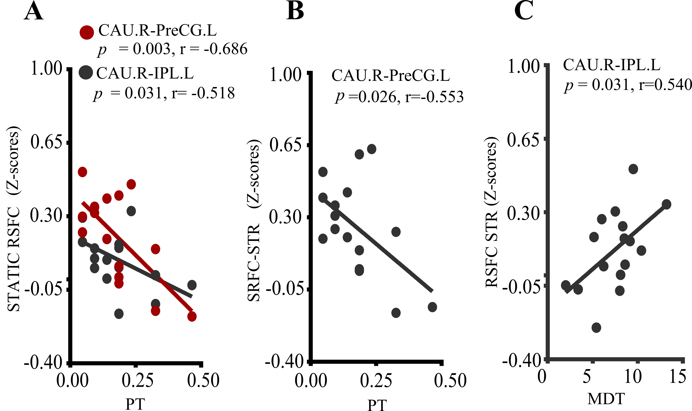
Supplementary Figure 3. Correlations of state properties with static and dynamic RSFC in HIV. (A) Reduced state-2 transitioning (PT) was negatively associated with the static RSFC of CAU.R-PreCG.L (red) and CAU.R-IPL.L (black). (B) The average dynamic RSFC of CAU.R-PreCG.L was also related to reduced transitioning (PT) of state 4. (C) The positive relationship between the mean dwelling time of the state with weaker occipital connectivity (state 2) and average dynamic CAU.R-IPL.L RSFC. P, P-value; r, Pearson’s correlation coefficient; R, right; L, left; CAU, the caudate nucleus; PreCG, precentral gyrus; IPL, inferior parietal lobe. Note: correlation was significant at p<0.05.

