Table S1 Sequence read counts in the investigated samples, before (raw) and after filtering, as obtained by 16S rRNA metabarcoding and QIIME analysis. In red, samples eliminated due to the low number of sequence reads.

Sample name | Sample type | N. filtered readsª | N. filtered reads^{b}
1NO.pna.R | Neottia ovata root | 14872 | 3712
2NO.pna.R | Neottia ovata root | 81525 | 10485
3NO.pna.R | Neottia ovata root | 230434 | 21921
4NO.pna.R | Neottia ovata root | 84467 | 43085
5NO.pna.R | Neottia ovata root | 123424 | 68985
1NO.pna.L | Neottia ovata leaf | 124733 | 7724
2NO.pna.L | Neottia ovata leaf | 139196 | 31770
3NO.pna.L | Neottia ovata leaf | 176719 | 13165
4NO.pna.L | Neottia ovata leaf | 79590 | 3665
5NO.pna.L | Neottia ovata leaf | 121435 | 12395
1NO.pna.St | Neottia ovata stem | 106355 | 12442
2NO.pna.St | Neottia ovata stem | 138309 | 21341
3NO.pna.St | Neottia ovata stem | 83306 | 47598
4NO.pna.St | Neottia ovata stem | 94665 | 19497
5NO.pna.St | Neottia ovata stem | 71061 | 14105
1NO.pna.C | Neottia ovata capsule | 132789 | 67383
2NO.pna.C | Neottia ovata capsule | 131636 | 52608
3NO.pna.C | Neottia ovata capsule | 93911 | 86523
4NO.pna.C | Neottia ovata capsule | 178654 | 2965
5NO.pna.C | Neottia ovata capsule | 91492 | 44615
1SV.pna.R | Serapias vomeracea root | 158718 | 154719
2SV.pna.R | Serapias vomeracea root | 49113 | 45852
3SV.pna.R | Serapias vomeracea root | 140623 | 135183
4SV.pna.R | Serapias vomeracea root | 97402 | 96791
5SV.pna.R | Serapias vomeracea root | 39425 | 36689
1SV.pna.L | Serapias vomeracea leaf | 68541 | 10784
2SV.pna.L | Serapias vomeracea leaf | 169618 | 106852
3SV.pna.L | Serapias vomeracea leaf | 67478 | 1617
4SV.pna.L | Serapias vomeracea leaf | 49553 | 16118
5SV.pna.L | Serapias vomeracea leaf | 17280 | 856
1SV.pna.St | Serapias vomeracea stem | 43027 | 7689
2SV.pna.St | Serapias vomeracea stem | 15882 | 8866
3SV.pna.St | Serapias vomeracea stem | 21545 | 17164
4SV.pna.St | Serapias vomeracea stem | 49761 | 20429
5SV.pna.St | Serapias vomeracea stem | 35442 | 17694
1SV.pna.C | Serapias vomeracea capsule | 76723 | 3075
2SV.pna.C | Serapias vomeracea capsule | 96062 | 3419
3SV.pna.C | Serapias vomeracea capsule | 75003 | 40828
4SV.pna.C | Serapias vomeracea capsule | 73642 | 5860
5SV.pna.C | Serapias vomeracea capsule | 32634 | 2154
1SS.pna.R | Spiranthes spiralis root | 26237 | 392
2SS.pna.R | Spiranthes spiralis root | 24966 | 6458
3SS.pna.R | Spiranthes spiralis root | 49762 | 8158
4SS.pna.R | Spiranthes spiralis root | 17117 | 239
5SS.pna.R | Spiranthes spiralis root | 1668 | 1190
1SS.pna.L | Spiranthes spiralis leaf | 9271 | 225
2SS.pna.L | Spiranthes spiralis leaf | 3 | 3
3SS.pna.L | Spiranthes spiralis leaf | 2791 | 307
4SS.pna.L | Spiranthes spiralis leaf | 22164 | 6356
5SS.pna.L | Spiranthes spiralis leaf | 909 | 74
1SS.pna.St | Spiranthes spiralis stem | 533 | 221
2SS.pna.St | Spiranthes spiralis stem | 22730 | 6737
3SS.pna.St | Spiranthes spiralis stem | 24983 | 913
4SS.pna.St | Spiranthes spiralis stem | 24149 | 612
5SS.pna.St | Spiranthes spiralis stem | 34074 | 28583
1SS.pna.C | Spiranthes spiralis capsule | 2758 | 1609
2SS.pna.C | Spiranthes spiralis capsule | 1018 | 748
3SS.pna.C | Spiranthes spiralis capsule | 1411 | 1174
4SS.pna.C | Spiranthes spiralis capsule | 12689 | 11217
5SS.pna.C | Spiranthes spiralis capsule | 6385 | 4224
1SS.pna.S | Spiranthes spiralis seed | 28382 | 6509
2SS.pna.S | Spiranthes spiralis seed | 15571 | 10351
3SS.pna.S | Spiranthes spiralis seed | 22338 | 4461
4SS.pna.S | Spiranthes spiralis seed | 12949 | 2348
5SS.pna.S | Spiranthes spiralis seed | 76735 | 47468
Total |  | 4,117,638 | 1,469,200

ª after quality/length filtering
^{b} after contaminant sequences filtering (mitochondrial, plastid and unassigned OTUs)

Table S2 Alpha diversity estimation of richness (observed OTUs), diversity (Shannon), Phylogenetic diversity (PD) and Good’s coverage of Neottia ovata samples microbiota, as assessed by 16S rRNA gene metabarcoding and calculated on the dataset rarefied at 2965 sequences per sample

Sample | Observed OTUs | Shannon | PD | Good’s coverage
1NO.pna.R | 70 | 3.75 | 9.94 | 1.00
2NO.pna.R | 84 | 3.62 | 11.07 | 0.99
3NO.pna.R | 70 | 3.18 | 9.13 | 1.00
4NO.pna.R | 64 | 3.56 | 9.50 | 0.99
5NO.pna.R | 94 | 4.35 | 10.58 | 0.99
1NO.pna.L | 58 | 3.75 | 8.40 | 1.00
2NO.pna.L | 60 | 3.97 | 5.61 | 0.99
3NO.pna.L | 62 | 3.95 | 9.11 | 1.00
4NO.pna.L | 48 | 3.82 | 3.96 | 1.00
5NO.pna.L | 52 | 2.66 | 7.96 | 1.00
1NO.pna.St | 48 | 3.22 | 4.78 | 1.00
2NO.pna.St | 41 | 3.19 | 6.59 | 1.00
3NO.pna.St | 49 | 3.47 | 7.23 | 1.00
4NO.pna.St | 55 | 3.81 | 5.07 | 1.00
5NO.pna.St | 58 | 3.87 | 8.34 | 1.00
1NO.pna.C | 78 | 3.40 | 9.70 | 0.99
2NO.pna.C | 43 | 2.68 | 7.56 | 0.99
3NO.pna.C | 26 | 0.91 | 2.97 | 1.00
4NO.pna.C | 66 | 3.21 | 8.98 | 0.99

Table S3 Alpha diversity estimation of richness (observed species), diversity (Shannon), Phylogenetic diversity (PD) and Good’s coverage of Serapias vomeracea samples microbiota, as assessed by 16S rRNA gene metabarcoding and calculated on the dataset rarefied at 1617 sequences per sample

Sample | Observed OTUs | Shannon | PD | Good’s coverage
1SV.pna.R | 69 | 3.50 | 9.61 | 0.96
2SV.pna.R | 46 | 2.69 | 6.82 | 0.97
3SV.pna.R | 54 | 3.08 | 5.78 | 0.98
4SV.pna.R | 31 | 3.37 | 3.83 | 0.99
5SV.pna.R | 47 | 2.87 | 7.99 | 0.98
1SV.pna.L | 51 | 2.66 | 8.50 | 0.98
2SV.pna.L | 25 | 1.97 | 5.83 | 0.98
3SV.pna.L | 52 | 4.14 | 8.54 | 0.98
4SV.pna.L | 64 | 4.37 | 9.21 | 0.98
5SV.pna.L | 32 | 2.94 | 6.93 | 0.99
1SV.pna.St | 65 | 3.75 | 9.09 | 0.98
2SV.pna.St | 52 | 2.04 | 9.06 | 0.97
3SV.pna.St | 75 | 3.81 | 9.52 | 0.96
4SV.pna.St | 67 | 4.54 | 6.14 | 0.98
5SV.pna.St | 33 | 1.86 | 3.80 | 0.99
1SV.pna.C | 27 | 2.42 | 3.25 | 0.99
2SV.pna.C | 42 | 2.69 | 8.12 | 0.98
3SV.pna.C | 29 | 1.85 | 3.24 | 0.98
4SV.pna.C | 49 | 2.99 | 5.72 | 0.97

Table S4 Alpha diversity estimation of richness (observed species), diversity (Shannon), Phylogenetic diversity (PD) and Good’s coverage of Spiranthes spiralis samples microbiota, as assessed by 16S rRNA gene metabarcoding and calculated on the dataset rarefied at 221 sequences per sample

Sample | Observed OTUs | Shannon | PD | Good’s coverage
1SS.pna.R | 29 | 3.17 | 2.43 | 0.94
2SS.pna.R | 69 | 4.96 | 10.60 | 0.82
3SS.pna.R | 102 | 6.21 | 13.45 | 0.76
4SS.pna.R | 57 | 4.87 | 6.62 | 0.88
5SS.pna.R | 68 | 5.12 | 9.56 | 0.85
1SS.pna.L | 45 | 4.06 | 8.54 | 0.88
3SS.pna.L | 49 | 4.11 | 8.55 | 0.89
4SS.pna.L | 19 | 1.64 | 5.12 | 0.95
1SS.pna.St | 66 | 5.16 | 9.47 | 0.84
2SS.pna.St | 27 | 3.35 | 3.24 | 0.96
3SS.pna.St | 45 | 3.90 | 7.86 | 0.90
4SS.pna.St | 22 | 3.04 | 2.56 | 0.97
5SS.pna.St | 23 | 2.57 | 6.52 | 0.94
1SS.pna.C | 21 | 2.37 | 5.59 | 0.96
2SS.pna.C | 19 | 2.07 | 2.56 | 0.95
3SS.pna.C | 40 | 3.94 | 7.62 | 0.90
4SS.pna.C | 14 | 1.55 | 2.33 | 0.97

Table S5 ADONIS pairwise comparisons of microbiota structure between orchid species and organs, calculated on Bray-Curtis dissimilarity measures of not rarefied dataset. Significant differences are highlighted in bold.

Species comparison | ADONIS Test
Species comparison | R² | p-value
Serapias vomeracea vs. Neottia ovata | 0.0306 | 0.0374
Serapias vomeracea vs. Spiranthes spiralis | 0.0374 | 0.0001
Neottia ovata vs. Spiranthes spiralis | 0.0364 | 0.0002
Organ comparison
Roots vs. Stems | 0.0439 | 0.0114
Roots vs. Leaves | 0.0465 | 0.0038
Roots vs. Capsules | 0.0460 | 0.0004
Stems vs. Leaves | 0.0396 | 0.1450
Stems vs. Capsules | 0.0434 | 0.0005
Leaves vs. Capsules | 0.0433 | 0.0098

Table S6 (included as excel file) Core microbiome OTUs detected in three terrestrial orchid species

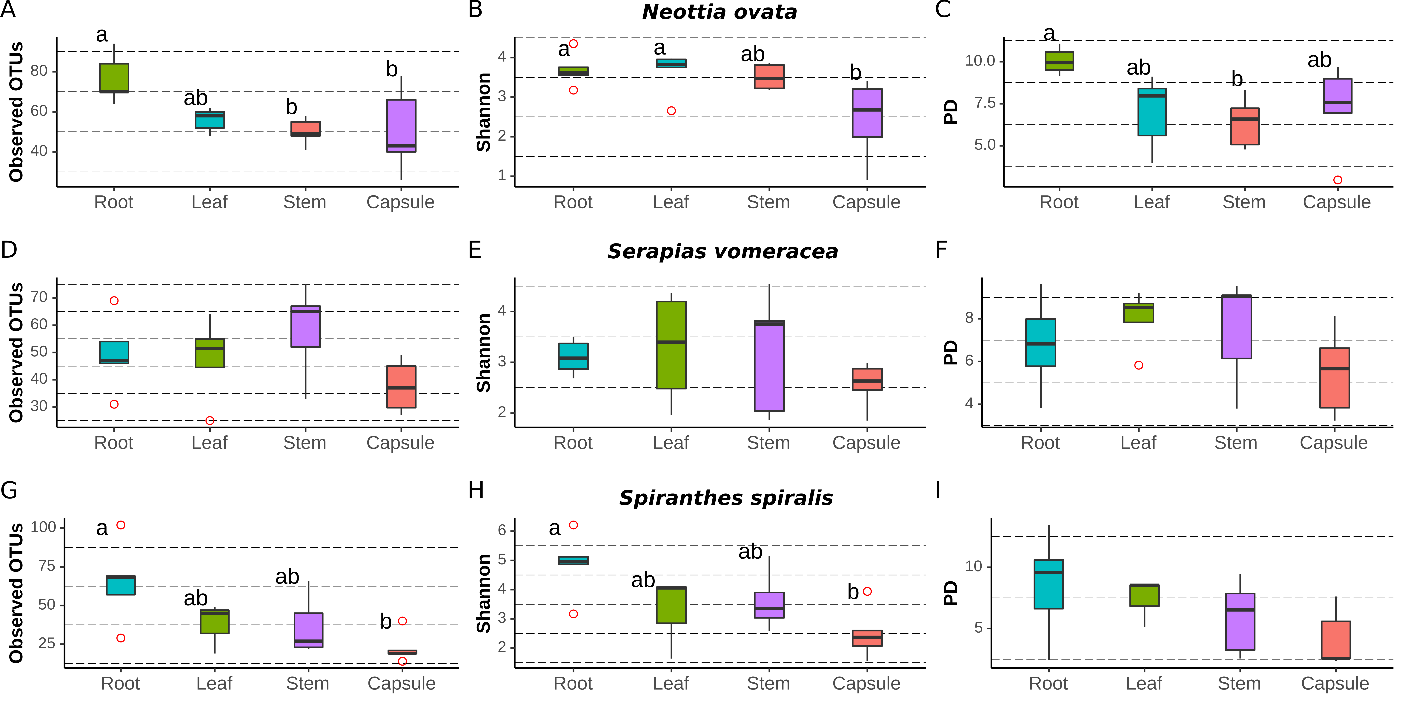
Fig. S1 Comparison of alpha-diversity indices between organs within each orchid plant. Richness (observed OTUs), diversity (Shannon) and phylogenetic diversity (PD) were used. ° indicates outliers. Different letters above the bars indicate significantly different means (Tukey test, p < 0.05); no letters (panels D-F and I) indicate no statistically significant differences.
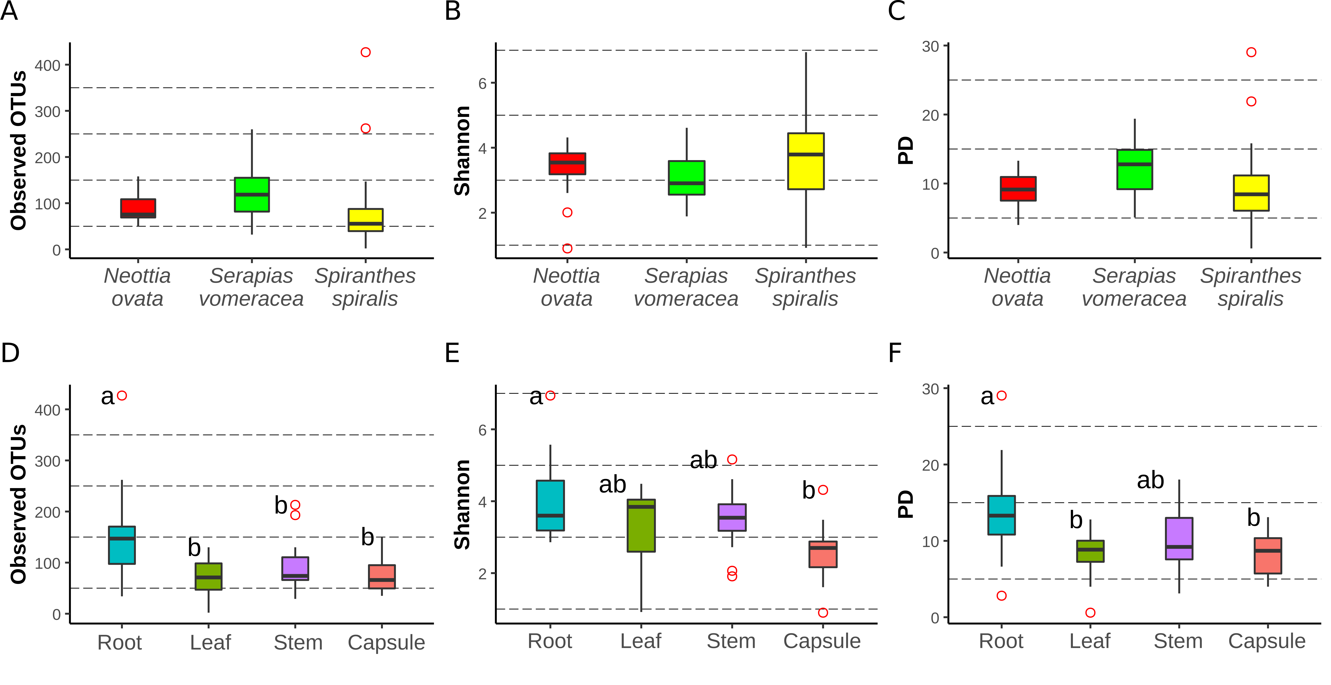

Fig S2 Comparison of alpha-diversity metrics between the microbiota of three Mediterranean orchid species, calculated on not rarefied dataset. Richness (observed OTUs), diversity (Shannon) and phylogenetic diversity (PD) for different plant species (A-C) and organs (D-F). ° indicates outliers. Different letters above the bars indicate significantly different means (Tukey test, p < 0.05); no letters indicate no statistically significant differences.
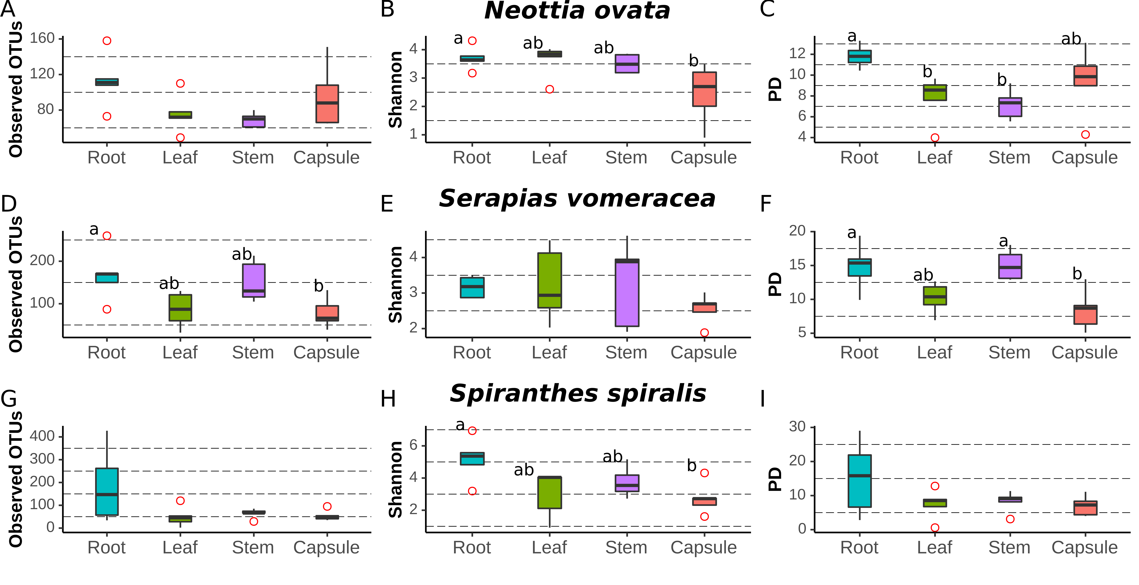Fig. S3 Comparison of alpha-diversity indices between the microbiota of plant organs within each orchid species, calculated on not rarefied dataset. Richness (observed OTUs), diversity (Shannon) and phylogenetic diversity (PD) were used. ° indicates outliers. Different letters above the bars indicate significantly different means (Tukey test, p < 0.05); no letters indicate no statistically significant differences.
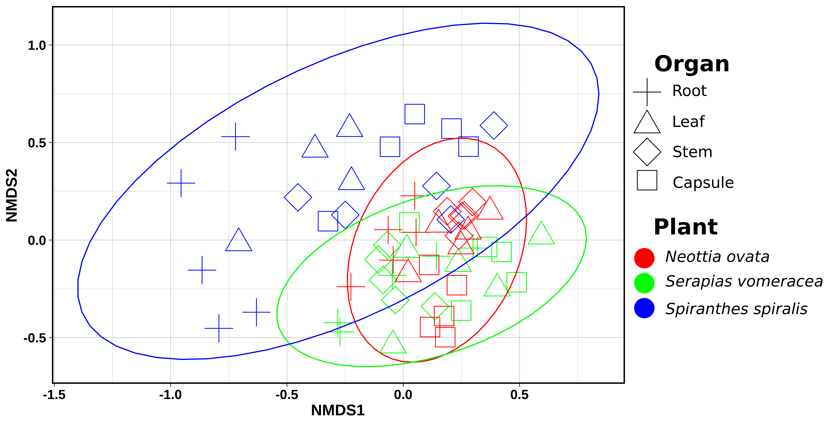
Fig. S4 Non-metric Multidimensional Scaling (NMDS) Plot visualization of beta diversity, using the Bray–Curtis distances, separating samples by orchid species/organs of no rarefied dataset. Plot ellipses represent the 95% confidence regions for species clusters (stress= 0.24).
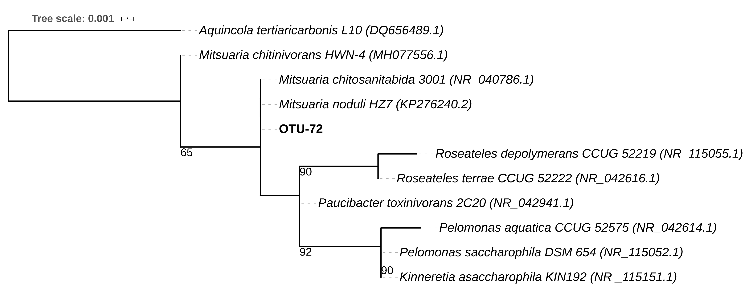

Fig. S5 Phylogenetic tree of OTU-72, based on16S rRNA gene partial sequence. Maximum likelihood 16S rRNA gene phylogenetic tree including the ambiguous taxon sequence (bold) and 16S reference sequences of Mitsuaria, Roseateles, Paucibacter, Pelomonas and Kinneretia type strains. Aquincola tertiaricarbonis L10 (GenBank accession (DQ656489.1) was used as outgroup. This tree was generated using the RAxML method; the numbers at the branch nodes indicate the bootstrap percentage values obtained from 1000 resamplings (only bootstraps >50% are shown). Scale bar indicates substitutions per site.

