Chemicals
The structures of Allium macrostemon saponin, new furostanol saponins(FS-1, FS-2 and FS-3), were reported previously as FS-1: (25R)-26-O-b- D -glucopyranosyl-5a-furostane-3b,12b, 22,26-tetraol-3-O-b- D -glucopyranosyl (1/2) [b- D -glucopyranosyl (1/3)]-b- D -glucopyranosyl (1/4)-b- D -galactopyranoside; FS-2: (25R)-26-O-b- D glucopyrano-syl-5a-furostane-3b,12a,22,26-tetraol-3-O-b- D -glucopyranosyl (1/2) [b-D -glucopyranosyl (1/3)]-b- D -glucopyranosyl (1/4)-b- D -galactopyranoside and FS-3: (25R)-26-O-b- D -glucopyranosyl-5b-furostane-3b,12a,22,26-tetraol-3-O-b- D -glucopyranosyl (1 / 2)-b- D -galactopyranoside(Ou et al., 2012).
REFERENCES
Ou, W.C., Chen, H.F., Zhong, Y., Liu, B.R., Liu, S.M., and Chen, K.J. (2012). Inhibition of platelet activation and aggregation by furostanol saponins isolated from the bulbs of Allium macrostemon Bunge. Am J Med Sci 344(4), 261-267. doi: 10.1097/MAJ.0b013e31823ea9f0.

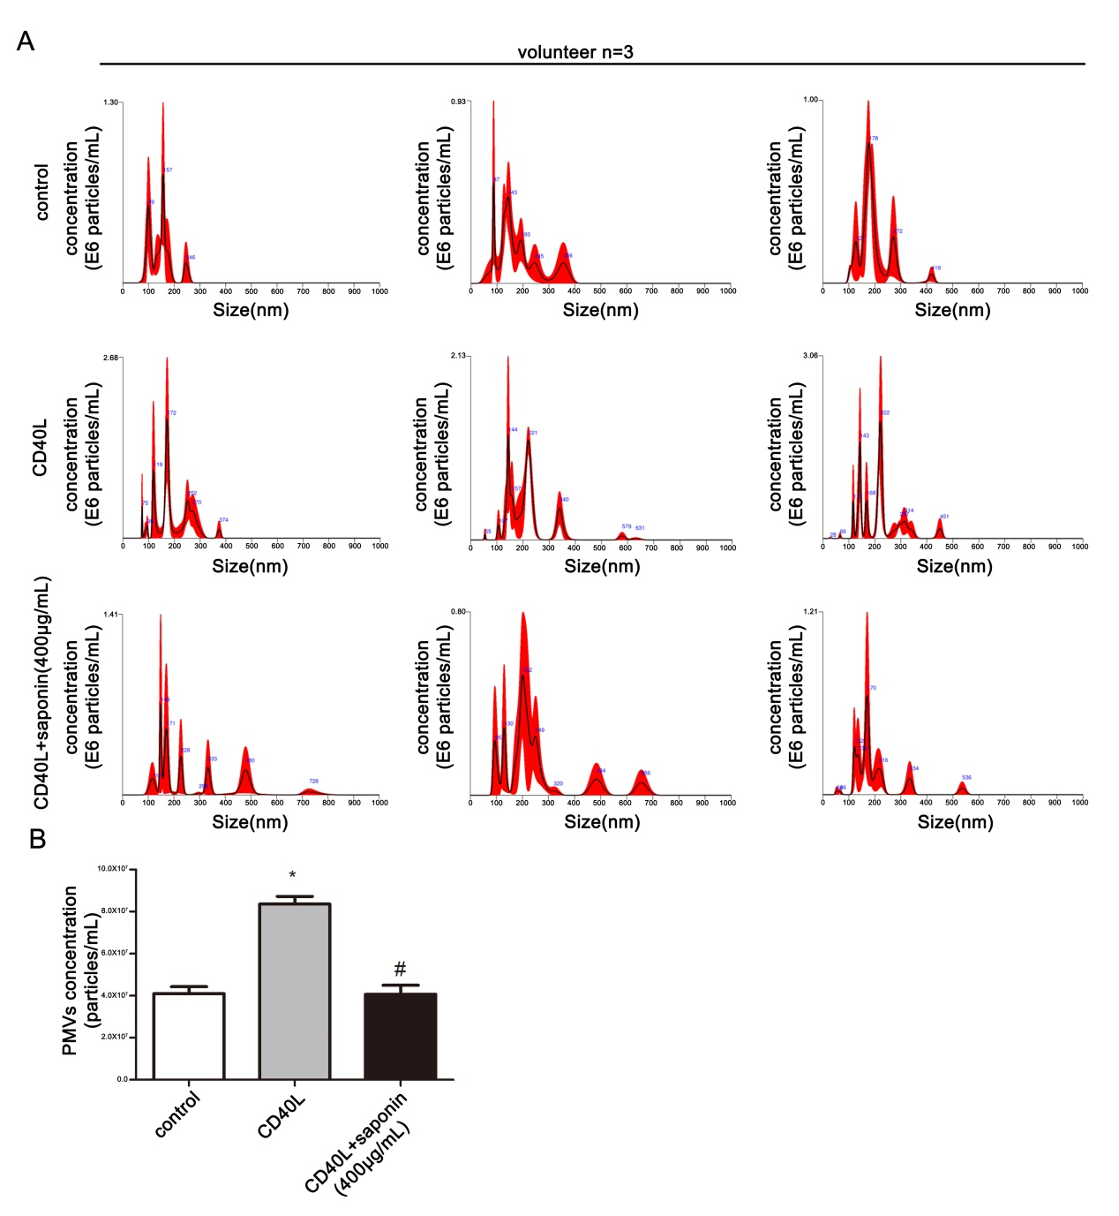
FIGURE S1. Saponins inhibit platelet-derived microvesicles(PMVs) release. (A, B) NTA detected PMVs from the platelets release, which peaked at 100 to 300nm.The chart showed the release concentration of PMVs in different treatment groups, *P<0.05 vs .control. #P<0.05 vs. CD40L.

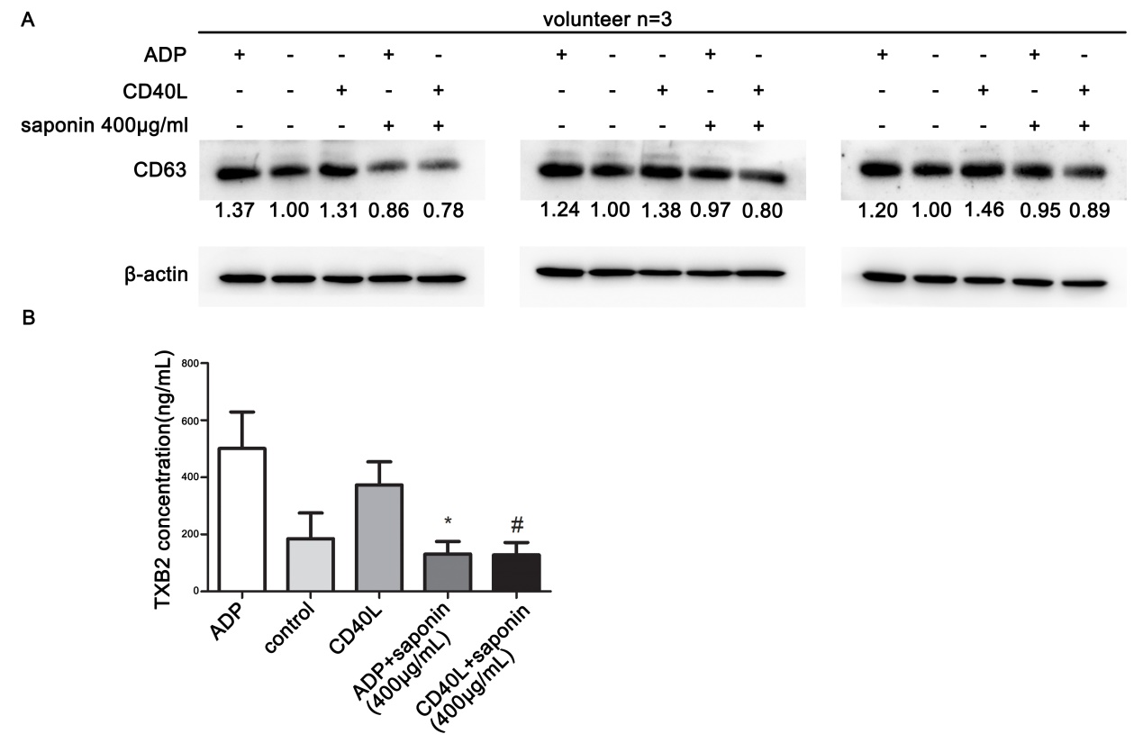
FIGURE S2. Saponins inhibit platelet activation induced by CD40L. (A) Western bloting method was used to detect the expression of CD63 protein in different treatment groups with β-actin as internal reference. (B) ELISA assay was used to detect the secretion of TXB2 in different treatment groups. *P<0.05 vs .ADP. #P<0.05 vs. CD40L.

