Supplementary materials: Robustness checks
1. SEM-analyses with control variables
We conducted robustness checks data through structural equation modelling. Specifically, we used the Lavaan package in R (Rosseel, 2012) to test whether the direct and indirect effects of stay-at-home orders were robust when controlling for differences in income, age, gender and number of new corona cases per state. The tested model included paths from the control variables (gender, age, income and number of new corona cases in the state) to all dependent variables in the model (well-being dimensions + resilience) (See supplementary figure 1). The exact operationalization of these variables can be found in the method section of the paper. Whereas the model fit is bad (χ2 = 96.22, p < .001, df = 10; CFI = .926, TLI = .558, RMSEA = .143, SRMR = .054), this model shows that the direct and indirect effects of stay-at-home orders previously reported are robust when these control variables are added to the model (See supplementary table 1).

Supplementary Figure 1. Conceptual model of relationship stay-at-home orders, resilience and well-being – including control variables
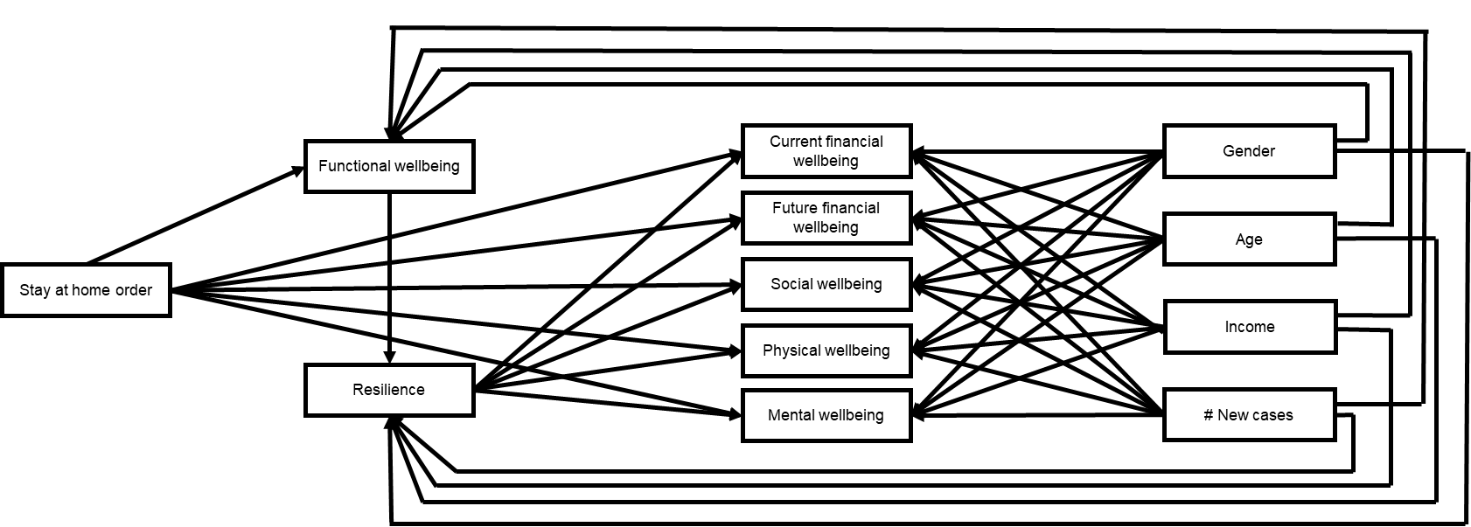

Supplementary Table 1. Path coefficients for direct and indirect effects of stay-at-home orders on resilience and well-being components controlling for income, gender, age and number of new corona infections
Path | Coefficient | SE (bootstrapped) | P-value | CI95
Direct effects
Stay-at-home order Future financial well-being | -0.170 | 0.097 | .080 | -0.360; 0.016
Stay-at-home order Current financial well-being | -0.190 | 0.096 | .048* | -0.375; 0.000
Stay-at-home order Social well-being | -0.189 | 0.079 | .016* | -0.346; -0.030
Stay-at-home order Mental well-being | -0.003 | 0.055 | .957 | -0.116; 0.104
Stay-at-home order Physical well-being | -0.011 | 0.081 | .894 | -0.166; 0.150
Stay-at-home order Functional well-being | -0.601 | 0.091 | <.001*** | -0.781; -0.427
Functional well-being Resilience | 0.128 | 0.041 | .002** | 0.047; 0.208
Indirect effects
Stay-at-home order Functional well-being Resilience Future financial well-being | -0.048 | 0.019 | .010* | -0.092;-0.018
Stay-at-home order Functional well-being Resilience Current financial well-being | -0.035 | 0.014 | .013* | -0.068;-0.013
Stay-at-home order Functional well-being Resilience Social well-being | -0.041 | 0.016 | .010* | -0.080;-0.016
Stay-at-home order Functional well-being Resilience Mental well-being | -0.053 | 0.020 | .009** | -0.100;-0.020
Stay-at-home order Functional well-being Resilience Physical well-being | -0.037 | 0.015 | .011* | -0.072;-0.014
* = p <.05, ** = p <.01, *** = p <.001

