Supplemental data
Figure S1.
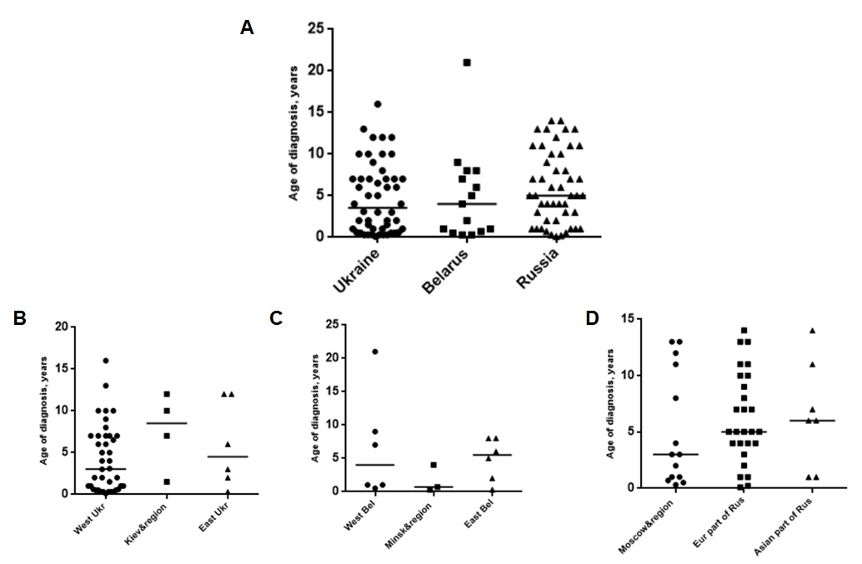
FIGURE S1 | Age of NBS diagnosis in East Slavic countries. (A) Median of age of NBS diagnosis in Ukraine, Belarus and Russia; (B) in Ukrainian regions; (C) in Belarusian regions; (D) Median age of NBS diagnosis in Russia, in European and Asian part of Russia.

Figure S2.
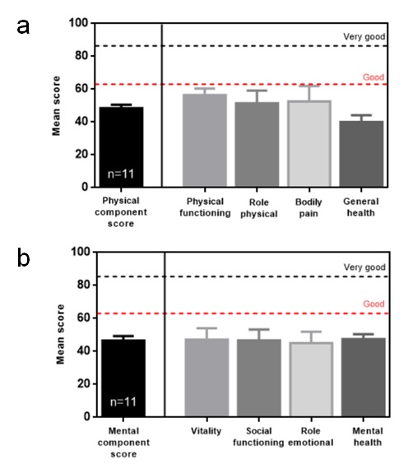
FIGURE S2 | SF-36 physical (a) and mental (b) component and domain scores of adult NBS patients at age older 18 years old (n=11). a. Physical functioning, role physical, bodily pain, and general health are domains of the physical component scores; vitality, social functioning, role emotional, and mental health are domains of the mental component score. ­­­ SF-36 mean current health scores for healthy population [adapted from 12].

