Electronic Supplemental Material
Consistent behavioral syndrome across seasons in an invasive freshwater fish
Juliane Lukas*, Gregor Kalinkat, Friedrich Wilhelm Miesen, Tim Landgraf, Jens Krause, David Bierbach
* correspondence: contact@julianelukas.com

Gillbach fish community
Samplings revealed 13 different fish taxa (capture or visual record, see Table 1), seven of which were non-native or ornamental species. Guppies were collected for behavioral testing, while ‘bycatch’ (i.e. all other native or non-native fish captured) were immediately euthanized with an overdose of clove oil and preserved in 99% ethanol for subsequent identification. Specimens were determined to the lowest feasible taxonomic level using the most recent literature available (Trewavas, 1983; Teugels and Thys Van den Audenaerde, 1992, 2003; Kottelat and Freyhof, 2007; Schmitter-Soto, 2007a, 2007b; Stiassny et al., 2007) and have been integrated into the collection of the Zoological Research Museum Alexander Koenig (Bonn, Germany).
Table 1: Fish community at the thermally-altered Gillbach. Summary of native and non-native fish observed (V) or caught (X) at the source of the Gillbach (SI), one kilometer downstream (SII) or further down (FD) during three samplings in 2016. *Note that sampling efforts were not standardized for examining species composition (i.e. sampling ceased once a sufficient number of adult Poecilia reticulata for experimental purposes were caught; see Table 2) and thus includes records of species previously described for this system.
 | Species | Origin | March |  |  | June |  |  | August |  |  | Previous records
 |  |  | SI | SII | FD | SI | SII | FD | SI | SII | FD
Anguillidae | Anguilla anguilla  (Linnaeus, 1758) | Europe |  |  |  |  |  |  |  |  |  | 4
Cichlidae | Amatitlania nigrofasciata  (Günther, 1867) | Central America | X | X |  | X | X | X | X | X | X | 3,4,5,6,9
 | Maylandia aurora  (Burgess, 1976) | Africa |  |  |  |  |  |  |  |  |  | 4
 | Oreochromis sp. | Africa |  | X | V |  |  | X | X |  | V | 4,5,6,9
 | Pelmatolapia mariae (Boulenger, 1899) | Africa |  |  |  |  |  |  |  |  | V | 9
Cyprinidae | Barbus barbus  (Linnaeus, 1758) | Europe |  |  |  | X | X |  |  |  |  | 4,5,9
 | Carassius auratus (gibelio)  (Linnaeus, 1758) | ornamental | V |  |  | V |  |  |  |  |  | 4,5
 | Chondrostoma nasus  (Linnaeus, 1758) | Europe |  |  |  |  |  |  |  |  | V | 5
 | Cyprinus carpio  (Linnaeus, 1758) | Europe/Asia |  |  |  |  |  | V |  |  | V | 5
 | Gobio gobio  (Linnaeus, 1758) | Europe |  | X |  |  |  |  |  | X | X | 3,4,5
 | Pseudorasbora parva  (Temminck & Schlegel 1846) | Asia |  |  |  |  |  |  |  |  |  | 4,5
 | Squalius cephalus  (Linnaeus, 1758) | Europe | X | X |  | X | X | X | X | X | X | 3,4,5,9
Loricariidae | Ancistrus sp. | South America |  |  |  |  | X | V | X |  | X | 5,6
Poeciliidae | Poecilia reticulata  (Peters, 1859) | South America | X | X |  | X | X |  | X | X |  | 4,5,6,8,9
 | Poecilia sphenops  (Valenciennes, 1846) | Central/South America | V
 | Poeciliidae I |  |  |  |  |  |  |  |  |  |  | 4
 | Poeciliidae II |  |  |  |  |  |  |  |  |  |  | 4
Siluridae | Silurus glanis  (Linnaeus, 1758) | Europe |  |  |  |  |  |  |  |  | V

Gillbach guppy population
Among the non-native species of the Gillbach, the guppy Poecilia reticulata was the most abundant (Table 1). Guppies were present at the Gillbach’s source (site 1) and one kilometer downstream (site 2) during all three samplings, however, we did not encounter any guppies beyond site 2 (Table 1, 2; Lukas et al. 2017b).
To estimate changes in population size as well as the degree of philopatry of the source population, we marked and released guppies sampled at site 1 during June and August of 2016. Visible implant elastomer tags (Northwest Marine Technology Ltd) were injected subcutaneously (for procedure details see Jourdan et al., 2014) using two colors (i.e. pink and green, respectively) to clearly differentiate between capture events. No previously marked fish were marked a second time. Recapture rates were recorded during subsequent samplings and analyzed with a log-linear model for closed populations (Mt in package Rcapture; Baillargeon and Rivest, 2007) after Jourdan et al. (2014). Overall, we tagged 250 guppies during two samplings and recovered 23 marked individuals (9 June tags retrieved 86 days post-release and 14 August tags retrieved 22 days post-release; Table 2). We estimated a total population size of 4487 (95% CI: 2584.2–9108.7) adult guppies in June and 514 (95% CI: 351.7–846.1) in August. The number of guppies that were taken to the laboratory for subsequent behavioral testing was added to the estimates, resulting in a population size estimate of about 4584 individuals in June and 688 individuals in August.
Table 2: List of guppies captured at the Gillbach in 2016. Summary of the total number of individuals captured, marked and recaptured at the Gillbach’s source (site 1) and 1-kilometer downstream (site 2).
Site | Sampling | Total fish captured (Male/Female/Juvenile) | Fish marked-released  (Male/Female/Juvenile) | Fish recaptured
Gillbach source (site 1) | March | 54  (10/25/19) | 0 | NA
 | June | 250  (83/114/53) | 146  (48/52/46) | NA
 | August | 278  (98/121/59) | 104  (45/28/31) | 9
 | September | 70  (17/39/14) | 0 | 14
Gillbach 1km (site 2) | March | 11  (3/5/3) | 0 | NA
 | June | 4  (1/1/2) | 0 | NA
 | August | 65  (19/33/12) | 0 | 0
 | September | NA | NA | NA
> site 2 | March | 0 | 0 | NA
 | June | 0 | 0 | NA
 | August | 0 | 0 | 0
 | September | 0 | 0 | 0

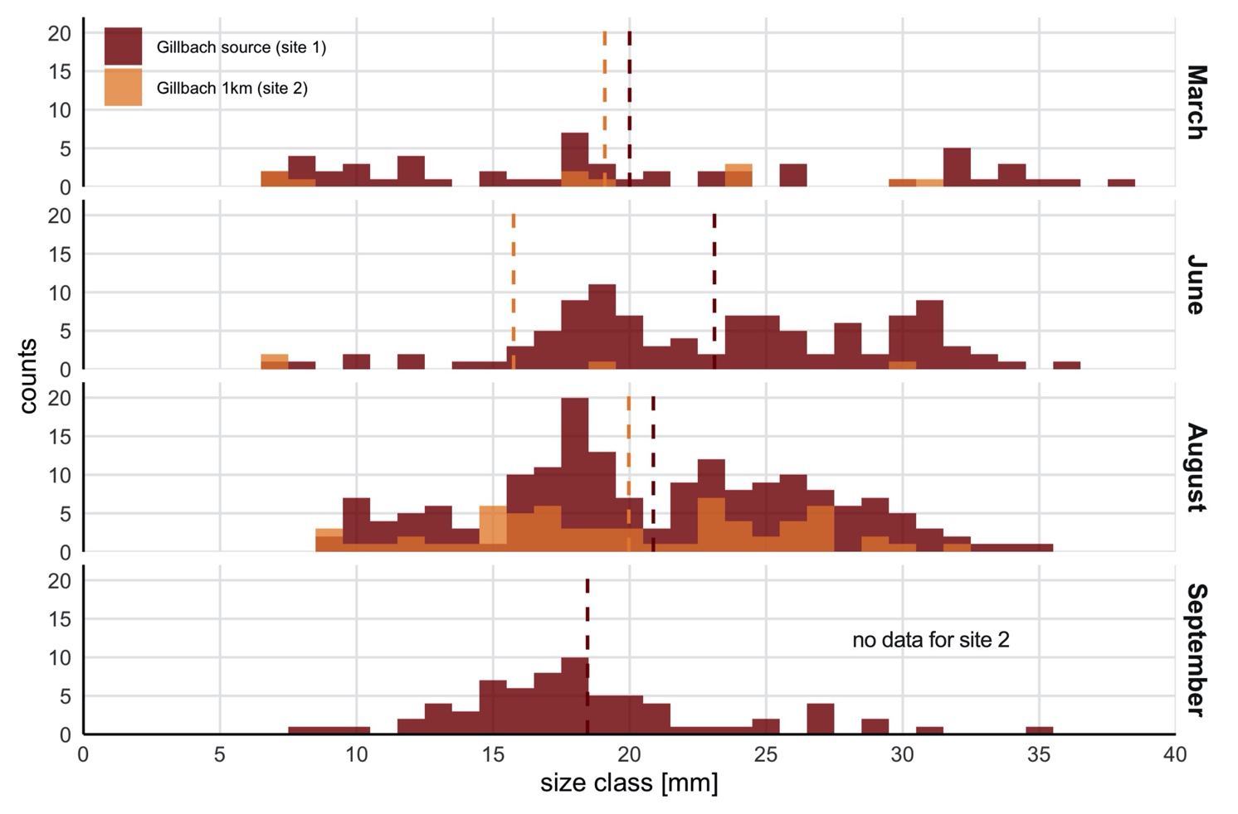 Figure 3: Body size distribution of guppies at the Gillbach in 2016. Body size (pre-acclimation) measured as standard length (SL) was determined for guppies caught at the Gillbach’s source (site 1) and 1-kilometer downstream (site 2) during four occasions. * Fish that were marked and released (n=146 in June and n =104 in August; Table 2) are not included, as size was not determined to reduce stress during the tagging procedure. The interrupted line indicates mean body sizes for each population.
We caught guppies ranging from 7 to 38 mm (Fig. 3). Males showed a very narrow body size range with a mean SL of 17.9 ± 1.4 mm (SD), while female body size was much more variable, with a mean SL of 25.3 ± 4.8 mm.
Notably, we found newly born fry and juveniles during all samplings. With a generation time of 2-3 months (Reznick & Endler 1982), this indicates that reproduction occurred continuously between March and September (Fig. 3). Female guppies have the ability to store sperm for long periods and give birth at a later time. As a result, a single female can found an entire population (Deacon et al. 2011). We thus argue that juveniles found at site 2, especially in March and June, are most likely the offspring of site 1 dispersers.

Fish were sexed on the basis of external signs of maturity. Fish below 15 mm did not exhibit any external signs of maturation. Upon maturation, wild-type guppies are sexually dimorphic. Males possess a fully developed gonopodium and display vivid orange, black and green spots or stripes (Fig. 4D-H). Females are colored an inconspicuous grey or brown with a gravid spot behind the anal fin (Fig. 4L-M). Gillbach guppies showed high plasticity in body coloration and fin dimension ranging from the sexual dimorphism typically encountered in natural guppy populations to the ornamentation derived from various strains used in the aquarium trade (Fig. 4).
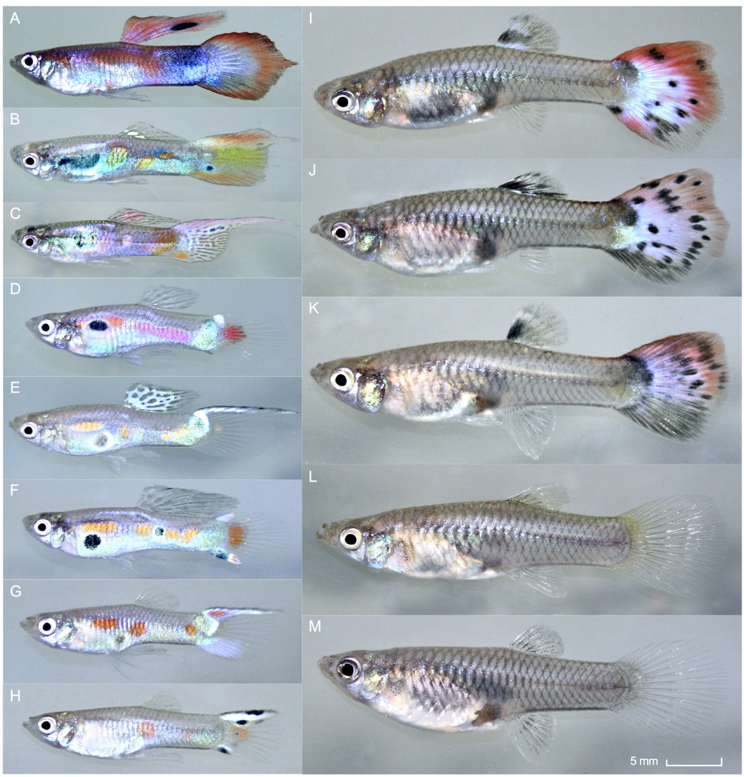
Figure 4: Specimens of feral guppies (Poecilia reticulata) collected from the Gillbach population in 2016. In the Gillbach population, both males (A-H) and females (I-M) exhibit high polymorphism in coloration and fin shape, including some rare color morphs (A-C, I-K), typical for fish of the ornamental trade.

Behavioral testing
Table 5: Variances from Repeatability models. Shown are estimates of within- and among-individual variance along with 95% confidence intervals computed from linear mixed models (see main text) for each behavioral traits of all population samples.
 | Boldness (log₁₀) |  | Sociability (log₁₀) |  | Activity
Population | V_{within}  [95% CI] | V_{among}  [95% CI] | V_{within}  [95% CI] | V_{among}  [95% CI] | V_{within}  [95% CI] | V_{among}  [95% CI]
March site 1 | 0.12  [0.09–0.17] | 0.12  [0.06–0.23] | 0.044  [0.031–0.061] | 0.015  [0.006–0.041] | 5.00  [3.58–6.98] | 1.87  [0.71–4.89]
June site 1 | 0.19  [0.14–0.25] | 0.12  [0.06–0.25] | 0.047  [0.035–0.064] | 0.022  [0.010–0.048] | 4.03  [2.97–5.46] | 1.73  [0.77–3.88]
August site 1 | 0.16  [0.12–0.21] | 0.18  [0.1–0.32] | 0.037  [0.028–0.051] | 0.019  [0.009–0.041] | 4.46  [3.28–6.06] | 2.69  [1.33–5.43]
August site 2 | 0.14  [0.1–0.19] | 0.16  [0.09–0.29] | 0.043  [0.031–0.058] | 0.041  [0.023–0.075] | 3.79  [2.78–5.16] | 2.14  [1.04–4.41]

Table 6: Variances from multivariate mixed models. Shown are estimates of within- and among-individual variance along with 95% confidence intervals computed from multivariate mixed models (see main text) for all population samples.
 | Boldness (log₁₀) |  | Sociability (log₁₀) |  | Activity
Population | V_{within}  [95% CI] | V_{among}  [95% CI] | V_{within}  [95% CI] | V_{among}  [95% CI] | V_{within}  [95% CI] | V_{among}  [95% CI]
March site 1 | 0.41  [0.29 – 0.57] | 0.56  [0.29 – 1.08] | 0.7  [0.5 – 0.97] | 0.3  [0.12 – 0.74] | 0.63  [0.45 – 0.88] | 0.36  [0.16 – 0.82]
June site 1 | 0.61  [0.45 – 0.82] | 0.36  [0.18 – 0.72] | 0.68  [0.5 – 0.92] | 0.32  [0.15 – 0.7] | 0.68  [0.5 – 0.92] | 0.28  [0.13 – 0.64]
August site 1 | 0.42  [0.31 – 0.57] | 0.53  [0.3 – 0.94] | 0.61  [0.45 – 0.83] | 0.37  [0.18 – 0.74] | 0.58  [0.43 – 0.79] | 0.42  [0.22 – 0.81]
August site 2 | 0.44  [0.32 – 0.59] | 0.52  [0.29 – 0.91] | 0.51  [0.38 – 0.7] | 0.46  [0.25 – 0.84] | 0.62  [0.45 – 0.84] | 0.38  [0.19 – 0.76]

References
- Baillargeon, S., and Rivest, L.-P. (2007). Rcapture: Loglinear Models for Capture-Recapture in R. J. Stat. Softw. 19, 1 –31.
- Deacon, A.E., Ramnarine, I.W., and Magurran, A.E. (2011). How reproductive ecology contributes to the spread of a globally invasive fish. PLoS ONE 6, e24416. doi: 10.1371/journal.pone.0024416
- Emde, S., et al. (2016). Cooling water of power plant creates “hot spots” for tropical fishes and parasites. Parasitol. Res. 115, 85–98. doi: 10.1007/s00436-015-4724-4
- Höfer, S., and Staas, S. (1998). Bericht zur fischereibiologischen Untersuchung des Gillbaches im Bereich Bergheim-Auenheim (Okt./Nov. 1998). (Zoologisches Institut der Universität zu Köln, Abt. Allgemeine Ökologie und Limnologie, Köln)
- Jourdan, J., et al. (2014). On the natural history of an introduced population of guppies (Poecilia reticulata Peters, 1859) in Germany. BioInvasions Rec. 3, 175–184. doi: 10.1093/czoolo/60.3.417
- Klotz, W., et al. (2013). Two Asian fresh water shrimp species found in a thermally polluted stream system in North Rhine-Westphalia, Germany. Aquat. Invasions 8, 333–339. doi: 10.3391/ai.2013.8.3.09
- Kottelat, M., and Freyhof, J. (2007). Handbook of European Freshwater Fishes. (Publications Kottelat, Cornol, Switzerland and Freyhof, Berlin), 646 pp.
- Lukas, J., et al. (2017a). Feral guppies in Germany – a critical evaluation of a citizen science approach as biomonitoring tool. Bull. Fish Biol. 17, 13–27.
- Lukas, J., et al. (2017b). On the occurrence of three non-native cichlid species including the first record of a feral population of Pelmatolapia (Tilapia) mariae (Boulenger, 1899) in Europe. Roy. Soc. Open Sci. 4, 170160. doi: 10.1098/rsos.170160
- Reznick, D., and Endler, J.A. (1982). The impact of predation on life-history evolution in Trinidadian guppies (Poecilia reticulata). Evolution 36, 160–177. doi: 10.2307/2407978
- Schmitter-Soto, J.J. (2007a). A systematic revision of the genus Archocentrus (Perciformes: Cichlidae), with the description of two new genera and six new species. Zootaxa 1603, 1–78.
- Schmitter-Soto, J.J. (2007b). Phylogeny of species formerly assigned to the genus Archocentrus (Perciformes: Cichlidae). Zootaxa 1618, 1–50.
- Stiassny, M.L.J., Lamboj, A., De Weirdt, D., Teugels, G.G. (2007). “Cichlidae,” in The Fresh and Brackish Water Fishes of Lower Guinea, West-Central Africa: Volume 2, eds. M.L.J. Stiassny, G.G. Teugels, C.D. Hopkins (IRD Éditions, Paris, France, Muséum national d'Histoire naturelle, Paris, France, and Musée royal de l’Afrique Central, Tervuren, Belgium), p. 269–403.
- Teugels, G.G., and Thys van den Audenaerde, D.F.E. (1992). “Cichlidae,” in The Fresh and Brackish Water Fishes of West Africa: Volume 2, eds. C. Levêque, D. Paugy, G.G. Teugels (ORSTOM, Paris, France, and Musée Royal de l’Afrique Centrale, Tervuren, Belgium), p. 714–779.
- Teugels, G.G., and Thys van den Audenaerde, D.F.E. (2003). “Cichlidae,” in The Fresh and Brackish Water Fishes of West Africa: Volume 2, eds. D. Paugy, C. Lévêque, G.G. Teugels (Institut de recherche de développement, Paris, France, Muséum national d’histoire naturelle, Paris, France and Musée royal de l’Afrique Central, Tervuren, Belgium), p. 521–600.
- Trewavas, E. (1983). Tilapiine fishes of the genera Sarotherodon, Oreochromis and Danakilia (British Museum [National History], London, UK), 583 pp.

