Overloaded adeno-associated virus as a novel gene therapeutic tool for otoferlin-related deafness
Vladan Rankovic^{1,2,#,*}, Christian Vogl^{1,3,4,#,*}, Nele M. Dörje^{1,3}, Iman Bahader^{4,5}, Carlos J. Duque-Afonso^{1,6,7}, Anupriya Thirumalai¹, Thomas Weber¹, Kathrin Kusch¹, Nicola Strenzke^{4,5}, and Tobias Moser^{1,4,6,7,8,9*}

Supplemental material:

Supp. Table 1. AAV serotypes used in the study with obtained titers, purity and ABR rescue efficacy (gc, genome copies).

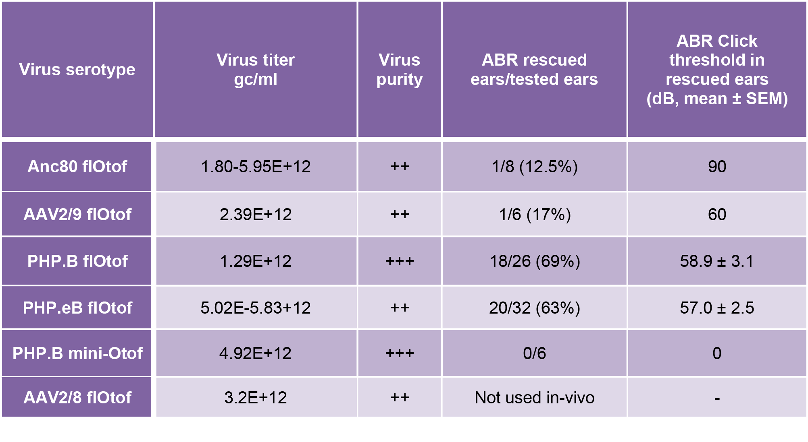

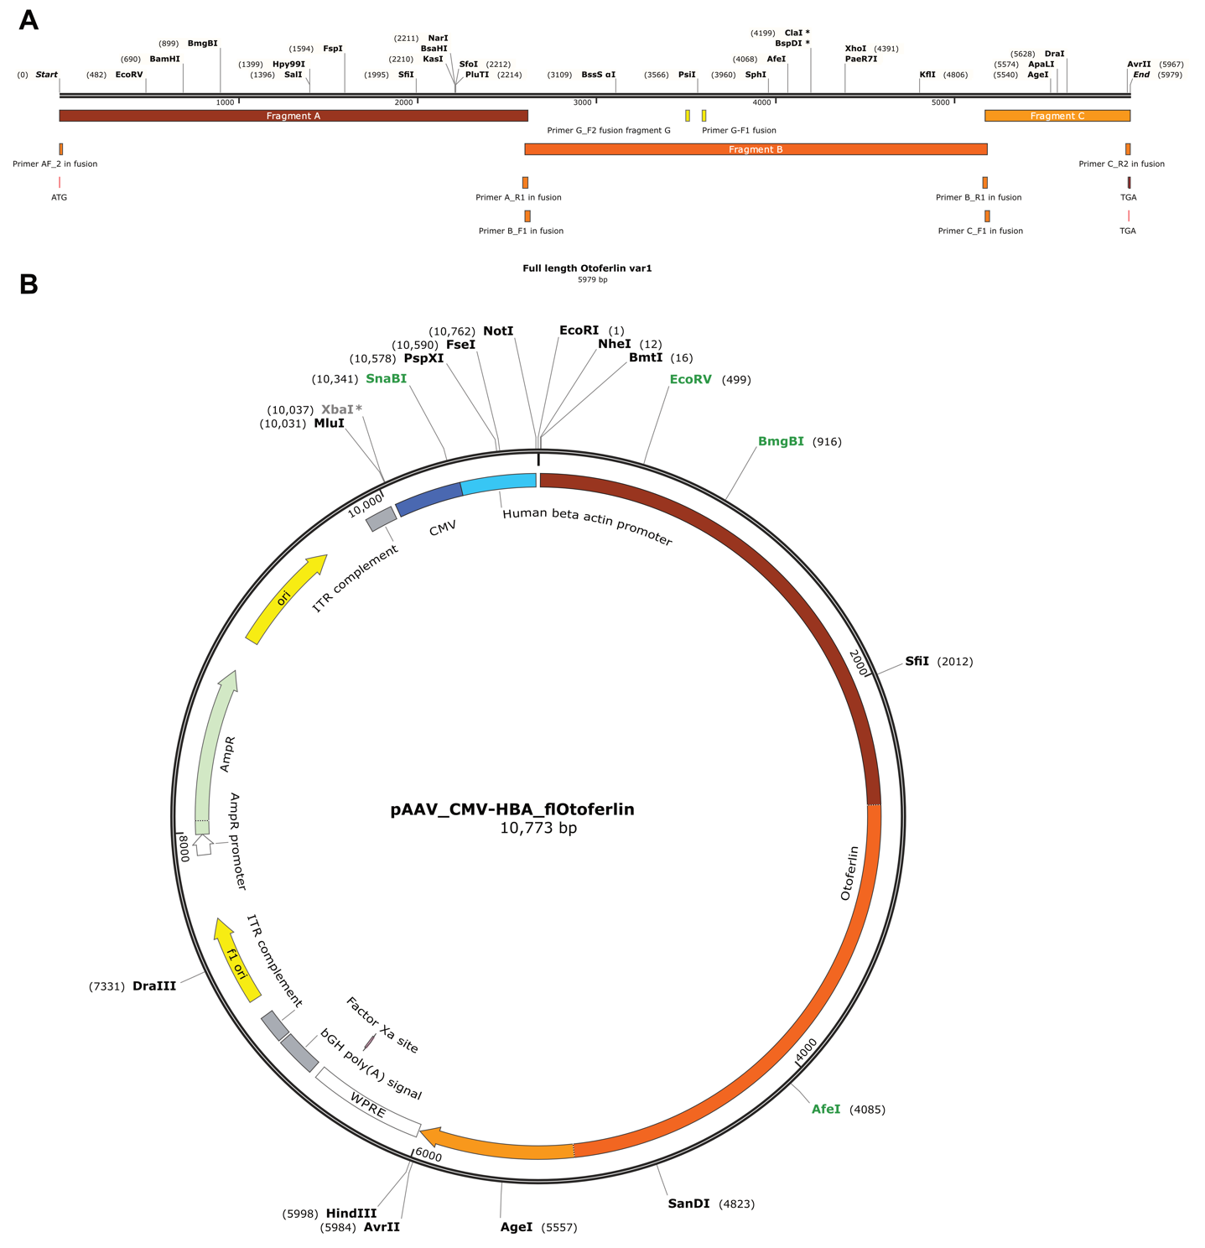
Supp. Figure 1: fl-Otof construct assembly and pAAV vector used for AAV packaging of fl-Otof. (A) linearized otoferlin sequence including primer binding sets used for the construct assembly. (B) pAAV cis-plasmid providing fl-otoferlin. Color code of fl-Otof-CDS corresponds to the fragments shown in panel A.

Supp. Figure 2: mini-Otof construct assembly and pAAV vector used for AAV packaging. (A) linearized mini-otoferlin sequence including primer binding sets used for the construct assembly. (B) pAAV cis-plasmid providing fused protein of EGFP and mini-Otof (C2E and C2F including the transmembrane domain).
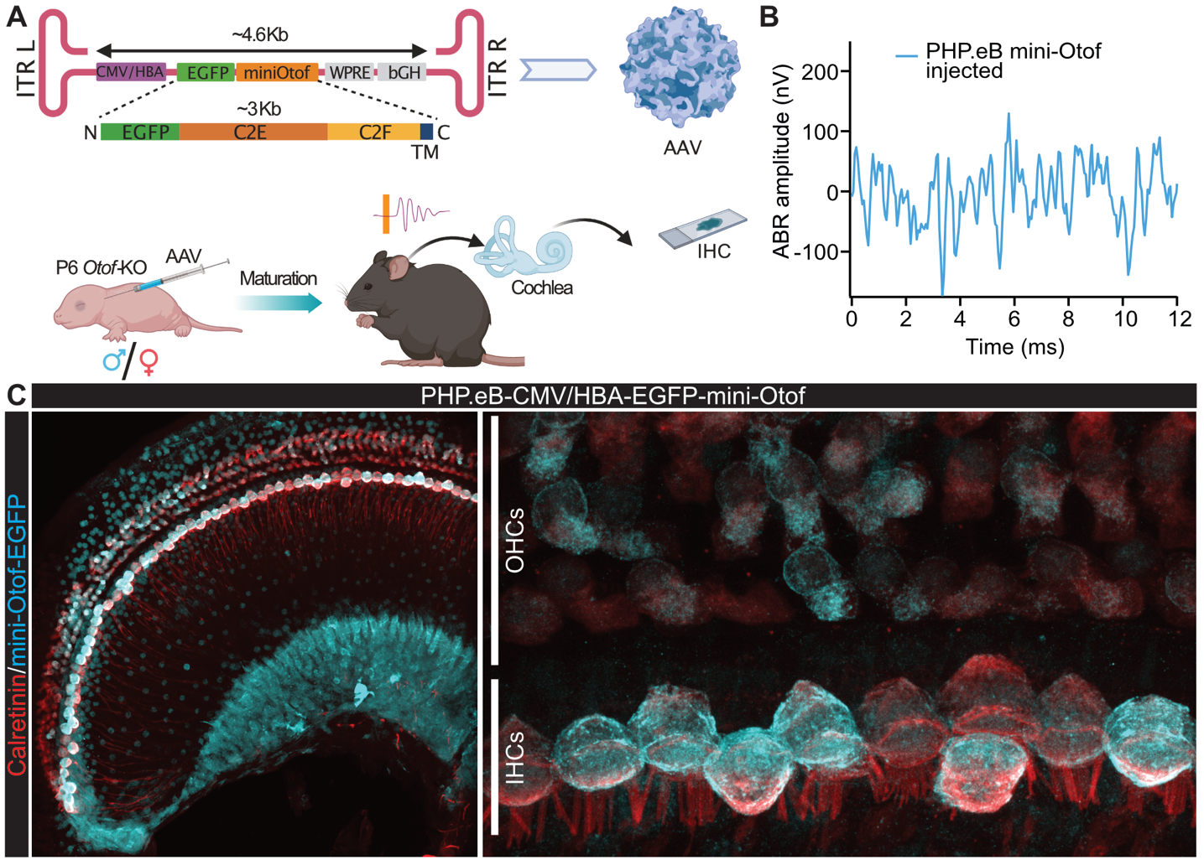
Supp. Figure 3: Insert size appears to determine AAV transduction/otoferlin expression rate. (A) Schematic illustration of the mini-Otof AAV construct design and experimental approach. The AAV/promoter construct is identical to the one used in our other experiments, but only encodes a short C-terminal and GFP-tagged otoferlin fragment (‘mini-Otof’) instead of the fl-Otof-CDS. (B) Treatment with the ‘mini-Otof’ AAV virus does not rescue hearing function assessed by ABRs to 100dB click stimulation despite (C) abundant viral transfection of IHC and OHC in the same ear (confocal z-projection, representative example).

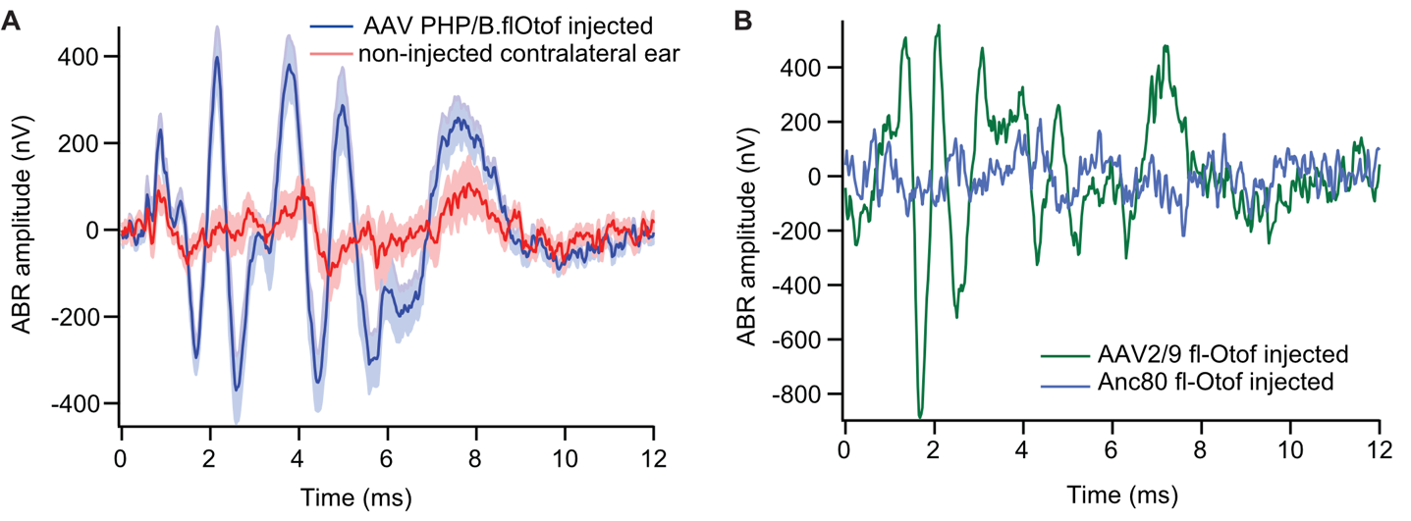
Supp. Figure 4: Rescue of hearing function in Otof-KO mice: ABR after successful rescue with other Otof viruses (related to Fig. 2 and suppl. Table 1). (A) Grand averages of ABR waveforms to 100 dB Click stimulation in Otof-KO mice with successful partial rescue of hearing function by PHP.B fl-Otof AAV (blue, n=14). ABRs from non-injected contralateral ears of the same animals are shown in red. (B) ABR waveforms to 100 dB click stimulation from the single rescued ears injected with Anc80 (blue) and AAV2/9 (green) viruses.

