Supplemental Table 1. Number of trees sampled during the various field campaigns. In 2016, two leaves were sampled per tree. In 2019, one leaf was sampled per tree. In 2918, five cuttings from European buckthorn were sampled in the laboratory.
Common name | Scientific name | Emitter? | 2016 trees | 2019 trees | Other
European buckthorn | Rhamnus cathartica | Y | 4 | 3 | 5 cuttings
Norway maple | Acer platanoides | N | 2 | 3
Siberian elm | Ulmus pumila | ? | 2 | 3
Black locust | Robinia pseudoacacia | ? |  | 3
White mulberry | Morus alba | N |  | 3
Tree-of-heaven | Ailanthus altissima | N |  | 3
Silver maple | Acer saccharinum | N | 2 | 3
Boxelder | Acer negundo | N | 2 | 3
Black walnut | Juglans nigra | N | 2 | 3
Black cherry | Prunus serotina | N |  | 3
Bur oak | Quercus macrocarpa | Y |  | 3
American elm | Ulmus americana | N |  | 3

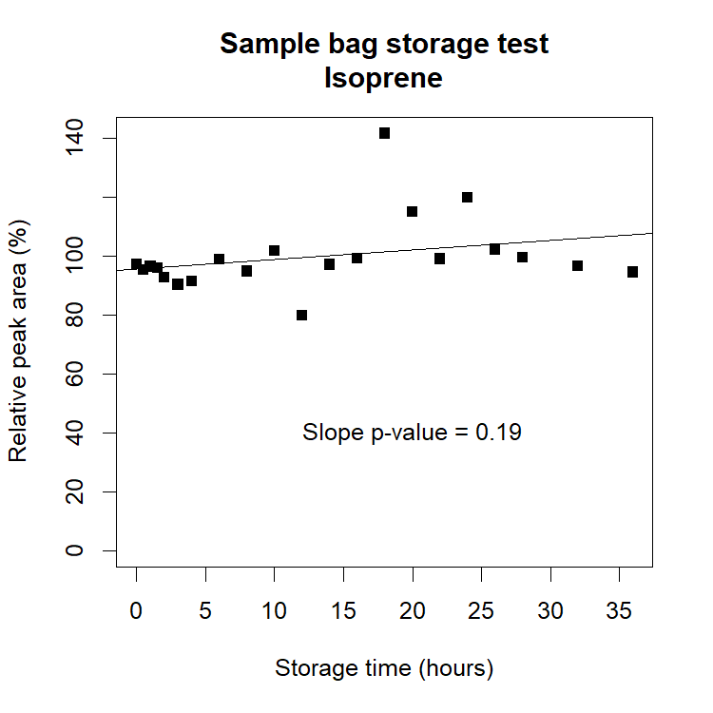
Figure S1. The same model SamplePro bags used during the experiment were filled with a mixture of isoprene standard gas (1.03 ppmv) and hydrocarbon trap-scrubbed zero air. The standard flow was 17.4 cm³ min⁻¹ and the zero flow 725 cm³ min⁻¹, to give a final concentration of 24.1 ppbv isoprene. The experiment was conducted over the course of 4 days, with bags filled at different times to provide different storage time ranges and to avoid the need for overnight sampling. The spread seen in some samples may have been due to the presence of concentrated alcohols from hand sanitizers necessary due to Covid-19 safety protocols. The mean of the peak area was computed from all the runs, and the results were expressed as a percentage of that mean. A linear regression between storage time and the relative peak area did not yield a slope significantly different from zero (p value 0.19).

