Table S1 Primers for qRT-PCR

Primer name | Primer sequence
UBQ5-F | TGGGAGAACCCTTGCTGATT
UBQ5-R | AGCGTTATGGTCTTCCCTGTC
AOS-F | CTCATATTCGCCACCTGCTT
AOS-R | TCGCTCTCATTGTGACTCTGC
JAZ-F | GAAATCAAACTTTGCCCACACT
JAZ-R | GCTGACCCGAAATCTCCAT
MYC2-F | TCCAGACCCAGTCAGATTGCT
MYC2-R | TTGGTCCCTTGGAAGTAGCC
PAL-F | TTTGGACTATGGTTTCAAGGGT
PAL-R | CCACGGCTTCTGCTGTTTT
C4H-F | AGTCACTGAACCAGACACCCAT
C4H-R | TCTCGGCTGAAATATCATACCC
4CL-F | CCAGTTCAGCAACCGTCCTT
4CL-R | GCTTGTAGAATGGATTGGCAGT
HCT-F | CAAGGGATGAAGAAGGAAGGAT
HCT-R | TTGAAACGAGTCACCTGGAAA
C3H-F | GGGTCAGTAGCATTCAACAACA
C3H-R | AAACATCCAACGAAGCCAAG
MYB85-F | GGTTACAACGTACCCAGAGACAC
MYB85-R | GAACGCCAGCACAAATCCT
MYB111-F | GCCCAGTCATCTTCACAATA
MYB111-R | ATCACTCACGGGAGCCAC
MYB15-F | CCAGGACGAACCGACAAC
MYB15-R | GGCATCCGTGAAGGATAAG
MYB20-F | ATTGCTTCTCATCTCCCTG
MYB20-R | CTTCTCCTTTCGCCTCTG
MYB60-F | CTCAAATGCTGGATAGGAA
MYB60-R | TTAGGAGGCAATGGGACA
MYB52-F | TCTTTCCATCACTGCCTTTA
MYB52-R | GCACCCAACACTCCATACA
MYB4-F | CGGTGAAGCTACAAAGAAAT
MYB4-R | TGATAAGCCTCCCTAACTAAA

Table S2 Results of RNA-Seq evaluation
Sample_name | G8h | G20h | G0h | G40h
Total reads | 5,741,626 | 8,263,184 | 7,394,830 | 21,010,198
Total mapped | 3,855,586 (67.15%) | 5,948,742 (71.99%) | 5,583,824 (75.51%) | 17,037,760 (81.09%)
Mutiple mapped | 933,628 (16.26%) | 1,198,724 (14.51%) | 1,201,908 (16.25%) | 2,612,462 (12.43%)
Unique mapped | 2,921,958 (50.89%) | 4,750,018 (57.48%) | 4,381,916 (59.26%) | 14,425,298 (68.66%)
Read1 mapped | 1,460,979 (25.45%) | 2,375,009 (28.74%) | 2,190,958 (29.63%) | 7,212,649 (34.33%)
Read2 mapped | 1,460,979 (25.45%) | 2,375,009 (28.74%) | 2,190,958 (29.63%) | 7,212,649 (34.33%)
Mapped to '+' | 14,60,979 (25.45%) | 2,375,009 (28.74%) | 2,190,958 (29.63%) | 7,212,649 (34.33%)
Mapped tp '-' | 1,460,979 (25.45%) | 2,375,009 (28.74%) | 2,190,958 (29.63%) | 7,212,649 (34.33%)
Non-splice reads | 2,921,958 (50.89%) | 4,750,018 (57.48%) | 4,381,916 (59.26%) | 14,425,298 (68.66%)
Splice reads | 0 (0.00%) | 0 (0.00%) | 0 (0.00%) | 0 (0.00%)
Reads mapped in proper pairs | 2,921,958 (50.89%) | 4,750,018 (57.48%) | 4,381,916 (59.26%) | 14,425,298 (68.66%)
Total Reads: the number of all clean data form each library
Total mapped: the number of reads that can be mapped to the reference sequences
Mutiple mapped: the number of reads with multiple alignment positions on the reference sequences
Unique mapped: the number of reads with unique alignment position on the reference sequences
Read1/ Read1 mapped: the number of reads form read1/read2 mapped to the reference sequences (only calculate unique mapped sequences)
Mapped to '+'/Mapped tp '-': the number of reads that can be mapped to positive/negative chains of reference sequences (only calculate unique mapped sequences)
Non-splice reads: the number of reads whose whole sequence are aligned to the exons
Splice reads: the number of reads that can be segmentally aligned to the reference sequences
Reads mapped in proper pairs: the number of paired reads that can be simultaneously aligned to the reference sequences

Note: we ran the RSEM program and invoked Bowtie with parameters of -v 2 -S for RNA-Seq evaluation. All the spliced unigenes after assembly from each library were regard as reference sequences. Clean reads from each library were aligned to reference sequences and then statistical results were obtained

Figure S1
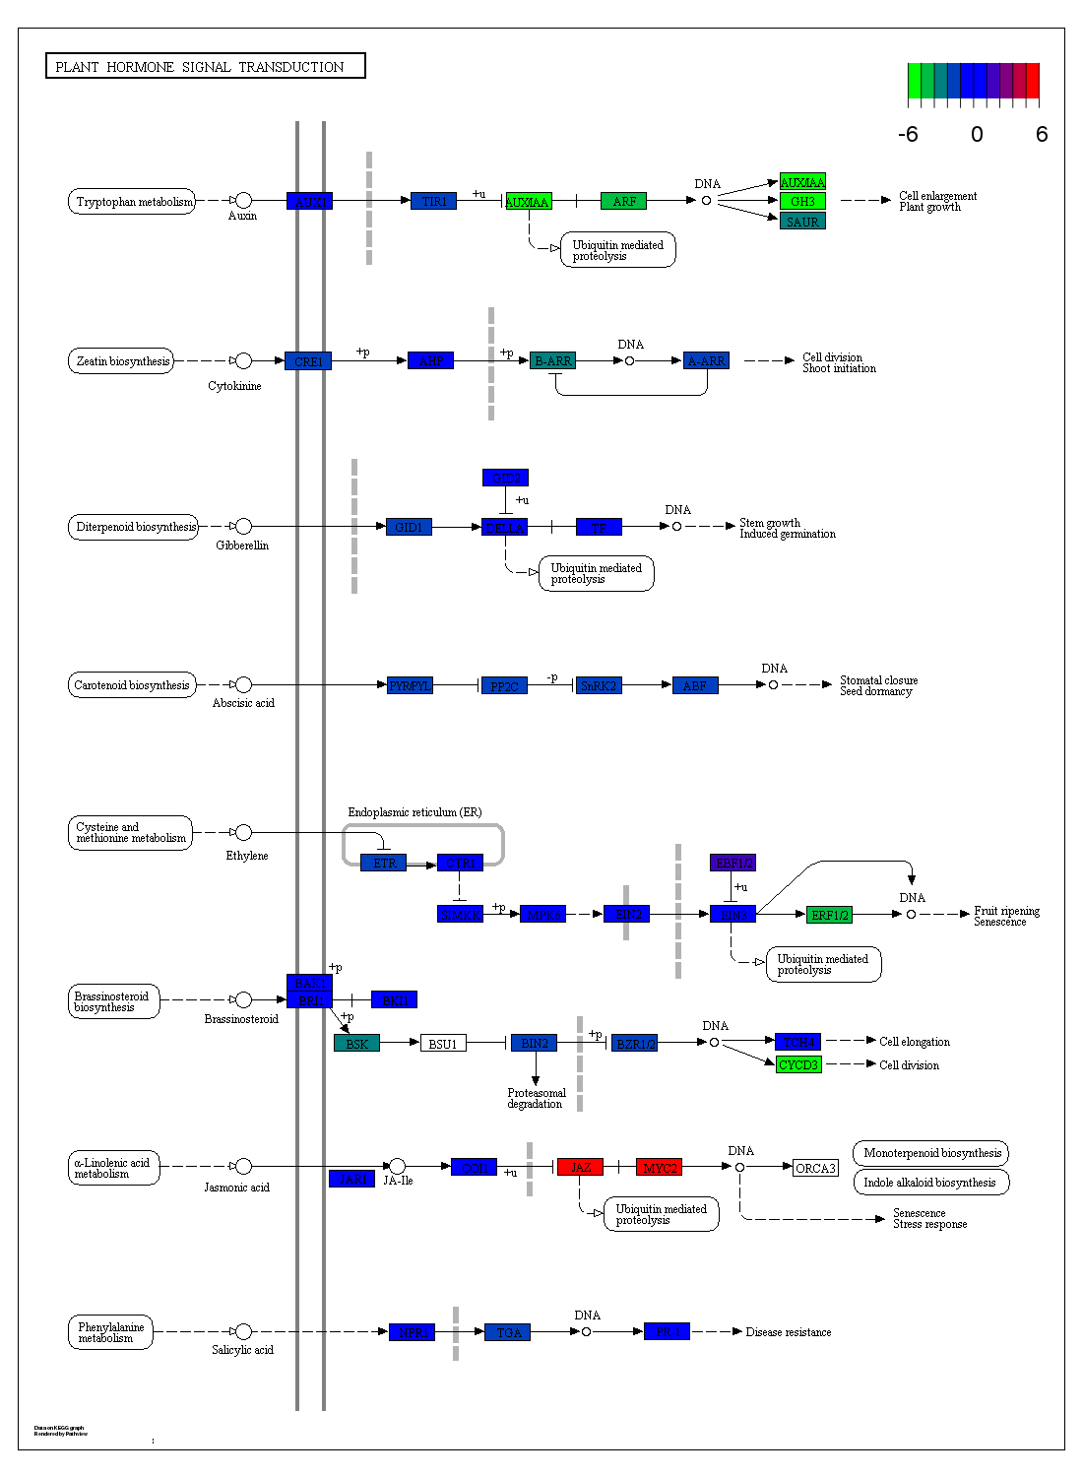
Note: all DEGs in plant hormone signal transduction pathway were mapped to KEGG pathway of ko04075, and different colors of rectangles meant relative expression of DEGs.
Figure S1 Plant hormone signal transduction pathway

Figure S2
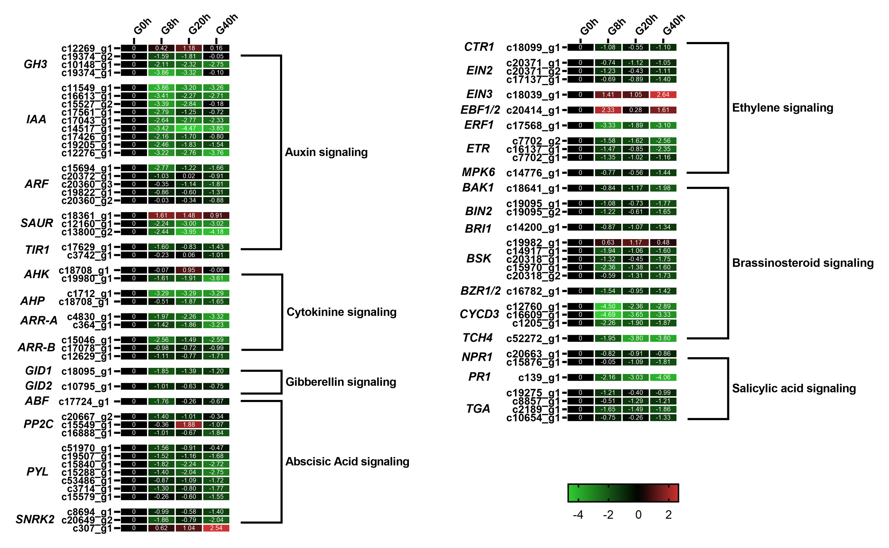
Figure S2 Expression heatmap of DEGs in plant hormone signal transduction pathway

