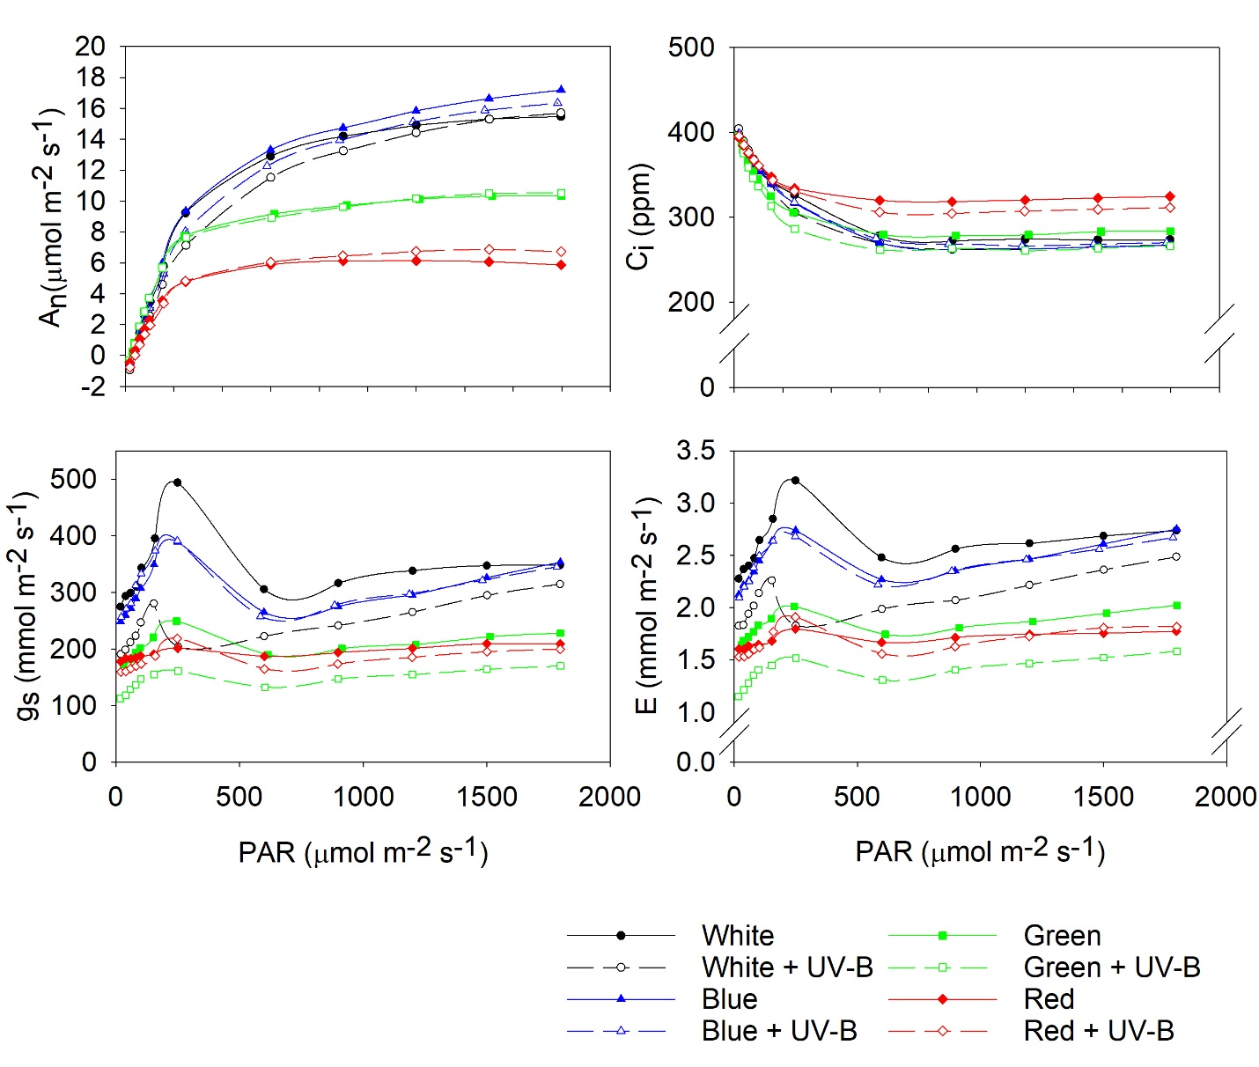
D
C
B
A
Supplementary Figure S1. Data of the light response curves used for Fig. 2A measured at day 9 to 13 of UV-B treatment in control Perspex OTBF boxes (Qian et al., 2019) with no UV-B exposure (solid line) and cellulose Acetate OTBF boxes with UV-B exposure (dashed lines) under four different PAR treatments (broadband white, blue, green and red). (A) net photosynthetic rate (P_{n}); (B) stomatal conductance (g_{s}), (C) intercellular CO₂ (C_{i}) and (D) transpiration rate (E). The data represent mean values (n = 7)

