Supplementary material
Molecular biomarkers of neovascular age-related macular degeneration with incomplete response to anti-vascular endothelial growth factor treatment.
Mantel Irmela¹*, Borgo Angelica¹, Guidotti Jacopo¹, Forestier Edwige¹, Kirsch Olga¹, Derradji Yasmine¹, Waridel Patrice³, Burdet Frédéric², Mehl Florence², Schweizer Claude¹ and Roduit Raphaël¹*
¹ Department of Ophthalmology, University of Lausanne, Jules-Gonin Eye Hospital, Lausanne, Switzerland. ² Swiss Institute of Bioinformatics, Lausanne, Switzerland. ³ Protein Analysis Facility, University of Lausanne, Lausanne, Switzerland.
* Correspondence:
Dr Irmela Mantel, Jules-Gonin Eye Hospital, Av. de France 15, CH-1002 Lausanne, Tél: +41 21 626 85 89, Fax: +41 21 626 54 55, irmela.mantel@fa2.ch
Dr Raphaël Roduit, Jules-Gonin Eye Hospital, Av. de France 15, CH-1002 Lausanne, Tél: +41 21 626 82 13, Fax: +41 21 626 54 55, raphael.roduit@fa2.ch
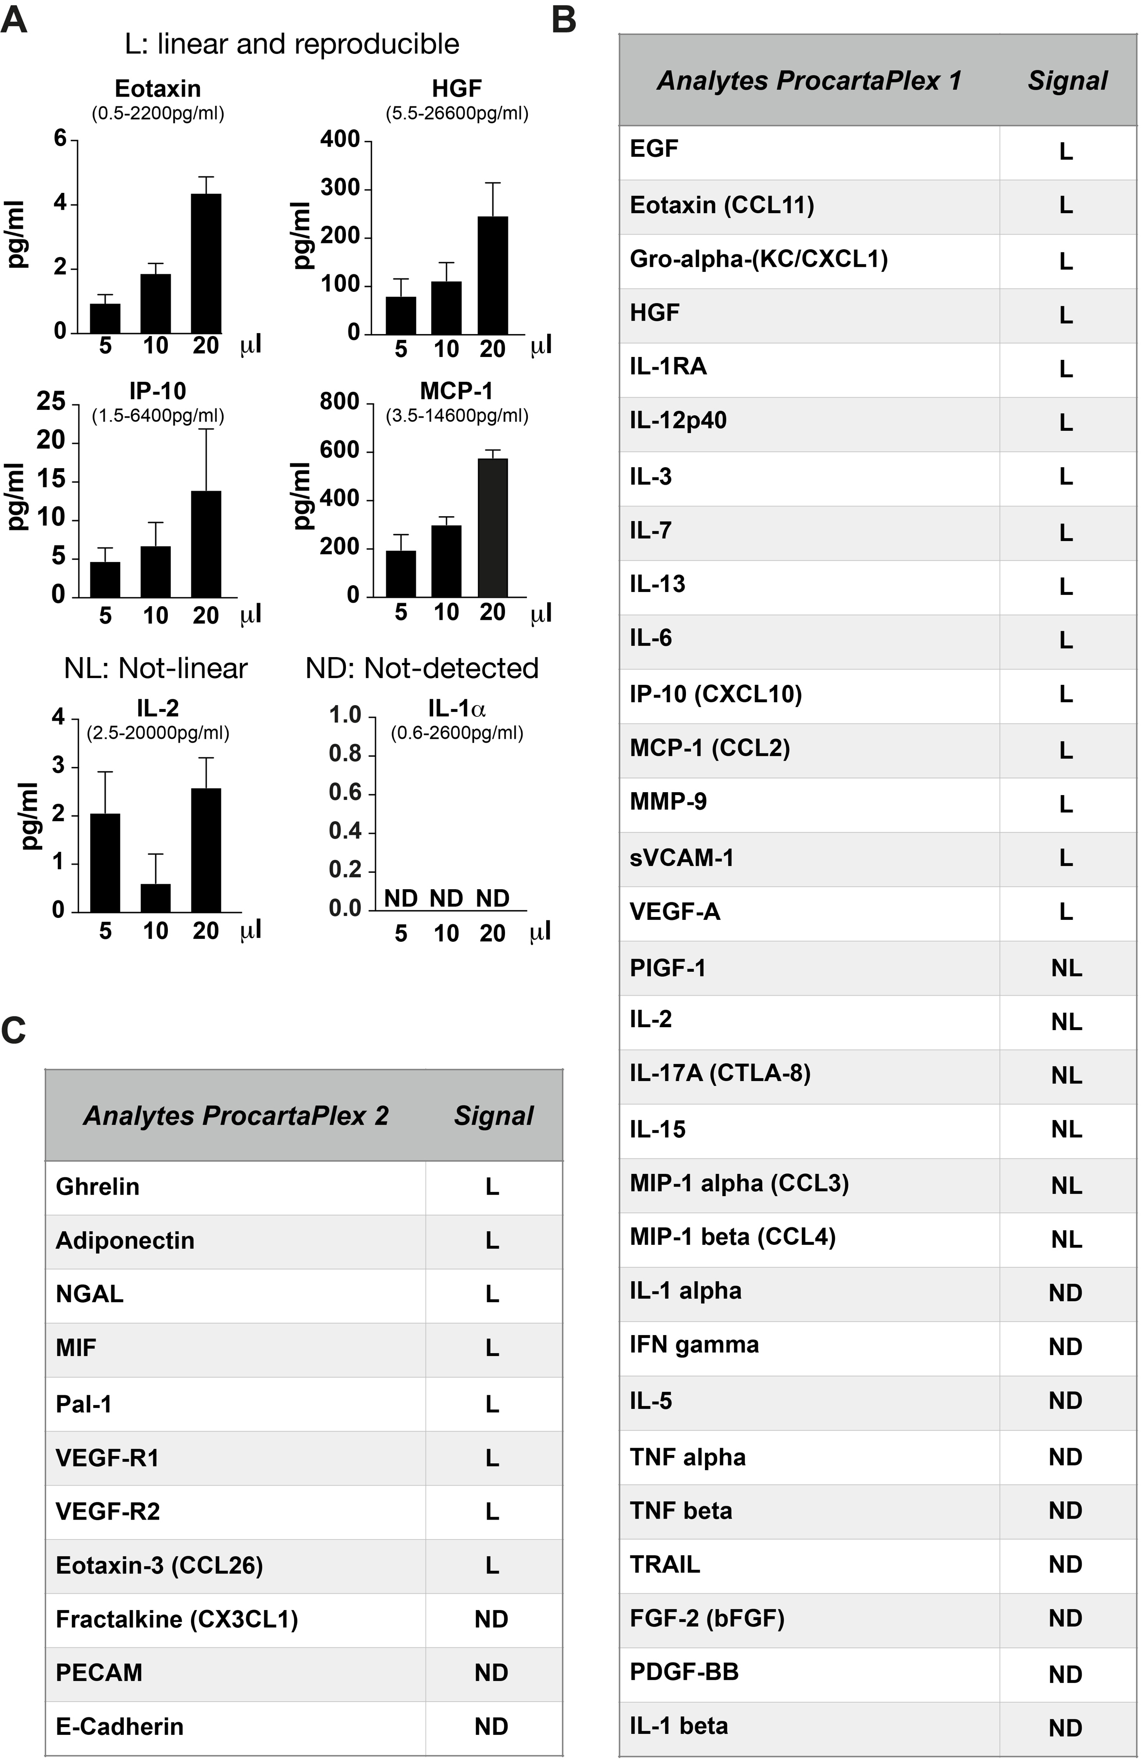
Supplemental Fig.1: Setup of Multiplex assay. A) Examples of linearity tests with 5, 10 and 20 ul of AH from 2 controls. EOTAXIN, HGF, IP-10 and MCP-1 had a linearity response and each dilution was in the standard curve (written below each metabolite); IL-2 showed a non-linear response close to the detection limit; IL-1α was below the detection limit. B) List of metabolites used in the first round of analysis with ProcartaPlex 1 to analyze the linearity response (5, 10 and 20ul of AH) and C) New metabolites added in the ProcartaPlex 2 and used in the second round analysis. (L) linear, (NL) non-linear and not detected (ND)

Supplemental Fig.2: Heatmap representation of proteomic data in AH from nAMD patients with normal response (N), incomplete response (R), and controls (C). We analyzed 10 samples per group using 15ul of AH.
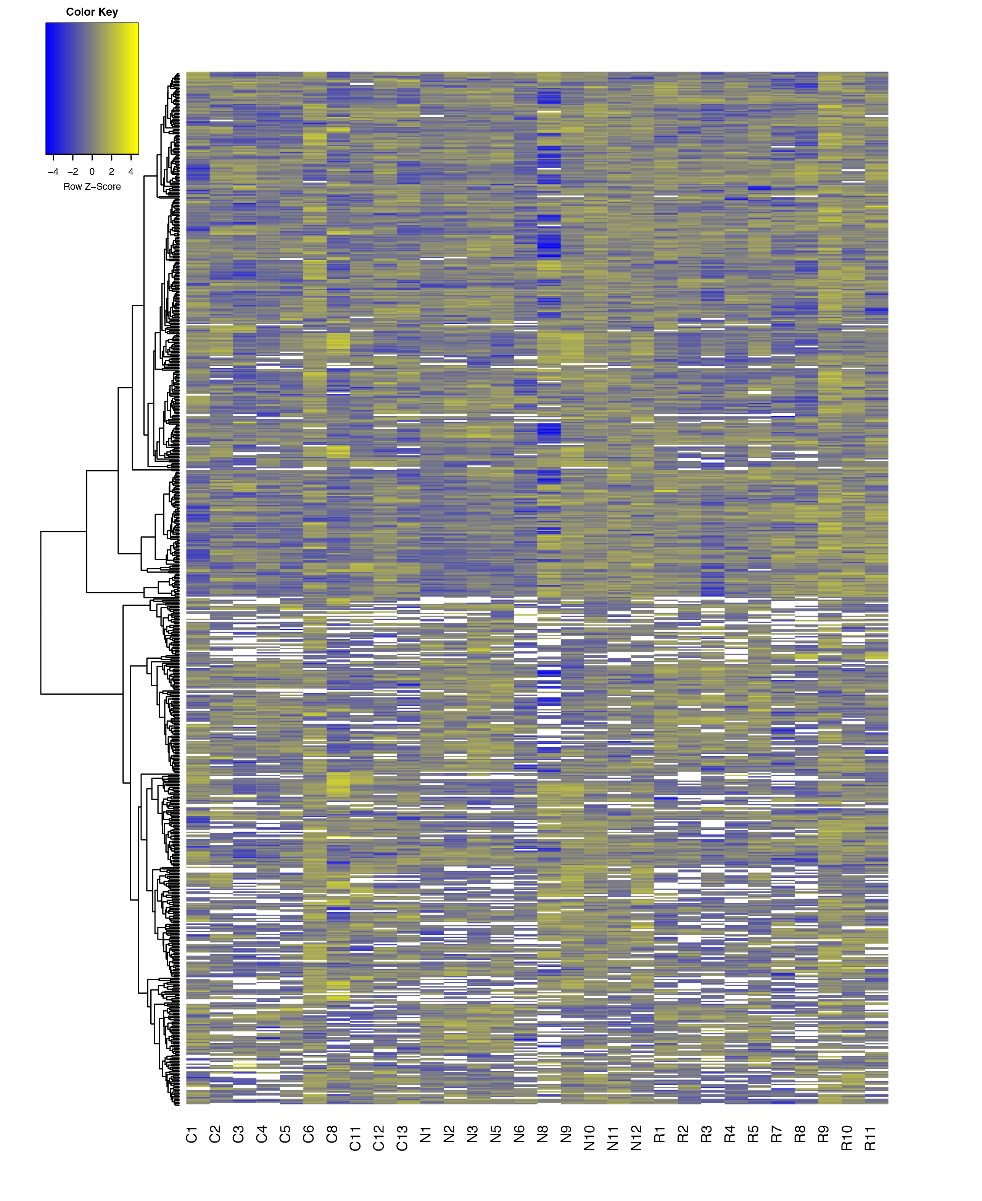
.

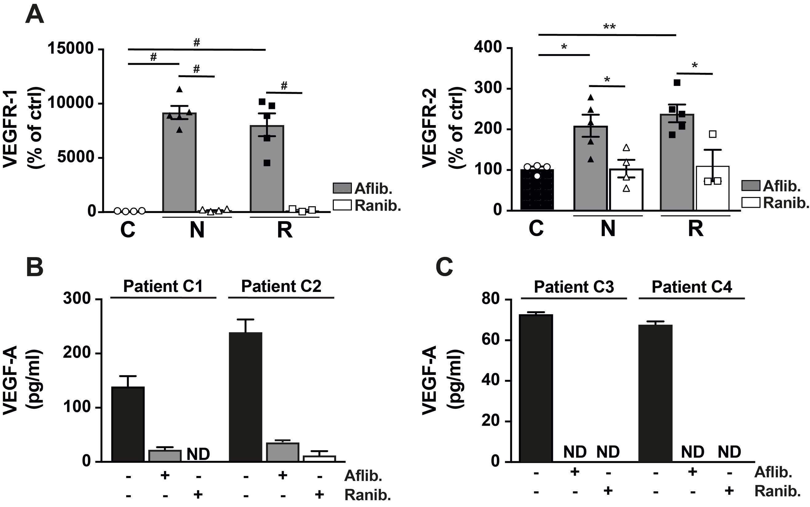
Supplemental Fig.3: Dosage of VEGFR-1, VEGFR-2 and VEGFA. A) Multiplex analysis of VEGFR-1 and VEGFR-2 in AH of the three different groups of patients depending of the treatment (aflibercept: Aflib. or ranibizumab: Ranib.). Results are expressed as mean ± SEM and as % of the control (* p < 0.05, ** p<0.009 and # p<0.0005, using ANOVA Holm-Sidak's multiple comparisons test per analyte). B) Dosage of VEGF-A by multiplex analysis using AH of control patients, with or without aflibercept (Aflib.) or ranibizumab (Ranib.). C) Dosage of VEGF-A by AlphaLISA analysis using AH of control patients, with or without aflibercept (Aflib.) or ranibizumab (Ranib.).

Supplemental Fig.4: Schematic representation of multiplex results showed in table 2 according to the drug. Dosage of sVCAM-1, HGF, PAI-1 and IL12p40 (A), EOTAXIN and MMP-9 (B). MCP-1 and IL-7 (C) by multiplex analysis using AH patients from the three different groups. Results are expressed as mean ± SEM and as % of the control (* p < 0.05, ** p<0.005 and *** p<0.0005, using ANOVA Holm-Sidak's multiple comparisons test per analyte).
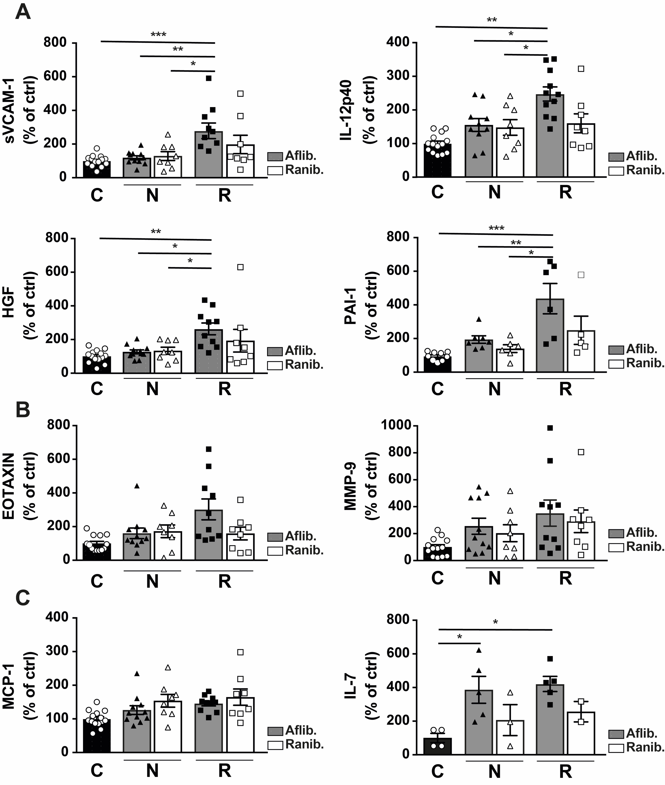

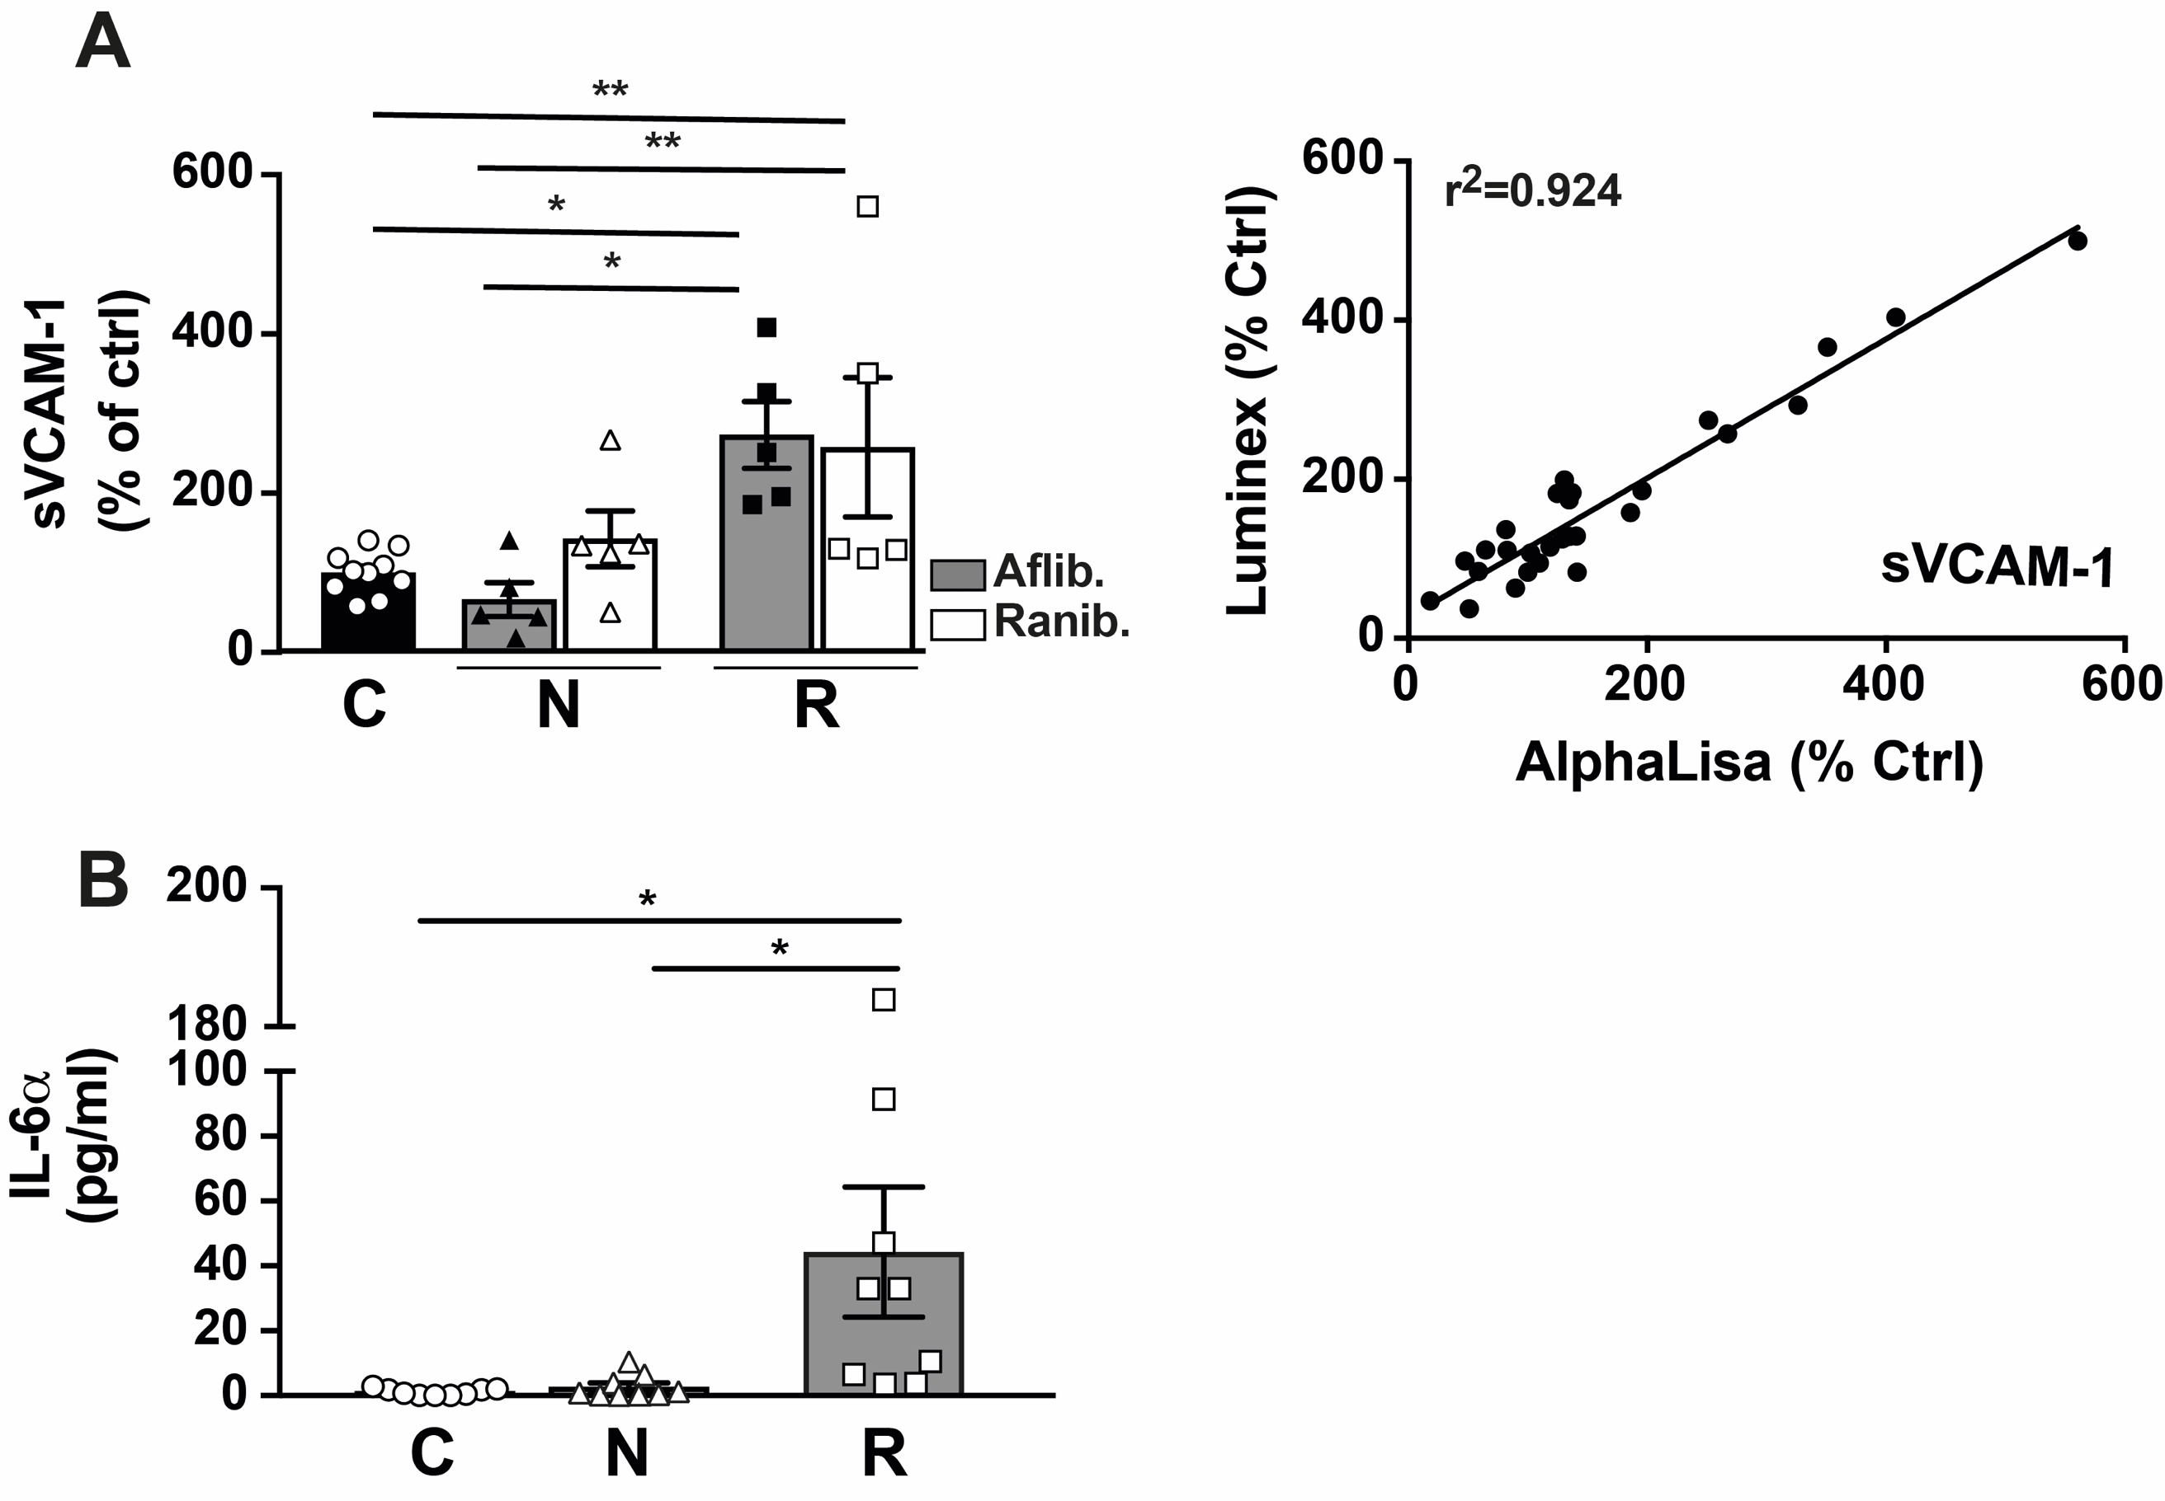
Supplemental Fig.5: AlphaLISA analysis. A) Dosage of sVCAM-1 by AlphaLISA in AH of the three different groups of patients depending of the treatment (aflibercept: Aflib. or ranibizumab: Ranib.). Results are expressed as mean ± SEM and as % of the control (* p < 0.05, ** p<0.005, using ANOVA Holm-Sidak's multiple comparisons test per analyte). Comparison of sVCAM-1 dosage by multiplex and AlphaLISA analysis. B) Dosage of IL-6 by AlphaLISA in AH of the three different groups of patients. Results are expressed as mean ± SEM and as % of the control (* p < 0.05, using ANOVA Holm-Sidak's multiple comparisons test per analyte)
Supplemental proteomic data (Excel file: SupplementalData1.xlsx)

