Supplementary Material

Supplementary Figure S4. Morphological descriptions of the Clionaidae species encountered in this study.
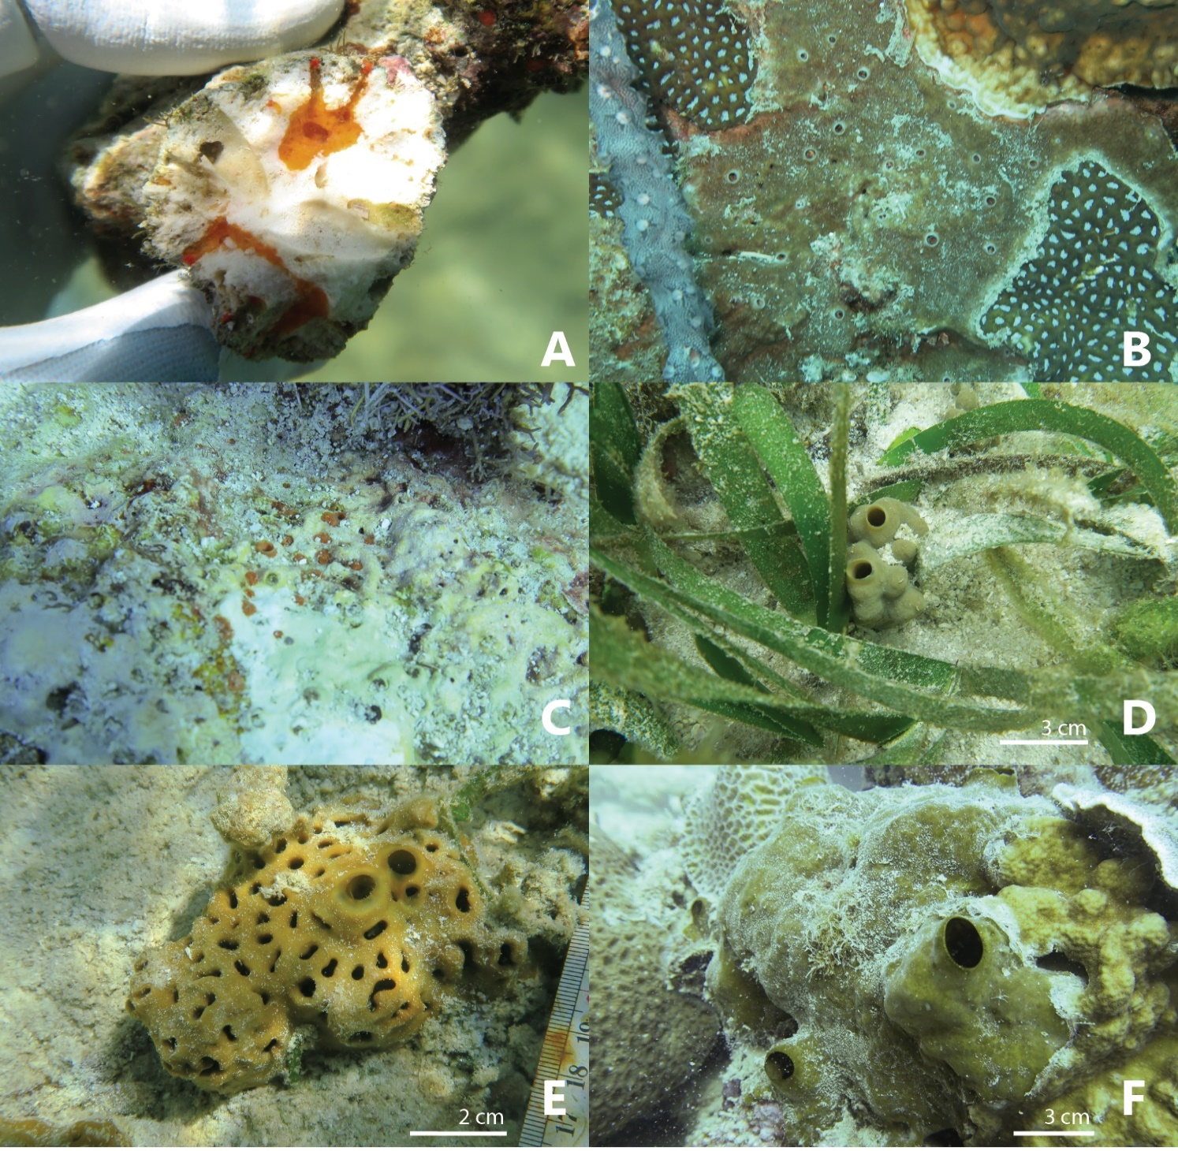
Figure S4. Photographs of the collected Clionaidae species in situ. No photograph of Cliona aff. orientalis is available. (A) Cliona sp. (RMNH.POR.11773) (B) Cliona thomasi (RMNH.POR.11776) (C) Cliona utricularis (RMNH.POR.11779) (D) Spheciospongia digitata (RMNH.POR.11780) (E) Spheciospongia maeandrina (RMNH.POR.12367) (F) Spheciospongia trincomaliensis (RMNH.POR.12433).

Cliona aff. orientalis Thiele, 1900
Cliona aff. orientalis was originally described from Ternate, Indonesia. A single specimen (RMNH.POR.11772) was collected from Kapoposang. The species is brownish in colour and had overgrown a piece of coral rubble (γ-growth form). The dimensions of the tylostyles are 262-331-380 µm (minimum-mean-maximum) by 5-6-8 µm. Microscleres dimensions are unknown. The species has been recorded from the Red Sea to the Great Barrier reef. Depth: unknown
Cliona sp. (Figure S4A)
Cliona sp. is yet undescribed. Two specimens were collected (RMNH.POR.11773 and RMNH.POR.11774). The species was similar in morphology to C. utricularis. The species eroded large chambers in rocky substrate. The papillae have a bright red colour, while the internal sponge tissue has an orange colour. The sponge was observed at Samalona and Bone Lola. The dimensions of the tylostyles are 148-448-661 µm by 4-10-18 µm. Microscleres are 24-41-65 µm in length. Depth: Shallow reef flat-6m
Cliona thomasi Mote, Schönberg, Samaai, Gupta & Ingole, 2019 (Figure S4B)
Cliona thomasi is described from the Arabian sea and is also reported from the Andaman sea. Specimen is morphologically undistinguishable from Cliona aff. orientalis. Three specimens were found at Badi, Kudingkareng Keke and Lumu Lumu. The species was found both α- and γ-growth forms. The dimensions of the tylostyles are 233-331-386 µm (minimum-mean-maximum) by 4-6-9 µm. Microscleres dimensions are unknown. Depth: Shallow reef flat-19.8m
Cliona utricularis Calcinai, Bavestrello & Cerrano, 2005 (Figure S4C)
Cliona utricularis was originally described from Northern Sulawesi, Indonesia. The sponge is characterized by bright reddish papillae and wide bag like erosion chambers. Only two specimens of this species were observed. These specimens were collected from Lumulumu and Kapoposang. The dimensions of the tylostyles are 188-360-444 µm by 6-9-14 µm. Microscleres are absent. The species has been recorded from various localities within the Indo-Pacific region. Depth: 4.8-6.5m
Spheciospongia digitata (Dendy, 1887) (Figure S4D)
Spheciospongia digitata was originally described as Suberites inconstans var. digitata from Eastern India. Specimen have a light brownish to yellow colour and show a tendency to form digitate processes. The species was observed at seven sites, the distribution was limited to the reef flat (less than three-meter depth). The tylostyle dimensions are 130-421-698 µm by 6-12-22 µm and the microscleres are 11-19-29 µm in length. The global distribution of S. digitata is unknown. Depth: exclusively shallow reef flat, located between sea grass beds
Spheciospongia maeandrina (Dendy, 1887) (Figure S4E)
Spheciospongia maeandrina was originally described as Suberites inconstans var. maeandrina from Eastern India. The species has a similar light brownish to yellow colour to S. digitata. Specimens generally displayed meandering groves. S. maeandrina was observed at ten different sites, the distribution was limited to the reef flat (less than two-meter depth). The tylostyle dimensions are 146-414-648 µm by 5-11-20 µm and the microscleres are 5-12-19 µm in length. The global distribution of S. maeandrina is unknown. Depth: exclusively shallow reef flat, located between sea grass beds
Spheciospongia trincomaliensis (Ridley, 1884) (Figure S4F)
Spheciospongia trincomaliensis was originally described as Spirastrella vagabunda var. trincomaliensis from South India and Sri Lanka. The species has an olive-green colour and large distinctive papillae. The species was widely distributed along the Spermonde archipelago and was recorded at thirteen different sites. The sponge was found boring in hard rocky substrates. The tylostyles dimensions range between 107-437-704 µm by 3-10-18 µm and the microscleres are 8-13-19 µm in length. S. trincomaliensis has been recorded from east Africa to the Fiji Islands. Depth: 5.7-18.3m

