**Genetic basis of host resistance to *Sparicotyle chrysophrii* in farmed gilthead sea bream (*Sparus aurata*) population**

*Muhammad Luqman Aslam \*****1****, Roberta Carraro****2****, Anna Kristina Sonesson****1****, Theodorus Meuwissen 3, Costas. S. Tsigenopoulos****4****, George Rigos****4****, Luca Bargelloni****2*** *and Konstantinos Tzokas5*

***1****Nofima, P.O. Box 210, N-1431 Ås, Norway*

***2*** *University of Padova, 35020 Legnaro, Italy*

***3****Norwegian University of Life Sciences, Norway*

***4****Hellenic Centre for Marine Research (HCMR), Heraklion, 71500, Greece*

***5****Andromeda Group, 26504 Rion Achaias, Greece*

**Figure S1.1:** Distribution of parasite count and the log transformed parasite count phenotypes.



**Figure S1.2:** Distribution of number of sibs per family along with the distribution of phenotype across full-sib families.



Panel **A)** is a distribution of sibs in full-fib families, panel **B)** is a distribution of parasite count across different full-sib families, and **C)** is a distribution of log transformed parasite count across different full-sib families.

**Figure S1.3:** Plot of linkage maps with distribution of markers across different linkage groups.



**Figure S1.4:** Pattern of linkage disequilibrium decay along the length (cM) of linkage groups.



**Figure S1.5:** Heat map of Linkage disequilibrium values for the top 5 significant markers in GWAS analysis.

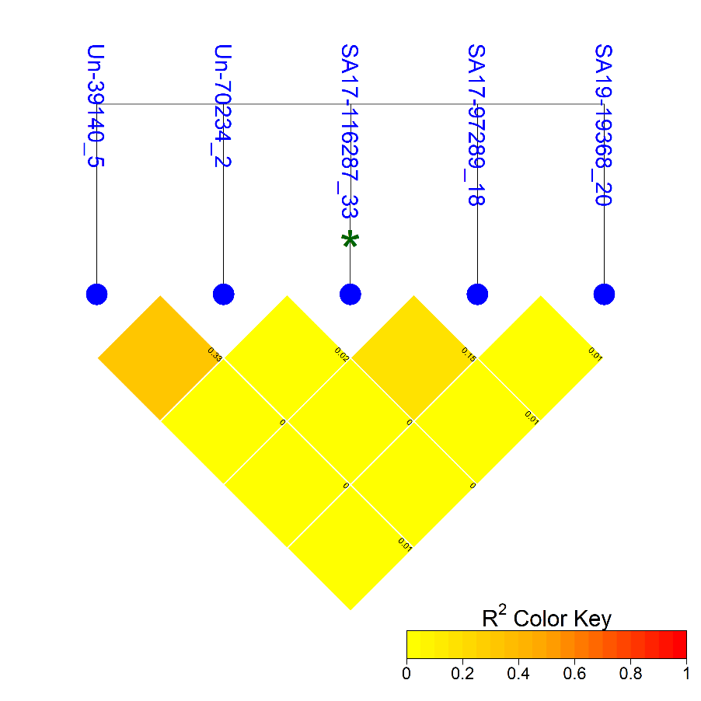

**\*** is a chromosome-wide significant.