Supplementary Material

Supplementary Figures and Tables

Supplementary Figures
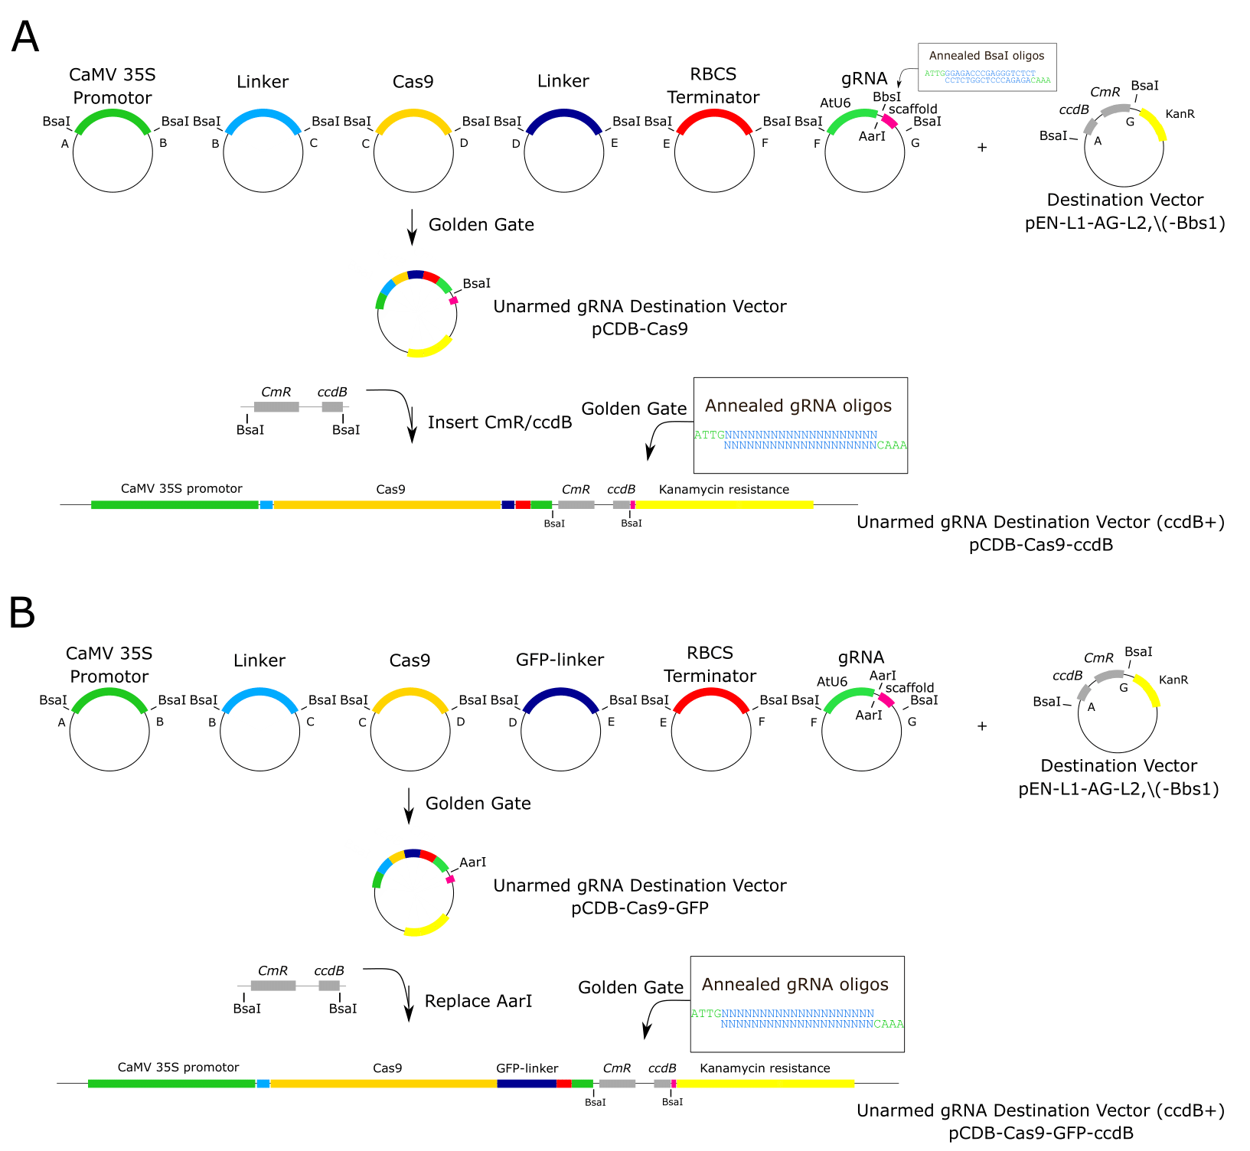
Supplementary Figure 1. Construction of (A) the Cas9 expression vector and (B) the Cas9-GFP expression vector.

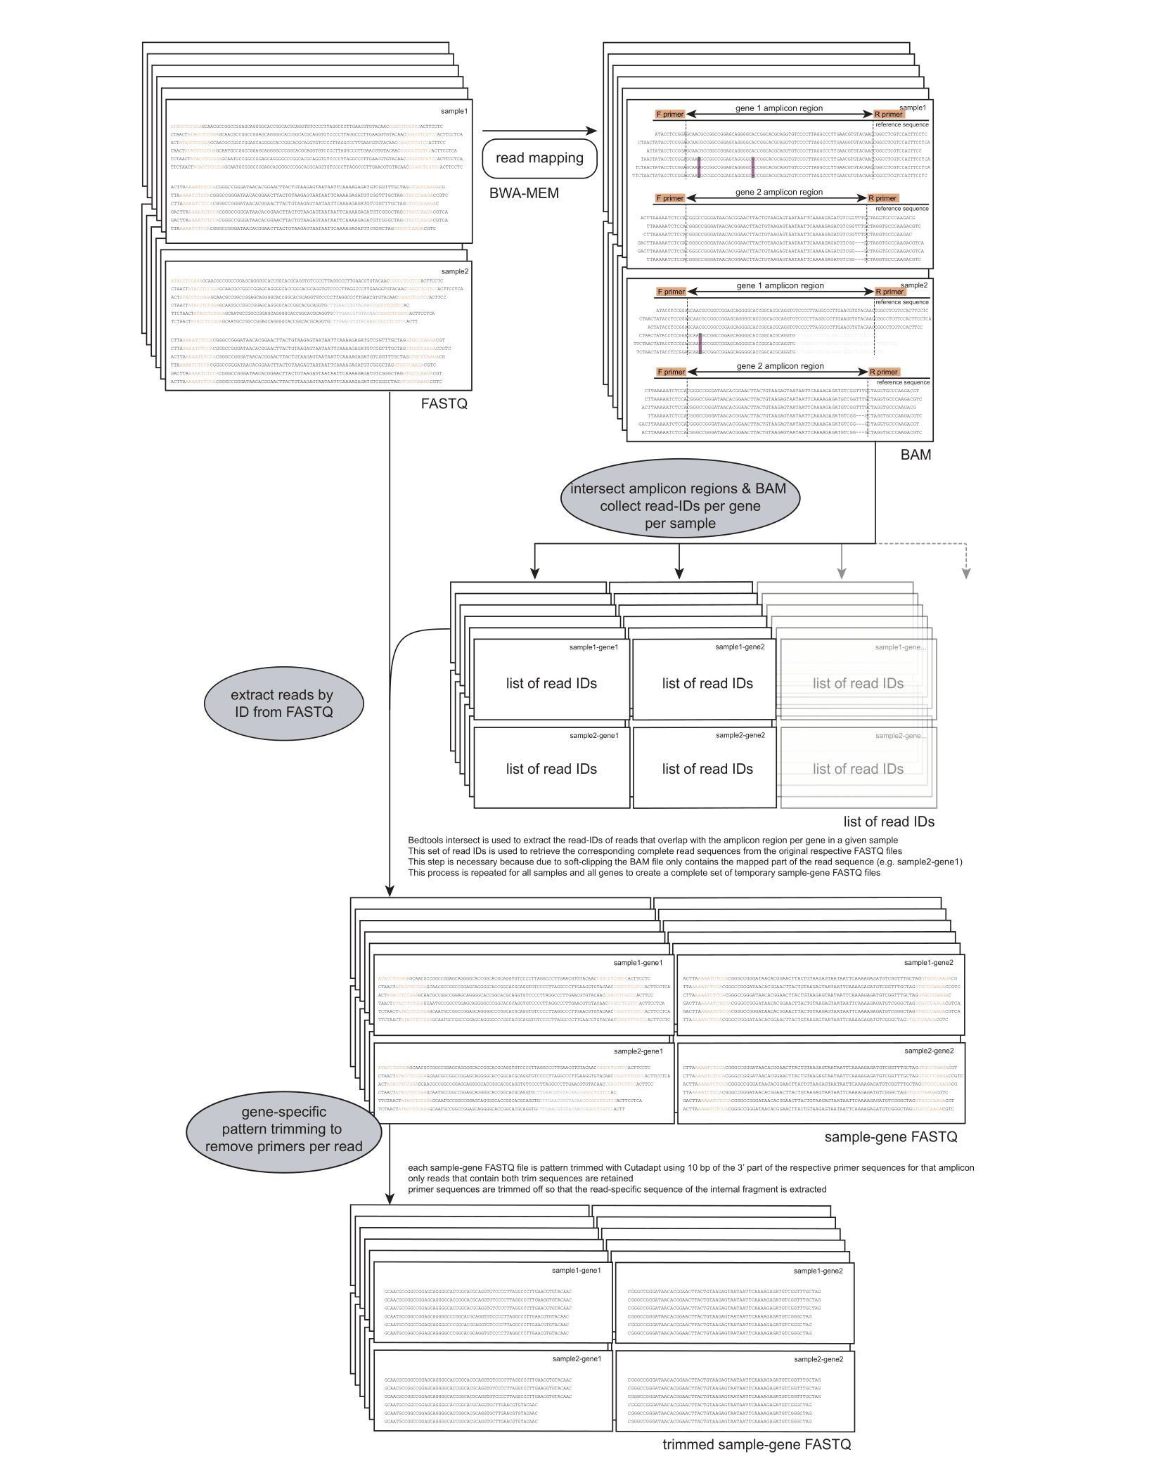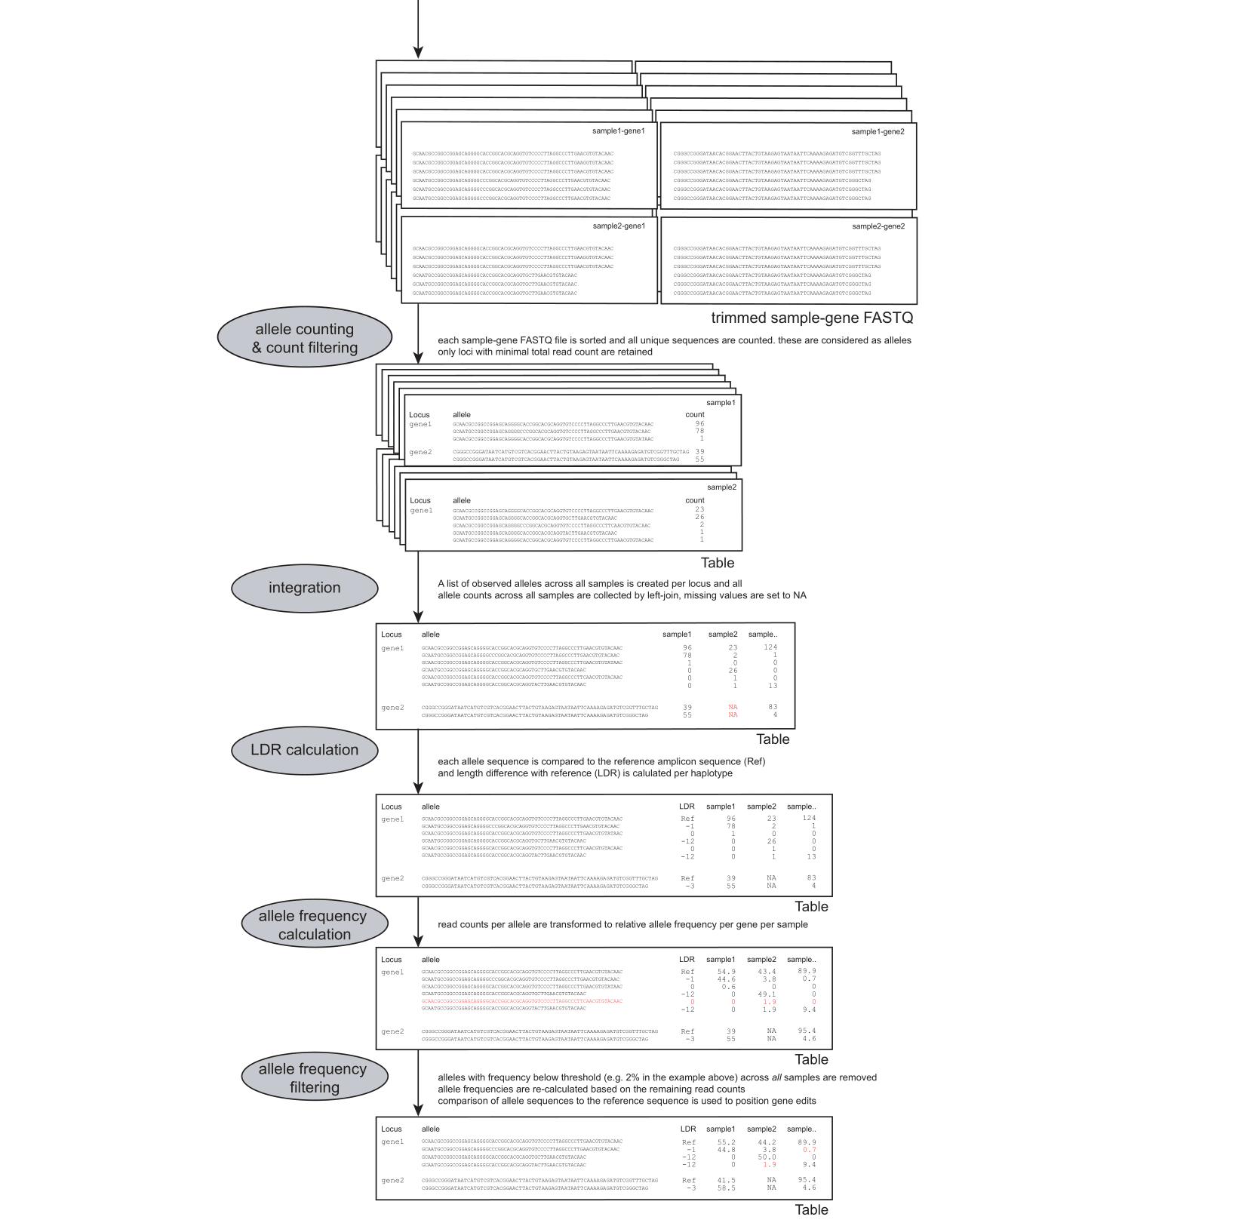
Supplementary Figure 2. Bioinformatics workflow to extract genome-edited alleles from HiPlex amplicon sequencing data

Supplementary Tables
Supplementary Table 1. Oligonucleotide and primer sequences. Underlined = N20 guide RNA sequence, Italic = vector overhangs
Oligo/Primer | Sequence | Purpose
Oligo1 | 5’-ATTGTTTGGATGCTGTGATGCCAT-3’ | PDS oligo F
Oligo2 | 5’-AAACATGGCATCACAGCATCCAAA-3’ | PDS oligo R
Oligo3 | 5’-ATTGCACATGGCAGTTTGTGACCA-3’ | GAS oligo F
Oligo4 | 5’-AAACTGGTCACAAACTGCCATGTG-3’ | GAS oligo R
Oligo5 | 5’-ATTGAGATTGTTAAAGAGATCTTG-3’ | GAO oligo F
Oligo6 | 5’-AAACCAAGATCTCTTTAACAATCT-3’ | GAO oligo R
Oligo7 | 5’-ATTGTTTCAGCTCCATTCGCGAAG-3’ | COS oligo F
Oligo8 | 5’-AAACCTTCGCGAATGGAGCTGAAA-3’ | COS oligo R
Oligo9 | 5’-ATTGGGAGACCCGAGGGTCTCT-3’ | BsaI insert
Oligo10 | 5’-AAACAGAGACCCTCGGGTCTCC-3’ | BsaI insert
Primer20 | 5’-TCCCAGGATTAGAATGATTAGG-3’ | pCas9_F
Primer24 | 5’-CCAGGAAACAGCTATGACCAT-3’ | pCas9_R
BbsIApaI_S | 5’-GGCCCAGTCATCCGACTGAGCCTTTCGTTTTATTTGATGCCTGGCAGTTCCCTACTCTCGCGTTAACGCTAGCATGGATGTTTTCCCAGTCACGACGTTGTAAAACGACGGCCAGTCTTAAGCTCGGGCC-3’ | BbsI mutated insert
Bbs1Apa1_AS | 5’-CGAGCTTAAGACTGGCCGTCGTTTTACAACGTCGTGACTGGGAAAACATCCATGCTAGCGTTAACGCGAGAGTAGGGAACTGCCAGGCATCAAATAAAACGAAAGGCTCAGTCGGATGACTG-3’ | BbsI mutated insert

Supplementary Table 2. Vector overview. ªThe cloning sites are four-nucleotides overhangs for Golden Gate cloning (according to Lampropoulos et al. 2013)
Full Name | Type | Cloning sitesª | Bacterial Selection | Length | Reference | Plasmid Deposit
Golden gate plant promotor
pGGA004 | 35S (Cauliflower mosaic virus 35S) promoter | A-B | Ampicillin | 3550 bp | Lampropoulos et al. (2013) | Addgene ID 48814
Golden gate N-tags
pGGB003 | B-dummy (default random sequence if no specific N-tag is desired) | B-C | Ampicillin | 2710 bp | Lampropoulos et al. (2013) | Addgene ID 48821
Golden gate C-tags
pGGD001 | linker-GFP | D-E | Ampicillin | 3507 bp | Lampropoulos et al. (2013) | Addgene ID 48833
pGGD002 | D-dummy (default random sequence with stop codon if no specific C-tag is desired) | D-E | Ampicillin | 2732 bp | Lampropoulos et al. (2013) | Addgene ID 48834
Golden gate plant terminator
pGGE001 | RBCS terminator (from pea) | E-F | Ampicillin | 3333 bp | Lampropoulos et al. (2013) | Addgene ID 48839
Coding sequences
pGG-C-Cas9PTA*-D | Cas9-SV40 with stop codon | C-D | Ampicillin | 6828 bp | Houbaert et al. (2018)
pGG-C-Cas9PTA-D | Cas9-SV40 | C-D | Ampicillin | 6825 bp | (Decaestecker et al., 2019)
Unarmed gRNA entry vectors |  |  |  |  | Decaestecker et al. (2019)
pGG-F-AtU6-26-BbsI-BbsI-G | AtU6-26 promoter and 'unarmed' gRNA scaffold | F-G | Ampicillin | 3177 bp | Decaestecker et al. (2019)
pGG-F-AtU6-26-AarI-AarI-G | AtU6-26 promoter and 'unarmed' gRNA scaffold | F-G | Ampicillin | 3183 bp | Decaestecker et al. 2019
Destination vector
pEN-L1-AG-L2 |  | A-G | Kanamycin | 3990 bp | Houbaert et al. (2018)
pEN-L1-AG-L2,\(-Bbs1) |  | A-G | Kanamycin | 3990 bp | This work
Unarmed gRNA destination vectors
pCDB-Cas9 |  |  | Kanamycin | 8789 bp | This work
pCDB-Cas9-GFP |  |  | Kanamycin | 9567 bp | This work
Unarmed gRNA destination vectors (ccdB+)
pCDB-Cas9-ccdB |  |  | Kanamycin | 10206 bp | This work
pCDB-Cas9-GFP-ccdB |  |  | Kanamycin | 10978 bp | This work
Expression vectors
pCDB-Cas9-PDS |  |  | Kanamycin | 8791 bp | This work
pCDB-Cas9-GFP-PDS |  |  | Kanamycin | 9559 bp | This work
pCDB-Cas9-GAS |  |  | Kanamycin | 8791 bp | This work
pCDB-Cas9-GAO |  |  | Kanamycin | 8791 bp | This work
pCDB-Cas9-COS |  |  | Kanamycin | 8791 bp | This work
Inserts
ccdB insert | ccdB gene |  |  |  | Decaestecker et al. (2019)
Other
pKAR6 | GFP vector without NLS signal |  | Carbenicillin | 4450 bp | Robert Blanvillain, unpublished data

Supplementary Table 3. Primer sequences used for HiPlex amplicon construction and ddPCR.
Primer | Sequence | Gene | Application
Primer1 | 5‘-TTCAAGCACACAGATCACTTCA-3’ | PDS_F | HiPlex
Primer2 | 5’-TGGTGTAAAAGAACGGGCACT-3’ | PDS_R | HiPlex
Primer3 | 5’-GATGAGTTTGATCTATACACAACTTCT-3’ | GAS_F | HiPlex
Primer4 | 5’-ATGGTGTGTCATGGTTGATCA-3’ | GAS_R | HiPlex
Primer5 | 5’-ATGATCGCCACCATATTGAGCA-3’ | GAO_F | HiPlex
Primer6 | 5’-TTGAAGGAAAGATATCAGCTACATCG-3’ | GAO_R | HiPlex
Primer7 | 5’-GGCGAATACTGGAGGCAGAT-3’ | COS_F | HiPlex
Primer8 | 5’-AGTTGATGGGTGTTCCTGCT-3’ | COS_R | HiPlex
Primer 9 | 5’- TGCTTACCCTAGTGCCTCTGA-3’ | PP2AA3_F | ddPCR
Primer 10 | 5’- TTCCCAAATTTGTAGCAGCA-3’ | PP2AA3_R | ddPCR
Primer 11 | 5’- CCGCCATTAACTCAAGTGGA-3’ | PDS_F | ddPCR
Primer 12 | 5’- TTGGGAATTGCAATCTGTGA-3’ | PDS_R | ddPCR

Supplementary Table 4. Two HiPlex detected CiPDS loci in all screened regenerated (control and albino) plants. Purple = PAM site, green = gRNA target site, dashed vertical line = cut site, blue = SNP.
CiPDS
Locus 1 | AGACTGTTTCAACATCACCTCAGGACAAAAAGATGTACTCTCATTTGGATGCTGTGATGCCATGGGTCACAGATTGCAATTC
Locus 2 | AGATTGTTTCAACATCACCTCAGGACAAAAAGATGTACTCTCATTTGGATGCTGTGATGCCATGGGTCACAGATTGCAATTC

Supplementary Table 5. Raw droplet digital PCR (ddPCR) data to quantify the copy number of CiPDS in a diploid ‘Van Hamme’ witloof plant. *, Deviating droplet profile; sample was excluded from the analysis.
# | Sample ID | Target | Positive droplets | Negative droplets | Total droplets | Concentration (copies.µL⁻¹)
1 | NTC | CiPDS | 0 | 17558 | 17558 | 0
2 | NTC | CiPDS | 0 | 16678 | 16678 | 0
3 | Van Hamme 1 | CiPDS | 11696 | 5140 | 16836 | 1396
4 | Van Hamme 1 | CiPDS | 12272 | 5465 | 17737 | 1385
5 | Van Hamme 2 | CiPDS | 12016 | 5812 | 17828 | 1319
6 | Van Hamme 2 | CiPDS | 11607 | 5348 | 16955 | 1357
7 | Van Hamme 3 | CiPDS | 11409 | 6053 | 17462 | 1246
8 | Van Hamme 3 | CiPDS | 11001 | 5683 | 16684 | 1267
9 | Van Hamme 4 | CiPDS | 9721 | 7490 | 17211 | 979
10 | Van Hamme 4 | CiPDS | 9584 | 7303 | 16887 | 986
11 | NTC | PP2AA3 | 0 | 18601 | 18601 | 0
12 | NTC | PP2AA3 | 0 | 18648 | 18648 | 0
13 | Van Hamme 1 | PP2AA3 | 4805 | 15194 | 19999 | 323
14 | Van Hamme 1 | PP2AA3 | 4013 | 13268 | 17281 | 311
15 | Van Hamme 2 | PP2AA3 | 4015 | 13693 | 17708 | 303
16 | Van Hamme 2 | PP2AA3 | 2313* | 11972* | 14285* | 208*
17 | Van Hamme 3 | PP2AA3 | 4126 | 14061 | 18187 | 303
18 | Van Hamme 3 | PP2AA3 | 3776 | 14027 | 17803 | 280
19 | Van Hamme 4 | PP2AA3 | 2793 | 14763 | 17556 | 204
20 | Van Hamme 4 | PP2AA3 | 3063 | 15287 | 18350 | 215
21 | NTC | UBQ10 | 0 | 17651 | 17651 | 0
22 | NTC | UBQ10 | 1 | 16842 | 16843 | 0.07
23 | Van Hamme 1 | UBQ10 | 6812 | 10860 | 17672 | 573
24 | Van Hamme 1 | UBQ10 | 6680 | 10226 | 16906 | 591
25 | Van Hamme 2 | UBQ10 | 6841 | 10549 | 17390 | 588
26 | Van Hamme 2 | UBQ10 | 6342 | 9603 | 15945 | 597
27 | Van Hamme 3 | UBQ10 | 5768 | 10663 | 16431 | 509
28 | Van Hamme 3 | UBQ10 | 5954 | 10103 | 16057 | 545
29 | Van Hamme 4 | UBQ10 | 4820 | 10753 | 15573 | 436
30 | Van Hamme 4 | UBQ10 | 4851 | 10693 | 15544 | 440

