Supplementary Material

Inkjet Printing-based Immobilization Method for a Single-step and Homogeneous Competitive Immunoassay in Microchannel Arrays
Yuko Kawai¹, Akihiro Shirai¹, Masaya Kakuta², Kotaro Idegami², Kenji Sueyoshi¹, Tatsuro Endo¹, Hideaki Hisamoto¹*
¹Department of Applied Chemistry, Graduate School of Engineering, Osaka Prefecture University, Osaka, Japan
²Sysmex Corporation, Hyogo, Japan
* Correspondence:
Hideaki Hisamoto
hisamoto@chem.osakafu-u.ac.jp
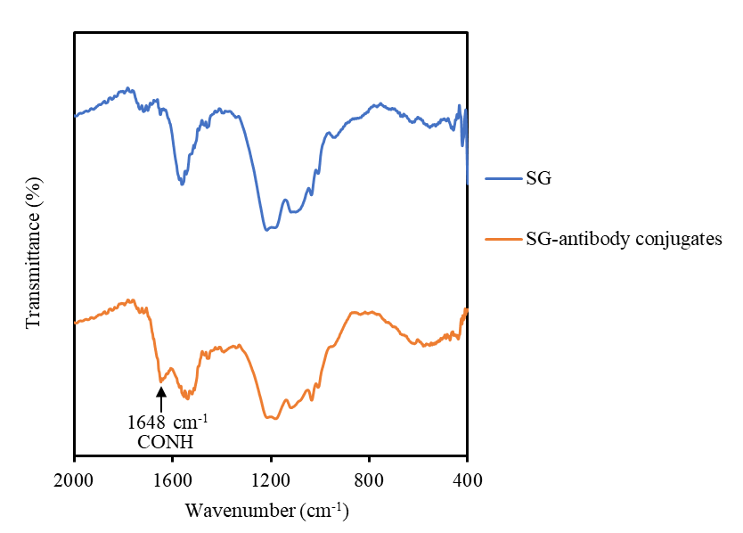

Figure S1. FTIR transmittance spectra of SG and SG-antibody conjugates. Appropriate amount of SG or SG-antibody powder was sandwiched by two KBr disks to form KBr pellet by compression. Transmittance spectra were measured by FT/IR 4200 (JASCO, Tokyo, Japan).
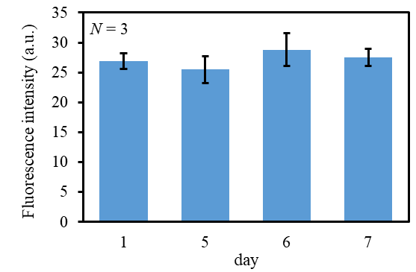

Figure S2. Evaluation of the storage stability of the immunoassay microdevice at room temperature. Fluorescence responses were obtained by using CRP (50 μg mL⁻¹) sample solutions.

