Supplementary Material

Table S1. Compilation of studies reporting detection of putative diazotrophs (DNA-based detection of nifH), nifH transcripts (RNA-based detection) and/or measurements of nitrogen fixation rates in various regions, environments, depths and seasons across the Arctic Ocean.
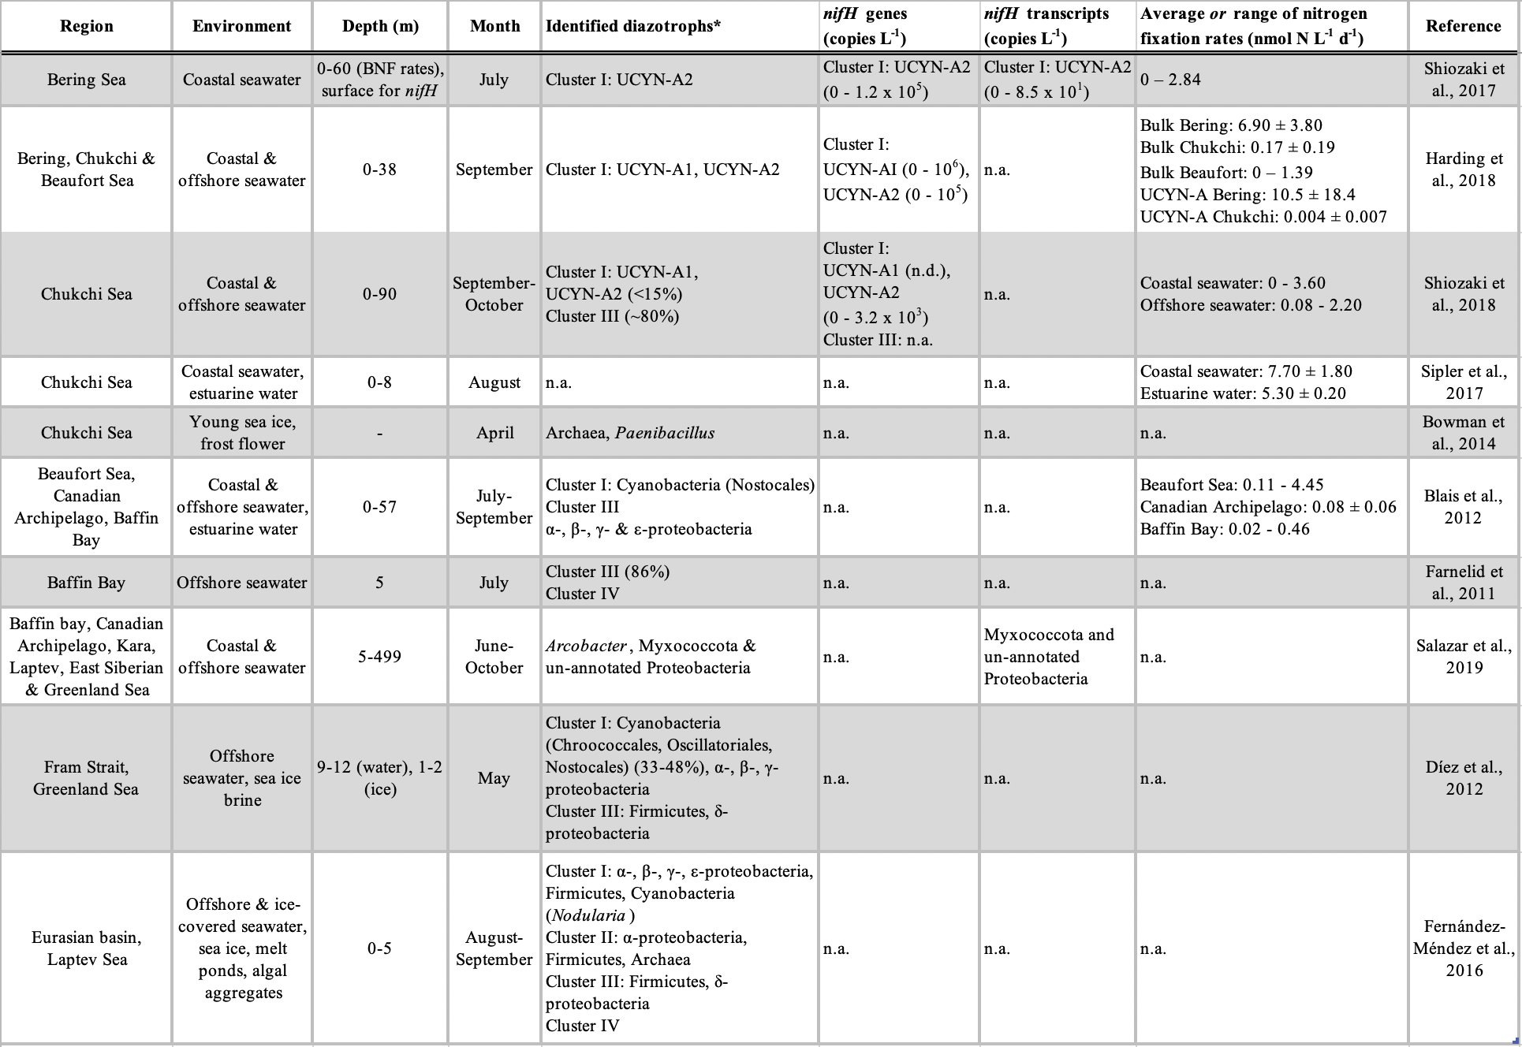
Geographical regions are depicted in Figure 1. nifH encodes dinitrogenase reductase.
n.a. = not analyzed, n.d. = not detected.
*percentages of relative abundances are presented in parentheses, and cluster-annotations of identified diazotrophs specified, when stated in the original study.

References
Blais, M., Tremblay, J., Jungblut, A. D., Gagnon, J., Martin, J., Thaler, M., et al. (2012). Nitrogen fixation and identification of potential diazotrophs in the Canadian Arctic. Global Biogeochem. Cycles 26, GB3022. doi:10.1029/2011GB004096.
Bowman, J. S., Berthiaume, C. T., Armbrust, E. V., and Deming, J. W. (2014). The genetic potential for key biogeochemical processes in Arctic frost flowers and young sea ice revealed by metagenomic analysis. FEMS Microbiol. Ecol. 89, 376–387. doi:10.1111/1574-6941.12331.
Díez, B., Bergman, B., Pedrós-Alió, C., Antó, M., and Snoeijs, P. (2012). High cyanobacterial nifH gene diversity in Arctic seawater and sea ice brine. Environ. Microbiol. Rep. 4, 360–366. doi:10.1111/j.1758-2229.2012.00343.x.
Farnelid, H., Andersson, A. F., Bertilsson, S., Al-Soud, W. A., Hansen, L. H., Sørensen, S., et al. (2011). Nitrogenase gene amplicons from global marine surface waters are dominated by genes of non-cyanobacteria. PLoS One 6, e19223. doi:10.1371/journal.pone.0019223.
Fernández-Méndez, M., Turk-Kubo, K. A., Buttigieg, P. L., Rapp, J. Z., Krumpen, T., Zehr, J. P., et al. (2016). Diazotroph diversity in the sea ice, melt ponds, and surface waters of the Eurasian Basin of the Central Arctic Ocean. Front. Microbiol. 7, 1–18. doi:10.3389/fmicb.2016.01884.
Harding, K., Turk-Kubo, K. A., Sipler, R. E., Mills, M. M., Bronk, D. A., and Zehr, J. P. (2018). Symbiotic unicellular cyanobacteria fix nitrogen in the Arctic Ocean. Proc. Natl. Acad. Sci. 115, 13371–13375. doi:10.1073/pnas.1813658115.
Salazar, G., Paoli, L., Alberti, A., Huerta-Cepas, J., Ruscheweyh, H.-J., Cuenca, M., et al. (2019). Gene expression changes and community turnover differentially shape the global ocean metatranscriptome. Cell 179, 1068–1083. doi:10.1016/j.cell.2019.10.014.
Shiozaki, T., Bombar, D., Riemann, L., Hashihama, F., Takeda, S., Yamaguchi, T., et al. (2017). Basin scale variability of active diazotrophs and nitrogen fixation in the North Pacific, from the tropics to the subarctic Bering Sea. Global Biogeochem. Cycles 31, 996–1009. doi:10.1002/2017GB005681.
Shiozaki, T., Fujiwara, A., Ijichi, M., Harada, N., Nishino, S., Nishi, S., et al. (2018). Diazotroph community structure and the role of nitrogen fixation in the nitrogen cycle in the Chukchi Sea (western Arctic Ocean). Limnol. Oceanogr. 63, 2191–2205. doi:10.1002/lno.10933.
Sipler, R. E., Gong, D., Baer, S. E., Sanderson, M. P., Roberts, Q. N., Mulholland, M. R., et al. (2017). Preliminary estimates of the contribution of Arctic nitrogen fixation to the global nitrogen budget. Limnol. Oceanogr. Lett. 2, 159–166. doi:10.1002/lol2.10046.

