Supplementary Material

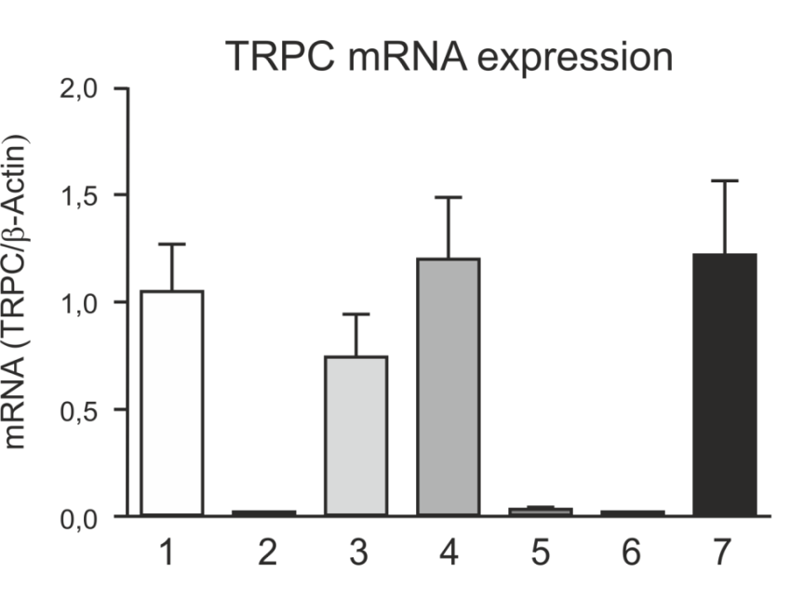
Supplementary Figure 1. Expression pattern of TRPC isoforms in RBL 2H3 cells. The expression of mRNA for seven members of the TRPC family was determined by RT-PCR.

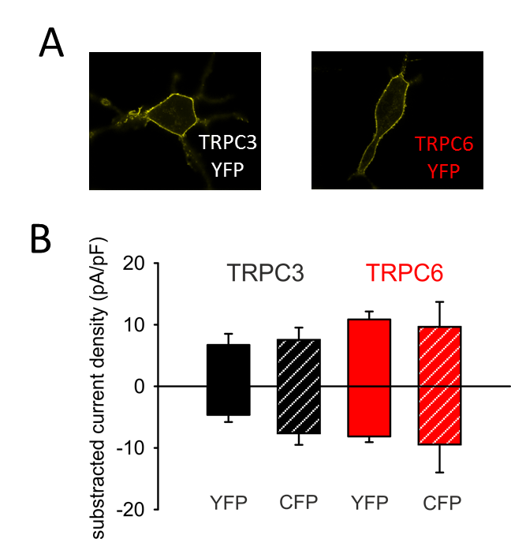
Supplementary Figure 2. (A) Representative epifluorescence images of RBL-2H3 cells expressing YFP-TRPC3 (n = 28) and YFP-TRPC6 (n = 28), respectively. Scale bar = 10 µm. (B) Current density of net, maximum responses obtained at -90 to +70 mV (mean ± SEM, n = 6-8 ). Statistical significance was tested by two tailed t-test (normally distributed values) or Mann–Whitney tests (non-normally distributed values), differences are not significant (p > 0.05).

.
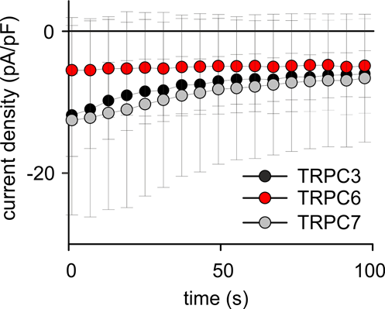
Supplementary Figure 3. Time courses of basal inward currents of YFP-TRPC3 (black, n = 5 cells), YFP-TRPC6 (red, n = 5 cells) and TRPC7-CFP (grey, n = 5 cells) overexpressed in RBL-2H3 cells. Conductance was recorded at -90 mV (mean ± SEM). Statistical significance of the decay of current densities within 100 s was tested by paired Student´s t test (normally distributed values), The decay was significant (p > 0.05) for TRPC3 and TRPC7 but not for TRPC6.

Supplementary Video: Light-induced TRPC6-mediated NFAT translocation, UV light was applied at frame 3.

