Additional Tables
Sepsis-1.0 was defined as having a suspected or confirmed site of infection, ≥ 2 systemic inflammatory response syndrome criteria (SIRS). Severe sepsis was defined as sepsis plus at least one sepsis-induced organ dysfunction. Septic shock was defined as severe sepsis associated with refractory hypotension; despite at least 2 h of adequate volume resuscitation, a systolic blood pressure (SBP) < 90 mmHg or a reduction of ≥40 mmHg from baseline level or a mean arterial pressure < 65 mmHg in the absence of other causes of hypotension or the need for vasopressors to maintain SBP ≥ 90 mmHg.
Table S1. The definition of Sepsis-1
Systemic inflammatory response syndrome criteria (SIRS) ≥ 2 criteria
Temperature > 38.3°C or < 36°C
Heart rate > 90/min
WBC count > 12,000/μL or < 4000/μL or Normal WBC count > 10% immature forms
Respiratory rate ≧20/min or PaCO₂ ≦ 32 mmHg, or on mechanical ventilation
Severe sepsis: sepsis + at least one organ dysfunction
Systolic blood pressure (SBP) < 90 mmHg or mean arterial pressure (MAP) < 65 mmHg or SBP decrease > 40mm Hg from patient’s baseline SBP
Creatinine > 2.0mg/dL
Acute oliguria (urine output < 0.5 mL/kg/hr for at least 2 hrs)
Hyperbilirubinemia (plasma total bilirubin > 2 mg/dL)
Thrombocytopenia (platelet count < 100,000/μL)
Hyperlactatemia ( > 2 mmol/L or 18.0mg/dL)
Coagulopathy (international normalized ratio > 1.5)
Acute lung injury with PaO₂/FIO₂ (P/F) < 250 mmHg in the absence of pneumonia as infection source
Acute lung injury with P/F < 200 in the presence of pneumonia as infection source
Septic shock: severe sepsis associated with hypotension
SBP < 90 mmHg or MBP < 65 mmHg or SBP decrease > 40mm Hg from baseline

Table S2. Baseline characteristics and outcomes of the patients with sepsis according to sepsis-1
 | All (n=2286) | Sepsis (n=438) | Severe sepsis (n=619) | Septic shock (n=1229) | P value
Age, Mean ±SD | 62.3±18.0 | 60.8±18.1 | 62.2±18.3 | 62.9±17.7 | 0.117
Sex, male (%) | 1497 (65.5) | 289 (66.0) | 427 (69.0) | 781(63.5) | 0.066
Severity on admission
APACHEII, median (IQR) | 19.0 (13.0- 25.0) | 15.0 (11.0- 20.0) | 17.0 (12.0- 23.0) | 21.0 (16.0-27.0) | <0.001
SOFA, median (IQR) | 8.0 (5.0- 11.0) | 5.0 (3.0- 8.0) | 8.0 (5.0- 10.0) | 9.0 (6.0- 13.0) | <0.001
Source of admission, n (%) |  |  |  |  | <0.001
Emergency Department | 542 (23.7) | 111 (25.3) | 203 (32.8) | 228 (18.6)
General wards | 820 (35.9) | 146 (33.3) | 197 (31.8) | 477 (38.8)
Emergency surgery | 299 (13.1) | 76 (17.4) | 77 (12.4) | 146 (11.9)
Elective surgery | 202 (8.8) | 54 (12.3) | 84 (13.6) | 64 (5.2)
Other ICU | 43 (1.9) | 9 (2.1) | 17 (2.7) | 17 (1.4)
Other hospital | 380 (16.6) | 42 (9.6) | 41 (6.6) | 297 (24.4)
Comorbidities, n (%)
Respiratory disease | 348 (15.2) | 52 (11.9) | 64 (10.3) | 232 (18.9) | <0.001
Cardiovascular disease | 427 (18.7) | 72 (16.4) | 115 (18.6) | 240 (19.5) | 0.361
Hypertension | 839 (36.7) | 147 (33.6) | 242 (39.1) | 450 (36.6) | 0.184
Diabetes mellitus | 457 (20.0) | 94 (21.5) | 134 (21.6) | 229 (18.6) | 0.215
Chronic renal failure | 299 (13.1) | 41 (9.4) | 57 (9.2) | 201 (16.4) | <0.001
Cancer | 230 (10.1) | 28 (6.4) | 52 (8.4) | 50 (12.2) | 0.001
Cirrhosis | 48 (2.1) | 5 (1.1) | 18 (2.9) | 25 (2.0) | <0.001
None | 640 (28.0) | 162 (37.0) | 214 (34.6) | 264 (21.5) | <0.001
Treatment during ICU
MV, n (%) | 1733 (75.8) | 286 (65.3) | 421 (68.0) | 1026 (83.5) | <0.001
RRT, n (%) | 418 (18.3) | 33 (7.5) | 91 (14.7) | 294 (23.9) | <0.001
Vasopressor, (%) | 2770 (56.4) | 1165 (41.3) | 1605 (76.9) |  | <0.001
Length of stay, days, median (IQR)
ICU | 8.0 (4.0 - 16.0) | 5.0 (3.0-11.0) | 7.0 (4.0- 15.0) | 9.0 (4.0- 17.0) | <0.001
Hospital | 18.0 (10.0- 28.0) | 17.0 (10.0- 27.0) | 18.0 (9.0- 28.0) | 19.0 (12.0-29.0) | 0.006
Mortality, n (%)
ICU | 579 (25.3) | 32 (7.3) | 84 (13.6) | 463 (37.7) | <0.001
Hospital | 709 (31.0) | 48 (11.0) | 129 (20.8) | 532 (43.3) | <0.001
SD, standard deviation; APACHE II, Acute Physiology and Chronic Health Evaluation; SOFA, Sequential Organ Failure Assessment; IQR, interquartile range; MV, mechanical ventilation; RRT, renal replacement therapy. ICU, intensive care unit; ARDS, acute respiratory distress syndrome; AKI, acute kidney injure.

Table S3. The distribution of isolated organisms in patients with positive cultures according to the type of infection
 | Lung  (n=786) | Pleura  (n=91) | Abdomen  (n=276) | Urinary tract  (n=68) | Bloodstream  (n=101) | Catheter-related (n=14) | Wound/soft tissue (n=56) | CNS  (n=18) | Unknown  (n=180)
Gram-positive, n (%) | 262 (33.3) | 34 (37.4) | 105 (38.0) | 27 (39.7) | 46 (45.5) | 7 (50.0) | 32 (57.1) | 4 (22.2) | 34 (37.4)
Staphylococcus | 168 (21.4) | 15 (16.5) | 42 (15.2) | 13 (19.1) | 25 (24.8) | 3 (21.4) | 15 (26.8) | 4 (22.2) | 15 (16.5)
Enterococcus | 66 (8.4) | 18 (19.8) | 62 (22.5) | 10 (14.7) | 20 (19.8) | 3 (21.4) | 11 (19.6) | 0 (0.0) | 18 (19.8)
Gram-negative, n (%) | 602 (76.6) | 78 (85.7) | 217 (78.6) | 52 (76.5) | 78 (77.2) | 8 (57.1) | 41 (73.2) | 15 (83.3) | 78 (85.7)
Acinetobacter | 296 (37.7) | 39 (42.9) | 61 (22.1) | 15 (22.1) | 30 (29.7) | 6 (42.9) | 10 (17.9) | 9 (50.0) | 39 (42.9)
Escherichia | 122 (15.5) | 15 (16.5) | 94 (34.1) | 26 (38.2) | 26 (25.7) | 2 (14.3) | 10 (17.9) | 1 (5.6) | 15 (16.5)
Klebsiella | 104 (13.2) | 16 (17.6) | 37 (13.4) | 7 (10.3) | 15 (14.9) | 1 (7.1) | 6 (10.7) | 2 (11.1) | 16 (17.6)
Pseudomonas | 200 (25.4) | 22 (24.2) | 51 (18.5) | 10 (14.7) | 19 (18.8) | 5 (35.7) | 12 (21.4) | 3 (16.7) | 22 (24.2)
Fungi§, n (%) | 79 (10.1) | 28 (30.8) | 61 (22.1) | 29 (42.6) | 24 (23.8) | 5 (35.7) | 9 (16.1) | 4 (22.2) | 28 (30.8)
Candida | 12 (1.5) | 21 (23.1) | 49 (17.8) | 24 (35.3) | 19 (18.8) | 3 (18.8) | 5 (8.9) | 4 (22.2) | 21 (23.2)
Aspergillus | 25 (3.2) | 2 (2.2) | 3 (1.1) | 2 (2.9) | 1 (1.1) | 1 (7.1) | 1 (7.1) | 0 (0.0) | 2 (2.2)
§Candida, yeasts, Aspergillus and Pneumocystis carinii were included.

Table S4. Types of isolated organisms in patients with positive cultures according to geographical region
Isolated organisms$＆ | Northeast  (n=81) | North China  (n=647) | East China  (n=22) | South China  (n=63) | Central China  (n=24) | Northwest  (n=44) | Southwest  (n=394) | All  (n=1275) | P value
Gram-positive, n (%) | 27(33.3) | 194 (30.0) | 8 (36.4) | 20 (31.7) | 24 (45.8) | 25 (56.8) | 122 (31.0) | 407 (31.9) | 0.012
Staphylococcus | 12 (14.8) | 135 (20.9) | 2 (9.1) | 12 (19.0) | 2 (8.3) | 10 (22.7) | 59 (15.0) | 232 (18.2) | <0.001
Enterococcus | 12(14.8) | 45 (7.0) | 5 (22.7) | 5 (7.9) | 8 (33.3) | 9 (20.5) | 48 (12.2) | 132 (10.4) | 0.533
Gram-negative, n (%) | 64 (79.0) | 451 (69.7) | 18 (81.8) | 34 (54.0) | 16 (66.7) | 32 (72.7) | 334 (84.8) | 949 (74.4) | <0.001
Acinetobacter | 20 (24.7) | 139 (21.5) | 2 (9.1) | 21 (33.3) | 5 (20.8) | 11(25.0) | 172 (43.7) | 370 (29.0) | 0.013
Escherichia | 20 (24.7) | 117 (18.1) | 11 (50.0) | 2 (3.2) | 7 (29.2) | 5 (11.4) | 94 (23.9) | 256 (20.1) | 0.037
Klebsiella | 13 (16.0) | 69 (10.7) | 5 (22.7) | 1 (1.6) | 2 (8.3) | 8 (18.2) | 49 (12.4) | 147 (11.5) | <0.001
Pseudomonas | 12 (14.8) | 162 (25.0) | 5 (22.7) | 7 (11.1) | 2 (8.3) | 14 (31.8) | 78 (20.1) | 281(22.0) | 0.129
Fungi§, n (%) | 18 (22.2) | 165 (25.5) | 4 (18.2) | 20 (31.7) | 3 (12.5) | 10 (22.7) | 106 (26.9) | 326 (25.6) | <0.001
Candida | 17 (21.0) | 123 (19.0) | 3 (13.6) | 16 (25.4) | 3 (12.5) | 4 (9.1) | 83 (21.1) | 249 (19.5) | 0.371
Aspergillus | 1 (1.2) | 24 (3.7) | 0 (0.0) | 2 (3.2) | 0 (0.0) | 2 (4.5) | 6 (1.5) | 35 (2.7) | 0.318
$percentage is not equal to 100 because patients may have one or more sites of infection.＆Patients may have more than one organisms isolated. §Candida, yeasts, Aspergillus and Pneumocystis carinii were included. ICU, intensive care unit.

Table S5. Characteristics of the patients with septic shock according to survival status
 | Survivors  (n=692) | Non-survivors  (n=442) | P value
Age, Mean ±SD | 59.1±17.6 | 69.5±15.9 | <0.001
Sex, male (%) | 430 (62.1) | 288 (65.2) | 0.303
Severity on admission
APACHE II, median (IQR) | 19.0 (14.0- 23.0) | 27.0 (22.0- 31.0) | <0.001
SOFA-initial, median (IQR) | 8.0 (6.0- 11.5) | 11.0 (8.0- 14.0) | <0.001
Comorbidities, n (%)
Respiratory disease | 124 (17.9) | 97 (21.9) | 0.095
Cardiovascular disease | 118 (17.1) | 107 (24.2) | 0.003
Hypertension | 217 (31.4) | 196 (44.3) | <0.001
Diabetes mellitus | 108 (15.6) | 104 (23.5) | 0.001
Chronic renal failure | 128 (18.5) | 63 (14.3) | 0.063
Cancer | 80 (11.6) | 61 (13.8) | 0.265
Cirrhosis | 12 (1.7) | 12 (2.7) | 0.263
None | 149 (21.5) | 81 (18.3) | 0.190
Treatment
MV, n (%) | 554 (80.1) | 398 (90.0) | <0.001
RRT, n (%) | 98 (14.2) | 173 (39.1) | <0.001
Length of Stay, days (IQR)
ICU | 8.5 (5.0-16.0) | 9.0 (4.0- 19.0) | 0.554
Hospital | 14.0 (5.5- 24.0) | 19.0 (10.0- 30.0) | <0.001
ARDS, n (%) | 153 (22.1) | 173 (39.2) | <0.001
AKI, n (%) | 292 (42.2) | 277 (62.7) | <0.001
SD, standard deviation; APACHE II, Acute Physiology and Chronic Health Evaluation; SOFA, Sequential Organ Failure Assessment; IQR, interquartile range; MV, mechanical ventilation; RRT, renal replacement therapy. ICU, intensive care unit; ARDS, acute respiratory distress syndrome; AKI, acute kidney injure.

Table S6. The mortality of the entire cohort according to geographical region
 | Northeast | North China | East China | South China | Central China | Northwest | Southwest | P
All participants | 671 | 2121 | 327 | 449 | 165 | 196 | 981
ICU mortality, n (%) | 63 (9.4) | 473 (22.4) | 13 (4.0) | 47 (10.5) | 6 (3.7) | 23 (11.7) | 211 (21.5) | <0.001
Hospital mortality, n (%) | 86 (12.8) | 561 (26.4) | 16(4.9) | 66 (14.7) | 13 (7.9) | 31 (15.8) | 284 (29.0) | <0.001
Non-sepsis | 522 (77.8) | 1069 (50.4) | 266 (81.3) | 241 (53.7) | 126 (76.4) | 125 (63.8) | 475 (48.4)
ICU mortality, n (%) | 31 (5.9) | 148 (13.9) | 6 (2.3) | 13 (5.4) | 1 (0.8) | 13 (10.4) | 55 (11.6) | <0.001
Hospital mortality, n (%) | 44 (8.4) | 190 (17.8) | 6 (2.3) | 19 (7.9) | 1 (0.8) | 17 (13.6) | 93 (19.5) | <0.001
Sepsis | 76 (11.3) | 329 (15.5) | 46(14.1) | 148 (33.0) | 16 (9.7) | 47 (24.0) | 290 (29.6)
ICU mortality, n (%) | 10 (13.2) | 50 (15.2) | 4 (8.7) | 12 (8.1) | 0 (0) | 1 (2.1) | 48 (16.6) | <0.001
Hospital mortality, n (%) | 14 (18.4) | 65 (19.8) | 6 (13.0) | 21 (14.2) | 3 (18.8) | 3 (6.4) | 72 (24.8) | <0.001
Septic shock | 73 (10.9) | 723 (34.1) | 15 (4.6) | 60 (13.3) | 23 (13.9) | 24 (12.2) | 216 (22.0)
ICU mortality, n (%) | 22 (30.1) | 273 (37.8) | 3 (20.0) | 22 (36.7) | 5 (21.7) | 9 (37.5) | 108 (50.0) | <0.001
Hospital mortality, n (%) | 28 (38.4) | 307 (42.5) | 4 (26.7) | 26 (43.3) | 9 (39.1) | 11 (45.8) | 119 (55.1) | <0.001
ICU, intensive care unit.

Additional Figures

Fig S1. Frequency of organ dysfunction and ICU mortality according to the severity of illness

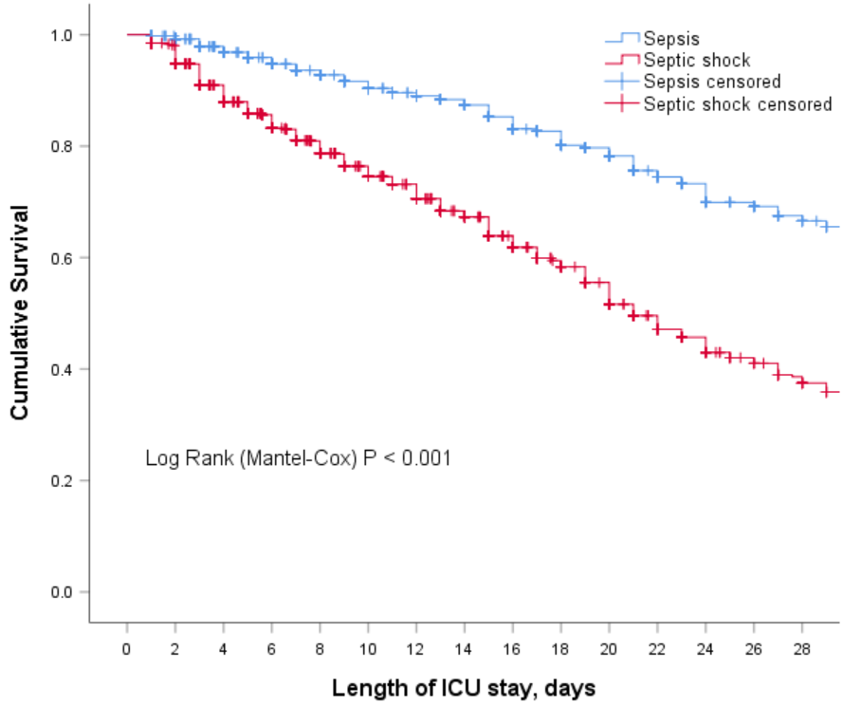
Fig S2. Kaplan Meier survival curve of 28-day mortality according to the severity of sepsis

