Sensitivity Analysis Figures
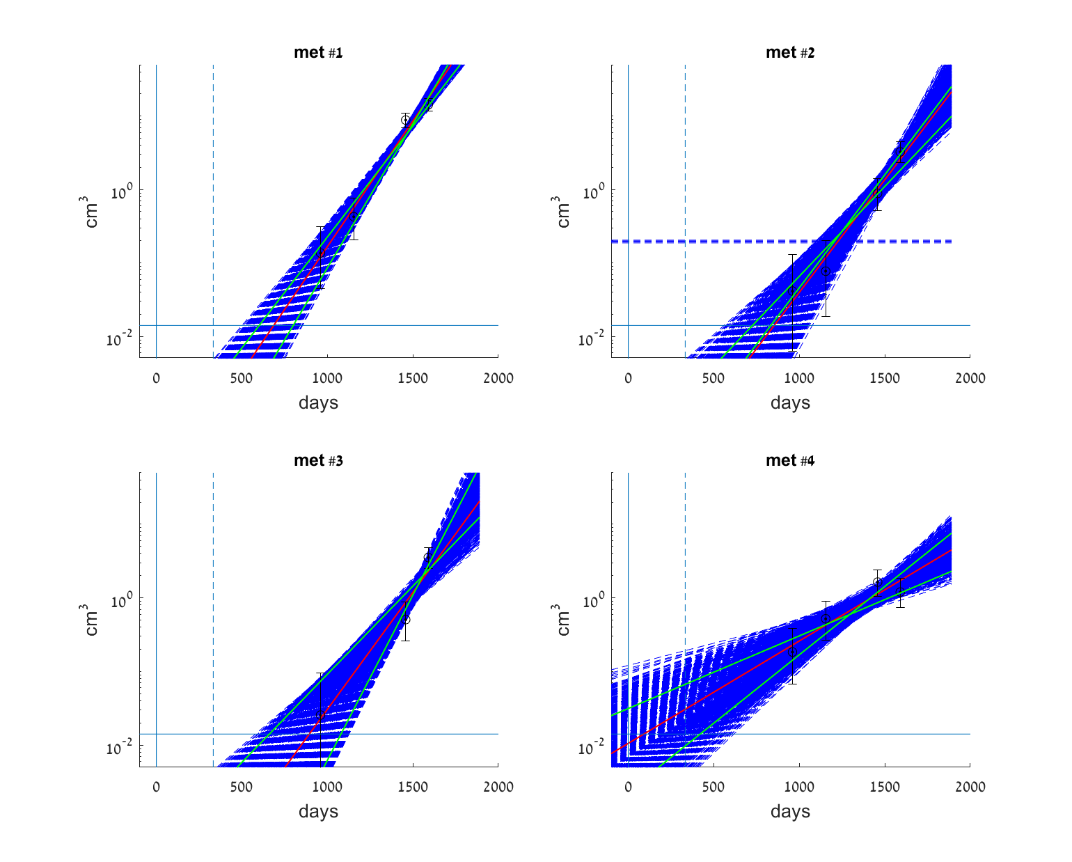
Figure S1: Exponential model - Sensitivity analysis of the fit. Blue dashed lines: exponential models, fitted to a 1000 random different measurement samples within the measured data error bars. Black circles: Clinical data measurements with measurement error bars. Red curve: The model fitted to the reported measurement data. Green curves: interdecile range (fitted models with 10% and 90% of the sorted $λ$ values).

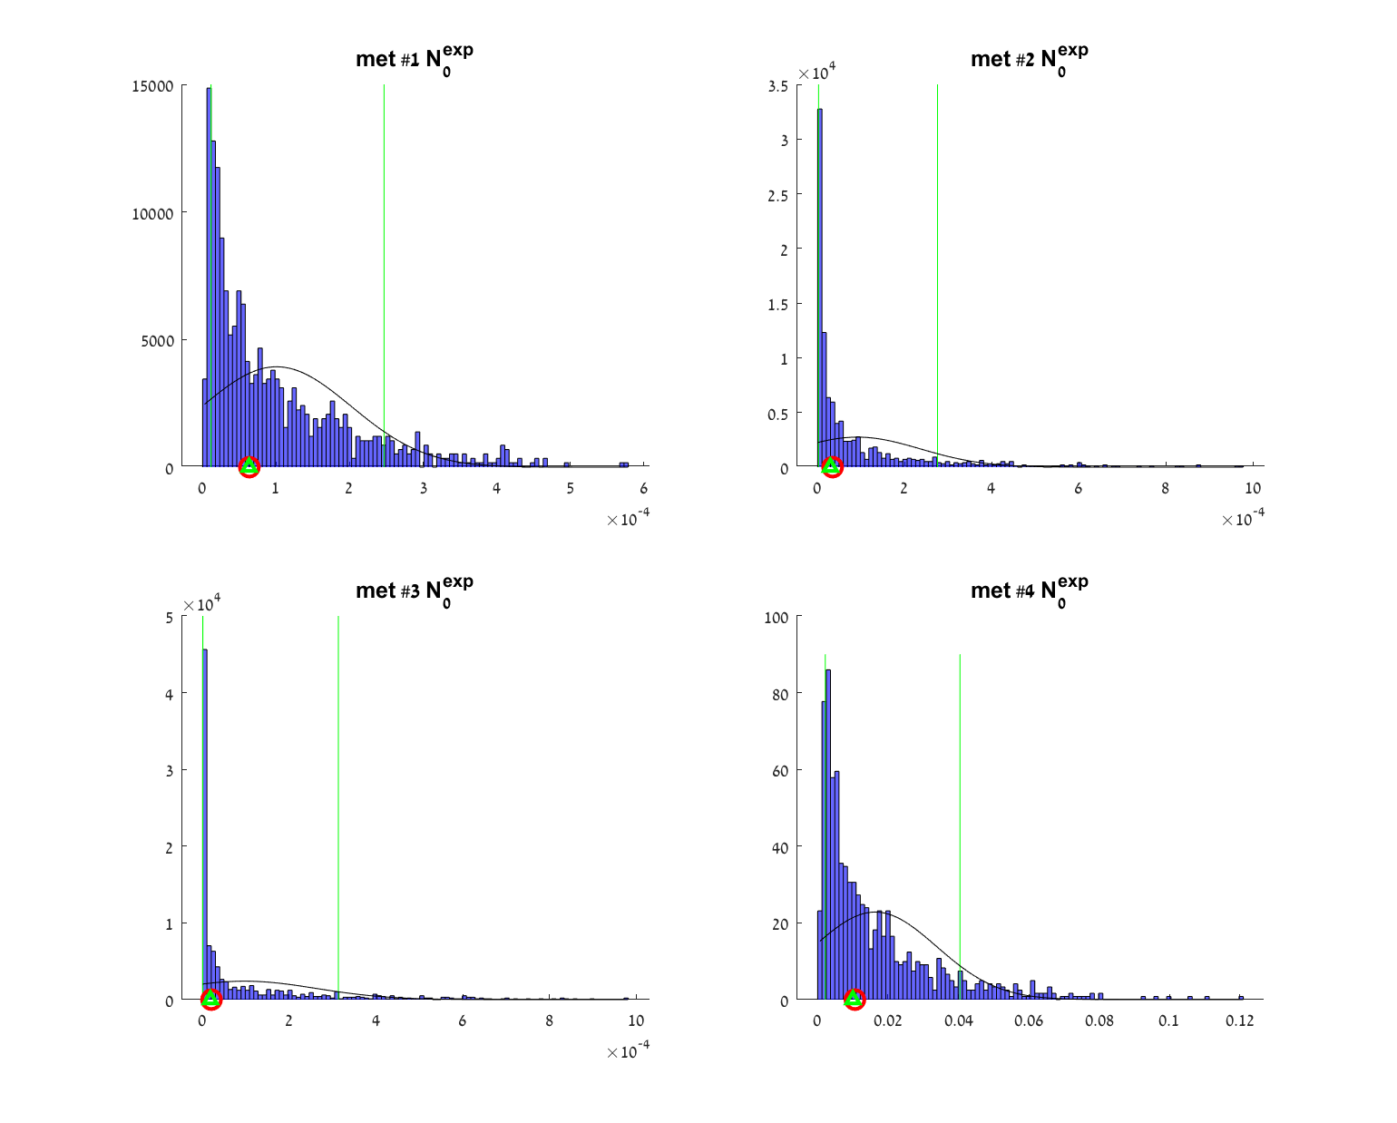
Figure S2: Exponential model - Sensitivity analysis of the fit. Blue bars: A histogram of $N_{0}^{exp}$ parameter values, fitted to a 1000 random measurement samples within the measured data error bars. Black curve: A PDF plot assuming normal distribution of the $N_{0}^{exp}$ values. Green triangle: Median $N_{0}^{exp}$ value. Green vertical lines: interdecile range (10% and 90% of the sorted $N_{0}^{exp}$ values). Red circle: The $N_{0}^{exp}$ value fitted to the reported measured data.

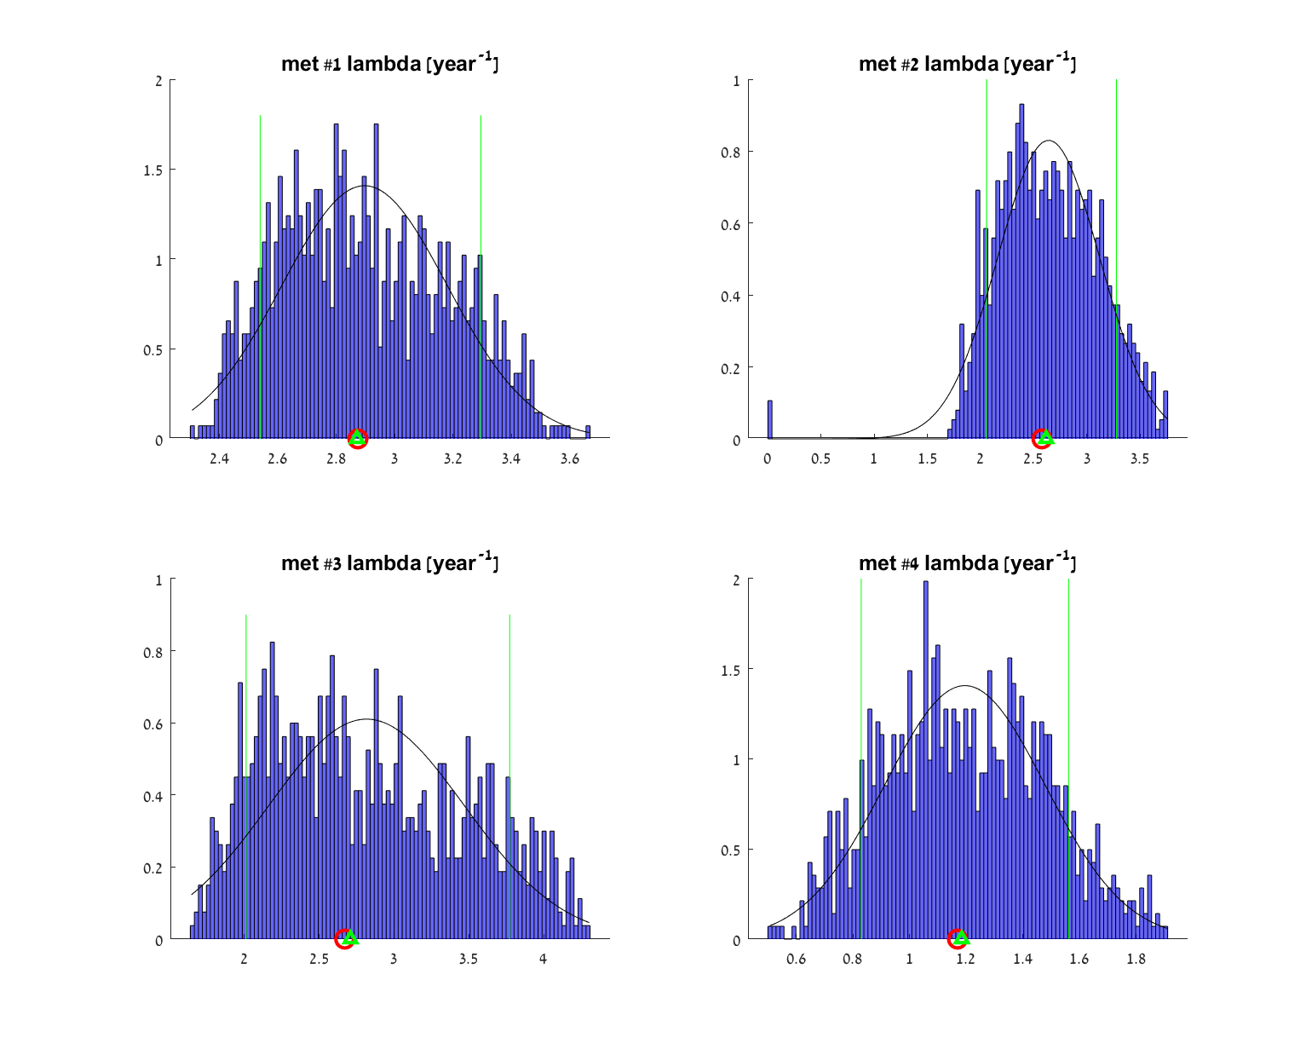
Figure S3: Exponential model - Sensitivity analysis of the fit. Blue bars: A histogram of $λ$ parameter values, fitted to a 1000 random measurement samples within the measured data error bars. Black curve: A PDF plot assuming normal distribution of the $λ$ values. Green triangle: Median $λ$ value. Green vertical lines: interdecile range (10% and 90% of the sorted $λ$ values). Red circle: The $λ$ value fitted to the reported measured data.

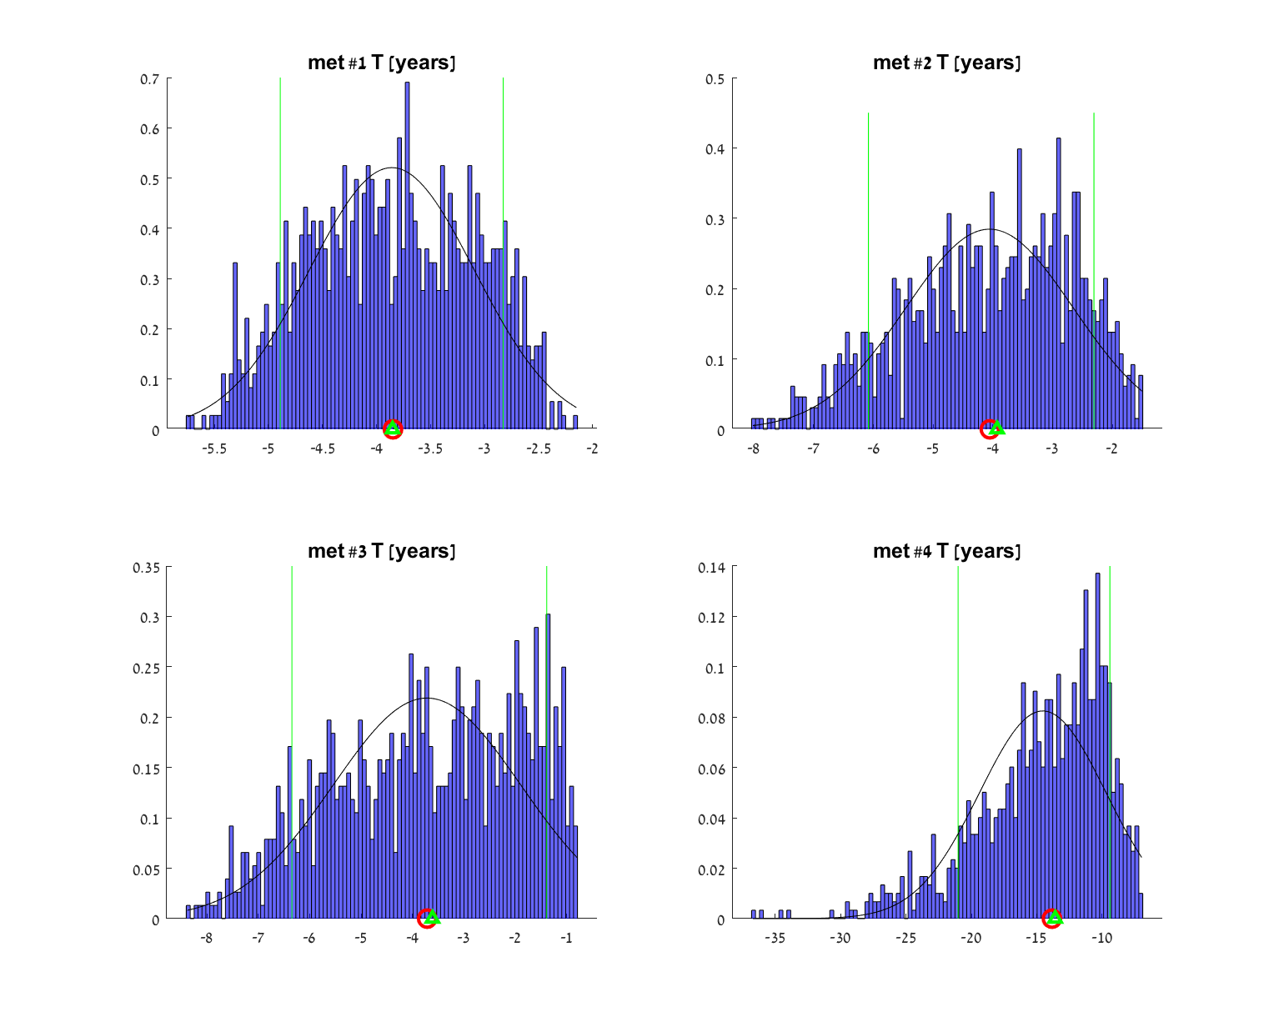
Figure S4: Exponential model - Sensitivity analysis of the fit. Blue bars: A histogram of metastasis onset time ($T$) values, calculated from values of model parameters that were fitted to a 1000 random measurement samples within the measured data error bars. Black curve: A PDF plot assuming normal distribution of the $T$ values. Green triangle: Median $T$ value. Green vertical lines: interdecile range (10% and 90% of the sorted values). Red circle: The $T$ value resulting from fit to the reported measured data.
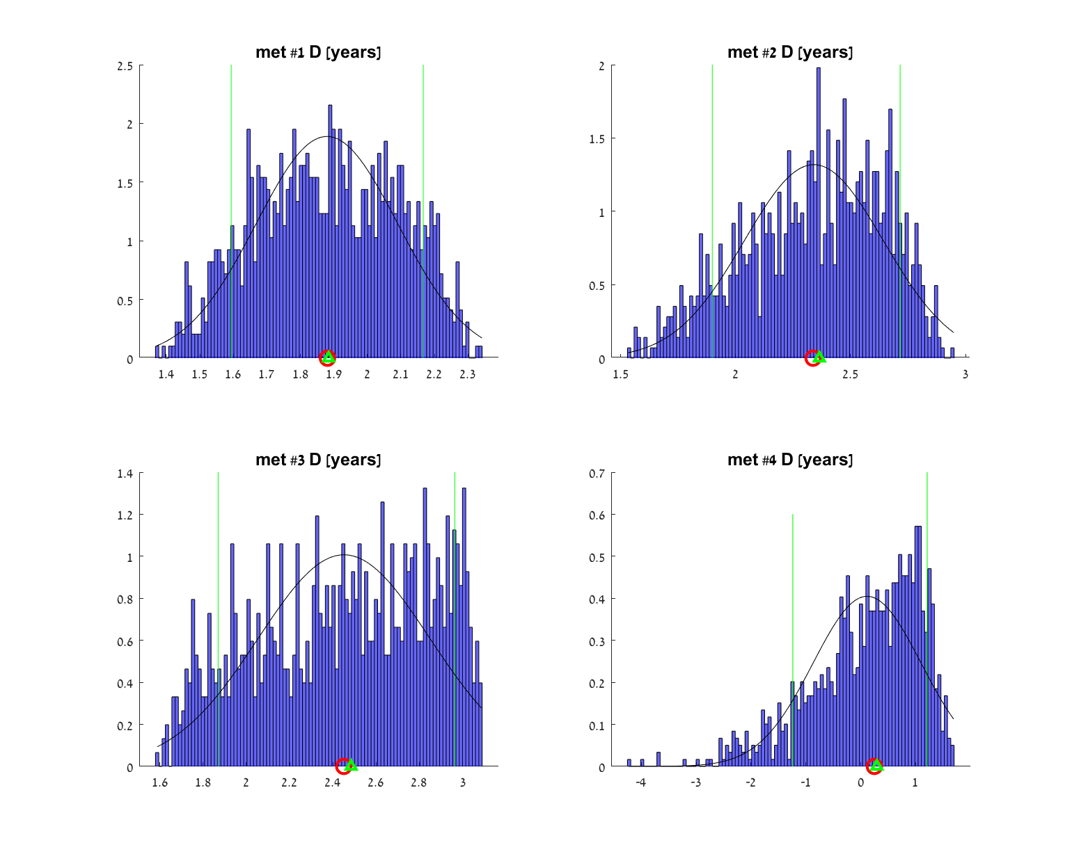
Figure S5: Exponential model - Sensitivity analysis of the fit. Blue bars: A histogram of earliest possible detection time ($D$) values, calculated from values of model parameters that were fitted to a 1000 random measurement samples within the measured data error bars. Black curve: A PDF plot assuming normal distribution of the $D$ values. Green triangle: Median $D$ value. Green vertical lines: interdecile range (10% and 90% of the sorted values). Red circle: The $D$ value resulting from fit to the reported measured data.

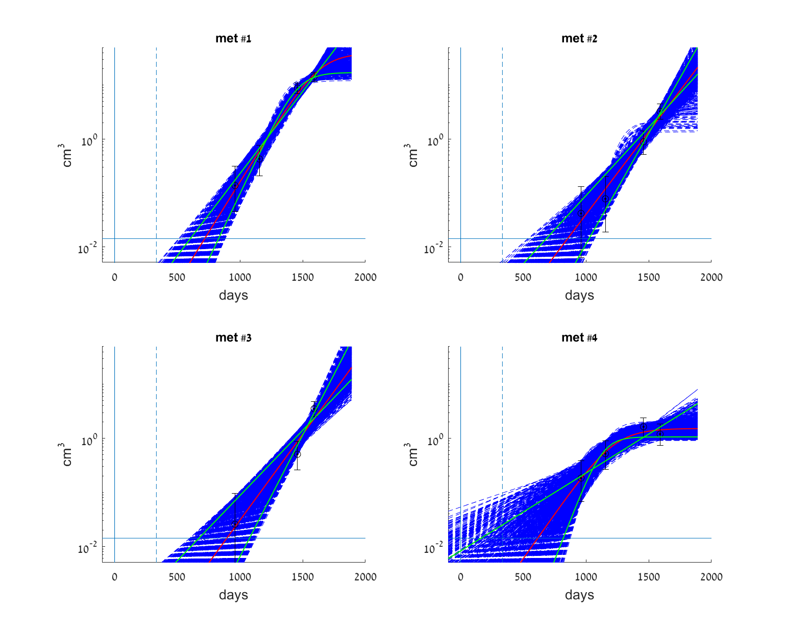
Figure S6: Logistic model - Sensitivity analysis of the fit. Blue dashed lines: logistic models, fitted to a 1000 random different measurement samples within the measured data error bars. Black circles: Clinical data measurements with measurement error bars. Red curve: The model fitted to the reported measurement data. Green curves: interdecile range (fitted models with 10% and 90% of the sorted $λ$ values).
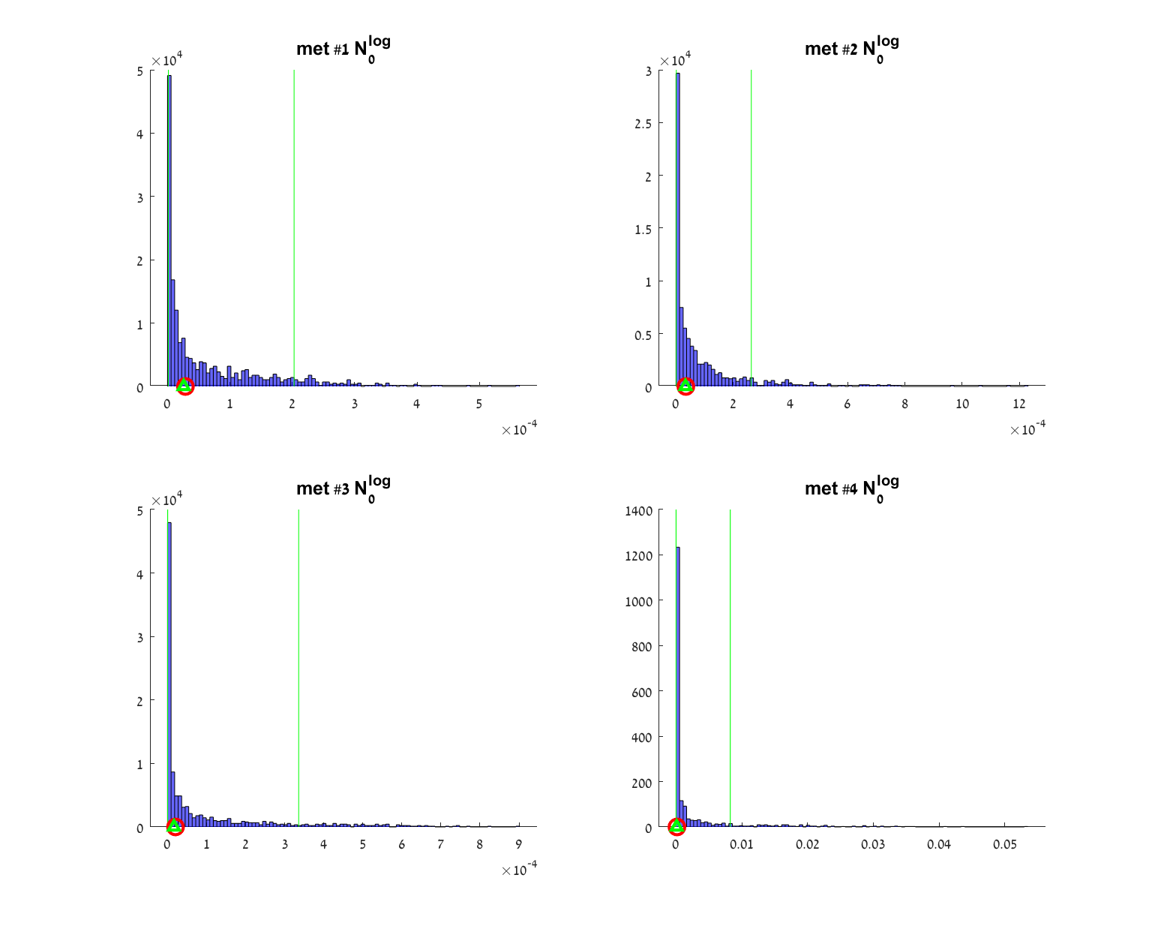
Figure S7: Logistic model - Sensitivity analysis of the fit. Blue bars: A histogram of $N_{0}^{log}$ parameter values, fitted to a 1000 random measurement samples within the measured data error bars. Green triangle: Median $N_{0}^{log}$ value. Green vertical lines: interdecile range (10% and 90% of the sorted $N_{0}^{log}$ values). Red circle: The $N_{0}^{log}$ value fitted to the reported measured data.
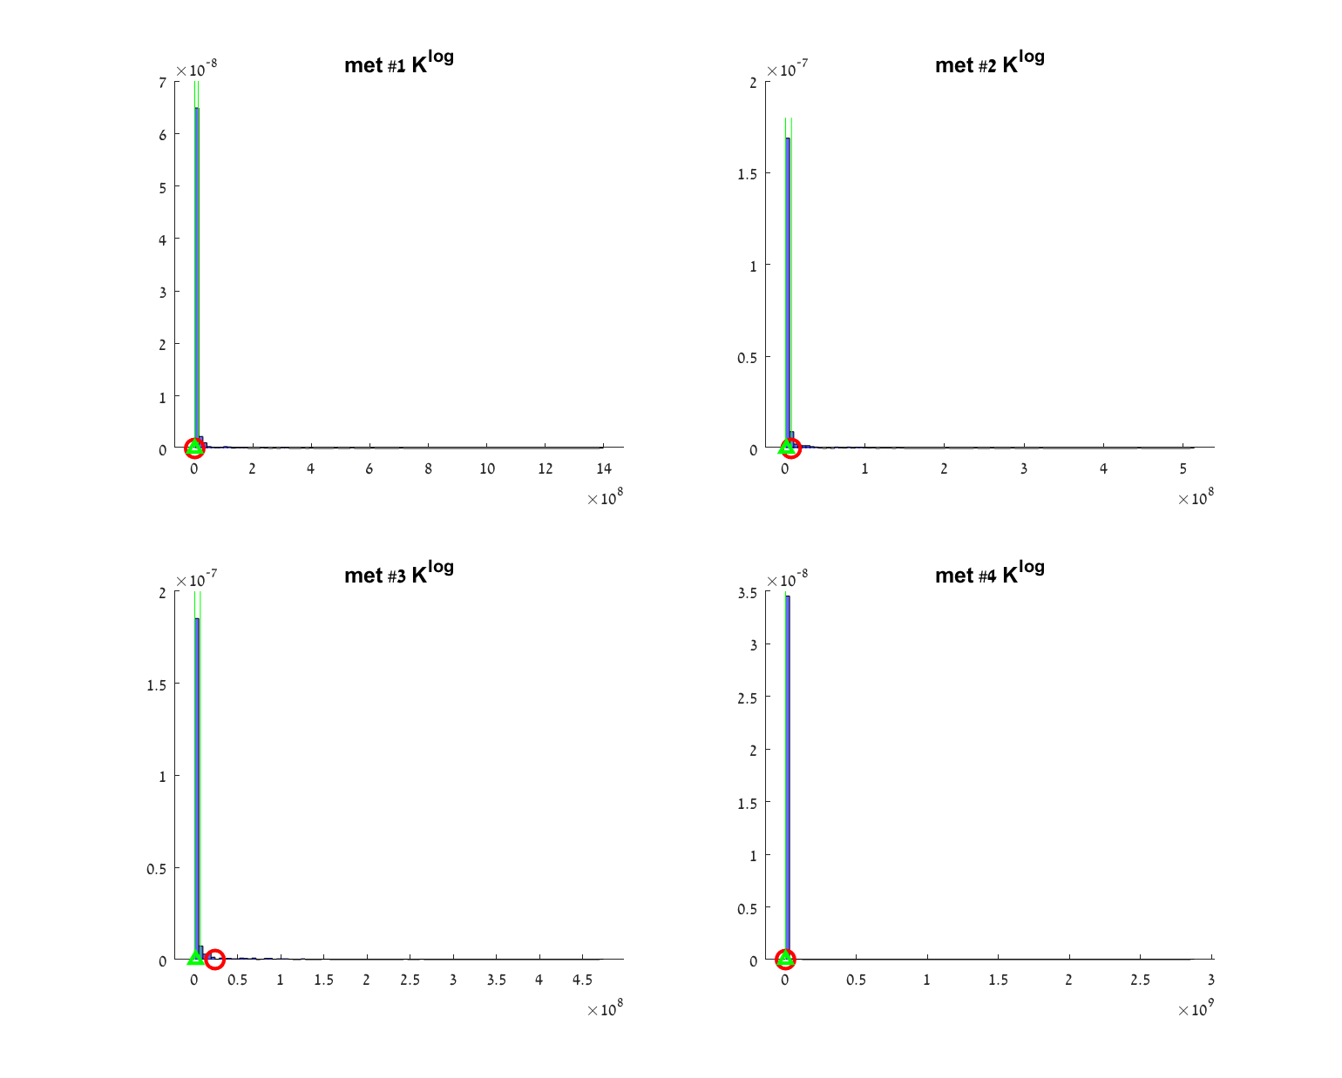
Figure S8: Logistic model - Sensitivity analysis of the fit. Blue bars: A histogram of $K_{}^{log}$ parameter values, fitted to a 1000 random measurement samples within the measured data error bars. Green triangle: Median $K_{}^{log}$ value. Green vertical lines: interdecile range (10% and 90% of the sorted $K_{}^{log}$ values). Red circle: The $K_{}^{log}$ value fitted to the reported measured data.

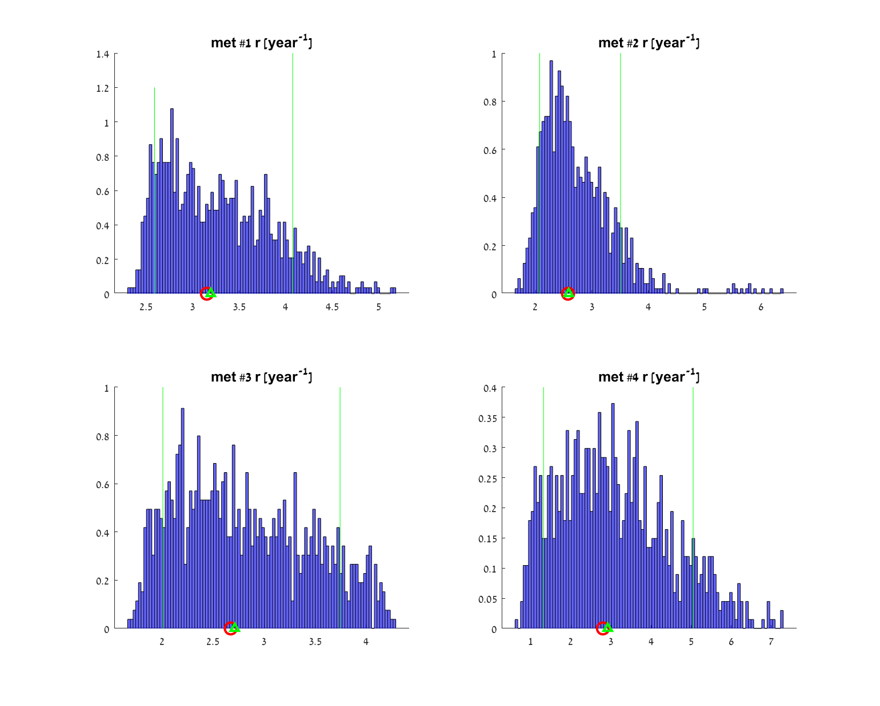
Figure S9: Logistic model - Sensitivity analysis of the fit. Blue bars: A histogram of $r$ parameter values, fitted to a 1000 random measurement samples within the measured data error bars. Green triangle: Median $r$ value. Green vertical lines: interdecile range (10% and 90% of the sorted $r$ values). Red circle: The $r$ value fitted to the reported measured data.

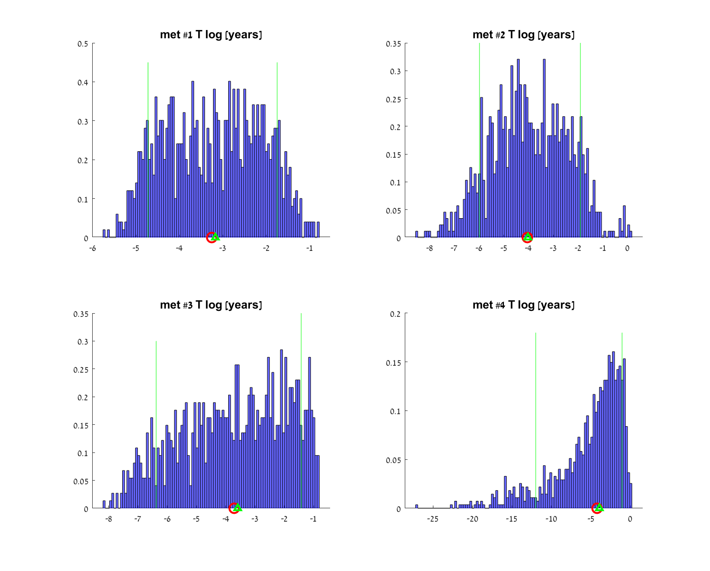
Figure S10: Logistic model - Sensitivity analysis of the fit. Blue bars: A histogram of metastasis onset time ($T$) values, calculated from values of model parameters that were fitted to a 1000 random measurement samples within the measured data error bars. Green triangle: Median $T$ value. Green vertical lines: interdecile range (10% and 90% of the sorted values). Red circle: The $T$ value resulting from fit to the reported measured data.

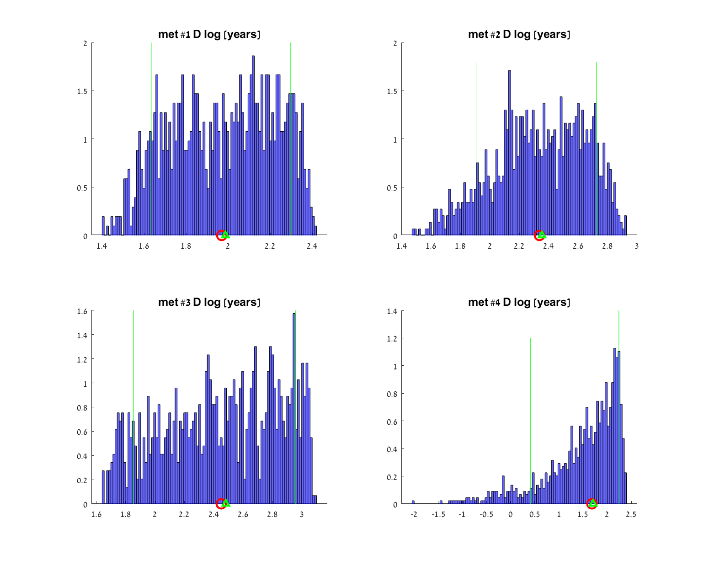
Figure S11: Logistic model - Sensitivity analysis of the fit. Blue bars: A histogram of earliest possible detection time ($D$) values, calculated from values of model parameters that were fitted to a 1000 random measurement samples within the measured data error bars. Green triangle: Median $D$ value. Green vertical lines: interdecile range (10% and 90% of the sorted values). Red circle: The $D$ value resulting from fit to the reported measured data.

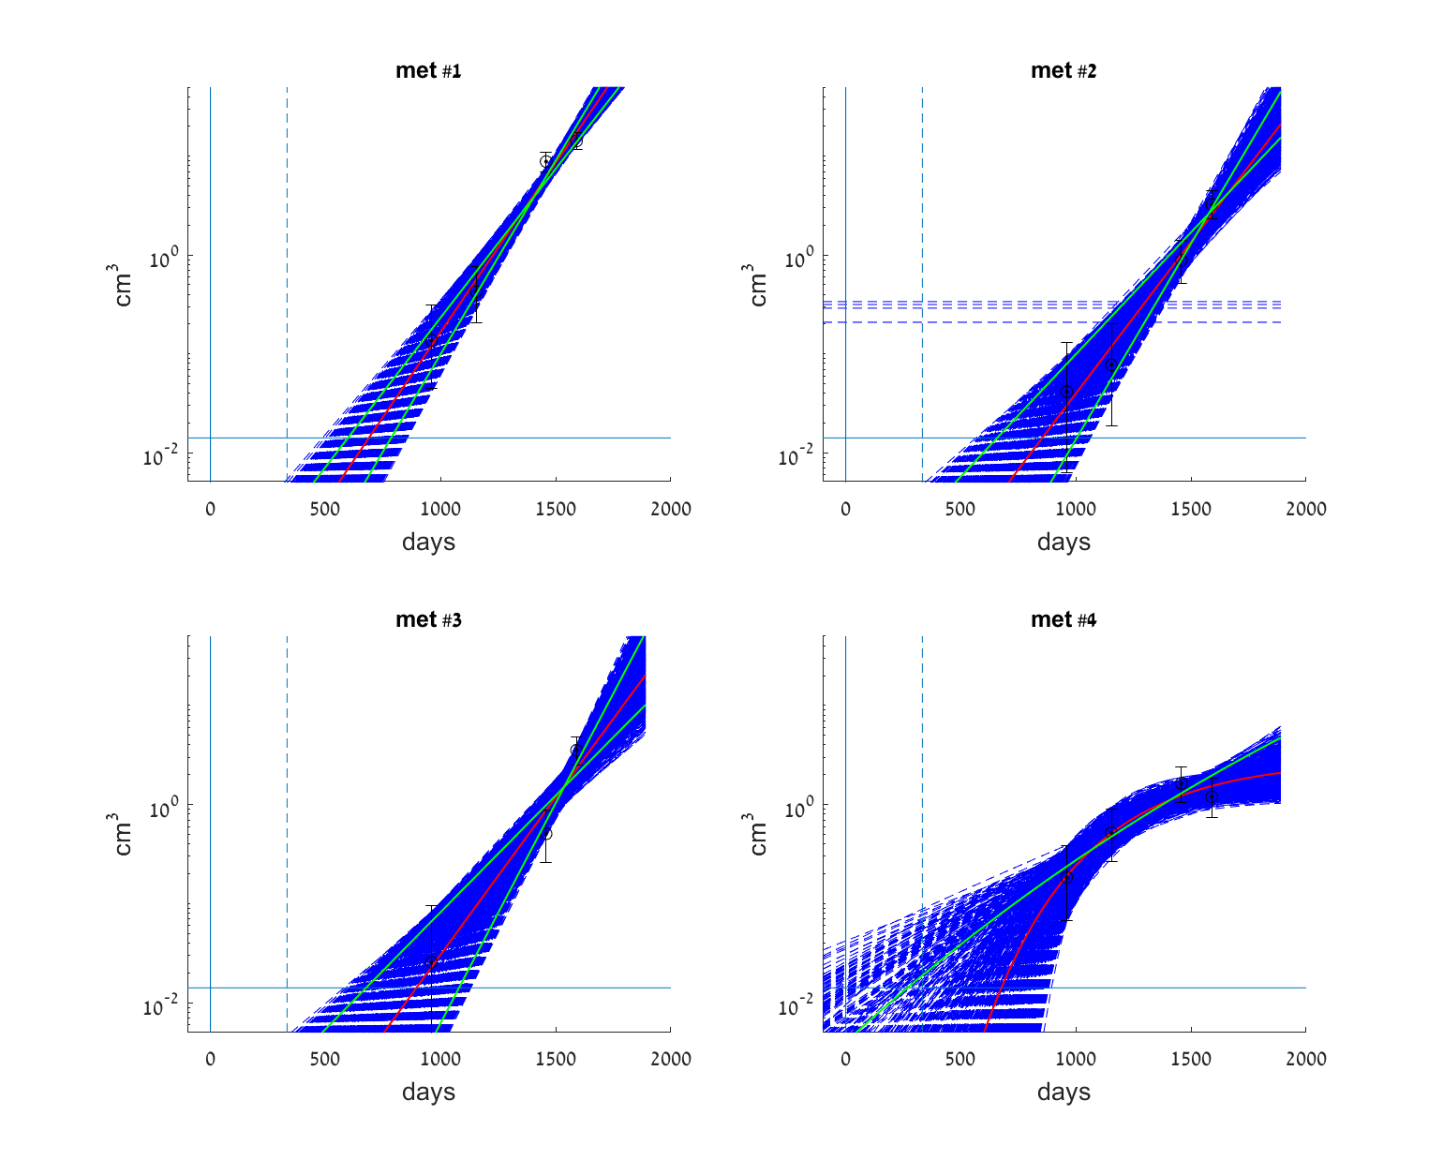
Figure S12: Gompertz model – Sensitivity analysis of the fit. Blue dashed lines: Gompertz models, fitted to a 1000 random different measurement samples within the measured data error bars. Black circles: Clinical data measurements with measurement error bars. Red curve: The model fitted to the reported measurement data. Green curves: interdecile range (fitted models with 10% and 90% of the sorted $λ$ values).
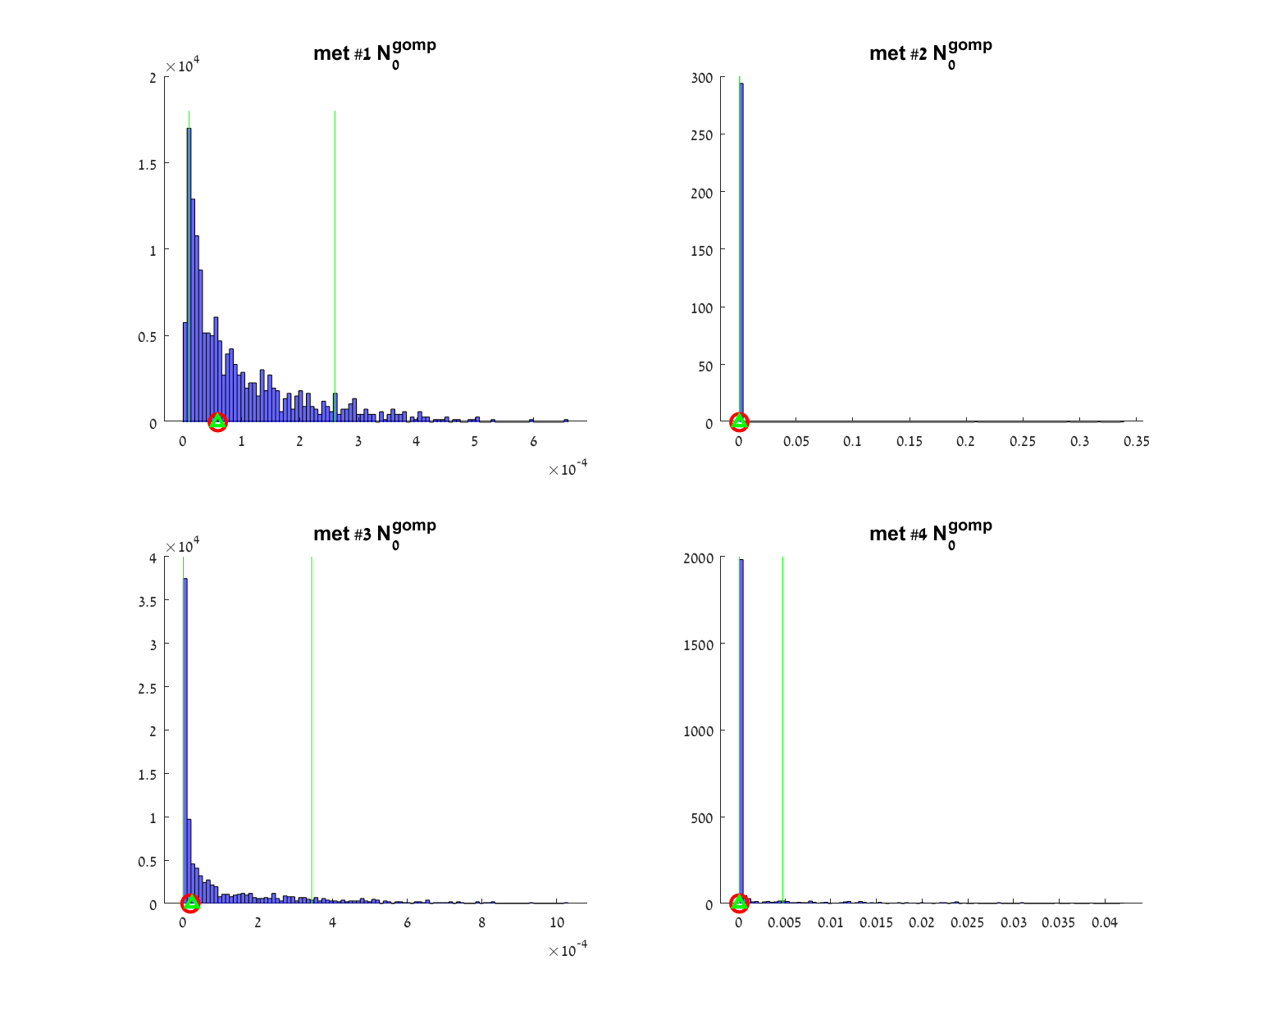
Figure S13: Gompertz model - Sensitivity analysis of the fit. Blue bars: A histogram of $N_{0}^{gomp}$ parameter values, fitted to a 1000 random measurement samples within the measured data error bars. Green triangle: Median $N_{0}^{gomp}$ value. Green vertical lines: interdecile range (10% and 90% of the sorted $N_{0}^{gomp}$ values). Red circle: The $N_{0}^{gomp}$ value fitted to the reported measured data.

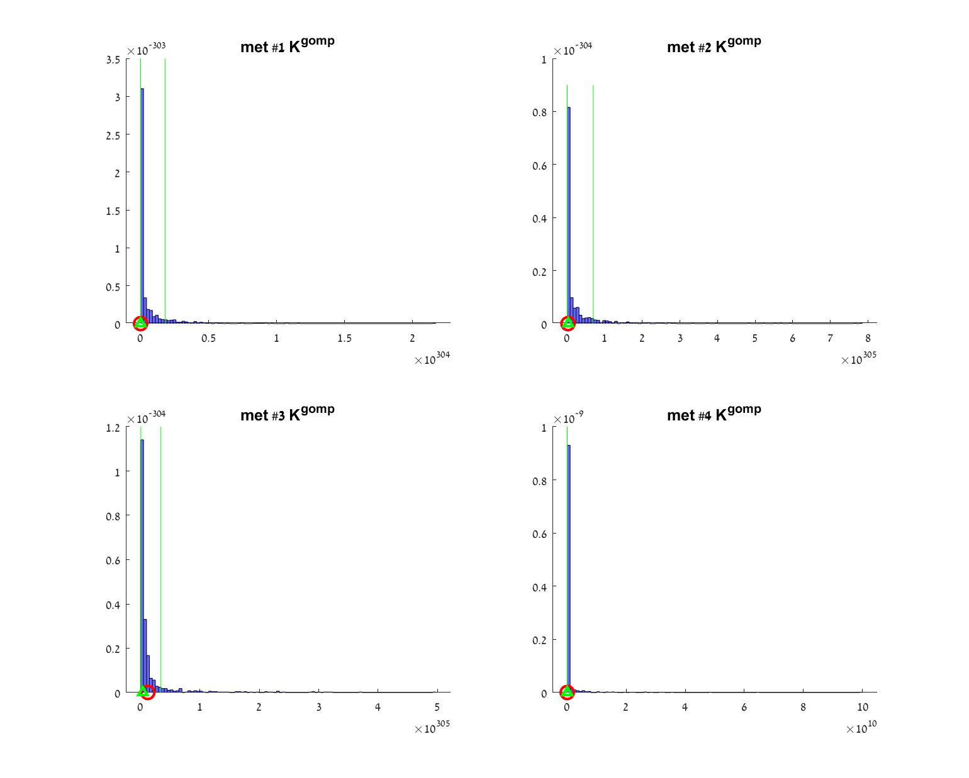
Figure S14: Gompertz model - Sensitivity analysis of the fit. Blue bars: A histogram of ${ K}_{}^{gomp}$ parameter values, fitted to a 1000 random measurement samples within the measured data error bars. Green triangle: Median ${ K}_{}^{gomp}$ value. Green vertical lines: interdecile range (10% and 90% of the sorted ${ K}_{}^{gomp}$ values). Red circle: The ${ K}_{}^{gomp}$ value fitted to the reported measured data.

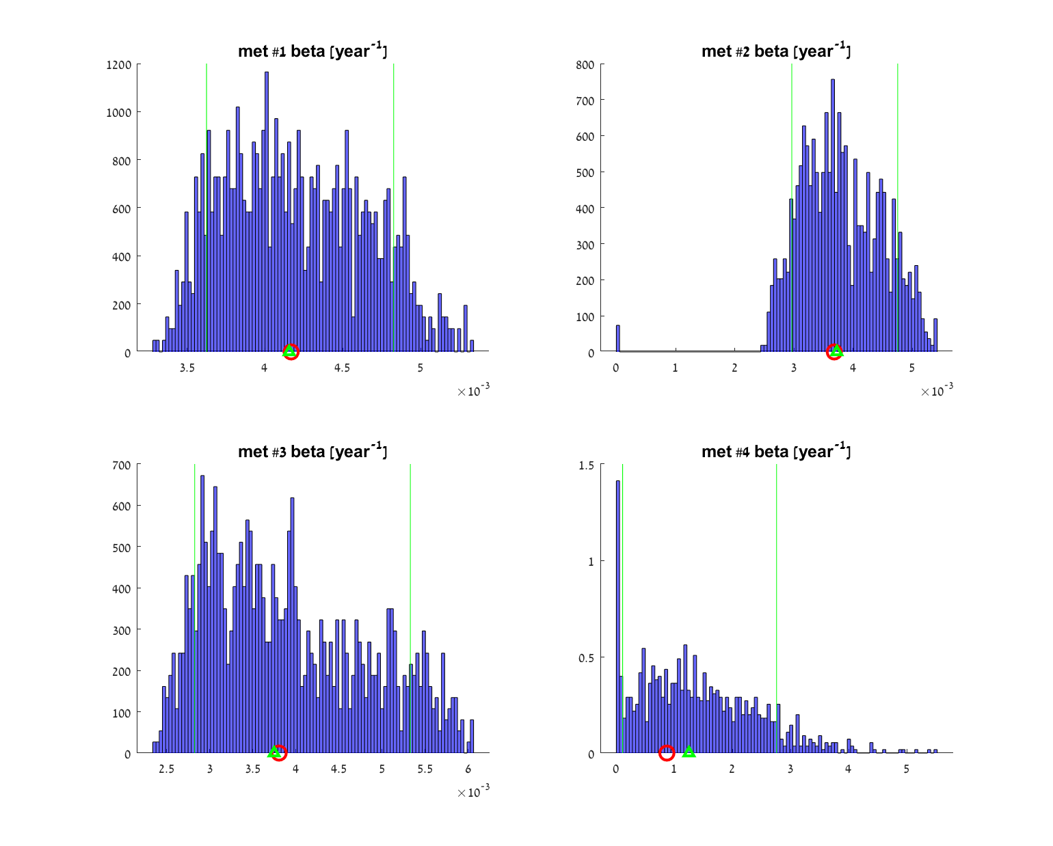
Figure S15: Gompertz model - Sensitivity analysis of the fit. Blue bars: A histogram of $β$ parameter values, fitted to a 1000 random measurement samples within the measured data error bars. Green triangle: Median $β$ value. Green vertical lines: interdecile range (10% and 90% of the sorted $β$ values). Red circle: The $β$ value fitted to the reported measured data.

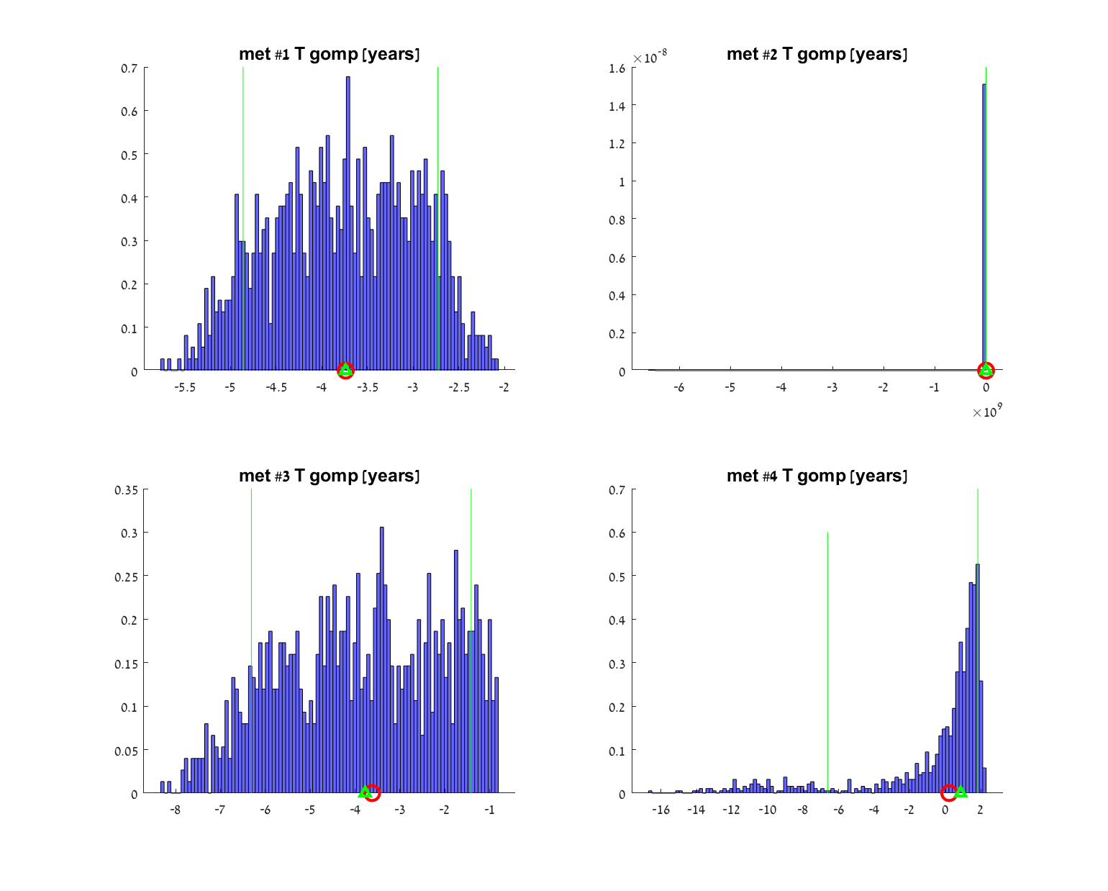
Figure S16: Gompertz model - Sensitivity analysis of the fit. Blue bars: A histogram of metastasis onset time ($T$) values, calculated from values of model parameters that were fitted to a 1000 random measurement samples within the measured data error bars. Green triangle: Median $T$ value. Green vertical lines: interdecile range (10% and 90% of the sorted values). Red circle: The $T$ value resulting from fit to the reported measured data.

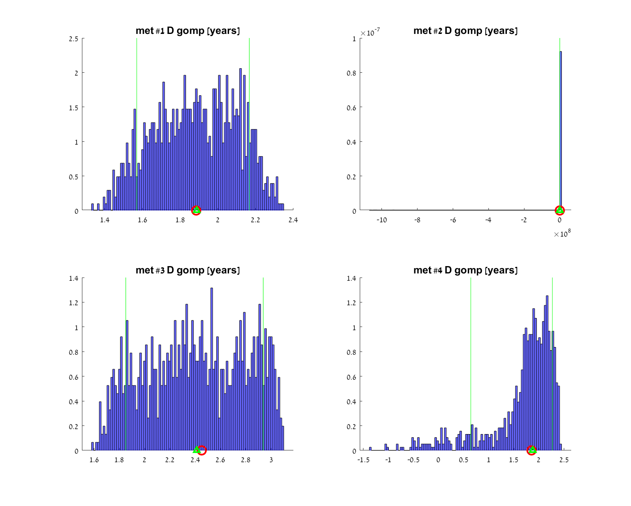
Figure S17: Gompertz model - Sensitivity analysis of the fit. Blue bars: A histogram of earliest possible detection time ($D$) values, calculated from values of model parameters that were fitted to a 1000 random measurement samples within the measured data error bars. Green triangle: Median $D$ value. Green vertical lines: interdecile range (10% and 90% of the sorted values). Red circle: The $D$ value resulting from fit to the reported measured data.

