Supplementary Material
Supplementary table 1. Definitions of prodigies with Author in parentheses.
“a child (typically younger than 10 years old) who is performing at the level of a highly trained adult in a very demanding field of endeavor.” | (Feldman, 1993)
“Prodigies are able to function at an advanced adult level in some domain before age 12.” | (Solomon, 2012)
“a child who, at onset of puberty (which for boys is usually 11–12 and girls 10–11), manifests extraordinary intellectual–creative performance and/or achievements in any type of a real activity (i.e. intellectual, artistic, musical, and so on).” | (Shavinina, 2016)
“Gifted children and prodigies display near-adult level skills and interests.” | (Winner, 2000)
“The current study deemed a child to have prodigious talent  if he or she had achieved national or international acclaim by adolescence.” | (Ruthsatz, Ruthsatz, & Stephens, 2014)
“Prodigies are children under 10 years of age who perform culturally relevant tasks at a level that is rare even among highly trained professionals.” | (Ruthsatz & Detterman, 2003)
“Prodigies are children who display exceptional talent early in life” | (McPherson & Hallam, 2009)

Supplementary table 2. Prodigies’ age for each type of achievement.
Subject | First prize in national or international competition | Second prize in national or international competition or first prize in regional competition | Special recognition of their talent
P1 |  | 14, 15, 16, 16 | 12: Orchestral debut  18: Admission to Juilliard
P2 |  | 8, 9, 10
P3 | 12, 15 | 9, 10
P4 | 9, 12, 13, 17 |  | 8: Television appearance
P5 |  | 18 | 10: Television appearance
P6 |  | 10, 13, 14, 15, 16, 17
P7 |  |  | 9: Television appearance
P8 | 13 | 15, 16 | 14: Television appearance  16: Television appearance
P9 |  | 13 | 12: Youngest concertmaster of the school’s orchestra  13: Television appearance
P10 | 14 |  | 12: Documentary appearance 16: Chosen to be in the YouTube symphony orchestra  17: Newspaper article  18: “Revelation of the year” by national television
P11 | 12, 16, 17 | 12, 12
P12 | 9, 14 | 10, 11, 12, 14
P13 |  | 11, 12, 14
P14 | 16, 16 | 18 | 7: Orchestral debut  12: Invited to perform with professional orchestra
P15 |  | 10, 11, 12, 12 | 10: 1st violin of youth orchestra  13: Winner of national television competition
P16 |  | 8, 9 | 11: Television appearance
P17 | 9, 10, 11, 13, 16, 17
P18 | 9
P19 | 10, 10, 12 |  | 13: Public’s favorite prodigy at an international competition

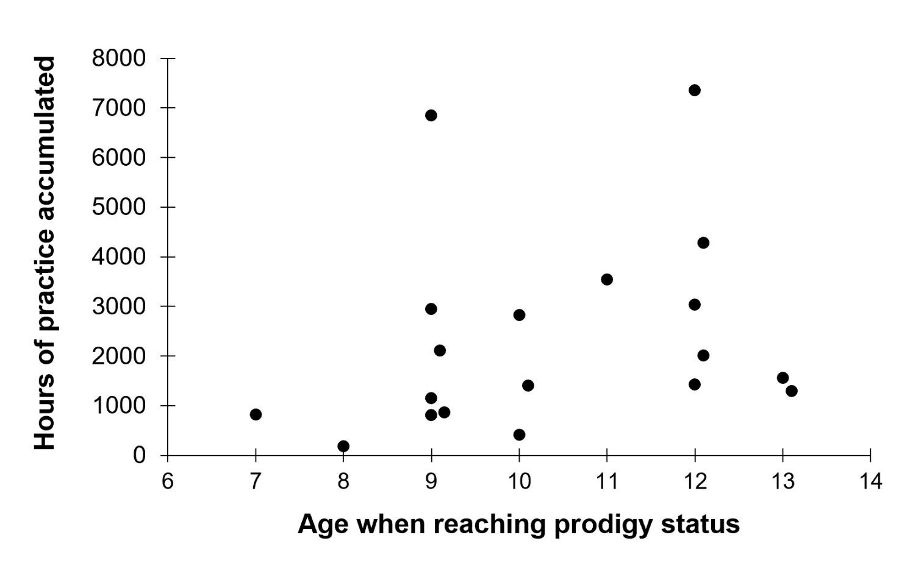
Supplementary figure 1. Age when reaching prodigy status and hours of practice accumulated by that age.

