**Supplementary Material**

**Further Development of Small Hydropower May Alter Nutrient Transport to the Pantanal Wetland of Brazil**

**Supplementary Table S1.** Characteristics of current hydropower facilities in the studied reaches. In a few cases information was not available (marked as no entry).



Sources of data on facilities: 1 Hydropower companies; 2 Brazilian National Agency for Electrical Energy (ANEEL). 3 Installed potential >30 MW.

**Supplementary Table S2.** Locations of sampling sites for nutrients and the associated current and future hydropower facilities. Codes refer to labelled points in the figures. SHP = small hydropower facility (<30 MW); UHE = facility >30 MW (*usina hidreléctrica*).



1 primary data with bedload sampling

1* primary data without bedload sampling

2 secondary data

**Supplementary Table S3**. Summary of primary data on water quality and nutrient concentrations and transport in rivers of the upper Paraguay River basin. Values are medians from multiple sampling dates (usually 13). Codes refer to labelled points in the figures. Nutrients include total nitrogen (TN), dissolved inorganic N (DIN), total phosphorus (TP), dissolved P (DP), suspended particulate organic carbon (POC). Bedload transport of TN, TP, and POC is also included. Specific conductance values corrected to 25°C. MT = Mato Grosso; MS = Mato Grosso do Sul states.



**Supplementary Table S4.** Discharge and concentrations and transport of total nitrogen (TN) and total phosphorus (TP) measured upstream and downstream of river reaches with current hydropower facilities. Discharge and concentration values are medians from multiple sampling dates (usually 13). Codes refer to labelled points in the figures. SHP = small hydropower facility (<30 MW); UHE = facility >30 MW (*usina hidreléctrica*).



**Supplementary Table S5.** Discharge and concentrations and transport of total nitrogen (TN) and total phosphorus (TP) measured upstream and downstream of river reaches where future small hydropower (SHP) facilities may be built. Discharge and concentration values are medians from multiple sampling dates (usually 13). Codes refer to labelled points in the figures. MT = Mato Grosso; MS = Mato Grosso do Sul states.



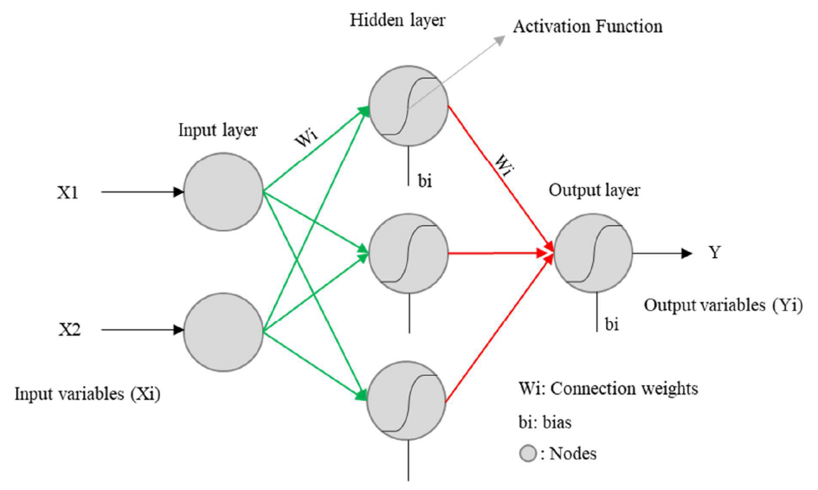

**Supplementary Figure S1.** Architecture of the artificial neural network model employed to project the impacts of new hydropower facilities on total suspended sediments, total nitrogen, and total phosphorus transport by upland rivers to the Pantanal (from Campos 2019).

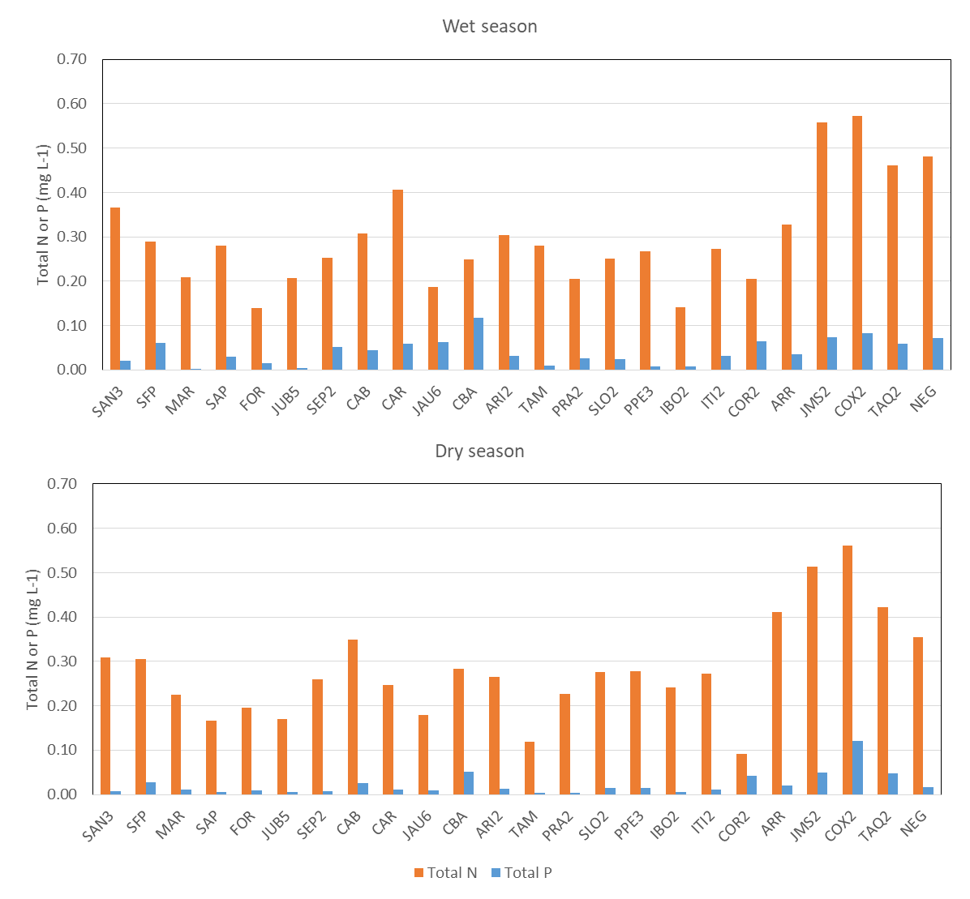

**Supplementary Figure S2.** TN and TP concentrations by river system and hydropower facility (codes refer to Table 1) during the wet season (A) and dry season (B). Observations were divided into seasons based on mean monthly rainfall, with May-Oct and Nov-Apr as the dry and wet seasons, respectively.

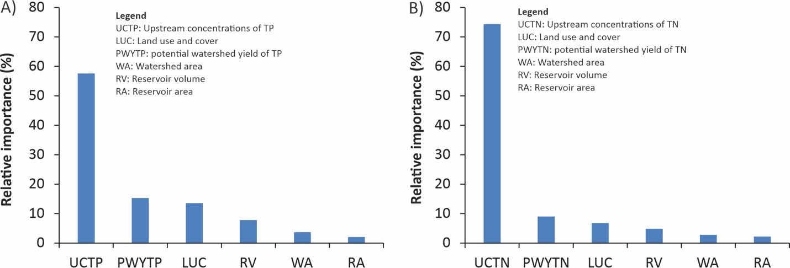

**Supplementary Figure S3.** Relative importance of the input variables in the artificial neural network models that predict nutrient retention. The relative importance of each input variable was evaluated through alternative ANN models in which one variable was left out at a time, keeping the rest of the model settings the same. The reduction in the Nash-Sutcliffe coefficient of the verification upon deletion of an input variable was used to calculate the relative importance of each input variable.