Appendix SA - The Ecopath with Ecosim and Ecospace modeling approach
Ecopath
The mass balance over a given time-period considered in Ecopath relies on two master equations. The first one describes the production of each functional group i:
$B_{i}×{\left(\frac{P}{B}\right)}_{i}=\sum_{j=1}^{N}{B_{j }}× {\left(\frac{Q}{B}\right)}_{j}×{DC}_{ji}+{\left(\frac{P}{B}\right)}_{i}× B_{i} ×\left(1-{EE}_{i}\right)+Y_{i}+E_{i}+{BA}_{i}$ (eq. A1)
where B_{i} is the biomass, (P/B)_{i} the production rate, Y_{i} the total fisheries yield, E_{i} the net emigration rate, BA_{i} the biomass accumulation, and EE_{i} the ecotrophic efficiency (proportion of the production utilized in the ecosystem). B_{j} is the biomass of j, one of the N predators of functional group i, which eats functional group i in DC_{ji} proportion in its diet, and whose consumption rate is (Q/B)_{j}. For each functional group i, Y_{i} and DC_{ij} are inputs parameters, and it is necessary to provide an estimate for three of the following parameters to Ecopath: B_{i}, (P/B)_{i}, (Q/B)_{i} and EE_{i} . The parameter not provided is estimated by Ecopath so that the mass-balanced hypothesis is satisfied (Christensen and Walters, 2004).
The second master equation defines a functional group’s productivity with respect to its consumption and maintenance needs:
$Q_{i}=P_{i}+R_{i}+{UA}_{i}$ (eq. A2)
where $Q_{i}$ is the consumption of functional group i, $P_{i}$ its production, defined in eq. 1 as $B_{i}×{\left(\frac{P}{B}\right)}_{i}$, R_{i} its respiration, and UA_{i} the unassimilated food. Thus, eq. A2 expresses that consumption is the sum of growth (both somatic and gonadal), metabolic costs and waste products (Winberg, 1956).
Ecosim
Principle and main equations. Ecosim is used to represent temporal changes in the ecosystem of interest in response to trophic interactions, fishing and/or environmental changes over time (Christensen et al., 2008; Christensen and Walters, 2004). Therefore, Ecosim relies on a set of differential equations expressing changes in the biomass of each functional group i over a given time interval dt:
$\frac{dB_{i}}{dt}= g_{i}×\sum_{j=1}^{N}{Q_{ji}-\sum_{j=1}^{N}{Q_{ij }}+I_{i}-\left({M0}_{i }+F_{i }+e_{i }+i_{i}\right)×B_{i }}$ (eq. A3)
The growth rate of functional group i over time interval dt is given by the difference between the matter produced by functional group i, migrations (emigration and immigration rates e_{i} and i_{i}), and losses in functional group i’s biomass due to fishing (fishing mortality rate F_{i}) and natural mortality due to predation (sum of the consumptions Q_{ij} by functional group i’s predators) or other causes (M0_{i} mortality rate). The matter produced by functional group i is expressed as the product of food consumed (consumption of all functional group i’s prey) and growth net efficiency g_{i}, which is given by the ratio of two EwE parameters: (Q/B)_{i} and (P/B)_{i}. Consumptions are calculated based on the “foraging arena” theory, which divides prey biomasses into vulnerable and invulnerable compartments, which are, respectively, accessible and not accessible to predators (Ahrens et al., 2012). For a given prey-predator couple (i,j), the consumption of i by j is estimated as follows (Ahrens et al., 2012; Christensen and Walters, 2004):
$Q_{i,j}=\frac{{a'}_{i,j}*v_{i,j}*B_{i}*P_{j}*T_{i}*T_{j}*\frac{M_{i,j}}{D_{j}}}{v_{i,j}+v_{i,j}*T_{i}*M_{i,j}+{a'}_{i,j}*M_{i,j}*B_{j}*\frac{T_{j}}{D_{j}}}*S_{t,j,}(e_{e},t)$ (eq. A4)
where $B_{j}$ is the biomass of the predator j; ${a'}_{i,j}$ is the rate of effective search of predator j for prey I; $T_{i}$ and $T_{j}$ correspond, respectively, to the prey and predator relative feeding time; $M_{i,j}$ is the eventual mediation effect of a third organism on the (i,j) trophic relationship; and $D_{j}$ is the handling time of the predator j for its prey. The vulnerability coefficient $v_{i,j}$ ranges from 1 to infinity and controls the transfer rate of the prey between the vulnerable and invulnerable compartments. For values of $v_{i,j}$ greater to 2, a large increase in $B_{j}$ results in a large increase in $Q_{i,j}$. Thus, for values of $v_{i,j}$ greater to 2, the quantity of prey i consumed by predator j is mainly influenced by predator j abundance. We are, then, under “top-down control”. Conversely, when $v_{i,j}$ tends to 1, a large increase in $B_{j}$ has a lower impact on $Q_{i,j}$; we are, then, under “bottom-up control”.
Hindcasting the past. The value of vulnerability coefficients, initially set to 2 by default as a trade-off between bottom-up and top-down controls, can be estimated through fitting the Ecosim model to observed time-series of biomass or catches. Vulnerability coefficients are estimated so as to minimize the weighted sum of squared deviations between log-scale observed and predicted values (where the weights can be set by the user according to the perceived quality of the observed time series). This hindcasting step can be implemented using a “predator-prey strategy”, where each prey-predator interaction is estimated individually, or using a “predator-only strategy”, where a mean vulnerability value per predator is estimated regardless of the consumed prey. The number of vulnerability coefficients to be estimated is limited by the number of observed time-series provided to Ecosim, and can be chosen either by the modeler or according to a stepwise procedure (Scott et al., 2016) that determines the vulnerability coefficients leading to the best fit to time-series data based on Akaike Information Criterion (Akaike, 1974).
Simulating the impact of fishing and environmental changes. The Ecosim model can be forced or driven using various time-series related to fishing or the environment. Forcing time-series of fishing mortality or fishing effort can be applied to, respectively, functional groups or the fisheries that target these functional groups to simulate the temporal impact of fishing. In particular, fishing mortality time-series can be directly employed in the Ecosim differential equations eq. 3.
Environmental changes can be modeled in two main ways. The first one consists of using observed time-series of primary production (Christensen et al., 2009). In EwE, the production of a primary producer i ${PP}_{i}$ is determined from its biomass using:
${PP}_{i}=\frac{r_{i}.B_{i}}{1+B_{i}.h_{i}}*{pp}_{i,t}^{rel}$ (eq. A5)
where r is the largest possible production/biomass ratio, $r_{i}$/$h_{i}$ is the maximum net primary production when the biomass is not limiting production. ${pp}_{i,t}^{rel}$ is a time-series of relative primary production that can be used to simulate the impact of observed changes in the production of lower trophic levels, resulting for instance from satellite remote sensing of chlorophyll-a concentration.
A second way of simulating the impact of environmental changes in Ecosim is to model mean species consumption as depending on specific environmental variables. This can be done using one or several functional responses $f_{e}$ related to environmental variables e_{e} to express a temporal forcing of the trophic group consumption (Fig. 1). The temporal forcing is realized using a multiplier of the consumption $S_{t,i,}(e_{e},t)$ (eq. 4) calculated as the product of all $f_{e,i}(e_{e},t)$ (Fig A1). For any value taken by an environmental variable e_{e} at time step t, the functional response $f_{e}$ provides a value between 0 and 1 modulating the size of the foraging arena. In the more recently published works, the functional response $f_{e}$ can, for instance, represents a preference function to water temperature (Bentley et al., 2017; Corrales et al., 2017; Serpetti et al., 2017) or oxygen concentration (de Mutsert et al., 2016), hence providing a multiplier of the consumption that vary according to the conditions in the the ecosystem.
If this way of modeling environment affects the whole consumption of the predator, some alternative ways of representing temporal effect of environment can target specific couples of predator-prey interactions. This is performed in EwE using the temporal forcing functions that can modify the consumption on a given prey by simultaneously or independently acting as a multiplier of $v_{i,j}$ or ${a'}_{i,j}$. The effective search rate ${a'}_{i,j}$ can be written as the ratio of a search rate $a_{i,j}$ and an area $A_{i,j}$ where foraging I possible. The forcing function thus can act as a multiplier of the former, altering the capacity of the predator to hunt (e.g. turbidity forcing function) or act as a multiplier of the former, increasing or descreasing the accessibility of preys (e.g. macrophytes forcing function restricting the areas where a predator can forage on its preys). Multiplying the exchange rate $v_{i,j}$, the forcing function can account for changes in preys behavior that would facilitate their catch (e.g. productive fronts functions representing the aggregation of zooplankton in favorable areas that would make them more vulnerable to their predator because of easier access to their prey). Dahood et al. (2019) notably used environmental multipliers of vulnerability, search rate and arena area to model the impact of sea-ice regimes on a Antarctic ecosystem.

Ecospace
Ecospace is the spatial component of the EwE framework. It is used to predict the spatial distribution of each functional group over a spatial horizontal 2D-grid based on both trophic and habitat considerations (Pauly et al., 2000; Walters, 1999). This is done through the definition of a habitat foraging capacity. For a given functional group j, the habitat foraging capacity of each cell c $C_{c,j}$ is defined according to the values of specific environmental variables e_{e} in the cell and to functional responses of j to these variables. Therefore, it is necessary to provide Ecospace with maps describing the spatial-temporal patterns of environmental variables and functional responses defined similarly as those employed in Ecosim. The capacity value of each cell, ranging from 0 to 1, is calculated as the product of functional responses resulting from local environmental conditions (see schematic Fig. 1). The ability of a predator to feed in a given grid cell depends on the capacity of this grid cell. This is modeled through the modification of predator j’s consumption in cell c, which is calculated as follows:
$Q_{c,i,j}=\frac{a_{i,j}*v_{i,j}*B_{c,i}*B_{c,j}}{2 v_{i,j}+a_{i,j}*{B_{c,j}}/{C_{c,j}}}$ (eq. A6)
Roughly speaking, Ecospace involves running both Ecopath and Ecosim for all the cells of the grid, which differ from one another in terms of functional group abundances and consumptions. However, the cells are not independent, and they exchange biomass with their adjacent neighbors. A biomass ${B^{out}}_{rc,i}$ exits each cell at each time-step and is relocated to the left, right, below or above cell:
${B^{out}}_{rc,i}= \sum_{d=1}^{4}{m_{i,rc→d}.B_{rc,i}}$ (eq. A7)
with $\left\{\begin{aligned}\sum_{d=1}^{4}{m_{i,rc→d}}={m_{i}}^{0} \\ m_{i,rc→d}=m_{i,d→rc}.\frac{B_{d,i}}{B_{rc,i}} ∀ d∈[1;4] \end{aligned}\right.$ (eq. A8)
where d represents each of the cardinal directions; $B_{d,i}$ is the biomass of functional group i in cell d; $m_{i,c→d}$ and $m_{i,d→c}$are the movement rates from cell c to cell d and from cell d to cell c, respectively; and ${m_{i}}^{0}$ is the base dispersal rate of functional group i. The dispersal rate quantifies the ability of functional i to disperse randomly over one year (km.y⁻¹) and is an input of the Ecospace model. All these specifications entail that movement is less likely towards a less suitable habitat. This adjustment of movement rates between adjacent cells based on their relative biomass allows for maintaining spatial gradients created by habitat foraging capacities.
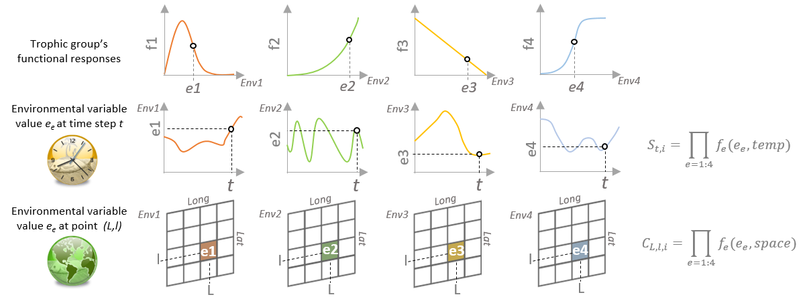
Fig. A1 – Schematic of the integration of environmental effects on species consumption in Ecosim and Ecospace. Functional responses can be common to the temporal and spatial dimensions.

References SA
Ahrens, R. N. M., Walters, C. J., and Christensen, V. (2012). Foraging arena theory: Foraging arena theory. Fish and Fisheries 13, 41–59. doi:10.1111/j.1467-2979.2011.00432.x.
Akaike, H. (1974). A new look at the statistical model identification. IEEE Transactions on Automatic Control 19, 716–723. doi:10.1109/TAC.1974.1100705.
Bentley, J. W., Serpetti, N., and Heymans, J. J. (2017). Investigating the potential impacts of ocean warming on the Norwegian and Barents Seas ecosystem using a time-dynamic food-web model. Ecological Modelling 360, 94–107. doi:10.1016/j.ecolmodel.2017.07.002.
Christensen, V., and Walters, C. J. (2004). Ecopath with Ecosim: methods, capabilities and limitations. Ecological Modelling 172, 109–139. doi:10.1016/j.ecolmodel.2003.09.003.
Christensen, V., Walters, C. J., Ahrens, R., Alder, J., Buszowski, J., Christensen, L. B., et al. (2009). Database-driven models of the world’s Large Marine Ecosystems. Ecological Modelling 220, 1984–1996. doi:10.1016/j.ecolmodel.2009.04.041.
Christensen, V., Walters, C. J., and Pauly, D. (2008). Ecopath with Ecosim version 6 user guide. Lenfest Ocean Futures Project 2008. Vancouver, Canada: Fisheries Centre, University of British Columbia.
Corrales, X., Coll, M., Ofir, E., Piroddi, C., Goren, M., Edelist, D., et al. (2017). Hindcasting the dynamics of an Eastern Mediterranean marine ecosystem under the impacts of multiple stressors. Marine Ecology Progress Series 580, 17–36. doi:10.3354/meps12271.
Dahood, A., Watters, G. M., and de Mutsert, K. (2019). Using sea-ice to calibrate a dynamic trophic model for the Western Antarctic Peninsula. PLoS ONE 14, e0214814. doi:10.1371/journal.pone.0214814.
de Mutsert, K., Steenbeek, J., Lewis, K., Buszowski, J., Cowan, J. H., and Christensen, V. (2016). Exploring effects of hypoxia on fish and fisheries in the northern Gulf of Mexico using a dynamic spatially explicit ecosystem model. Ecological Modelling 331, 142–150. doi:10.1016/j.ecolmodel.2015.10.013.
Moullec, F., Gascuel, D., Bentorcha, K., Guénette, S., and Robert, M. (2017). Trophic models: What do we learn about Celtic Sea and Bay of Biscay ecosystems? Journal of Marine Systems 172, 104–117. doi:10.1016/j.jmarsys.2017.03.008.
Pauly, D., Christensen, V., and Walters, C. (2000). Ecopath, Ecosim, and Ecospace as tools for evaluating ecosystem impact of fisheries. ICES J. Mar. Sci. 57, 697–706. doi:10.1006/jmsc.2000.0726.
Scott, E., Serpetti, N., Steenbeek, J., and Heymans, J. J. (2016). A Stepwise Fitting Procedure for automated fitting of Ecopath with Ecosim models. SoftwareX 5, 25–30. doi:10.1016/j.softx.2016.02.002.
Serpetti, N., Baudron, A. R., Burrows, M. T., Payne, B. L., Helaouët, P., Fernandes, P. G., et al. (2017). Impact of ocean warming on sustainable fisheries management informs the Ecosystem Approach to Fisheries. Scientific Reports 7. doi:10.1038/s41598-017-13220-7.
Walters, C. (1999). Ecospace: Prediction of Mesoscale Spatial Patterns in Trophic Relationships of Exploited Ecosystems, with Emphasis on the Impacts of Marine Protected Areas. Ecosystems 2, 539–554. doi:10.1007/s100219900101.
Winberg, G. G. (1956). Rate of Metabolism and Food Requirements of Fishes: New Information on Metabolic Rate in Fishes. Fisheries Research Board of Canada.

Appendix SB - The Celtic Sea Ecopath model
Modification of the model structure and input parameters
With the aim of avoiding total modification of the base Celtic Sea EwE model, we limited the structural modifications brought to the pre-existing model. Most of the modifications introduced in the Celtic Sea Ecopath model pertained to the structure of the model. Some of the functional groups that were previously defined based on size or taxonomic criteria were redefined for the present study based on additional (trophic) considerations. Cephalopods were split into benthic and pelagic components to take into account the larger proportion of small pelagic fish in the diet of squids and cuttlefish and the larger proportion of benthic invertebrates in the diet of octopuses. Elasmobranch groups were already separated into large pelagic and demersal components (i.e. “Large pelagic sharks” and “Sharks and Rays”). However, the latter group included a diversity of species with very contrasting feeding habits. For instance, the proportion of fish in the diet of the dogfish (Squalus acanthias) was estimated to be greater than 50%, while some ray species like the spotted ray (Raja montagui) were almost exclusively benthivorous. Under the assumption that species size largely influences fish metabolic and diet characteristics, the three multi-species demersal fish groups from Moullec et al. (2017) ’s model were defined based on species size, distinguishing between (≤30cm), medium (≥30cm and ≤60cm) and large demersal fishes (≥60cm). For ecological reasons, we redistributed the species from the three multi-species demersal fish groups into five new functional groups: “Piscivorous demersal fish”, “Epibenthivorous demersal fish”, “Endobenthivorous demersal fish”, “Small benthivorous demersal fish” and “Suprabenthivorous demersal fish”. This new definition of demersal fish groups allows one to distinguish between (i) large species that feed mainly on fish, (ii) medium to large species that eventually feed on fish, but essentially eat large benthic invertebrates that are easily accessible on the bottom (e.g. crawling crustaceans) or invertebrates swimming in the close water layer (e.g. shrimps), (iii) medium to large species that feed on invertebrates inhabiting burrows (e.g. worms or small bivalves), (iv) small benthivorous fish whose diet is similar to the diet of endobenthivorous or epibenthivorous fish, but are of smaller size and hence represents primary prey for many larger demersal fish, and (v) small fish that also represent an important prey source for other demersal fish, that largely feed on plankton, and that potentially move over a larger portion of water column (e.g. that undertake large diel migrations). Finally, based on respect to recent trophic studies in the Celtic Sea (Day et al., 2019; Issac et al., 2017), the multi-stanza cod and hake groups were maintained and a new multi-stanza anglerfish group was created. The list of species included in the model is presented in Tab. 4.B1.
The Celtic Sea diet matrix from Moullec et al. (2017) ’s model was built based only on literature studies (Bentorcha et al., 2016). We updated the literature search from Moullec et al. (2017); see Appendix 3D Tab.3 E1. The updated literature information was then used as informative prior knowledge on the food-web topology and dietary proportions of all the functional groups in the Bayesian integrated model EcoDiet (Hernvann et al., in press; Théro et al., 2020). EcoDiet incorporated stable isotope and stomach content analyses conducted from fish collected recently in the Celtic Sea (within the EATME project, IFREMER; Appendix 3.E). EcoDiet outputs provided new information on diets in the Celtic Sea, especially for commercial species for which both isotope and stomach data were available. The construction of the new diet matrix and the changes introduced in the diet matrix compared to Moullec et al. (2017) and their impacts on the estimated Celtic Sea food-web are analyzed in detail in Kopp et al. (in prep.). Since the diet matrix constructed from EcoDiet outputs corresponds to 2016, the diet matrix for 1985 was derived from it by correcting dietary proportions to the pro-rata of changes in prey abundance. The diet matrix is presented in Tab. B2
After modification of the diet matrix, in Tab. B2, integration of fisheries catches and discards, in Tab. B3, and slight update of the model parameters, the model was balanced. The biomass and vital rates did not vary greatly regarding the previous version of the model. The modifications required for balancing mainly resulted from diet modifications. The input and post-balancing estimates of the model parameters are presented in Tab. B4. Depending on whether the parameters were estimated by the model or provided as input data, and in the latter case, according to the to the origin and reliability of the data, a different value of Pedigree scores was attributed. Pedigree scores are presented in Tab. B5.

Table B1 – Functional groups represented in the updated Celtic Sea Ecopath with Ecosim (EwE) model and their species composition. Species included in the model are species that have been either collected during fisheries-independent surveys conducted over the study area or mentioned in official catch statistics. Because of possible taxonomic misidentifications in official catch reports, species reported in official catch statistics were included in the EwE model only if their spatial distribution reported in aquamaps.org included our study area. Biblio, SCA and SIA columns indicate whether species data was integrated in EcoDiet to estimate the diet of the functional group it pertains. Biblio refers to diet knowledge from the literature, SCA to stomach content analyzes and SIA to stable isotope analyzes. A*, B* and C* mean that prior knowledge on the Celtic Sea food-web integrated into EcoDiet, respectively comes from Valentina et al. (2014), comes from Moullec et al. (2015), or was adapted from Ainsworth (2001), Moullec et al. (2017) and Agnetta et al. (2019).
Common name | Latin name | Ecopath group | Comments | Stat. | evhoe | biblio | SCA | SIA
Northern gannet | Sula bassana | Plunge and pursuit  divers seabirds |  |  |  | A*
Common murre | Uria aalge
Razorbills | Alca torda
Atlantic puffin | Fratercula arctica
Herring gull | Larus argentatus | Surface feeders  seabirds | They mainly differ from plunge and pursuit divers by their higher consumption of discards
Yellow-legged gull | Larus michachellis
Lesser black-backed gull | Larus fuscus
great black-backed gull | Larus maritimus
Kittiwakes | Rissa tridactyla
Minke whale | Balaenoptera acutorostrata | Baleen whales |  |  |  | B*
Humpback whale | Megaptera novaengliae
Sei whale | Balaenoptera borealis
Fin whale | Balaenoptera physalus
Blue whale | Balaenoptera musculus
Harbour porpoise | Phocoena phocoena | Toothed whales  and Seals
Common dolphin | Delphinus delphis
Striped dolphin | Stenella coeruleoalba
Bottlenose dolphin | Tursiops truncates
Risso's dolphin | Grampus griseus
White-beaked dolphin | Lagenorhynchus albirostris
Atlantic White-sided dolphin | Lagenorhynchus acutus
False Killer Whale | Pseudorca crassidens
Long-finned Pilot Whale | Globicephala melas
Short-finned Pilot Whale | Globicephala macrorhynchus
Killer Whale (Orca) | Orcinus orca
Halichoerus grypus | Grey seal
Phoca vitulina | Harbour seal
Gervais beaked whale | Mesoplodon europaeus
True's beaked whale | Mesoplodon mirus
pygmy sperm whale | Kogia breviceps
dwarf sperm whale | Kogia simus
Thresher | Alopias vulpinus | Pelagic sharks |  | x |  | x |  | x
Bluntnose sixgill shark | Hexanchus griseus |  |  | x | x
Shortfin mako | Isurus oxyrinchus |  |  | x
Porbeagle | Lamna nasus |  |  | x | x | x
Blue shark | Prionace glauca |  |  | x |  | x |  | x
Tope shark | Galeorhinus galeus |  |  | x | x | x |  | x
Shagreen ray | Leucoraja fullonica | Piscivorous demersal  elasmobranchs | Demersal sharks and rays that feed largely on fish, especially pelagic species | x | x | x |  | x
Blue skate | Raja batis |  |  | x | x | x |  | x
White skate | Raja alba |  |  | x |  |  |  | x
Angelshark | Squatina squatina |  |  | x
Longnose spurdog | Squalus blainville |  |  | x
Marbled electric ray | Torpedo marmorata |  |  | x | x | x
Picked dogfish | Squalus acanthias |  |  | x | x | x |  | x
Starry smooth-hound | Mustelus asterias | Benthivorous demersal  elasmobrancs | Demersal sharks and rays that mainly feed on benthic invertebrates and, to a lesser extent, on small benthic fish | x | x | x |  | x
Cuckoo ray | Leucoraja naevus |  |  | x | x | x |  | x
Smooth-hound | Mustelus mustelus |  |  | x | x | x |  | x
Blonde ray | Raja brachyura |  |  | x | x | x |  | x
Spotted ray | Raja montagui |  |  | x | x | x |  | x
Thornback ray | Raja clavata |  |  | x | x | x |  | x
Blackmouth catshark | Galeus melastomus |  |  | x | x | x |  | x
Common stingray | Dasyatis pastinaca |  |  | x | x
Common eagle ray | Myliobatis aquila |  |  | x | x
Sandy ray | Raja circularis |  |  | x |  |  |  | x
Longnosed skate | Raja oxyrinchus |  |  | x |  |  |  | x
Undulate ray | Raja undulata |  |  | x | x
Small-spotted catshark | Scyliorhinus canicula |  |  | x | x | x |  | x
Nursehound | Scyliorhinus stellaris |  |  | x | x | x |  | x
Small-eyed ray | Raja microocellata |  |  | x | x |  |  | x
Blackbellied angler | Lophius budegassa | Anglerfish |  | x | x | x | x | x
Angler(=Monk) | Lophius piscatorius |  |  | x | x | x | x | x
European seabass | Dicentrarchus labrax | Sea bass |  | x | x | x |  | x
European hake | Merluccius merluccius | Hake |  | x | x | x | x | x
Atlantic cod | Gadus morhua | Cod |  | x | x | x | x | x
Haddock | Melanogrammus aeglefinus | Haddock |  | x | x | x | x | x
Whiting | Merlangius merlangus | Whiting |  | x | x | x | x | x
Megrim | Lepidorhombus whiffiagonis | Megrim |  | x | x | x | x | x
Norway pout | Trisopterus esmarkii | Pouts |  | x | x | x |  | x
Pouting(=Bib) | Trisopterus luscus |  |  | x | x | x |  | x
Poor cod | Trisopterus minutus |  |  | x | x | x |  | x
European plaice | Pleuronectes platessa | Plaice |  | x | x | x | x | x
Common sole | Solea solea | Sole |  | x | x | x | x | x
European conger | Conger conger | Piscivorous  demersal fish | Demersal fish mainly that feed on fish, both benthic and pelagic. Usually of large size (max. length > 60cm). | x | x | x |  | x
Pollack | Pollachius pollachius |  |  | x | x | x |  | x
Turbot | Psetta maxima |  |  | x | x | x |  | x
Brill | Scophthalmus rhombus |  |  | x | x | x
Ling | Molva molva |  |  | x | x | x |  | x
John dory | Zeus faber |  |  | x | x | x |  | x
Common lingue | Molva macrophthalma |  |  |  | x | x |  | x
Common dentex | Dentex dentex |  |  | x
Meagre | Argyrosomus regius |  |  | x | x
Saithe(=Pollock) | Pollachius virens |  |  | x |  | x |  | x
Atlantic halibut | Hippoglossus hippoglossus |  |  | x |  |  |  | x
Silver scabbardfish | Lepidopus caudatus |  |  | x | x |  |  | x
Blackbelly rosefish | Helicolenus dactylopterus |  |  |  |  | x |  | x
Wreckfish | Polyprion americanus |  |  | x
European eel | Anguilla anguilla |  |  | x | x
Atlantic salmon | Salmo salar |  |  | x
Sea trout | Salmo trutta |  |  | x
Black Sea brill | Psetta maeotica |  |  |  | x |  |  | x
Atlantic thornyhead | Trachyscorpia cristulata |  |  | x
Barracudas nei | Sphyraena spp |  |  | x
Spotted seabass | Dicentrarchus punctatus |  |  |  | x
Four-spot megrim | Lepidorhombus boscii | Epibenthivorous  demersal fish | Demersal fish that mainly feed on benthic invertebrates, especially crustacean decapods, as well as on some small demersal fish. Usually of medium size (max. length between 30 and 60 cm) |  | x | x |  | x
Greater forkbeard | Phycis blennoides |  |  | x | x | x |  | x
Fourbeard rockling | Enchelyopus cimbrius |  |  |  | x | x |  | x
Red gurnard | Chelidonichthys cuculus |  |  | x | x | x |  | x
Surmullet | Mullus surmuletus |  |  | x | x | x |  | x
Blackspot seabream | Pagellus bogaraveo |  |  | x | x | x |  | x
Argentine | Argentina sphyraena |  |  | x | x | x |  | x
Three-bearded rocling | Gaidropsarus vulgaris |  |  |  | x | x |  | x
Tub gurnard | Chelidonichthys lucerna |  |  | x | x | x |  | x
Grey gurnard | Eutrigla gurnardus |  |  | x | x | x |  | x
Red scorpionfish | Scorpaena scrofa |  |  | x | x
Black scorpionfish | Scorpaena porcus |  |  | x
Comber | Serranus cabrilla |  |  | x
Greater weever | Trachinus draco |  |  | x | x | x |  | x
Atlantic wolffish | Anarhichas lupus |  |  | x
Gilthead seabream | Sparus aurata |  |  | x | x |  |  | x
Streaked gurnard | Chelidonichthys lastoviza |  |  | x | x
Thicklip grey mullet | Chelon labrosus |  |  | x
Ballan wrasse | Labrus bergylta |  |  | x
Axillary seabream | Pagellus acarne |  |  | x | x | x |  | x
Common pandora | Pagellus erythrinus |  |  | x | x | x
Black seabream | Spondyliosoma cantharus |  |  | x | x
Golden grey mullet | Liza aurata |  |  | x | x
Thinlip grey mullet | Liza ramada |  |  | x | x
Flathead grey mullet | Mugil cephalus |  |  | x
Piper gurnard | Eutrigla lyra |  |  | x | x |  |  | x
Lumpfish(=Lumpsucker) | Cyclopterus lumpus |  |  | x
Grey triggerfish | Balistes capriscus |  |  |  | x
Longfin gurnard | Chelidonichthys obscurus |  |  |  | x
Lesser weever | Echiichthys vipera |  |  |  | x
Lesser weever | Labrus mixtus |  |  |  | x
Amer. Plaice | Hippoglossoides platessoides |  |  | x | x | x |  | x
Cuckoo wrasse | Pagrus pagrus |  |  |  | x
Common dab | Limanda limanda | Endobenthivorous  demersal fish | Benthic fish mainly that feed on benthic invertebrates, especially polychaetes, gastropods and bivalves (large part of the endobenthos). Mainly flatfish of medium or large size. | x | x | x |  | x
Witch flounder | Glyptocephalus cynoglossus |  |  | x | x | x |  | x
Lemon sole | Microstomus kitt |  |  | x | x | x |  | x
Thickback sole | Microchirus variegatus |  |  | x | x | x |  | x
Sand sole | Solea lascaris |  |  | x | x |  |  | x
European flounder | Platichthys flesus |  |  | x |  |  |  | x
Dragonet | Callionymus lyra | Small benthivorous  demersal fish | Demersal fish that feed on benthic invertebrates and large proportions of plankton and/or micronekton. Usually of small size (max. length < 30 cm). They represent important fish prey for other demersal fish. |  | x | x |  | x
Spotted ragonet | Callionymus maculatus |  |  |  | x | x |  | x
Fivebeard rockling | Ciliata mustela |  |  |  | x |  |  | x
Sand goby | Pomatoschistus minutus |  |  |  | x | x |  | x
Butterfly blenny | Blennius ocellaris |  |  |  | x | x |  | x
Imperial scaldfish | Arnoglossus imperialis |  |  |  | x | x |  | x
Scale-rayed wrasse | Acantholabrus palloni |  |  |  | x
Mediterranean scaldfish | Arnoglossus laterna |  |  |  | x | x |  | x
Solenette | Buglossidium luteum |  |  |  | x
Fries's goby | Lesueurigobius friesii |  |  |  | x
Greater pipefish | Syngnathus acus |  |  |  | x
Black goby | Gobius niger |  |  |  | x | x |  | x
Norwegian topknot | Phrynorhombus norvegicus |  |  |  | x
Lozano's goby | Pomatoschistus lozanoi |  |  |  | x | x
Red bandfish | Cepola macrophthalma | Suprabenthivorous  demersal fish | Demersal fish feeding on benthic invertebrates and large proportions of plankton and/or micronekton. Usually of small size (max length < 30 cm). They play an important role in the transfer of organic material from the pelagic to the demersal compartment. |  | x | x |  | x
Silvery pout | Gadiculus argenteus |  |  |  | x | x |  | x
Silvery lightfish | Maurolicus muelleri |  |  |  | x | x |  | x
Bogue | Boops boops |  |  | x | x
Greater argentine | Argentina silus |  |  | x |  | x |  | x
Greater sand-eel | Hyperoplus immaculatus |  |  |  | x |  |  | x
Great sandeel | Hyperoplus lanceolatus |  |  |  | x | x
Small sandeel | Ammodytes tobianus |  |  |  | x | x
Transparent goby | Aphia minuta |  |  |  | x |  |  | x
Smooth sandeel | Gymnammodytes semisquamatus |  |  |  | x
Longspine snipefish | Macrorhamphosus scolopax |  |  |  | x | x
Blue whiting | Micromesistius poutassou | Blue whiting |  | x | x | x | x | x
Boarfish | Capros aper | Boarfish |  | x | x | x |  | x
Atlantic mackerel | Scomber scombrus | Mackerel |  | x | x | x |  | x
Atlantic horse mackerel | Trachurus trachurus | Horse mackerel |  | x | x | x |  | x
Atlantic herring | Clupea harengus | Herring |  | x | x | x |  | x
European sprat | Sprattus sprattus | Sprat |  | x | x | x |  | x
European pilchard | Sardina pilchardus | Sardine |  | x | x | x |  | x
Garfish | Belone belone | Large Pelagic fish |  | x |  | x
Atlantic bonito | Sarda sarda |  |  | x | x | x
Golden redfish | Sebastes marinus |  |  | x
Albacore | Thunnus alalunga |  |  | x
Atlantic bluefin tuna | Thunnus thynnus |  |  | x |  | x
Swordfish | Xiphias gladius |  |  | x |  | x
Atlantic pomfret | Brama brama |  |  | x
Little tunny | Euthynnus alletteratus |  |  | x
Skipjack tuna | Katsuwonus pelamis |  |  | x
Allis and twaite shads | Alosa alosa, A. fallax | Medium pelagic fish | Zooplanktivorous pelagic fish. Usually of medium size. | x | x | x
European anchovy | Engraulis encrasicolus |  |  | x | x | x |  | x
European smelt | Osmerus eperlanus |  |  | x
Atlantic saury | Scomberesox saurus |  |  | x
Sand smelt | Atherina presbyter |  |  |  | x | x
Atlantic chub mackerel | Scomber colias |  |  |  | x | x
Chub mackerel | Scomber japonicus |  |  |  | x | x
Mediterranean horse mackerel | Trachurus mediterraneus |  |  |  | x | x
Broadtail shortfin squid | Illex coindetii | Squids | Pelagic and bentho-pelagic squids. | x | x | x |  | x
Northern shortfin squid | Illex illecebrosus |  |  | x
European squid | Loligo vulgaris |  |  | x | x | x |  | x
European flying squid | Todarodes sagittatus |  |  | x
European common squid | Alloteuthis subulata |  |  |  | x | x |  | x
Veined squid | Loligo forbesi |  |  |  | x | x |  | x
lesser flying squid | Todaropsis eblanae |  |  |  | x | x |  | x
Common cuttlefish | Sepia officinalis | Benthic cephalopods |  | x | x | x |  | x
Pink cuttlefish | Sepia orbignyana |  |  | x | x | x |  | x
Elegant cuttlefish | Sepia elegans |  |  |  | x
Bobtail squid | Sepiola sp |  |  |  | x | x |  | x
Horned octopus | Eledone cirrhosa |  |  | x | x | x |  | x
Common octopus | Octopus vulgaris |  |  | x
Stout bobtail | Rossia macrosoma |  |  |  | x | x |  | x
Norway lobster | Nephrops norvegicus | Norway lobster |  | x | x | x |  | x
Edible crab | Cancer pagurus | Commercial  large crustaceans |  | x |  | x |  | x
European lobster | Homarus gammarus |  |  | x | x | x
Spinous spider crab | Maja squinado/brachydactyla |  |  | x | x | x |  | x
Velvet swimcrab | Necora puber |  |  | x | x
Common spiny lobster | Palinurus elephas |  |  | x | x | x
Shrimps (Sh) |  |  | Benthic Shrimps-like invertebrates | x | x | C* |  | x
Commercial bivalves (ComBiv) |  |  | Bivalve suspension feeders that are commercially  exploited (e.g. Pectinids) | x | x |  |  | x
Suprabenthos (Supra) |  |  | Suspension feeders (e.g.mysids) that live in the water layer close to the seabed and with sufficient swimming ability to move within this layer |  | x |  |  | x
Suspension and surface deposit feeders (SSDF) |  |  | Susupension feeder filtering suspended particles from the seabed plus deposivores feeding on particles at the sediment-water interface (e.g., polychaetes, reg. urchins, amphiurids, isopods, cumaceans) | x | x |  |  | x
Subsurface deposit feeders (SubSDF) |  |  | Deposivorous organisms that feed on particles within the sediments, by ingesting and filtering sediment or by directly selecting particles (mainly polychaetes, few amphipods and irregular urchins) |  | x |  |  | x
Carnivores and necrophages (CarnNec) |  |  | Benthic invertebrates that are either predators or scavengers (small crabs, squat lobsters, welks, ophiurids, worms, amphipods...) | x | x |  |  | x
Benthic meiofauna (Meio) |  |  | Invertebrates living in the sediment (nematods) |  | x
Macrozooplankton (MacroZ) |  |  | Zooplankton of size ≥ 1cm (omnivorous and carnivorous; they mainly include  euphausiids, large carnivorous plankton, gelatinous, tunicates, thecostomates, chaetognathes, and larvae)
Mesozooplankton - Large (MesoL) |  |  | Zooplankton of size ≥ 2mm and < 1cm. (larger copepods, with limited planktivorous behaviour) |  |  |  |  | x
Mesozooplankton - Small (MesoS) |  |  | Zooplankton of size ≥ 0.5mm and < 2mm (essentially herbivorous copepods)
Microzooplankton (MicroZ) |  |  | Zooplankton of size < 0.5mm (ciliates and heterotrophic flagellates)
Phytoplankton - Large (PhL) |  |  | Phytoplankton of size ≥ 5 μm. Mainly diatoms and dinoflagellates
Phytoplankton - Small (PhS) |  |  | Phytoplankton of size < 5 μm. Nano- and picoplankton

Table B2 – Diet Matrix of the Celtic Sea EwE model - 1985
 | Prey \ predator | 1 | 2 | 3 | 4 | 5 | 6 | 7 | 8 | 9 | 10 | 11 | 12 | 13 | 14 | 15 | 16 | 17 | 18 | 19 | 20 | 21 | 22 | 23 | 24 | 25
1 | Seabirds - Divers
2 | Seabirds - Surface feeders
3 | Baleen whales
4 | Toothed cetaceans / Seals
5 | Pelagic sharks |  |  |  | 0.014 | 0.001
6 | Carnivorous dem. elasmobranchs |  |  |  | 0.002 | 0.007
7 | Benthivorous dem. elasmobranchs |  |  |  | 0.003 |  | 0.001
8 | Sea bass |  |  |  |  |  |  |  | 0.022
9 | Anglerfish adult |  |  |  | 0.029 | 0.009 |  |  |  | 0.001 |  | 0.006 |  | 0.002 |  | 0.001 |  |  | 0.007 |  |  | 0.001
10 | Anglerfish juvenile |  |  |  |  |  |  |  |  | 0.000 |  | 0.000 | 0.001 | 0.001 |  | 0.000 |  |  | 0.000 |  |  | 0.001
11 | Hake adult |  |  |  | 0.004 | 0.001 |  |  |  | 0.005 |  | 0.019 |  |  |  |  |  |  | 0.000 |  |  | 0.023
12 | Hake juvenile |  |  |  |  |  |  |  | 0.000 | 0.001 | 0.002 | 0.010 | 0.002 | 0.002 | 0.002 | 0.001 |  |  | 0.001 |  |  | 0.001
13 | Cod adult |  |  |  | 0.001 | 0.006 | 0.001 |  |  | 0.008 |  |  |  |  |  | 0.002 |  |  |  |  |  | 0.004
14 | Cod juvenile |  |  |  |  | 0.005 | 0.000 |  |  | 0.003 | 0.002 |  |  |  |  | 0.001 |  |  | 0.002 |  |  | 0.002 | 0.001
15 | Whiting |  |  |  | 0.000 | 0.002 | 0.000 | 0.004 | 0.001 | 0.026 | 0.005 | 0.001 | 0.002 | 0.008 | 0.002 | 0.003 |  |  | 0.000 |  |  | 0.021 | 0.002
16 | Haddock |  |  |  |  | 0.008 | 0.008 | 0.007 |  | 0.005 | 0.002 |  |  | 0.005 | 0.004 | 0.007 |  |  | 0.001 |  |  | 0.003 | 0.002
17 | Pouts |  |  |  | 0.080 | 0.160 | 0.155 | 0.126 | 0.114 | 0.266 | 0.241 | 0.097 | 0.022 | 0.153 | 0.056 | 0.232 | 0.002 | 0.016 | 0.116 |  |  | 0.142 | 0.027
18 | Megrim |  |  |  |  |  |  |  |  | 0.029 | 0.006 | 0.004 |  | 0.012 | 0.003 |  |  |  | 0.008
19 | Sole |  |  |  |  |  |  |  | 0.012 | 0.003 |  |  |  | 0.010 | 0.005
20 | Plaice |  |  |  | 0.001 |  | 0.001 |  | 0.006 | 0.001 |  |  |  | 0.010 | 0.002 |  |  |  | 0.001 |  |  | 0.000
21 | Piscivorous demersal fish |  |  |  | 0.016 | 0.005 |  |  | 0.002 | 0.041 |  |  |  | 0.001 |  |  |  |  |  |  |  | 0.030
22 | Epibenthivorous demersal fish | 0.067 |  |  | 0.023 | 0.044 | 0.004 | 0.005 | 0.005 | 0.067 | 0.010 | 0.007 | 0.015 | 0.006 | 0.042 | 0.004 |  | 0.016 | 0.045 |  |  | 0.101
23 | Endobenthivorous demersal fish |  |  | 0.104 |  | 0.093 | 0.013 |  | 0.009 | 0.047 | 0.024 |  |  | 0.001 | 0.006 |  |  |  | 0.021 |  |  | 0.002 | 0.002
24 | Suprabenthivorous demersal fish |  |  |  |  |  |  | 0.000 | 0.006 | 0.008 | 0.017 | 0.010 | 0.023 | 0.004 | 0.010 | 0.015 | 0.001 |  | 0.053 |  |  | 0.042 |  |  | 0.027
25 | Small benthivorous demersal fish |  |  | 0.065 | 0.056 | 0.002 | 0.017 | 0.017 | 0.005 | 0.015 | 0.275 | 0.007 | 0.003 | 0.009 | 0.024 | 0.005 | 0.001 | 0.006 | 0.073 |  |  | 0.098 | 0.082 | 0.002 |  | 0.052
26 | Mackerel | 0.062 | 0.032 | 0.019 | 0.014 | 0.002 | 0.031 | 0.012 | 0.100 | 0.022 | 0.002 | 0.033 |  | 0.008 | 0.005 | 0.007 |  |  | 0.006 |  |  | 0.010 |  |  | 0.001
27 | Horse mackerel | 0.552 | 0.411 |  | 0.023 | 0.017 | 0.372 | 0.009 | 0.210 | 0.130 |  | 0.350 | 0.343 | 0.017 |  | 0.132 |  |  | 0.071 |  |  | 0.088 |  |  | 0.003 | 0.006
28 | Boarfish |  |  |  | 0.000 |  |  | 0.001 |  |  |  |  |  |  |  | 0.002 |  |  |  |  |  | 0.001
29 | Sprat |  | 0.004 |  | 0.011 | 0.021 | 0.067 | 0.004 | 0.075 |  |  | 0.020 | 0.001 | 0.005 | 0.002 | 0.089 | 0.003 |  | 0.021 |  |  | 0.015
30 | Blue whiting |  |  |  | 0.018 | 0.000 | 0.013 | 0.066 | 0.001 | 0.032 | 0.060 | 0.220 | 0.013 | 0.013 | 0.002 | 0.043 |  |  | 0.036 |  |  | 0.101
31 | Pilchard | 0.119 | 0.125 |  | 0.025 | 0.002 | 0.004 |  | 0.013 | 0.000 |  | 0.024 | 0.005 |  |  | 0.018 |  |  | 0.002 |  |  | 0.014 |  |  | 0.002
32 | Herring | 0.143 | 0.079 | 0.076 | 0.055 | 0.055 | 0.065 | 0.010 |  | 0.040 | 0.083 | 0.038 |  | 0.012 | 0.010 | 0.035 | 0.002 | 0.001 |  |  |  | 0.012 | 0.004
33 | Pelagic - Large |  |  |  | 0.009 | 0.031 | 0.002 |  |  |  |  | 0.001
34 | Pelagic - Medium | 0.014 | 0.015 | 0.008 | 0.026 | 0.011 | 0.004 | 0.000 | 0.013 | 0.008 | 0.013 | 0.006 | 0.008 | 0.017 | 0.000 | 0.013 | 0.001 | 0.000 |  |  | 0.002 |  | 0.004
35 | Squids |  |  | 0.038 | 0.124 | 0.233 | 0.004 | 0.013 |  | 0.025 | 0.006 |  | 0.003 | 0.053 | 0.005 | 0.012 |  |  | 0.005 |  |  | 0.022
36 | Benthic cephalopods |  |  | 0.015 | 0.439 | 0.225 | 0.032 | 0.010 | 0.010 | 0.027 | 0.028 | 0.008 | 0.002 | 0.007 | 0.000 | 0.064 | 0.001 |  | 0.015 | 0.055 |  | 0.040 | 0.007 |  | 0.002 | 0.011
37 | Commercial crustaceans |  |  |  |  |  | 0.001 | 0.046 | 0.001 |  |  |  |  | 0.005 | 0.006 |  |  |  |  |  | 0.006 | 0.028
38 | Nephrops |  |  |  |  |  | 0.016 | 0.011 |  | 0.013 |  |  |  | 0.037 | 0.025 | 0.004 |  | 0.001 | 0.004 |  |  | 0.008 | 0.001 |  | 0.001
39 | Commercial bivalves |  |  |  |  |  |  |  |  |  |  |  |  | 0.001 | 0.003 |  |  |  |  | 0.005
40 | Shrimps |  |  |  |  | 0.049 | 0.006 | 0.094 | 0.110 | 0.018 | 0.023 | 0.059 | 0.019 | 0.186 | 0.234 | 0.083 | 0.007 | 0.097 | 0.194 | 0.012 | 0.001 | 0.041 | 0.107 | 0.031 | 0.048 | 0.021
41 | Carnivores/Necrophages |  |  |  |  |  | 0.007 | 0.368 | 0.138 | 0.007 | 0.011 | 0.010 | 0.003 | 0.366 | 0.482 | 0.009 | 0.419 | 0.109 | 0.180 | 0.168 | 0.180 | 0.015 | 0.179 | 0.174 | 0.004 | 0.110
42 | Suspension/Surface detritus Feeders |  |  |  |  |  | 0.007 | 0.027 | 0.114 | 0.011 | 0.020 | 0.042 | 0.023 | 0.030 | 0.015 | 0.034 | 0.426 | 0.030 | 0.015 | 0.684 | 0.513 |  | 0.074 | 0.484 | 0.011 | 0.304
43 | Subsurface deposit feeders |  |  |  |  |  |  | 0.005 |  |  | 0.005 | 0.002 |  | 0.014 | 0.003 | 0.018 | 0.078 | 0.001 | 0.002 | 0.064 | 0.275 |  | 0.001 | 0.093 |  | 0.116
44 | Suprabenthos |  |  |  |  |  |  | 0.010 | 0.034 |  |  | 0.024 | 0.234 | 0.001 | 0.001 | 0.015 | 0.012 | 0.244 | 0.107 | 0.008 | 0.017 | 0.011 | 0.381 | 0.061 | 0.012 | 0.091
45 | Benthic meiofauna |  |  |  |  |  |  |  |  |  |  |  |  |  |  |  |  |  |  | 0.001 |  |  |  |  |  | 0.012
46 | Macrozooplankton |  | 0.025 |  |  |  | 0.170 |  |  |  |  |  | 0.279 | 0.004 | 0.001 | 0.039 | 0.033 | 0.365 | 0.010 | 0.002 | 0.004 |  | 0.012 | 0.003 | 0.400 | 0.263
47 | Mesozooplankton - Large |  | 0.098 | 0.375 |  |  |  | 0.062 |  |  |  |  | 0.000 | 0.000 | 0.018 | 0.015 | 0.010 | 0.079 |  |  |  | 0.060 | 0.066 | 0.088 | 0.055 | 0.005
48 | Mesozooplankton - Small |  | 0.033 | 0.299 |  |  |  | 0.083 |  |  |  |  | 0.000 | 0.000 | 0.032 | 0.096 | 0.004 | 0.027 |  |  |  | 0.064 | 0.048 | 0.064 | 0.435 | 0.009
49 | Microzooplankton
50 | Bacteria
51 | Phytoplankton - Large |  |  |  |  |  |  |  |  |  |  |  |  |  |  |  |  |  |  |  |  |  | 0.001
52 | Phytoplankton - Small
53 | Discards | 0.043 | 0.180
54 | Detritus |  |  |  |  |  |  | 0.008 |  |  |  |  |  |  |  |  |  | 0.007
 | Import |  |  |  | 0.026 | 0.012 |  |  |  | 0.142 | 0.165

 | Prey \ predator | 26 | 27 | 28 | 29 | 30 | 31 | 32 | 33 | 34 | 35 | 36 | 37 | 38 | 39 | 40 | 41 | 42 | 43 | 44 | 45 | 46 | 47 | 48 | 49 | 50
1 | Seabirds - Divers
2 | Seabirds - Surface feeders
3 | Baleen whales
4 | Toothed cetaceans / Seals
5 | Pelagic sharks |  |  |  |  |  |  |  | 0.009
6 | Carnivorous dem. elasmobranchs
7 | Benthivorous dem. elasmobranchs
8 | Sea bass
9 | Anglerfish adult
10 | Anglerfish juvenile |  |  |  |  |  |  |  |  |  | 0.000
11 | Hake adult
12 | Hake juvenile |  | 0.001 |  |  |  |  |  |  |  | 0.000 | 0.000
13 | Cod adult
14 | Cod juvenile |  | 0.001 |  |  |  |  |  |  |  | 0.000
15 | Whiting |  | 0.006
16 | Haddock
17 | Pouts |  |  |  |  |  |  |  | 0.002 |  | 0.121
18 | Megrim
19 | Sole |  |  |  |  |  |  |  |  |  |  | 0.000
20 | Plaice
21 | Piscivorous demersal fish |  |  |  |  |  |  |  |  |  | 0.005
22 | Epibenthivorous demersal fish |  | 0.002 |  |  |  |  |  | 0.002 |  | 0.052 | 0.000
23 | Endobenthivorous demersal fish |  |  |  |  |  |  |  | 0.014
24 | Suprabenthivorous demersal fish |  | 0.044 |  |  | 0.047 |  |  | 0.005 |  | 0.210 | 0.004
25 | Small benthivorous demersal fish |  |  |  |  | 0.005 |  |  | 0.013 |  | 0.013 | 0.239 |  | 0.001
26 | Mackerel |  |  |  |  |  |  |  | 0.004 |  | 0.008 | 0.001
27 | Horse mackerel |  |  |  |  |  |  |  | 0.114 |  | 0.083 | 0.004
28 | Boarfish |  |  |  |  |  |  |  | 0.016
29 | Sprat |  | 0.001 |  |  |  |  |  | 0.008 |  | 0.020
30 | Blue whiting | 0.052 | 0.018 |  |  | 0.026 |  |  |  |  | 0.024 | 0.004
31 | Pilchard |  |  |  |  |  |  |  | 0.010
32 | Herring |  | 0.008 |  |  |  |  |  | 0.012 |  | 0.015
33 | Pelagic - Large |  |  |  |  |  |  |  | 0.016
34 | Pelagic - Medium | 0.004 | 0.006 |  |  | 0.005 |  | 0.002 | 0.008 |  | 0.005
35 | Squids | 0.004 | 0.001 |  |  | 0.008 |  |  | 0.064 |  | 0.040 | 0.004
36 | Benthic cephalopods | 0.002 | 0.009 |  |  | 0.007 |  | 0.002 | 0.039 | 0.004 | 0.055 | 0.053 |  | 0.031
37 | Commercial crustaceans |  |  |  |  |  |  |  |  |  |  | 0.036 | 0.024
38 | Nephrops |  |  |  |  | 0.003 |  |  |  |  | 0.004 | 0.003
39 | Commercial bivalves |  |  |  |  |  |  |  |  |  |  |  | 0.031 |  |  |  | 0.003
40 | Shrimps | 0.015 | 0.057 | 0.003 | 0.083 | 0.010 |  | 0.013 | 0.011 |  | 0.052 | 0.090 | 0.196 | 0.021 |  | 0.016
41 | Carnivores/Necrophages |  | 0.008 | 0.037 | 0.051 | 0.016 |  | 0.004 | 0.040 | 0.021 | 0.002 | 0.302 | 0.310 | 0.267 |  | 0.183 | 0.060
42 | Suspension/Surface detritus Feeders |  | 0.001 | 0.032 | 0.113 | 0.018 | 0.093 | 0.021 | 0.004 | 0.077 |  | 0.049 | 0.132 | 0.213 |  | 0.227 | 0.337
43 | Subsurface deposit feeders |  |  | 0.004 |  | 0.002 |  |  |  | 0.014 |  | 0.012 | 0.181 | 0.235 |  | 0.115 | 0.192
44 | Suprabenthos | 0.010 | 0.004 | 0.051 |  | 0.041 |  |  |  | 0.094 |  | 0.160 |  | 0.043 |  | 0.040 |  |  |  |  |  | 0.104
45 | Benthic meiofauna |  |  |  |  |  |  |  |  |  |  |  |  | 0.032 |  | 0.040 |  |  | 0.319 | 0.034
46 | Macrozooplankton | 0.521 | 0.340 | 0.049 | 0.014 | 0.724 | 0.107 | 0.236 | 0.109 | 0.023 | 0.036 | 0.040 | 0.069 | 0.053 |  | 0.031
47 | Mesozooplankton - Large | 0.270 | 0.369 | 0.606 | 0.177 | 0.066 | 0.350 | 0.508 |  | 0.252 | 0.191 |  |  |  |  | 0.011 |  |  |  |  |  | 0.110
48 | Mesozooplankton - Small | 0.123 | 0.123 | 0.218 | 0.562 | 0.022 | 0.447 | 0.214 |  | 0.515 | 0.064 | 0.000 |  |  |  | 0.019 |  |  |  | 0.038 |  | 0.245 | 0.111
49 | Microzooplankton |  |  |  |  |  |  |  |  |  |  |  |  |  |  | 0.121 |  |  |  | 0.113 |  | 0.125 | 0.167 | 0.075 | 0.048
50 | Bacteria |  |  |  |  |  |  |  |  |  |  |  |  |  |  |  |  | 0.053 | 0.130 | 0.150 | 0.091 |  |  |  | 0.095
51 | Phytoplankton - Large |  | 0.000 |  |  |  | 0.003 |  |  |  |  |  |  | 0.048 | 0.150 | 0.011 | 0.012 | 0.531 | 0.001 | 0.206 |  | 0.125 | 0.417 | 0.283 | 0.143
52 | Phytoplankton - Small |  |  |  |  |  |  |  |  |  |  |  |  |  | 0.300 |  |  | 0.106 |  | 0.206 |  | 0.125 | 0.231 | 0.566 | 0.381 | 0.050
53 | Discards |  |  |  |  |  |  |  |  |  |  |  | 0.003 | 0.002 |  |  | 0.001
54 | Detritus |  |  |  |  |  |  |  |  |  |  |  | 0.056 | 0.053 | 0.550 | 0.186 | 0.396 | 0.309 | 0.549 | 0.253 | 0.909 | 0.166 | 0.074 | 0.075 | 0.333 | 0.950
 | Import |  |  |  |  |  |  |  | 0.502

Table B3 – EwE inputs 1985 – Fishery landings and discards per functional group
Group name | Landings | Discards
Seabirds - Divers | 0 | 0
Seabirds - Surface feeders | 0 | 0
Baleen whales | 0 | 0
Toothed cetaceans / Seals | 0 | 0
Pelagic sharks | 0,001655468 | 0,002375133
Carnivorous dem. elasmobranchs | 0,02998101 | 0,01303352
Benthivorous dem. elasmobranchs | 0,05040251 | 0,02191128
Sea bass | 0,006176509 | 4,41E-05
Anglerfish
Anglerfish adult | 0,08526047 | 0,002013557
Anglerfish juvenile | 0,0107485 | 0,008173936
Hake
Hake adult | 0,07081173 | 0,004222286
Hake juvenile | 0,002125019 | 0,000745109
Cod
Cod adult | 0,0307071 | 0,000732107
Cod juvenile | 0,002948705 | 0,00483317
Whiting | 0,04397539 | 0,01997533
Haddock | 0,01634743 | 0,007265786
Pouts | 0,005402181 | 0,002315221
Megrim | 0,0636155 | 0,01029495
Sole | 0,01406094 | 0,000316553
Plaice | 0,0188 | 0,01001616
Piscivorous demersal fish | 0,07579874 | 0,03295134
Epibenthivorous demersal fish | 0,01493525 | 0,006492905
Endobenthivorous demersal fish | 0,01882821 | 0,008185319
Suprabenthivorous demersal fish | 0,000415831 | 0,000178213
Small benthivorous demersal fish | 4,24E-08 | 0,004634042
Mackerel | 0,0953 | 0,023825
Horse mackerel | 0,1744716 | 0,001762339
Boarfish | 1,00E-08 | 4,63E-09
Sprat | 0,02946571 | 0
Blue whiting | 0,0249508 | 0,0124754
Pilchard | 0,02706771 | 0
Herring | 0,08287889 | 0,001657578
Pelagic - Large | 0,0547801 | 0
Pelagic - Medium | 0,000874821 | 0,00038036
Squids | 0,004737154 | 0,002059381
Benthic cephalopods | 0,01204677 | 0,005237087
Commercial crustaceans | 0,06842601 | 0,02974603
Nephrops | 0,01944769 | 0,004120504
Commercial bivalves | 0,06309443 | 0
Shrimps | 0,000460528 | 0,000197369
Carnivores/Necrophages | 0,02322321 | 0,009952805
Suspension/Surface detritus Feeders | 0,008835248 | 0,003786535
Subsurface deposit feeders | 0 | 0
Suprabenthos | 0 | 0
Benthic meiofauna | 0 | 0
Macrozooplankton | 0 | 0
Mesozooplankton - Large | 0 | 0
Mesozooplankton - Small | 0 | 0
Microzooplankton | 0 | 0
Bacteria | 0 | 0
Phytoplankton - Large | 0 | 0
Phytoplankton - Small | 0 | 0
Discards | 0 | 0
Detritus | 0 | 0
Sum | 1,253057 | 0,2559104

Table B4 - Ecopath model for 1985 - basic parameters and estimates (in bold) inputs
 | Group name | TL | B (t/km²) | P/B (/y⁻¹) | C/B (y⁻¹) | EE | P/C (y⁻¹) | BA (y⁻¹) | Unassim
1 | Seabirds - Divers | 4,40 | 0,00 | 0,15 | 135,26 | 0,00 | 0,001 | 0 | 0.2
2 | Seabirds - Surface feeders | 3,86 | 0,00 | 0,25 | 114,47 | 0,00 | 0,001 | 0 | 0.2
3 | Baleen whales | 3,63 | 0,07 | 0,04 | 4,77 | 0,00 | 0,01 | 0 | 0.2
4 | Toothed cetaceans / Seals | 4,88 | 0,03 | 0,14 | 12,00 | 0,00 | 0,01 | 0 | 0.2
5 | Pelagic sharks | 4,80 | 0,12 | 0,20 | 1,96 | 0,60 | 0,10 | 0 | 0.2
6 | Piscivorous dem. elasmobranchs | 4,39 | 0,15 | 0,47 | 3,13 | 0,65 | 0,15 | 0 | 0.2
7 | Benthivorous dem. elasmobranchs | 3,96 | 0,22 | 0,52 | 3,48 | 0,65 | 0,15 | 0 | 0.2
8 | Sea bass | 4,18 | 0,05 | 0,28 | 1,52 | 0,58 | 0,18 | 0 | 0,2
9 | Anglerfish adult | 4,65 | 0,26 |  | 2,38 | 0,57 | 0,31 | 0 | 0,2
10 | Anglerfish juvenile | 4,50 | 0,04 |  | 6,89 | 0,38 | 0,19 | 0 | 0,2
11 | Hake adult | 4,49 | 0,10 |  | 2,52 | 0,96 | 0,47 | 0 | 0,2
12 | Hake juvenile | 4,00 | 0,05 |  | 5,56 | 0,22 | 0,24 | 0 | 0,2
13 | Cod adult | 4,15 | 0,08 |  | 2,58 | 0,85 | 0,27 | 0 | 0.2
14 | Cod juvenile | 3,95 | 0,02 |  | 5,04 | 0,90 | 0,19 | 0 | 0.2
15 | Whiting | 4,24 | 0,17 | 0,92 | 3,70 | 0,97 | 0,25 | 0 | 0.2
16 | Haddock | 3,43 | 0,06 | 0,86 | 3,33 | 0,98 | 0,26 | 0 | 0.2
17 | Pouts | 3,61 | 0,94 | 1,35 | 5,40 | 0,95 | 0.25 | 0 | 0.2
18 | Megrim | 4,17 | 0,30 | 0,45 | 2,24 |  | 0.2 | 0 | 0.2
19 | Sole | 3,32 | 0,05 | 0,47 | 2,58 | 0,96 | 0.18 | 0 | 0.2
20 | Plaice | 3,32 | 0,04 | 0,81 | 4,50 | 0,97 | 0.18 | -0,01 | 0.2
21 | Piscivorous dem. fish | 4,45 | 0,33 | 0,64 | 3,21 | 0,85 | 0.2 | 0 | 0.2
22 | Epibenthivorous dem. fish | 3,63 | 0,50 | 0,86 | 4,30 | 0,95 | 0.2 | 0 | 0.2
23 | Endobenthivorous dem. fish | 3,29 | 0,15 | 1,09 | 5,45 | 0,95 | 0.2 | 0 | 0.2
24 | Suprabenthivorous dem. fish | 3,44 | 0,49 | 1,88 | 7,52 | 0,95 | 0.25 | 0 | 0.25
25 | Small benthivorous dem. fish | 3,50 | 0,95 | 1,83 | 7,34 | 0,95 | 0.25 | 0 | 0.25
26 | Mackerel | 3,58 | 0,95 | 0,26 | 1,04 | 0,97 | 0.25 | 0 | 0.2
27 | Horse mackerel | 3,59 | 6,40 | 0,25 | 1,00 | 0,79 | 0.25 | 0 | 0.2
28 | Boarfish | 3,30 | 0,15 | 1,20 | 4,80 | 0,07 | 0.25 | 0 | 0.2
29 | Sprat | 3,25 | 0,26 | 0,85 | 7,00 | 0,95 | 0,12 | 0 | 0.2
30 | Blue whiting | 3,73 | 0,48 | 1,43 | 5,70 | 0,94 | 0.25 | 0 | 0.2
31 | Pilchard | 3,22 | 0,31 | 0,68 | 6,80 | 0,62 | 0,10 | 0 | 0.2
32 | Herring | 3,37 | 0,81 | 0,51 | 4,59 | 0,97 | 0,11 | 0 | 0.2
33 | Pelagic - Large | 4,34 | 0,20 | 0,42 | 2,80 | 0,90 | 0.15 | 0 | 0.2
34 | Pelagic - Medium | 3,21 | 0,16 | 0,88 | 5,93 | 0,95 | 0.148 | 0 | 0.2
35 | Squids | 4,20 | 0,09 | 3,90 | 13,00 | 0.9 | 0.3 | 0 | 0.2
36 | Benthic cephalopods | 3,97 | 0,23 | 3,90 | 13,00 | 0.9 | 0.3 | 0 | 0.2
37 | Commercial crustaceans | 3,56 | 0,78 | 0,55 | 3,67 | 0,80 | 0.15 | 0 | 0.2
38 | Nephrops | 3,36 | 0,22 | 0,60 | 4,00 | 0,77 | 0.15 | 0 | 0.2
39 | Commercial bivalves | 2,00 | 0,30 | 3,50 | 17,50 | 0,73 | 0.2 | 0 | 0.2
40 | Shrimps | 3,09 | 1,20 | 3,00 | 20,00 | 0.95 | 0.15 | 0 | 0.2
41 | Carnivores/Necrophages | 2,75 | 5,02 | 6,11 | 40,73 | 0.95 | 0.15 | 0 | 0.2
42 | Suspension/Surface detritus Feeders | 2,05 | 15,55 | 6,35 | 31,75 | 0.95 | 0.2 | 0 | 0.2
43 | Subsurface deposit feeders | 2,48 | 21,69 | 2,88 | 14,40 | 0.9 | 0.2 | 0 | 0.3
44 | Suprabenthos | 2,36 | 1,53 | 7,70 | 38,50 | 0.95 | 0.2 | 0 | 0.2
45 | Benthic meiofauna | 2,09 | 11,41 | 10,00 | 50,00 | 0.95 | 0.2 | 0 | 0.4
46 | Macrozooplankton | 2,70 | 2,25 | 7,50 | 25,00 | 0,74 | 0.28 | 0 | 0.3
47 | Mesozooplankton - Large | 2,31 | 1,98 | 8,01 | 26,69 | 0,90 | 0.28 | 0 | 0.3
48 | Mesozooplankton - Small | 2,09 | 9,61 | 25,35 | 84,50 | 0,12 | 0.28 | 0 | 0.3
49 | Microzooplankton | 2,15 | 2,52 | 63,90 | 213,00 | 0,70 | 0.29 | 0 | 0.32
50 | Bacteria | 2,00 | 1,75 | 157,44 | 393,60 | 0,65 | 0.31 | 0 | 0.32
51 | Phytoplankton - Large | 1,00 | 14,19 | 76,45 |  | 0,57 |  | 0 | 0
52 | Phytoplankton - Small | 1,00 | 10,49 | 76,45 |  | 0,98 |  | 0 | 0
53 | Discards | 1,00 | 0,25 |  |  | 0,62 |  | 0,40 | 0,2
54 | Detritus | 1,00 | 124,00 |  |  | 0,79 |  | 3,88 | 0
Assessment of the reliability of the Ecopath model input parameters.
In order to quantity the reliability of the information used as Ecopath input parameters, a Pedigree score was attributed to each of them (Christensen et Walters, 2004; Morissette, 2007). The criteria used to assign Pedigree scores depend on the type of parameters and are listed in Tab. B5. These Pedigree scores are used to assess the sensitivity of the Ecosim model to Ecopath input parameters (Heymans et al., 2016; Steenbeek et al., 2018; see main article). This sensitivity analysis is conducted based on confidence intervals deduced from the Pedigree scores and indicated in Tab. B5. The green values correspond to high Pedigree scores, hence small uncertainties around parameter values and small confidence intervals. On the contrary, low Pedigree scores in red correspond to very uncertain data, hence large confidence intervals.

Table B5 – (Below) Confidence intervals associated to each bacis Ecopath parameter, i.e. biomass B, productivity rate P/B, consumption rate Q/B, diet proportions DC and catches Y, and derived from the Pedigree. The criteria for employed to set a Pedigree are listed to the right of the table. These confidence intervals are used in the Monte Carlo analysis.
Functional group | B | P/B | Q/B | DC | Y
Seabirds - Divers | 0.3 | 0.7 | 0.7 | 0.8 | _
Seabirds - Surface feeders | 0.3 | 0.7 | 0.7 | 0.8 | _ |  | Criteria for Pedigree attribution
Baleen whales | 0.5 | 0.7 | 0.7 | 0.8 | _
Toothed cetaceans / Seals | 0.5 | 0.7 | 0.7 | 0.8 | _ |  |  | Biomass
Pelagic sharks | 0.8 | 0.8 | 0.5 | 0.5 | 0.3
Piscivorous dem. elasmobranchs | 0.8 | 0.8 | 0.5 | 0.5 | 0.3 |  | 0.1 | WGCSE - local stock assessment
Benthivorous dem. elasmobranchs | 0.8 | 0.8 | 0.5 | 0.3 | 0.3 |  | 0.3 | ICES WGs -widely distributed stock assessment wider distribution
Sea bass | 0.1 | 0.5 | 0.5 | 0.5 | 0.3 |  | 0.5 | Approximate / indirect method
Anglerfish adult | 0.3 | 0.5 | 0.5 | 0.1 | 0.3 |  | 0.8 | EwE estimate / guesstimate / empirical relationship
Anglerfish juvenile | 0.3 | 0.7 | 0.8 | 0.1 | 0.3
Hake adult | 0.3 | 0.5 | 0.5 | 0.1 | 0.3 |  |  | P/B
Hake juvenile | 0.3 | 0.7 | 0.8 | 0.1 | 0.3 |  | 0.4 | Experimental study
Cod adult | 0.1 | 0.5 | 0.5 | 0.1 | 0.3 |  | 0.5 | Empirical relationship
Cod juvenile | 0.1 | 0.7 | 0.8 | 0.1 | 0.3 |  | 0.7 | Guesstimate
Whiting | 0.1 | 0.5 | 0.5 | 0.1 | 0.3 |  | 0.8 | EwE estimate
Haddock | 0.1 | 0.5 | 0.5 | 0.1 | 0.3
Pouts | 0.8 | 0.8 | 0.5 | 0.5 | 0.3 |  |  | Q/B
Megrim | 0.3 | 0.5 | 0.8 | 0.1 | 0.3 |  | 0.4 | Experimental study
Sole | 0.1 | 0.5 | 0.8 | 0.1 | 0.3 |  | 0.5 | Empirical relationship
Plaice | 0.1 | 0.5 | 0.8 | 0.1 | 0.3 |  | 0.7 | Guesstimate
Piscivorous demersal fish | 0.8 | 0.8 | 0.5 | 0.5 | 0.3 |  | 0.8 | EwE estimate
Epibenthivorous demersal fish | 0.8 | 0.8 | 0.5 | 0.3 | 0.3
Endobenthivorous demersal fish | 0.8 | 0.8 | 0.5 | 0.3 | 0.3 |  |  | Diet
Suprabenthivorous demersal fish | 0.8 | 0.8 | 0.5 | 0.5 | 0.3 |  | 0.1 | EcoDiet integrating SCA, SIA and literature
Small benthivorous demersal fish | 0.8 | 0.8 | 0.5 | 0.5 | 0.3 |  | 0.3 | EcoDiet integrating SIA (representative +
Mackerel | 0.5 | 0.5 | 0.8 | 0.3 | 0.3 |  |  | large sample size) and literature
Horse mackerel | 0.5 | 0.5 | 0.8 | 0.3 | 0.3 |  | 0.5 | EcoDiet integrating SIA (low representativity +
Boarfish | 0.5 | 0.8 | 0.5 | 0.3 | 0.3 |  |  | small sample size) and literature
Sprat | 0.8 | 0.5 | 0.5 | 0.5 | 0.3 |  | 0.8 | EcoDiet integrating literature
Blue whiting | 0.5 | 0.8 | 0.5 | 0.1 | 0.3
Pilchard | 0.5 | 0.5 | 0.5 | 0.5 | 0.3 |  |  | Catch
Herring | 0.1 | 0.5 | 0.5 | 0.5 | 0.3 |  | 0.3 | ICES Statlant data / Stock assessments
Pelagic - Large | 0.8 | 0.8 | 0.5 | 0.5 | 0.3
Pelagic - Medium | 0.8 | 0.8 | 0.5 | 0.5 | 0.3
Squids | 0.8 | 0.8 | 0.8 | 0.3 | 0.3
Benthic cephalopods | 0.8 | 0.8 | 0.8 | 0.3 | 0.3
Commercial crustaceans | 0.8 | 0.5 | 0.8 | 0.5 | 0.3
Nephrops | 0.5 | 0.5 | 0.8 | 0.3 | 0.3
Commercial bivalves | 0.8 | 0.5 | 0.8 | 0.5 | 0.3
Shrimps | 0.8 | 0.5 | 0.8 | 0.5 | 0.3
Carnivores/Necrophages | 0.8 | 0.5 | 0.8 | 0.5 | 0.3
Suspension/Surface detritus Feeders | 0.8 | 0.5 | 0.8 | 0.5 | 0.3
Subsurface deposit feeders | 0.8 | 0.5 | 0.8 | 0.5 | 0.3
Suprabenthos | 0.8 | 0.5 | 0.8 | 0.5 | _
Benthic meiofauna | 0.8 | 0.5 | 0.8 | 0.8 | _
Macrozooplankton | 0.5 | 0.8 | 0.5 | 0.8 | _
Mesozooplankton - Large | 0.5 | 0.8 | 0.5 | 0.8 | _
Mesozooplankton - Small | 0.5 | 0.8 | 0.5 | 0.8 | _
Microzooplankton | 0.5 | 0.8 | 0.5 | 0.8 | _
Bacteria | 0.8 | 0.5 | 0.8 | 0.8 | _
Phytoplankton - Large | 0.3 | 0.5 | _ | _ | _
Phytoplankton - Small | 0.3 | 0.5 | _ | _ | _
Discards | 0.5 | _ | _ | _ | _
Detritus | 0.8 | _ | _ | _ | _

Assessment of the ecological quality of the Celtic Sea model using a PreBal diagnostic
A PreBal diagnostic of the Celtic Sea Ecopath model was conducted in order to assess its ecological quality. The PreBal procedure (Link, 2010) uses general ecological principles to study across functional groups the patterns in the biomass and vital rates or various parameters to assess the relevance of their values.
The changes operated to build the new version of the Celtic Sea Ecopath model from the version inherited from Moullec et al. (2017) did not cause major balancing problem as it had been already balanced and checked using PreBal. Thus, the PREBAL diagnostic was here mainly used to a posteriori validate the quality of the Celtic Sea model.
Similarly to Bentley et al. (2019), we listed the rules of thumb implied by PreBal in the following Tab. B6 and indicated whether the required criteria were met and, if not, we discussed about the results. The Figures B1 to 4.B8 illustrate the behavior of the Celtic Sea model regarding the PreBal criteria.

Table B6 - Summary of the criteria required to be validated in PREBAL and corresponding scores in the Celtic Sea.
Criteria | Celtic Sea model results | Comment
Biomass should span 5-7 orders of magnitude | Spans 6 orders of magnitude | _
Biomass slope (log scale) arount5-10% decline with increasing TL | 9.3% | _
Are any functional group biomasses notably above/below the line? | Met; Fig. 4.B1 | Below B:  - The two seabird: B values issued from the literature; lower biomass compared with neighboring areas have been well described; potential anthropogenic impacts  - Discards but results only regulated by fishing;  Above:  - Horse mackerel: large biomass but corresponds to exceptional recruitments combined to low fishing in 1985;  - Benthic invertebrate groups: B estimated by the model and support predation of multiple compartments including themselves
Compared across taxa, the ratio between predator and prey biomass should be <1 and ~1-2 decimal places, depending on TL | 71.3 % ⊆ ]0.01;1]  8.7% ⊆ ]0;0.01]  19.8 % > 1  Fig. 4.B2 | The large proportion of cells with a ratio > 1 is related to very is explained by various elements : (i) the integration of prey in the diet even when they represent really low contributions, especially for species whose biomass substantially increased over the study period (e.g. boarfish); (ii) the exceptional biomass levels of particular fish groups that dominate in the ecosystem (e.g. horse mackerel); (iii) the presence of juvenile multi-stanza that are predated by numerous groups and are often in lower abundance.
PB should decline with increasing TL (excluding homeotherms) | Met; Fig. 4.B3 | Low values for whales; high values for cephalopods
QB should decline with increasing TL (excluding homeotherms) | Met; Fig. 4.B4 | Q/B especially high for seabirds
No taxa should have PB grater than phytoplankton | Met; Fig. 4.B3 | _
PQ should fall below 1 for all functional groups | Met; Fig. 4.B5 | true for all groups except for homeotherms with really low values
PR should fall below 1 for all functional groups | Met; Fig. 4.B6 | _
EE should fall below 1 for all functional groups | Met; Tab. 4.B4 | _
Total consumption an production should decrease with increasing TL | Met; Fig. 4.B7 and Fig. 4.B8 | _

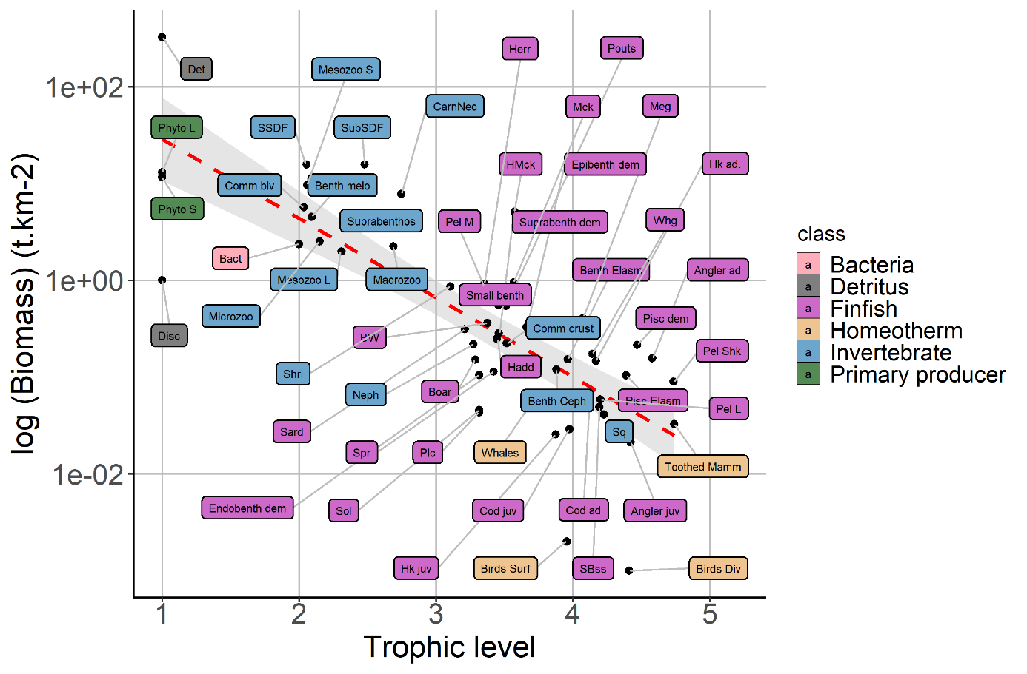
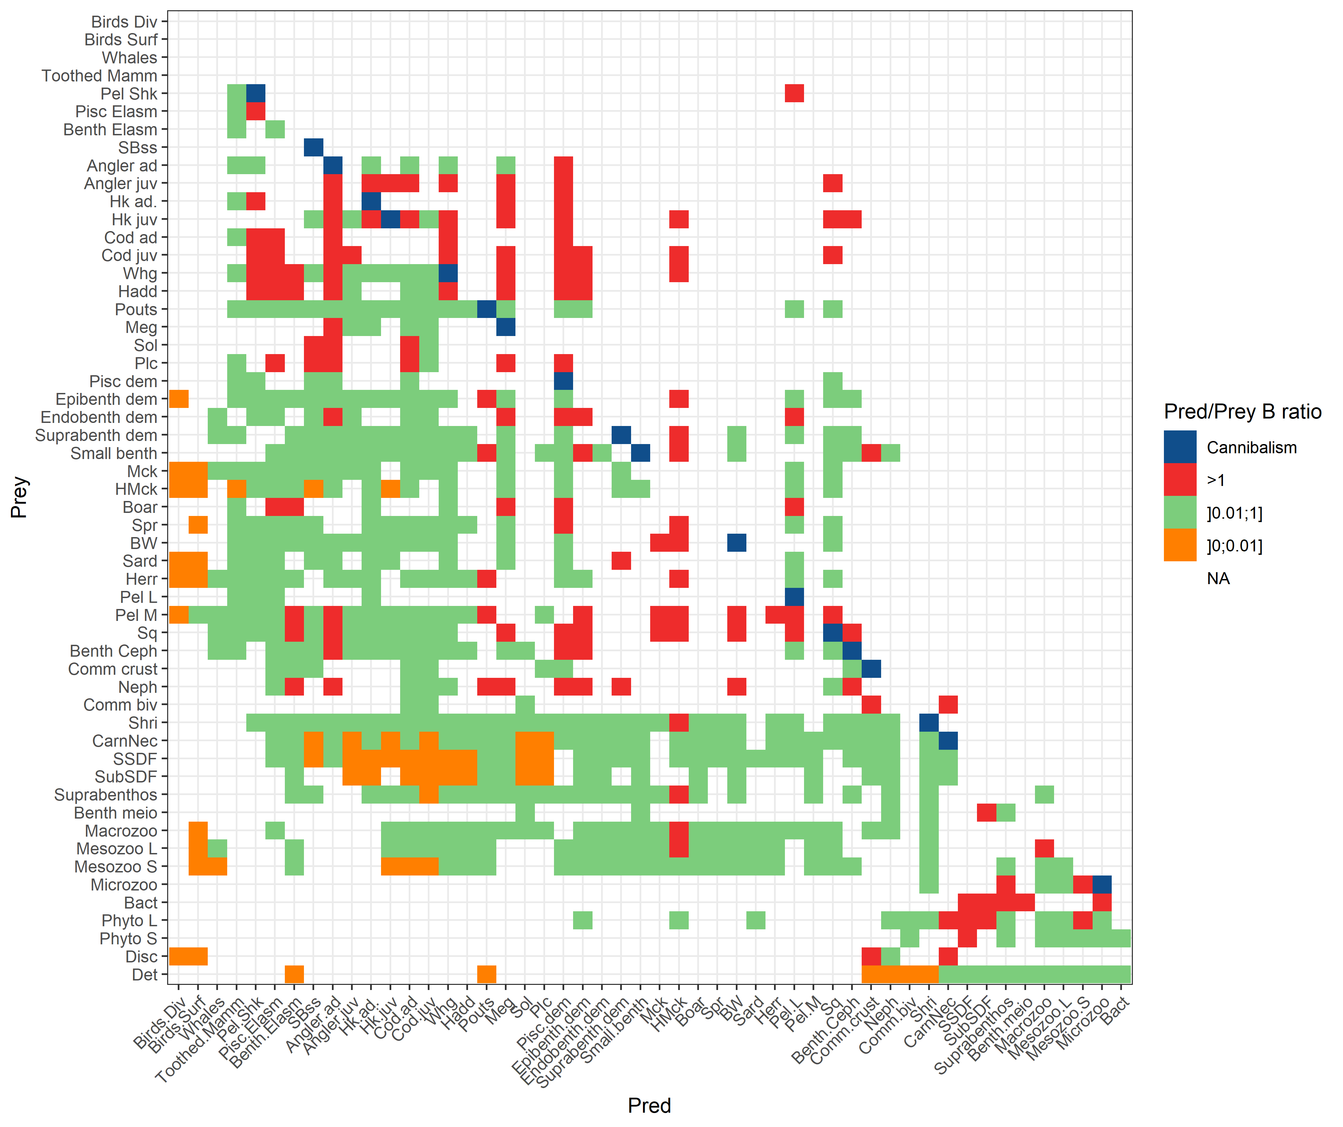
Figure B1 - Negative relationship between the biomass (log10) and the trophic level of functional groups in the Celtic Sea Ecopath model and the log10 of biomass.
Figure B2 - Biomass ratio between predators and their prey sorted according to 3 classes of values and identifying the trophic relationships due to cannibalism.
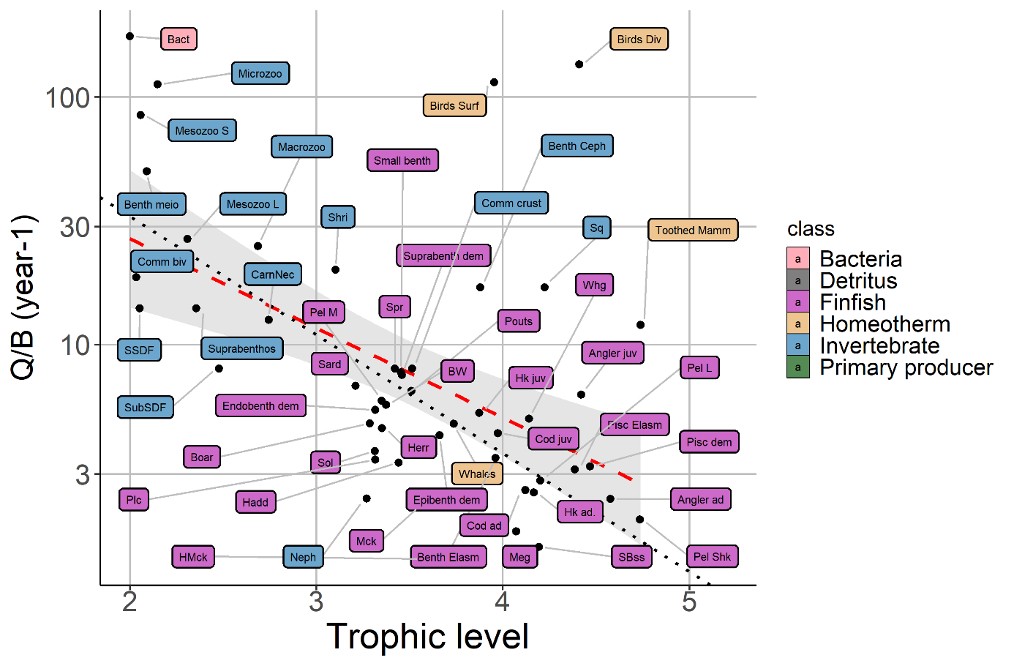
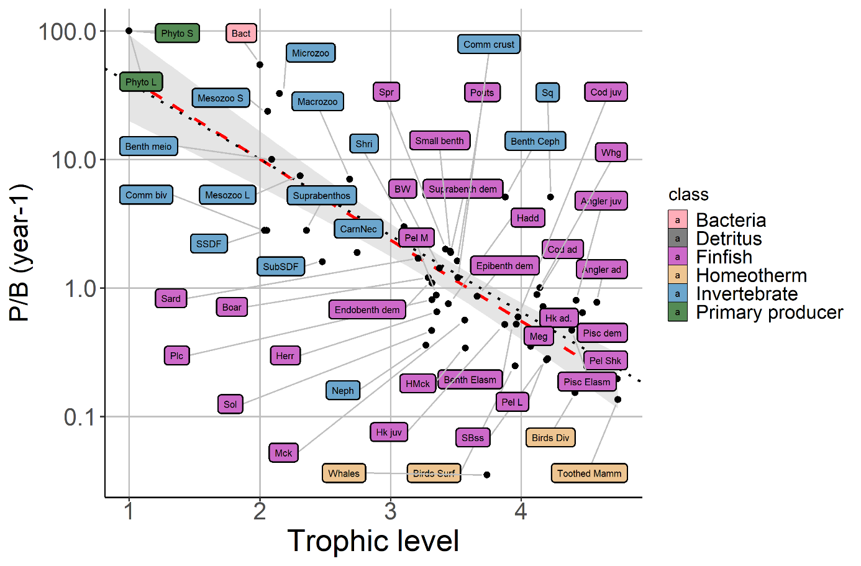
Figure B3 - Negative relationship between the PB rate (log10) and the trophic level of functional groups in the Celtic Sea Ecopath model. The red line corresponds to the regression including homeotherms and the black one excluding homeotherms.
Figure B4 - Negative relationship between the QB rate (log scale) and the trophic level of functional groups in the Celtic Sea Ecopath model. The red line corresponds to the regression including homeotherms and the black one excluding homeotherms.
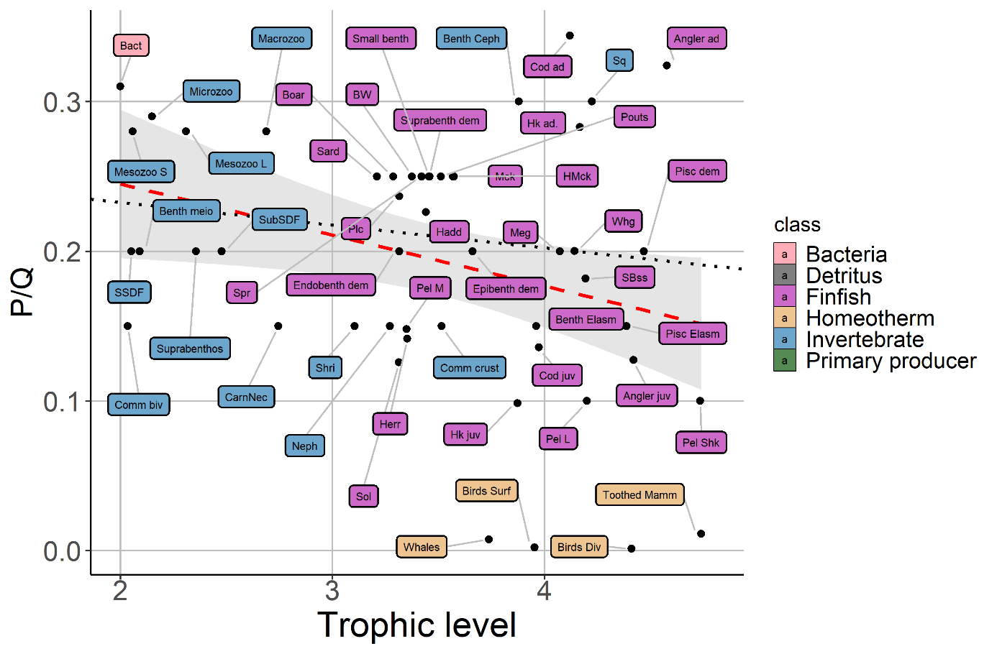
Figure B5 - Negative relationship between the PQ rate (log scale) and the trophic level of functional groups in the Celtic Sea Ecopath model. The red line corresponds to the regression including homeotherms and the black one excluding homeotherms.
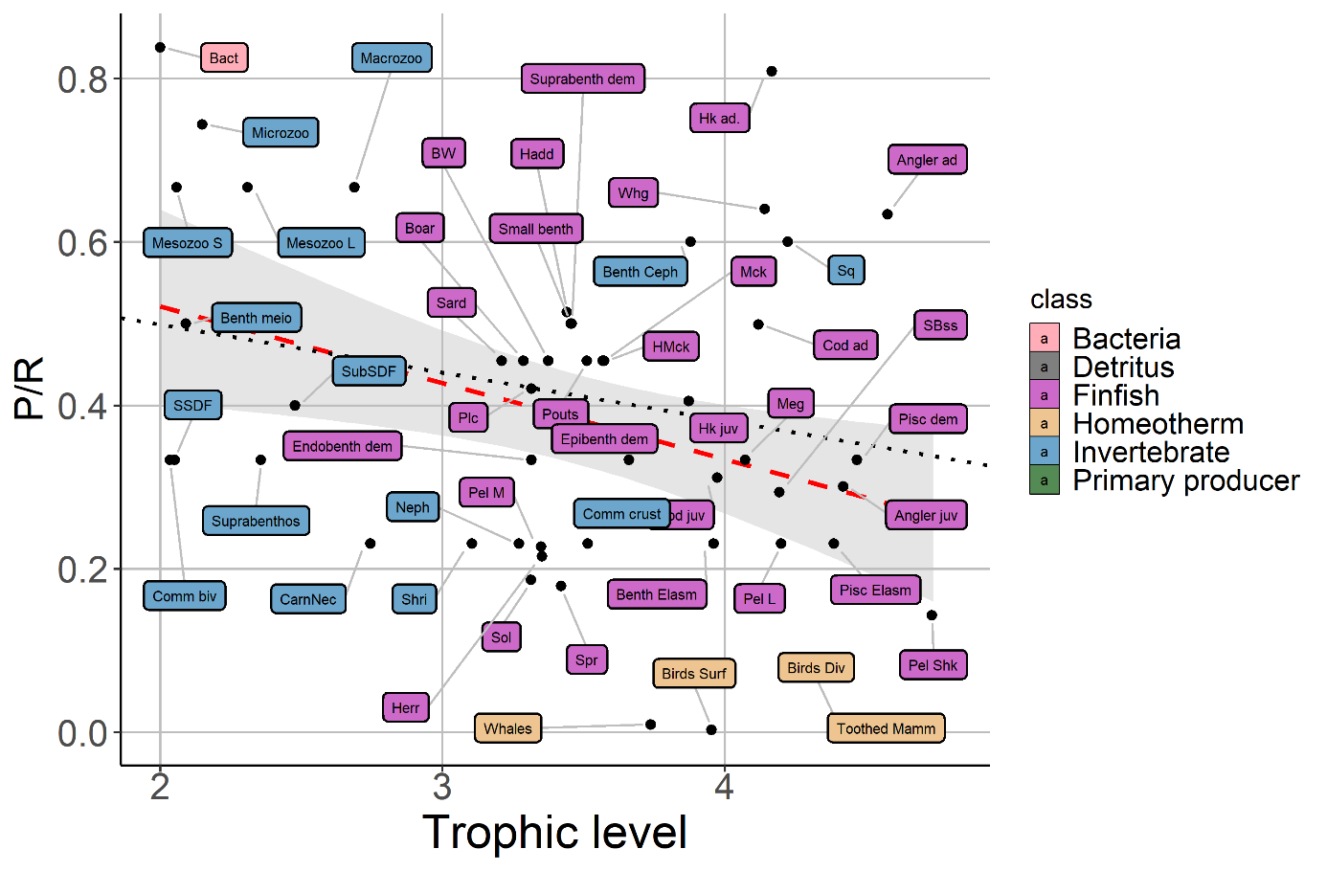
Figure B6 - Negative relationship between the PR rate (log scale) and the trophic level of functional groups in the Celtic Sea Ecopath model. The red line corresponds to the regression including homeotherms and the black one excluding homeotherms.
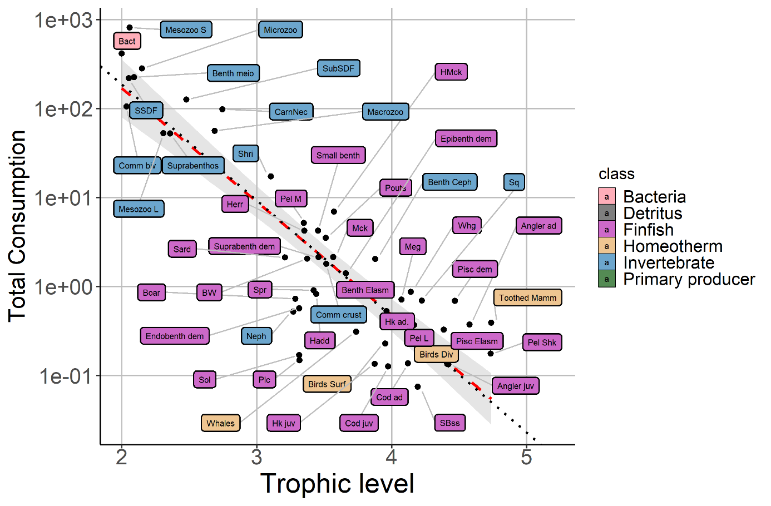
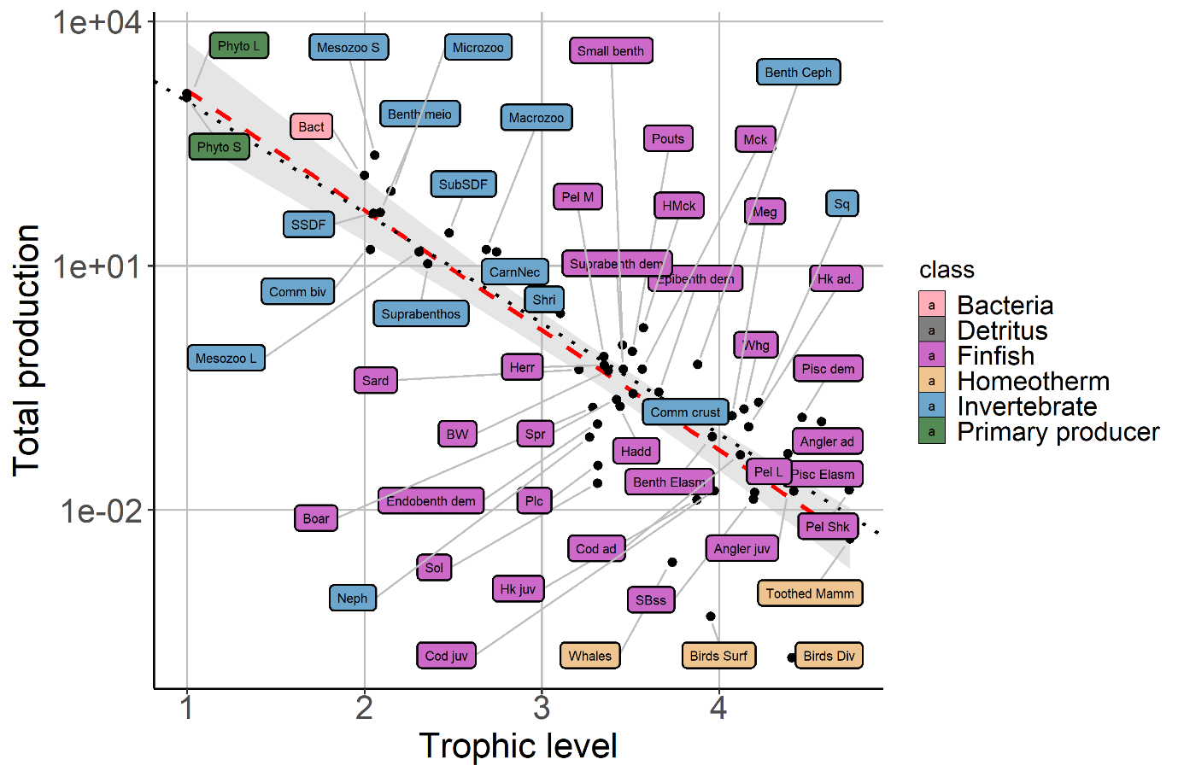
Figure B7 - Negative relationship between the total production (log scale) and the trophic level of functional groups in the Celtic Sea Ecopath model. The red line corresponds to the regression including homeotherms and the black one excluding homeotherms.
Figure B8 - Negative relationship between the total consumption (log scale) and the trophic level of functional groups in the Celtic Sea Ecopath model. The red line corresponds to the regression including homeotherms and the black one excluding homeotherms.

References SB
Ainsworth, C., Feriss, B., Leblond, E., & Guénette, S. (2001). The Bay of Biscay, France: 1998 and 1970 models. Fish. Cent. Res. Rep., 9(4), 271-313.
Agnetta, D., Badalamenti, F., Colloca, F., D’Anna, G., Di Lorenzo, M., Fiorentino, F., et al. (2019). Benthic-pelagic coupling mediates interactions in Mediterranean mixed fisheries: An ecosystem modeling approach. PLoS ONE 14, e0210659. doi:10.1371/journal.pone.0210659.
Bentley, J., Serpetti, N., Fox, C. J., Reid, D. G., and Heymans, J. J. (2019). Modelling the food web in the Irish Sea in the context of a depleted commercial fish community. Part 2: ICES Ecopath with Ecosim Key Run. doi:10.13140/RG.2.2.15136.12809.
Bentorcha, A., Gascuel, D., and Guénette, S. (2016). Using trophic models to assess the impact of fishing on marine ecosystems. Application to the Bay of Biscay and Celtic Sea case study. Fisheries Science Submitted.
Christensen, V., and Walters, C. J. (2004). Ecopath with Ecosim: methods, capabilities and limitations. Ecological Modelling 172, 109–139. doi:10.1016/j.ecolmodel.2003.09.003.
Day, L., Kopp, D., Robert, M., and Le Bris, H. (2019). Trophic ecology of large gadiforms in the food web of a continental shelf ecosystem. Progress in Oceanography 175, 105–114. doi:10.1016/j.pocean.2019.03.007.
Issac, P., Robert, M., Le Bris, H., Rault, J., Pawlowski, L., and Kopp, D. (2017). Investigating feeding ecology of two anglerfish species, Lophius piscatorius and Lophius budegassa in the Celtic Sea using gut content and isotopic analyses. Food Webs 13, 33–37. doi:10.1016/j.fooweb.2017.08.001.
Lauria, V. (2012). Impacts of Climate Change and Fisheries on the Celtic Sea Ecosystem (PhD thesis). Plymouth University, School of Science and Technology, Faculty of Marine Science and Engineering, UK. 248 pp.
Link, J. S. (2010). Adding rigor to ecological network models by evaluating a set of pre-balance diagnostics: A plea for PREBAL. Ecological Modelling 221, 1580–1591. doi:10.1016/j.ecolmodel.2010.03.012.
Morissette, L. (2007). Complexity, cost and quality of ecosystem models and their impact on resilience: a comparative analysis, with emphasis on marine mammals and the Gulf of St. Lawrence (Doctoral dissertation, University of British Columbia).
Moullec, F., Gascuel, D., Bentorcha, K., Guénette, S., and Robert, M. (2017b). Trophic models: What do we learn about Celtic Sea and Bay of Biscay ecosystems? Journal of Marine Systems 172, 104–117. doi:10.1016/j.jmarsys.2017.03.008.
Théro, H., Rivot, E., Robert, M., Guitton, J., Kopp, D., Gascuel, D., et al. (2020). EcoDiet. R package version 1.0.0.0. doi:10.5281/ZENODO.4081537.

Appendix SC – Spatial-temporal data used to improve low TLs representation
Primary production
1985-1989 | 1990-1994 | 1995-1999
2000-2004 | 2005-2009 | 2010-2016
Figure C1 : Mean distribution of the primary production by 5-years periods

Climatologies of the mesozooplankton habitat model
A
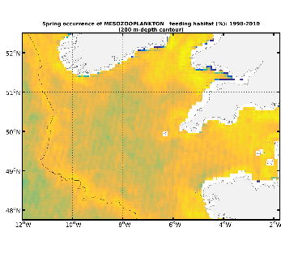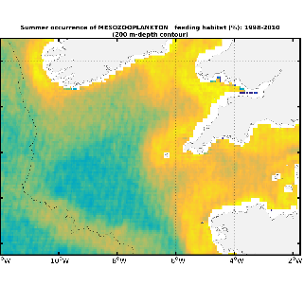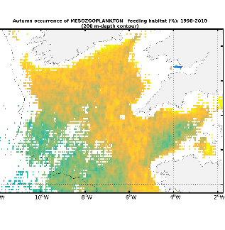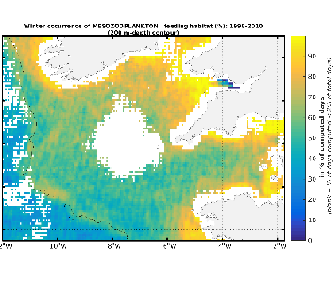
B
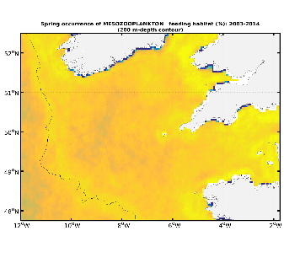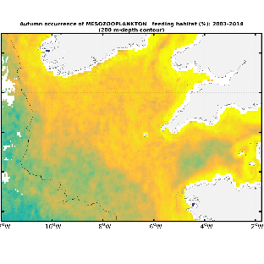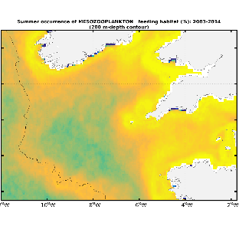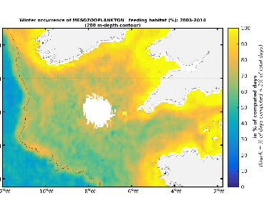
Figure C2 – Mean climatologies of mesozooplantkon habitat derived from A/ SeaWiFS sensor (1998-2010) and B/ Modis-Aqua (2002-2013). From left to right: spring, summer, fall, winter. (Druon et al., 2019).

References SC
Druon, J.-N., Hélaouët, P., Beaugrand, G., Fromentin, J.-M., Palialexis, A., and Hoepffner, N. (2019). Satellite-based indicator of zooplankton distribution for global monitoring. Sci Rep 9, 4732. doi:10.1038/s41598-019-41212-2.

Appendix SD - Datasets used in statistical habitat models
Fisheries-independent survey database
Description of the surveys considered in this study and of survey data processing
The presence/absence data considered in the present study were collected by European International Bottom Trawl Surveys (IBTS, datras.ices.dk). Because sampling design is highly complex for North Sea IBTS surveys, we chose to not consider the data collected in the North Sea and to use only those IBTS data that were collected on the Western European shelf. The main characteristics of the surveys considered in the present study are described in Tab. D1 and the spatial distribution of the survey data is shown in Fig. D1. One of the main reasons for selecting the surveys detailed in Tab. D1 is that they cover two neighboring Large Marine Ecosystems (i.e. Celtic Biscay Shelf and Iberian Coastal) under similar hydro-climatic influences, while also encompassing a wide range of environmental conditions. Additionally, the widely-ranging species present in the Celtic Sea (e.g. hake Merluccius merluccius, horse mackerel Trachurus trachurus) are found within the area encompassed by the ensemble of IBTS surveys considered in this study.
IBTS surveys are conducted to monitor demersal fish populations and provide information on commercial species to stock assessments, as well as to gather information on other demersal or benthopelagic species, including cephalopods or crustaceans. Though IBTS surveys are not designed to monitor the abundance of pelagic species, in particular the smallest ones (e.g., sardine, anchovy or sprat), they can provide valuable information on their spatial distributions. At a minimum, the species captured, the number of individuals of each species captured, and their total wet weight are reported for all IBTS hauls. The survey database we constructed thus gathered encounter/non-encounter data aggregated by survey, year, sampling station and functional group. Functional groups include multi-stanza groups since length data were collected in all IBTS surveys for cod, anglerfish, and hake.
Because some of the thirteen surveys collected data using random sampling schemes, while the others employed fixed-station sampling schemes, we summarized the presence/absence data using a 0.125° spatial grid for western European waters before fitting survey data to GAMs. Specifically, for each survey and year: (1) we assigned the encounter/non-encounter data points for a given functional group to their closest 0.125° cell; and (2) assumed the functional group to be encountered within a 0.125° cell if at least one of the data points for the functional group falling in that 0.125° cell was an encounter estimate. The data points falling within a given 0.125° cell were assigned the geographical coordinates of the barycenter of that 0.125° cell.
Table D1 – Characteristics of the fisheries-independent surveys considered in the present study. The surveys conducted in the Celtic Sea are indicated in bold. Datas code refers to the identifier of the survey in the dedicated database of the ICES.
Datras code | Survey name | Used for LTL benthos | Acronym | ICES div. | Months | Gear | Year covered | Number of stations | Reference
_ | CAmpagne MANche OCcidentale pluridisciplinaire | Yes | CAMANOC | 7de | Q4 | GOV 36/47 | 2014 | 2724 | Travers-Trolet and Vérin, 2014
FR-CGFS | French Survey in the Eastern English Channel | Yes | FR-CGFS-Q4 | 7d | Q4 | GOV 36/47 | 1989—2017 |  | Coppin et al., 1988
EVHOE | French Survey in the Celtic Sea and Bay of Biscay | Yes | FR-EVHOE-Q4 | 7fghj  8ab | Q4 | GOV 36/47 | Celtic Sea: from 1997  Bay of Biscay: from 1987 | 4189 | Duhamel et al., 2018
IE-IGFS | Irish Survey | No | EI -IGFS-Q4 | 6a  7bgj | Q4 | GOV 36/47 | 2003-2017 | 2299 | Stokes et al., 2015
NIGFS Q1 | Northern Ireland Survey in the Irish Sea | No | UK-NIGFS-Q1 | 7a | Q1 | Rock-hopper | 1992—2017 | 592 | Cronne, 2016; Moriarty et al., 2019
NIGFS Q4 | Northern Ireland Groundfish Survey in the Irish Sea | No | UK-NIGFS-Q4 | 7a | Q4 | Rock-hopper | 1992—2017 | 1145
PT-IBTS | Portuguese Survey in Portuguese Shelf | No | PT-IGFS-Q4 | 9aMS | Q4 | Norwegian Campell Trawl | 1992-2017 (\2012) | 1144
SWC-IBTS-Q1 | Scottish Western Coast Survey | No | UK-SCO-WCGFS-Q1 | 6a | Q1 | GOV 36/47 | 1996-2010 | 450
SWC-IBTS-Q4 | Scottish Western Coast Survey | No | UK-SCO-WCGFS-Q4 | 6a | Q4 | GOV 36/47 | 1990-2017 | 331
SP-NORTH | Spanish Survey in Northern Spanish Shelf | No | SP-NSGFS-Q4 | 8c  9aN | Q4 | BACA 44/60 | 1990-2017 | 3086
SP-PORC | Spanish Survey in the Porcupine Bank | No | SP-PORC-Q3 | 7bck | Q3 | BACA 40/52 | 2001-2017 | 1446
SP-ARSA-Q1 | Spanish Survey in the Gulf of Cadiz | No | SP-GCGFS-Q1 | 9aS | Q1 | BACB44/60 | 1996-2017 | 571
SP-ARSA-Q4 | Spanish Survey in the Gulf of Cadiz | No | SP-GCGFS-Q4 | 9aS | Q4 | BACB44/60 | 1997-2017 | 579

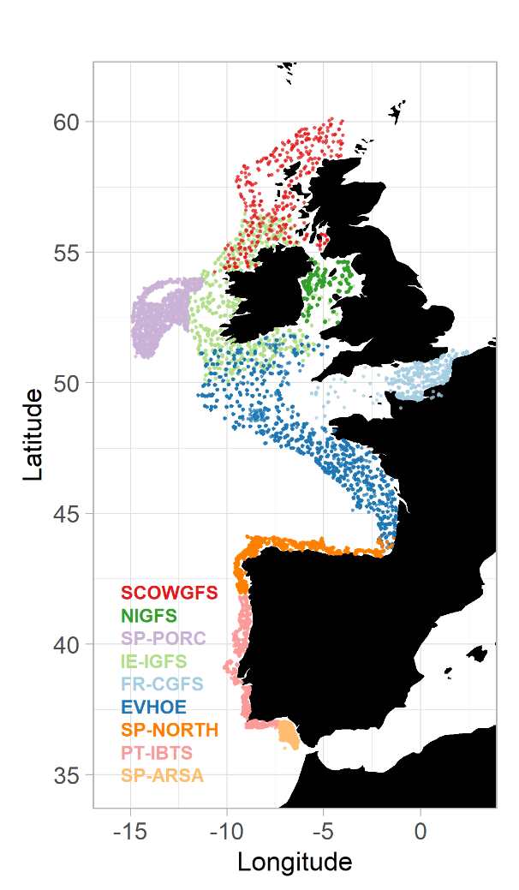
Figure D1 – Spatial distribution of the stations sampled by the International Bottom Groundfish Surveys considered in this study.

Environmental database
Data description and data processing
Topographical, habitat and hydro-climatic variables known to influence fish productivity and spatial distributions in the Celtic Sea were considered in this study. A part of these variables were unvarying through time, namely bathymetry (in m), distance to the coast (in m), and seabed substrate types (categorical). For these variables, unique large scale datasets were available. However, this was not the case for time-varying variables, i.e. surface (first 10 m) and bottom sea temperature, salinity and dissolved oxygen concentration, as well as phytoplankton concentration. Because of the large spatial and temporal extents of the surveys used in the present study, and for the sake of consistency, we aimed to minimize the number of data sources for each environmental variable. Thus, for time-varying variables, we used outputs of two sets of regional physical and biogeochemical models. The first set of models corresponds to the North West Shelf (NWS) reanalyzes, analyzes, and forecast systems produced by the Met Office (Exeter, UK). It includes a physical model, the Forecasting Ocean Assimilation Model - 7km Atlantic Margin Model (FOAM AMM7), which is coupled to an ecological and sediment model issued from the ERSEM (Baretta et al., 1995). These models were used to provide environmental variables for the largest part of Western Europe since they cover the region spreading from the middle of the Iberian Sea to the North of Scotland. The second set of models corresponds to the Irish Sea – Bay of Biscay (IBI) reanalysis, analysis and forecast systems produced by Mercator Océan (Toulouse, France). They include one physical model, the Mercator Ocean assimilation SAM2, which is coupled to the biogeochemical model PISCES v2 (Aumont et al., 2015). They were used to provide data for the areas from the Gulf of Cadiz to the middle of the Iberian Sea. Data from IBI were corrected from potential biases with NWS. Biases were also corrected between the different versions of the products (i.e. 1985-2013 data for NWS results from the combination of 1985-2013 and 1992-2013 products).All the variables gathered in the environmental database were available at a spatial resolution finer than the 0.125° resolution of the spatial grid for Western European waters. Thus, it was straightforward to process numerical environmental data so that they matched the resolution of spatial grid for Western European waters. The processing of the seabed map issued from EMODnet was slightly different since seabed type is a categorical variable. We calculated the percentage of each seabed type in each cell of the spatial grid for Western European waters. These computations were necessary as Grüss et al. (2018)’s method relies on continuous environmental variables only.
The datasets used in our study and the associated references are listed in the Tab. D2.

Table D2 - Characteristics of the environmental variables considered in the present study.
Code | Variable | Data product | Underlying models | Position water column | Temporal extent | Spatial extent | Treatment/Access
Bath | Depth |  | _ | _ | _ | World | General Bathymetric Chart of the Oceans  https://www.gebco.net/
Dist | Distance to coast | computed from Bathy using the "raster" R package | _ | _ | _ | _ | _
pMud | Percentage occupancy of 'mud' substrate | Seabed substrate 1:250 000 – Europe  © EMODnet Geology, European Commission, 2016  2008 Mesh EUNIS habitat | _ | seabed | _ | Europe | European Marine Observation and Data Network products  https://www.emodnet-seabedhabitats.eu/
pSand | Percentage occupancy of 'mud' sand |  |  | seabed | _
pCoarse | Percentage occupancy of 'mud' coarse |  |  | seabed | _
pMixed | Percentage occupancy of 'mud' mixed |  |  | seabed | _
pRock | Percentage occupancy of 'mud' rock |  |  | seabed | _
SST | Sea surface temperature | NORTHWESTSHELF_REANALYSIS_PHY_004_009  NORTHWESTSHELF_ANALYSIS_FORECAST_PHYS_004_001  (O'Dea et al., 2012, 2017; King et al., 2018)  IBI_REANALYSIS_PHYS_005_002  IBI_ANALYSIS_FORECAST_PHYS_005_001  (Bloom et al., 1996 ; Egbert et al,. 2002 ; Large et al., 2004 ; Lyard et al ., 2006 ; Madec et al. , 2008 ; Sotillo et al., 2007 ; Sotillo et al., 2015 ; Umlauf et al., 2003) | FOAM  FOAM  SAM2  SAM2 | first 10m | 1985-2013  2014-2017  1992-2013  2014-2017 | 40°N, 20°W, 65°N, 13°E  40°N, 20°W, 65°N, 13°E  26°N, 19°W, 56°N, 5°E  26°N, 19°W, 56°N, 5°E | E.U. Copernicus Marine Environment Monitoring Service  http://marine.copernicus.eu
SBT | Sea bottom temperature |  |  | bottom layer
SSS | Sea surface salinity |  |  | first 10m
SBS | Sea bottom salinity |  |  | bottom layer
MLD | Mixed layer depth |  |  | _
SO2 | Surface concentration in dissolved oxygen | NORTHWESTSHELF_REANALYSIS_BIO_004_011  NORTHWESTSHELF_ANALYSIS_FORECAST_BIO_004_002  (Butenschön et al., 2016)  IBI_REANALYSIS_BIO_005_003 | FOAM/ ERSEM  FOAM/ ERSEM  SAM2 / PISCES | first 10m | 1985-2011  2012-2017  1992-2017 | 40°N, 20°W, 65°N, 13°E  40°N, 20°W, 65°N, 13°E  26°N, 19°W, 56°N, 5°E
BO2 | Bottom concentration in dissolved oxygen |  |  | bottom layer
Chl | Chlorophyll-a concentration |  |  | first 30m

Variables used for habitat modeling
Figure D2: Spatial distribution of time-unvarying environmental variables used for habitat modelling: bathymetry and seabed substrate
A 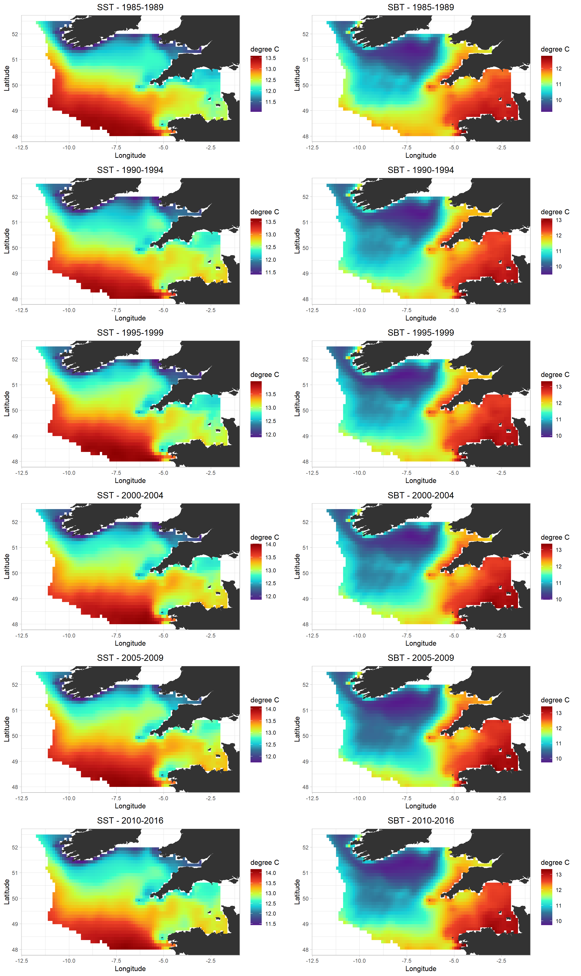
B 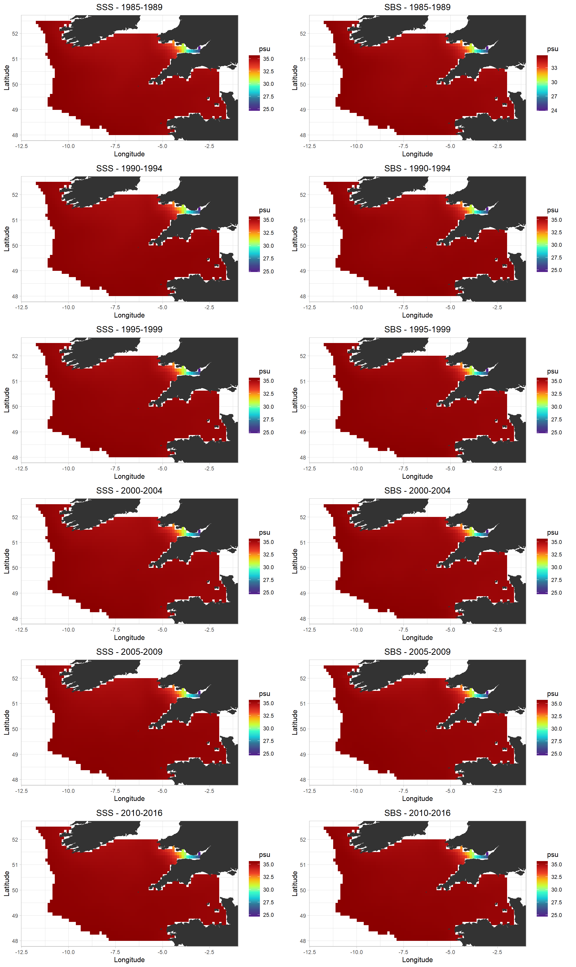
C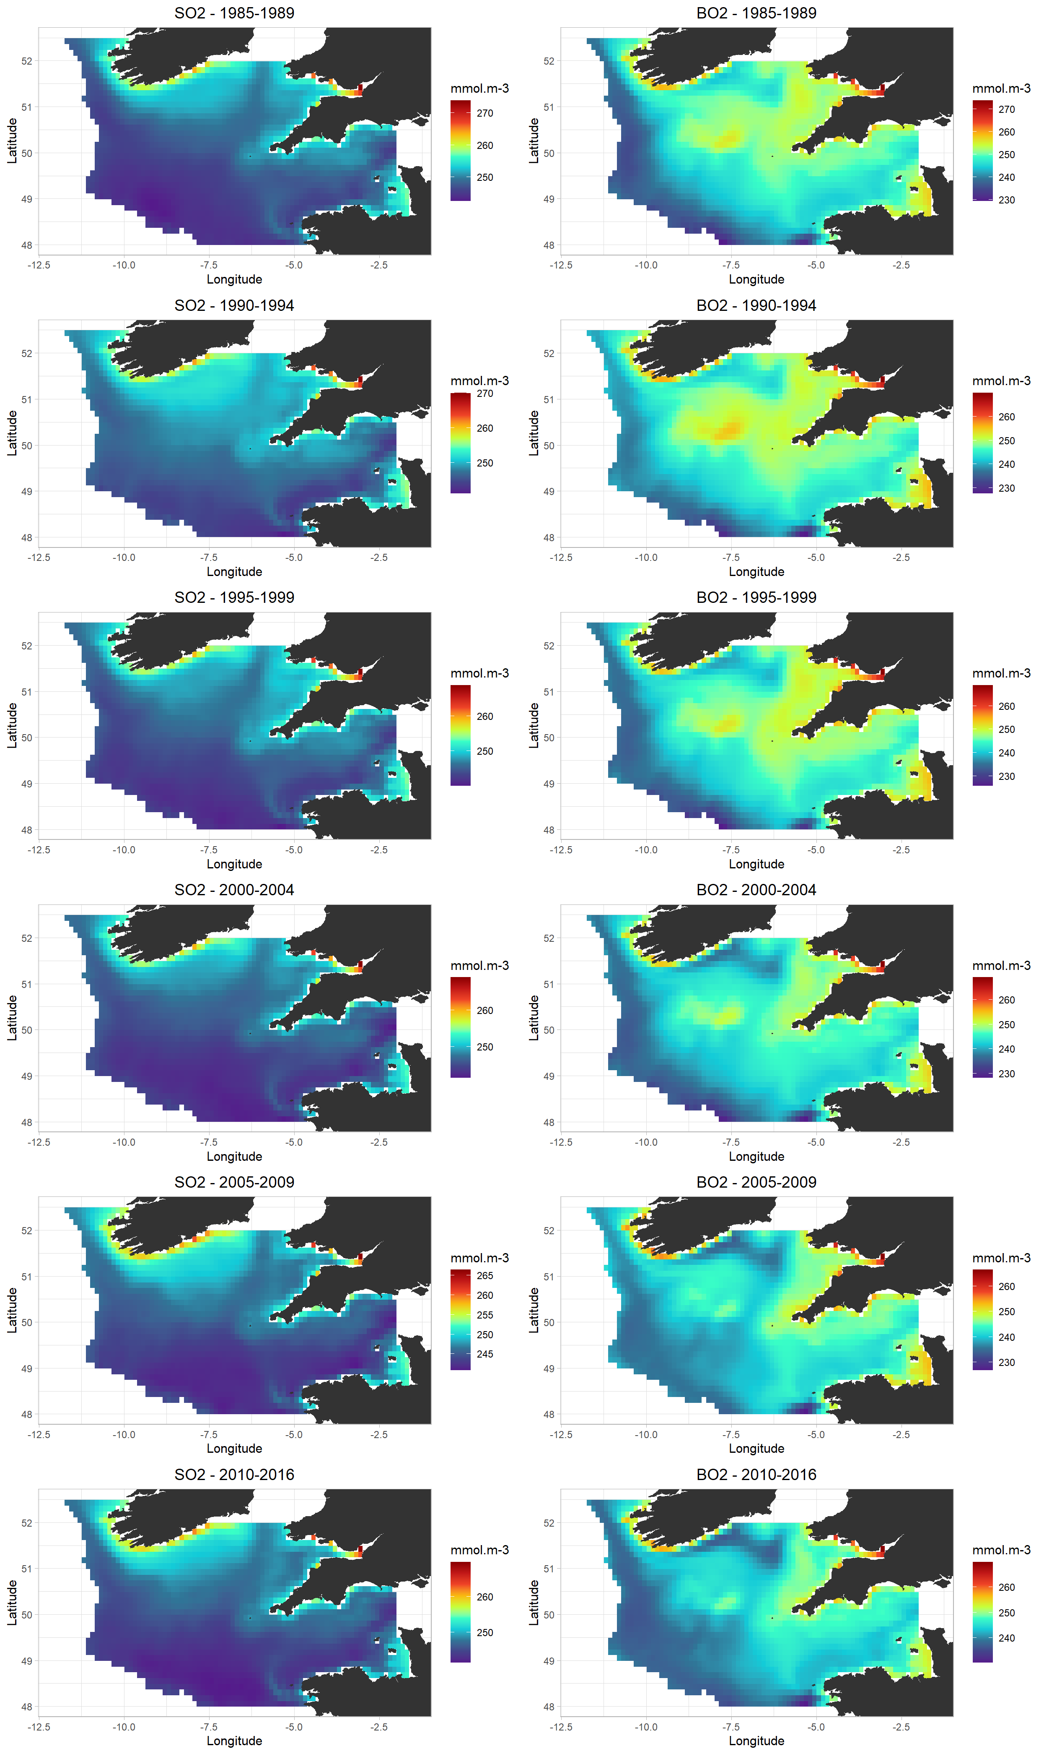
D 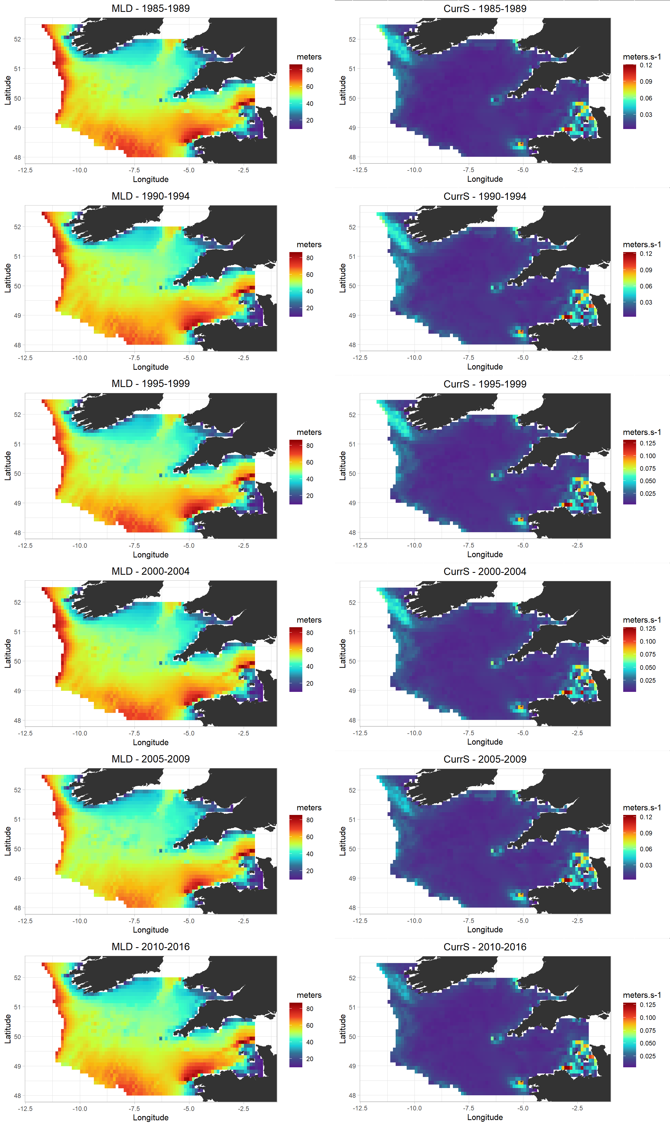
Figure D3 : Mean distribution by 5-years periods of time varying environmental variables used in the habitat modeling framework. SST = sea surface temperature, SBT = sea bottom temperature, SSS= sea surface salinity, SBS= sea bottom salinity, SO2= dissolved oxygen concentration at the surface, BO2= dissolved oxygen concentration at the bottom, MLD = mixed layer depth, CurrS = speed of the current at the bottom.

References SD
Aumont, O., Ethé, C., Tagliabue, A., Bopp, L., and Gehlen, M. (2015). PISCES-v2: an ocean biogeochemical model for carbon and ecosystem studies. Geoscientific Model Development Discussions 8, 1375–1509. doi:10.5194/gmdd-8-1375-2015.
Baretta, J. W., Ebenhöh, W., and Ruardij, P. (1995). The European regional seas ecosystem model, a complex marine ecosystem model. Netherlands Journal of Sea Research 33, 233–246. doi:10.1016/0077-7579(95)90047-0.
Bloom, S. C., Takacs, L. L., Da Silva, A. M., & Ledvina, D. (1996). Data assimilation using incremental analysis updates. Monthly Weather Review, 124(6), 1256-1271.
Butenschön, M., Clark, J., Aldridge, J. N., Allen, J. I., Artioli, Y., Blackford, J., et al. (2016). ERSEM 15.06: a generic model for marine biogeochemistry and the ecosystem dynamics of the lower trophic levels. Geosci. Model Dev. 9, 1293–1339. doi:10.5194/gmd-9-1293-2016.
Coppin, F., Giraldo, C., and Travers-Trolet, M. (1988). CGFS : Channel Ground Fish Survey. doi:10.18142/11.
Cronne, L. (2016). SISP 15 - manual of the IBTS North Eastern Atlantic surveys. Ser. ICES Surv. Protoc. SISP 15:92. doi: 10.17895/ices.pub.3519
Duhamel, E., Pawlowski, L., and Garren, F. (2018). EVHOE 2018 cruise,Thalassa R/V. doi:10.17600/18000518.
Egbert, G. D., & Erofeeva, S. Y. (2002). Efficient inverse modeling of barotropic ocean tides. Journal of Atmospheric and Oceanic technology, 19(2), 183-204.
King, R. R., While, J., Martin, M. J., Lea, D. J., Lemieux-Dudon, B., Waters, J., et al. (2018). Improving the initialisation of the Met Office operational shelf-seas model. Ocean Modelling 130, 1–14. doi:10.1016/j.ocemod.2018.07.004.
Large, W. G., & Yeager, S. G. (2004). Diurnal to decadal global forcing for ocean and sea-ice models: The data sets and flux climatologies.
Lyard, F., Lefevre, F., Letellier, T., and Francis, O. (2006). Modelling the global ocean tides: modern insights from FES2004. Ocean Dynamics 56, 394–415. doi:10.1007/s10236-006-0086-x.
Madec, G. (2008). NEMO ocean general circulation model reference manuel. Paris: LODYC/IPSL.
Moriarty, M., Greenstreet, S. P. R., Rasmussen, J., and de Boois, I. (2019). Assessing the State of Demersal Fish to Address Formal Ecosystem Based Management Needs: Making Fisheries Independent Trawl Survey Data ‘Fit for Purpose.’ Front. Mar. Sci. 6, 162. doi:10.3389/fmars.2019.00162.
O’Dea, E., Furner, R., Wakelin, S., Siddorn, J., While, J., Sykes, P., et al. (2017). The CO5 configuration of the 7 km Atlantic Margin Model: large-scale biases and sensitivity to forcing, physics options and vertical resolution. Geosci. Model Dev. 10, 2947–2969. doi:10.5194/gmd-10-2947-2017.
O’Dea, E. J., Arnold, A. K., Edwards, K. P., Furner, R., Hyder, P., Martin, M. J., et al. (2012). An operational ocean forecast system incorporating NEMO and SST data assimilation for the tidally driven European North-West shelf. Journal of Operational Oceanography 5, 3–17. doi:10.1080/1755876X.2012.11020128.
Sotillo, M. G., Cailleau, S., Lorente, P., Levier, B., Aznar, R., Reffray, G., et al. (2015). The MyOcean IBI Ocean Forecast and Reanalysis Systems: operational products and roadmap to the future Copernicus Service. Journal of Operational Oceanography 8, 63–79. doi:10.1080/1755876X.2015.1014663.
Sotillo, M. G., Jordi, A., Ferrer, M. I., Conde, J., Tintoré, J., & Alvarez-Fanjul, E. (2007, January). The ESEOO regional ocean forecasting system. In The Seventeenth International Offshore and Polar Engineering Conference. International Society of Offshore and Polar Engineers.
Stokes, D., Gerritsen. H., O'Hea, B., Moore, S.J. & Dransfeld, L., " Irish Groundfish Survey Cruise Report, Sept. 24th – Dec. 17th, 2014", Marine Institute 2014

Travers-Trolet, M., and Verin, Y. (2014). CAMANOC cruise,Thalassa R/V. doi:10.17600/14001900.
Umlauf, L., and Burchard, H. (2003). A generic length-scale equation for geophysical turbulence models. Journal of Marine Research 61, 235–265. doi:10.1357/002224003322005087.

Appendix SE – Statistical habitat modeling framework
Additional details on GAM fitting and evaluation
GAMs predictors’ selection
The selection of predictors used to predict the probability of encounter of functional groups was implemented before, during, and after GAMs fitting. The a priori selection of predictors based on the literature aimed to retain only a subset of relevant environmental variables for statistical modeling. For example, bottom temperature and seabed type variables were ignored when we developed the GAMs of small epipelagic species. Conversely, they were usually considered when developing the GAMs of demersal and benthic species. In the case of species for which guild attribution was relatively ambiguous, both bottom and surface variables were considered. Specific variables such as the distance to the shore or the chlorophyll-a concentration were considered in statistical analyses, as proxies of variables identified in the literature as influencing the spatial distribution patterns of Celtic Sea organisms.
Environmental variables are known to co-vary in space, hence potentially influencing regression-like statistical methods (Guisan et al., 2002). Two variables with high degree of co-variation can bring redundant information. For instance, one could expect that depth and bottom temperatures are substantially correlated. For this reason, we conducted a collinearity analysis, consisting of calculating Pearson’s correlation coefficients between environmental predictors and between environmental predictors and eastings and northings. When a Pearson’s correlation coefficient exceeded 0.7 in absolute value, one of the two environmental predictors under consideration was not included in the GAM (Dormann et al., 2013; Leathwick et al., 2008). After the collinearity analysis was conducted, GAMs including the predictors retained after the collinearity analysis were fitted to presence/absence survey data. Smoothing terms for each environmental predictor were estimated using the maximum likelihood (REML) optimization method and while operating a shrinkage approach that, roughly speaking, penalizes over-fitting (Mannocci et al., 2017; Roberts et al., 2016). In addition, as the smoothing parameter approached zero, an extra penalty was applied to each environmental covariate, allowing for the complete removal of a predictor from a GAM when the smoothing parameter was equal to zero (Marra and Wood, 2011). Finally, after a GAM we fitted, if an environmental predictor p-value was larger than 0.05, we removed the environmental predictor from the GAM and refitted it.
Production of preference functions
Fitted GAMs were utilized to produce groups expressing the preferences of functional groups for specific environmental parameter values. For each environmental variable $i$ integrated in a GAM, predictions were made with the GAM over a vector of values ranging between the minimum and maximum values of environmental variable $i$ in the Celtic Sea, while: (1) setting eastings X and northings Y to their values at the barycenter of the Celtic Sea; 2); (2) keeping the other environmental variables constant at their mean value from the GAM modeled dataset; and (3) setting the two factors, Survey and Year, at their mode from the GAM modeled dataset.
We denote the jth value of the ith environmental predictor by $x_{i,j}$, where $x_{i,j}$ ranges between the minimum and maximum values of the ith environmental predictor in the Celtic Sea, and we denote by $p_{i,j}$ the probability of encounter resulting from the computations described above when the ith environmental variable is set to $x_{i,j}$. Then, for each individual environmental variable $i$, where $i ∈1, …, n$, preferences $f_{i,j}$ are calculated from $p_{i,j}$ values as follows:
$f_{i,j}=\frac{p_{i,j} -min\left\{p_{1,min} , …, p_{n,min}\right\}}{max\left\{p_{1,max} , …, p_{n,max}\right\}-min\left\{p_{1,min} , …, p_{n,min}\right\}}$ (Eq E1)
where $p_{1,min} , …, p_{n,min}$ are the minimum values of probability of encounter calculated for environmental parameters $1, …, n$; and $p_{1,max} , …, p_{n,max}$ are the maximum values of probability of encounter calculated for environmental parameters $1, …, n$. The calculation of preferences described in Equation 2 allows them to range between 0 and 1 while accounting for the relative effect of each environmental variable on the probability of encounter. Preference functions estimated in this study are displayed in Fig. E1. The preference function for temperature used in Ecosim was issued of the same GAM as the one used in Ecospace except that it was not transformed by Eq E1 and was directly issued of $p_{i,j}$.
Results of the GAMs fitting and prediction of the spatial habitat foraging capacity
Based on these functional responses generated from the predictions of the GAMs fitted for all functional groups and the spatial distribution of environmental variables at each year, the spatial distribution of habitat foraging capacity can be calculated for each year. Maps of habitat foraging capacity for all functional groups for 1985 and 2016 are provided in Fig. E2.
GAM evaluation.
Final models were evaluated using a “Leave Group Out Cross Validation” procedure. In this approach, datasets for a given functional group are split into two sub-datasets (Grüss et al., 2016). The first data subset is composed of a random selection of 60% of the original dataset and is called the “training dataset”. The training dataset is employed to refit a GAM including the final environmental predictors. The second data subset, which comprise the remaining 40% of the data, is used as a “testing dataset” to evaluate/validate the GAM. Two performance metrics are employed within the Leave Group Out Cross Validation procedure: the adjusted coefficient of determination, R²_{adj}, and area under the receiver operating characteristic curve, AUC. The R²_{adj} provides an indication of the proportion of the dataset’s variance that is explained by the GAM (Legendre and Legendre, 2012). The AUC quantifies the ability of the GAM to properly separate observed encounters from observed non-encounters (Hanley and McNeil, 1982). In other words, the AUC indicates if the model better predicts encounters and non-encounters compared to a random choice. The Leave Group Out Cross Validation procedure was repeated ten times. Thus, for each individual GAM, ten models were trained using distinct training data sets, which were then evaluated using distinct test data sets, each corresponding to a specific training data set. We considered a GAM acceptable when the medians of the ten R²_{adj} and AUC from the ten iterations were respectively greater than 0.1 and 0.7. The results of the evaluation procedure are presented in Fig. E3.

References SF
Dormann, C.F., Elith, J., Bacher, S., Buchmann, C., Carl, G., Carré, G., Marquéz, J.R.G., Gruber, B., Lafourcade, B., Leitão, P.J., Münkemüller, T., McClean, C., Osborne, P.E., Reineking, B., Schröder, B., Skidmore, A.K., Zurell, D., Lautenbach, S., 2013. Collinearity: a review of methods to deal with it and a simulation study evaluating their performance. Ecography 36, 27–46. https://doi.org/10.1111/j.1600-0587.2012.07348.x
Grüss, A., Yemane, D., Fairweather, T., 2016. Exploring the spatial distribution patterns of South African Cape hakes using generalised additive models. African Journal of Marine Science 38, 395–409. https://doi.org/10.2989/1814232X.2016.1218367
Grüss, A., Drexler, M. D., Ainsworth, C. H., Babcock, E. A., Tarnecki, J. H., and Love, M. S. (2018). Producing Distribution Maps for a Spatially-Explicit Ecosystem Model Using Large Monitoring and Environmental Databases and a Combination of Interpolation and Extrapolation. Front. Mar. Sci. 5, 16. doi:10.3389/fmars.2018.00016.
Grüss, A., Rose, K. A., Justić, D., and Wang, L. (2020). Making the most of available monitoring data: A grid-summarization method to allow for the combined use of monitoring data collected at random and fixed sampling stations. Fisheries Research 229, 105623. doi:10.1016/j.fishres.2020.105623.
Guisan, A., Edwards, T.C., Hastie, T., 2002. Generalized linear and generalized additive models in studies of species distributions: setting the scene. Ecological Modelling 157, 89–100. https://doi.org/10.1016/S0304-3800(02)00204-1
Hanley, J.A., McNeil, B.J., 1982. The meaning and use of the area under a receiver operating characteristic (ROC) curve. Radiology 143, 29–36. https://doi.org/10.1148/radiology.143.1.7063747
Leathwick, J., Moilanen, A., Francis, M., Elith, J., Taylor, P., Julian, K., Hastie, T., Duffy, C., 2008. Novel methods for the design and evaluation of marine protected areas in offshore waters: Designing offshore MPAs. Conservation Letters 1, 91–102. https://doi.org/10.1111/j.1755-263X.2008.00012.x
Legendre, P., Legendre, L., 2012. Numerical ecology, Third English edition. ed, Developments in environmental modelling. Elsevier, Amsterdam.
Mannocci, L., Roberts, J.J., Miller, D.L., Halpin, P.N., 2017. Extrapolating cetacean densities to quantitatively assess human impacts on populations in the high seas: Cetacean Densities in the High Seas. Conservation Biology 31, 601–614. https://doi.org/10.1111/cobi.12856
Marra, G., Wood, S.N., 2011. Practical variable selection for generalized additive models. Computational Statistics & Data Analysis 55, 2372–2387. https://doi.org/10.1016/j.csda.2011.02.004
Roberts, J.J., Best, B.D., Mannocci, L., Fujioka, E., Halpin, P.N., Palka, D.L., Garrison, L.P., Mullin, K.D., Cole, T.V.N., Khan, C.B., McLellan, W.A., Pabst, D.A., Lockhart, G.G., 2016. Habitat-based cetacean density models for the U.S. Atlantic and Gulf of Mexico. Scientific Reports 6. https://doi.org/10.1038/srep22615

A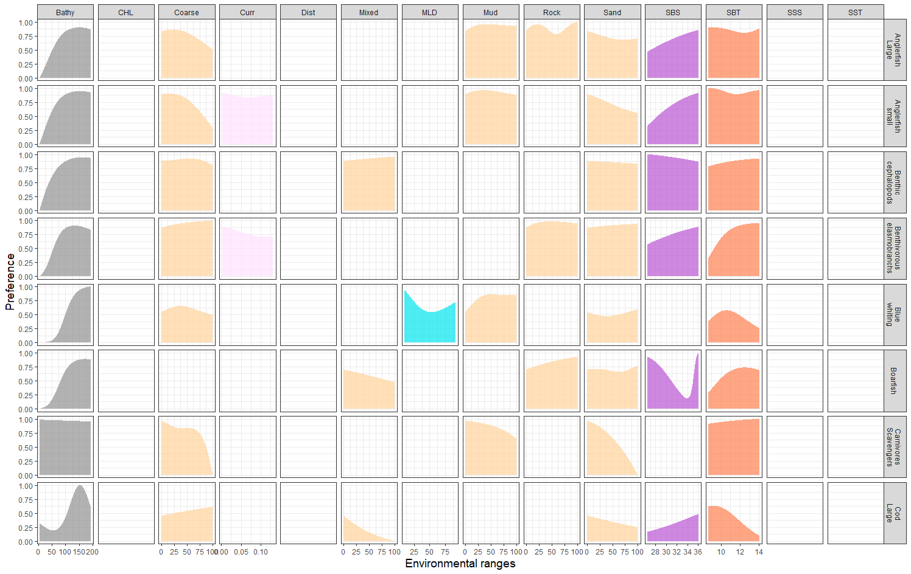
B 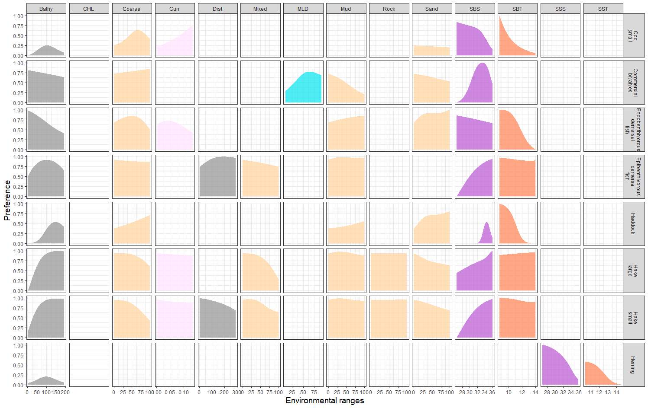
C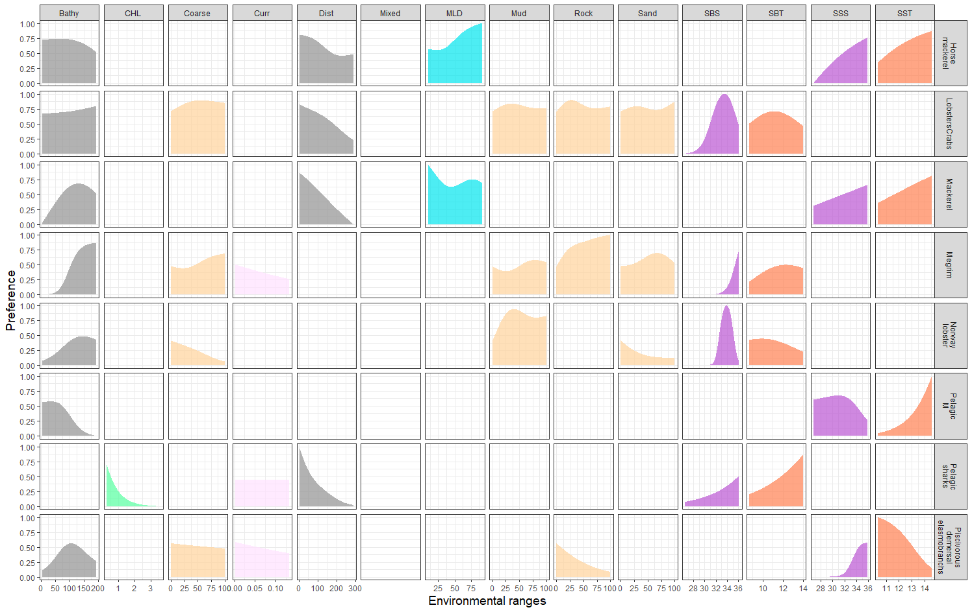
D 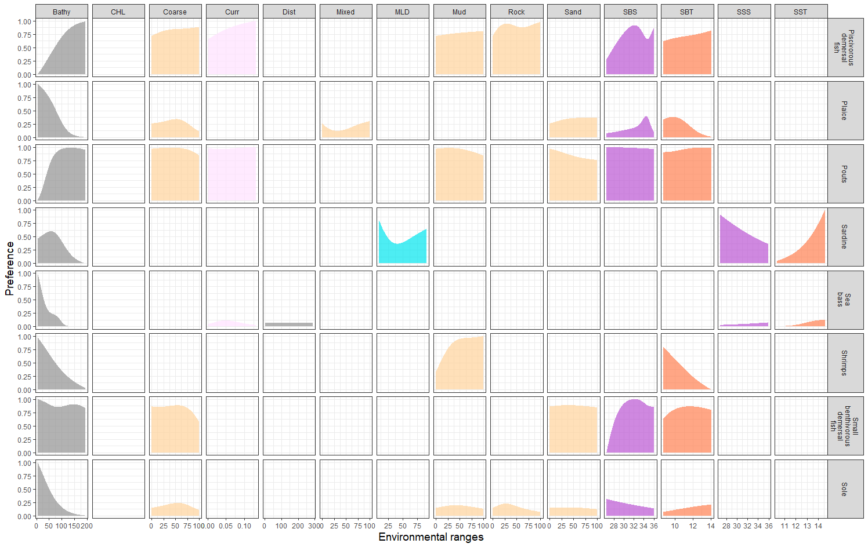
E 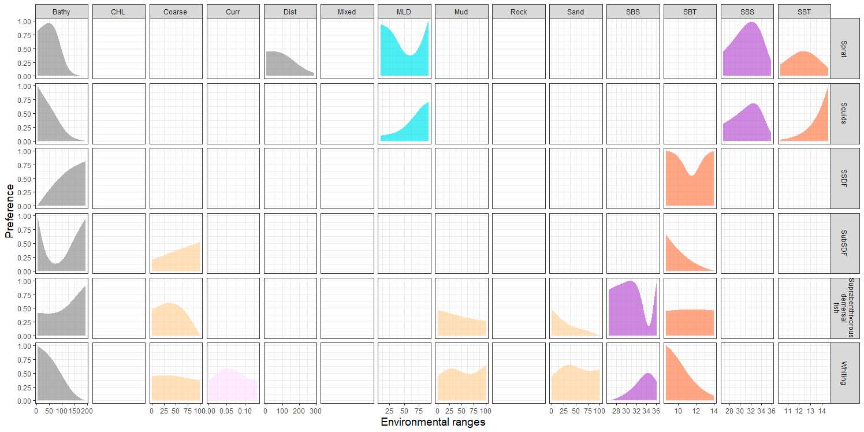
Figure E1 : Preference functions of each Ecopath groups (line) to environmental covariates (columns) for which a habitat model was fitted. Bathy = seabed depth, Curr= speed of the current on the seabed, Dist = distance to the shore, CHL = surface concetration in chlorophyll, MLD = mixed layer depth, SST = sea surface temperature, SBT = sea bottom temperature, SSS= sea surface salinity, SBS= sea bottom salinity, Coarse = proportion of coarseer substrate, Mixed = proportions of mixed sediments substrate, Mud= proportion of muddy substrate, Rock = proportion of rocky substrate, Sand = proportion of sandy substrate. The environmental ranges over which preference functions are represented are defined by the minimum and the maximum values (yearly mean) of the variables observed among all cells of the Ecospace grid and over 1985-2016.

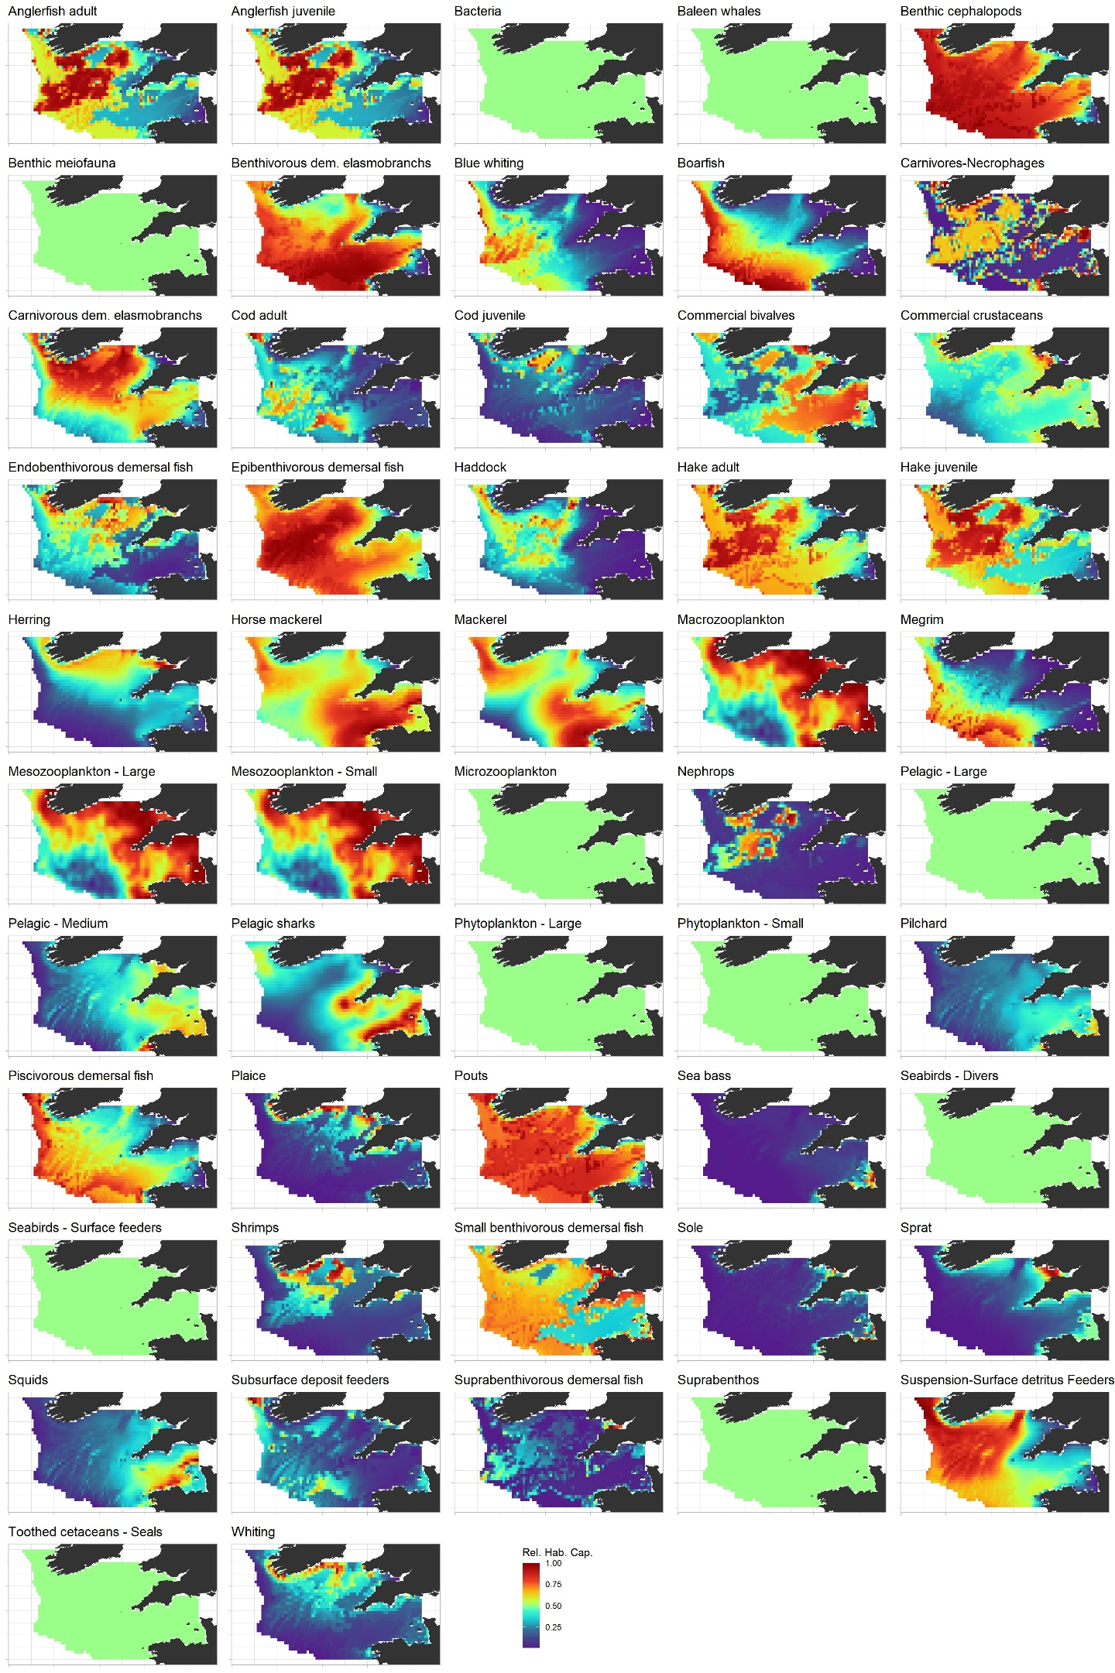
Figure E2 : Relative habitat capacity distribution averaged over the period 1985-1989 for all Celtic Sea Ecospace functional groups. Full green maps correspond to Ecopath groups for which no habitat data has been provided.

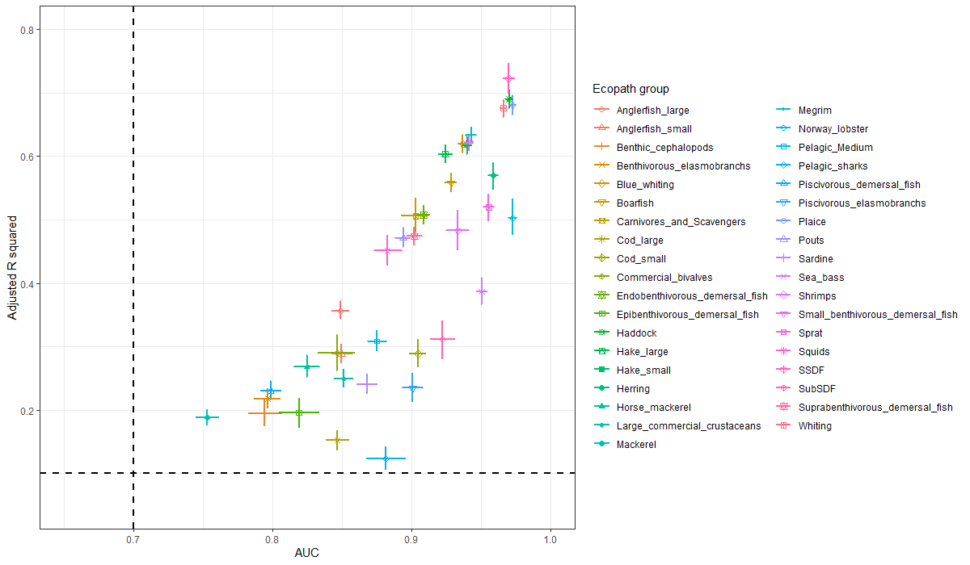Figure E3 : Quality assessment of the GAMs Performance indices used for GAM evaluation. Adjusted-R2 and AUC respectively quantify GAM fit to the observed data and GAM predictive capacity. The use of a “Leave group out cross-validation” procedure for evaluating GAMs allows for the quantification of uncertainty around the performance indices. The dotted lines represent the lower limits under which a GAM is considered not to have passed the evaluation test.

Appendix SF - The Celtic Sea Ecosim model
A stability test of the Ecopath model prior to any Ecosim simulation
Prior to any further analysis and attempt to forcing and fitting, the Ecopath with Ecosim model was tested for stability. This stability test aimed at identify the problems such as prey-predator cycles over multiple trophic levels, drastic reduction in the biomass of some compartments in response to predation or competition or stock recruitment instabilities (Christensen and Walters, 2000).
This test was performed by modifying the fishing effort time-series so that the system is perturbed and exploring the model’s behavior over 100 years of simulation. We tested here 3 types of perturbations related to fishing: a complete cessation of fishing activities from 1985, a brutal and temporary (8 years) increase in fishing effort between 1986 and 1994 and, conversely, a brutal and temporary (8 years too) decrease in fishing effort between 1986 and 1994. The results of the simulations for these three scenarios were compared to the reference one, in which the effort remained constant. The Fig. F1 a), b) and c) represent the ratio between the predicted trends in the alternative scenarios of perturbation and the reference scenario.
The complete cessation of fishing drove a shift toward different status of the ecosystem for which equilibrium was observed around 10 years after the simulations start. The groups with the highest positive variation in biomass were those for which fishing contributed to the largest proportion of the total mortality, including anglerfish, megrim, cod, demersal elasmobranchs, plaice, sole etc. (Fig. F1-a). Note that the compartment with biomass becoming null is the discard detritus box that is not fed anymore when fishing stops. A shorter duration of fishing effort reduction followed by a return to the initial fishing conditions highlighted the reasonable qualitative and quantitative changes in functional groups biomass compared with the reference scenario (Fig. F1-b). In this case, most species responded with an increase in their biomass. Similarly, a short increase in fishing pressure also led to consistent patterns. In this case, the responses among functional groups were more diverse and several invertebrate (e.g.cephalopods) or small prey fish species (e.g. small benthivorous demersal, pouts) due to fishing-induced reduction of their predator abundance.
As a conclusion, the update of the Celtic Sea EwE model did not display particular behavior that required to be corrected. This should be linked to the previous parameterization of the model by Moullec et al. (2017) in which Ecosim parameters such as feeding time adjustment rates of switching power were altered from their default value. After this stability test, these Ecosim parameters were also updated using recently published work (Celić et al., 2018). This parameters are presented in the following Tab. F1.

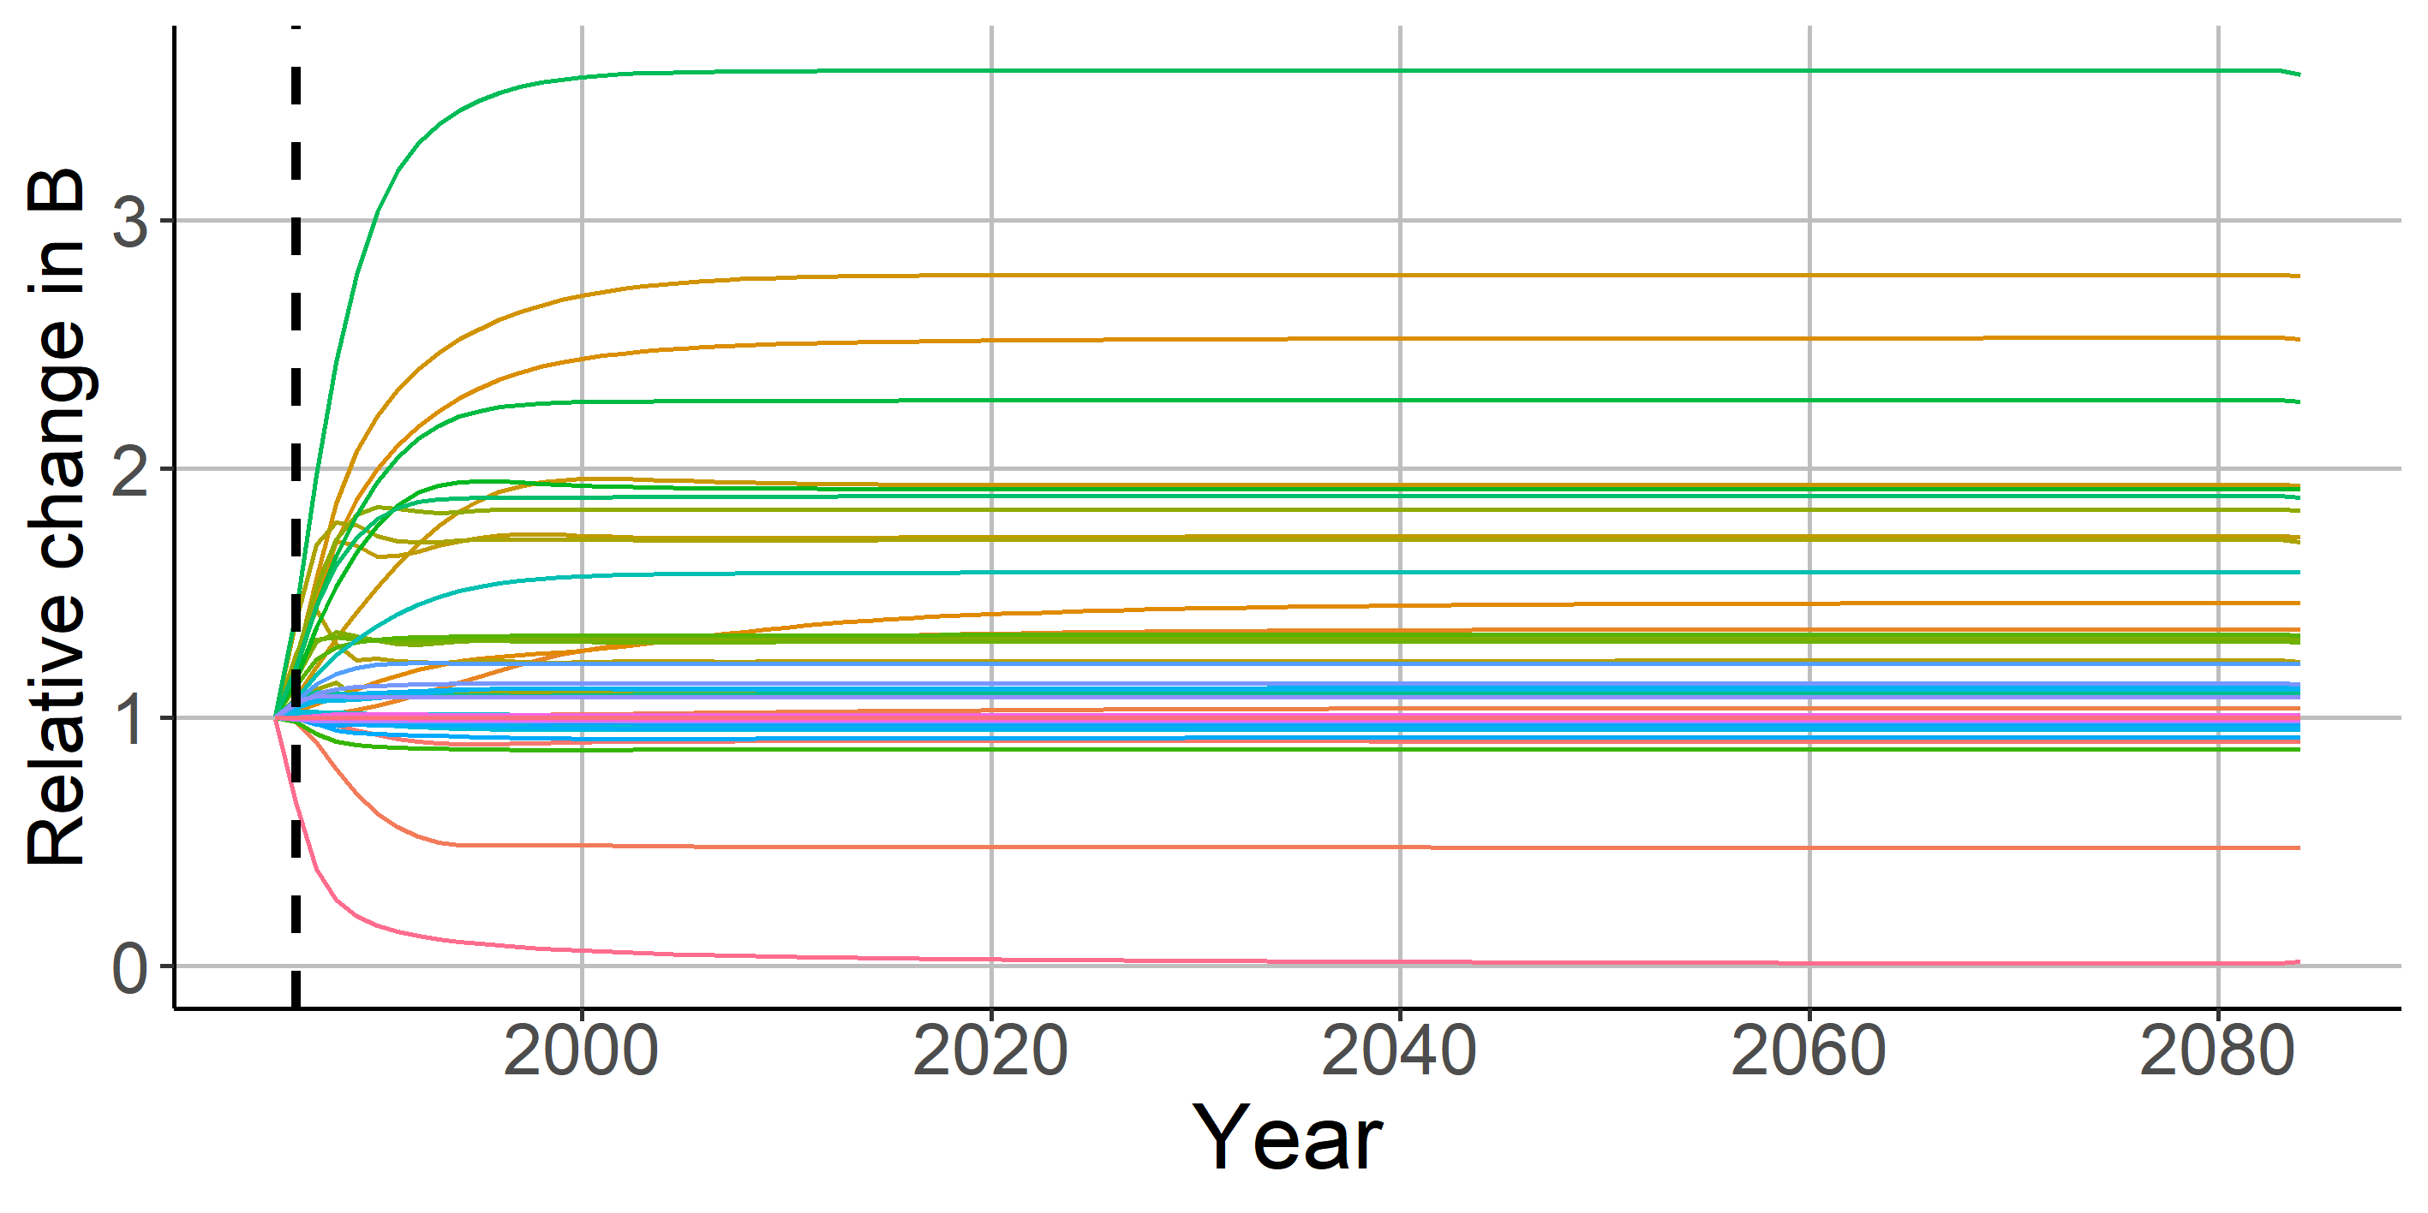a)
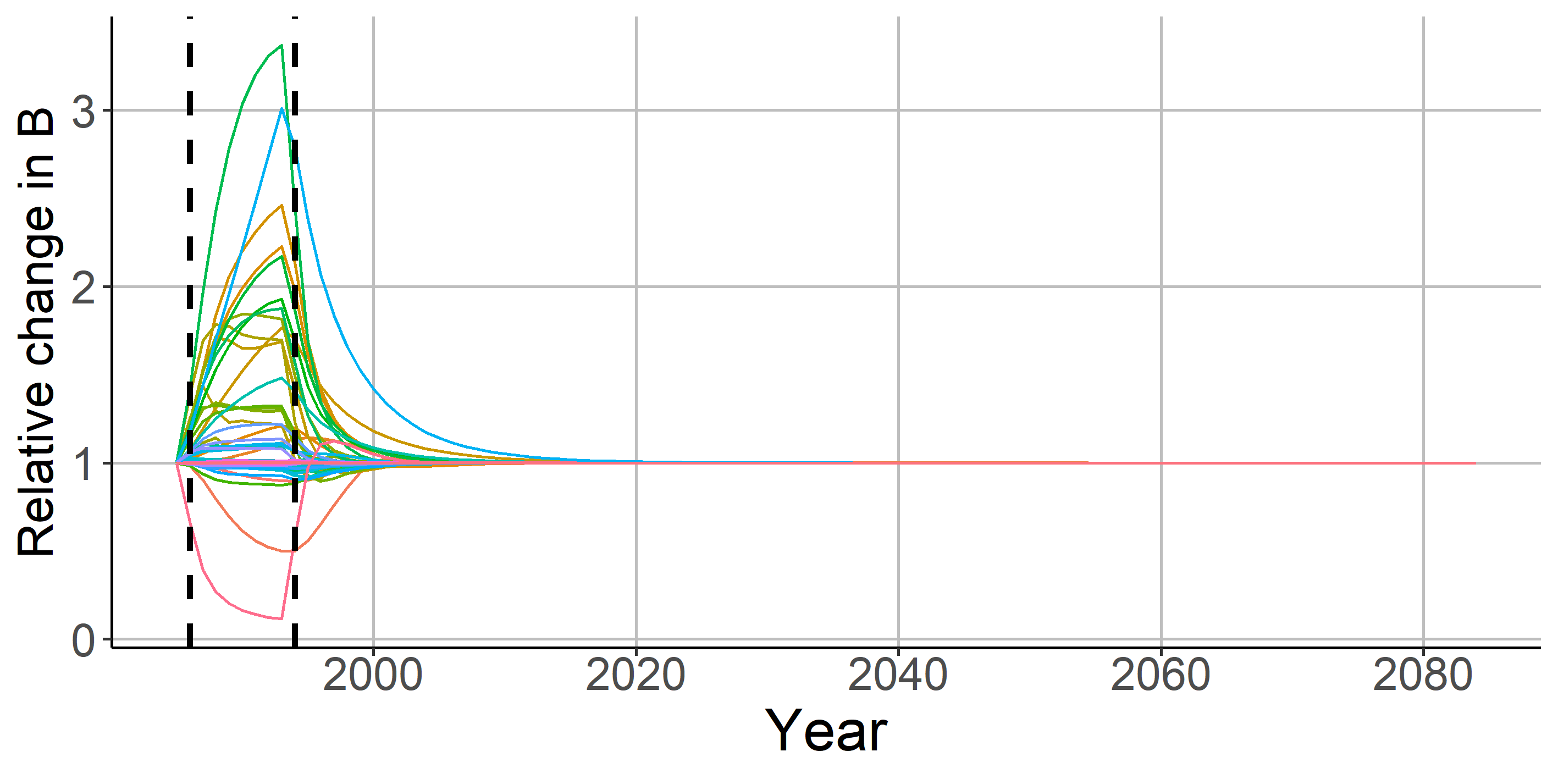b)
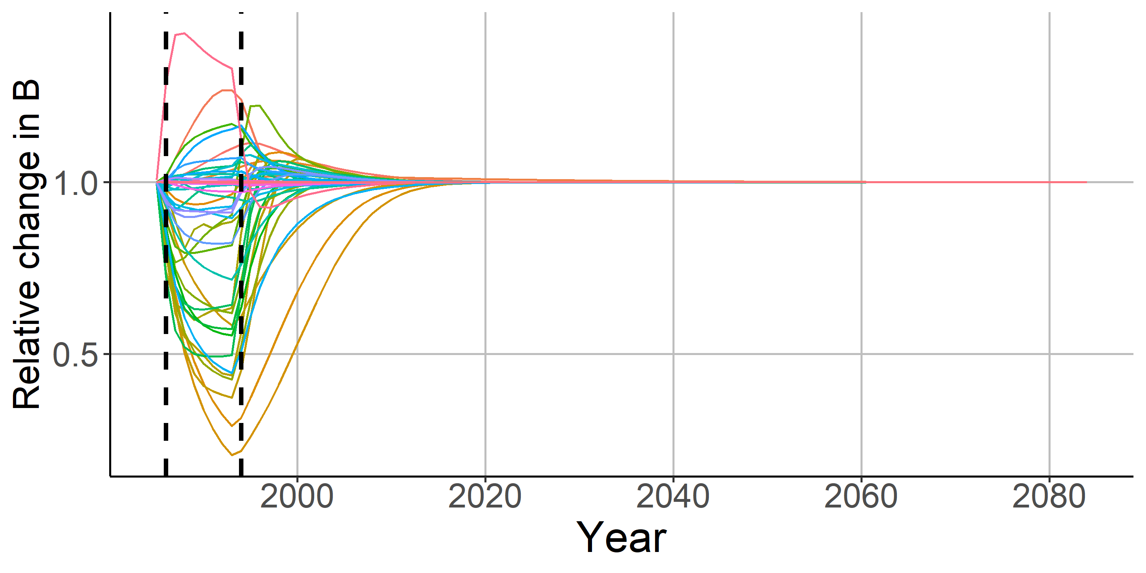c)
Figure F1 - Relative changes in the biomass trends of each functional group in response to the different fishing-related perturbations: a) the total stop of fishing, b) the temporary fishing effort reduction by a factor 2 c) the temporary fishing effort increase.

More data on abundance trends of multispecies groups
Most of the time-series used in the model developed by Moullec et al. (2017) were time-series of catch, for almost all functional groups in the ecosystem, and abundance and fishing mortality time-series for monospecific groups assessed by the ICES. Although abundance indices time-series were included in the Bay of Biscay model in Moullec et al. (2017), they were not for the Celtic Sea, the reason being the shortness of the time-series comparatively to the study period. Indeed, the EVHOE survey was only conducted in the Celtic Sea since 1997. Such a late start definitely reduced our ability to explore fishing and environment impacts on the Celtic Sea ecosystem, especially when previous studies have shown that substantial environmental changes occurred during the late 1980s and the mid-1990s. Thus, we looked for other sources of information on abundance trends of fish functional groups, especially the non-assessed multispecific groups. In collaboration with Verena Trenkel (IFREMER) and John Pinnegar (CEFAS), we extracted time-series derived from the UK-WCGFS, an English survey that was conducted in the Celtic Sea between 1982 and 2002. In previous work, the authors have compared the reliability of both EVHOE and UK-WCGFS – derived population abundance indices. Trenkel et al. (2004) concluded that there were substantial differences between several indices of population abundance but also concluded that the surveys could provide a good picture of changes operating at the community scale. During the calibration step, each time-series issue from the two surveys was integrated into the model independently (but providing two intermediary short-length relative series of biomass).
Fitting procedure
The Ecosim model was fitted to observed time-series based on a procedure adapted from Bentley et al. (2019). This procedure was applied for all the configurations of the model, including or not fishing, plankton-related and temperature forcing. The following consisted into:
- Considering the relative and reference time-series (Table F2) as observed time-series, and forcing the model by various time-series depending on the ecosystem drivers explored (forcing time-series in Table F2 and environmental time-series and preference functions described in the article).
- Following the principle of the automated fitting procedure developed by Scott et al. (2016) to determine the best number N of predator-specific vulnerabilities to be estimated while minimizing the AIC score. This step was not conducted using the proper automated fitting procedure as the latter does not allow to specify a primary production anomaly (i.e., it can only be estimated), hence alternative fits were conducted successively by the modeler.
- Setting the N predator-specific vulnerabilities at the values estimated by the best model identified in the above fitting procedure.
- While keeping the N predator-specific estimated values for the vulnerabilities, manually looking at the number N’ of complementary predator-prey specific vulnerabilities to be estimated so that the lowest AICc is reached. The number of N’ investigated was limited to the maximal number of functional groups with time-series (56) minus N.
The finally selected model for each configuration was the one with N predator-specific vulnerabilities and N’ predator-prey –sprecific vulnerabilities estimated.

Note on the use of zooplankton related time-series:
The mesozooplankton habitat data was used to force the relative changes in the predator-prey dynamics of involving zooplankton as prey and as predator. For trophic interactions between no-zooplantkon predator and zooplankton, the ZSH time-series was used to affect the vulnerability of the zooplankton to its predator. This may represent that, when the habitat is suitable for zooplankton, its aggregation in highly productive areas (i.e., fronts) make predation easier for its consumers. For trophic interactions between zooplankton and phytoplankton, the ZSH time-series was used to affect the foraging arena size. This may represent that highly productive areas are characterized by aggregation of both phytoplankton and zooplankton, hence reducing the area over the latter feed on the former. Final, for trophic interactions between two zooplankton groups, the ZSH time-series was used to influence both the vulnerability and the foraging arena size, hence representing the favourable effect on predators and unfavourable effect on prey of their aggregation in the same highly productive areas.

Table F1 – Ecosim inputs – Ecosim group parameters
 | Group name | Max rel. P/B | Max rel. feeding time | Feeding time adjust rate | % of oth. mortality sens. to chg. in feeding time | Predator effect on feeding time | Density-dep. catchability | QBmax / QBo | Switching power parameter
1 | Seabirds - Divers | 2 | 1.25 | 0.5 | 1 | 0 | 1 | 3 | 2
2 | Seabirds - Surface feeders | 2 | 1.25 | 0.5 | 1 | 0 | 1 | 3 | 2
3 | Baleen whales | 2 | 1.25 | 0.1 | 1 | 0 | 1 | 3 | 2
4 | Toothed cetaceans / Seals | 2 | 1.25 | 0.1 | 1 | 0 | 1 | 3 | 2
5 | Pelagic sharks | 2 | 1.25 | 0.1 | 1 | 0 | 1 | 10 | 2
6 | Carnivorous dem. elasmobranchs | 2 | 1.25 | 0.1 | 1 | 1 | 1 | 3 | 1
7 | Benthivorous dem. elasmobranchs | 2 | 1.25 | 0.1 | 1 | 1 | 1 | 3 | 1
8 | Sea bass | 2 | 1.25 | 0.1 | 1 | 1 | 1 | 3 | 2
 | Anglerfish
9 | Anglerfish adult | 2 | 1.25 | 0.1 | 1 | 1 | 1 | 3 | 1
10 | Anglerfish juvenile | 2 | 1.25 | 0.2 | 1 | 0.75 | 1 | 3 | 1
 | Hake
11 | Hake adult | 2 | 1.25 | 0.1 | 1 | 1 | 1 | 3 | 2
12 | Hake juvenile | 2 | 1.25 | 0.2 | 1 | 0.75 | 1 | 3 | 1
 | Cod
13 | Cod adult | 2 | 1.25 | 0.1 | 1 | 1 | 1 | 3 | 2
14 | Cod juvenile | 2 | 1.25 | 0.2 | 1 | 1 | 1 | 3 | 2
15 | Whiting | 2 | 1.25 | 0.1 | 1 | 1 | 1 | 3 | 2
16 | Haddock | 2 | 1.25 | 0.1 | 1 | 1 | 1 | 3 | 1
17 | Pouts | 2 | 1.25 | 0.1 | 1 | 1 | 1 | 3 | 2
18 | Megrim | 2 | 1.25 | 0.1 | 1 | 1 | 1 | 3 | 1
19 | Sole | 2 | 1.25 | 0.5 | 1 | 1 | 1 | 10 | 0.5
20 | Plaice | 2 | 1.25 | 0.5 | 1 | 1 | 1 | 10 | 0.5
21 | Piscivorous demersal fish | 2 | 1.25 | 0.1 | 1 | 1 | 1 | 3 | 2
22 | Epibenthivorous demersal fish | 2 | 1.25 | 0.1 | 1 | 1 | 1 | 3 | 2
23 | Endobenthivorous demersal fish | 2 | 1.25 | 0.5 | 1 | 1 | 1 | 10 | 0.5
24 | Suprabenthivorous demersal fish | 2 | 1.25 | 0.1 | 1 | 0.75 | 1 | 3 | 0
25 | Small benthivorous demersal fish | 2 | 1.25 | 0.5 | 1 | 0.75 | 1 | 3 | 0.5
26 | Mackerel | 2 | 1.25 | 0.5 | 1 | 0.5 | 1 | 3 | 0
27 | Horse mackerel | 2 | 1.25 | 0.5 | 1 | 0.5 | 1 | 3 | 0
28 | Boarfish | 2 | 1.25 | 0.5 | 1 | 0.5 | 1 | 3 | 0
29 | Sprat | 2 | 1.25 | 0.5 | 1 | 0.5 | 1 | 3 | 0
30 | Blue whiting | 2 | 1.25 | 0.5 | 1 | 0.5 | 1 | 3 | 0
31 | Pilchard | 2 | 1.25 | 0.5 | 1 | 0.5 | 1 | 3 | 0
32 | Herring | 2 | 1.25 | 0.5 | 1 | 0.5 | 1 | 3 | 0
33 | Pelagic - Large | 2 | 1.25 | 0.1 | 1 | 1 | 1 | 10 | 1
34 | Pelagic - Medium | 2 | 1.25 | 0.5 | 1 | 0.5 | 1 | 3 | 0
35 | Squids | 2 | 1.25 | 0.1 | 1 | 1 | 1 | 3 | 1
36 | Benthic cephalopods | 2 | 1.25 | 0.1 | 1 | 1 | 1 | 3 | 1
37 | Commercial crustaceans | 2 | 1.25 | 0.1 | 1 | 0.75 | 1 | 3 | 1
38 | Nephrops | 2 | 1.25 | 0.1 | 1 | 0.75 | 1 | 3 | 1
39 | Commercial bivalves | 2 | 1 | 0.05 | 0 | 0 | 1 | 3 | 0
40 | Shrimps | 2 | 1.25 | 0.1 | 1 | 0.5 | 1 | 3 | 1
41 | Carnivores/Necrophages | 2 | 1.25 | 0.1 | 1 | 0.5 | 1 | 3 | 1
42 | Suspension/Surface detritus Feeders | 2 | 1.25 | 0.1 | 1 | 0.5 | 1 | 3 | 0
43 | Subsurface deposit feeders | 2 | 1.25 | 0.1 | 1 | 0.5 | 1 | 3 | 0
44 | Suprabenthos | 2 | 1.5 | 1 | 1 | 0.5 | 1 | 3 | 0
45 | Benthic meiofauna | 2 | 1.5 | 1 | 0 | 0 | 1 | 3 | 0
46 | Macrozooplankton | 2 | 1.5 | 1 | 1 | 0 | 1 | 3 | 1
47 | Mesozooplankton - Large | 2 | 1.5 | 1 | 1 | 0 | 1 | 3 | 0
48 | Mesozooplankton - Small | 2 | 1.5 | 1 | 1 | 0 | 1 | 3 | 0
49 | Microzooplankton | 2 | 1.5 | 1 | 1 | 0 | 1 | 3 | 0
50 | Bacteria | 2 | 1.5 | 0.05 | 1 | 0 | 1 | 3 | 0
51 | Phytoplankton - Large | 2 | 1 | 0.5 | 1 | 0 | 1 | 1000 | 0
52 | Phytoplankton - Small | 2 | 1 | 0.5 | 1 | 0 | 1 | 1000 | 0

Table F2 – Ecosim inputs – Time-series used for the fit – Contact the authors for data access
Group nb | Group | Data type | Period | Origin
1 | Seabirds - Divers | Biomass (forcing) | 1985-2016 | JNCC
2 | Seabirds - Surface feeders | Biomass (forcing) | 1985-2016 | JNCC
5 | Pelagic sharks | Biomass (relative) | 1985-1999 | UK-WCGFS (CEFAS)
 |  | Biomass (relative) | 1997-2016 | FR-EVHOE (Duhamel et al., 2018)
 |  | Catches (forcing) | 1985-2016 | Statlant (ices.dk) - Discard rates from Discardless project (discardless.eu)
6 | Piscivorous dem. elasmobranchs | Biomass (relative) | 1985-1999 | UK-WCGFS (CEFAS)
 |  | Biomass (relative) | 1997-2016 | FR-EVHOE (Duhamel et al., 2018)
 |  | Catches (forcing) | 1985-2016 | Statlant (ices.dk) - Discard rates from Discardless project (discardless.eu)
7 | Benthivorous dem. elasmobranchs | Biomass (relative) | 1985-1999 | UK-WCGFS (CEFAS)
 |  | Biomass (relative) | 1997-2016 | FR-EVHOE (Duhamel et al., 2018)
 |  | Catches (forcing) | 1985-2016 | Statlant (ices.dk) - Discard rates from Discardless project (discardless.eu)
8 | Sea bass | Biomass (relative) | 1985-2016 | WGCSE
 |  | Catches (reference) | 1985-2016 | WGCSE - Statlant
 |  | Fishing mortality | 1985-2016 | WGCSE
9-10 | Anglerfish adult / juvenile | Biomass (relative) | 1985-2016 | WGBIE
 |  | Catches (reference) | 1985-2016 | WGBIE - Statlant
 |  | Fishing mortality | 1985-2016 | WGBIE
11-12 | Hake adult / juvenile | Biomass (relative) | 1985-2016 | WGBIE
 |  | Catches (reference) | 1985-2016 | WGBIE - Statlant
 |  | Fishing mortality | 1985-2016 | WGBIE
13-14 | Cod adult / juvenile | Biomass (relative) | 1985-2016 | WGCSE
 |  | Catches (reference) | 1985-2016 | WGCSE - Statlant
 |  | Fishing mortality | 1985-2016 | WGCSE
15 | Whiting | Biomass (relative) | 1985-2016 | WGCSE
 |  | Catches (reference) | 1985-2016 | WGCSE - Statlant
 |  | Fishing mortality | 1985-2016 | WGCSE
16 | Haddock | Biomass (relative) | 1985-2016 | WGCSE
 |  | Catches (reference) | 1985-2016 | WGCSE - Statlant
 |  | Fishing mortality | 1985-2016 | WGCSE
17 | Pouts | Biomass (relative) | 1985-1999 | UK-WCGFS (CEFAS)
 |  | Biomass (relative) | 1997-2016 | FR-EVHOE (Duhamel et al., 2018)
 |  | Catches (forcing) | 1985-2016 | Statlant (ices.dk) - Discard rates from Discardless project (discardless.eu)
18 | Megrim | Biomass (relative) | 1985-2016 | WGBIE
 |  | Catches (reference) | 1985-2016 | WGBIE - Statlant
 |  | Fishing mortality | 1985-2016 | WGBIE
19 | Sole | Biomass (relative) | 1985-2016 | WGCSE
 |  | Catches (reference) | 1985-2016 | WGCSE - Statlant
 |  | Fishing mortality | 1985-2016 | WGCSE
20 | Plaice | Biomass (relative) | 1985-2016 | WGCSE
 |  | Catches (reference) | 1985-2016 | WGCSE - Statlant
 |  | Fishing mortality | 1985-2016 | WGCSE
21 | Piscivorous dem. fish | Biomass (relative) | 1985-1999 | UK-WCGFS (CEFAS)
 |  | Biomass (relative) | 1997-2016 | FR-EVHOE (Duhamel et al., 2018)
 |  | Catches (forcing) | 1985-2016 | Statlant (ices.dk) - Discard rates from Discardless project (discardless.eu)
22 | Epibenthivorous dem. fish | Biomass (relative) | 1985-1999 | UK-WCGFS (CEFAS)
 |  | Biomass (relative) | 1997-2016 | FR-EVHOE (Duhamel et al., 2018)
 |  | Catches (forcing) | 1985-2016 | Statlant (ices.dk) - Discard rates from Discardless project (discardless.eu)
23 | Endobenthivorous dem. fish | Biomass (relative) | 1985-1999 | UK-WCGFS (CEFAS)
 |  | Biomass (relative) | 1997-2016 | FR-EVHOE (Duhamel et al., 2018)
 |  | Catches (forcing) | 1985-2016 | Statlant (ices.dk) - Discard rates from Discardless project (discardless.eu)
24 | Suprabenthivorous dem. fish | Biomass (relative) | 1985-1999 | UK-WCGFS (CEFAS)
 |  | Biomass (relative) | 1997-2016 | FR-EVHOE (Duhamel et al., 2018)
 |  | Catches (forcing) | 1985-2016 | Statlant (ices.dk) - Discard rates from Discardless project (discardless.eu)
25 | Small benthivorous dem. fish | Biomass (relative) | 1985-1999 | UK-WCGFS (CEFAS)
 |  | Biomass (relative) | 1997-2016 | FR-EVHOE (Duhamel et al., 2018)
 |  | Catches (forcing) | 1985-2016 | Statlant (ices.dk) - Discard rates from Discardless project (discardless.eu)
26 | Mackerel | Biomass (relative) | 1985-1999 | UK-WCGFS (CEFAS)
 |  | Biomass (relative) | 1997-2016 | FR-EVHOE (Duhamel et al., 2018)
 |  | Catches (reference) | 1985-2016 | Statlant / WGWIDE
 |  | Fishing mortality | 1985-2016 | WGWIDE
27 | Horse mackerel | Biomass (relative) | 1985-1999 | UK-WCGFS (CEFAS)
 |  | Biomass (relative) | 1997-2016 | FR-EVHOE (Duhamel et al., 2018)
 |  | Catches (reference) | 1985-2016 | Statlant / WGWIDE
 |  | Fishing mortality | 1985-2016 | WGWIDE
28 | Boarfish | Biomass (relative) | 1985-1999 | UK-WCGFS (CEFAS)
 |  | Biomass (relative) | 1997-2016 | FR-EVHOE (Duhamel et al., 2018)
 |  | Catches (reference) | 1985-2016 | Statlant / WGWIDE
 |  | Fishing mortality | 1985-2016 | WGWIDE
29 | Sprat | Biomass (relative) | 1985-2016 | Abundance index - HAWG
 |  | Catches (forcing) | 1985-2016 | Statlant (ices.dk) - Discard rates from Discardless project (discardless.eu)
30 | Blue whiting | Biomass (relative) | 1985-1999 | UK-WCGFS (CEFAS)
 |  | Biomass (relative) | 1997-2016 | FR-EVHOE (Duhamel et al., 2018)
 |  | Catches (reference) | 1985-2016 | Statlant / WGWIDE
 |  | Fishing mortality | 1985-2016 | WGWIDE
31 | Pilchard | Biomass (relative) | 1985-2016 | WGHANSA
 |  | Catches (reference) | 1985-2016 | WGHANSA - Statlant
 |  | Fishing mortality | 1985-2016 | WGHANSA
32 | Herring | Biomass (relative) | 1985-2016 | HAWG
 |  | Catches (reference) | 1985-2016 | HAWG - Statlant
 |  | Fishing mortality | 1985-2016 | HAWG
33 | Pelagic - Large | Biomass (relative) | 1985-2016 | Abundance index - IACCT
 |  | Catches (forcing) | 1985-2016 | Statlant (ices.dk) - Discard rates from Discardless project (discardless.eu)
34 | Pelagic - Medium | Biomass (relative) | 1985-2016 | UK-WCGFS (CEFAS)
 |  | Biomass (relative) | 1985-2016 | FR-EVHOE (Duhamel et al., 2018)
 |  | Catches (forcing) | 1985-2016 | Statlant (ices.dk) - Discard rates from Discardless project (discardless.eu)
35 | Squids | Biomass (relative) | 1985-1999 | UK-WCGFS (CEFAS)
 |  | Biomass (relative) | 1997-2016 | FR-EVHOE (Duhamel et al., 2018)
 |  | Catches (forcing) | 1985-2016 | Statlant (ices.dk) - Discard rates from Discardless project (discardless.eu)
36 | Benthic cephalopods | Biomass (relative) | 1997-2016 | FR-EVHOE (Duhamel et al., 2018)
 |  | Catches (forcing) | 1985-2016 | Statlant (ices.dk) - Discard rates from Discardless project (discardless.eu)
37 | Commercial crustaceans | Biomass (relative) | 1985-1999 | UK-WCGFS (CEFAS)
 |  | Biomass (relative) | 1997-2016 | FR-EVHOE (Duhamel et al., 2018)
 |  | Catches (forcing) | 1985-2016 | Statlant (ices.dk) - Discard rates from Discardless project (discardless.eu)
38 | Nephrops | Biomass (relative) | 1985-2016 | WGCSE
 |  | Catches (reference) | 1985-2016 | WGCSE - Statlant
 |  | Fishing mortality | 1985-2016 | WGCSE
39 | Commercial bivalves | Biomass (relative) | 1997-2016 | FR-EVHOE (Duhamel et al., 2018)
 |  | Catches (forcing) | 1985-2016 | Statlant (ices.dk) - Discard rates from Discardless project (discardless.eu)
40 | Shrimps | Biomass (relative) | 1997-2016 | FR-EVHOE (Duhamel et al., 2018)
 |  | Catches (forcing) | 1985-2016 | Statlant (ices.dk) - Discard rates from Discardless project (discardless.eu)
41 | Carnivores/Necrophages | Biomass (relative) | 2003-2016 | FR-EVHOE (Duhamel et al., 2018)
 |  | Catches (forcing) | 1985-2016 | Statlant (ices.dk) - Discard rates from Discardless project (discardless.eu)
42 | Suspension/Surface detritus Feeders | Biomass (relative) | 2003-2016 | FR-EVHOE (Duhamel et al., 2018)
 |  | Catches (forcing) | 1985-2016 | Statlant (ices.dk) - Discard rates from Discardless project (discardless.eu)
43 | Subsurface deposit feeders | Biomass (relative) | 2003-2016 | FR-EVHOE (Duhamel et al., 2018)
 |  | Catches (forcing) | 1985-2016 | Statlant (ices.dk) - Discard rates from Discardless project (discardless.eu)
46 | Macrozooplankton | Biomass (relative) | 1985-2016 | chaetognaths, hyperiids, mysids, sergestids - CPR survey (cprsurvey.org)
47 | Mesozooplankton - Large | Biomass (relative) | 1985-2016 | large copepods and euphausiids - CPR survey (cprsurvey.org)
48 | Mesozooplankton - Small | Biomass (relative) | 1985-2016 | small copepods - CPR survey (cprsurvey.org)
51 | Phytoplankton - Large | Biomass (relative) | 1985-2016 | total diatoms and dinoflagellates - CPR survey (cprsurvey.org)
52 | Phytoplankton - Small | Biomass (relative) | 1985-2016 | PCI index - CPR survey (cprsurvey.org)

Table F3 – Ecosim fitting outputs: Estimated vulnerabilities
 | Prey \ predator | 1 | 2 | 3 | 4 | 5 | 6 | 7 | 8 | 9 | 10 | 11 | 12 | 13 | 14 | 15 | 16 | 17 | 18 | 19 | 20 | 21 | 22 | 23 | 24 | 25 | 26
1 | Seabirds - Divers
2 | Seabirds - Surface feeders
3 | Baleen whales
4 | Toothed cetaceans / Seals
5 | Pelagic sharks |  |  |  | 1.00E+00 | 1.00E+00
6 | Carnivorous dem. elasmobranchs |  |  |  | 1.00E+00 | 1.00E+00
7 | Benthivorous dem. elasmobranchs |  |  |  | 1.00E+00 |  | 1.34E+00
8 | Sea bass |  |  |  |  |  |  |  | 1.00E+00
9 | Anglerfish adult |  |  |  | 1.00E+00 | 1.00E+00 |  |  |  | 1.00E+00 |  | 6.93E+00 |  | 1.13E+00 |  | 1.00E+00 |  |  | 1.00E+00 |  |  | 1.00E+00
10 | Anglerfish juvenile |  |  |  |  |  |  |  |  | 1.00E+00 |  | 6.93E+00 | 1.46E+01 | 1.13E+00 |  | 1.00E+00 |  |  | 1.00E+00 |  |  | 1.00E+00
11 | Hake adult |  |  |  | 1.00E+00 | 1.00E+00 |  |  |  | 1.00E+00 |  | 6.93E+00 |  |  |  |  |  |  | 1.00E+00 |  |  | 1.00E+00
12 | Hake juvenile |  |  |  |  |  |  |  | 1.00E+00 | 1.00E+00 | 1.37E+00 | 6.93E+00 | 1.46E+01 | 1.13E+00 | 1.22E+00 | 1.00E+00 |  |  | 1.00E+00 |  |  | 1.00E+00
13 | Cod adult |  |  |  | 1.00E+00 | 1.00E+00 | 1.34E+00 |  |  | 1.00E+00 |  |  |  |  |  | 1.00E+00 |  |  |  |  |  | 1.00E+00
14 | Cod juvenile |  |  |  |  | 1.00E+00 | 1.34E+00 |  |  | 1.00E+00 | 1.37E+00 |  |  |  |  | 1.00E+00 |  |  | 1.00E+00 |  |  | 1.00E+00 | 1.00E+00
15 | Whiting |  |  |  | 1.00E+00 | 1.00E+00 | 1.34E+00 | 3.96E+00 | 1.00E+00 | 1.00E+00 | 1.37E+00 | 6.93E+00 | 1.46E+01 | 1.13E+00 | 1.22E+00 | 1.00E+00 |  |  | 1.00E+00 |  |  | 1.00E+00 | 1.00E+00
16 | Haddock |  |  |  |  | 1.00E+00 | 1.34E+00 | 3.96E+00 |  | 1.00E+00 | 1.37E+00 |  |  | 1.13E+00 | 1.22E+00 | 1.00E+00 |  |  | 1.00E+00 |  |  | 1.00E+00 | 1.00E+00
17 | Pouts |  |  |  | 1.00E+00 | 1.00E+00 | 1.34E+00 | 3.96E+00 | 1.00E+00 | 1.00E+00 | 1.37E+00 | 6.93E+00 | 1.46E+01 | 1.13E+00 | 1.22E+00 | 1.00E+00 | 1.00E+00 | 1.00E+00 | 1.00E+00 |  |  | 1.00E+00 | 1.00E+00
18 | Megrim |  |  |  |  |  |  |  |  | 1.00E+00 | 1.37E+00 | 6.93E+00 |  | 1.13E+00 | 1.22E+00 |  |  |  | 1.00E+00
19 | Sole |  |  |  |  |  |  |  | 1.00E+00 | 1.00E+00 |  |  |  | 1.13E+00 | 1.22E+00
20 | Plaice |  |  |  | 1.00E+00 |  | 1.34E+00 |  | 1.00E+00 | 1.00E+00 |  |  |  | 1.13E+00 | 1.22E+00 |  |  |  | 1.00E+00 |  |  | 1.00E+00
21 | Piscivorous demersal fish |  |  |  | 1.00E+00 | 1.00E+00 |  |  | 1.00E+00 | 1.00E+00 |  |  |  | 1.13E+00 |  |  |  |  |  |  |  | 1.00E+00
22 | Epibenthivorous demersal fish | 1.00E+00 |  |  | 1.00E+00 | 1.00E+00 | 1.34E+00 | 3.96E+00 | 1.00E+00 | 1.00E+00 | 1.37E+00 | 6.93E+00 | 1.46E+01 | 1.13E+00 | 1.22E+00 | 1.00E+00 |  | 1.00E+00 | 1.00E+00 |  |  | 1.00E+00
23 | Endobenthivorous demersal fish |  |  | 1.93E+00 |  | 1.00E+00 | 1.34E+00 |  | 1.00E+00 | 1.00E+00 | 1.37E+00 |  |  | 1.13E+00 | 1.22E+00 |  |  |  | 1.00E+00 |  |  | 1.00E+00 | 1.00E+00
24 | Suprabenthivorous demersal fish |  |  | 1.93E+00 | 1.00E+00 |  |  | 3.96E+00 | 1.00E+00 | 1.00E+00 | 1.37E+00 | 6.93E+00 | 1.46E+01 | 1.13E+00 | 1.22E+00 | 1.00E+00 | 1.00E+00 |  | 1.00E+00 |  |  | 1.00E+00 |  |  | 1.00E+00
25 | Small benthivorous demersal fish |  |  |  |  |  | 1.34E+00 | 3.96E+00 | 1.00E+00 | 1.00E+00 | 1.37E+00 | 6.93E+00 | 1.46E+01 | 1.13E+00 | 1.22E+00 | 1.00E+00 | 1.00E+00 | 1.00E+00 | 1.00E+00 |  | 3.04E+00 | 1.00E+00 | 1.00E+00 | 1.62E+00 |  | 1.00E+00
26 | Mackerel | 1.00E+00 | 1.00E+00 | 1.93E+00 | 1.00E+00 | 1.00E+00 | 1.34E+00 | 3.96E+00 | 1.00E+00 | 1.00E+00 | 1.37E+00 | 6.93E+00 |  | 1.13E+00 | 1.22E+00 | 1.00E+00 |  |  | 1.00E+00 |  |  | 1.00E+00 |  |  | 1.00E+00
27 | Horse mackerel | 1.00E+00 | 1.00E+00 |  | 1.00E+00 | 1.00E+00 | 1.34E+00 | 3.96E+00 | 1.00E+00 | 1.00E+00 |  | 6.93E+00 | 1.46E+01 | 1.13E+00 |  | 1.00E+00 |  |  | 1.00E+00 |  |  | 1.00E+00 |  |  | 1.00E+00 | 1.00E+00
28 | Boarfish |  |  |  | 1.00E+00 |  | 1.34E+00 | 3.96E+00 |  |  |  | 6.93E+00 |  |  |  | 1.00E+00 |  |  | 1.00E+00 |  |  | 1.00E+00
29 | Sprat |  | 1.00E+00 |  | 1.00E+00 | 1.00E+00 | 1.34E+00 | 3.96E+00 | 1.00E+00 |  |  | 6.93E+00 | 1.46E+01 | 1.13E+00 | 1.22E+00 | 1.00E+00 | 1.00E+00 |  | 1.00E+00 |  |  | 1.00E+00
30 | Blue whiting |  |  |  | 1.00E+00 | 1.00E+00 | 1.34E+00 | 3.96E+00 | 1.00E+00 | 1.00E+00 | 1.37E+00 | 6.93E+00 | 1.46E+01 | 1.13E+00 | 1.22E+00 | 1.00E+00 |  |  | 1.00E+00 |  |  | 1.00E+00 |  |  |  |  | 1.20E+00
31 | Pilchard | 1.00E+00 | 1.00E+00 |  | 1.00E+00 | 1.00E+00 | 1.34E+00 |  | 1.00E+00 | 1.00E+00 |  | 6.93E+00 | 1.46E+01 |  |  | 1.00E+00 |  |  | 1.00E+00 |  |  | 1.00E+00 |  |  | 1.00E+00
32 | Herring | 1.00E+00 | 1.00E+00 | 1.93E+00 | 1.00E+00 | 1.00E+00 | 1.34E+00 | 3.96E+00 |  | 1.00E+00 | 1.37E+00 | 6.93E+00 |  | 1.13E+00 | 1.22E+00 | 1.00E+00 | 1.00E+00 | 1.00E+00 |  |  |  | 1.00E+00 | 1.00E+00
33 | Pelagic - Large |  |  |  | 1.00E+00 | 1.00E+00 | 1.34E+00 |  |  |  |  | 6.93E+00
34 | Pelagic - Medium | 1.00E+00 | 1.00E+00 | 1.93E+00 | 1.00E+00 | 1.00E+00 | 1.34E+00 | 3.96E+00 | 1.00E+00 | 1.00E+00 | 1.37E+00 | 6.93E+00 | 1.46E+01 | 1.13E+00 | 1.22E+00 | 1.00E+00 | 1.00E+00 | 1.00E+00 |  |  | 3.04E+00 |  | 1.00E+00 |  |  |  | 1.20E+00
35 | Squids |  |  | 1.93E+00 | 1.00E+00 | 1.00E+00 | 1.34E+00 | 3.96E+00 | 1.00E+00 | 1.00E+00 | 1.37E+00 | 6.93E+00 | 1.46E+01 | 1.13E+00 | 1.22E+00 | 1.00E+00 |  |  | 1.00E+00 |  |  | 1.00E+00 | 1.00E+00 |  |  |  | 1.20E+00
36 | Benthic cephalopods |  |  | 1.93E+00 | 1.00E+00 |  | 1.34E+00 | 3.96E+00 | 1.00E+00 | 1.00E+00 | 1.37E+00 | 6.93E+00 | 1.46E+01 | 1.13E+00 | 1.22E+00 | 1.00E+00 | 1.00E+00 |  | 1.00E+00 | 1.91E+00 |  | 1.00E+00 | 1.00E+00
37 | Commercial crustaceans |  |  |  |  |  | 1.34E+00 | 3.96E+00 | 1.00E+00 |  |  |  |  | 1.13E+00 | 1.22E+00 |  |  |  |  |  | 3.04E+00 | 1.00E+00
38 | Nephrops |  |  |  |  |  | 1.34E+00 | 3.96E+00 |  | 1.00E+00 |  |  |  | 1.13E+00 | 1.22E+00 | 1.00E+00 |  | 1.00E+00 | 1.00E+00 |  |  | 1.00E+00 | 1.00E+00 |  | 1.00E+00
39 | Commercial bivalves |  |  |  |  |  |  |  |  |  |  |  |  | 1.13E+00 | 1.22E+00 |  |  |  |  | 1.91E+00
40 | Shrimps |  |  |  |  | 1.00E+00 | 1.34E+00 | 3.96E+00 | 1.00E+00 | 1.00E+00 | 1.37E+00 | 6.93E+00 | 1.46E+01 | 1.13E+00 | 1.22E+00 | 1.00E+00 | 1.00E+00 | 1.00E+00 | 1.00E+00 | 1.91E+00 | 3.04E+00 | 1.00E+00 | 1.00E+00 | 1.62E+00 | 1.00E+00 | 1.00E+00 | 1.20E+00
41 | Carnivores/Necrophages |  |  |  |  |  | 1.34E+00 | 3.96E+00 | 1.00E+00 | 1.00E+00 | 1.37E+00 | 6.93E+00 | 1.46E+01 | 1.13E+00 | 1.22E+00 | 1.00E+00 | 1.00E+00 | 1.00E+00 | 1.00E+00 | 1.91E+00 | 3.04E+00 | 1.00E+00 | 1.00E+00 | 1.62E+00 | 1.00E+00 | 1.00E+00
42 | Suspension/Surface detritus Feeders |  |  |  |  |  | 1.34E+00 | 3.96E+00 | 1.00E+00 | 1.00E+00 | 1.37E+00 | 6.93E+00 | 1.46E+01 | 1.13E+00 | 1.22E+00 | 1.00E+00 | 1.00E+00 | 1.00E+00 | 1.00E+00 | 1.91E+00 | 3.04E+00 |  | 1.00E+00 | 1.62E+00 | 1.00E+00 | 1.00E+00
43 | Subsurface deposit feeders |  |  |  |  |  |  | 3.96E+00 |  |  | 1.37E+00 | 6.93E+00 |  | 1.13E+00 | 1.22E+00 | 1.00E+00 | 1.00E+00 | 1.00E+00 | 1.00E+00 | 1.91E+00 | 3.04E+00 |  | 1.00E+00 | 1.62E+00 |  | 1.00E+00
44 | Suprabenthos |  |  |  |  |  |  | 3.96E+00 | 1.00E+00 |  |  | 6.93E+00 | 1.46E+01 | 1.13E+00 | 1.22E+00 | 1.00E+00 | 1.00E+00 | 1.00E+00 | 1.00E+00 | 1.91E+00 | 3.04E+00 | 1.00E+00 | 1.00E+00 | 1.62E+00 | 1.00E+00 | 1.00E+00 | 1.20E+00
45 | Benthic meiofauna |  |  |  |  |  |  |  |  |  |  |  |  |  |  |  |  |  |  | 1.91E+00 |  |  |  |  |  | 1.00E+00
46 | Macrozooplankton |  | 1.00E+00 |  |  |  | 1.34E+00 |  |  |  |  |  | 1.46E+01 | 1.13E+00 | 1.22E+00 | 1.00E+00 | 1.00E+00 | 1.00E+00 | 1.00E+00 | 1.91E+00 | 3.04E+00 |  | 1.00E+00 | 1.62E+00 | 1.00E+00 | 1.00E+00 | 1.20E+00
47 | Mesozooplankton - Large |  | 1.00E+00 | 1.93E+00 |  |  |  | 3.96E+00 |  |  |  |  | 1.46E+01 | 1.13E+00 | 1.22E+00 | 1.00E+00 | 1.00E+00 | 1.00E+00 |  |  |  | 1.00E+00 | 1.00E+00 | 1.62E+00 | 1.00E+00 | 1.00E+00 | 1.20E+00
48 | Mesozooplankton - Small |  | 1.00E+00 | 1.93E+00 |  |  |  | 3.96E+00 |  |  |  |  | 1.46E+01 | 1.13E+00 | 1.22E+00 | 1.00E+00 | 1.00E+00 | 1.00E+00 |  |  |  | 1.00E+00 | 1.00E+00 | 1.62E+00 | 1.00E+00 | 1.00E+00 | 1.20E+00
49 | Microzooplankton
50 | Bacteria
51 | Phytoplankton - Large |  |  |  |  |  |  |  |  |  |  |  |  |  |  |  |  |  |  |  |  |  | 1.00E+00
52 | Phytoplankton - Small
53 | Discards | 1.00E+00 | 1.00E+00
54 | Detritus |  |  |  |  |  |  | 3.96E+00 |  |  |  |  |  |  |  |  |  | 1.00E+00

 | Prey \ predator | 27 | 28 | 29 | 30 | 31 | 32 | 33 | 34 | 35 | 36 | 37 | 38 | 39 | 40 | 41 | 42 | 43 | 44 | 45 | 46 | 47 | 48 | 49 | 50
1 | Seabirds - Divers
2 | Seabirds - Surface feeders
3 | Baleen whales
4 | Toothed cetaceans / Seals
5 | Pelagic sharks |  |  |  |  |  |  | 8.29E+00
6 | Carnivorous dem. elasmobranchs
7 | Benthivorous dem. elasmobranchs
8 | Sea bass
9 | Anglerfish adult
10 | Anglerfish juvenile |  |  |  |  |  |  |  |  | 1.00E+00
11 | Hake adult
12 | Hake juvenile | 1.00E+10 |  |  |  |  |  |  |  | 1.00E+00 | 1.00E+00
13 | Cod adult
14 | Cod juvenile | 1.00E+10 |  |  |  |  |  |  |  | 1.00E+00
15 | Whiting | 1.00E+10
16 | Haddock
17 | Pouts |  |  |  |  |  |  | 8.29E+00 |  | 1.00E+00
18 | Megrim
19 | Sole
20 | Plaice
21 | Piscivorous demersal fish |  |  |  |  |  |  |  |  | 1.00E+00
22 | Epibenthivorous demersal fish | 1.00E+10 |  |  |  |  |  | 8.29E+00 |  | 1.00E+00 | 1.00E+00
23 | Endobenthivorous demersal fish |  |  |  |  |  |  | 8.29E+00
24 | Suprabenthivorous demersal fish | 1.00E+10 |  |  | 3.54E+00 |  |  | 8.29E+00 |  | 1.00E+00 | 1.00E+00
25 | Small benthivorous demersal fish | 1.00E+10 |  |  | 3.54E+00 |  |  |  |  | 1.00E+00 | 1.00E+00 | 2.00E+00 | 1.97E+00
26 | Mackerel |  |  |  |  |  |  | 8.29E+00 |  | 1.00E+00
27 | Horse mackerel |  |  |  |  |  |  | 8.29E+00 |  | 1.00E+00
28 | Boarfish |  |  |  |  |  |  | 8.29E+00
29 | Sprat | 1.00E+10 |  |  |  |  |  | 8.29E+00 |  | 1.00E+00
30 | Blue whiting | 1.00E+10 |  |  | 3.54E+00 |  |  |  |  | 1.00E+00
31 | Pilchard |  |  |  |  |  |  | 8.29E+00
32 | Herring | 1.00E+10 |  |  |  |  |  | 8.29E+00 |  | 1.00E+00
33 | Pelagic - Large |  |  |  |  |  |  | 8.29E+00
34 | Pelagic - Medium | 1.00E+10 |  |  | 3.54E+00 |  | 1.55E+00 | 8.29E+00 |  | 1.00E+00
35 | Squids | 1.00E+10 |  |  | 3.54E+00 |  |  | 8.29E+00 |  | 1.00E+00 | 1.00E+00
36 | Benthic cephalopods |  |  |  |  |  |  | 8.29E+00 |  | 1.00E+00 | 1.00E+00
37 | Commercial crustaceans |  |  |  |  |  |  |  |  |  | 1.00E+00 | 2.00E+00
38 | Nephrops |  |  |  | 3.54E+00 |  |  |  |  | 1.00E+00 | 1.00E+00
39 | Commercial bivalves |  |  |  |  |  |  |  |  |  |  | 2.00E+00 |  |  |  | 1.00E+10
40 | Shrimps | 1.00E+10 | 2.67E+01 | 5.76E+01 | 3.54E+00 |  | 1.55E+00 | 8.29E+00 |  | 1.00E+00 | 1.00E+00 | 2.00E+00 | 1.97E+00 |  | 5.88E+01
41 | Carnivores/Necrophages | 1.00E+10 | 2.67E+01 | 5.76E+01 | 3.54E+00 |  | 1.55E+00 | 8.29E+00 | 1.00E+00 | 1.00E+00 | 1.00E+00 | 2.00E+00 | 1.97E+00 |  | 5.88E+01 | 1.00E+10
42 | Suspension/Surface detritus Feeders | 1.00E+10 | 2.67E+01 | 5.76E+01 | 3.54E+00 | 1.00E+00 | 1.55E+00 | 8.29E+00 | 1.00E+00 |  | 1.00E+00 | 2.00E+00 | 1.97E+00 |  | 5.88E+01 | 1.00E+10
43 | Subsurface deposit feeders |  | 2.67E+01 |  | 3.54E+00 |  |  |  | 1.00E+00 |  |  | 2.00E+00 | 1.97E+00 |  | 5.88E+01 | 1.00E+10
44 | Suprabenthos | 1.00E+10 | 2.67E+01 |  | 3.54E+00 |  |  |  | 1.00E+00 |  | 1.00E+00 |  | 1.97E+00 |  | 5.88E+01 |  |  |  |  |  | 1.00E+00
45 | Benthic meiofauna |  |  |  |  |  |  |  |  |  |  |  | 1.97E+00 |  | 5.88E+01 |  |  | 1.00E+00 | 2.04E+00
46 | Macrozooplankton | 1.00E+10 | 2.67E+01 | 5.76E+01 | 3.54E+00 | 1.00E+00 | 1.55E+00 | 8.29E+00 | 1.00E+00 | 1.00E+00 |  | 2.00E+00 | 1.97E+00 |  | 5.88E+01
47 | Mesozooplankton - Large | 1.00E+10 | 2.67E+01 | 5.76E+01 | 3.54E+00 | 1.00E+00 | 1.55E+00 |  | 1.00E+00 | 1.00E+00 |  |  |  |  | 5.88E+01 |  |  |  |  |  | 1.00E+00
48 | Mesozooplankton - Small | 1.00E+10 | 2.67E+01 | 5.76E+01 | 3.54E+00 | 1.00E+00 | 1.55E+00 |  | 1.00E+00 | 1.00E+00 | 1.00E+00 |  |  |  | 5.88E+01 |  |  |  | 2.04E+00 |  | 1.00E+00 | 1.71E+01
49 | Microzooplankton |  |  |  |  |  |  |  |  |  |  |  |  |  | 5.88E+01 |  |  |  | 2.04E+00 |  | 1.00E+00 | 1.71E+01 | 1.00E+10 | 2.55E+00
50 | Bacteria |  |  |  |  |  |  |  |  |  |  |  |  |  |  |  | 1.00E+00 | 1.00E+00 | 2.04E+00 | 1.00E+10 |  |  |  | 2.55E+00
51 | Phytoplankton - Large | 1.00E+10 |  |  |  | 1.00E+00 |  |  |  |  |  |  | 1.97E+00 | 1.00E+00 | 5.88E+01 | 1.00E+10 | 1.00E+00 | 1.00E+00 | 2.04E+00 |  | 1.00E+00 | 1.71E+01 | 1.00E+10 | 2.55E+00
52 | Phytoplankton - Small |  |  |  |  |  |  |  |  |  |  |  |  | 1.00E+00 |  |  | 1.00E+00 |  | 2.04E+00 |  | 1.00E+00 | 1.71E+01 | 1.00E+10 | 2.55E+00 | 1.00E+00
53 | Discards |  |  |  |  |  |  |  |  |  |  | 2.00E+00 | 1.97E+00 |  |  | 1.00E+10
54 | Detritus |  |  |  |  |  |  |  |  |  |  | 2.00E+00 | 1.97E+00 | 1.00E+00 | 5.88E+01 | 1.00E+10 | 1.00E+00 | 1.00E+00 | 2.04E+00 | 1.00E+10 | 1.00E+00 | 1.71E+01 | 1.00E+10 | 2.55E+00 | 1.00E+00

References SF
Bentley, J., Serpetti, N., Fox, C. J., Reid, D. G., and Heymans, J. J. (2019). Modelling the food web in the Irish Sea in the context of a depleted commercial fish community. Part 2: ICES Ecopath with Ecosim Key Run. doi:10.13140/RG.2.2.15136.12809.
Celić, I., Libralato, S., Scarcella, G., Raicevich, S., Marčeta, B., and Solidoro, C. (2018). Ecological and economic effects of the landing obligation evaluated using a quantitative ecosystem approach: a Mediterranean case study. ICES Journal of Marine Science 75, 1992–2003. doi:10.1093/icesjms/fsy069.
Christensen, V., and Walters, C. J. (2000). Ecopath with Ecosim: methods, capabilities and limitations.
Scott, E., Serpetti, N., Steenbeek, J., and Heymans, J. J. (2016). A Stepwise Fitting Procedure for automated fitting of Ecopath with Ecosim models. SoftwareX 5, 25–30. doi:10.1016/j.softx.2016.02.002.
Trenkel, V. M., Pinnegar, J. K., Rochet, M.-J., and Rackham, B. D. (2004). Different surveys provide similar pictures of trends in a marine fish community but not of individual fish populations. ICES Journal of Marine Science 61, 351–362. doi:10.1016/j.icesjms.2004.01.004.

Appendix SG - The Celtic Sea Ecospace model
Table G1 – Ecospace input (all years) – Ecospace dispersal table
 | Group Name | Base dispersal rate | Rel. disp. in bad hab (%) | Rel. vuln. to pred in bad hab. | Barrier avoid. | Mig. in area movement
1 | Seabirds - Divers | 275 | 5 | 2 | 0 | 0.1
2 | Seabirds - Surface feeders | 275 | 5 | 2 | 0 | 0.1
3 | Baleen whales | 652 | 5 | 2 | 0 | 0.1
4 | Toothed cetaceans / Seals | 974 | 5 | 2 | 0 | 0.1
5 | Pelagic sharks | 275.124 | 5 | 2 | 0 | 0.1
6 | Carnivorous dem. elasmobranchs | 275.124 | 5 | 2 | 0 | 0.1
7 | Benthivorous dem. elasmobranchs | 157.214 | 5 | 2 | 0 | 0.1
8 | Sea bass | 196.517 | 5 | 2 | 0 | 0.1
9 | Anglerfish adult | 157.214 | 5 | 2 | 0 | 0.1
10 | Anglerfish juvenile | 78.607 | 5 | 2 | 0 | 0.1
11 | Hake adult | 196.517 | 5 | 2 | 0 | 0.1
12 | Hake juvenile | 78.607 | 5 | 2 | 0 | 0.1
13 | Cod adult | 196.517 | 5 | 2 | 0 | 0.1
14 | Cod juvenile | 78.607 | 5 | 2 | 0 | 0.1
15 | Whiting | 157.214 | 5 | 2 | 0 | 0.1
16 | Haddock | 157.214 | 5 | 2 | 0 | 0.1
17 | Pouts | 157.214 | 5 | 2 | 0 | 0.1
18 | Megrim | 78.607 | 5 | 2 | 0 | 0.1
19 | Sole | 75 | 5 | 2 | 0 | 0.1
20 | Plaice | 75 | 5 | 2 | 0 | 0.1
21 | Piscivorous demersal fish | 157.214 | 5 | 2 | 0 | 0.1
22 | Epibenthivorous demersal fish | 115 | 5 | 2 | 0 | 0.1
23 | Endobenthivorous demersal fish | 75 | 5 | 2 | 0 | 0.1
24 | Suprabenthivorous demersal fish | 78.607 | 5 | 2 | 0 | 0.1
25 | Small benthivorous demersal fish | 78.607 | 5 | 2 | 0 | 0.1
26 | Mackerel | 235.82 | 5 | 2 | 0 | 0.1
27 | Horse mackerel | 235.82 | 5 | 2 | 0 | 0.1
28 | Boarfish | 235.82 | 5 | 2 | 0 | 0.1
29 | Sprat | 78.607 | 5 | 2 | 0 | 0.1
30 | Blue whiting | 157.214 | 5 | 2 | 0 | 0.1
31 | Pilchard | 206.81 | 5 | 2 | 0 | 0.1
32 | Herring | 206.81 | 5 | 2 | 0 | 0.1
33 | Pelagic - Large | 1200 | 5 | 2 | 0 | 0.1
34 | Pelagic - Medium | 189.08 | 5 | 2 | 0 | 0.1
35 | Squids | 189.08 | 5 | 2 | 0 | 0.1
36 | Benthic cephalopods | 189.08 | 5 | 2 | 0 | 0.1
37 | Commercial crustaceans | 14.18 | 1 | 10 | 0 | 0.1
38 | Nephrops | 543.61 | 1 | 10 | 0 | 0.1
39 | Commercial bivalves | 29.871 | 1 | 10 | 0 | 0.1
40 | Shrimps | 29.871 | 1 | 10 | 0 | 0.1
41 | Carnivores/Necrophages | 29.871 | 1 | 10 | 0 | 0.1
42 | Suspension/Surface detritus Feeders | 29.871 | 1 | 10 | 0 | 0.1
43 | Subsurface deposit feeders | 29.871 | 1 | 10 | 0 | 0.1
44 | Suprabenthos | 29.871 | 1 | 10 | 0 | 0.1
45 | Benthic meiofauna | 3 | 1 | 10 | 0 | 0.1
46 | Macrozooplankton | 3 | 5 | 2 | 0 | 0.1
47 | Mesozooplankton - Large | 3 | 5 | 2 | 0 | 0.1
48 | Mesozooplankton - Small | 3 | 5 | 2 | 0 | 0.1
49 | Microzooplankton | 3 | 5 | 2 | 0 | 0.1
50 | Bacteria | 3 | 5 | 2 | 0 | 0.1
51 | Phytoplankton - Large | 3 | 5 | 2 | 0 | 0.1
52 | Phytoplankton - Small | 3 | 5 | 2 | 0 | 0.1
53 | Discards | 10 | 5 | 2 | 0 | 0.1
54 | Detritus | 10 | 5 | 2 | 0 | 0.1

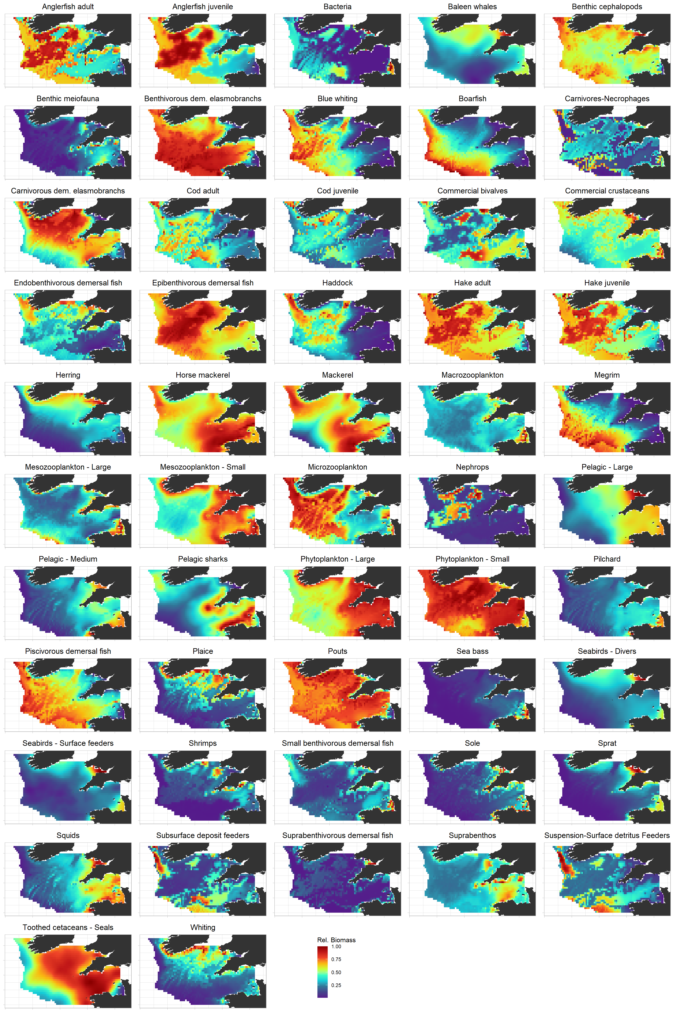
Figure G1 – Predicted maps of biomass averaged over the 198-1989 period for all Celtic Sea Ecospace functional groups (t.km-2). The color scale represents the relative abundance of the considered group, from zero (blue), to maximum (red).

