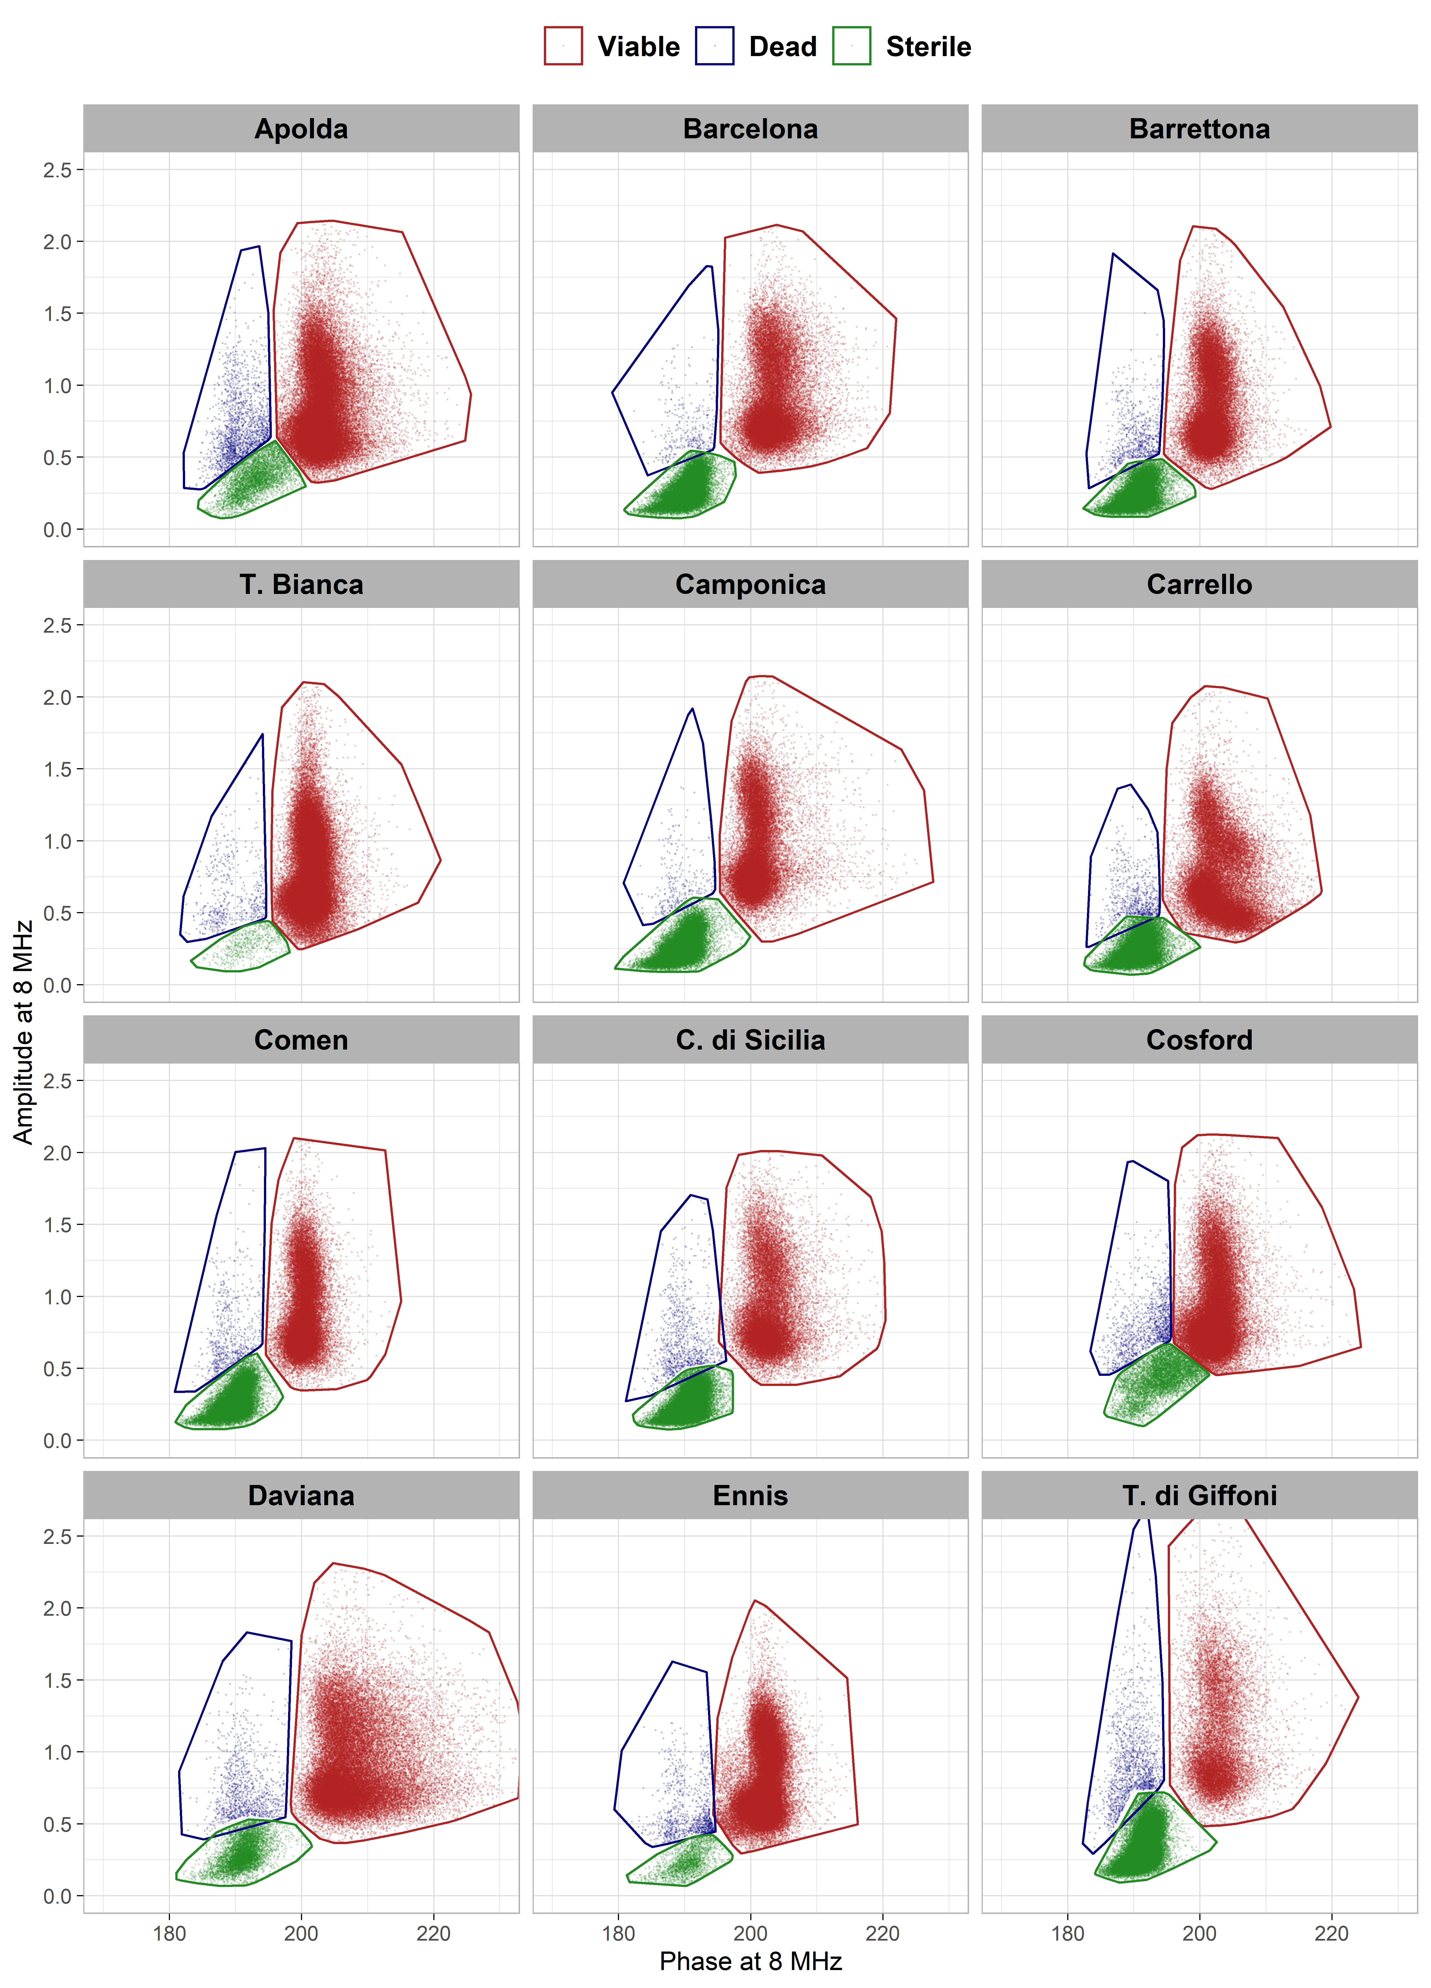
Fig. S2. Gated phase vs amplitude scatterplots for 33 cultivated and two wild hazelnuts analyzed at 8 MHz on a chip provided with a 120 µm × 120 µm microchannel.
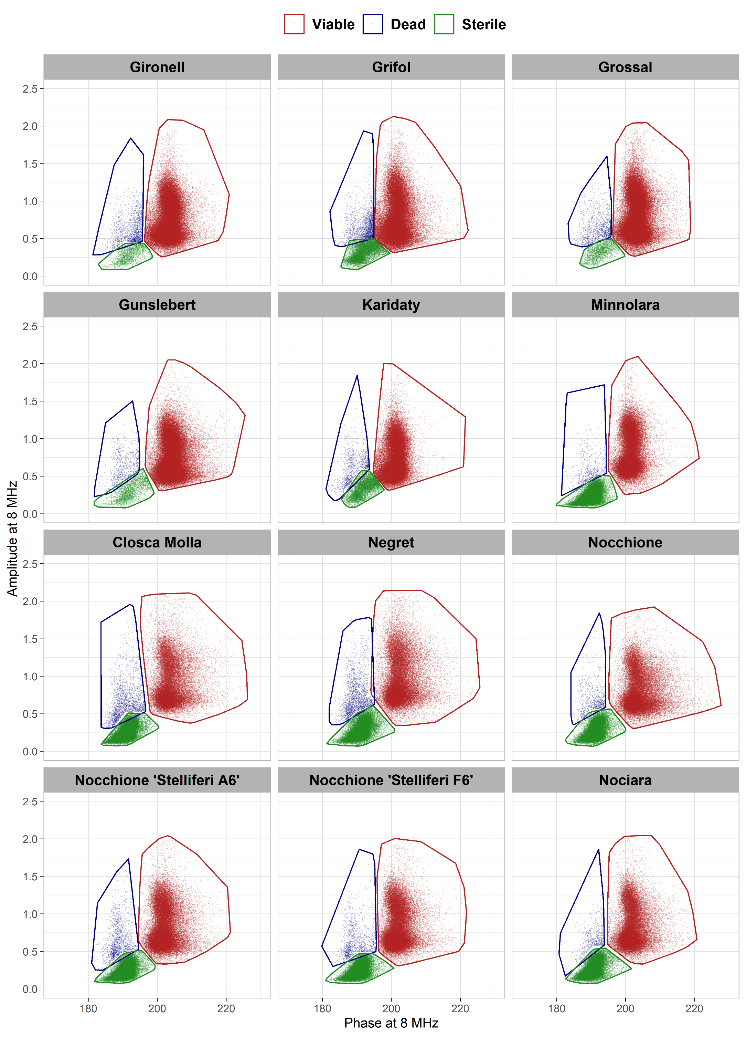
Fig. S2 (continue). Gated phase vs amplitude scatterplots for 33 cultivated and two wild hazelnuts analyzed at 8 MHz on a chip provided with a 120 µm × 120 µm microchannel.
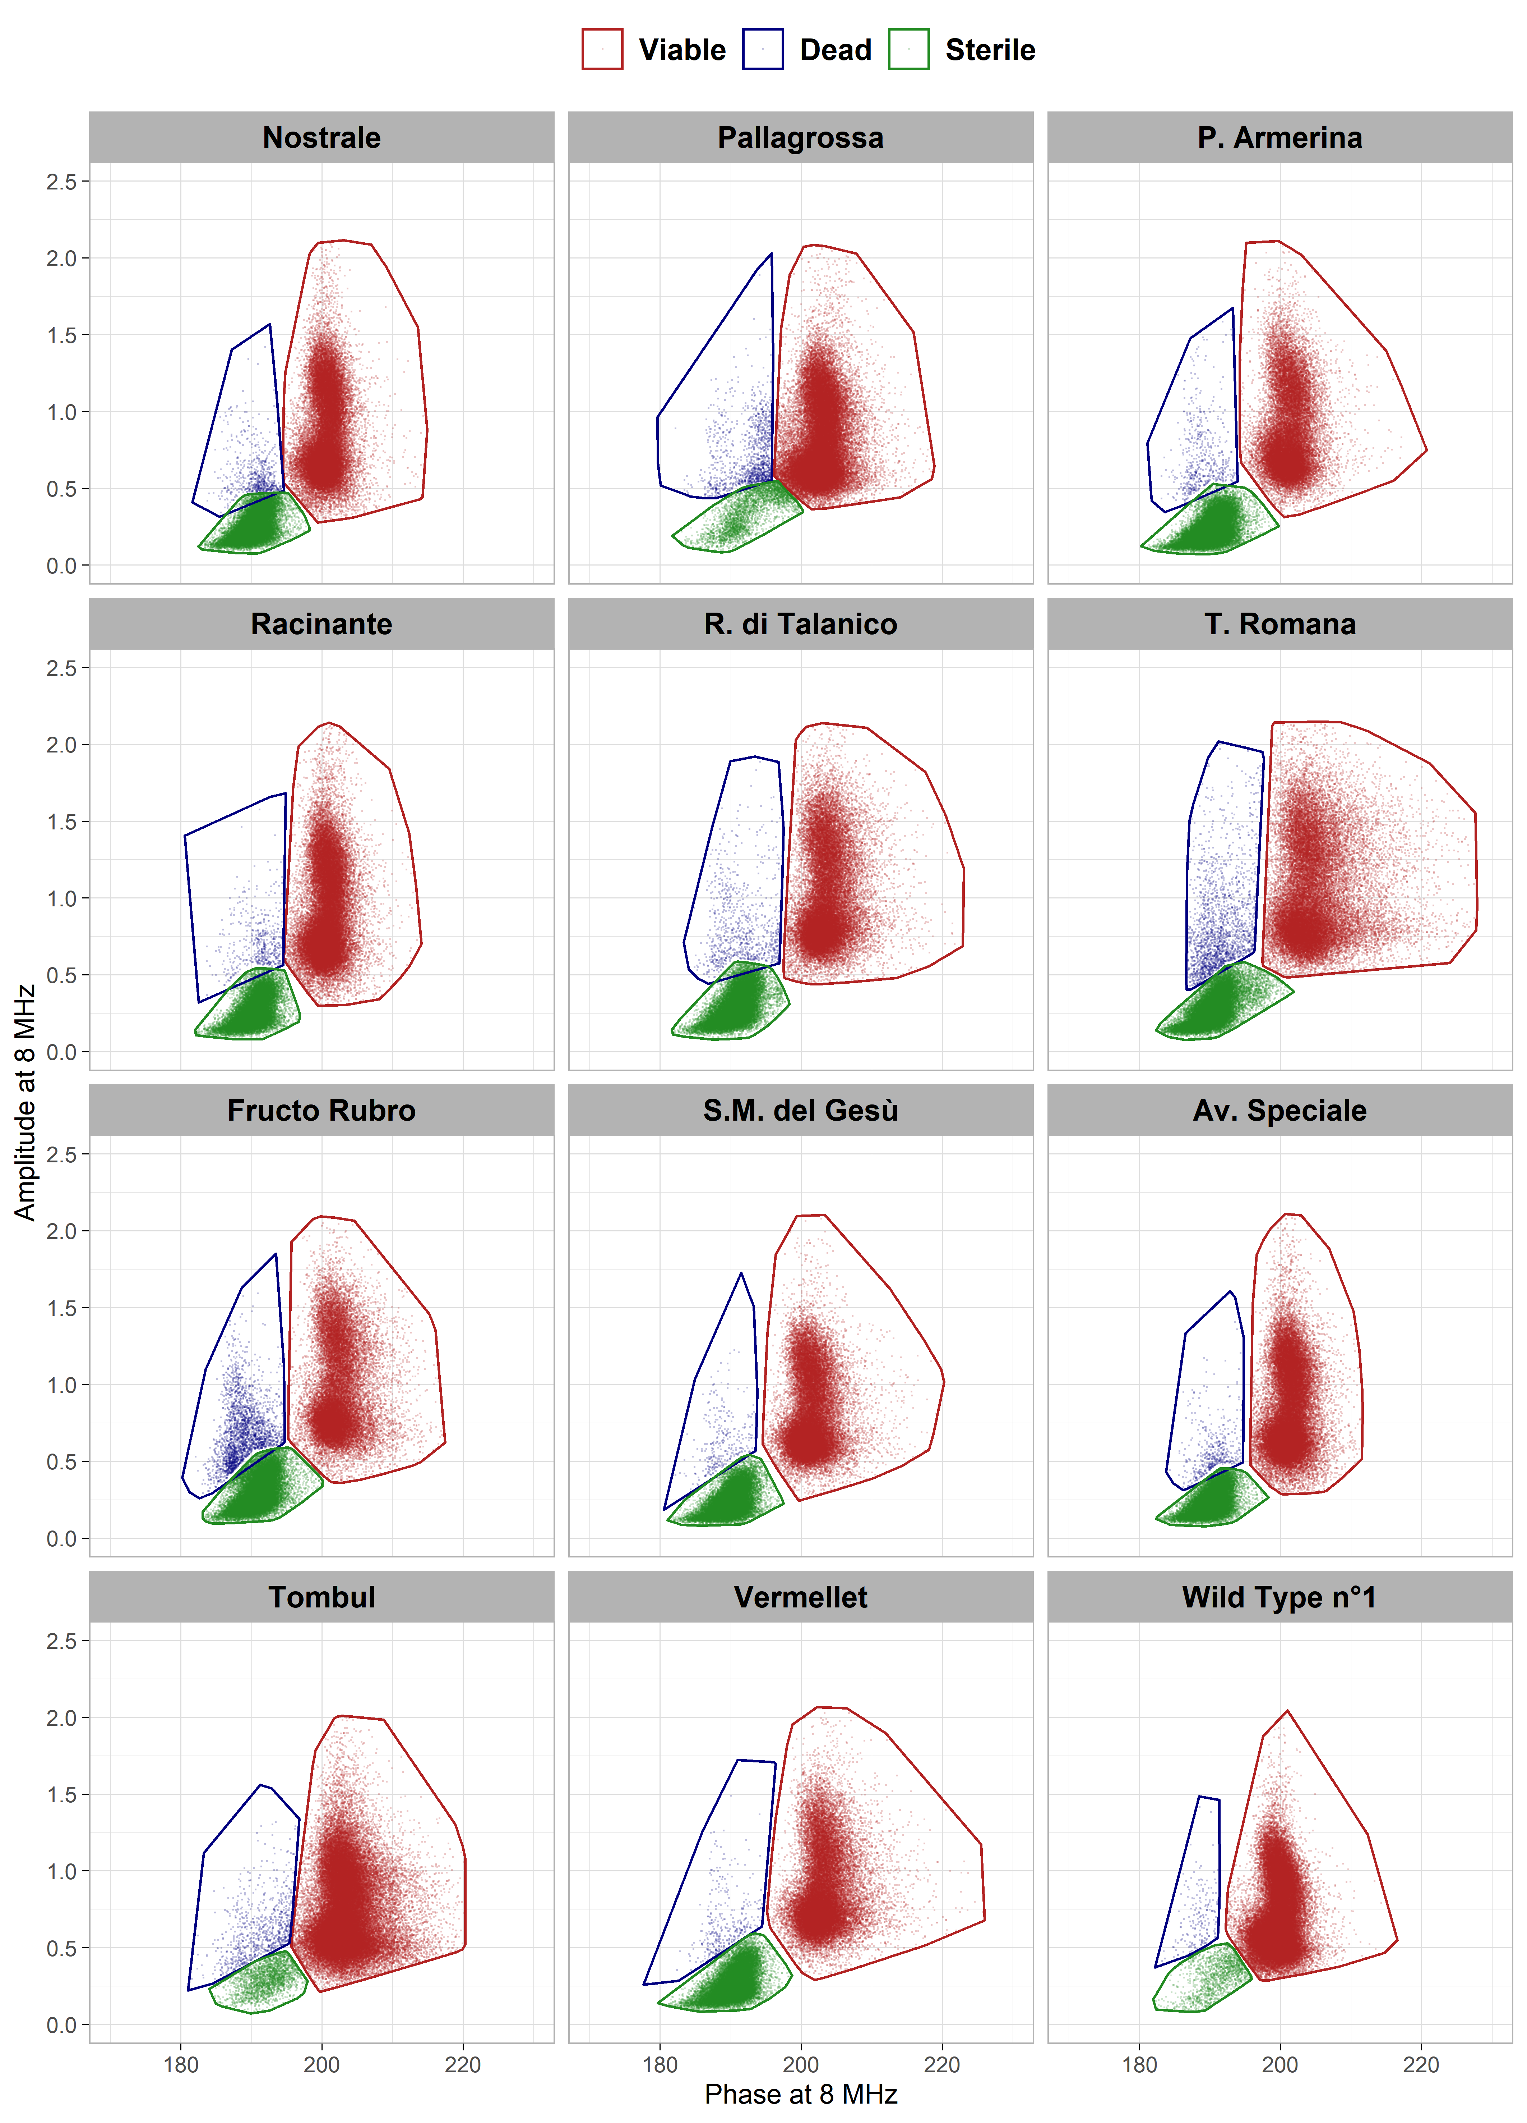
Fig. S2 (continue). Gated phase vs amplitude scatterplots for 33 cultivated and two wild hazelnuts analyzed at 8 MHz on a chip provided with a 120 µm × 120 µm microchannel.
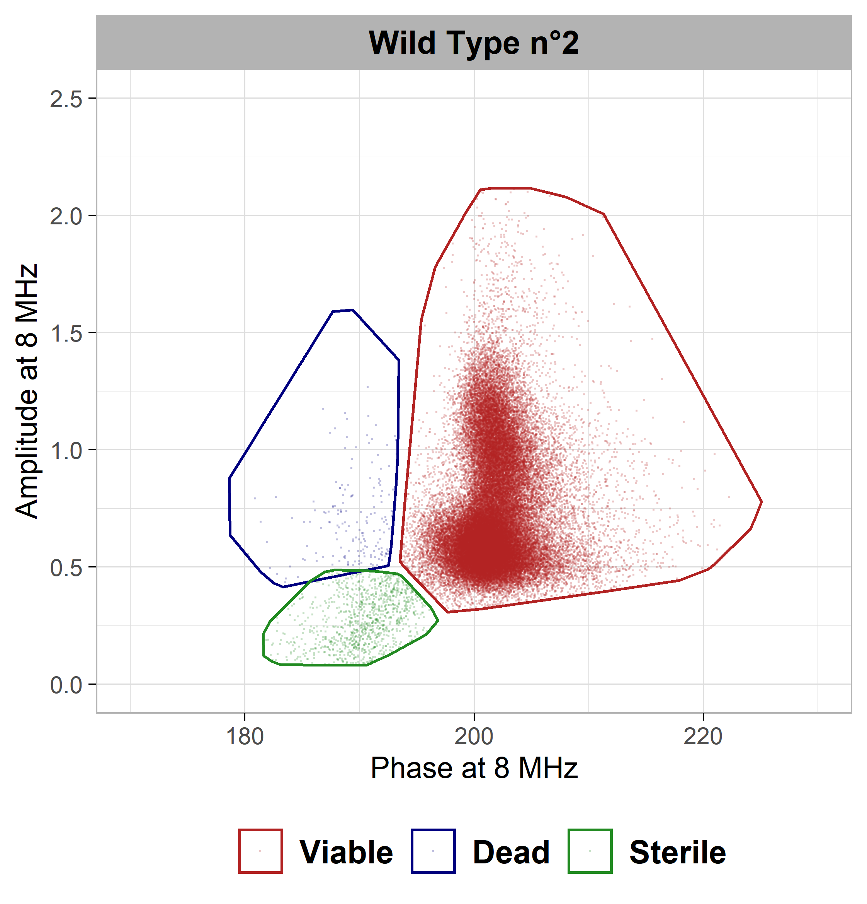
Fig. S2 (continue). Gated phase vs amplitude scatterplots for 33 cultivated and two wild hazelnuts analyzed at 8 MHz on a chip provided with a 120 µm × 120 µm microchannel.

