Supp Table 1 Comorbidies by regional area in Italy
Regional Area |  | Number of Comorbidities¹
 | n | 0 | 1 | 2 | 3 | ≥4
Lombardia | 1397 | 32.4 | 33.2 | 22.7 | 7.6 | 4.1
Northeastern | 634 | 29.7 | 32.7 | 21.9 | 11.8 | 3.9
Northwestern | 380 | 33.7 | 29.2 | 23.2 | 8.7 | 5.3
Central | 400 | 51.0 | 30.8 | 9.5 | 7.5 | 1.3
Southern | 368 | 33.4 | 37.5 | 16.9 | 8.2 | 4.1
¹ Number of comorbidities were summed for each patient and included: atrial fibrillation, blood cancer, organ cancer, coronary artery disease, cardiomyopathy, chronic heart failure, COPD, chronic renal failure, diabetes, hypertension, obesity and stroke

Supp Table 2: Characteristics of comorbidity count groups¹
 |  |  |  |  |  |  | Hypertension Mediations
Number |  |  | Age |  | Age ≥65 | Male | ARB | ACEi | Diuretic | Beta-blocker | Ca-antagonist
of |  | n | mean | SD | % | % | % | % | % | % | %
Comorbidities¹ | 0 | 982 | 58.1 | 14.9 | 31.9 | 66.6 | 0.7 | 1.2 | 0.6 | 1.4 | 0.5
 | 1 | 927 | 67.7 | 13.0 | 61.6 | 69.8 | 20.6 | 23.7 | 11.8 | 22.8 | 16.6
 | 2 | 595 | 73.2 | 11.6 | 76.8 | 68.4 | 24.7 | 29.4 | 25.4 | 37.8 | 19.8
 | 3 | 250 | 75.8 | 10.4 | 87.2 | 71.2 | 22.4 | 34.4 | 36.0 | 44.4 | 26.8
 | ≥4 | 114 | 77.5 | 10.1 | 89.5 | 68.4 | 18.4 | 31.6 | 49.1 | 52.6 | 31.6
P |  | 2868 | <0.001 |  | <0.001 | 0.523 | <0.001 | <0.001 | <0.001 | <0.001 | <0.001
¹ Number of comorbidities were summed for each patient and included: atrial fibrillation, blood cancer, organ cancer, coronary artery disease, cardiomyopathy, chronic heart failure, COPD, chronic renal failure, diabetes, hypertension, obesity and stroke
Supp Figure 1. The number of patients contributed by each clinical site, n=3179, 56 sites
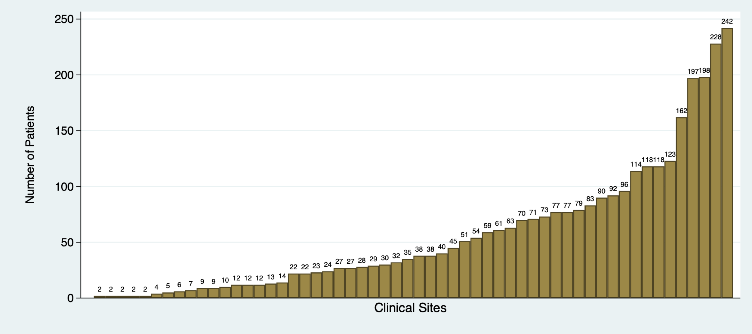

Supp Figure 2. Histogram of patient age (n=3179)
