Supplementary Material
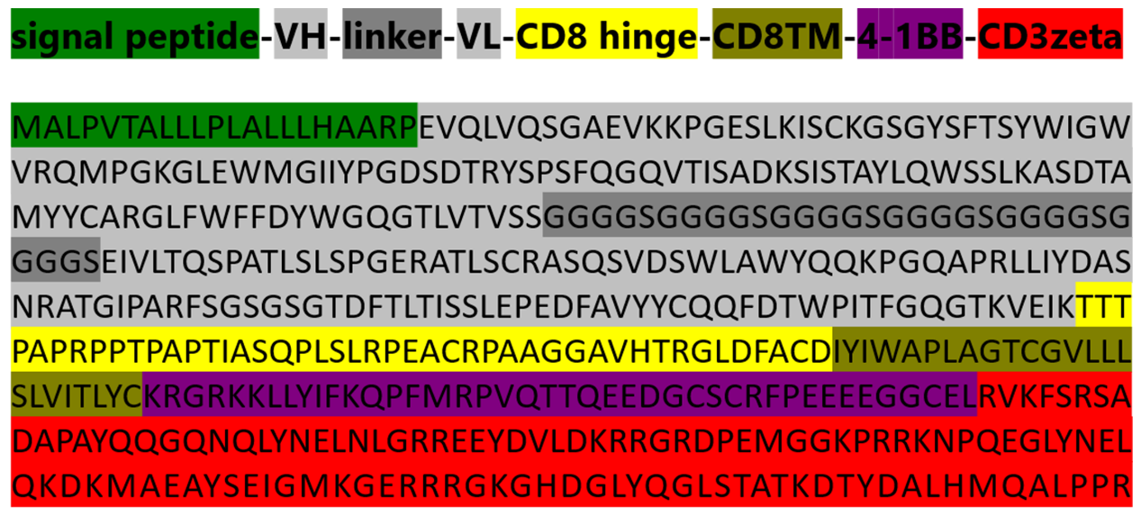
Figure S1 Amino acid sequence of CII-CAR.

Figure S2 Effect of CII-CAR-T Cells on Inducing Apoptosis When Co-Cultured with C28/I2
(A) Representative flow cytometry data to illustrate gating and quadrant strategy for FACS measurement of apoptosis. No obvious effect on inducing (B) apoptosis or (C) necrosis was when co-cultured with C28/I2. Data are represented as mean ± SE of 3 independent experiments.
Figure S3 Changes in IL-6 levels were compared between the treatment groups.
Changes in IL-6 levels in the treatment group with TNF-α or culture supernatant of CII-activated CII-CAR-T, spontaneous release of IL-6 by cartilage were used as control. *p < 0.05; **p < 0.01. Data are represented as mean ± SE of 3 independent experiments.

