Survey questions translated
How often do you cycle at this time of year?
5 days a week or more
3 to 4 days a week
1 to 2 days a week
1 to 3 days a month
Less often

How often do you drive a car at this time of year?
5 days a week or more
3 to 4 days a week
1 to 2 days a week
1 to 3 days a month
Less often
I don’t drive

Information page
In this survey, you’ll be shown pictures of cycle lanes. We sometimes ask you to evaluate the cycle lane as a whole and sometimes only the colour.
These are the pictures you will be asked about.
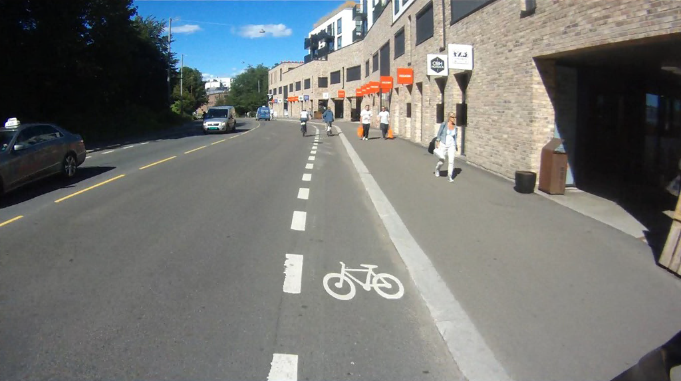

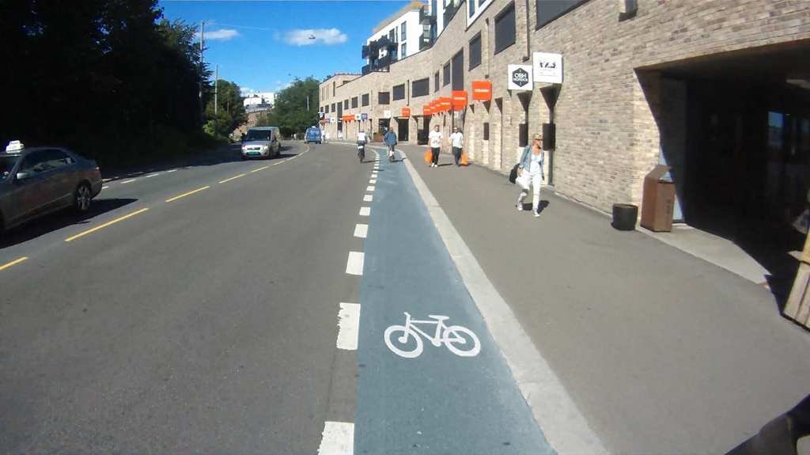
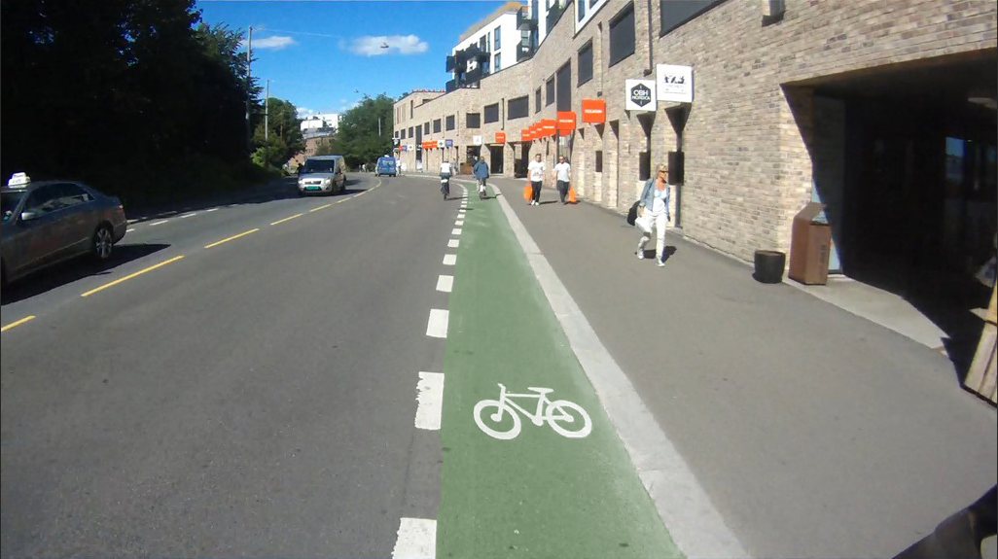
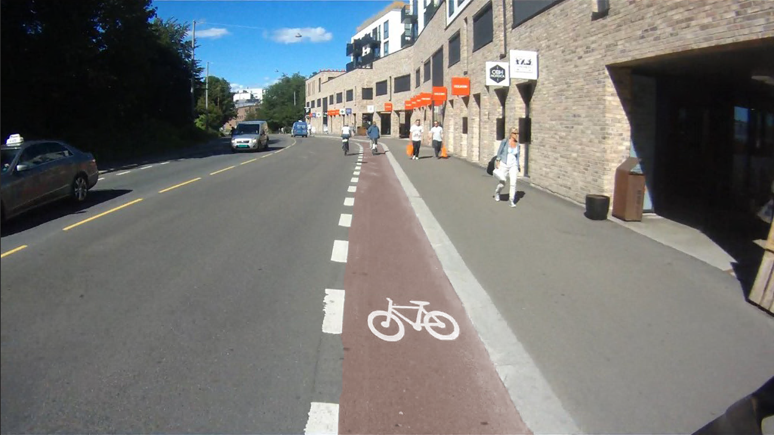

© Original uncoloured cycle lane picture by Lode, M. H. (2015) https://mortenhowlode.wordpress.com/2015/08/14/hvor-kan-man-da-sykle-om-ikke-midt-i-veien/

[All respondents] To me, this cycle lane is …
[Picture with uncoloured lane shown first, then randomized order of colour]
1 Barely visible
2
3
4
5
6
7 Very visible

[Cyclists] To me, to cycle in this cycle lane seems …
[Picture with uncoloured lane shown first, then randomized order of colour]
1 Very uninviting
2
3
4
5
6
7 Very inviting

[Cyclists] To me, cycling in this cycle lane seems …
[Picture with uncoloured lane shown first, then randomized order of colour]
1 Very unsafe
2
3
4
5
6
7 Very safe

[Motorists] To me, driving a car in this street seems …
[Picture with uncoloured lane shown first, then randomized order of colour]
1 Very unsafe
2
3
4
5
6
7 Very safe

[Cyclists] To what extent do you think motorists will drive or stop in the bike lane pictured?
[Picture with uncoloured lane shown first, then randomized order of colour]
1 To a very small extent
2
3
4
5
6
7 To a very large extent

[Motorists] To what extent do you imagine you could drive or stop in the cycle lane pictured?
[Picture with uncoloured lane shown first, then randomized order of colour]
1 To a very small extent
2
3
4
5
6
7 To a very large extent

[Motorists] To what extent do you think motorists in general will drive or stop in the bike lane pictured?
[Picture with uncoloured lane shown first, then randomized order of colour]
1 To a very small
2
3
4
5
6
7 To a very large extent

[All] To me, that the cycle lane has a different colour than the carriageway is …
1 Very unimportant
2
3
4
5
6
7 Very important

[All] To me, whether the cycle lane is red, green or blue is …
1 Very irrelevant
2
3
4
5
6
7 Very relevant

[All] Where do you live now?
Oslo and surrounding area
Bergen and surrounding area
Trondheim and surrounding area
Stavanger and surrounding area
Other

[All] Have you lived a place with coloured cycle lanes?
Yes
No

[All] How old are you?
Under 20
20-29
30-39
40-49
50-59
60-69
70-79
80 or older

[All] Finally, we’d like to know your gender
Man
Woman
Other/don’t want to say

[All] Do you have any comments to the survey?
Please do not provide health information in the comments section.
Write here:

