Supporting information

Understanding microbial community dynamics in up-flow bioreactors to improve mitigation strategies for oil souring
Avishek Dutta^{1*}, Ben Smith², Thomas Goldman³, Leanne Walker⁴, Matthew Streets⁴, Bob Eden⁴, Reinhard Dirmeier³, Jeff S Bowman^{1,5}
¹Integrative Oceanography Division, Scripps Institution of Oceanography, UC San Diego
²BP Upstream Technology
³BP Biosciences Center
⁴Rawwater Engineering Company Ltd.
⁵Center for Microbiome Innovation, UC San Diego
Corresponding author:
Avishek Dutta
Email ID: avdutta@ucsd.edu; avishekdutta14@gmail.com

Materials and Methods
Experimental Setup
Six pressurized up-flow bioreactors were used to understand the shift in microbial diversity across different phases of biosouring and mitigation. The bioreactors were packed with a mixture of ‘pre-soured’ 98% low-iron sand, and 2% Kaolin by weight. The pre-soured sand used in this study consisted of core matrix material from decommissioned, pressurized bioreactors that operated in a previous bioreactor study. The core material was extracted from the ‘Control,’ and ‘Nitrate-dosed’ bioreactor groups from the previous study, and the columns were known to contain a mature, pre-established oilfield microbiological consortium. Packing with ‘pre-soured’ sand significantly reduces the time to observe inferred microbiological activity from chemical analysis (e.g., sulfide production, nitrate reduction, VFA utilization), hence no prolonged period at the start of the new bioreactor study for an initial establishment phase.
Seawater was injected in all the six bioreactors. Three of the bioreactors were seawater-wetted, and the other three were oil-wetted. Seawater used in this study is composed of 90% synthetic seawater (Instant Ocean) and 10% Irish Sea seawater mix. The natural seawater used in the pressurized bioreactor contains an average of 2,800 mg/L sulfate, < 0.1 mg/L nitrate, and < 0.1mg/L VFA. The pH of the natural seawater typically varied between 8.0 and 8.5. The detailed composition of natural and synthetic seawater is present in Table S19. In the oil-wetted bioreactor, columns were saturated with dead crude oil. The bioreactors were operated at 30 ℃ and 18.27 MPa. Anaerobiosis was maintained in the influent vessels by a positive pressure N₂ gas head. Oxygen scavenger (potassium metabisulfite) was also added to the influent if dissolved O₂ concentrations were greater than 0.5 mg L⁻¹. A continuous injection method was used to inject influent at a target flow rate of 0.05 mL min⁻¹.
Phases were designed to mimic the overall process of sulfidogenesis followed by nitrate control (application of nitrate for mitigation) [M], rebound sulfidogenesis (after stopping nitrate treatment) [RS], and rebound control (mitigation of rebound sulfidogenesis) [RC]. Shifts between phases in seawater- and oil- wetted columns were marked by shifts in average sulfide concentrations (Supporting Table S1). Rebound control phases were treated differently in seawater- and oil- wetted columns. In the seawater bioreactors, a low salinity (LS) treatment was used, whereas, in the oil-wetted columns, the re-application of nitrate was conducted for the RC phase. In the LS treatment, seawater was replaced with deionized water having sulfate salt in it. Two different concentrations of the salt were used in two different columns (10 mg L⁻¹ in sample S7 and 100 mg L⁻¹ in S8). VFAs were added in all the columns throughout the experiment. VFAs consisted of acetate (33 mg L⁻¹), formate (3.3 mg L⁻¹), propionate (1.65 mg L⁻¹), and butyrate (1.65 mg L⁻¹). Calcium nitrate salts were used in this study for mitigation. The concentrations of nitrate ions used in different phases are mentioned in Supporting Table S1.
In the seawater- and oil- wetted columns, samples for microbial analyses were collected from three different phases (M, RS, and RC). Seventeen samples were analyzed for this study. Three samples each from the M and RS phases and two samples from the RC phase were used for seawater columns, whereas for oil columns, three samples each from M, RS, and RC phases were used.

Library preparation and sequencing
Bacterial 16S ribosomal RNA gene-targeted sequencing was performed using the Quick-16S NGS Library Preparation Kit (Zymo Research, Irvine, CA). These proprietary bacterial 16S primers amplified the V3-V4 region of the 16S rRNA gene. The primers have been custom-designed by Zymo Research to provide the best coverage of the 16S gene while maintaining high sensitivity. The sequencing library was prepared using an innovative library preparation process in which PCR reactions were performed in real-time PCR machines to control cycles and therefore prevent PCR chimera formation. The final PCR products were quantified with qPCR fluorescence readings and pooled together based on equal molarity. The final pooled library was cleaned up with Select-a-Size DNA Clean & Concentrator (Zymo Research, Irvine, CA), then quantified with TapeStation (Agilent) and Qubit (Life Technologies). The final library was sequenced on the Illumina MiSeq with a v3 reagent kit (600 cycles). The sequencing was performed with >10% PhiX spike-in. All library preparation and sequencing were performed at Zymo Research.

Tables
Table S1: Nutrients in effluents and influents of different bioreactors across M (mitigation), RS (rebound sulfidogenesis), and RC (rebound control) phases of seawater and oil enrichments
Sample  Name | Column  type | Phases | Column | Effluent Average  Sulfide  (mg L⁻¹) | Effluent Average  VFA  (mg L⁻¹) | Influent  Average  Sulfate (mg L⁻¹) | Influent  Nitrate  (mM)
S1 | Seawater | M | Column 1 | 1.1 | 0.4 | 2241.15 | 0.54
S2 | Seawater | M | Column 2 | 0.3 | 0.4 | 2240.72 | 0.54
S3 | Seawater | M | Column 3 | 0.3 | 0.4 | 2240.23 | 0.54
S4 | Seawater | RS | Column 1 | 17.5 | 0.2 | 1762.45 | 0
S5 | Seawater | RS | Column 2 | 14.4 | 0.2 | 1867.73 | 0
S6 | Seawater | RS | Column 3 | 13.4 | 0.2 | 1880.82 | 0
S7 | Seawater | RC | Column 2 | 1.0 | 28.4 | 12.54 | 0
S8 | Seawater | RC | Column 3 | 3.4 | 23.4 | 103.92 | 0
S9 | Oil | M | Column 4 | 0.7 | 0.5 | 2241.98 | 1.07
S10 | Oil | M | Column 5 | 0.5 | 0.4 | 2241.98 | 1.07
S11 | Oil | M | Column 6 | 0.5 | 0.4 | 2241.98 | 1.07
S12 | Oil | RS | Column 4 | 17.9 | 0.4 | 2146.67 | 0.54
S13 | Oil | RS | Column 5 | 16.2 | 0.4 | 2146.67 | 0.54
S14 | Oil | RS | Column 6 | 24.2 | 0.4 | 2155.39 | 0.54
S15 | Oil | RC | Column 4 | 0.3 | 2.2 | 2239.03 | 1.54
S16 | Oil | RC | Column 5 | 0.4 | 1.9 | 2239.03 | 1.54
S17 | Oil | RC | Column 6 | 0.3 | 1.0 | 2239.03 | 1.54

Table S2: Details of pooled samples for DNA extraction from different columns across different phases
Sample Name | Column name | Extraction Date | Sample Name | Column name | Extraction Date
S1 | Column 1 | 19-05-2016 | S9 | Column 4 | 19-05-2016
 | Column 1 | 02-06-2016 |  | Column 4 | 02-06-2016
 | Column 1 | 09-06-2016 |  | Column 4 | 09-06-2016
 | Column 1 | 15-06-2016 | S10 | Column 5 | 19-05-2016
 | Column 1 | 23-06-2016 |  | Column 5 | 02-06-2016
S2 | Column 2 | 19-05-2016 |  | Column 5 | 09-06-2016
 | Column 2 | 02-06-2016 | S11 | Column 6 | 19-05-2016
 | Column 2 | 09-06-2016 |  | Column 6 | 02-06-2016
 | Column 2 | 15-06-2016 |  | Column 6 | 09-06-2016
 | Column 2 | 23-06-2016 | S12 | Column 4 | 20-07-2016
S3 | Column 3 | 19-05-2016 |  | Column 4 | 27-07-2016
 | Column 3 | 02-06-2016 |  | Column 4 | 04-08-2016
 | Column 3 | 09-06-2016 |  | Column 4 | 10-08-2016
 | Column 3 | 15-06-2016 |  | Column 4 | 18-08-2016
 | Column 3 | 23-06-2016 | S13 | Column 5 | 20-07-2016
S4 | Column 1 | 23-08-2016 |  | Column 5 | 27-07-2016
 | Column 1 | 30-08-2016 |  | Column 5 | 03-08-2016
 | Column 1 | 07-09-2016 |  | Column 5 | 10-08-2016
 | Column 1 | 14-09-2016 |  | Column 5 | 18-08-2016
 | Column 1 | 21-09-2016 | S14 | Column 6 | 20-07-2016
S5 | Column 2 | 23-08-2016 |  | Column 6 | 27-07-2016
 | Column 2 | 30-08-2016 |  | Column 6 | 03-08-2016
 | Column 2 | 07-09-2016 |  | Column 6 | 10-08-2016
 | Column 2 | 14-09-2016 |  | Column 6 | 18-08-2016
 | Column 2 | 21-09-2016 | S15 | Column 4 | 21-09-2016
S6 | Column 3 | 23-08-2016 |  | Column 4 | 28-09-2016
 | Column 3 | 30-08-2016 |  | Column 4 | 05-10-2016
 | Column 3 | 07-09-2016 |  | Column 4 | 19-10-2016
 | Column 3 | 14-09-2016 |  | Column 4 | 26-10-2016
 | Column 3 | 21-09-2016 | S16 | Column 5 | 21-09-2016
S7 | Column 2 | 25-10-2016 |  | Column 5 | 28-09-2016
 | Column 2 | 02-11-2016 |  | Column 5 | 05-10-2016
 | Column 2 | 08-11-2016 |  | Column 5 | 19-10-2016
 | Column 2 | 16-11-2016 |  | Column 5 | 26-10-2016
 | Column 2 | 23-11-2016 | S17 | Column 6 | 21-09-2016
S8 | Column 3 | 26-10-2016 |  | Column 6 | 28-09-2016
 | Column 3 | 02-11-2016 |  | Column 6 | 05-10-2016
 | Column 3 | 08-11-2016 |  | Column 6 | 19-10-2016
 | Column 3 | 16-11-2016 |  | Column 6 | 26-10-2016
 | Column 3 | 23-11-2016

Table S3: Sequence information and alpha diversity indices

 | Column  type | Phases | input | filtered | denoisedF | denoisedR | merged | Observed  edges | Shannon | Simpson | InvSimpson | Fisher
S1 | Seawater | M | 122104 | 121666 | 117465 | 110090 | 107439 | 44 | 2.40 | 0.85 | 6.72 | 4.35
S2 | Seawater | M | 103519 | 103114 | 98355 | 94737 | 91424 | 48 | 2.61 | 0.87 | 7.62 | 4.88
S3 | Seawater | M | 124071 | 123579 | 119772 | 109686 | 107008 | 55 | 2.66 | 0.89 | 9.39 | 5.58
S4 | Seawater | RS | 138886 | 138368 | 133169 | 129081 | 125929 | 21 | 0.88 | 0.34 | 1.52 | 1.89
S5 | Seawater | RS | 126137 | 125673 | 119702 | 109618 | 105624 | 18 | 1.49 | 0.64 | 2.75 | 1.62
S6 | Seawater | RS | 67108 | 66887 | 59114 | 56881 | 51420 | 18 | 2.05 | 0.81 | 5.17 | 1.75
S7 | Seawater | RC | 104245 | 103906 | 99817 | 93904 | 90789 | 43 | 2.18 | 0.75 | 4.08 | 4.32
S8 | Seawater | RC | 82927 | 82623 | 74095 | 73866 | 67326 | 22 | 1.92 | 0.77 | 4.29 | 2.12
S9 | Oil | M | 111024 | 110632 | 107594 | 101288 | 99647 | 29 | 1.90 | 0.78 | 4.45 | 2.76
S10 | Oil | M | 87711 | 87367 | 83608 | 78430 | 76296 | 23 | 1.46 | 0.68 | 3.09 | 2.20
S11 | Oil | M | 124475 | 123987 | 120540 | 111877 | 109870 | 39 | 2.23 | 0.79 | 4.87 | 3.80
S12 | Oil | RS | 135304 | 134827 | 130976 | 124677 | 122699 | 21 | 1.27 | 0.58 | 2.36 | 1.90
S13 | Oil | RS | 114729 | 114319 | 110647 | 103044 | 101071 | 17 | 1.19 | 0.54 | 2.17 | 1.53
S14 | Oil | RS | 94430 | 94080 | 90162 | 84283 | 82292 | 13 | 1.26 | 0.57 | 2.34 | 1.16
S15 | Oil | RC | 94331 | 93996 | 91282 | 86896 | 85010 | 35 | 1.94 | 0.76 | 4.19 | 3.46
S16 | Oil | RC | 85636 | 85318 | 82413 | 77030 | 74730 | 26 | 1.45 | 0.63 | 2.67 | 2.53
S17 | Oil | RC | 103254 | 102906 | 100322 | 94134 | 91896 | 20 | 1.75 | 0.78 | 4.64 | 1.85

Table S4: Relative percentage abundance of most abundant phylum in SWCs and OWCs
 | S1 | S2 | S3 | S4 | S5 | S6 | S7 | S8 | S9 | S10 | S11 | S12 | S13 | S14 | S15 | S16 | S17 | Average | Standard Deviation
Proteobacteria | 96.01 | 97.11 | 96.44 | 95.67 | 94.25 | 94.25 | 92.17 | 94.71 | 99.61 | 98.76 | 97.03 | 89.86 | 88.68 | 81.52 | 89.28 | 89.19 | 92.20 | 93.34 | 4.56
Bacteroidetes | 0.82 | 1.73 | 0.88 | 0.54 | 1.30 | 0.86 | 1.69 | 0.64 | 0.39 | 0.96 | 1.67 | 8.79 | 10.49 | 15.06 | 9.00 | 9.59 | 7.22 | 4.21 | 4.69
Calditrichaeota | 1.85 | 0.00 | 1.39 | 1.00 | 0.65 | 3.11 | 0.00 | 1.89 | 0.00 | 0.28 | 0.55 | 0.98 | 0.83 | 2.79 | 1.41 | 1.07 | 0.46 | 1.08 | 0.92
Tenericutes | 0.48 | 0.62 | 0.00 | 2.36 | 1.61 | 0.00 | 0.00 | 0.00 | 0.00 | 0.00 | 0.00 | 0.23 | 0.00 | 0.00 | 0.00 | 0.00 | 0.00 | 0.31 | 0.67
Ignavibacteriae | 0.00 | 0.00 | 0.00 | 0.00 | 0.63 | 0.00 | 2.33 | 1.81 | 0.00 | 0.00 | 0.00 | 0.00 | 0.00 | 0.00 | 0.00 | 0.00 | 0.00 | 0.28 | 0.70
Chloroflexi | 0.00 | 0.37 | 0.00 | 0.00 | 0.39 | 0.00 | 1.26 | 0.63 | 0.00 | 0.00 | 0.76 | 0.14 | 0.00 | 0.63 | 0.00 | 0.00 | 0.00 | 0.25 | 0.37
Acidobacteria | 0.00 | 0.00 | 0.79 | 0.30 | 1.05 | 1.09 | 0.00 | 0.00 | 0.00 | 0.00 | 0.00 | 0.00 | 0.00 | 0.00 | 0.00 | 0.00 | 0.00 | 0.19 | 0.39
Firmicutes | 0.63 | 0.00 | 0.00 | 0.00 | 0.12 | 0.00 | 1.10 | 0.00 | 0.00 | 0.00 | 0.00 | 0.00 | 0.00 | 0.00 | 0.31 | 0.00 | 0.12 | 0.13 | 0.30
Spirochaetes | 0.22 | 0.17 | 0.49 | 0.12 | 0.00 | 0.69 | 0.00 | 0.32 | 0.00 | 0.00 | 0.00 | 0.00 | 0.00 | 0.00 | 0.00 | 0.15 | 0.00 | 0.13 | 0.20
Actinobacteria | 0.00 | 0.00 | 0.00 | 0.00 | 0.00 | 0.00 | 1.46 | 0.00 | 0.00 | 0.00 | 0.00 | 0.00 | 0.00 | 0.00 | 0.00 | 0.00 | 0.00 | 0.09 | 0.35
Unassigned | 0.00 | 0.00 | 0.00 | 0.00 | 0.00 | 0.00 | 0.00 | 0.00 | 0.00 | 0.00 | 0.00 | 0.00 | 0.00 | 0.00 | 0.00 | 0.00 | 0.00 | 0.00 | 0.00

Table S5: DESeq2 results showing significant fold changes of bacterial classes between RS vs. M phases of seawater-wetted columns (SWCs)
 | log2FoldChange | lfcSE | stat | p-value | p-adj
Epsilonproteobacteria | 18.73 | 1.36 | 13.72 | 7.22E-43 | 5.77E-42
Gammaproteobacteria | -2.70 | 0.61 | -4.45 | 8.61E-06 | 3.45E-05

Table S6: DESeq2 results showing significant fold changes of bacterial classes between RS vs. M phases of oil-wetted columns (OWCs)
 | log2FoldChange | lfcSE | stat | p-value | p-adj
Sphingobacteriia | 2.82 | 0.38 | 7.45 | 9.62E-14 | 8.66E-13
Alphaproteobacteria | -2.59 | 0.91 | -2.86 | 0.00423 | 0.01904

 | S1 | S2 | S3 | Mean | SD | S4 | S5 | S6 | Mean | SD | S7 | S8 | Mean | SD
Phase | M | M | M | M | M | RS | RS | RS | RS | RS | RC | RC | RC | RC
Marinobacterium | 30.44 | 5.54 | 11.52 | 15.83 | 12.99 | 0.00 | 0.00 | 10.03 | 3.34 | 5.79 | 1.23 | 0.00 | 0.62 | 0.87
Marinobacter | 14.50 | 9.69 | 21.73 | 15.30 | 6.06 | 0.00 | 0.00 | 0.00 | 0.00 | 0.00 | 0.00 | 0.00 | 0.00 | 0.00
Alteromonas | 0.26 | 13.32 | 26.37 | 13.32 | 13.06 | 1.12 | 0.00 | 3.38 | 1.50 | 1.72 | 0.00 | 0.00 | 0.00 | 0.00
Desulfobacula | 6.21 | 1.71 | 7.49 | 5.13 | 3.04 | 8.52 | 17.54 | 21.27 | 15.78 | 6.56 | 0.74 | 2.46 | 1.60 | 1.21
Cycloclasticus | 2.32 | 8.94 | 2.69 | 4.65 | 3.72 | 0.00 | 0.00 | 0.00 | 0.00 | 0.00 | 0.00 | 0.00 | 0.00 | 0.00
Pseudomonas | 8.99 | 0.03 | 0.00 | 3.01 | 5.18 | 0.81 | 1.27 | 0.00 | 0.69 | 0.64 | 58.78 | 1.96 | 30.37 | 40.17
Desulfatibacillum | 2.62 | 0.00 | 1.37 | 1.33 | 1.31 | 2.34 | 0.00 | 6.89 | 3.08 | 3.50 | 1.29 | 37.70 | 19.50 | 25.75
Hyphomonas | 0.89 | 0.78 | 1.03 | 0.90 | 0.13 | 0.51 | 3.18 | 1.14 | 1.61 | 1.40 | 4.13 | 26.79 | 15.46 | 16.02
Ca. Puniceispirillum | 0.00 | 0.00 | 0.75 | 0.25 | 0.43 | 0.00 | 3.17 | 4.52 | 2.56 | 2.32 | 8.19 | 12.49 | 10.34 | 3.04
Sulfurimonas | 0.00 | 0.00 | 0.00 | 0.00 | 0.00 | 80.55 | 56.27 | 35.09 | 57.31 | 22.75 | 0.79 | 0.00 | 0.39 | 0.56
Maricaulis | 0.00 | 0.00 | 0.00 | 0.00 | 0.00 | 0.00 | 1.18 | 0.00 | 0.39 | 0.68 | 5.77 | 2.87 | 4.32 | 2.05
Table S7: Average relative percentage abundance of most abundant genera in SWCs with the mean and standard deviation of M, RS, and RC phases

 | S9 |  | S10 |  | S11 |  | Mean |  | SD |  | S12 |  | S13 |  | S14 |  | Mean |  | SD |  | S15 |  | S16 |  | S17 |  | Mean |  | SD
Phase |  | M |  | M |  | M |  | M |  | M |  | RS |  | RS |  | RS |  | RS |  | RS |  | RC |  | RC |  | RC |  | RC |  | RC
Marinobacterium |  | 24.01 |  | 40.00 |  | 40.97 |  | 34.99 |  | 9.53 |  | 61.34 |  | 65.18 |  | 0.00 |  | 42.17 |  | 36.57 |  | 9.58 |  | 8.62 |  | 7.58 |  | 8.59 |  | 1.00
Thalassolituus |  | 37.10 |  | 39.67 |  | 9.28 |  | 28.68 |  | 16.85 |  | 0.00 |  | 0.00 |  | 0.00 |  | 0.00 |  | 0.00 |  | 5.82 |  | 4.46 |  | 3.97 |  | 4.75 |  | 0.96
Marinobacter |  | 16.00 |  | 3.59 |  | 7.59 |  | 9.06 |  | 6.33 |  | 0.00 |  | 0.00 |  | 0.00 |  | 0.00 |  | 0.00 |  | 3.74 |  | 0.25 |  | 0.02 |  | 1.34 |  | 2.08
Desulfobacula |  | 4.74 |  | 7.16 |  | 7.14 |  | 6.35 |  | 1.39 |  | 19.69 |  | 16.35 |  | 62.49 |  | 32.84 |  | 25.73 |  | 12.47 |  | 13.27 |  | 20.41 |  | 15.39 |  | 4.37
Alcanivorax |  | 0.71 |  | 0.00 |  | 11.26 |  | 3.99 |  | 6.31 |  | 1.01 |  | 0.18 |  | 0.00 |  | 0.40 |  | 0.54 |  | 5.03 |  | 1.02 |  | 29.51 |  | 11.86 |  | 15.42
Alteromonas |  | 4.37 |  | 0.00 |  | 2.08 |  | 2.15 |  | 2.18 |  | 0.99 |  | 3.10 |  | 0.00 |  | 1.37 |  | 1.59 |  | 0.55 |  | 0.58 |  | 0.00 |  | 0.38 |  | 0.33
Caldithrix |  | 0.00 |  | 0.28 |  | 0.55 |  | 0.27 |  | 0.27 |  | 0.98 |  | 0.83 |  | 2.79 |  | 1.53 |  | 1.09 |  | 1.41 |  | 1.07 |  | 0.46 |  | 0.98 |  | 0.48
Pelobacter |  | 0.00 |  | 0.00 |  | 0.00 |  | 0.00 |  | 0.00 |  | 0.00 |  | 0.00 |  | 0.00 |  | 0.00 |  | 0.00 |  | 5.21 |  | 2.22 |  | 1.50 |  | 2.98 |  | 1.97
Sulfurimonas |  | 0.00 |  | 0.00 |  | 0.00 |  | 0.00 |  | 0.00 |  | 0.00 |  | 0.00 |  | 12.87 |  | 4.29 |  | 7.43 |  | 0.00 |  | 0.00 |  | 0.00 |  | 0.00 |  | 0.00
Table S8: Average relative percentage abundance of most abundant genera in OWCs with the mean and standard deviation of M, RS, and RC phases

Table S9: Overall average dissimilarity for different phases of seawater enrichments
 | M | RS | RC
M |  | 85.1 | 91.54
RS | 85.1 |  | 88.72
RC | 91.54 | 88.72

Table S10: Overall average dissimilarity for different phases of oil enrichments
 | M | RS | RC
M |  | 63.41 | 63.52
RS | 63.41 |  | 65.5
RC | 63.52 | 65.5

Table S11: Average relative percentage abundance of most abundant CCGs or CEGs in SWCs with the mean and standard deviation of M, RS, and RC phases
 | S1 | S2 | S3 | Mean | SD | S4 | S5 | S6 | Mean | SD | S7 | S8 | Mean | SD
Phase | M | M | M | M | M | RS | RS | RS | RS | RS | RC | RC | RC | RC
Marinobacterium aestuarii | 30.44 | 5.54 | 11.52 | 15.83 | 12.99 | 0.00 | 0.00 | 10.03 | 3.34 | 5.79 | 1.23 | 0.00 | 0.62 | 0.87
Marinobacter sp. LQ44 | 9.67 | 0.00 | 18.71 | 9.46 | 9.36 | 0.00 | 0.00 | 0.00 | 0.00 | 0.00 | 0.00 | 0.00 | 0.00 | 0.00
Alteromonas macleodii | 0.00 | 5.10 | 14.98 | 6.69 | 7.61 | 0.00 | 0.00 | 0.00 | 0.00 | 0.00 | 0.00 | 0.00 | 0.00 | 0.00
Desulfobacula toluolica Tol2 | 6.21 | 1.71 | 7.49 | 5.13 | 3.04 | 8.52 | 17.54 | 21.27 | 15.78 | 6.56 | 0.74 | 2.46 | 1.60 | 1.21
Alteromonas mediterranea U8 | 0.00 | 3.17 | 10.83 | 4.67 | 5.57 | 0.00 | 0.00 | 0.00 | 0.00 | 0.00 | 0.00 | 0.00 | 0.00 | 0.00
Cycloclasticus sp. P1 | 2.32 | 8.94 | 2.69 | 4.65 | 3.72 | 0.00 | 0.00 | 0.00 | 0.00 | 0.00 | 0.00 | 0.00 | 0.00 | 0.00
Thalassolituus oleivorans MIL-1 | 0.00 | 0.00 | 0.00 | 0.00 | 0.00 | 0.00 | 0.00 | 0.00 | 0.00 | 0.00 | 0.00 | 0.00 | 0.00 | 0.00
Thalassolituus oleivorans | 0.00 | 6.34 | 3.55 | 3.30 | 3.18 | 0.00 | 0.00 | 0.00 | 0.00 | 0.00 | 0.00 | 0.00 | 0.00 | 0.00
Alcanivorax borkumensis SK2 | 4.43 | 1.67 | 0.00 | 2.03 | 2.24 | 0.00 | 0.00 | 0.00 | 0.00 | 0.00 | 0.00 | 0.00 | 0.00 | 0.00
Desulfatibacillum alkenivorans AK-01 | 2.62 | 0.00 | 1.37 | 1.33 | 1.31 | 2.34 | 0.00 | 6.89 | 3.08 | 3.50 | 1.29 | 37.70 | 19.50 | 25.75
Ca. Puniceispirillum marinum IMCC1322 | 0.00 | 0.00 | 0.75 | 0.25 | 0.43 | 0.00 | 3.17 | 4.52 | 2.56 | 2.32 | 8.19 | 12.49 | 10.34 | 3.04
Pelobacter sp. SFB93 | 0.40 | 0.00 | 0.00 | 0.13 | 0.23 | 0.00 | 0.00 | 0.00 | 0.00 | 0.00 | 0.00 | 0.00 | 0.00 | 0.00
Hyphomonas neptunium ATCC 15444 | 0.00 | 0.00 | 0.00 | 0.00 | 0.00 | 0.00 | 0.00 | 0.00 | 0.00 | 0.00 | 4.03 | 26.53 | 15.28 | 15.91
Maricaulis maris MCS10 | 0.00 | 0.00 | 0.00 | 0.00 | 0.00 | 0.00 | 1.18 | 0.00 | 0.39 | 0.68 | 5.77 | 2.87 | 4.32 | 2.05
Pseudomonas stutzeri | 0.00 | 0.00 | 0.00 | 0.00 | 0.00 | 0.00 | 0.00 | 0.00 | 0.00 | 0.00 | 9.99 | 0.00 | 4.99 | 7.06
Sulfurimonas | 0.00 | 0.00 | 0.00 | 0.00 | 0.00 | 80.55 | 56.27 | 35.09 | 57.31 | 22.75 | 0.79 | 0.00 | 0.39 | 0.56

Table S12: Average relative percentage abundance of most abundant CCGs or CEGs in OWCs with the mean and standard deviation of M, RS, and RC phases
 | S9 | S10 | S11 | Mean | SD | S12 | S13 | S14 | Mean | SD | S15 | S16 | S17 | Mean | SD
Phase | M | M | M | M | M | RS | RS | RS | RS | RS | RC | RC | RC | RC | RC
Marinobacterium aestuarii | 24.01 | 40.00 | 40.97 | 34.99 | 9.53 | 61.34 | 65.18 | 0.00 | 42.17 | 36.57 | 9.58 | 8.62 | 7.58 | 8.59 | 1.00
Marinobacter sp. LQ44 | 14.83 | 1.97 | 1.69 | 6.16 | 7.51 | 0.00 | 0.00 | 0.00 | 0.00 | 0.00 | 1.10 | 0.00 | 0.00 | 0.37 | 0.64
Alteromonas macleodii | 2.17 | 0.00 | 1.01 | 1.06 | 1.08 | 0.45 | 0.00 | 0.00 | 0.15 | 0.26 | 0.00 | 0.00 | 0.00 | 0.00 | 0.00
Desulfobacula toluolica Tol2 | 4.74 | 7.16 | 7.14 | 6.35 | 1.39 | 19.69 | 16.35 | 62.49 | 32.84 | 25.73 | 12.47 | 13.27 | 20.41 | 15.39 | 4.37
Alteromonas mediterranea U8 | 1.04 | 0.00 | 0.77 | 0.60 | 0.54 | 0.22 | 0.92 | 0.00 | 0.38 | 0.48 | 0.06 | 0.26 | 0.00 | 0.10 | 0.13
Cycloclasticus sp. P1 | 0.00 | 0.00 | 0.00 | 0.00 | 0.00 | 0.00 | 0.00 | 0.00 | 0.00 | 0.00 | 0.00 | 0.00 | 0.00 | 0.00 | 0.00
Thalassolituus oleivorans MIL-1 | 37.1 | 39.3 | 7.82 | 28.07 | 17.57 | 0.00 | 0.00 | 0.00 | 0.00 | 0.00 | 5.79 | 4.29 | 0.00 | 3.36 | 3.00
Thalassolituus oleivorans | 0.02 | 0.36 | 1.45 | 0.61 | 0.75 | 0.00 | 0.00 | 0.00 | 0.00 | 0.00 | 0.03 | 0.17 | 3.97 | 1.39 | 2.24
Alcanivorax borkumensis SK2 | 0.70 | 0.00 | 11.15 | 3.95 | 6.25 | 1.01 | 0.18 | 0.00 | 0.40 | 0.54 | 5.00 | 1.01 | 29.48 | 11.83 | 15.42
Desulfatibacillum alkenivorans AK-01 | 0.00 | 0.00 | 0.90 | 0.30 | 0.52 | 0.27 | 0.00 | 0.00 | 0.09 | 0.16 | 0.00 | 0.00 | 0.00 | 0.00 | 0.00
Ca. Puniceispirillum marinum IMCC1322 | 0.00 | 0.00 | 0.00 | 0.00 | 0.00 | 0.00 | 0.00 | 0.00 | 0.00 | 0.00 | 0.00 | 0.00 | 0.00 | 0.00 | 0.00
Pelobacter sp. SFB93 | 0.00 | 0.00 | 0.00 | 0.00 | 0.00 | 0.00 | 0.00 | 0.00 | 0.00 | 0.00 | 5.21 | 2.22 | 1.48 | 2.97 | 1.98
Hyphomonas neptunium ATCC 15444 | 0.00 | 0.00 | 0.00 | 0.00 | 0.00 | 0.00 | 0.00 | 0.00 | 0.00 | 0.00 | 0.00 | 0.00 | 0.00 | 0.00 | 0.00
Maricaulis maris MCS10 | 0.00 | 0.00 | 0.00 | 0.00 | 0.00 | 0.00 | 0.00 | 0.00 | 0.00 | 0.00 | 0.00 | 0.00 | 0.00 | 0.00 | 0.00
Pseudomonas stutzeri | 0.44 | 0.00 | 0.00 | 0.15 | 0.25 | 0.00 | 0.00 | 0.00 | 0.00 | 0.00 | 0.00 | 0.00 | 0.00 | 0.00 | 0.00
Sulfurimonas | 0.00 | 0.00 | 0.00 | 0.00 | 0.00 | 0.00 | 0.00 | 12.87 | 4.29 | 7.43 | 0.00 | 0.00 | 0.00 | 0.00 | 0.00

Table S13: DESeq2 results showing significant fold changes of CCGs and CEGs between M vs. RS phases across SWCs and OWCs
 | log2FoldChange | lfcSE | stat | p-value | p-adj
Thalassolituus oleivorans MIL-1 | 30.00 | 3.00 | 9.99 | 1.70E-23 | 8.95E-22
Sulfurimonas | -29.82 | 3.00 | -9.93 | 3.08E-23 | 8.95E-22
Cycloclasticus sp. P1 | 27.91 | 3.00 | 9.29 | 1.48E-20 | 2.86E-19
Rhodobacteraceae | 27.41 | 3.00 | 9.13 | 6.97E-20 | 1.01E-18
Pelobacter carbinolicus | 26.29 | 3.00 | 8.75 | 2.05E-18 | 2.38E-17
Candidatus Rickettsiella viridis | 25.33 | 3.00 | 8.43 | 3.35E-17 | 3.24E-16
Alteromonadales | 24.96 | 3.00 | 8.31 | 9.46E-17 | 7.84E-16
Ruegeria pomeroyi | 24.22 | 3.00 | 8.06 | 7.59E-16 | 5.51E-15
Marinobacter sp. LQ44 | 16.53 | 2.52 | 6.55 | 5.56E-11 | 3.59E-10
Marinobacter sp. CP1 | 13.19 | 2.12 | 6.21 | 5.15E-10 | 2.99E-09
Marinobacter | 11.94 | 2.04 | 5.85 | 4.81E-09 | 2.53E-08
Thalassolituus oleivorans | 13.78 | 2.51 | 5.49 | 4.05E-08 | 1.96E-07
Marinobacter hydrocarbonoclasticus | 13.08 | 2.43 | 5.38 | 7.45E-08 | 3.32E-07
Marinobacter hydrocarbonoclasticus | 12.44 | 2.40 | 5.19 | 2.11E-07 | 8.76E-07
Marinobacter salinus | 10.88 | 2.19 | 4.98 | 6.52E-07 | 2.52E-06
Marinobacter hydrocarbonoclasticus | 9.74 | 2.73 | 3.57 | 0.000355 | 0.001287
Marinobacter | 8.20 | 2.43 | 3.37 | 0.000747 | 0.002549
Alcanivorax | 6.61 | 2.18 | 3.03 | 0.002425 | 0.007814
Pseudomonas sp. LPH1 | 7.23 | 2.65 | 2.73 | 0.006319 | 0.018601
Celeribacter indicus | 6.55 | 2.40 | 2.73 | 0.006414 | 0.018601
Oleiphilus messinensis | 6.56 | 2.71 | 2.42 | 0.015338 | 0.040691
Alteromonas macleodii | 6.99 | 2.89 | 2.42 | 0.015434 | 0.040691
Breoghania sp. L-A4 | 6.51 | 3.00 | 2.17 | 0.030202 | 0.07616
Gammaproteobacteria | 5.37 | 2.62 | 2.05 | 0.040351 | 0.097516

 | log2FoldChange | lfcSE | stat | p-value | p-adj
Candidatus Puniceispirillum marinum | 30 | 2.78 | 10.79 | 3.7E-27 | 3.5E-25
Hyphomonas neptunium | 30 | 2.97 | 10.10 | 5.3E-24 | 1.7E-22
Cycloclasticus sp. P1 | 30 | 2.97 | 10.10 | 5.3E-24 | 1.7E-22
Thalassolituus oleivorans | -29.68 | 2.98 | -9.96 | 2.2E-23 | 5.3E-22
Rhodobacteraceae | 29.51 | 2.97 | 9.94 | 2.8E-23 | 5.4E-22
Maricaulis maris | 28.60 | 2.97 | 9.63 | 5.9E-22 | 9.4E-21
Acidobacteria | 27.31 | 2.87 | 9.52 | 1.8E-21 | 2.5E-20
Melioribacter roseus | 27.90 | 2.97 | 9.39 | 5.7E-21 | 6.9E-20
Brevundimonas subvibrioides | 27.40 | 2.97 | 9.23 | 2.8E-20 | 3E-19
Rhodobacteraceae | 26.30 | 2.97 | 8.85 | 8.4E-19 | 8.1E-18
Confluentimicrobium sp. EMB200-NS6 | 25.57 | 2.97 | 8.61 | 7.2E-18 | 6.3E-17
Brevefilum fermentans | 25.49 | 2.97 | 8.58 | 9.4E-18 | 7.5E-17
Candidatus Rickettsiella viridis | 24.63 | 2.97 | 8.29 | 1.1E-16 | 8.4E-16
Anaerolineaceae | -20.31 | 2.98 | -6.81 | 9.9E-12 | 6.8E-11
Anaerolineaceae | 9.11 | 2.97 | 3.07 | 0.00214 | 0.01361
Ruegeria pomeroyi | 8.94 | 2.93 | 3.05 | 0.00227 | 0.01361
Ignavibacteriales | 8.63 | 2.97 | 2.91 | 0.00365 | 0.02061
Hyphomonas | 5.23 | 1.88 | 2.78 | 0.00543 | 0.02897
Rhodobacteraceae | 8.11 | 2.97 | 2.73 | 0.00635 | 0.03188
Pelobacter carbinolicus | 8.05 | 2.96 | 2.71 | 0.00664 | 0.03188
Thalassococcus sp. SH-1 | 7.58 | 2.90 | 2.61 | 0.00895 | 0.04091
Desulfatibacillum alkenivorans | 6.93 | 2.70 | 2.56 | 0.01038 | 0.04531
Sediminispirochaeta smaragdinae | 6.33 | 2.49 | 2.55 | 0.01088 | 0.0454
Sulfurimonas | 7.28 | 2.89 | 2.52 | 0.01178 | 0.04712
Phyllobacterium zundukense | 7.37 | 2.97 | 2.48 | 0.01326 | 0.04992
Candidatus Izimaplasma sp. HR1 | 7.15 | 2.90 | 2.47 | 0.01352 | 0.04992
Hyphomonas sp. Mor2 | 5.31 | 2.27 | 2.34 | 0.01915 | 0.06811
Pseudomonas | 6.85 | 2.98 | 2.30 | 0.02144 | 0.0735
Proteobacteria | 6.55 | 2.98 | 2.20 | 0.02795 | 0.09251
Pseudomonas stutzeri | 5.94 | 2.99 | 1.99 | 0.04675 | 0.14959
Table S14: DESeq2 results showing significant fold changes of CCGs and CEGs between SWCs vs. OWCs across different phases

Table S15: DESeq2 results showing significant fold changes of CCGs and CEGs between RC vs. RS phases across SWCs and OWCs
 | log2FoldChange | lfcSE | stat | p-value | p-adj
Hyphomonas neptunium ATCC 1544 | 30 | 3.01 | 9.95 | 2.49E-23 | 3.41E-22
Brevundimonas subvibrioides | 30 | 3.01 | 9.95 | 2.49E-23 | 3.41E-22
Rhodobacteraceae | 30 | 3.01 | 9.95 | 2.50E-23 | 3.41E-22
Thalassolituus oleivorans MIL-1 | 28.03 | 3.02 | 9.30 | 1.43E-20 | 1.46E-19
Pelobacter sp. SFB93 | 27.46 | 3.02 | 9.11 | 8.34E-20 | 6.84E-19
Candidatus Izimaplasma sp. HR1 | -26.87 | 3.04 | -8.85 | 8.98E-19 | 6.14E-18
Acidobacteria | -25.07 | 3.04 | -8.25 | 1.54E-16 | 9.03E-16
Alphaproteobacteria | 8.30 | 3.02 | 2.75 | 0.00594 | 0.03046
Pseudomonas | 7.66 | 3.02 | 2.53 | 0.01125 | 0.05125
Proteobacteria | 7.36 | 3.02 | 2.43 | 0.01493 | 0.0612
Pseudomonas stutzeri | 6.75 | 3.03 | 2.23 | 0.02591 | 0.09659
Maricaulis maris MCS10 | 5.92 | 2.90 | 2.04 | 0.0412 | 0.13596
Gammaproteobacteria | 5.38 | 2.66 | 2.02 | 0.04311 | 0.13596

Table S16: Summary of clustsig results showing p-values
 | [,1] | [,2] | [,3]
[1,] | -12 | -13 | 1
[2,] | -15 | -16 | 1
[3,] | -9 | -10 | NA
[4,] | -4 | -5 | 1
[5,] | -17 | 2 | 0.029029
[6,] | -11 | 3 | 0.238238
[7,] | -14 | 1 | 0.017017
[8,] | -1 | -3 | NA
[9,] | -6 | -8 | NA
[10,] | -2 | 8 | 0.207207
[11,] | -7 | 9 | 0.108108
[12,] | 5 | 7 | 0.001001
[13,] | 6 | 10 | 0
[14,] | 4 | 11 | 0.003003
[15,] | 12 | 13 | 0
[16,] | 14 | 15 | 0

Table S17: Significant clusters observed from clustsig results. Significant clusters are marked with similar colours in Figure 3 of the manuscript.
Cluster number | Samples | Samples | Samples
$significantclusters[[1]] | S4 | S5
$significantclusters[[2]] | S7 | S6 | S8
$significantclusters[[3]] | S17
$significantclusters[[4]] | S15 | S16
$significantclusters[[5]] | S14
$significantclusters[[6]] | S12 | S13
$significantclusters[[7]] | S11 | S9 | S10
$significantclusters[[8]] | S2 | S1 | S3

Table S18: Summary of pvclust results where the #edge corresponds to the edge number mentioned in Figure S6
#edge | au | bp | se.au | se.bp | v | c | pchi
1 | 0.999 | 0.24 | 0 | 0.005 | -1.18 | 1.886 | 0.97
2 | 1 | 0.269 | 0 | 0.005 | -1.559 | 2.177 | 0.888
3 | 0.999 | 0.303 | 0 | 0.005 | -1.353 | 1.87 | 0.87
4 | 1 | 0.139 | 0 | 0.004 | -1.269 | 2.354 | 0.81
5 | 0.995 | 0.208 | 0.001 | 0.004 | -0.886 | 1.7 | 0.918
6 | 1 | 0.228 | 0 | 0.005 | -1.385 | 2.132 | 0.078
7 | 1 | 0.2 | 0 | 0.004 | -1.29 | 2.133 | 0.74
8 | 0.999 | 0.235 | 0 | 0.005 | -1.21 | 1.932 | 0.969
9 | 0.999 | 0.098 | 0 | 0.003 | -0.985 | 2.279 | 0.896
10 | 1 | 0.164 | 0 | 0.004 | -1.465 | 2.445 | 0.166
11 | 1 | 0.133 | 0 | 0.004 | -1.238 | 2.35 | 0.828
12 | 1 | 0.178 | 0 | 0.004 | -1.298 | 2.219 | 0.804
13 | 1 | 0.236 | 0 | 0.005 | -1.519 | 2.24 | 0.702
14 | 1 | 0.191 | 0 | 0.004 | -1.212 | 2.087 | 0.335
15 | 1 | 0.148 | 0 | 0.004 | -1.148 | 2.195 | 0.813
16 | 1 | 0.104 | 0 | 0.003 | -1.167 | 2.424 | 0.882
17 | 0.999 | 0.167 | 0 | 0.004 | -1.124 | 2.091 | 0.709
18 | 1 | 0.176 | 0 | 0.004 | -1.367 | 2.296 | 0.329
19 | 0.996 | 0.051 | 0.002 | 0.002 | -0.496 | 2.135 | 0.85
20 | 0.998 | 0.061 | 0.001 | 0.003 | -0.69 | 2.24 | 0.795
21 | 0.999 | 0.082 | 0.001 | 0.003 | -0.864 | 2.254 | 0.314
22 | 0.999 | 0.084 | 0.001 | 0.003 | -0.799 | 2.176 | 0.503
23 | 1 | 0.023 | 0 | 0.002 | -0.857 | 2.858 | 0.914
24 | 1 | 0.079 | 0 | 0.003 | -1.1 | 2.51 | 0.602
25 | 1 | 0.025 | 0 | 0.002 | -0.788 | 2.753 | 0.783
26 | 0.999 | 0.028 | 0.001 | 0.002 | -0.569 | 2.485 | 0.442
27 | 1 | 0.037 | 0 | 0.002 | -0.896 | 2.679 | 0.545
28 | 1 | 0.009 | 0.001 | 0.001 | -0.499 | 2.852 | 0.574
29 | 1 | 0.034 | 0 | 0.002 | -0.786 | 2.618 | 0.425
30 | 0.999 | 0.337 | 0 | 0.005 | -1.302 | 1.723 | 0.955

Table S19: Comparative composition of natural seawater and synthetic seawater (Instant Ocean) used in this study
Ion | Natural Seawater  (g/kg) | Instant Ocean  (g/kg)
Sodium | 10.781 | 10.780
Potassium | 0.399 | 0.420
Magnesium | 1.284 | 1.320
Calcium | 0.4119 | 0.400
Strontium | 0.00794 | 0.00880
Chloride | 19.353 | 19.290
Sulphate | 2.712 | 2.660
Bicarbonate | 0.126 | 0.200
Bromide | 0.0673 | 0.056
Boric acid | 0.0257 | -
Fluoride | 0.00130 | 0.001

Figures
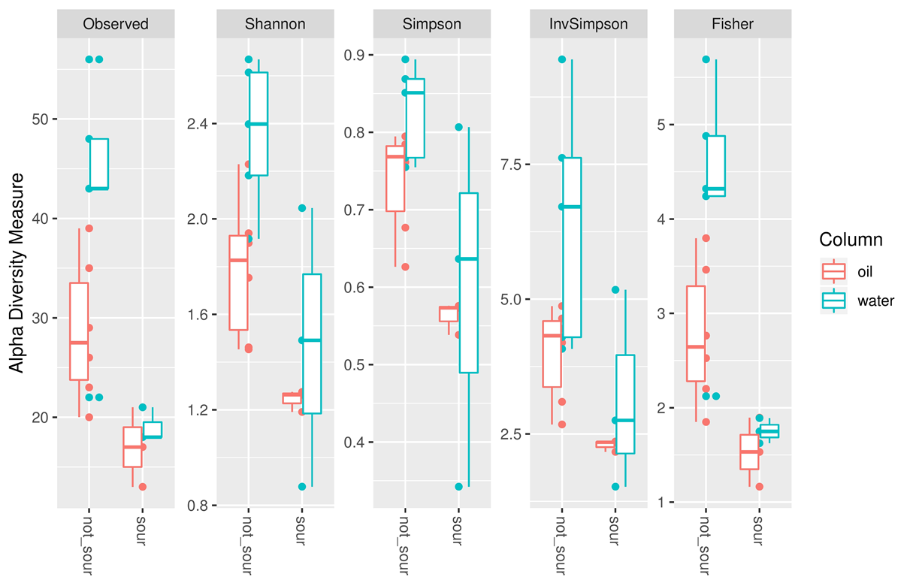

Figure S1: Box plot of alpha diversity indices observed across sour and non-sour phases of seawater and oil enrichment.

Figure S2: Average relative abundance of Bacteroidetes across different phases of oil enrichment.

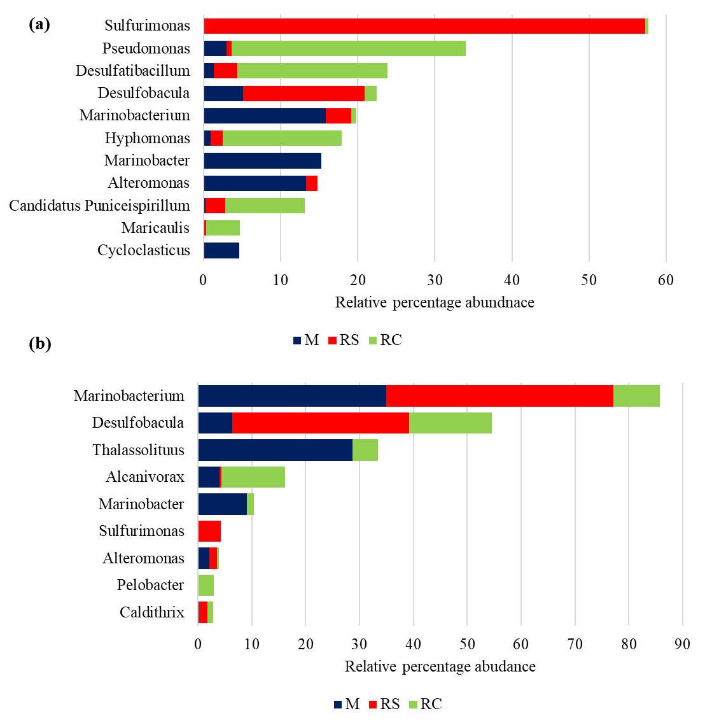
(B)
(A)
Figure S3: Distribution of the five most abundant genera observed across different phases in (A) SWCs and (B) OWCs. Average abundances of each genus across different phases are plotted.

Figure S4: Plot showing relative abundance of Desulfobacula toluolica Tol2 across M and RS phases in different columns. Columns 1, 2, and 3 are seawater-wetted columns and Columns 4, 5, and 6 are oil-wetted columns

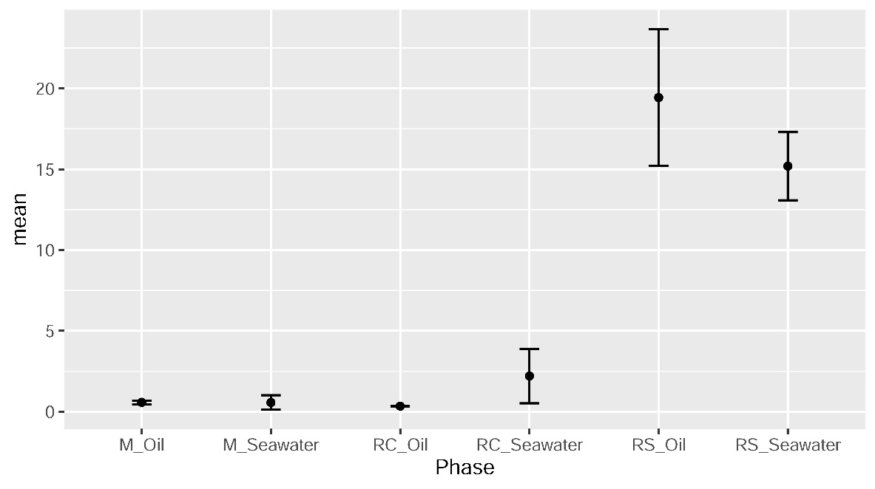
Figure S5: Plot showing mean and standard deviation of sulfide production (in mg L⁻¹) across different phases of SWCs and OWCs

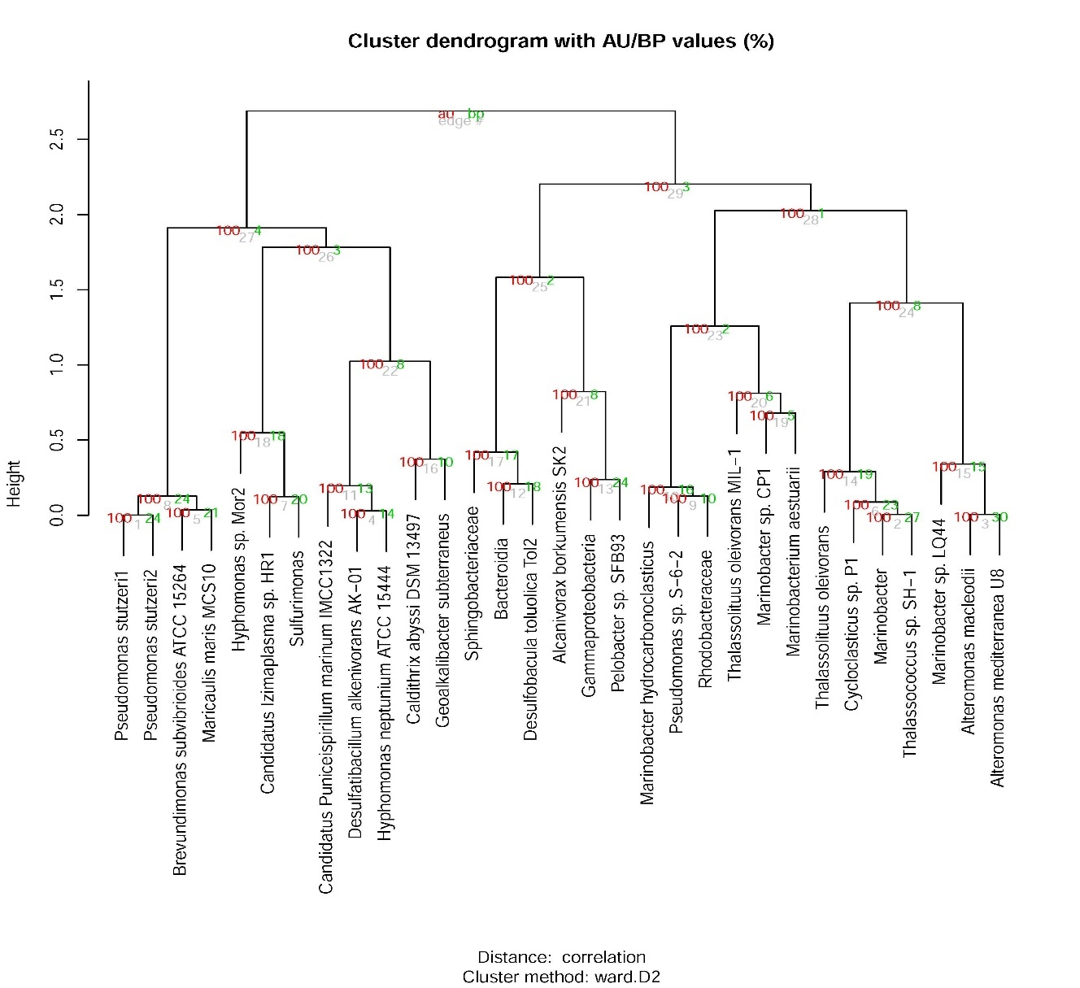

Figure S6: Dendogram showing au (approximately unbiased) p-values and bp (bootstrap probability) values for different clusters of the most abundant taxa. Clusters are considered significant for AU > 95 indicating 95% probability of not being a random cluster.

